Facial Emotion Detection using OpenCv and Deepface

**ABSTRACT**

Facial emotion detection is a model based on facial expressions which can be used in several fields such as criminal investigation, healthcare, human-machine interfaces, academics etc. Facial Emption Recognition (FER) has been recognized for a long time and is a vital topic in the field of computer vision and machine learning. Researchers in this field are interested in developing models that help in better interpretation of facial expressions and extracting these properties to use them later. This model presents the use of deep learning library Deepface which is developed by researchers at Facebook and a very famous computer vision library OpenCv to detect facial emotions. It works on three main steps: Face detection, features extraction and emotion classification. The interest of this model is to provide insights on recent works on automatic facial emotion recognition (FER) via deep learning.

*Keywords:* Facial emotion detection, Deep learning, Computer vision, Automatic Recognition, Deepface, OpenCv.

# **INTRODUCTION**

With deep learning, a lot of new applications of computer vision techniques have been introduced and are now becoming parts of our everyday lives. These include face recognition and indexing, photo stylization or machine vision in self-driving cars.

At its heart, the field of computer vision focuses on designing computer systems that possess the ability to capture, understand, and interpret important visual information contained with image and video data.

Computer vision systems then translate this data, using contextual knowledge provided by human beings, into insights used to drive decision making. Turning raw image data into higher-level concepts so that humans or computers can interpret and act upon them is the principal goal of computer vision technology.

# **Related Work**

Body language and facial expressions play a very crucial role in human interation all over the world. Not only humans but also animals, produce specific muscle movements that belong to a certain mental state. Charles Darwin already published on globally common facial expressions in the nineteenth century, which play an important role in nonverbal communication.[1]

In 1971, Ekman Friesen declared facial behaviors to be correlated uniformly with specific emotions.[2]

1. **Proposed Model**
   1. **Emotion detection using deep learning:**

In this model we use the deep learning library “DeepFace” provided by Facebook for emotion detection which employs a nine-layer neural network with over 120 million connection weights and was trained on four million images uploaded by Facebook users. The following flow chart shows the flow of program that’ll be recognizing the expressions.

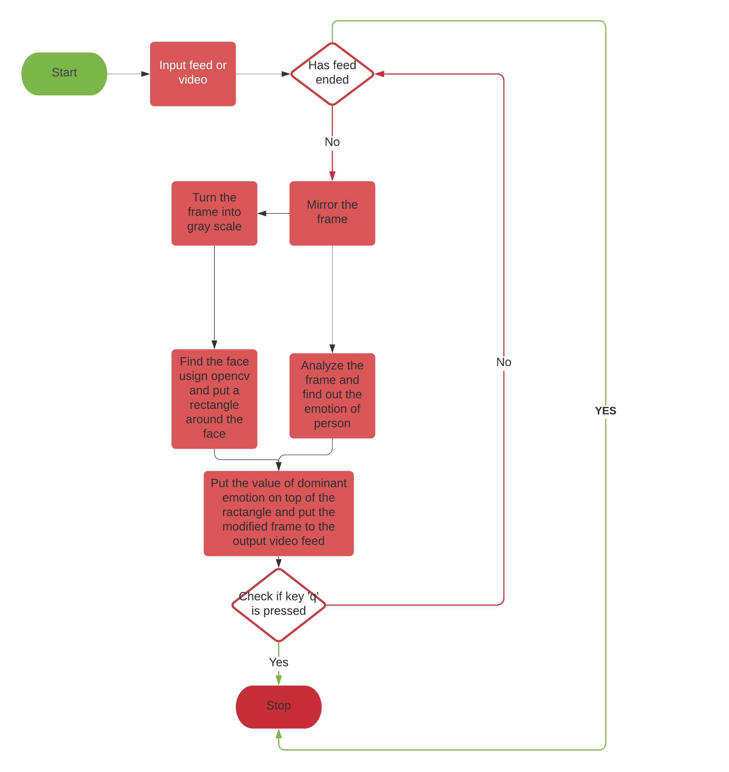

* 1. **Implementation proposed model:**

Libraries opencv and deepface need to be preinstalled to use this model. Following algorithm works with web cam of the device and outputs a modified video.

**Algorithm**

#python 3.9.7, CRLF, tab-size = 4

#importing libraries

import cv2

from deepface import DeepFace

#declaring cascade to be used for face detection

cascade = cv2.CascadeClassifier(cv2.data.haarcascades + 'haarcascade_frontalface_default.xml')

#opening webcam for video input

cap = cv2.VideoCapture(1)

if not cap.isOpened():

cap = cv2.VideoCapture(0)

if not cap.isOpened():

raise IOError('Cannot Open Camera')

#code that extracts and updates video frame

w hile True:

#read the camera feed

ret, frame = cap.read()

#if condition to check input is continuos. If not exit

if ret:

#mirror the camera feed for user convenience

frame = cv2.flip(frame,1)

#convert frame to gray and extract faces in frame

gray= cv2.cvtColor(frame,cv2.COLOR_BGR2GRAY)

faces = cascade.detectMultiScale(gray,1.2, 4)

#font used for displaying emotion

font = cv2.FONT_HERSHEY_SIMPLEX

#each iteration puts a rectangle box around the face and emotion on top of rectangle in the frame

for (x,y,w,h) in faces:

result=DeepFace.analyze(frame,actions=['emotion'])

cv2.rectangle(frame, (x,y), (x+w, y+h), (0,255,0), 1)

cv2.putText(frame,

result['dominant_emotion'].capitalize(),

(x,y-10),

font, 1,

(0,0,255),

2

)

#output the modified frame

cv2.imshow('video', frame)

#if key ‘q’ is pressed exit()

if cv2.waitKey(2) & 0xff == ord('q'):

break

else:

break

#stop reading webcam feed

cap.release()

#destroy windows used for taking input and showing output

cv2.destroyAllWindows()

# **Experiment Details**

We conducted sevral eperiments on the concept of FER using proposed model to assess model’s emotion detection capability. This section describes the results on different datasets used for the experiment.

1. We passed the following image dataset and got respective results:

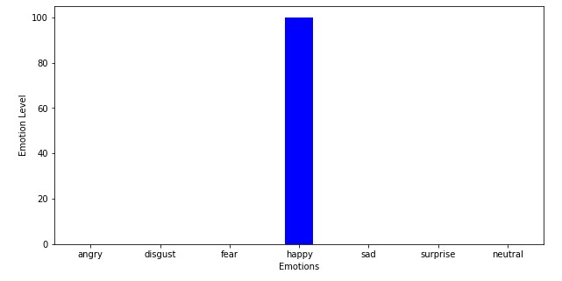

1. Another dataset was as follows:

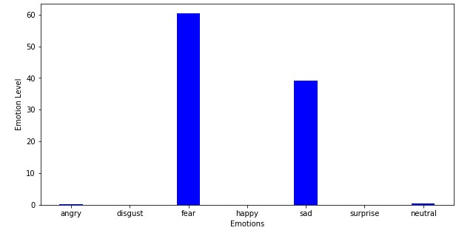

Further we used the model to detect emotions of a person sitting in front of the camera for half an hour and got the following results:

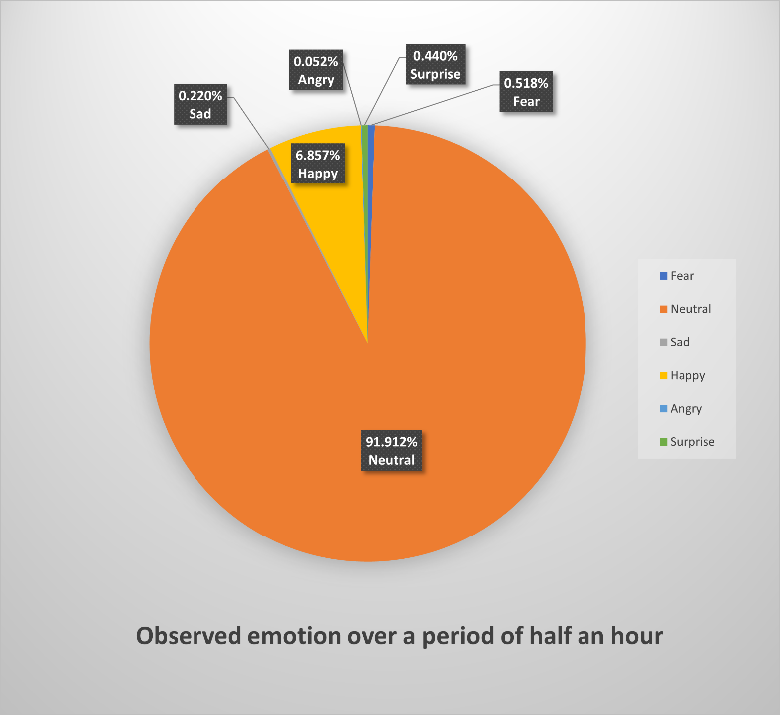

# **Conclusion**

In this study, we have proposed an algorithm to detect facial expressions of a person in a video or webcam feed and showed how deep-learning and computer vision together be used to create a program that can be helpful in solving different real world problems.

**Acknowledgment**

This work was carried out during the academic session 2021-2022 as a project under the practical course CSP353 by a group of students from NIT Uttarakhand (names mentioned under authors section) under the guidance of Dr. Krishan Kumar CSE Department NIT Uttarakhand.

**References**

1. C. R. Darwin, "The expression of the emotions in man and animals" in , John Murray, London, 1872.
2. P. Ekman and W. V. Friesen, "Constants across cultures in the face and emotion", Journal of personality and social psychology, vol. 17, no. 2, pp. 124, 1971.

**Authors**

Anupam Panwar (BT19CSE002)

Neha Dhyani (BT19CSE003)

Purvi Goyal (BT19CSE011)

Priyanshu Upadhyay (BT19CSE020)

**Project link**

<https://github.com/PriyanshuUpadhyay/FacialEmotionDetection>