**(FIT@GYM – A Gym based Website)**

A

Report submitted in partial fulfilment

Of

the requirement for the degree

of

**Bachelor of Technology**

in

**Computer Science & Engineering**

specialized in

**Data Science**

**Under the Supervision of**

Mrs. Garima Verma

Assistant Professor

**By**

##### Kishan Singh

(2001641540032)



Pranveer Singh Institute of Technology, Kanpur

Dr. APJ A.K. Technical University

Lucknow

**Certificate**

This is to certify that Project report entitled as **“FIT@GYM - a gym based website”** which is submitted by **Kishan Singh** in partial fulfilment of the requirement for the award of degree **B.Tech** in department of **Computer Science and Engineering** specialised in **Data Science** , affiliated to **Dr. A.P.J Abdul Kalam Technical University, Lucknow** is a record of the candidate’s own work carried out by them under my/our supervision. The project embodies result of original work and studies carried out by the students themselves and the contents of the project do not form the basis for the award of any degree to the candidate or to somebody else.

Signature:

Dr. Vishal Nagar

Head of Department

CSE Department,

PSIT, Kanpur

Date:

**Declaration**

We hereby declare that this submission is our own work and that, to the best of my knowledge and belief, it contains no material previously published or written by another person nor material which to a substantial extent has been accepted for the award of any other degree or diploma of the university or other institute of higher learning, except where due acknowledgment has been made in the text.

|  |
| --- |
| Signature  **Name:** Kishan Singh  **Roll No.**: 2001641540032  **Date:** 21/02/2022 |

**Acknowledgement**

It gives us a great sense of pleasure to present the report of the B.Tech. Project undertaken during B.Tech second year. We owe special debt of gratitude to our project supervisor **Mrs. Garima Verma, Department of Computer Science and Engineering, Pranveer Singh Institute of Technology, Kanpur** for her constant support and guidance throughout the course of our work. Her sincerely, thoroughness and perseverance have been a constant source of inspiration for us. It is only his cognizant efforts that our endeavours have seen light of the day.

We also do not like to miss the opportunity to acknowledge the contribution of all faculty members of the department for their kind assistance and cooperation during the development of our project. Last but not the least, we acknowledge our friends for their contribution in the completion of the project.

|  |  |
| --- | --- |
| Signature  **Name**: Kishan Singh  **Roll No.**: 2001641540032 |  |

**Content**

Certificate………………………………………………………………………1

Declaration…………………………………………………………………......2

Acknowledgement………………………………………………………….......3

Objective……………………………………………………………………….4

Introduction…………………………………………………………………….5

* Languages and Technology Used……………………………………....6
* Software/ Hardware requirement……………………………………….8

Flow Of Website………………………………………………………………9

Source Code……………………………………………………………….…14

Testing/Result………………………………………………………………..17

Future scope………………………………………………………………….19

Bibliography…………………………………………………………………20

**Objective**

The main objective of this website is to provide a connection between the company and its customer and to provide information about the gym from anywhere at any time, because as looking to the present scenario of the world, people are more conscious about their health and fitness.

So, this website is a very helpful for both the user and company.

This website helps in keeping the records of the customer as well as providing updates and information to the customer.

Here some more features to look over:

* Training tips that build on lessons learned or exercises completed in one of your classes.
* Diet tips for a healthy, holistic lifestyle.
* Weight loss tips that are specific to the classes or training services that you offer at your gym.

**Introduction**

The "Gym Website" has been developed to override the problems prevailing in the practicing manual system. This software is supported to eliminate and, in some cases, reduce the hardships faced by this existing system. Moreover, this system is designed for the particular need of the company to carry out operations in a smooth and effective manner.

The application is reduced as much as possible to avoid errors while entering the data. It also provides error message while entering invalid data. No formal knowledge is needed for the user to use this system. Thus, by this all it proves it is user-friendly. Gym Website, as described above, can lead to error free, secure, reliable and fast management system. It can assist the user to concentrate on their other activities rather to concentrate on the record keeping. Thus, it will help organization in better utilization of resources.

Every organization, whether big or small, has challenges to overcome and managing the information of Trainer, Gym, Facility, Time Slot, Fitness Class. Every Gym Website has different Gym needs; therefore, we design exclusive website for the management systems that are adapted to your managerial requirements. This is designed to assist in strategic planning, and will help you ensure that your organization is equipped with the right level of information and details for your future goals. Also, for those busy executive who are always on the go, our systems come with remote access features, which will allow you to manage your workforce anytime, at all times. These systems will ultimately allow you to better manage resources.

* Languages & Technology Used
  + HTML

The **Hyper Text Markup Language**, or **HTML** is the standard markup language for documents designed to be displayed in a web browser. It can be assisted by technologies cascading style sheet (CSS) and scripting languages such as JavaScript.

Web browsers receive HTML documents from a web server or from local storage and render the documents into multimedia web pages. HTML describes the structure of a web page semantically and originally included cues for the appearance of the document.

HTML elements are the building blocks of HTML pages. With HTML constructs, images and other objects such as interactive forms may be embedded into the rendered page. HTML provides a means to create structured documents by denoting structural semantics for text such as headings, paragraphs, lists, links, quotes and other items.

* CSS

**Cascading Style Sheets** (**CSS**) is style sheet language used for describing the presentation of a document written in a markup language such as HTML. CSS is a cornerstone technology of the World Wide Web, alongside HTML and JavaScript.

CSS is designed to enable the separation of presentation and content, including layout, colours, and fonts. This separation can improve content accessibility; provide more flexibility and control in the specification of presentation characteristics; enable multiple web pages to share formatting by specifying the relevant CSS in a separate .css file, which reduces complexity and repetition in the structural content; and enable the .css file to be cached to improve the page load speed between the pages that share the file and its formatting.

Separation of formatting and content also makes it feasible to present the same markup page in different styles for different rendering methods, such as on-screen, in print, by voice (via speech-based browser or screen reader), and on Braille-based tactile devices. CSS also has rules for alternate formatting if the content is accessed on a mobile-devices.

The name *cascading* comes from the specified priority scheme to determine which style rule applies if more than one rule matches a particular element. This cascading priority scheme is predictable.

* JavaScript

**JavaScript** , often abbreviated **JS**, is a [programming language](https://en.wikipedia.org/wiki/Programming_language) that is one of the core technologies of the [World Wide Web](https://en.wikipedia.org/wiki/World_Wide_Web), alongside [HTML](https://en.wikipedia.org/wiki/HTML) and [CSS](https://en.wikipedia.org/wiki/CSS). Over 97% of [websites](https://en.wikipedia.org/wiki/Website) use JavaScript on the [client](https://en.wikipedia.org/wiki/Client_(computing)) side for [web page](https://en.wikipedia.org/wiki/Web_page) behaviour,  often incorporating third-party [libraries](https://en.wikipedia.org/wiki/Library_(computing)).[[13]](https://en.wikipedia.org/wiki/JavaScript#cite_note-lib_usage-13) All major [web browsers](https://en.wikipedia.org/wiki/Web_browser) have a dedicated [JavaScript engine](https://en.wikipedia.org/wiki/JavaScript_engine) to execute the [code](https://en.wikipedia.org/wiki/Source_code) on [users](https://en.wikipedia.org/wiki/User_(computing))' devices.

JavaScript is a high-level, often just-in-time compiled language that conforms to the ECMA Script standard. It has dynamic typing, prototype-based object orientation , and first class function. It is multi paradigm, supporting event-driven, functional, and imperative programming skills. It has Application Programming Interfaces (APIs) for working with text, dates, regular expressions, standard data structures, and the Document Object Model (DOM).

* API

An **application programming interface** (**API**) is a connection between [computers](https://en.wikipedia.org/wiki/Computer) or between [computer programs](https://en.wikipedia.org/wiki/Computer_program). It is a type of software [interface](https://en.wikipedia.org/wiki/Interface_(computing)), offering a service to other pieces of [software](https://en.wikipedia.org/wiki/Software). A document or standard that describes how to build or use such a connection or interface is called an API specification. A computer system that meets this standard is said to implement or expose an API. The term API may refer either to the specification or to the implementation.

Here, 2 API’s are used in this website:

* **Sheetdb** for saving the user information to a google spreadsheet.
* **Google API** for embed map in the website.
* Software/Hardware Requirements
* Visual studio code

Visual Studio Code is a **streamlined code editor with support for development operations like debugging, task running, and version control**. It aims to provide just the tools a developer needs for a quick code-build-debug cycle and leaves more complex workflows to fuller featured IDEs, such as Visual Studio IDE.

* Computer/Laptop
* Internet connection
* Web server

**Flow of Website**



Service & Equipments



On click

Pop Up Registration page

Membership



For data storing – Google spreadsheet



Contact

About us

Gallery

**Source Code**

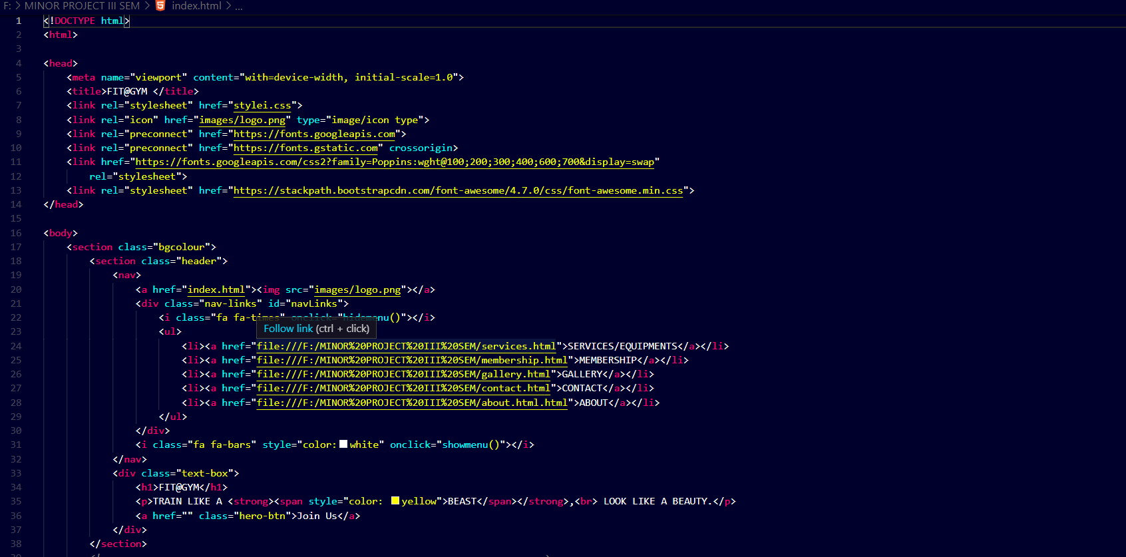

This is the basic code for the front page of the project.

Links and images are inserted here through this code on the website’s frontpage.

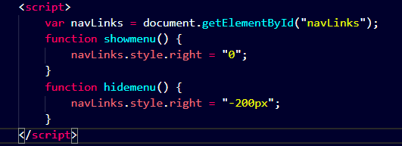

JavaScript code is used to add the parallax effect to the website.

*{

  margin: 0;

  padding: 0;

  font-family: "Poppins", sans-serif;

}

.header {

  min-height: 70vh;

  width: 100%;

  background-image: linear-gradient(rgba(4, 9, 30, 0.7), rgba(4, 9, 30, 0.7)),

  url(images/banner.jpg);

  background-position: center;

  background-size: cover;

  position: relative;

}

nav {

  display: flex;

  padding: 2% 6%;

  justify-content: space-between;

  align-content: center;

}

nav img {

  width: 150px;

  margin-top: -0.7cm;

}

.nav-links {

  flex: 1;

  text-align: right;

}

.nav-links ul li {

  list-style: none;

  display: inline-block;

  padding: 8px 12px;

  position: relative;

}

.nav-links ul li a {

  color: white;

  text-decoration: none;

  font-size: 16px;

}

.nav-links ul li::after {

  content: "";

  width: 0%;

  height: 2px;

  background: yellow;

  display: block;

  margin: auto;

  transition: 0.5s;

}

.nav-links ul li:hover::after {

  width: 100%;

}

.text-box {

  width: 90%;

  color: white;

  position: absolute;

  top: 50%;

  left: 50%;

  transform: translate(-50%, -50%);

  text-align: center;

}

.text-box h1 {

  font-size: 84px;

  color: transparent;

  -webkit-text-stroke: 1px yellow;

  background-image: url(images/back.jpg);

  -webkit-background-clip: text;

  background-position: 0 0;

  animation: back 2s linear infinite;

}

.bgcolour {

  width: 100%;

  background: rgba(0, 0, 0, 0.3);

}

.bgcolour1 {

  width: 100%;

  background: transparent;

}

@keyframes back {

  100% {

    background-position: 2000px 0;

  }

}

.text-box p {

  margin: 10px 0 40px;

  font-size: 24px;

}

.hero-btn {

  display: inline-block;

  text-decoration: none;

  color: white;

  border: 2px solid white;

  padding: 08px 28px;

  font-size: 20px;

  background: rgba(0, 0, 0, 0.3);

  position: relative;

  border-radius: 1vh;

  cursor: pointer;

}

.hero-btn:hover {

  border: 1px solid yellow;

  background: yellow;

  color: black;

  transition: 1s;

}

.hero1-btn {

  display: inline-block;

  text-decoration: none;

  color: black;

  border: 2px solid black;

  padding: 08px 28px;

  font-size: 20px;

  background: rgb(0, 0, 0, 0.3);

  position: relative;

  border-radius: 1vh;

  cursor: pointer;

}

.hero1-btn:hover {

  border: 2px solid black;

  background: yellow;

  color: black;

  transition: 0.8s;

}

.hero2 {

  display: inline-block;

  text-decoration: none;

  color: black;

  border: 2px solid black;

  padding: 08px 28px;

  font-size: 20px;

  background: rgb(0, 0, 0, 0.3);

  position: relative;

  border-radius: 1vh;

  cursor: pointer;

}

.hero2:hover {

  border: 2px solid black;

  background: yellow;

  color: black;

  transition: 0.8s;

}

nav .fa {

  display: none;

}

  }

  .nav-links ul li a {

    color: black;

    font-size: 14px;

  }

  nav .fa {

    display: block;

    color: black;

    margin: 10px;

    font-size: 20px;

    cursor: pointer;

  }

  .nav-links ul {

    padding: 25px;

  }

  .row {

    flex-direction: column;

  }

  .cta h1 {

    font-size: 24px;

  }

To make responsive:

@media (max-width: 700px) {

  .text-box h1 {

    font-size: 50px;

  }

  .text-box p {

    font-size: 18px;

  }

  .nav-links ul li {

    display: block;

  }

  .nav-links {

    position: fixed;

    background: yellow;

    height: 70vh;

    width: 200px;

    top: 0;

    right: -200px;

    color: yellow;

    text-align: left;

    z-index: 2;

    transition: 1s;

.about-col h1 {

    font-size: 200%;

  }

  .pricing-table {

    flex: 100%;

  }

  .sub-header h1 {

    font-size: 40px;

  }

  .contact-col input,

  .contact-col textarea {

    width: 90%;

  }

}

CSS script for the front page. Positioning, colour and responsiveness of the Website is handle here in this CSS code.

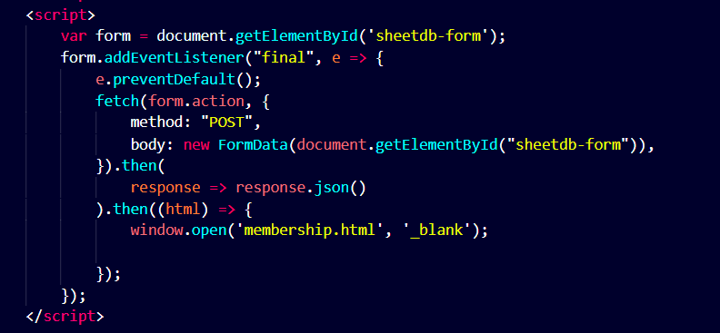JavaScript Code to send the user data to the google spreadsheet.

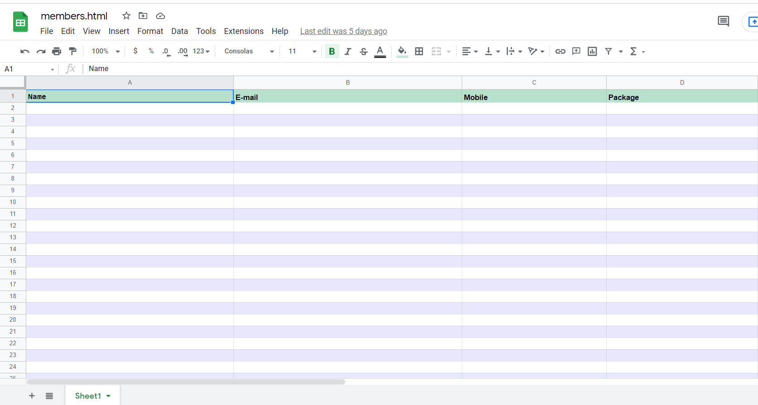

Google spreadsheet where data will be stored.

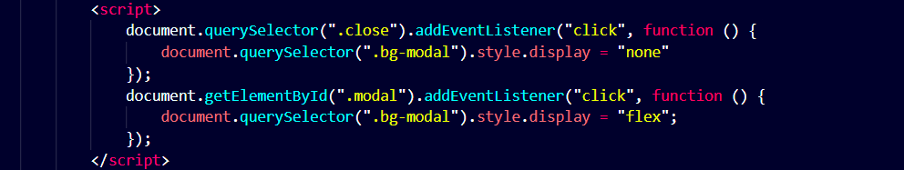

JavaScript code to pop in and pop out Registration page.

**Testing/Result**

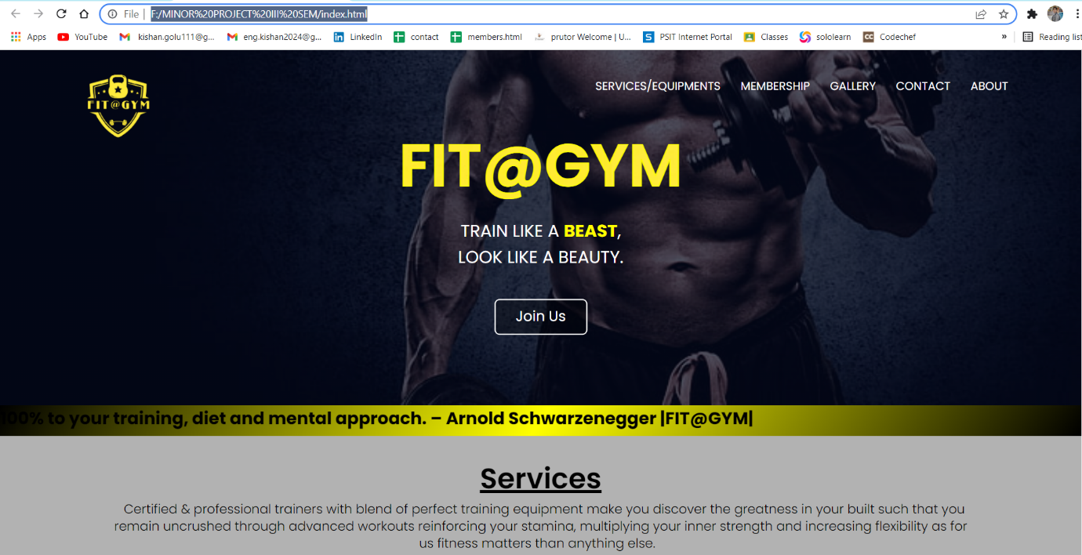

The front page looks something like this.

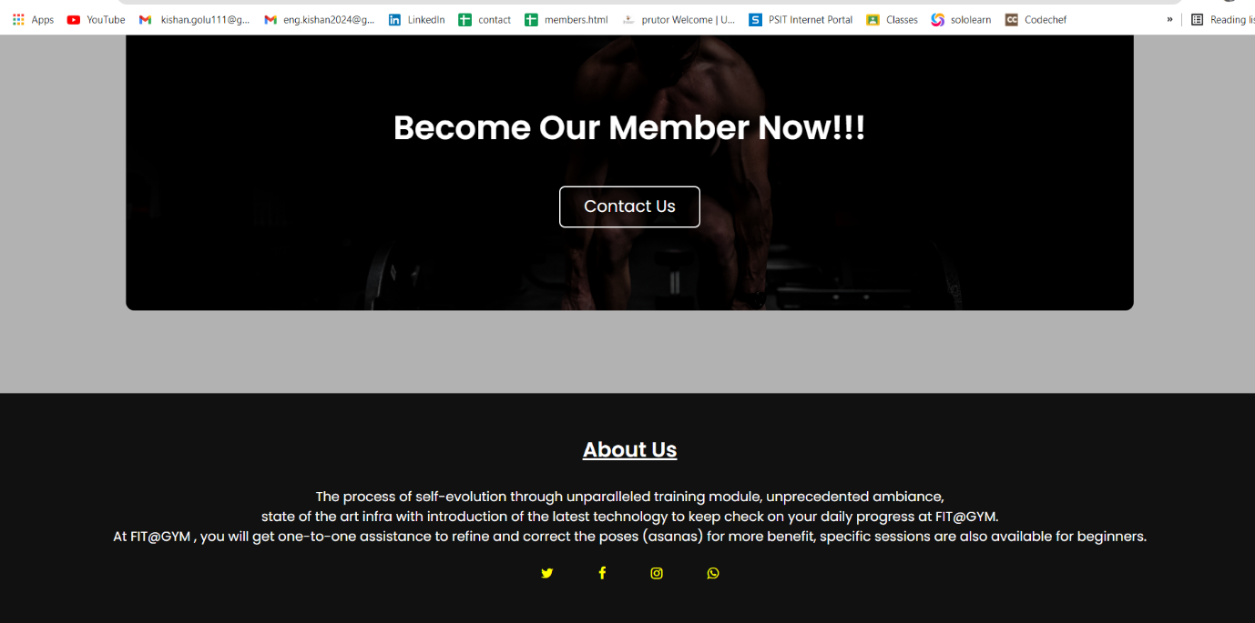

The bottom of front page looks something like this.

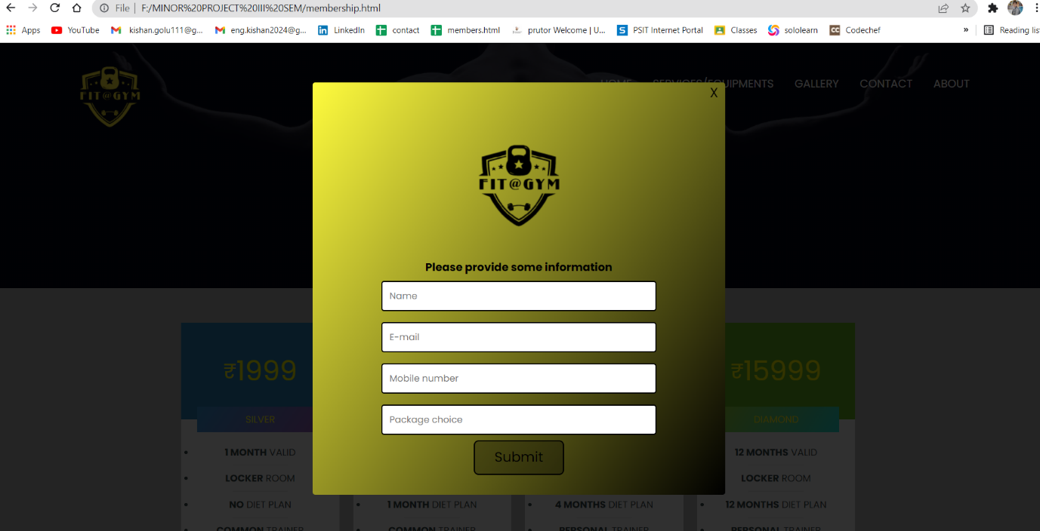

This is the pop-up window for registration page.

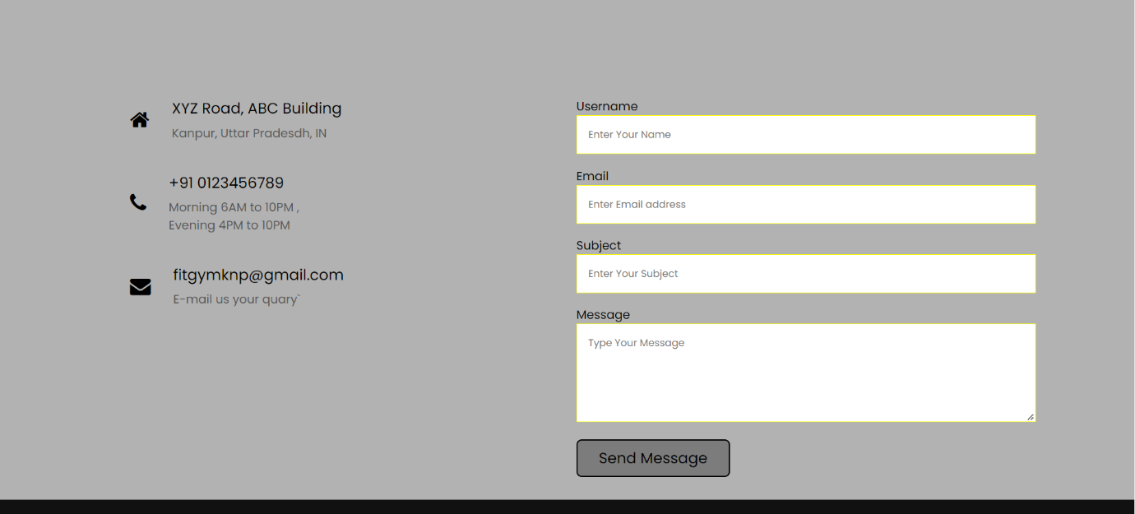

The User form window for any type of query.

**Future Scope**

As this website is helpful in maintaining the relationship between a user and a company, this website can be more helpful to them by keeping their membership tracking from anywhere.

Also, this website can be extended at the level of e-commerce website by adding a section where a user can buy equipments and products related to health and fitness and can do transactions online.

Thus, making it a complete website for a gym as well as shopping related to health and fitness.

**Bibliography**

To make this project I have taken lessons and help from the following:

* Geek for Geeks
* Sololearn and Udemy courses for web development
* JavaScript course and back end from YouTube
* Wikipedia