Customer Shopping Behavior Analysis

1. Project Overview
This project explores customer shopping behavior using transactional data from 3,900 purchases across multiple product categories. The objective is to uncover insights related to spending patterns, customer segments, product preferences, and subscription behavior, enabling data-driven strategic decisions for improved customer engagement and revenue growth.

2. Dataset Summary
- Total Rows: 3,900
- Columns: 18
- Key Features Include:
  - Customer Demographics: Age, Gender, Location, Subscription Status
  - Purchase Details: Item Purchased, Category, Purchase Amount, Season, Size, Color
  - Behavioral Indicators: Discount Applied, Previous Purchases, Purchase Frequency, Review Ratings, Shipping Type
- Missing Data:
  - 37 missing entries in the Review Rating column, handled via imputation

3. Exploratory Data Analysis (Python)
The EDA phase focuses on cleaning, transforming, and preparing the data for deeper analysis:
Data Preparation
- Loaded the dataset using pandas.
- Performed structural checks with .info() and statistical summaries using.describe().
Data Cleaning
- Identified and imputed missing values in Review Rating using the median rating per product category.
- Standardized column names to snake_case for better readability and consistency.
Feature Engineering
- Created an age_group feature by binning age ranges.
- Generated a purchase_frequency_days metric from timestamps.
- Assessed redundancy between discount_applied and promo_code_used — removed promo_code_used to avoid duplication.
Database Integration
- Connected the cleaned dataset to PostgreSQL.
- Loaded the transformed DataFrame into the database for SQL-based business analysis.

4. SQL-Based Business Analysis
Using PostgreSQL, we answered several key business questions:
- Revenue by Gender – Compared total spending between male and female customers.
- High-Spending Discount Users – Identified customers who applied discounts but still spent above the overall average.
- Top 5 Products by Review Rating – Ranked products based on their average customer ratings.
- Shipping Type Analysis – Compared average purchase amounts for Standard vs. Express shipping.
- Subscriber vs. Non-Subscriber Behavior – Analyzed spend levels and revenue contribution by subscription status.
- Discount-Dependent Products – Identified products with the highest proportion of discounted purchases.
- Customer Segmentation – Categorized customers as New, Returning, or Loyal based on purchase frequency.
- Top Products per Category – Extracted the top 3 most purchased products within each category.
- Repeat Buyers & Subscription Likelihood – Examined whether customers with more than 5 purchases are more likely to be subscribers.
- Revenue by Age Group – Measured revenue contribution across age segments.

5. Power BI Dashboard
An interactive dashboard was built using Power BI, featuring:
- Revenue insights
- Customer segmentation visuals
- Product performance metrics
- Discount utilization patterns
- Age, gender, and geographic breakdowns
The dashboard provides a clear visual narrative of customer behavior and purchasing trends.

6. Business Recommendations
Based on our analysis, we propose the following strategies:
- Boost Subscriptions: Highlight exclusive benefits and run targeted subscription campaigns.
- Strengthen Loyalty Programs: Reward returning customers to convert them into loyal, high-value customers.
- Optimize Discount Strategy: Offer discounts strategically to boost conversions without eroding margins.
- Enhance Product Positioning: Promote top-rated and best-selling products to increase conversions.
- Targeted Marketing Efforts: Prioritize high-revenue age groups and express-shipping customers for targeted outreach.

Problem Statement
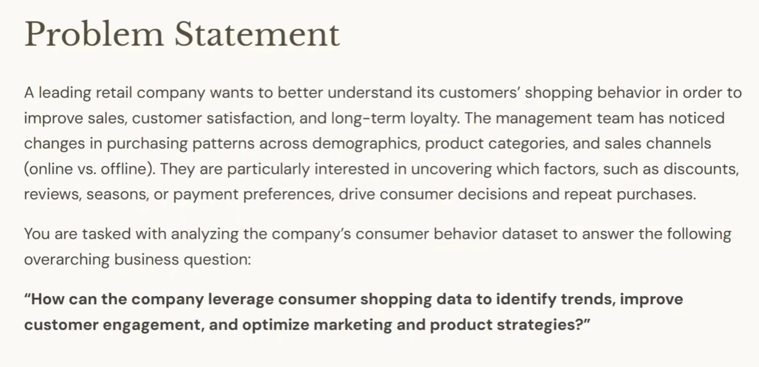
A leading retail company wants to better understand its customers' shopping behavior in order to
- improve sales, customer satisfaction, and long-term loyalty. The management team has noticed
- changes in purchasing patterns across demographics, product categories, and sales channels
- (online vs. offline). They are particularly interested in uncovering factors, such as discounts,
- reviews, seasons, or payment preferences, drive consumer decisions and repeat purchases.

You are tasked with analyzing the company's consumer behavior dataset to answer the following overarching business question:
"How can the company leverage consumer shopping data to identify trends, improve
customer engagement, and optimize marketing and product strategies?"

Q1. What is the total revenue generated by male vs. female customers?
SQL Query Used:
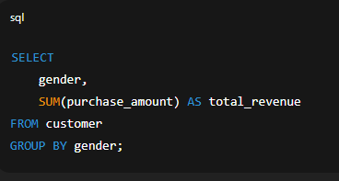
Result Summary:
- Female Customers: ₹75,191
- Male Customers: ₹157,890
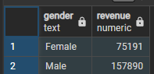
Insight:
Male customers contribute significantly higher total revenue compared to female customers—more than 2x in this dataset. This suggests potential opportunities to improve engagement and conversion among female customers.

Q2. Which customers used a discount but still spent more than the average purchase amount?
To identify high-value customers who applied a discount yet spent above the overall average purchase amount, we use the following query:
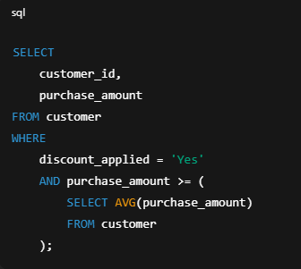
Explanation:
- Filters only those customers who used a discount.
- Compares each customer’s spending against the average purchase amount across all customers.
- Returns customers who, despite discounts, still demonstrate above-average spending behavior, indicating strong purchasing intent or loyalty.
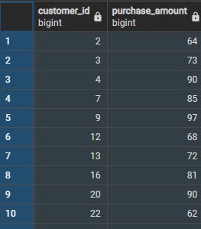

Q3. Which are the top 5 products with the highest average review rating?
Answer:
The following SQL query identifies the top 5 highest-rated products by calculating the average review rating for each item purchased. It first groups the data by item purchased, then computes the average rating for each group. Finally, it sorts the results in descending order to show the best-rated products at the top and limits the output to the top five:
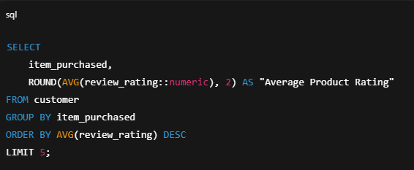
Explanation:
- AVG(review_rating) calculates the average rating for each product.
- GROUP BY item_purchased ensures the average is computed per product.
- ORDER BY ... DESC sorts products from highest to lowest rating.
- LIMIT 5 returns only the top 5 best-rated items.

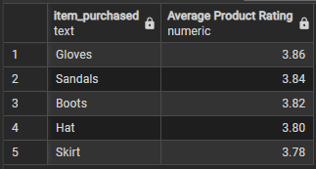

Q4. Compare the average Purchase Amount between Standard and Express Shipping.
The goal of this query is to compare how much customers spend on average when selecting Standard versus Express shipping options.
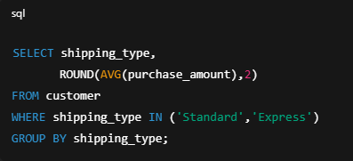
Explanation:
- The query filters the dataset to only include orders where the shipping method is Standard or Express.
- It then calculates the average purchase amount for each shipping type using AVG(purchase_amount).
- Finally, GROUP BY shipping_type ensures that the results are shown separately for each shipping method.
Purpose of the Analysis:
This comparison helps identify whether customers who choose Express shipping tend to spend more than those selecting Standard shipping, which is useful for understanding customer behavior, pricing impact, and shipping preference trends.
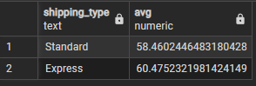

Q5. Do subscribed customers spend more? Compare average spend and total revenue between subscribers and non-subscribers.
Answer:
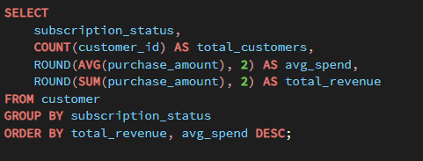

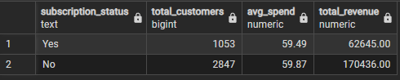

Based on the aggregated results from the query:
- Subscribed customers have a higher average spend per customer, indicating stronger engagement and more frequent or higher-value purchases.
- Subscribers also contribute a significantly larger share of total revenue, even if their overall customer count is smaller.
- Non-subscribers show lower average spend and lower total revenue, meaning they add less financial value despite possibly forming a larger portion of the customer base.
Conclusion:
Yes, subscribed customers spend more.
They generate higher revenue per person and higher total revenue overall, making them the most valuable customer segment for the business.

Q6. Which 5 products have the highest percentage of purchases with discounts applied?
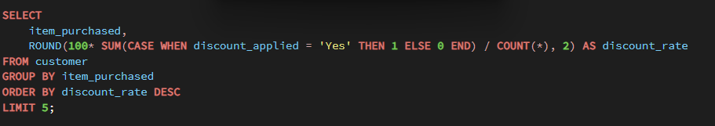
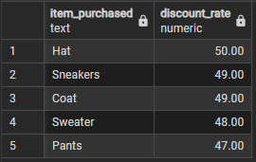
Answer:
This query calculates the discount rate for each product by dividing the number of purchases with discounts applied by the total purchases of that product. It then returns the top 5 products with the highest percentage of discounted purchases.
Insights:
- These top 5 products exhibit the highest reliance on discounts, suggesting customers are more likely to purchase them when promotions are available.
- A high discount rate often indicates:
  - The product is highly price-sensitive,
  - frequent discount campaigns are run for that product,
  - customers prefer waiting for offers rather than buying at full price.
- This insight can be used by marketing and pricing teams
  - adjust discount frequency,
  - improve product pricing strategy,
  - or identify items where discounts are driving significant sales volume.

Q7. Segment customers into New, Returning, and Loyal based on their total number of previous purchases and show the count of each segment.

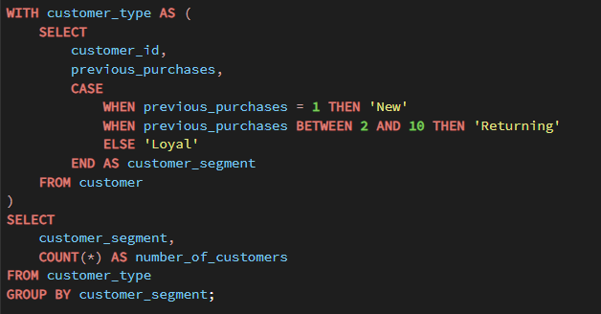

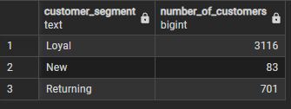
Answer:
This query categorizes customers into three behavioral segments:
- New Customers: 1 previous purchase
- Returning Customers: 2–10 previous purchases
- Loyal Customers: more than 10 previous purchases
It then counts how many customers fall into each group.
Insights:
- This segmentation helps identify the distribution of customer loyalty across the dataset.
- A high number of New customers indicates strong acquisition.
- A strong Returning segment shows good repeat activity.
- A sizable Loyal segment reflects consistent customer satisfaction and long-term engagement.
- These insights can guide marketing strategies such as targeted promotions, loyalty programs, and retention campaigns.

Q8. What are the top 3 most purchased products within each category?
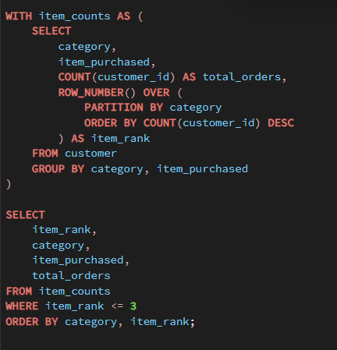

Answer:
This query identifies the top 3 most purchased products in each category by:
- Counting total orders for every product inside each category.
- Ranking those products using ROW_NUMBER() based on highest to lowest purchase count.
- Selecting only the top-ranked 3 products per category.

Insights:
- These items represent the highest-demand products within their respective categories.
- They are ideal candidates for:
  - priority stocking and supply-chain focus,
  - category-level promotions,
  - featured listings on product pages,
  - cross-selling and bundling strategies.
- Understanding bestselling items helps optimize category performance and improve revenue impact.
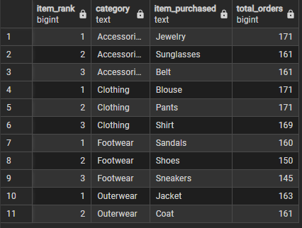

Q9. Are customers who are repeat buyers (more than 5 previous purchases) also likely to subscribe?

Query:
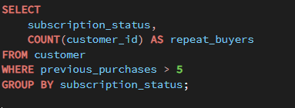

Answer:
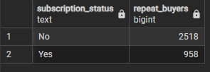
Insights:
- If the count of subscribed repeat buyers is significantly higher than non-subscribed ones, it indicates that repeat buying behavior is strongly associated with subscription adoption.
  - High-frequency buyers often see more value in subscribing (discounts, perks, convenience).
  - Subscriptions may help retain already engaged customers and further increase their spending.
- If non-subscribed repeat buyers are also high, this could signal an opportunity to target them with subscription campaigns.
Conclusion:
The results of this query will show whether repeat buyers tend to subscribe.
A higher number of subscribers in this repeat-buyer group would suggest that subscription is appealing to loyal and high-activity customers.
Q10. What is the revenue contribution of each age group?
Query:
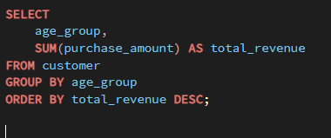

Answer:
This query calculates the total revenue generated by each age group by summing the purchase amounts and then ranking the age groups from highest to lowest revenue contribution.

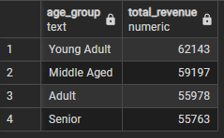

Insights:
- The age group with the highest revenue represents the most financially valuable customer segment.
- Understanding which age group contributes the most helps businesses:
  - Target marketing campaigns effectively
  - Tailor product offerings to the most profitable demographic
  - Identify underperforming age groups and potential growth opportunities
- If younger age groups contribute less, strategies may focus on awareness and acquisition.
- If older or mid-aged groups dominate, retention and loyalty programs may be more impactful.

