

E-Commerce Sales Analytics Dashboard Report
  - Data Visualisation Assignment
 | DataVinci Private Limited |  | Prepared by Priyanshu Joshi



Overview
The objective of this assignment was to analyze an e-commerce transaction dataset and create meaningful visualizations that answer the business questions provided in the assignment given.
The analysis was performed using Microsoft Power BI.
The steps Performed during the analysis were data cleaning, transformation, visualization and dashboard design.

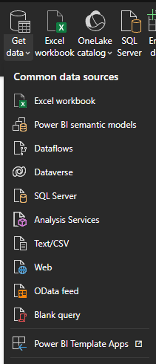

Step-1: Data validation
The CSV was imported into Power BI using the option:
Get data -> Text/CSV option,

Initially the dataset was inspected to verify that all required columns were present.

The dataset contained the following fields:

- TransactionNo
- Date
- ProductNo
- Product
- Price
- Quantity
- CustomerNo
- Country
- Category

The date column was verified to ensure it was recognized as a date Data Type before the beginning of the analysis.

Figure 1

Step -2: Data Cleaning
To ensure accurate analysis, the dataset was cleaned before creating any visualizations.
The following cleaning steps were performed:

Removing Cancelled Transactions:
The TransactionNo column contained transactions beginning with the letter "C", indicating cancelled orders.
These cancelled records were removed using Power Query so that only completed purchases were included in the analysis.

Removing Invalid Quantities
The Quantity column contained negative values representing returned or cancelled items.
A filter was applied to retain only transactions where:
Quantity > 0
This ensured that only successful purchases contributed to revenue calculations.

Creating the Revenue Column
A new custom column named Revenue was created using the formula:
Revenue = Price × Quantity
This new field became the primary measure used throughout the dashboard.

Revenue Column Data Type
While creating the Revenue distribution chart, it was discovered that the Revenue column had been stored as Text instead of a numeric value.
Because of this, Power BI only allowed grouping by individual values instead of creating numeric bins.
Resolution
The Revenue column's data type was changed from Text to Decimal Number.
After correcting the data type, Power BI successfully generated numeric bins for the histogram.
To answer the first business question, a histogram was created.
Since Power BI does not include a native histogram visual, Revenue bins were generated using the New Group (Bins) feature.

step 3: Distrubution of Transaction amounts

Q. Questions:
1. What is the distribution of transaction amounts?

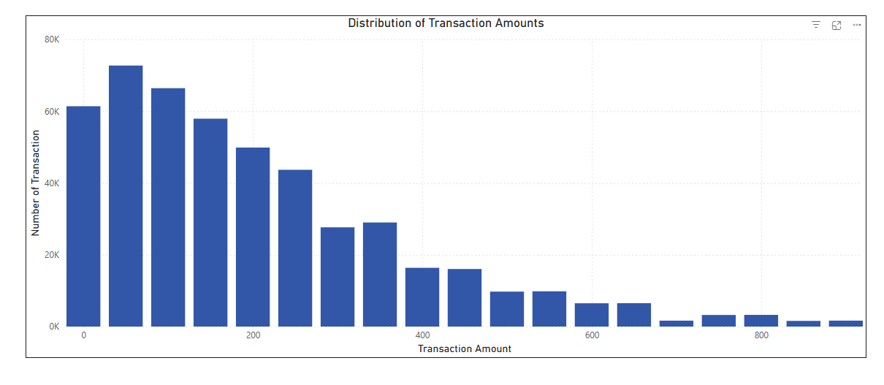

The visualization showed that:
- Most transactions fall within lower revenue ranges.
- High-value transactions occur much less frequently.
This indicates that the business generates most of its sales through numerous small purchases rather than a few expensive transactions.

Key Business Insight
Transaction Distribution
Most customer purchases consist of relatively small transaction amounts, while high-value purchases are comparatively rare.

Step 4: Revenue Trend OVer time
2. How does the total transaction amount vary over time?

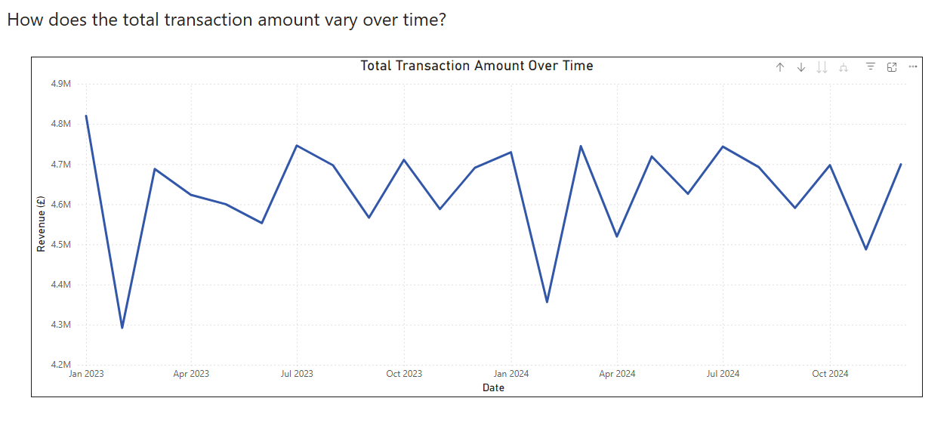

A line chart was created using:
- Date
- Sum of Revenue

Daily Data Was Too Crowded
Using daily transaction dates produced an extremely noisy chart that made it difficult to identify trends.
Resolution
The Date hierarchy was used, and the visualization was aggregated by Month instead of Day.
This produced a much cleaner and more meaningful representation of revenue trends over time.
The monthly trend clearly highlighted seasonal fluctuations and overall sales consistency.

Key Business Insight:

Revenue Trend
Revenue remained within a narrow range across most months, suggesting relatively stable sales performance with limited seasonality. The decline observed in February 2023 and February 2024 may warrant further investigation into operational or seasonal factors.

Step 5: Revenue by Product Category

3. Which product categories generate the most revenue?
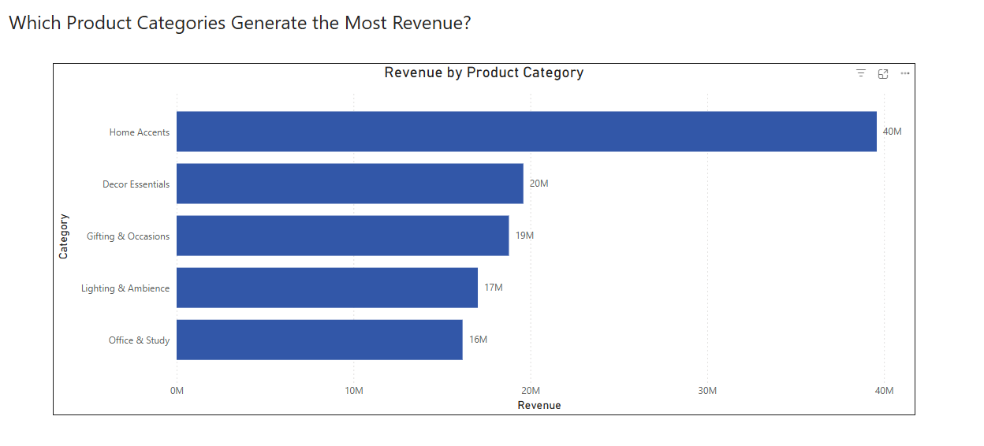
A clustered horizontal bar chart was created.
The chart compared total revenue generated by each product category.
Categories were sorted in descending order of revenue.
The analysis showed that:
- Home Accents generated the highest revenue.
- Office & Study generated the lowest revenue.
This visualization identified the strongest performing product categories.

Key Business Insight:

Product Performance
Home Accents generated the largest share of revenue, indicating strong customer demand for products in this category.
Home Accents contributed approximately twice the revenue of the second-highest category, suggesting this category should remain a strategic focus for inventory planning and promotional campaigns.

Step 6: Customer Purchasing Behaviour

4. Can you identify any trends or patterns in customer purchasing behavior?

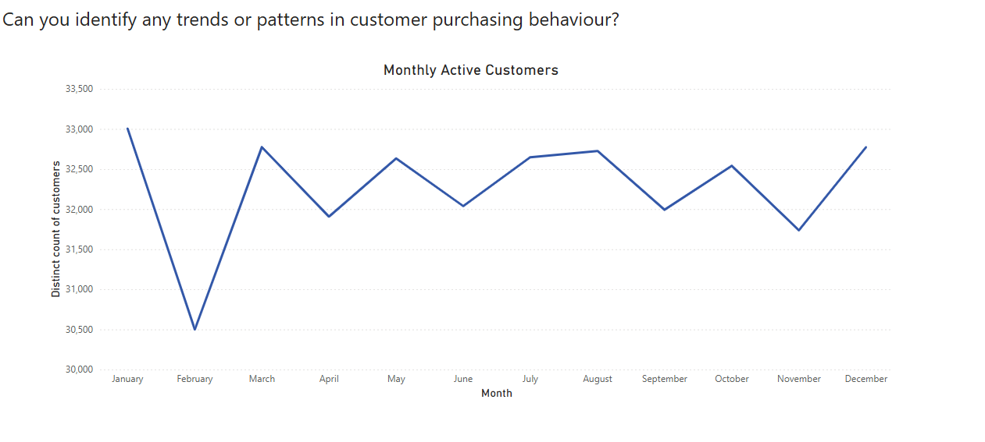
To answer the final business question, a line chart showing Monthly Active Customers was created.
The visualization used:
- Month
- Distinct Count of CustomerNo
The chart demonstrated that customer activity remained relatively stable throughout the analysis period with only minor monthly variations.
This indicates consistent customer engagement over time.

Key Business Insights:

Customer Behavior
The relatively stable number of active customers suggests healthy customer retention.
Since customer acquisition remained steady, future revenue growth may depend on increasing average order value rather than customer volume.

Step 7: Dashboard Design

After completing all required visualizations, they were combined into a single interactive dashboard.

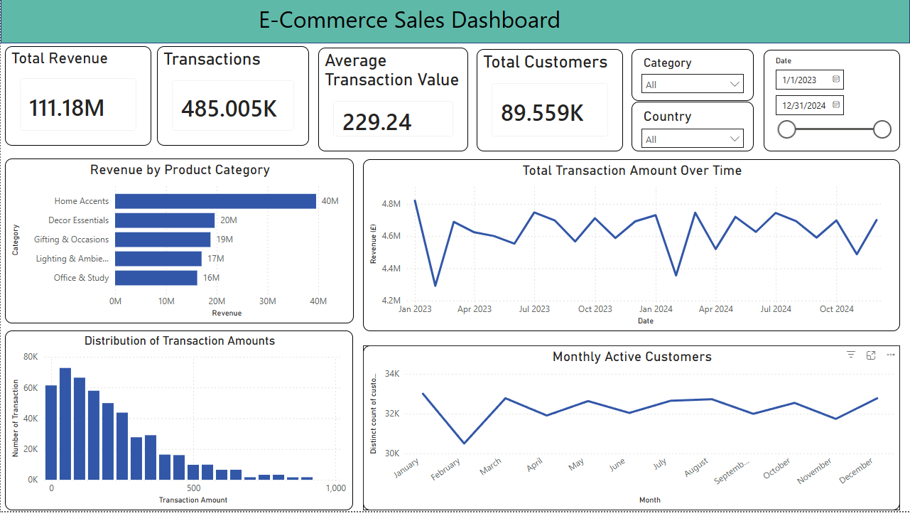
The dashboard included:
- KPI Cards
  - Total Revenue
  - Total Customers
  - Total Transactions
  - Average Transaction Value
- Revenue Distribution
- Monthly Revenue Trend
- Revenue by Product Category
- Monthly Active Customers
Interactive slicers were also added for:
- Category
- Country
- Date

These slicers allow users to dynamically filter the dashboard and explore the data interactively.

Recommendation 1
Continuing investing in the Home Accents category because it contributes the highest share of revenue.

Recommendation 2
Investigate reasons for lower revenue during February to determine whether the decline is seasonal or operational.

Recommendation 3
Increase the average transaction value by promoting complementary products through bundled offers.

Recommendation 4
Monitor Office & Study products to determine whether low sales are caused by pricing, inventory, or customer demand.

Conclusion
This project successfully transformed raw e-commerce transaction data into a meaningful and interactive Power BI dashboard that answers the key business questions provided in the assignment. The process involved validating the dataset, cleaning and transforming the data, creating relevant visualizations, and designing an easy-to-use dashboard.
During the analysis, a few challenges were encountered, such as handling cancelled transactions, removing invalid quantities, correcting data types, and improving overly detailed daily visualizations by aggregating them into monthly trends. Resolving these issues helped ensure that the final dashboard presented accurate and meaningful insights.
The analysis revealed that most transactions were of relatively low value, monthly revenue remained consistent over the analysis period, Home Accents was the highest performing product category, and customer activity remained stable across most months. These findings provide a clear overview of sales performance and customer purchasing behavior.
Thank you.

