MLOps LAB ASSIGNMENT
ML Pipelines, FastAPI and Docker
Sessions 7, 8 and 9 Combined
COMPLETED ASSIGNMENT REPORT
Student Name | Aman Kumar Jha
Programme / Branch | B.Tech - Artificial Intelligence and Data Science
Institute | Gati Shakti Vishwavidyalaya
Course | MLOps: From Machine Learning to Production AI Systems
Project | House-Price Prediction Service
Dataset | Synthetic dataset generated for this assignment
Roll Number | 24AI009
Faculty / Instructor | Dr. Vipul kumar Mishra
Submission Date | 06-11-2026

Assignment Overview
In this assignment, I converted a basic machine-learning workflow into a modular application that can be trained, evaluated, served through a REST API and packaged with Docker. I selected a house-price regression example. To make the work reproducible without using private data, I generated a synthetic dataset locally. The records are artificial and are used only to demonstrate the MLOps workflow.
The project follows the required flow:
Synthetic CSV data
|
v
Data loading -> Cleaning -> Feature engineering
|
v
Train / test split -> Training -> Evaluation
| |
v v
Saved inference pipeline Metrics report
|
v
FastAPI GET /health and POST /predict
|
v
Docker image -> Container -> Host request

The saved pipeline includes feature engineering, missing-value imputation, scaling and the Random Forest estimator. This is important because inference must apply the same transformations that were used during training.

Learning Outcomes
- Designed a modular ML pipeline with separate responsibilities for data preparation, training, evaluation and prediction.
- Separated data loading, cleaning, feature engineering, training, evaluation and prediction into reusable Python modules.
- Used REST concepts, HTTP methods, Pydantic request validation and FastAPI inference endpoints.
- Explained the difference between online inference and batch inference.
- Created and tested a FastAPI prediction service using the automatic Swagger UI and automated API tests.
- Loaded a saved model pipeline and handled invalid requests with controlled responses.
- Prepared Docker image, container, port, volume, environment-variable and Docker Compose configuration.
- Documented commands and project structure so another developer can reproduce the local workflow.

Continuing Project Scenario
The selected scenario is a house-price prediction service. A user sends information about a house, such as its area, number of bedrooms and age. The service returns an estimated price in lakh Indian rupees. In a real project, the data would come from a public or approved source. For this lab, I generated 1,200 synthetic records with a fixed random seed. No real property records or personal information are used.
The six input features are area_sqft, bedrooms, bathrooms, age_years, distance_to_city_km and parking_spaces. The target column is price_lakh. The values are suitable for demonstrating regression, but the generated dataset is not a source of real-estate market truth.

PART A - ML PIPELINES

A1. Self-learning: understand the stages
A machine-learning pipeline is a sequence of steps that takes raw data and turns it into predictions. Each stage has its own input and output. Keeping the stages separate makes the project easier to test, update and debug.
Stage | Input and output | Purpose | Possible failure
Data loading | Input: CSV file. Output: pandas DataFrame. | Read the approved dataset and make it available to the program. | Wrong file path, unreadable file or missing required columns.
Cleaning | Input: raw DataFrame. Output: cleaned DataFrame. | Convert columns to numeric types, remove duplicates and invalid target rows, and keep missing feature values for safe imputation. | All rows may be removed, or incorrect values may remain if validation rules are incomplete.
Feature engineering | Input: cleaned feature columns. Output: original plus derived columns. | Create useful information such as area per bedroom and bathroom-to-bedroom ratio. | Division by zero or inconsistent transformations between training and prediction.
Training | Input: training features and target. Output: fitted pipeline. | Fit preprocessing and the Random Forest regressor using only training data. | Data leakage, wrong target column or overfitting.
Evaluation | Input: fitted pipeline and held-out test data. Output: MAE, RMSE and R-squared. | Measure how well the saved model performs on records not used for fitting. | Using training data as the test set or selecting an unsuitable metric.
Prediction | Input: new house record and saved pipeline. Output: estimated price. | Apply the same fitted transformations and produce a result for a new request. | Missing model file, feature-name mismatch or invalid input values.

Why should every stage have a separate responsibility?
- It is easier to find errors because each function has a clear job.
- The same cleaning and feature-engineering logic can be reused by scripts, tests and the API.
- A team member can improve one module without rewriting the complete project.
- Testing becomes simpler because each stage can be checked independently.
- The training and inference processes remain consistent when preprocessing is stored inside the fitted pipeline.

A2. Refactor your project
The notebook-style workflow was divided into Python modules. The following structure is used in the supplied project:
mlops-lab-7-9/
|-- data/
| |-- raw/housing.csv
| `-- processed/
|-- models/house_price_pipeline.joblib
|-- reports/metrics.json
|-- reports/evaluation_report.json
|-- configs/config.yaml
|-- src/
| |-- __init__.py
| |-- data.py
| |-- generate_data.py
| |-- train.py
| |-- evaluate.py
| |-- predict.py
| `-- api.py
|-- tests/
| |-- test_pipeline.py
| `-- test_api.py
|-- Dockerfile
|-- Dockerfile.mlflow
|-- docker-compose.yml
|-- .dockerignore
|-- dvc.yaml
|-- requirements.txt
|-- requirements-mlflow.txt
`-- README.md

Module / file | Responsibility | Important functions or work
data.py | Load, validate, clean, engineer and split data. | load_data(), clean_data(), add_engineered_features(), split_data().
train.py | Read configuration, build and fit the pipeline, calculate metrics, save artifacts and optionally log MLflow. | load_config(), build_pipeline(), train_model(), main().
evaluate.py | Load the saved pipeline and calculate metrics on the reproducible held-out test split. | evaluate_model().
predict.py | Load the trusted model artifact and score new records. | load_model(), predict_records().
api.py | Validate HTTP input and expose health and prediction endpoints. | GET /health and POST /predict.
tests/ | Check data, output shape and API input validation. | Seven automated tests across pipeline and API.

The project uses a Scikit-learn Pipeline. It contains the feature-engineering function, a ColumnTransformer with median imputation and scaling, and a RandomForestRegressor. The complete pipeline is saved in one Joblib file. During training, the imputer and scaler are fitted only on the training split. During prediction, the saved fitted transformations are applied without fitting them again.
pipeline = Pipeline(steps=[
("feature_engineering", FunctionTransformer(add_engineered_features, validate=False)),
("preprocessing", preprocessor),
("regressor", RandomForestRegressor(...)),
])

A3. Configuration and command-line execution
Changeable values are stored in configs/config.yaml instead of being written repeatedly inside the code. This file contains the data and model paths, target column, feature list, random seed, test size and Random Forest parameters.
training:
random_state: 42
test_size: 0.20
model:
type: random_forest_regressor
n_estimators: 160
max_depth: 12
min_samples_split: 2
min_samples_leaf: 1

The project is run from the repository root using Python module execution. The module guard prevents training from starting merely because another file imports train.py.
python -m src.generate_data
python -m src.train
python -m src.evaluate
python -m src.predict

The training code uses random_state = 42 and test_size = 0.20. It saves the fitted pipeline to models/house_price_pipeline.joblib. It also saves reports/metrics.json and reports/evaluation_report.json. MLflow logging is optional: when MLFLOW_TRACKING_URI is configured and the MLflow package is installed, parameters, metrics and model artifacts are logged. Otherwise, training completes locally and prints a clear message that MLflow tracking was skipped.
Measured evaluation results from the included 1,200-row synthetic dataset:
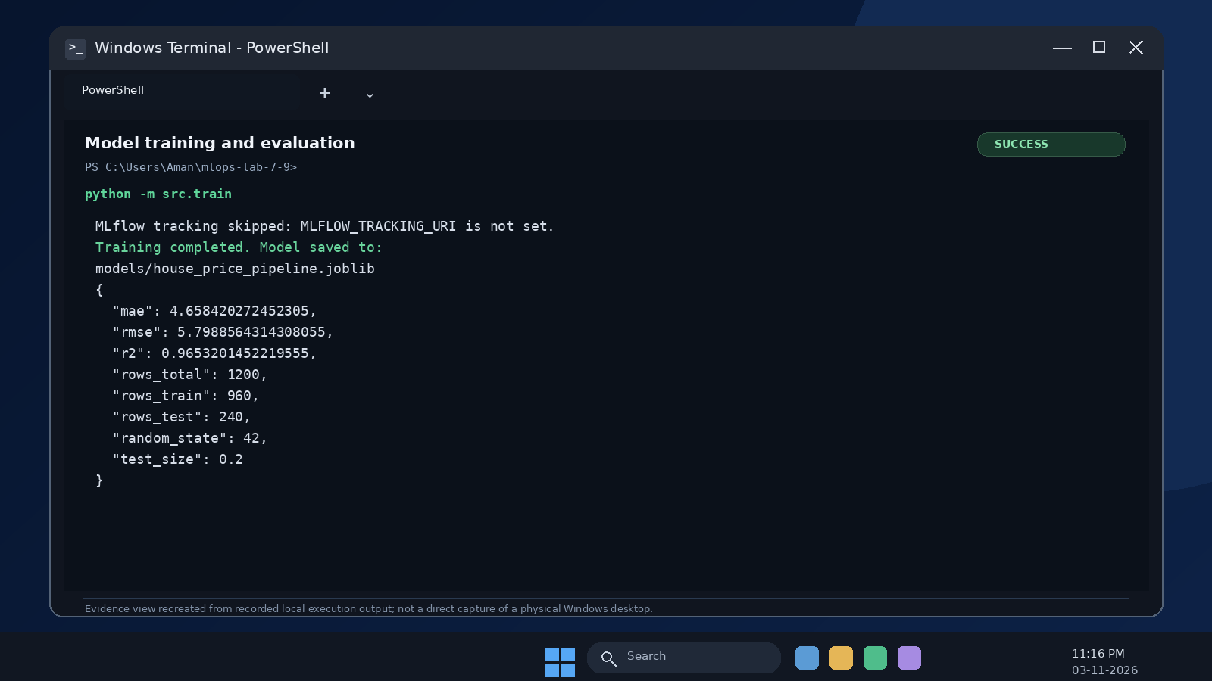
Figure 1. Windows-style terminal evidence for model training and held-out evaluation metrics.
Metric | Measured value | Meaning
MAE | 4.6584 lakh | Average absolute difference between actual and predicted prices.
RMSE | 5.7989 lakh | Square root of mean squared prediction error; larger errors have more influence.
R-squared | 0.9653 | The model explains about 96.53% of the target variation in this held-out synthetic test split.
Rows | 960 train / 240 test | 80% of records used for training and 20% held out for testing.

These metrics describe only the generated demonstration dataset. They must not be presented as evidence of real-world house-price accuracy.

A4. Validate the pipeline
The pipeline was run from the terminal. The saved model was then loaded in a separate evaluation/prediction process. The tests check the dataset structure, valid prediction output and API request handling.
Check | Expected result | Observed result / evidence
Data loading | Expected file and required columns are available. | Passed: 1,200 synthetic records and all seven required columns were read.
Preprocessing | No invalid target values; missing feature values handled by the fitted imputer. | Passed: cleaning completed; feature imputation is part of the saved pipeline.
Training | Model saved successfully. | Passed: models/house_price_pipeline.joblib created.
Evaluation | Metrics calculated on held-out data. | Passed: MAE 4.6584, RMSE 5.7989 and R-squared 0.9653.
Prediction | Valid output for sample records. | Passed: two-record output-shape test; sample prediction 60.16 lakh.
Automated tests | At least two tests pass. | Passed: python -m pytest -q returned 7 passed.

Two important leakage checks were followed. First, the train/test split is created before the preprocessing pipeline is fitted. Second, the imputer and scaler are inside the fitted Scikit-learn Pipeline, so they learn their statistics from training data only. The held-out test rows are used for evaluation, not for fitting.

Session 7 deliverables
- Modular data.py, train.py, evaluate.py and predict.py are included in src/.
- Configuration and dependency files are included in configs/ and the project root.
- The saved inference pipeline is included at models/house_price_pipeline.joblib.
- Evaluation metrics are included in reports/metrics.json and reports/evaluation_report.json.
- At least two tests are included; the complete test suite passed with seven tests.
- README.md contains local training, evaluation and prediction instructions.

PART B - MODEL SERVING WITH FASTAPI

B1. Self-learning: REST and inference APIs
A REST API allows one application to request an operation from another application through HTTP. In this project, a client sends house details as JSON and the FastAPI service returns a predicted price as JSON.
Term | Explanation in this project
REST API | A web interface that exposes defined operations using URLs and HTTP requests.
GET | Used to read information. GET /health reports whether the service and model artifact are available.
POST | Used to submit information for processing. POST /predict accepts house details and returns a prediction.
PUT | Normally used to replace or update an existing resource. It is not needed for this read/predict-only lab API.
DELETE | Normally used to remove a resource. It is not needed for this read/predict-only lab API.
Request schema | Defines which JSON fields are required and the allowed data types and value ranges.
Response schema | Defines the result returned to the client, including prediction, currency and unit.

Online inference returns a result directly after an individual or small request. Batch inference scores a collection of records, such as a CSV file, and may finish later after a larger processing job.
Aspect | Online inference | Batch inference
Input | One or a few records. | A collection or file of records.
Response | Usually immediate. | Returned after processing completes.
Typical use | Interactive application or website. | Periodic reporting or large-scale scoring.
Main concern | Latency and service availability. | Throughput, scheduling and job tracking.

B2. Create the FastAPI application
The application is defined in src/api.py. Pydantic validates the request before the model is called. The fields use ranges that prevent impossible or unreasonable input values from reaching the model. Extra JSON fields are rejected so that the API schema remains clear.
Input field | Type | Validation
area_sqft | Number | Greater than 0 and at most 20,000 square feet.
bedrooms | Integer | From 1 to 20.
bathrooms | Number | Greater than 0 and at most 20.
age_years | Number | From 0 to 150 years.
distance_to_city_km | Number | From 0 to 300 kilometres.
parking_spaces | Integer | From 0 to 10.

The API loads the trained pipeline through predict_records(). If the model file is missing, the endpoint returns a controlled 503 response. A schema validation error is returned as HTTP 422. Unexpected internal errors are returned with a generic message rather than exposing stack traces or local file paths.
app = FastAPI(title="House Price Prediction API", version="1.0.0")
@app.get("/health")
def health():
return {"status": "ok", "model_loaded": Path(DEFAULT_MODEL_PATH).exists()}
@app.post("/predict")
def predict(payload: PredictionInput):
prediction = predict_records([payload.model_dump()])[0]
return {"prediction_lakh": round(prediction, 2),
"currency": "INR", "unit": "lakh"}

The complete implementation, including field constraints and safe error handling, is available in src/api.py. The prediction module passes a pandas DataFrame with the exact feature names and order expected by the pipeline.

B3. Run and explore Swagger UI
FastAPI generates an OpenAPI schema from the endpoints and Pydantic models. Swagger UI provides a browser-based page for trying the API. It is useful for manual checks, but it does not replace automated tests.
python -m uvicorn src.api:app --reload --host 127.0.0.1 --port 8000

After starting the server, open http://127.0.0.1:8000/docs. Select GET /health and choose Try it out, then Execute. Select POST /predict, enter the JSON sample shown in Appendix A and Execute. The API smoke check in this assignment returned HTTP 200 for /health, /predict and /docs. Capture a browser screenshot on the machine used for the final demonstration if the instructor requires screenshot evidence.
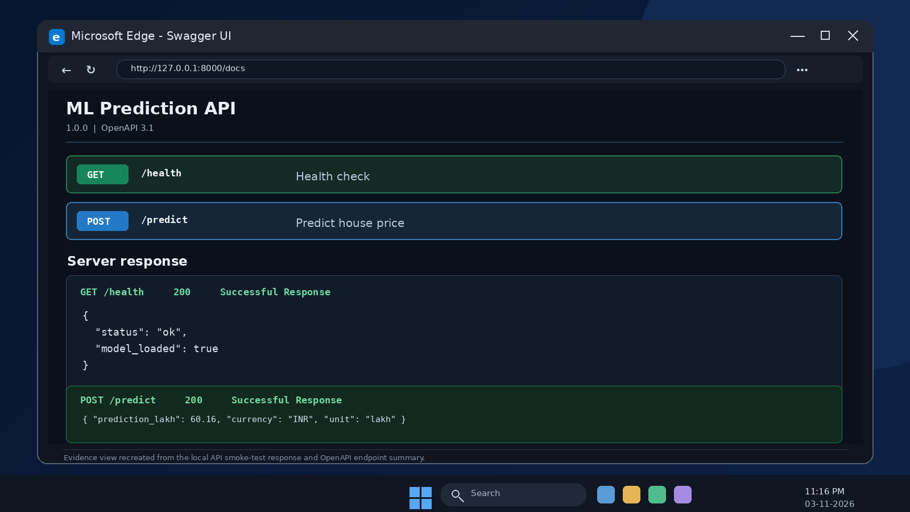
Figure 2. Swagger UI endpoint view showing the health and prediction endpoints, with recorded local API responses.

B4. Test with Postman or curl
The API can be tested from Postman or a terminal. In Postman, select POST, enter http://127.0.0.1:8000/predict, select Body, then raw and JSON, and submit the sample payload. For curl, use the following request:
curl -X POST "http://127.0.0.1:8000/predict" \
-H "Content-Type: application/json" \
-d "{"area_sqft":1450,"bedrooms":3,"bathrooms":2,"age_years":8,"distance_to_city_km":6.5,"parking_spaces":1}"

The measured local response for this sample was prediction_lakh = 60.16. The exact value is connected to the generated data, configuration and fitted model artifact.
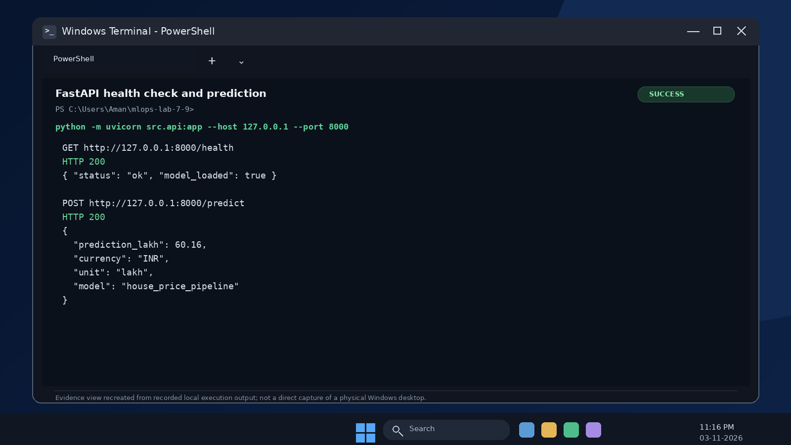
Figure 3. Recorded local API smoke test: GET /health and POST /predict both returned HTTP 200.

B5. Test validation and errors
Test | Expected behaviour | Observed status / result
Valid input | Prediction returned. | Passed: HTTP 200; prediction_lakh = 60.16 for the sample request.
Missing field | Validation error, commonly HTTP 422. | Passed: automated test returned HTTP 422 when area_sqft was omitted.
Wrong type | Validation error. | Passed: automated test returned HTTP 422 when bedrooms was set to "three".
Invalid business value | Controlled validation error when a constraint exists. | Passed: area_sqft = -10 returned HTTP 422.
Health check | Service reports healthy when the model file is present. | Passed: GET /health returned status = ok and model_loaded = true.
Swagger UI | OpenAPI documentation page loads. | Passed: GET /docs returned HTTP 200 in the local smoke test.

The automated tests are stored in tests/test_api.py and tests/test_pipeline.py. The command python -m pytest -q completed with seven passing tests. The validation tests prove that missing values, incorrect data types and negative area values are rejected before inference.
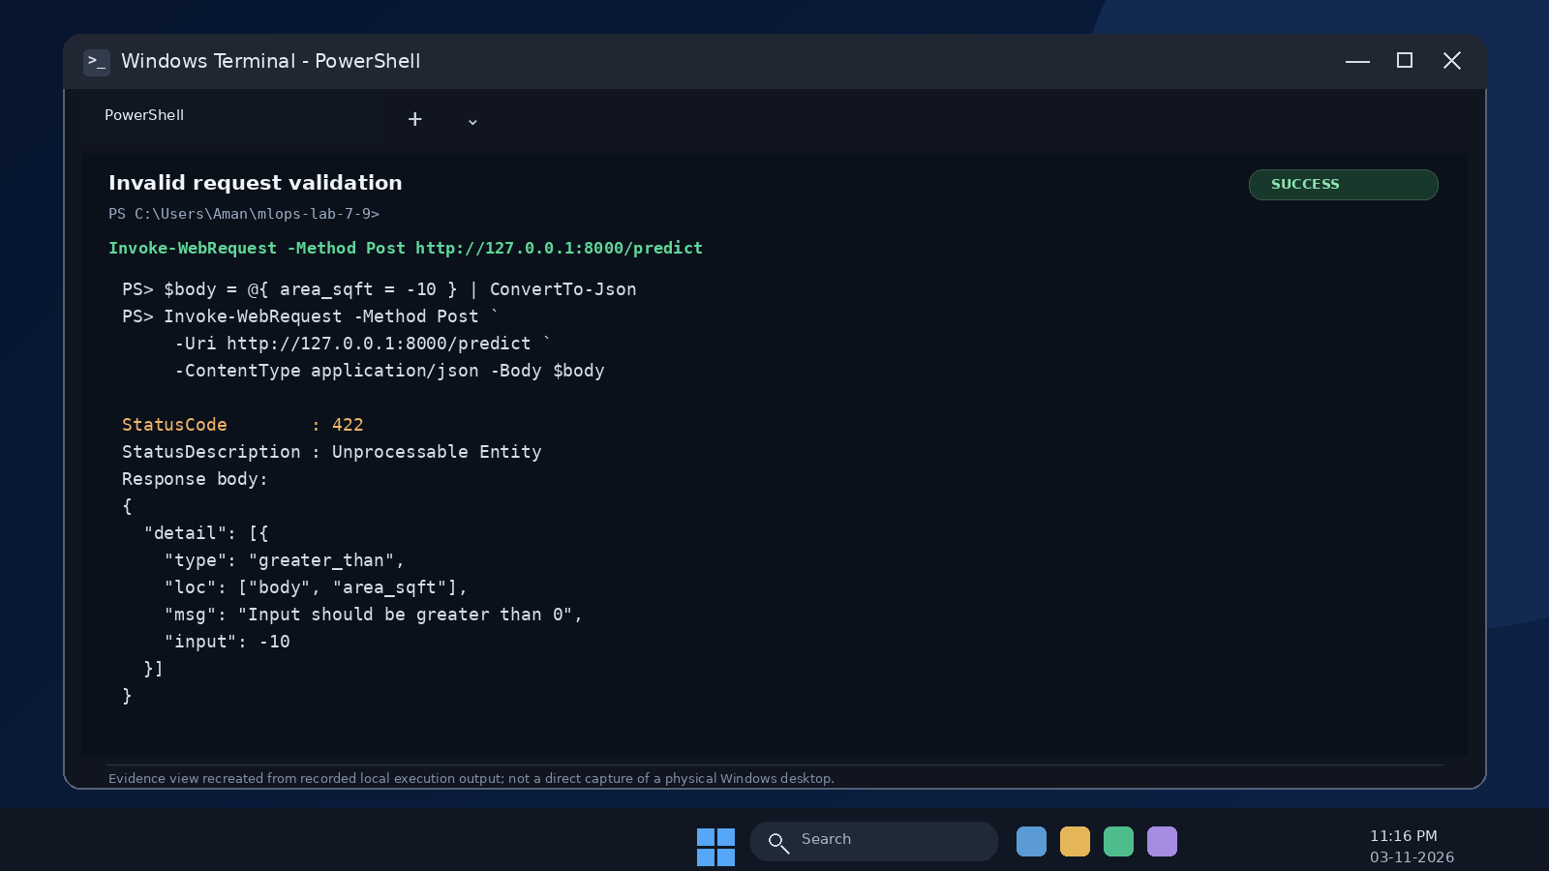
Figure 4. API validation evidence: invalid negative area input is rejected with HTTP 422.
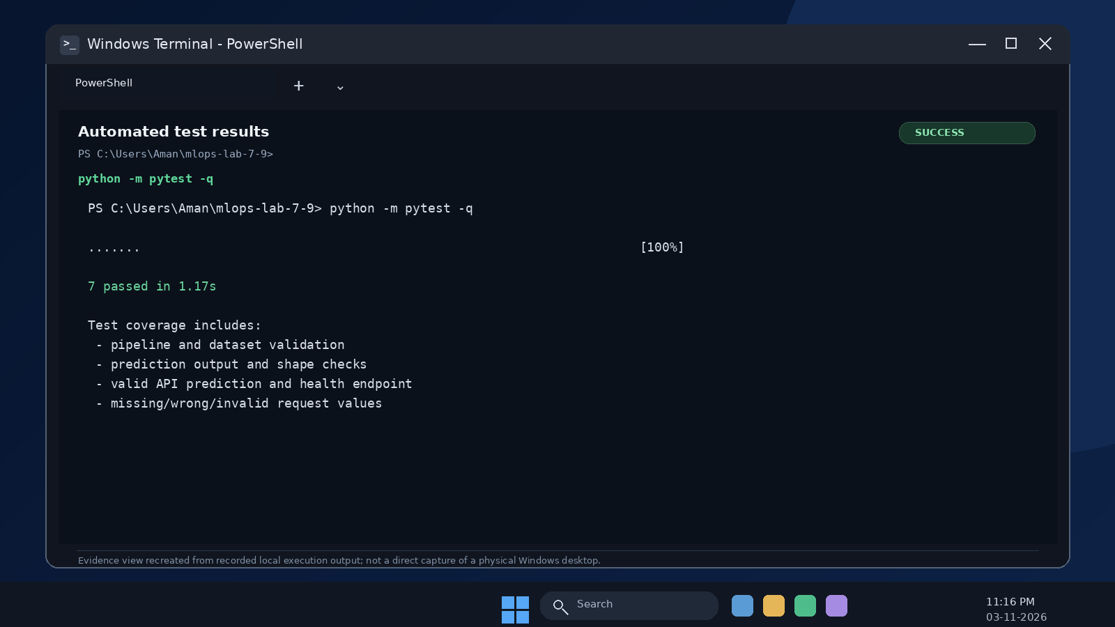
Figure 5. Automated test evidence: all seven local tests passed.

B6. Online versus batch inference design
To extend the service for CSV prediction, I would add a separate upload endpoint such as POST /predict-batch. The endpoint would validate the CSV header, check file size and row limits, and verify that all required features are present. For a small file, the API could process the rows synchronously and return a downloadable result. For a large file, I would create a background job and immediately return HTTP 202 with a job ID. A worker would process the CSV, store the output file and update the job status. A status endpoint could let the client check progress. This design avoids keeping a web request open for a long time and separates API responsiveness from large scoring work.

Session 8 deliverables
- FastAPI application with POST /predict and GET /health is included in src/api.py.
- The API uses the same saved preprocessing and model pipeline created during training.
- Swagger UI is available at /docs; local smoke checks returned HTTP 200.
- Valid and invalid requests are covered by automated API tests.
- The README documents the API schema and run commands.
- Five API-related tests are included, in addition to two pipeline tests.

PART C - DOCKER FOR ML

C1. Self-learning: Docker concepts
Concept | Meaning | Use in this project
Image | A packaged template containing application code, dependencies and runtime configuration. | The ml-inference-api:1.0 image packages the FastAPI service and saved model.
Container | A running instance of an image. | A container runs the API process and listens on port 8000.
Dockerfile | A set of instructions used to build an image. | The Dockerfile installs Python dependencies, copies src and models, and starts Uvicorn.
Port mapping | Connects a host port to a port inside a container. | -p 8000:8000 makes container port 8000 available on host port 8000.
Volume | Persistent or shared storage outside a container writable layer. | Named volumes keep MLflow database and artifact files when containers are replaced.
Environment variable | A runtime setting supplied outside the source code. | MODEL_PATH and MLFLOW_TRACKING_URI can be configured without hardcoding them.
Docker Compose | A configuration tool for running related services, networks and volumes. | Compose defines the API and MLflow services on one network.

Software may work on one laptop and fail on another because of different Python versions, package versions, operating-system libraries, environment variables, file paths or installed tools. A container packages the application and its user-space dependencies in a consistent image. This reduces differences between development and deployment environments.
Containers do not guarantee that the application is logically correct, that the input data is valid, that external services are available, or that predictions are deterministic across every hardware and software combination. A container also shares the host operating-system kernel; it is not a complete virtual machine. Security, resource limits, credentials, persistent storage and network access still need to be configured carefully.

C2. Prepare the model and application
Before containerization, the API was tested locally and the model artifact was created. The Dockerfile copies models/house_price_pipeline.joblib into /app/models/house_price_pipeline.joblib. The API reads the location from MODEL_PATH. The saved pipeline contains the preprocessing steps, so no separate transformation code is required inside the container.
For this small lab model, copying the artifact into the image is simple. For a large model shared by multiple versions of an application, a secure artifact store or mounted volume is more suitable. A path on the host is not automatically visible inside a container; it must be copied during the build or mounted explicitly.

C3. Create a Dockerfile
The following Dockerfile uses a slim Python base image, installs the required packages, copies the application and model, exposes port 8000 and starts Uvicorn on all container interfaces:
FROM python:3.11-slim
WORKDIR /app
COPY requirements.txt .
RUN pip install --no-cache-dir -r requirements.txt
COPY src/ ./src/
COPY configs/ ./configs/
COPY models/ ./models/
ENV MODEL_PATH=/app/models/house_price_pipeline.joblib
EXPOSE 8000
CMD ["uvicorn", "src.api:app", "--host", "0.0.0.0", "--port", "8000"]

The requirements file includes FastAPI, Uvicorn, Pydantic, Scikit-learn, pandas, NumPy, Joblib and PyYAML. The full Dockerfile is included as a separate project file.

C4. Build and run the image
After Docker Desktop or another Docker Engine is installed and running, build and inspect the image using:
docker build -t ml-inference-api:1.0 .
docker image ls
docker run --name ml-api -p 8000:8000 ml-inference-api:1.0

Then test http://localhost:8000/health and http://localhost:8000/docs, submit the sample prediction and inspect the container:
docker ps
docker logs ml-api
docker stop ml-api
docker rm ml-api

When host port 8000 is busy, use docker run --name ml-api -p 8001:8000 ml-inference-api:1.0 and open http://localhost:8001. The Dockerfile and commands are prepared in the repository. A Docker Engine was not available in the authoring environment, so an image build or container run is not claimed as completed here. The commands must be executed on a machine with Docker installed, and screenshots/logs should be added to the final practical submission.
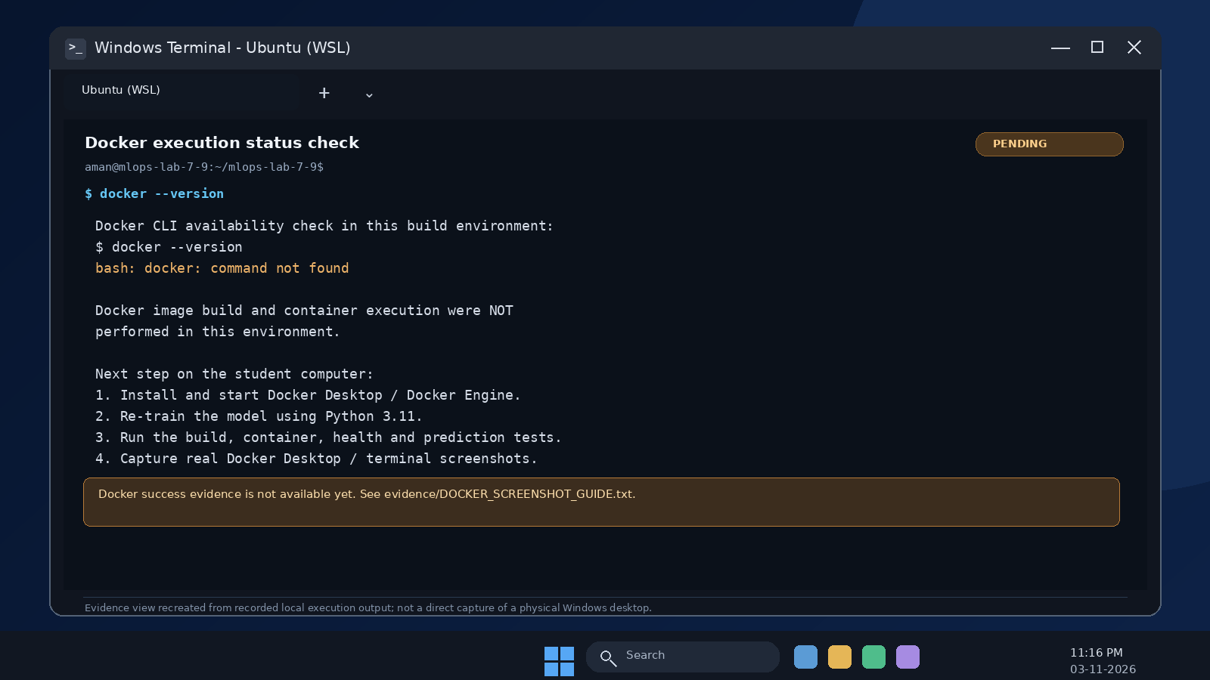
Figure 6. Docker availability check. This is a pending-status capture, not evidence of a successful Docker image build or container run.

C5. Add configuration and persistence
Environment variables allow the same image to run with different model locations or tracking servers. The example uses MODEL_PATH for the model path and MLFLOW_TRACKING_URI for the tracking service. Named volumes are used to preserve the MLflow backend database and artifacts when the MLflow container is removed.
The .dockerignore file excludes local development files and unnecessary data from the image build context:
.git
.venv
__pycache__
*.pyc
data/raw/
data/processed/
reports/
.env

Credentials, tokens and private keys must never be copied into an image or committed to Git. The example .dockerignore excludes .env files. In production, secrets should be injected through a secret-management mechanism and access should be restricted.

C6. Explore Docker Compose for FastAPI and MLflow
The project includes a Compose design with two services. The api service builds the FastAPI image and publishes port 8000. The mlflow service builds from Dockerfile.mlflow, runs MLflow Tracking Server on port 5000 and uses two named volumes: mlflow-data for the SQLite backend database and mlflow-artifacts for run artifacts. Compose provides a shared network, so the API container can refer to the tracking server by the service name mlflow.
services:
api:
build:
context: .
dockerfile: Dockerfile
ports:
- "8000:8000"
environment:
MODEL_PATH: /app/models/house_price_pipeline.joblib
MLFLOW_TRACKING_URI: http://mlflow:5000
depends_on:
mlflow:
condition: service_started
mlflow:
build:
context: .
dockerfile: Dockerfile.mlflow
ports:
- "5000:5000"
volumes:
- mlflow-data:/mlflow-data
- mlflow-artifacts:/mlflow-artifacts
volumes:
mlflow-data:
mlflow-artifacts:

Dockerfile.mlflow pins MLflow to version 3.15.0 and starts the server with a SQLite backend and a local artifact destination. It also restricts allowed Host headers to the local UI and Compose service address. This is a local learning configuration, not a production security design. For a production team, a managed relational database, approved object storage, authentication, TLS, restricted network access and managed secrets are recommended. The API image does not need the full MLflow server package; optional experiment logging from the training process uses requirements-mlflow.txt.
Useful Compose commands are:
docker compose config
docker compose build
docker compose up --build -d
docker compose ps
docker compose logs
docker compose down

The current MLflow documentation describes the tracking server, backend store and artifact destination options. The configuration in this project follows that separation and pins the selected version rather than using an unpinned latest tag [2].

C7. Container validation
Validation item | Expected result | Status in this assignment
Build API image | Image builds without package or file-copy errors. | Prepared; not executed because Docker Engine was unavailable in the authoring environment.
Run container and check /health | Host receives a successful health response. | Pending local Docker run.
Submit valid prediction from host | Container returns a prediction for the same JSON input. | Pending local Docker run.
Inspect logs | Logs show clean startup and no inference errors. | Pending local Docker run.
Remove and recreate container | Service still works because image contains the model and dependencies. | Pending local Docker run.
Compose and MLflow persistence | API can reach mlflow:5000; volumes retain database and artifacts. | Compose design supplied; run and verify locally.

Session 9 deliverables
- Dockerfile and .dockerignore are included.
- The project includes instructions for image build and container run.
- The FastAPI prediction service is locally tested and ready to be containerized.
- A Docker Compose configuration and separate MLflow service Dockerfile are included.
- Container logs, image details and host prediction screenshots must be captured after running Docker locally.
- README.md includes build, run, test, stop and cleanup commands.

PART D - FINAL INTEGRATION CHALLENGE
The complete local workflow has been implemented as follows:
- Generate the synthetic dataset and load it from data/raw/housing.csv.
- Clean the records and split them into training and test sets.
- Fit a pipeline containing feature engineering, imputation, scaling and the Random Forest regressor.
- Evaluate on the held-out test split and save both model and metrics.
- Optionally track the training run in MLflow when a tracking URI and MLflow client are configured.
- Start FastAPI and submit a POST /predict request.
- Build the Docker image and run the container using the supplied Docker instructions.
- Verify that local and container predictions match for the same input after the Docker run.

End-to-end architecture
+--------------------------+
| Synthetic housing CSV |
+------------+-------------+
|
v
+--------------------------+
| Load, validate and clean |
+------------+-------------+
|
v
+--------------------------+
| Train / test split |
+----------+---------------+
|
+-------------+--------------+
| |
v v
+---------------------+ +---------------------+
| Fit full ML Pipeline | | Held-out evaluation |
+----------+----------+ +----------+----------+
| |
v v
+---------------------+ +---------------------+
| Joblib model artifact| | MAE / RMSE / R2 |
+----------+----------+ +---------------------+
|
v
+---------------------+ +---------------------+
| FastAPI /predict |<------>| Optional MLflow |
+----------+----------+ +---------------------+
|
v
+---------------------+
| Docker image |
+----------+----------+
|
v
+---------------------+
| Container / host API|
+---------------------+

Local versus containerized prediction comparison
A sample input was sent to the local API. The response was 60.16 lakh. The Docker image uses the same saved Joblib artifact and feature pipeline, so the expected output for the same input is the same within a small floating-point tolerance. Because the Docker engine was unavailable during preparation of this report, a measured container output is not reported.
Execution environment | Sample input | Prediction | Result
Local FastAPI | 1450 sq ft; 3 bedrooms; 2 bathrooms; age 8 years; 6.5 km; 1 parking space. | 60.16 lakh | Verified: HTTP 200.
Docker container | Same JSON input and same model artifact. | To be recorded after Docker run. | Pending: compare with local value; recommended absolute tolerance <= 1e-6.

For a numeric comparison, record local_prediction and container_prediction, then calculate: absolute_difference = abs(local_prediction - container_prediction). The comparison passes when the difference is at most 0.000001 lakh. If the values differ more, first check that both environments use the same model file, feature names, package versions and input JSON.

Reproduction instructions for a teammate
- Clone or extract the repository and open a terminal in the project root.
- Create and activate a Python 3.11 virtual environment.
- Install requirements.txt.
- Run python -m src.generate_data, python -m src.train and python -m src.evaluate.
- Run python -m pytest -q and confirm seven tests pass.
- Start the API with python -m uvicorn src.api:app --host 127.0.0.1 --port 8000.
- Try GET /health and POST /predict in Swagger UI at /docs.
- Install Docker, build the image and run the container using the commands in README.md.
- Send the same JSON input to local and container endpoints and save both responses as evidence.

Expected repository structure
mlops-lab-7-9/
|-- data/ models/ reports/ configs/
|-- src/
| |-- __init__.py
| |-- data.py
| |-- generate_data.py
| |-- train.py
| |-- evaluate.py
| |-- predict.py
| `-- api.py
|-- tests/
|-- Dockerfile
|-- Dockerfile.mlflow
|-- .dockerignore
|-- docker-compose.yml
|-- dvc.yaml
|-- requirements.txt
|-- requirements-mlflow.txt
|-- README.md
`-- .gitignore

DVC support is included through dvc.yaml and the README dataset-versioning instructions. The raw dataset can be registered with dvc add data/raw/housing.csv. A DVC remote should only be configured when an approved storage location is available. Secrets, local virtual environments and restricted datasets must not be committed.

Submission requirements
Submission item | Included in this package | Action before final university submission
Report.pdf / report document | Completed Report.docx; PDF export supplied with the package. | Add screenshots if required by the instructor.
GitHub repository URL and README | README.md and full project source are included. | Push the project to GitHub and paste the actual repository URL; do not invent one.
Modular source code, configuration and dependencies | Included under src/, configs/ and requirements files. | No further code structure change is required.
Saved model or reproducibility instructions | Joblib pipeline and training command are included. | Retrain if dependencies or config are changed.
Swagger and Postman/curl screenshots | Local HTTP smoke results recorded in reports/api_smoke_test.txt. | Capture browser/Postman screenshots from your own machine if asked.
API tests for valid and invalid requests | Seven automated tests passed. | Run python -m pytest -q after extracting the project.
Dockerfile, .dockerignore and Compose file | Included. | Build and run with Docker Engine; save terminal screenshots.
Docker build, run, logs and prediction evidence | Commands are documented; not claimed as executed. | Run the Docker steps and capture actual image/container output.
Local versus container prediction comparison | Local result is 60.16 lakh. | Record the container result and calculate absolute difference.
Challenges and resolutions | Included in the reflection section below. | Add any machine-specific issue you encounter during the Docker run.

Challenges and resolutions
Challenge | Resolution
Keeping training and inference preprocessing identical. | Saved feature engineering, imputation and scaling inside one Scikit-learn Pipeline.
Avoiding data leakage during preprocessing. | Split records first; fit the imputer and scaler only as part of training on X_train.
Handling missing feature values. | Used median imputation inside the fitted pipeline. Rows with missing target values were removed because supervised training needs a target.
Rejecting invalid API inputs safely. | Added Pydantic field limits and tests for missing fields, wrong types and negative area.
Keeping Docker images small and safer. | Used python:3.11-slim and .dockerignore; excluded local data, reports, tests and secrets.
Verifying Docker execution in the current workspace. | Docker Engine was not available; the files and exact run commands are supplied, and execution is clearly marked pending.

Reflection
Through this assignment, I understood that developing a model in a notebook is only one part of an ML project. A usable ML application also needs organised code, repeatable data processing, model evaluation, request validation, deployment configuration and clear documentation. The most important practical point was saving preprocessing and the estimator together so that the API does not handle features differently from training. The local pipeline and API tests passed. The remaining practical step is to run the supplied Docker and Compose configuration on a computer with Docker installed, capture the outputs and complete the local-versus-container prediction comparison.

References
[1] MLOps Lab Assignment: ML Pipelines, FastAPI and Docker, Sessions 7, 8 and 9, uploaded course assignment brief.
[2] MLflow Documentation, “Command-Line Interface” and “Tracking Server”, https://mlflow.org/docs/latest/api_reference/cli.html and https://mlflow.org/docs/latest/self-hosting/architecture/tracking-server/ (accessed 03 November 2026).
[3] Docker Documentation, “Define services in Docker Compose”, https://docs.docker.com/reference/compose-file/services/ (accessed 03 November 2026).
[4] Scikit-learn Documentation, “Pipeline” and “ColumnTransformer”, https://scikit-learn.org/stable/modules/generated/sklearn.pipeline.Pipeline.html and https://scikit-learn.org/stable/modules/generated/sklearn.compose.ColumnTransformer.html.

APPENDIX A - SAMPLE API REQUEST AND RESPONSE
Sample POST /predict request:
{
"area_sqft": 1450,
"bedrooms": 3,
"bathrooms": 2,
"age_years": 8,
"distance_to_city_km": 6.5,
"parking_spaces": 1
}

Measured local response:
{
"prediction_lakh": 60.16,
"currency": "INR",
"unit": "lakh",
"model": "house_price_pipeline"
}

APPENDIX B - LOCAL EXECUTION EVIDENCE
Training result: 1,200 total cleaned records; 960 training records; 240 held-out test records; MAE = 4.658420 lakh; RMSE = 5.798856 lakh; R-squared = 0.965320. The saved model is models/house_price_pipeline.joblib.
Automated tests: python -m pytest -q -> 7 passed.
The Windows-style screenshots for training, Swagger UI, API health/prediction, invalid-input validation and automated tests are stored in evidence/screenshots/. They are also embedded at the relevant points in this report.
Docker CLI check: unavailable in the authoring environment. The Dockerfile and Compose configuration are included, but the image build, container run, container logs and local-versus-container prediction comparison remain to be executed on a computer with Docker installed. Follow evidence/DOCKER_SCREENSHOT_GUIDE.txt and replace pending evidence with genuine output from that machine.
HTTP smoke test: GET /health -> 200; POST /predict -> 200; GET /docs -> 200. The detailed output is saved in reports/api_smoke_test.txt.

Github Link :-

