ONLINE COURSES
Exploratory Data Analysis Report
A Power BI EDA Project on a Multi-Platform Online Learning Dataset
Dataset: Online_Courses.csv | 8,092 records × 45 columns
Sources: Coursera · Future Learn · Udacity · Simplilearn
Deliverable: online_course_insights.pbix
Prepared as a Power BI EDA Portfolio Project

1. Introduction & Objective
This report documents a complete exploratory data analysis (EDA) performed on a raw, real-world dataset of online courses, culminating in an interactive Power BI dashboard. The dataset aggregates course listings scraped from four major e-learning platforms — Coursera, Future Learn, Udacity, and Simplilearn — into a single flat file.
The objective of this project is threefold:
- Understand and document the structure, quality, and quirks of a genuinely messy, multi-source dataset before any modeling begins.
- Clean and reshape the raw data so it can be reliably loaded and modeled inside Power BI.
- Build a Power BI dashboard that surfaces meaningful insights about course categories, skills, ratings, viewership, and instructors.
This document is the full narrative report; a condensed slide version is available in Project_Presentation.pptx, and a quick-reference summary is available in README.md.

2. Dataset Overview

2.1 Source & Scope
The raw file, Online_Courses.csv, contains 8,092 rows and 45 columns. Each row represents one course, program, specialization, or track listed on one of four platforms.
Metric | Value
Total records | 8,092
Total columns | 45
Source platforms | 4 (Future Learn, Coursera, Udacity, Simplilearn)
Unique course titles | 4,908
Exact duplicate rows | 0
Columns with 0% missing | Title, URL, Site (Unnamed: 0 index also complete)
Table 2.1 — Dataset scale summary

2.2 Records per Platform
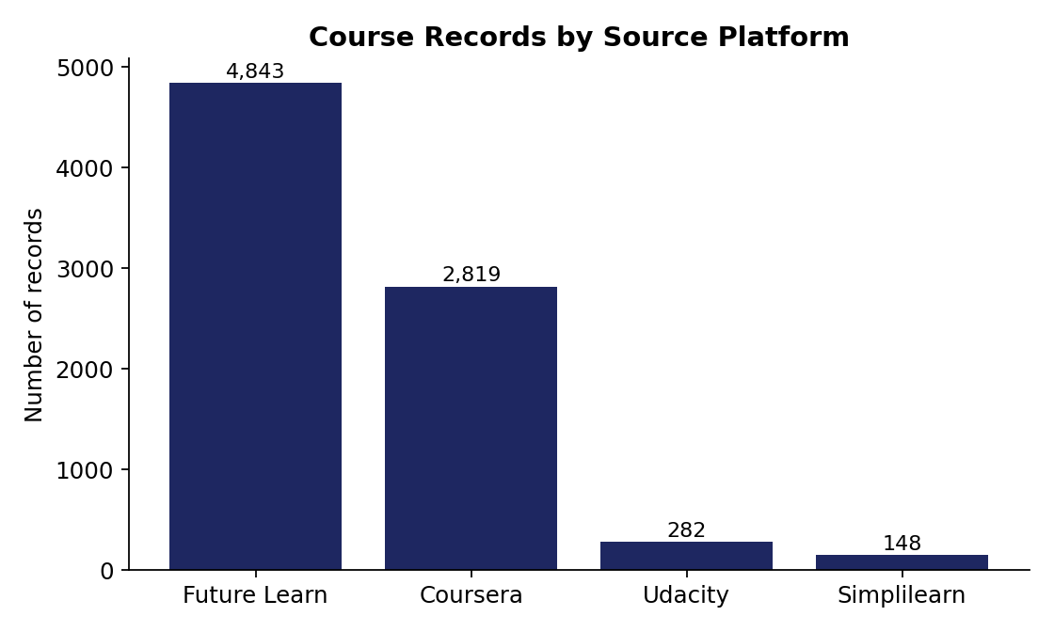
Figure 2.1 — Distribution of course records by source platform
Future Learn contributes the largest share of rows (59.9%), followed by Coursera (34.8%), Udacity (3.5%) and Simplilearn (1.8%). However, row count is not the same as data richness — as shown in Section 3, Coursera carries by far the most usable analytical fields.

3. Data Structure & Schema Analysis
A key discovery of this EDA is that Online_Courses.csv is not one dataset with one schema — it is four different platform schemas stacked (unioned) into a single table. Each platform populates a different subset of the 45 columns, which explains why so many columns appear mostly empty at first glance.

3.1 Universal Columns (populated across all platforms)
- Title — course/program name
- URL — listing link
- Short Intro — one-line description
- Duration — free-text length (format differs per platform)
- Site — source platform label

3.2 Platform-Specific Columns
Platform | Rows | Distinctive columns populated only for this platform
Coursera | 2,819 | Category, Sub-Category, Course Type, Language, Subtitle Languages, Skills, Instructors, Rating, Number of viewers
Future Learn | 4,843 | Courses, Weekly study, Topics related to CRM, ExpertTracks, Course Title/URL/Short Intro
Udacity | 282 | Program Type, Level, Prequisites, What you learn, School
Simplilearn | 148 | Program, Number of ratings, Price, COURSE CATEGORIES
Table 3.1 — Platform-specific schema fragments within the unioned dataset
Practical implication: any analysis of ratings, skills, categories or viewership is effectively a Coursera-only analysis, since those fields simply do not exist for the other three platforms. This scoping decision is made explicit throughout the rest of this report and in the Power BI model.

4. Data Cleaning & Quality Assessment

4.1 Missing Values
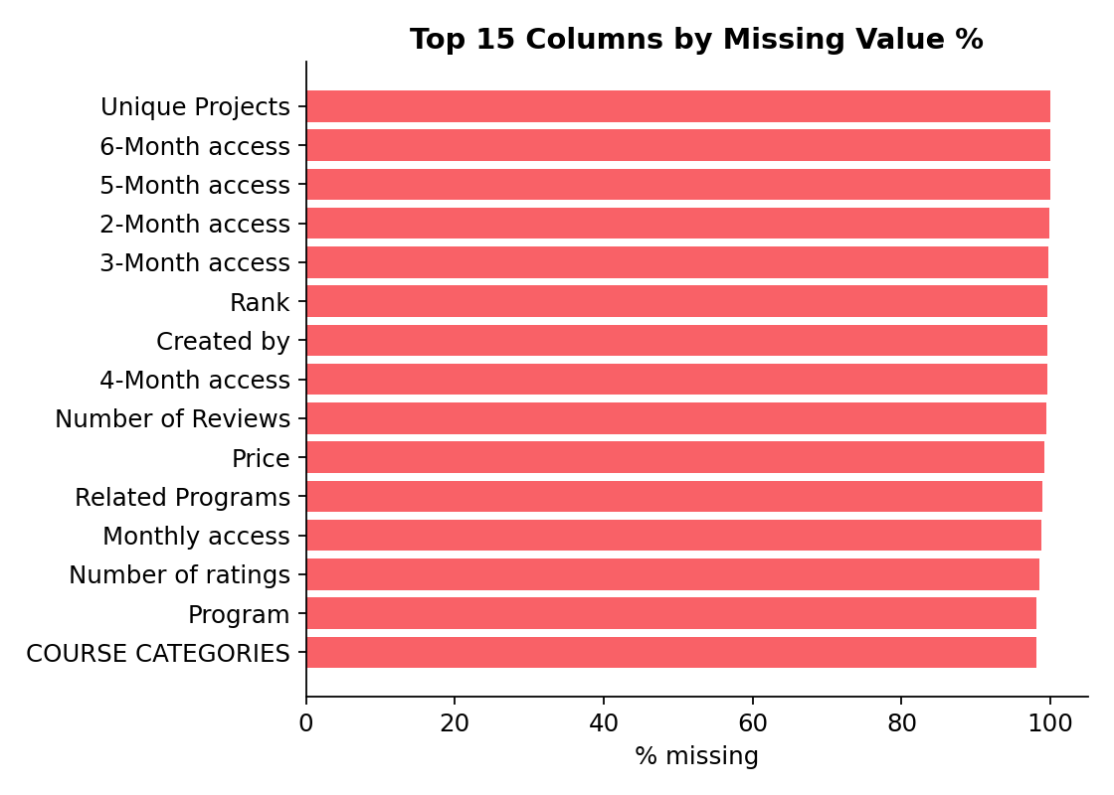
Figure 4.1 — Top 15 columns ranked by missing value percentage
31 of 45 columns are missing in more than 90% of rows. As established in Section 3, this is structural (schema-fragment) missingness rather than random data-quality loss, and should not be imputed as if it were — a Udacity-only field like 'School' has no valid value for a Coursera row, and filling it in would fabricate data.

4.2 Data Type & Formatting Issues Found
- Rating is stored as text with an inconsistent suffix, e.g. "4.9stars", with a handful of rows missing the suffix entirely — requires regex extraction before numeric analysis.
- Number of viewers mixes plain counts ("10,438") with review-style strings ("108,885 reviews") in the same column — requires pattern-based numeric extraction.
- Duration format differs by platform: Coursera uses "Approx. N hours/months to complete"; Future Learn expresses weekly study load instead (Weekly study column); Udacity and Simplilearn use their own free text — a unified 'Duration in hours' measure has to branch by platform.
- Instructors is a single comma-separated string that interleaves person names with credentials and organizations (e.g., 'PhD', 'MBA', 'Google Cloud Training' all appear as top values after a naive split) — needs a cleaning pass before being used as a true entity dimension.
- Title duplication: 3,184 rows share a title with at least one other row (mostly Coursera courses re-listed under multiple specializations), and 2,819 rows share a URL — both should be de-duplicated or explicitly modeled as many-to-many before counting unique courses.
- Price is numeric but populated for only 65 of 8,092 rows (Simplilearn only) — not viable as a general feature without heavy scope reduction.

4.3 Cleaning Steps Applied
- Split the raw file conceptually into platform-scoped subsets so each analysis only draws on fields that genuinely exist for that platform.
- Parsed Rating into a numeric 0–5 field by stripping the 'stars' suffix and coercing to float.
- Parsed Number of viewers into a numeric field using regex extraction of the leading digit/comma sequence.
- Built a platform-aware Duration in hours calculated column in Power Query (Coursera 'hours'/'months' converted; Future Learn's Weekly study used as a proxy).
- Exploded Skills and Instructors into one-row-per-value structures for frequency analysis, then re-aggregated for the dashboard's word cloud and instructor visuals.
- Retained duplicate titles as valid rows (each represents a distinct specialization/listing) but flagged the duplication rate in this report so it is not misread as unique-course volume.

5. Exploratory Data Analysis

5.1 Course Type Mix (Coursera)
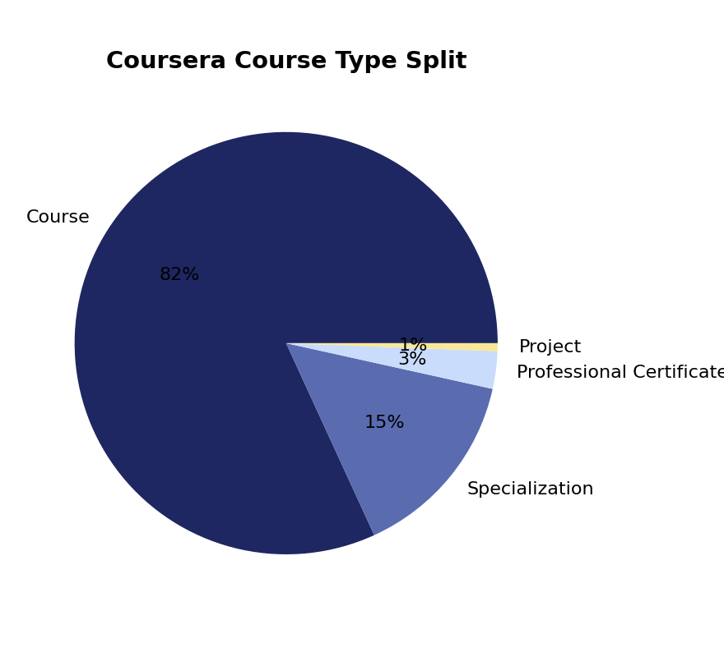
Figure 5.1 — Coursera course type split
Standalone Courses make up the large majority of Coursera's catalog (2,307 of 2,819 rows), with Specializations (414), Professional Certificates (81) and Projects (17) filling out the rest.

5.2 Category Distribution (Coursera)
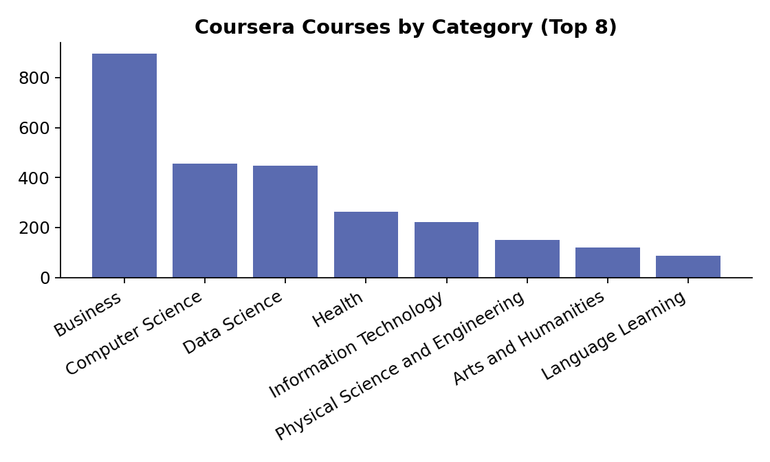
Figure 5.2 — Coursera courses by top-level category
Business (895 courses) and Computer Science (455) lead the catalog, followed closely by Data Science (448). Health (264) and Information Technology (221) round out the top five, showing a catalog weighted heavily toward professional/technical upskilling rather than purely academic subjects.

5.3 Rating Distribution (Coursera)
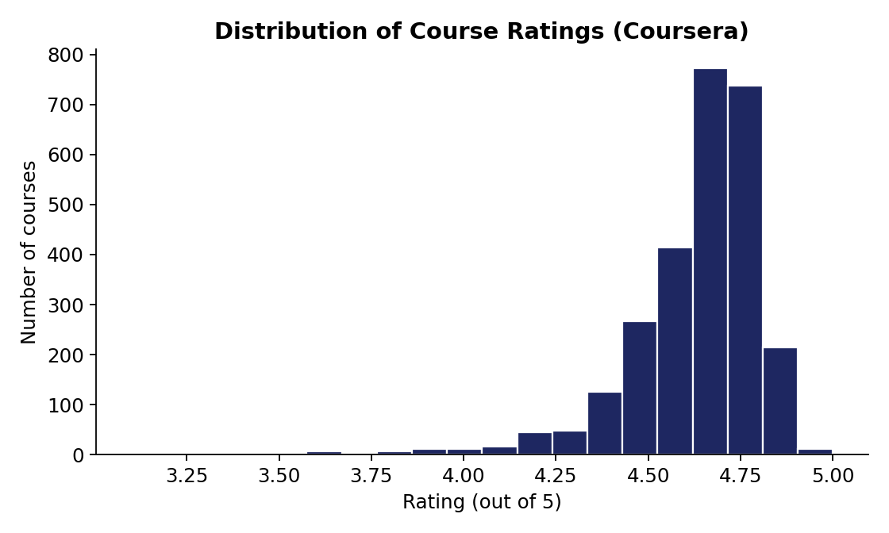
Figure 5.3 — Distribution of course ratings, 3.1–5.0 scale
Mean rating is 4.66 (median 4.7, std. dev. 0.19) across 2,695 rated courses. Ratings are heavily left-skewed and tightly clustered between 4.5 and 4.9 — very few courses fall below 4.0. This ceiling effect means rating is a poor differentiator of course quality on this platform; most published courses are rated similarly well.

5.4 Skills Analysis (Coursera)
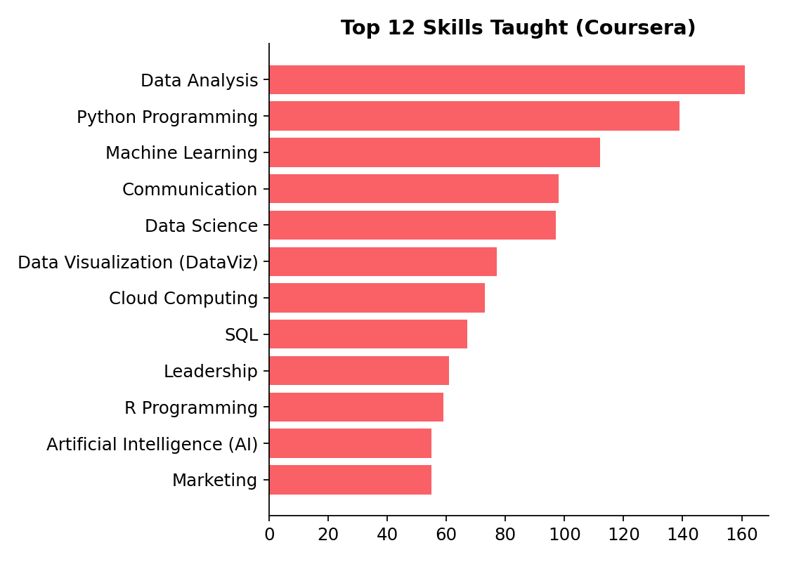
Figure 5.4 — Twelve most frequently taught skills
Across 3,293 distinct skill tags, Data Analysis, Python Programming and Machine Learning are the three most common, reflecting the catalog's data/tech tilt already seen in the category breakdown. Communication and Leadership also rank highly, showing a meaningful business/soft-skills presence alongside the technical content.

5.5 Rating vs. Viewership — Bivariate Analysis
Pearson correlation between numeric Rating and numeric Number of viewers (Coursera, n = 2,695): r ≈ 0.11 — a very weak positive relationship.
Interpretation: highly-viewed courses are not meaningfully more (or less) likely to be highly rated. Viewership appears to be driven more by course topic, instructor brand, and marketing placement (e.g. Andrew Ng's Machine Learning Specialization at 220,747 viewers) than by the rating itself. This is an important caveat for the dashboard: viewer-count and rating should be read as two independent success signals, not a single combined 'quality' metric.

5.6 Other Platform Snapshots

Future Learn — Weekly Study Load
Weekly study time clusters around 3 hours/week (1,786 courses), 4 hours/week (1,139) and 2 hours/week (1,055) — i.e., most Future Learn courses are designed as light, part-time commitments rather than intensive tracks.

Udacity — Level & School
Of 181 Udacity rows with a stated level, Intermediate (111) is most common, ahead of Beginner (43) and Advanced (27). By school/domain, Programming & Development (140) and Artificial Intelligence (45) are the two largest program areas.

Simplilearn — Categories & Price
Simplilearn's 148 listings concentrate in Business & Leadership, Software Development and Agile & Scrum (18, 18 and 16 courses respectively). Where price is available (65 rows), it ranges from 129 to 4,600, with a median around 855 — consistent with certification-style paid programs rather than free MOOCs.

6. Power BI Dashboard Design
The cleaned and shaped data feeds a single Power BI report page, "Online Course Analysis", built from two model tables:
- Online_Courses — the primary fact table (cleaned/shaped version of the CSV)
- Teachers — an instructor-level table derived from the exploded Instructors field

6.1 Calculated Fields
Field | Type | Purpose
course id | Calculated column | Surrogate key for counting/aggregating course rows
Duration in hours | Calculated column | Normalizes free-text durations into a comparable numeric value
Subtitle_lang_count | Calculated column | Number of subtitle languages offered per course
Count of skills Provided | Calculated column | Number of skills listed per course
Rank_category_by_avg_views | Calculated column / measure | Ranks each category by its average viewer count
Instructor_rating | Calculated column (Teachers table) | Rolls up average rating per instructor
Table 6.1 — Custom calculated fields used in the data model

6.2 Page Layout & Visuals
Visual | Fields used | Business question answered
Category slicer | Category | Filter the whole page to one subject area
Bar chart | Course Type × count of course id | How is the catalog split across Course / Specialization / Certificate / Project
Column chart | Sub-Category, Language × sum of viewers | Which sub-categories and languages drive the most engagement
Word cloud | Skills | What are the most in-demand skills across the catalog
Pie chart | Language × count of course id | What is the language mix of the catalog
Pivot table | Category, Language × Rank_category_by_avg_views | Which category/language combinations perform best by average views
Line chart | Subtitle_lang_count × sum of viewers | Does broader subtitle coverage relate to higher viewership
Clustered column | Instructor × Instructor_rating | Who are the top and bottom-rated instructors
Sub-Category slicer (Teachers) | Sub-Category | Filter the instructor view by subject
Line chart | Duration in hours × count of non-null viewers | Does course length relate to viewership
Pivot table | Category, Sub-Category × Count of skills Provided | How skill density varies by subject area
Table 6.2 — Visual-by-visual breakdown of the dashboard page
The page uses a dark plum/magenta theme (background #50005c, title accent #b50877) with rounded-card containers, giving the dashboard a distinct visual identity rather than default Power BI styling.

7. Key Insights & Findings
- Future Learn supplies the most rows (60%), but Coursera supplies almost all of the analytically rich fields (category, rating, skills, viewership) — any KPI built on those fields is implicitly Coursera-scoped.
- The Coursera catalog is dominated by Business, Computer Science and Data Science content, together accounting for roughly two-thirds of categorized courses.
- Average rating (4.66/5) is high and narrowly distributed — ratings alone are not a reliable way to separate 'good' from 'great' courses on this platform.
- Rating and viewership are only weakly correlated (r ≈ 0.11) — popularity is driven by factors other than star rating (topic demand, instructor recognition, platform promotion).
- Data Analysis, Python Programming and Machine Learning are the dominant taught skills, reinforcing the platform's data/tech leaning even outside the 'Data Science' category label.
- The Instructors field requires cleanup before it can be trusted as a true instructor dimension, since credentials and organization names are currently mixed in with individual names.
- Future Learn courses are designed as light, part-time commitments (2–4 hours/week for the vast majority), a structurally different product from Coursera's specialization-heavy catalog.

8. Recommendations & Future Work
- Clean the Instructors field with named-entity recognition or a manual lookup table to separate real instructor names from credentials/organizations before building instructor-level KPIs.
- Extend the Power BI model with a platform-aware 'Duration in hours' fallback for Udacity and Simplilearn (currently only Coursera and Future Learn are well normalized).
- Introduce a de-duplication key (e.g., normalized Title + Site) so 'course count' visuals can optionally report unique offerings alongside total listings.
- If pricing insight becomes a priority, scope a follow-up scrape or enrichment pass targeting Coursera/Udacity list prices, since the current Price field only covers Simplilearn (0.8% of rows).
- Add a bookmark-based platform toggle to the dashboard so users can switch between an 'all platforms, universal fields only' view and a 'Coursera deep-dive' view without confusing the two scopes.

9. Conclusion
This project turned a genuinely messy, four-platform union dataset into a documented, cleaned data model and a working Power BI dashboard. The most important analytical decision was recognizing early that the 45 columns are not one schema but four overlapping schemas — every subsequent cleaning, modeling, and visualization choice follows directly from that finding. The resulting dashboard surfaces category, skill, rating, and viewership patterns for Coursera (the platform with the richest fields), while the wider dataset still supports platform-level comparisons on the handful of fields every source shares.

Appendix A — Full Data Dictionary
All 45 raw columns, their data type, missing-value percentage, and a short description of what each field represents and which platform(s) populate it.
Column | Type | Missing % | Description
Unnamed: 0 | int64 | 0% | Row index carried over from the scrape / export
Title | str | 0% | Course or program title (universal field, all platforms)
URL | str | 0% | Course listing URL (universal field, all platforms)
Short Intro | str | 0.6% | One-line course description/tagline
Category | str | 65.2% | Top-level subject area (Coursera only)
Sub-Category | str | 65.2% | Secondary subject classification (Coursera only)
Course Type | str | 65.2% | Course / Specialization / Professional Certificate / Project (Coursera only)
Language | str | 65.2% | Primary teaching language (Coursera only)
Subtitle Languages | str | 65.4% | List of languages subtitles are available in (Coursera only)
Skills | str | 74.1% | Comma-separated list of skills taught (Coursera only)
Instructors | str | 65.3% | Comma-separated instructor names / credentials (Coursera only)
Rating | str | 66.1% | Course star rating as text, e.g. '4.9stars' (Coursera only)
Number of viewers | str | 66.7% | Learner/viewer count, mixed numeric/text format (Coursera only)
Duration | str | 1.8% | Course length in free text, format varies by platform
Site | str | 0% | Source platform: Coursera, Future Learn, Udacity, Simplilearn
Program Type | str | 96.5% | Program classification (Udacity only)
Courses | str | 38.9% | Sub-course listing text (Future Learn only)
Level | str | 97.8% | Difficulty level: Beginner/Intermediate/Advanced (Udacity only)
Number of Reviews | str | 99.4% | Count of learner reviews (sparse, mixed platforms)
Unique Projects | float64 | 100% | Numeric field, 100% empty in this extract
Prequisites | str | 96.5% | Prerequisite knowledge needed (Udacity only)
What you learn | str | 96.6% | Learning outcomes list (Udacity only)
Related Programs | str | 98.9% | Cross-linked related programs (sparse)
Monthly access | str | 98.8% | Subscription pricing tier (sparse)
6-Month access | str | 100% | Subscription pricing tier, 100% empty in this extract
4-Month access | str | 99.5% | Subscription pricing tier (sparse)
3-Month access | str | 99.7% | Subscription pricing tier (sparse)
5-Month access | str | 100% | Subscription pricing tier, 100% empty in this extract
2-Month access | str | 99.9% | Subscription pricing tier (sparse)
School | str | 96.7% | Udacity 'school'/domain the program belongs to (Udacity only)
Topics related to CRM | str | 42.3% | Related-topic tags (Future Learn only)
ExpertTracks | str | 40.2% | Related expert-track program links (Future Learn only)
FAQs | str | 86.6% | Frequently asked questions text block (sparse)
Course Title | str | 40.2% | Secondary title field used by Future Learn's schema
Course URL | str | 40.2% | Secondary URL field used by Future Learn's schema
Course Short Intro | str | 40.2% | Secondary intro field used by Future Learn's schema
Weekly study | str | 40.2% | Expected weekly study time, e.g. '3 hours' (Future Learn only)
Premium course | str | 80% | Flag/text noting premium/paid status (sparse)
What's include | str | 94.8% | What's included in the course package (sparse)
Rank | str | 99.5% | Platform ranking field (sparse)
Created by | str | 99.5% | Course creator/organization (sparse)
Program | str | 98.2% | Program name (Simplilearn only)
Number of ratings | str | 98.4% | Count of ratings received (sparse)
Price | float64 | 99.2% | Course price in local currency (Simplilearn only, 65 rows)
COURSE CATEGORIES | str | 98.2% | Subject category (Simplilearn only)

