Priority-Induced Round-robin scheduling algorithm with dynamic time quantum for Cloud computing environment
Priyanshu Niranjan#, Dr. M. Thenmozhi*
#*Computer Science and Engineering Department, Puducherry Technological University (PTU), Puducherry
¹priyanshun2017@ptuniv.edu.in
²thenmozhi@ptuniv.edu.in

Abstract – Cloud computing provides a virtual platform that allows resources to be accessed through the Internet. As cloud environment needs to serve multiple requests, efficient task scheduling is required to maintain its performance. Round Robin Scheduling algorithm is one of the most employed algorithms for task scheduling in cloud environment. In this paper, an improved Round Robin algorithm has been proposed. The proposed algorithm introduces dynamic time quantum and priority for scheduling the tasks. It is carried out by categorizing the tasks based on their urgency to complete the task from the ready queue. A comparative study is also established and inferred that the proposed algorithm is comparatively enhanced and is optimum for the Cloud Computing environment.

Keywords – Round Robin, Cloud Computing, Dynamic Time Quantum, Priority Queue, Ready Queue.
- Introduction
Scheduling in cloud computing refers to the intelligent allocation of virtualized resources, such as CPU, memory, and storage, to execute tasks or workloads efficiently. It aims to maximize resource utilization, minimize execution time, and ensure fairness among users. Cloud schedulers use various algorithms and policies to make these decisions, considering factors like task priorities, resource availability, and cost constraints. Effective scheduling enhances the performance and cost-effectiveness of cloud services, making it a critical component in cloud infrastructure management.
Round Robin (RR) is one of the widely used scheduling algorithms and its use has further been implemented into the cloud computing environment for allocating tasks to the various virtual machines available. Although in the traditional way of computing the calculations for the RR, mostly static time quantum was chosen in recent years algorithms have been developed that calculate the time quantum in a more precise way by also considering the arrival times and burst times of the current round in the ready queue.
However, by considering dynamic time quantum in every round better results can be attained on Average-Waiting-Time (AWAT), and Average-Turn-Around-Time (ATAT) and lower the number of context switches between the processes, this may help when there is no priority considered [1]. But if priority is assigned to the task the lower priority task may be executed ahead of a higher priority task because of the difference in the burst times.
In this paper, the tasks are aligned by their arrival time, and priority, and the time quantum is calculated dynamically [2]. Also to reduce the number of context switches when a high-priority task arrives in the ready queue the remaining time of the current executing task and the burst time of the high-priority task is compared and if the remaining time of the current executing task is lower than the burst time of the high priority task then the current task is executed completely and later the high priority task starts its execution.
If the remaining time of the currently executing task is greater than the burst time of the high-priority task then there is a context switch in the processes and the task is rescheduled by the remaining time. A comprehensive study is also carried out and provided in the paper to analyse the AWAT, ATAT, and number of context switches that occur for a given dataset.
- Literature Review
The introduced algorithm represents a significant advancement to the conventional RR scheduling technique, incorporating innovative features like priority considerations and a dynamic quantum [3]. Processes are segregated into distinct Priority and lower-priority queues. Notably, the quantum duration is linked to the burst time of the highest-priority task within the Priority Queue. This strategic approach yields improvements in context switching frequency and a reduction in the average waiting time, as substantiated through iterative implementation of the RR algorithm. Through the integration of priority-based classification and quantum adjustments, this novel approach displays promising potential in optimizing process scheduling and enhancing resource utilization within operating systems [3].
In another study [4], the Median-Average Round Robin (MARR) scheduling algorithm is presented, showcasing the ability to adaptively modify the time quantum for superior performance compared to static RR and existing dynamic scheduling methods. Notably excelling in metrics such as ATAT and AWAT, this unique approach maintains consistency in context switch occurrences across dynamic algorithms. While the proposed algorithm demonstrates notable optimization, its efficacy could be further refined through the integration of dynamic context switch control. A comprehensive investigation into hardware prerequisites and interrupt frequencies is indispensable to comprehending and minimizing context switch operations.
Furthermore, resource allocation strategies within cloud computing are addressed in [5]. The research juxtaposes the utilization of genetic and simulated annealing algorithms in cloud resource scheduling, leveraging simulation to evaluate performance. The study comprises theoretical analysis, model validation, and performance assessment, encapsulating the advantages, drawbacks, and convergence rates of the respective algorithms. The insights gleaned from this study hold substantial value for practical engineering applications, enabling the informed selection of appropriate resource scheduling techniques tailored to cloud computing environments.
A distinct enhancement to the RR scheduling algorithm, presented in [6], augments system efficiency within cloud environments. The algorithm effectively minimizes waiting, turnaround, and response times. It attains this optimization by dynamically computing the time quantum based on task arrivals, employing both fixed and dynamic time quantum strategies. The sequencing of tasks within the ready queue factors in burst times and arrival times, with the average burst time guiding quantum computation. A pivotal feature of this approach is the dynamic adjustment of task positioning based on burst time relative to the quantum, leading to substantial reductions in average waiting and turnaround times, thereby showcasing a robust enhancement in task scheduling efficiency.
Another intelligent round-robin CPU scheduling algorithm is introduced in [7], focusing on proficient management of a large number of processes. The algorithm ingeniously segregates the ready queue into sub-queues, employing burst time deviations and optimal thresholds as segmentation criteria. This division facilitates the dynamic determination of quantum numbers for each sub-queue, culminating in optimized performance. The outcome is a marked reduction in average waiting time, average turnaround time, and the frequency of context switches, signifying a promising resolution for achieving optimal process scheduling and resource allocation.
Furthermore, a dynamic approach to handling time quantum in process scheduling is proposed [8]. The algorithm accounts for burst times and priorities in tandem with adaptive quantum adjustments. The Round Robin with Adaptive Priority Scheduling (RRAPS) algorithm ensures efficient allocation of resources by promptly executing high-priority tasks. In cases of queue emptiness, the quantum is set equal to the burst time, whereas in non-empty queues, it approximates the average burst time. The algorithm dynamically modulates priorities and quantum values to strike a balance between fairness and efficiency. This approach effectively prevents resource starvation, judiciously allocates CPU time, and ensures equitable distribution of resources. The net result is an elevated process scheduling approach that adeptly accommodates priority and quantum dynamics.

- Proposed Scheduling Strategy
Applying priority helps to schedule tasks available in the ready queue to be sorted effectively and it provides us more insight about the tasks. Also, we initialize the remaining time array with the burst time of the tasks when they arrive in the ready queue array.
During the sorting of the tasks by their arrival times there can be a case in which there are two tasks with the same arrival time, in the following case priority helps us to improve the outcomes, also if there are tasks with the same arrival times and priority then there burst times can be considered to order them. As there are more parameters are available on the tasks a better ordering of the tasks is achieved as compared to the available scheduling algorithms in which priority is not considered.
Firstly, when there is the arrival of tasks in the ready queue with the arrival times, priority, and burst times specialized heap sort is applied to the tasks with the various conditions discussed in Fig. 1. After the sorting of the tasks is completed the Time quantum for the current task is found out by using the given equations and the conditions discussed in Fig. 2.

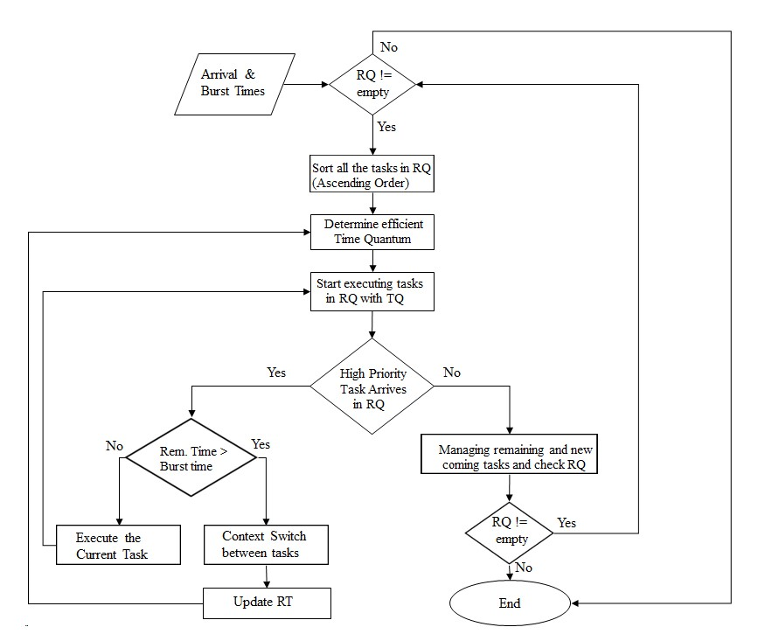
Fig. 1 Flowchart of the proposed changes to the RR Algorithm by introducing dynamic Time Quantum and priority to the tasks.

After the tasks start executing with the Time Quantum for the current round there are two cases that will happen. In the first case, the tasks execute normally with no hindrance from the priority of the other tasks. In this case, the AWAT and ATAT obtained are some of the lowest values possible also the number of context switches between the tasks is reduced to a bare minimum.
In the second case when a higher priority task comes in the ready queue and there is a task with low priority currently being executed then we compare the remaining time of the currently executing task and compare it with the burst time of the new task with high priority. The remaining time of the low-priority task can be calculated by taking the difference between the arrival times of the two tasks.
Now if the remaining time is found to be lower than the newly arrived high-priority task, there is no context switch and the low-priority task is executed completely later by calculating the Time Quantum for the remaining tasks the high-priority task is executed. But if the remaining time of the currently executing task is found to be higher than the newly arrived high-priority task there is a context switch between the tasks and the high-priority task starts its execution, also while finding the dynamic Time Quantum next time the remaining time of the task is to be considered.

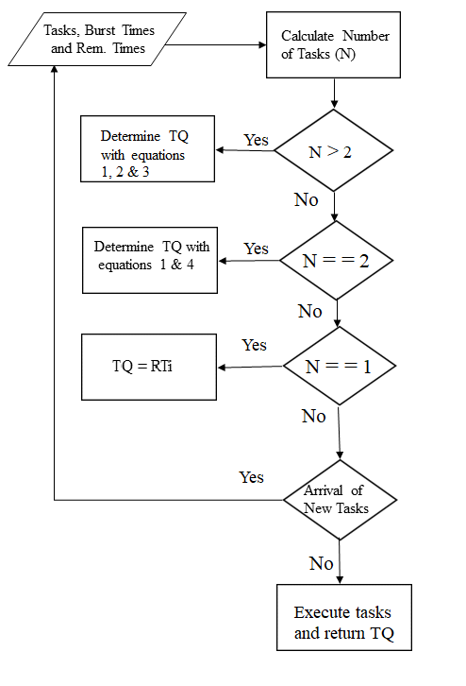

Fig. 2 Contd. Flowchart of the proposed changes to the RR Algorithm by introducing dynamic Time Quantum and priority to the tasks.

While calculating the dynamic Time Quantum of the current round the number of tasks currently in the ready queue and the remaining times of the tasks are considered, if the number of tasks is found to be one then the time quantum is taken as the remaining time of the task. If found to be two then it is found using the equation (1) and equation (4). If the number of tasks is found to be greater than two then the Time Quantum is taken by solving equation (1), equation (2), and equation (4).
Lastly in the procedure, a check is made whether the ready queue is empty or not and whether new tasks have arrived in the ready queue. If the ready queue is not empty then continue the execution of the tasks accordingly and if found empty then the program is to stop its execution and return the AWAT, ATAT, and the number of context switches that occurred during its lifetime.
The following are the equations used in finding the dynamic time quantum for the scheduling algorithm:
D₁ = RT_{MAX1} – RT_{MAX2} (1)
D₂ = RT_{MAX1} – RT_{MAX3} (2)
TQ = ((D₁ + D₂ + RT_{MAX2} + RT_{MAX3})/2) -1 (3)
When N=2.
TQ = (D1 + RT_{MAX1} + RT_{MAX2})/2 (4)
When N>2.

- Architecture and result analysis of the system
- Architecture Algorithms
The system architecture presented showcases a comprehensive framework for efficient task scheduling and execution within a multitasking environment. By combining priority-based scheduling and dynamic time quantum calculations, the architecture aims to balance responsiveness and resource utilization.
At its core, the architecture employs a ready queue to manage tasks based on their arrival times and priorities. The algorithm iteratively selects tasks for execution, adapting the time quantum dynamically to task characteristics. This adaptability ensures optimal performance across various scenarios.
Furthermore, the system's adaptability to varying task arrival times empowers it to handle real-world scenarios effectively. This flexibility minimizes context switches and optimizes execution sequences, resulting in improved system efficiency.

Algorithm 1: The implementation of the suggested algorithm.

Input:
Number of tasks and Tasks (T₁, T₂, T₃ ……. T_{n})
Arrival Times (AT₁, AT₂, AT₃, …….AT_{n})
Execution Times (ET₁, ET₂, ET₃, …….ET_{n})
Output:
AWAT, ATAT, NCS

1: Assign all tasks to the ready queue based on Priority and Arrival Times.
2: while (Ready Queue is not empty) do
3:Sort all tasks in ascending order based on their remaining burst times.
4: Determine the time quantum based on Algorithm 2.
5: for each task T_{i} in Ready Queue do
6: Execute T_{i}
7: RT_{i} = RT_{i} - time quantum.
8: If (priority[i] > priority[j] && RT_{i} > RT_{i}) then
9: Context Switch and start executing Task T_{j}.
10: Put task T_{i} back in the Ready Queue with RT_{i}.
11: End if
12: if RT_{i} < time quantum then
13: Execute T_{i} again.
14: End if
15: Else
16: Put T_{i} back into the Ready Queue.
17: End else
18: if RT_{i} == 0 then
19: Remove T_{i} from the Ready Queue.
20: End if
21: End for
22: if New task T_{i} arrives then
23: Assign T_{i} into the Ready Queue.
24: Go to step 2.
25: End if
26: Go to step 2.
27: End while
28: End

The algorithm to determine the dynamic time quantum is considered mostly taken from [1]. This algorithm provides the lowest possible AWAT and ATAT for some given cases. But while considering the Priority of the tasks, the Remaining time of tasks is considered as the surety that the task will be executed during its entry for processing is not taken care of.

Algorithm 2: Dynamic Time Determination Process for the Proposed Algorithm

Input: Execution Times (ET₁, ET₂, ET₃, …….ET_{n})
Number of tasks and Tasks (T₁, T₂, T₃ ……. T_{n})
Output: Time Quantum (TQ).

1: Begin
2: Calculate the number of tasks (n) in the RQ.
3: if n > 1 then
4: Determine the 3 maximum RT_{i} in the RQ.
5: Max1 = nth RT_{i}
6: Max2 = (n - 1)th RT_{i}
7: Max3 = (n - 2)th RT_{i}
8: Determine D₁ based on equation 1.
9: Determine D₂ based on equation 2.
10: Determine TQ based on equation 3.
11: else if n == 2 then
12: Determine the 2 maximum RT_{i} in the RQ.
13: Max1 = nth RT_{i}
14: Max2 = (n - 1)th RT_{i}
15: Determine D₁ based on equation 1.
16: Determine TQ based on equation 4.
17: Return TQ
18: else if n == 1 then
19: TQ = RT_{i} of that task.
20: else
21: Return -1;
22: End if
23: Return TQ
24: End
- Result Analysis through Table I and Table II
Table I contains the dataset over which the proposed algorithm is tested. The table contains the arrival time, burst time and the priority of the respective tasks. There are five tasks considered in the ready queue and the time quantum is calculated dynamically by using the four formulae discussed above. ATi (Arrival Time of Task Ti): This refers to the time at which a specific task Ti arrives and becomes eligible for execution in the system. BTi (Burst Time of Task Ti): This is the amount of time required for a particular task Ti to complete its execution once it starts running on the processor. It signifies the total time needed for a task to finish its job.
TABLE I
Datasets Used for Algorithm Testing
Datasets  (DS) | Tasks (T_{i}) with their Arrival Times (AT_{i}) and Execution Times (ET_{i})
Datasets  (DS) | Tasks | T1 | T2 | T3 | T4 | T5
Dataset 1  (DS 1) | AT_{i}  ET_{i}  Priority | 0  7  5 | 0  8  15 | 0  10  20 | 0  14  40 | 0  15  80
Dataset 2  (DS 2) | AT_{i}  ET_{i}  Priority | 0  4  10 | 2  6  20 | 8  10  40 | 16  8  30 | 24  12  15
Dataset 3  (DS 3) | AT_{i}  ET_{i}  Priority | 0  8  30 | 2  8  30 | 4  8  30 | 6  2  30 | 8  15  30
Dataset 4  (DS 4) | AT_{i}  ET_{i}  Priority | 0  12  40 | 2  9  30 | 4  6  20 | 6  3  10 | 8  1  5

Priority is a numerical value assigned to each task, determining its relative importance or urgency in the scheduling algorithm. Tasks with higher priorities are typically given precedence in execution over tasks with lower priorities. The priority value guides the scheduling decisions and the order in which tasks are selected for execution
Firstly the tasks are ordered by their priority, Arrival time and Burst time. The time quantum is calculated based on Algorithm 2. The tasks start executing in the order and the context switch is done as explained in Algorithm 1.
In Dataset 1, the arrival time of all the tasks is considered to be zero which is the same. The priority and the burst times however are different. The tasks are first scheduled in ascending order by their priority as the arrival time of all tasks is the same. The tasks execute with the number of context switches being at the lowest value possible. Also, the AWAT and ATAT are quite low.
In Dataset 2, it is observed that the arrival time of tasks is changed and the context switch between tasks T3 and T4 is stopped because of the remaining time condition, similarly, between the tasks T4 and T5 there is no context switch between the tasks. This reduces the number of context switches hence improving the AWAT and the ATAT respectively.
However in Dataset 3 and Dataset 4 there are quite a lot of context switches because the remaining time was greater than the burst time of the new incoming task and hence it affects the AWAT and ATAT.
In all cases, the system demonstrates dynamic scheduling behaviour, adapting to task characteristics and achieving efficient resource utilization by employing priority-based scheduling and dynamic time quantum. The presented datasets highlight how these strategies affect context switching, AWAT, and ATAT, showcasing the trade-offs in different scheduling scenarios.
Table II presents the outcomes of the proposed scheduling algorithm alongside the results of two alternative scheduling methods deployed in a cloud environment. The metrics evaluated include the Number of Context Switches (NCS), AWAT, and ATAT for four distinct datasets, each processed using the respective algorithms.
TABLE II
Result of the Proposed Algorithm and Comparison
Approach | Datasets  (DS) | Proposed Algorithm Result Comparisons over 4 distinct datasets
 | Datasets  (DS) | DS 1 | DS 2 | DS 3 | DS 4
Proposed  Algorithm | NCS  AWAT  ATAT | 6  7.8  10.8 | 6  2.4  10.4 | 6  10.8  19.0 | 10  7.0  13.2
Classical  Priority  Induced | NCS  AWAT  ATAT | 6  17.2  28.0 | 6  5.5  12.5 | 6  10.8  19.0 | 6  12.2  13.0
MARR[4] | NCS  AWAT  ATAT | 16  10.2  21.0 | 18  5.0  12.6 | 16  3.8  12 | 10  6.6  12.2
Graphical representations have been constructed utilizing the data extracted from Table II, showcasing the comparative performance of the proposed scheduling algorithm alongside two alternative scheduling methods in a cloud environment. This graph provides a visual insight into key metrics, including the NCS, AWAT, and ATAT, across four distinct datasets.
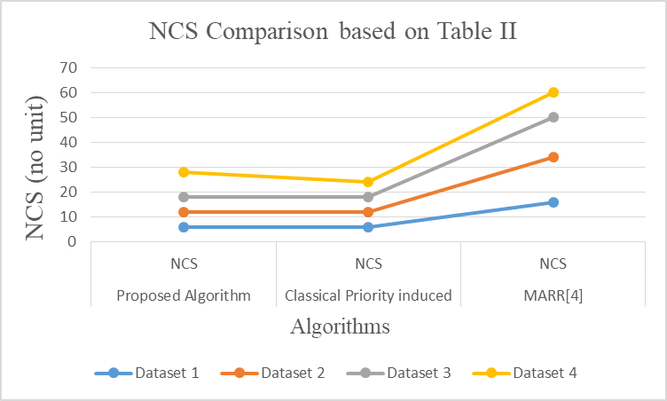
Fig. 3 Graphical representation for comparison of NCS in different colours for different datasets
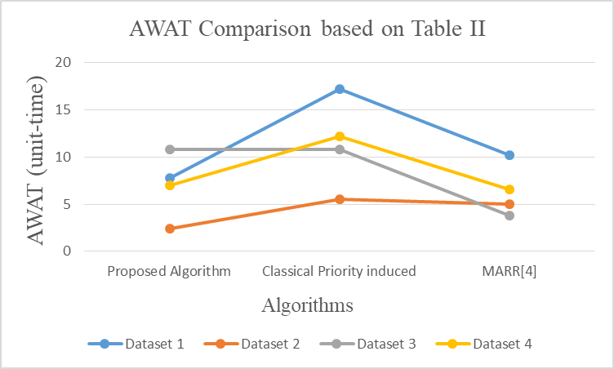

Fig. 4 Graphical representation for comparison of AWAT in different colours for different datasets

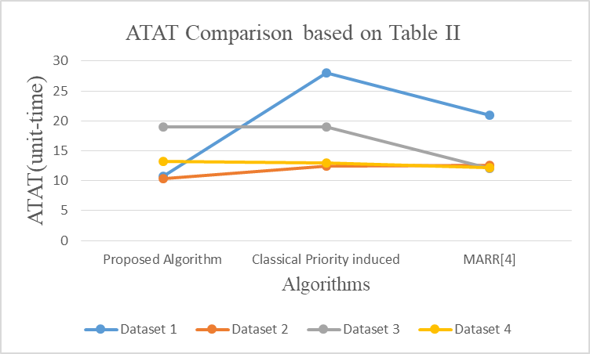
Fig. 5 Graphical representation for comparison of ATAT in different colours for different datasets

It can be deduced that the proposed algorithm exhibits the fewest number of context switches while maintaining comparable AWAT and ATAT when compared to the alternate approaches, as shown in Fig. 3, Fig. 4 and Fig. 5.
- Conclusions
The paper concludes that incorporating priority into the existing RR algorithm, along with a dynamic time quantum adjustment at the start of each round, leads to a reduction in the occurrence of context switches. This reduction is achieved by comparing the remaining execution time of the currently running task with the burst time of newly arrived high-priority tasks. Additionally, there is a notable decrease in both the AWAT and ATAT by a significant factor. Through a combination of theoretical analysis, model verification, and other technical methodologies, the paper provides a comprehensive overview of the benefits and drawbacks associated with the proposed algorithm as well as alternative algorithms. These findings serve as valuable insights for practical engineering applications.
In cloud computing, prioritization enables the efficient allocation of resources to tasks or applications based on their relative importance, ensuring that critical workloads receive preferential treatment. This is instrumental in meeting performance objectives, optimizing resource utilization, and ensuring fairness among cloud users. Research in priority scheduling encompasses the development of innovative algorithms, policies, and mechanisms to enhance service quality, meet Service-Level Agreements (SLAs), and optimize cost-effectiveness within cloud environments.
References
- Dipto Biswas, Md. Samsuddoha, Md. Rashid Al Asif, Md. Manjur Ahmed, "Optimized Round Robin Scheduling Algorithm Using Dynamic Time Quantum Approach in Cloud Computing Environment", International Journal of Intelligent Systems and Applications(IJISA), Vol.15, No.1, pp.22-34, 2023. DOI:10.5815/ijisa.2023.01.03.
- J. B. Dave, P. S. Yadev, M. Mathuria, and Y. M. Sharma, ”Optimize Task Scheduling Act By Modified Round Robin Scheme with Vigorous Time Quantum”, Int. Conf. Intell. Sustain. Syst., No. ICISS, pp. 905–910, 2017.
- K. Surendhar, L. S. Chamarthy, D. Priyadharshini, G. Keerthana, G. Sinha and A. V. Kumar, "Enhancement of Round Robin Algorithm with Dynamic Quantum in Cloud Computing," 2023 International Conference on Inventive Computation Technologies (ICICT), Lalitpur, Nepal, 2023, pp. 799-803, doi: 10.1109/ICICT57646.2023.10133995.
- Sharma C, Sharma S, Kautish S, Alsallami SA, Khalil EM, Mohamed AW. A new median-average round Robin scheduling algorithm: An optimal approach for reducing turnaround and waiting time. Alexandria Engineering Journal. 2022 Dec 1;61(12):10527-38.
- X. Yan, J. Zhao and J. Han, "Research on Intelligent Scheduling Algorithm Based on Cloud Computing," 2023 15th International Conference on Computer Research and Development (ICCRD), Hangzhou, China, 2023, pp. 100-104, doi: 10.1109/ICCRD56364.2023.10080165.
- Ghazy N, Abdelkader A, Zaki MS, Eldahshan KA. An ameliorated Round Robin algorithm in the cloud computing for task scheduling. Bulletin of Electrical Engineering and Informatics. 2023 Apr 1;12(2):1103-14.
- Sharma, Prem Sagar, et al. "A novel intelligent round robin CPU scheduling algorithm." International Journal of Information Technology 14.3 (2022): 1475-1482.
- Iqbal M, Ullah Z, Khan IA, Aslam S, Shaheer H, Humayon M, Salahuddin MA, Mehmood A. Optimizing Task Execution: The Impact of Dynamic Time Quantum and Priorities on Round Robin Scheduling. Future Internet. 2023 Mar 8;15(3):104.

