**MySQL Assignment -1**

1. Create database Infosys

* CREATE DATABASE Infosys;
* USE Infosys;

1. Create a table employee with e_id and e_name.

* CREATE TABLE employee ( #Employee Table created

e_id INT PRIMARY KEY,

e_name VARCHAR(50));

1. Display the structure of the table

* DESC Employee
* 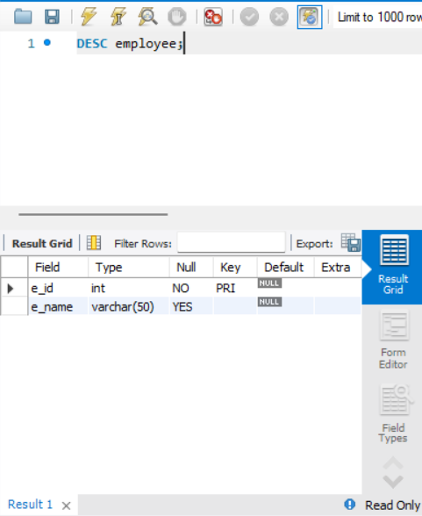

1. Rename the table employee to emp_personel_detail

* ALTER TABLE employee RENAME TO emp_personel_detail;

1. Display the structure of the table

* DESC emp_personel_detail;

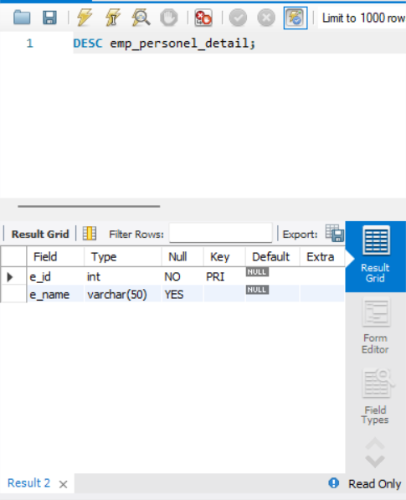

1. Add a field place

* ALTER TABLE emp_personel_detail ADD place VARCHAR(50);

1. Display the structure of the table

* DESC emp_personel_detail;

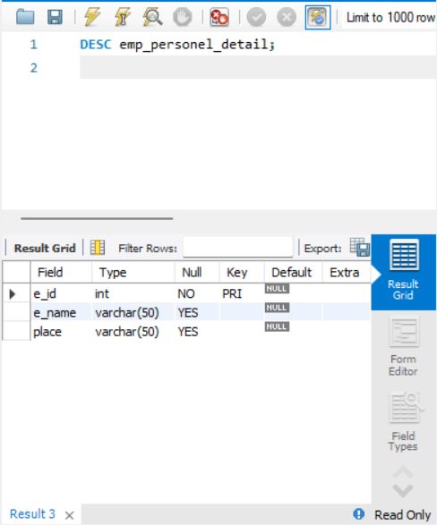

1. Rename field name place to e_place

* ALTER TABLE emp_personel_detail CHANGE place e_place VARCHAR(50);

1. Display the structure of the table

* DESC emp_personal_detail

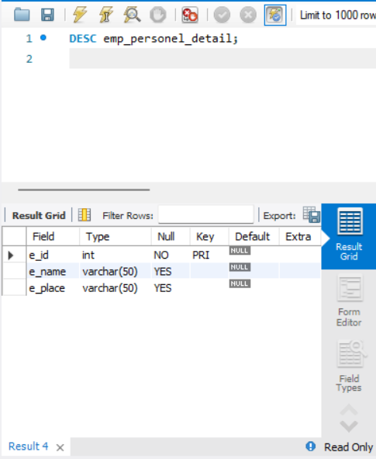

1. Modify field size of e_name i.e  increase the size.

* ALTER TABLE emp_personel_detail MODIFY e_name VARCHAR(100);

1. Display the structure of the table

* DESC emp_personal_table;

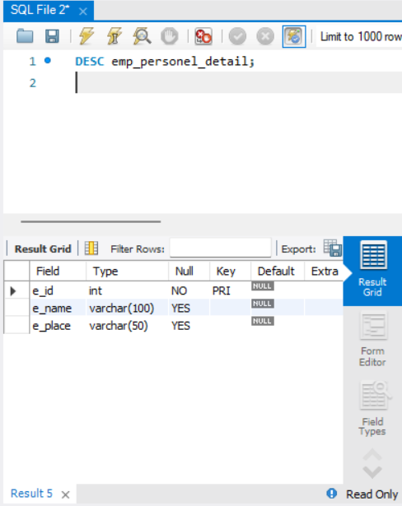

1. Add a field e_email

* ALTER TABLE emp_personel_detail ADD e_email VARCHAR(100);

1. Display the structure of the table

* DESC emp_personal_detail;

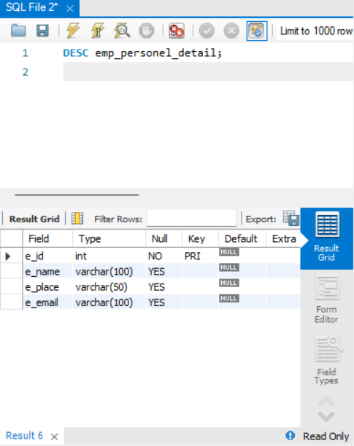

1. Remove i.e Drop the field e_email

* ALTER TABLE emp_personel_detail DROP COLUMN e_email;

1. Display the structure of the table

* DSEC emp_personal_detail

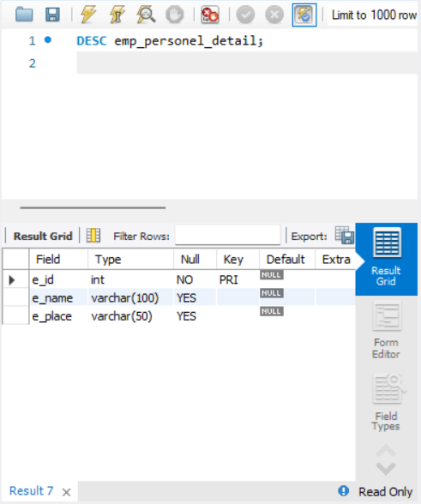

1. Add  a field e_yoe(employee years of experience ).

* ALTER TABLE emp_personel_detail ADD e_yoe INT;

1. Display the structure of the table

* DSEC emp_personal_detail
* 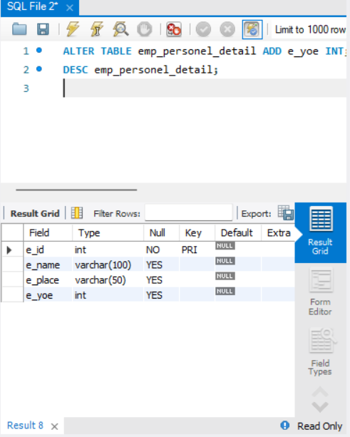

1. Insert the following table data.

* INSERT INTO emp_personel_detail (e_id, e_name, e_place, e_yoe) VALUES

(101, 'Ramu', 'Mysore', 3),

(102, 'Raju', 'Bangalore', 4),

(103, 'Rani', 'Chennai', 3),

(104, 'Sam', 'Hyderabad', 2),

(105, 'Raja', 'Madurai', 1),

(106, 'Ramya', 'Trichy', 0),

(107, 'Selvi', 'Bombay', 3),

(108, 'Kalyani', 'Bangalore', 7),

(109, 'Tom', 'Mysore', 4),

(110, 'Vasu', 'Chennai', 5);

|  |  |  |  |
| --- | --- | --- | --- |
| e_id | e_name | e_place | e_yoe |
| 101 | Ramu | Mysore | 3 |
| 102 | Raju | Bangalore | 4 |
| 103 | Rani | Chennai | 3 |
| 104 | Sam | Hyderabad | 2 |
| 105 | Raja | Madurai | 1 |
| 106 | Ramya | Trichy | 0 |
| 107 | Selvi | Bombay | 3 |
| 108 | Kalyani | Bangalore | 7 |
| 109 | Tom | Mysore | 4 |
| 110 | Vasu | Chennai |  |

1. Insert three records at a time i.e by using single query.

* INSERT INTO emp_personel_detail (e_id, e_name, e_place, e_yoe) VALUES

(111, 'John', 'Pune', 2),

(112, 'David', 'Delhi', 6),

(113, 'Anita', 'Mumbai', 5);

1. Display all records

* SELECT * FROM emp_personel_detail;

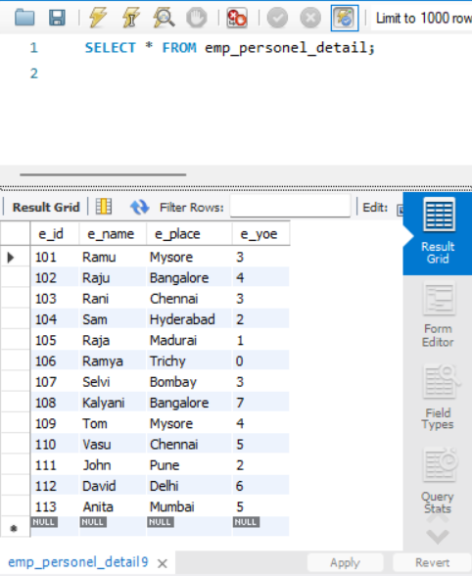

1. Insert only e_id, e_name , e_place values for 2 more records

* INSERT INTO emp_personel_detail (e_id, e_name, e_place) VALUES

(114, 'Sita', 'Goa'),

(115, 'Mohan', 'Kolkata');

1. Display all records

* SELECT * FROM emp_personel_detail;

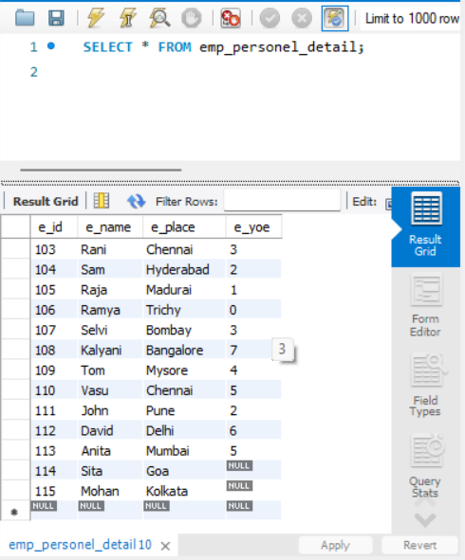

1. Update the e_yoe fields which is having null value.

* UPDATE emp_personel_detail SET e_yoe = 0 WHERE e_yoe IS NULL;

1. Display all records

* SELECT * FROM emp_personel_detail;



1. Delete the employee records which is having e_id value is equal to 105

* DELETE FROM emp_personel_detail WHERE e_id = 105;

1. Display all records

* 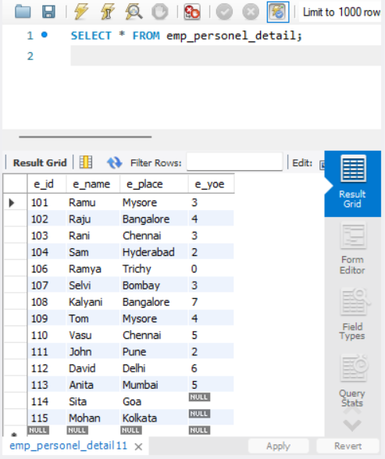

1. Delete the employee records who are having less than two years of experience

* DELETE FROM emp_personel_detail WHERE e_yoe < 2;

1. Display all records

* 