1. Pension Management

a. **Status Of Pending old Pension Scheme (Except Family Pension)**

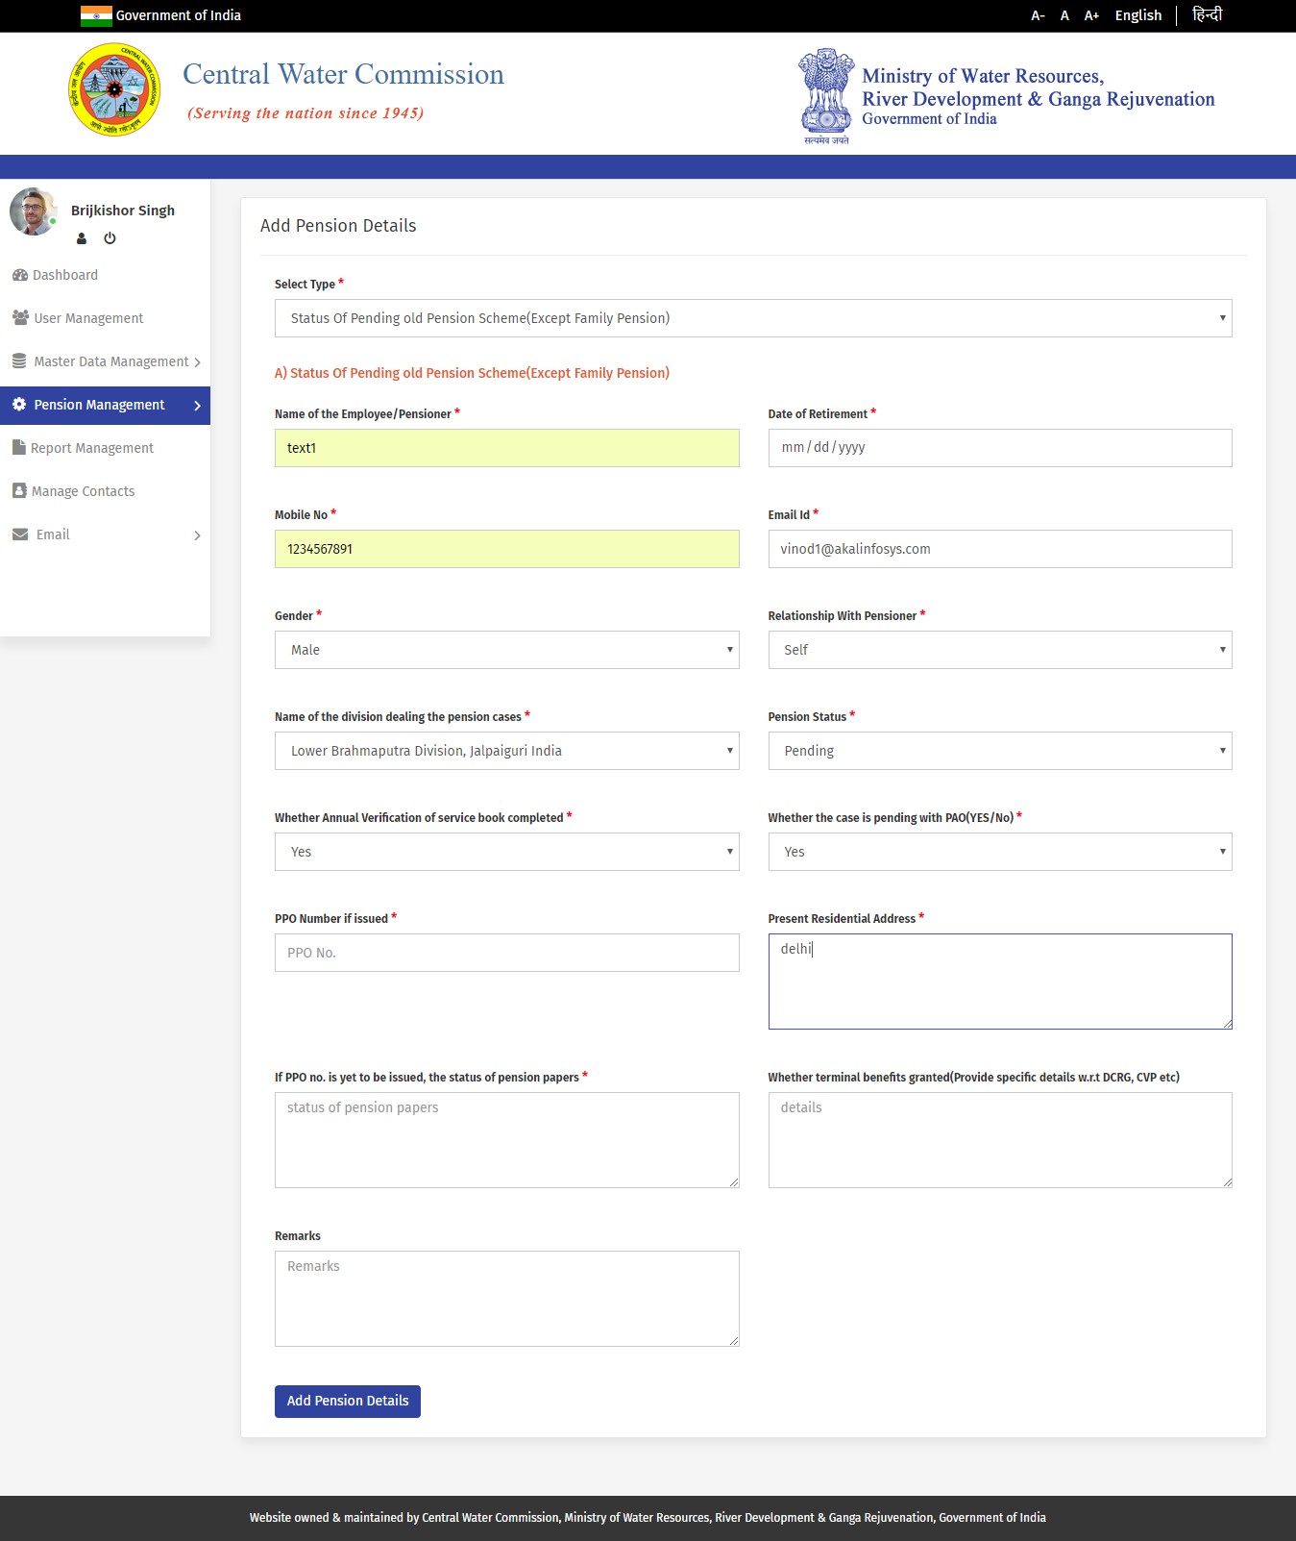

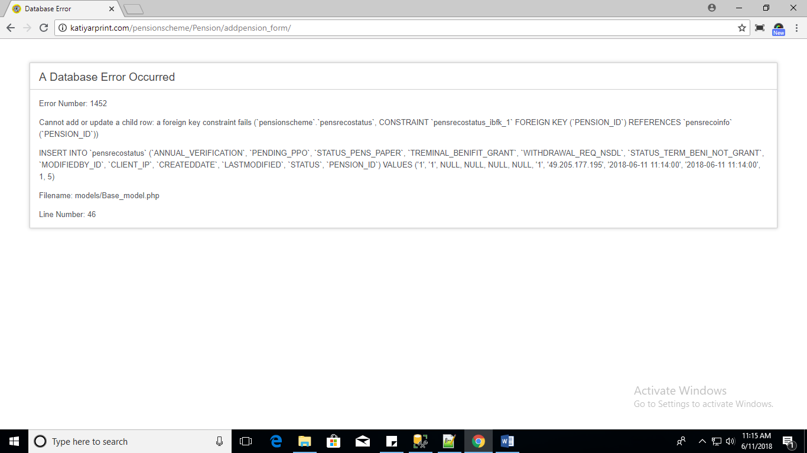

b. **Status Of Pending old Pension Scheme (Only Family Pension)**

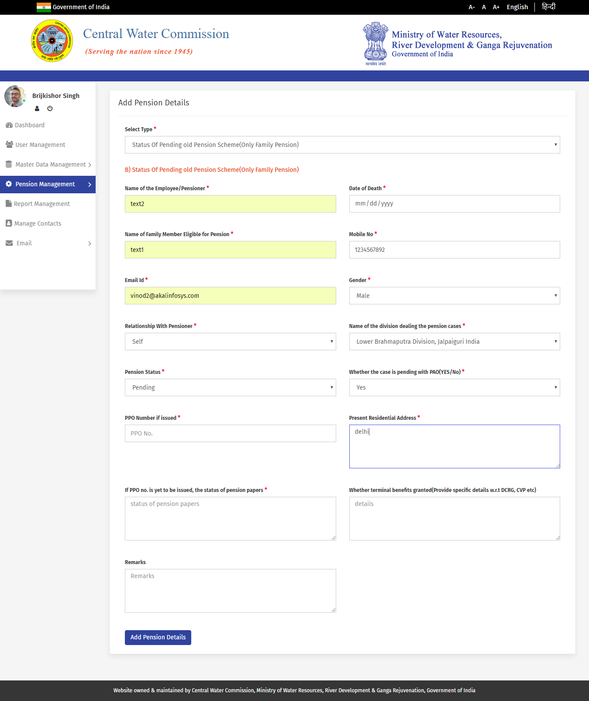

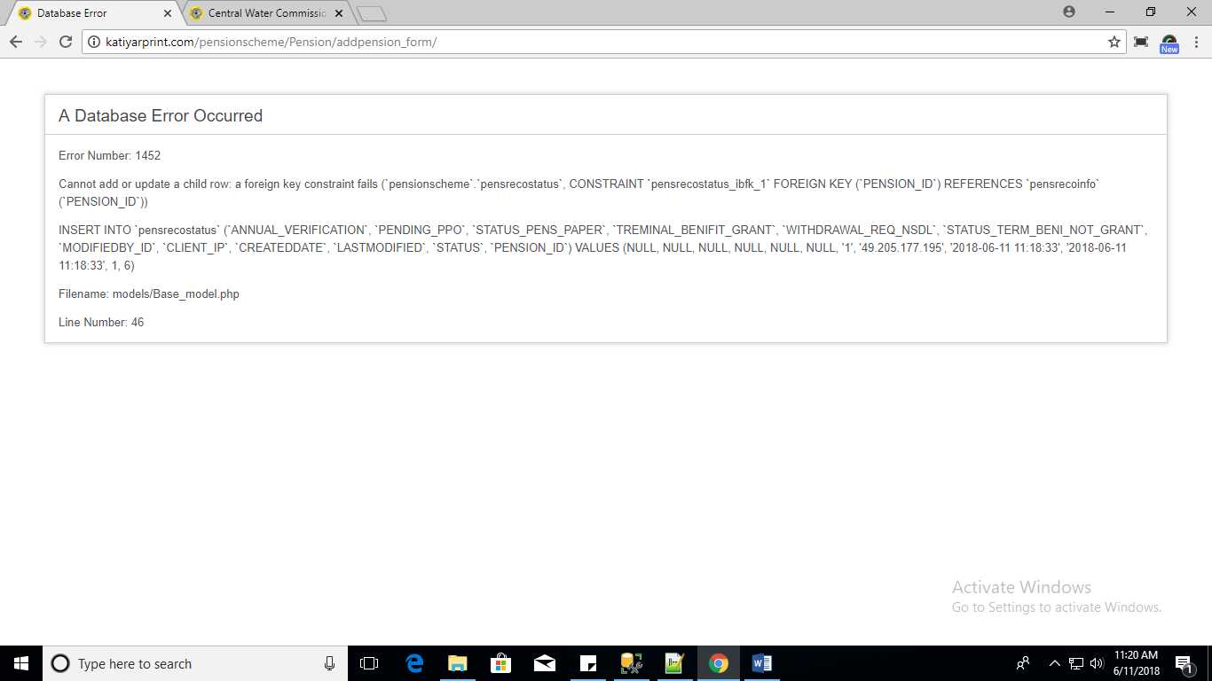

c. **Status Of Pending New Pension Scheme (Except Family Pension)**

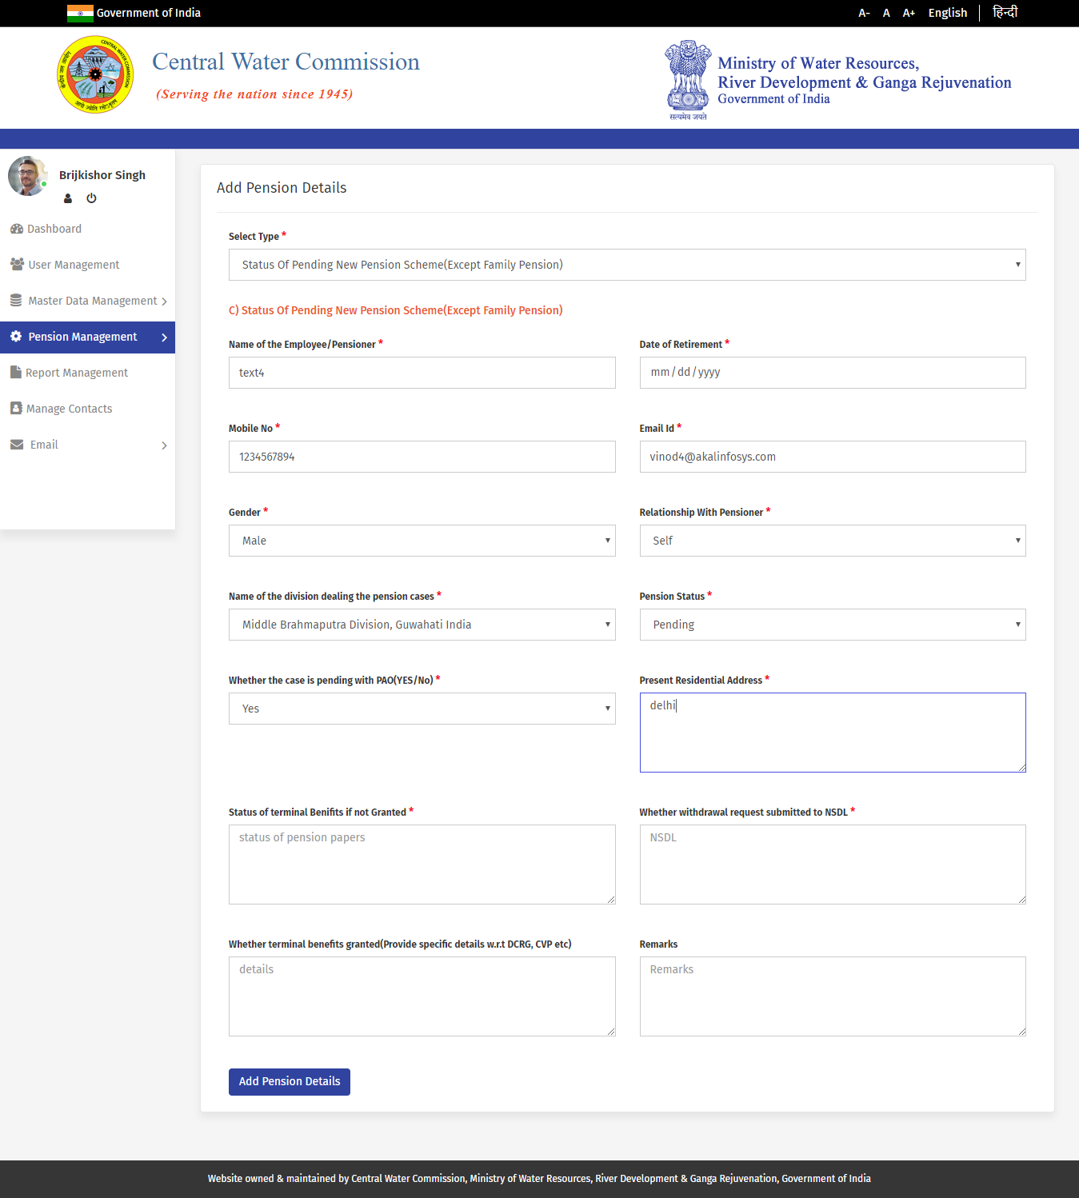

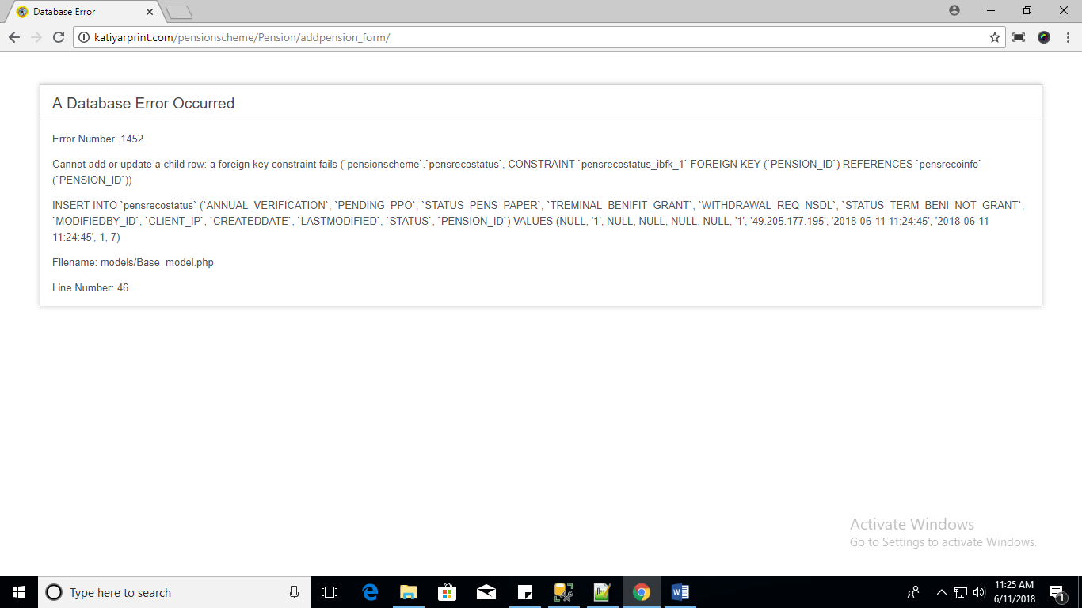

d. **Status Of Pending New Pension Scheme (Only Family Pension)**

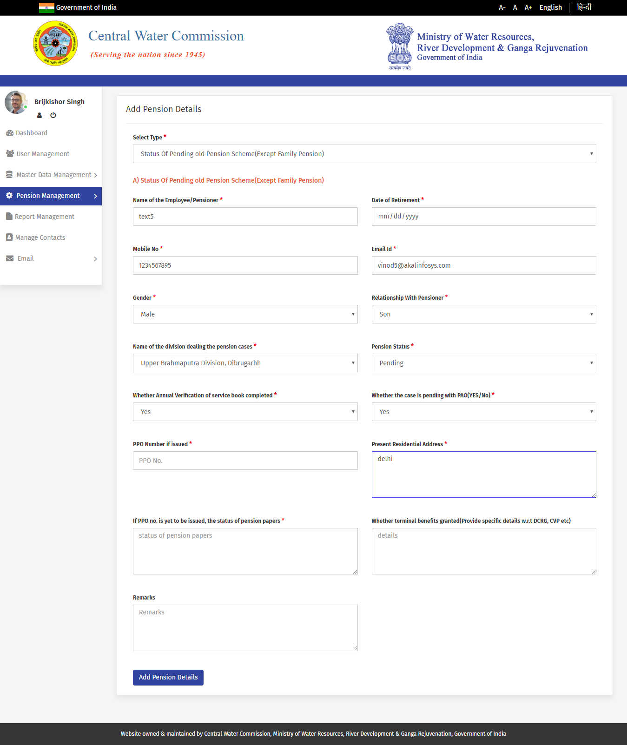

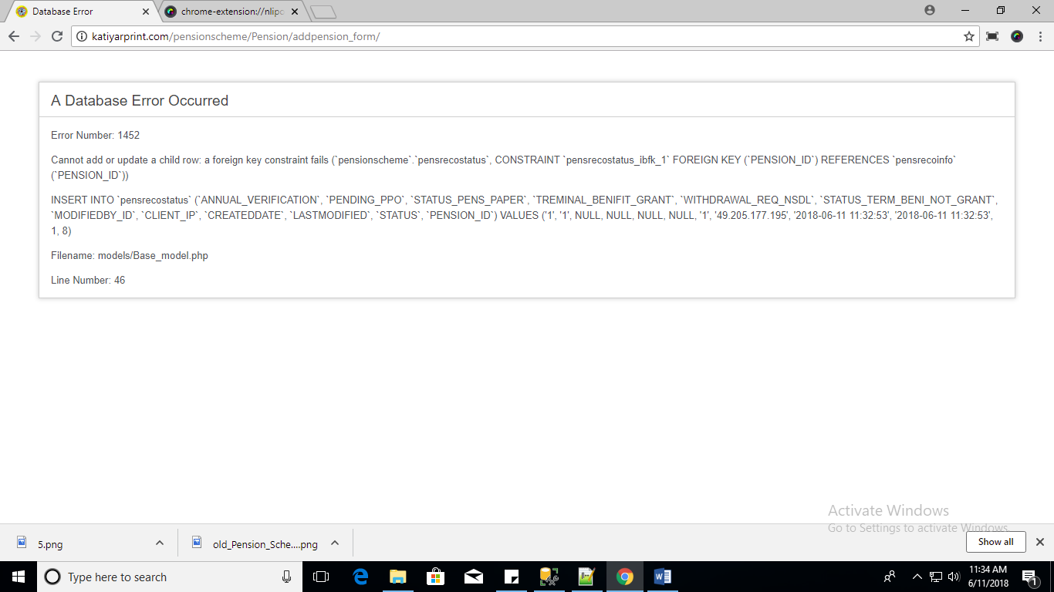

Pension List

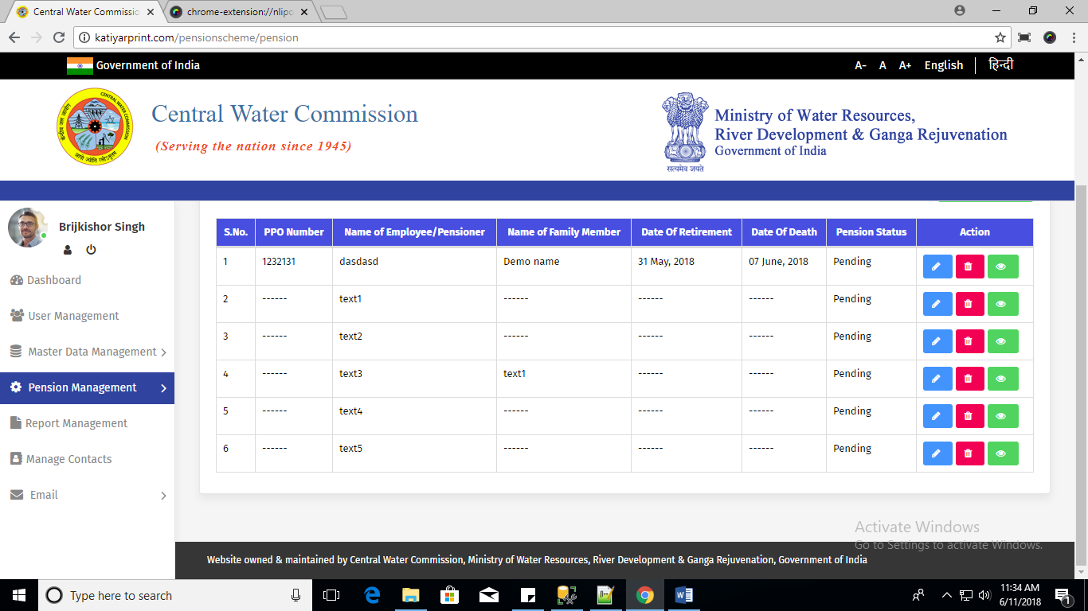

All error are occurred on Add Pension for all select type.

**Login page for admin**

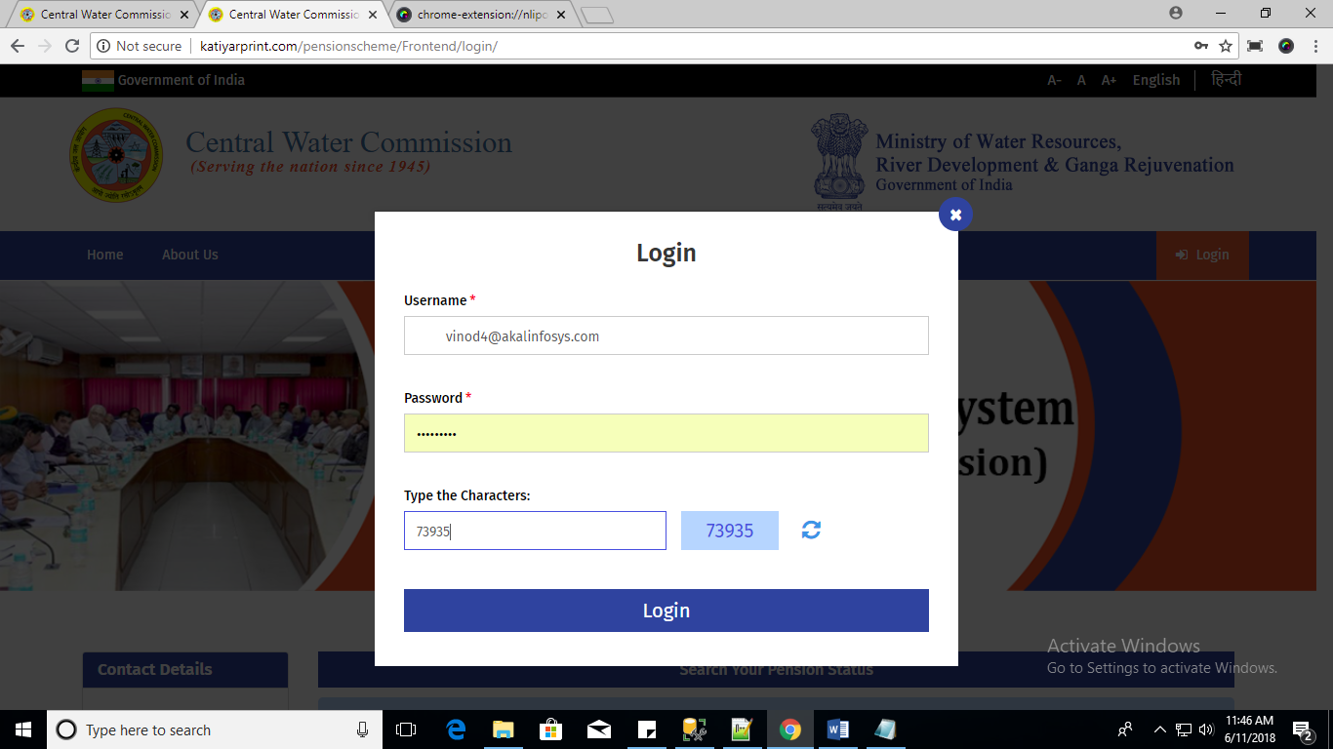

Use trim function on username textbox.