Exploratory Data Analysis (EDA) Project
Weekly U.S. Gasoline Product Supplied — Fiscal Years 2020–2026

Objective
Perform an in-depth Exploratory Data Analysis on a real-world weekly production dataset to clean, preprocess, and visualize the data in order to uncover trends, seasonality, and year-over-year patterns.

Dataset Description
Weekly volume (gallons) of finished motor gasoline supplied to the U.S. market, compiled by the DOT Federal Highway Administration from EIA weekly petroleum supply data. 356 weekly records (FY2020–FY2026, partial), 7 raw fields: fiscal year, fiscal week, current- and previous-year production, YoY difference, and current-year cumulative production / cumulative difference.

Tools and Libraries Used
Python (Jupyter Notebook) · Pandas · NumPy · Matplotlib · Seaborn

Screenshots of Key Visualizations
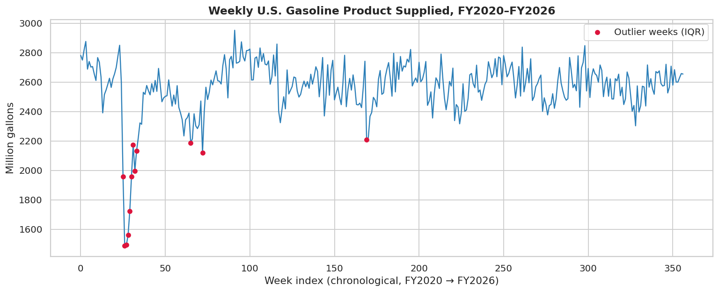  Weekly production, FY2020–FY2026 (COVID-19 dip flagged) | 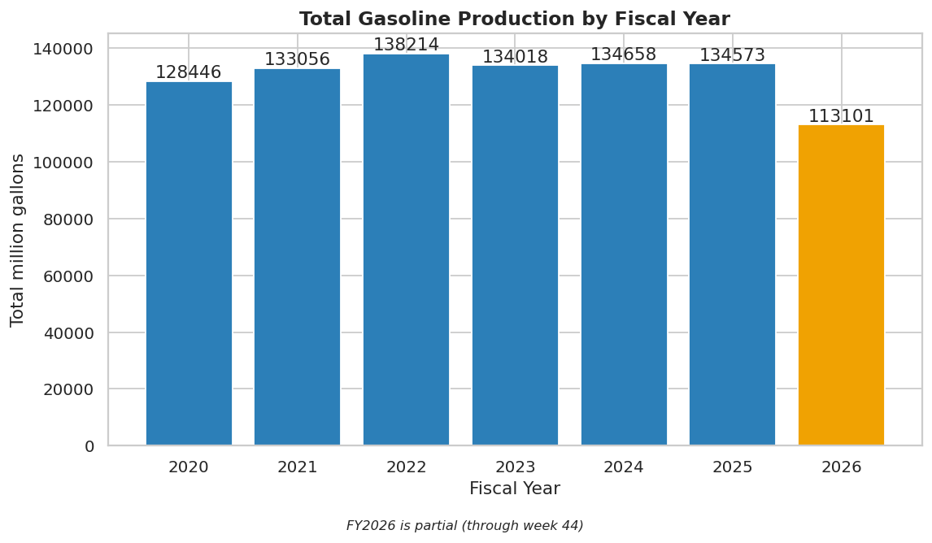  Total production by fiscal year
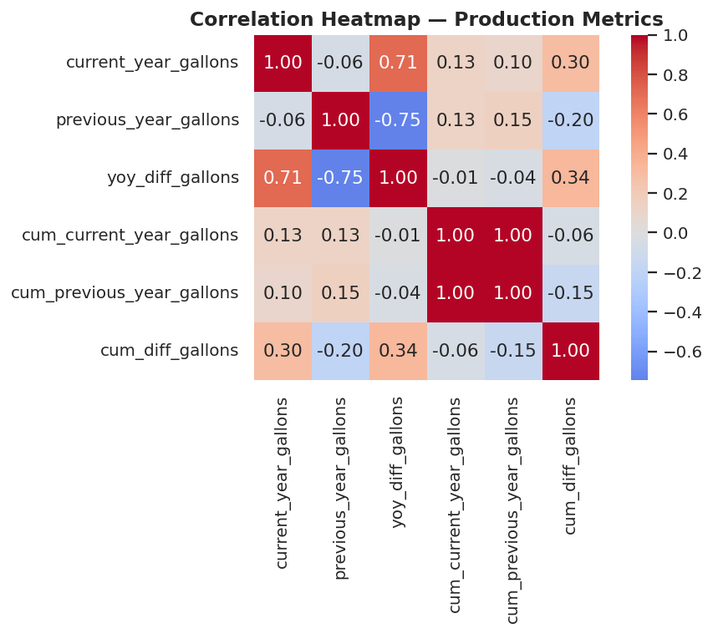  Correlation heatmap | 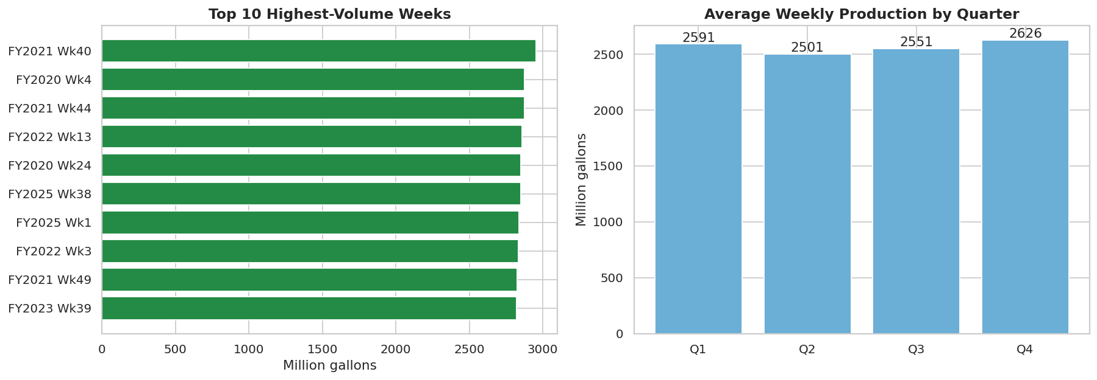  Top weeks & average production by quarter

Summary of Insights
- Average weekly production across FY2020–FY2026: ~2,566 million gallons/week.
- FY2022 had the highest average weekly output (2,608 M gal/week); FY2020 had the lowest (2,470 M gal/week) — the COVID-19 year.
- Q4 (summer driving season) is the strongest quarter (avg 2,626 M gal/week); Q2 (winter) is the weakest.
- 12 weeks flagged as statistical outliers (IQR method), all clustered in FY2020 — kept and flagged rather than removed, since they reflect the real COVID-19 demand shock.
- Raw weekly current-vs-previous-year correlation is weak (r ≈ -0.06) — week-level noise dominates — while cumulative current-vs-previous-year totals are almost perfectly correlated (r ≈ 0.996), which is why cumulative pace tracking is far more reliable than comparing single weeks.
- FY2026 is running slightly behind FY2025's pace — about 0.60 billion gallons — through week 44 on a cumulative basis.

Challenges Faced and Solutions
Challenge | Solution
Numbers stored as quoted text with commas; some negatives had a stray Excel "force-text" apostrophe | Wrote a clean_number() function to strip the apostrophe and commas before casting to float
FY2022 week 53 (leap week) has no comparable prior-year week; source recorded Previous Year Production = 0 | Treated 0 as not-applicable and set it to NaN instead of a real zero-production week
FY2025 week 11 was missing entirely (whole row absent, not just null) | Recovered the exact value from the untouched cumulative column (cum(wk12) - cum(wk10) - production(wk12)) instead of estimating
A cluster of unusually low FY2020 weeks looked like data errors at first | Confirmed via IQR outlier detection + date-checking that it reflects the real COVID-19 demand collapse; flagged and kept rather than deleted

