PROJECT REPORT
On
Expenditure Based Website
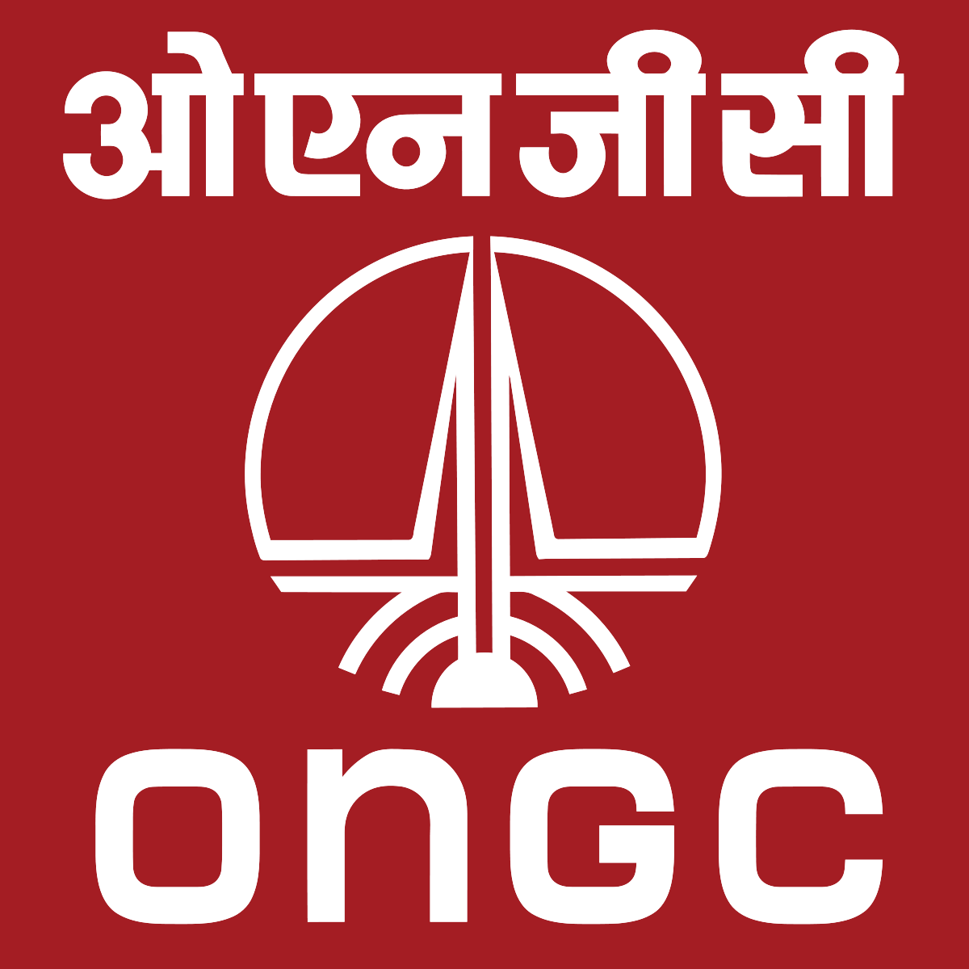ch

Submitted to: Submitted By :

Mr.Himanshu Kumar Gupta Rachit Gupta
Tushar Darmora
Priyanshu Bisht
Ashish
CERTIFICATE

Certified that Mr. Rachit Gupta and others has developed project on “Management Based Website” for the Internship In ONGC. The project carried out by Students is their own work as best of my knowledge and by the help of the mentor.

Date:21 JULY 2021

ACKNOWLEDGMENT

We wish to thank our parents for their continuing support and encouragement. We also wish to thank them for providing us with the opportunity to reach this far in our studies.
We would like to thank particularly our mentor Mr. Himanshu Kumar Gupta Sir for their patience, support and encouragement throughout the completion of this project and having faith in us.
At last but not the least We greatly indebted to all other persons who directly or indirectly helped us during this work.

Mr. Rachit Gupta

TABLE OF CONTENTS

- Introduction about the Ongc
- About the Ongc
- History of Ongc
- Strength , Opportunity and competitor of Ongc

2.Introduction
- About the project
- Roles assigned
- Use of the project
- Future work

3.Learning behind the project

4.Technology behind the project
- HTML
- CSS
- MySQL
- PHP
- JavaScript

- Software Development
- Use of SDLC
- ER Diagram

- Flowchart

- Code Link

- Bibliography

Oil and Natural Gas Corporation

Oil and Natural Gas Corporation (ONGC) is an Indian government-owned crude oil and natural gas corporation. Its registered office is in New Delhi. It is under the ownership of Ministry of Petroleum and Natural Gas, Government of India. It is the largest oil and gas exploration and production company in the country, and produces around 70% of India's crude oil (equivalent to around 57% of the country's total demand) and around 84% of its natural gas/ In November 2010, the Government of India conferred the Maharatna status to ONGC

ONGC was founded on 14 August 1956 by Government of India. It is involved in exploring for and exploiting hydrocarbons in 26 sedimentary basins of India, and owns and operates over 11,000 kilometers of pipelines in the country. Its international subsidiary ONGC Videsh currently has projects in 17 countries. ONGC has discovered 7 out of the 8 producing Indian Basins, adding over 7.15 billion tonnes of In-place Oil & Gas volume of hydrocarbons in Indian basins. Against a global decline of production from matured fields, ONGC has maintained production from its brown fields like Mumbai High, with the help of aggressive investments in various IOR (Improved Oil Recovery) and EOR (Enhanced Oil Recovery) schemes. ONGC has many matured fields with a current recovery factor of 25–33%.Its Reserve Replacement Ratio for between 2005 and 2013, has been more than one.During FY 2012–13, ONGC had to share the highest ever under-recovery of INR 89765.78 billion (an increase of INR 17889.89 million over the previous financial year) towards the under-recoveries of Oil Marketing Companies (IOC, BPCL and HPCL).On 1 November 2017, the Union Cabinet approved ONGC for acquiring majority 51.11% stake in HPCL (Hindustan Petroleum Corporation Limited). On Jan 30th 2018, Oil & Natural Gas Corporation acquired the entire 51.11% stake of Hindustan Petroleum Corporation.

ONGC has a unique distinction of being a company with in-house service capabilities in all areas of Exploration and Production of oil & gas and related oil-field services. Winner of the Best Employer award, this public sector enterprise has a dedicated team of around 28,500 professionals who toil round the clock in challenging locations.

History Behind the ONGC-

Foundation to 1956
After independence, the Central Government of India realized the importance of oil and gas for rapid industrial development and its strategic role in defense. Consequently, while framing the Industrial Policy Statement of 1948, the development of the petroleum industry in the country was considered to be of utmost necessity.

Until 1955, private oil companies mainly carried out exploration of hydrocarbon resources of India. In Assam, the Assam Oil Company was producing oil at Digboi (discovered in 1889) and Oil India Ltd. (a 50% joint venture between Government of India and Burmah Oil Company) was engaged in developing two newly discovered large fields Naharkatiya and Moraan in Assam.

1961 – 1990

Since its inception, ONGC has been instrumental in transforming the country's limited upstream sector into a large viable playing field, with its activities spread throughout India and significantly in overseas territories. In the inland areas, ONGC not only found new resources in Assam but also established new oil province in Cambay basin (Gujarat), while adding new petroliferous areas in the Assam-Arkansan Fold Belt and East coast basins (both inland and offshore).

ONGC went offshore in early 70's and discovered a giant oil field in the form of Bombay High, now known as Mumbai High. This discovery, along with subsequent discoveries of huge oil and gas fields in Western offshore changed the oil scenario of the country. Subsequently, over 5 billion tonnes of hydrocarbons, which were present in the country, were discovered. The most important contribution of ONGC, however, is its self-reliance and development of core competence in E&P activities at a globally competitive level.

1990 onwards

The liberalized economic policy, adopted by the Government of India in July 1991, sought to deregulate and DE-license the core sectors (including petroleum sector) with partial disinvestment of government equity in Public Sector Undertakings and other measures. As a consequence thereof, ONGC was re-organized as a limited Company under the Company's Act, 1956 in February 1994.

After the conversion of business of the erstwhile Oil & Natural Gas Commission to that of Oil & Natural Gas Corporation Limited in 1993, the Government disinvest 2 per cent of its shares through competitive bidding. Subsequently, ONGC expanded its equity by another 2 per cent by offering shares to its employees.

Strengths Opportunities and Competitor

Strengths
1. ONGC is India's largest crude oil and natural gas producer
2. Strong brand name of ONGC company
3. High profit making and high revenues
4. Has over 30,000 employees in its workforce
5. ONGC produces about 30% of India's crude oil requirement
6. Contributes 70%+ of India's crude oil production and 80%+ of India's natural gas production
7. Commemorative Coin set was released to mark 50 Years of ONGC
8. Strong advertising and branding of the company along with recognition from several awards
9. Owned by the Govt of India, ONGC has got a strong financial backing

Opportunities
1. Increasing fuel/oil prices means higher margins for ONGC
2. Increasing natural gas market
3. ONGC can increase business by more oil well discoveries
4. Expand global export market and have international tie-ups

Competitors
1. Bharat Petroleum
2. IOCL
3. Reliance Industries Limited

INTRODUCTION ABOUT THE PROJECT

In this project we have created two website one for the user and other for the admin. We have created a website for Expenditure based website in which user can upload there excel sheet and then they can edit it and can give the remark about the status of the product.

ABOUT THE PROJECT
This is website is divide into two main part

1 Admin side
2 User side

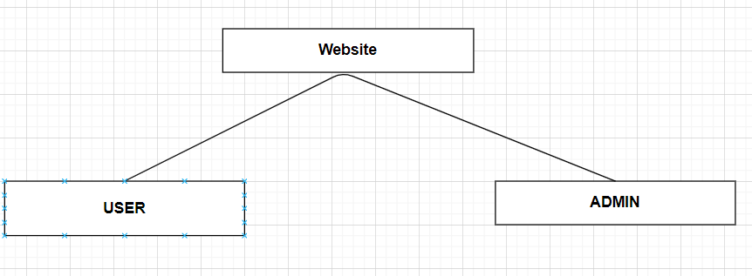

USER SIDE

- In user side person can upload the excel sheet and it will store in the local storage of the computer. And while uploading the file it will shown in the local storage by whom file is uploaded.

- This uploading system is totally based on the PHP .

- And to make user friendly we created a web page using HTML,CSS , JavaScript .

- User can upload more than one file and all the file will be store in the
Local storage

ADMIN SIDE

- In admin side person can see the uploaded file

- In this admin can give remark and could change the content of the file

- To view the file we have created a database and then created a table to store the content

- To view the content of excel we have again created a web page using HTML, CSS, JavaScript

ROLES ASSIGNED

As we all know project are mean to be created in the group. And this project is also created by the team of 4 member which is lead by Rachit Gupta from Graphic Era University along with Tushar Darmora , Priyanshu Bisht and Ashish.

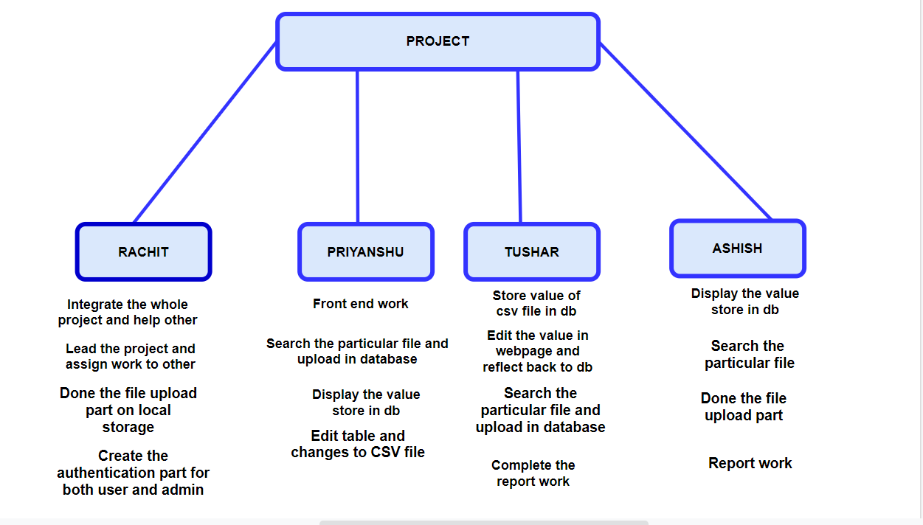
USE OF THE PROJECT

This project is created for the purpose for the daily work . As Ongc is one of the biggest corporation in India As there is so many budget sheet are used in the form of excel sheet. So this website can be used to decrease the workload of the individual .

By the help of this project a user can easily upload the excel sheet and it will store in the Local Storage.

It will also help to view the uploaded file and the user can easily modify the data or can give the remark .

FUTURE WORK

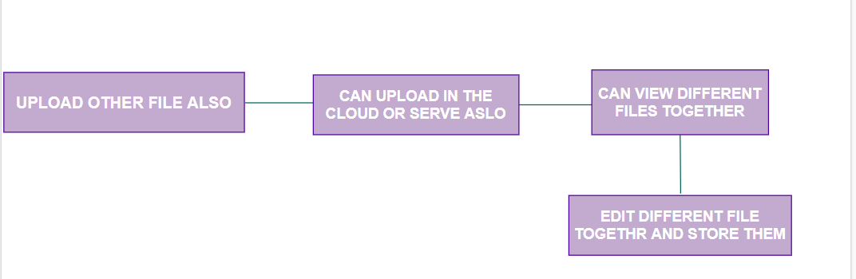

LEARNING BEHIND THE PROJECT

Project are meant to be learn new things.And in this project everybody learns a lot new things under the guidance of our mentor Mr Himanshu sir.

Everyone in the team learn new things. Everyone got new experience.

- Almost everyone in the team is not aware of the PHP . But in the end of this project we have a good skill in PHP and can implement our project in PHP

- Learn how to read csv file and store in the database .

- Learn new skill in database and front end development

- Learn about the software development and also learn about the SDLC

- Learn about the concept of spreadsheet and simple excel in PHP
SOFTWARE DEVELOPMENT

Software Development Life Cycle (SDLC) is a process used by the software industry to design, develop and test high quality softwares
It aims to produce a high-quality software that meets or exceeds customer expectations, reaches completion within times and cost estimates.

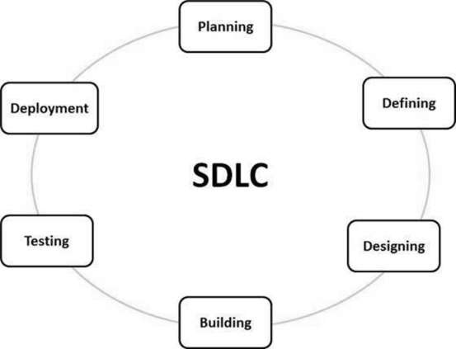

Stage1: Planning and requirement analysis

Requirement Analysis is the most important and necessary stage in SDLC.
The senior members of the team perform it with inputs from all the stakeholders and domain experts or SMEs in the industry.

Stage2: Defining Requirements
Once the requirement analysis is done, the next stage is to certainly represent and document the software requirements and get them accepted from the project stakeholders.

Stage3: Designing the Software
The next phase is about to bring down all the knowledge of requirements, analysis, and design of the software project. This phase is the product of the last two, like inputs from the customer and requirement gathering.

Stage4: Developing the project
In this phase of SDLC, the actual development begins, and the programming is built. The implementation of design begins concerning writing code. Developers have to follow the coding guidelines described by their management and programming tools like compilers, interpreters, debuggers, etc. are used to develop and implement the code.

Stage5: Testing
After the code is generated, it is tested against the requirements to make sure that the products are solving the needs addressed and gathered during the requirements stage.

Stage6: Deployment
Once the software is certified, and no bugs or errors are stated, then it is deployed.Then based on the assessment, the software may be released as it is or with suggested enhancement in the object segment.

Stage7: Maintenance
Once when the client starts using the developed systems, then the real issues come up and requirements to be solved from time to time.

USE OF SDLC IN THIS PROJECT

- SDLC is used to design the product for the client and it is also used to design the project.
- SDLC play a vital role to develop any project.And in this we have created the project according to the SDLC phase.

PHASE 1- Planning

It is the starting phase of the SDLC.In this planning has done by all the team member .

PHASE 2- Defining Requirements

In this phase requirement are discuss and decide the blueprint of the project

PHASE 3-Designing the Software
All the requirements and analysis of the project is done here and the roles are also decide here.

PHASE4- Developing the project
In this phase actual development is start, all the member start doing the work which was assign in the last phase.
Coding as well development part is done in this phase.

PHASE 5-Testing
In this phase we tested our website . Check wether file uploading system is working properly or not ? And also check some other things

PHASE 6-Deployment
This phase is implemented when all the bugs and all the things are sorted . In this phase basically software is deployed

ER DIAGRAM

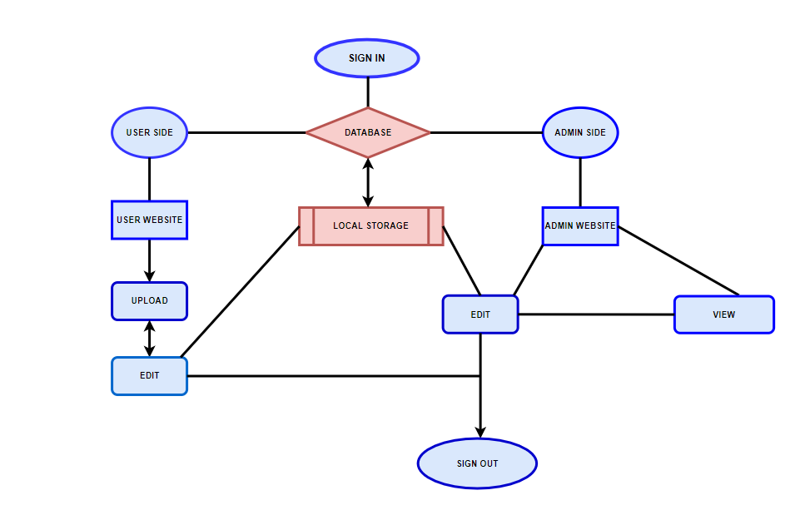

FLOWCHART

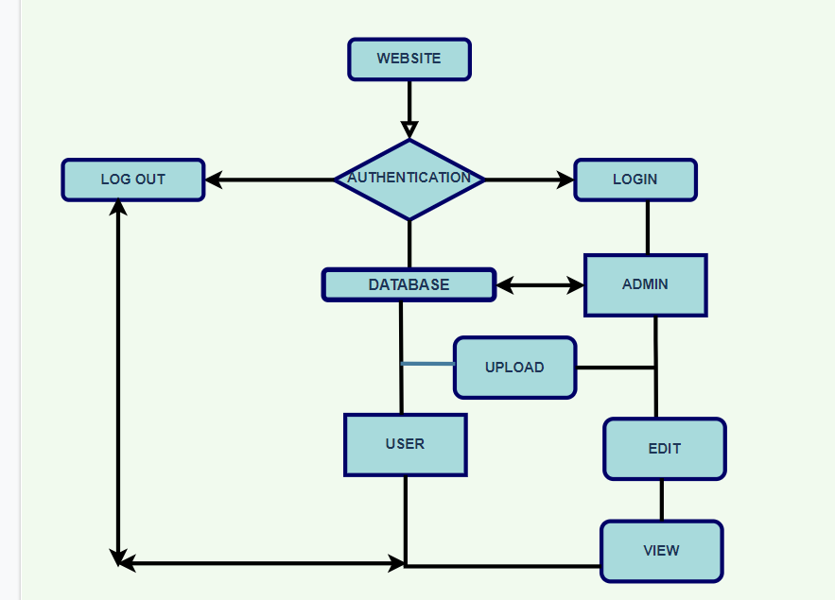

A flowchart is a type of diagram that represents a workflow or process. A flowchart can also be defined as a diagrammatic representation of an algorithm, a step-by-step approach to solving a task.

The flowchart shows the steps as boxes of various kinds, and their order by connecting the boxes with arrows. This diagrammatic representation illustrates a solution model to a given problem. Flowcharts are used in analyzing, designing, documenting or managing a process or program in various fields

CODE
Technology used-
HTML HyperText Markup Language 

HTML is the standard markup language for Web pages. It can be assisted by technologies such as Cascading Style Sheets (CSS) and scripting languages such as JavaScript.
Web browsers receive HTML documents from a web server or from local storage and render the documents into multimedia web pages. HTML describes the structure of a web page semantically and originally included cues for the appearance of the document.

HTML elements are the building blocks of HTML pages. With HTML constructs, images and other objects such as interactive forms may be embedded into the rendered page. HTML provides a means to create structured documents by denoting structural semantics for text such as headings, paragraphs, lists, links, quotes and other items. HTML elements are delineated by tags, written using angle brackets. Tags such as <image /> and <input /> directly introduce content into the page. Other tags such as <p> surround and provide information about document text and may include other tags as sub-elements. Browsers do not display the HTML tags, but use them to interpret the content of the page.

History of HTML

HTML was created by Sir Tim Berners-Lee in late 1991 but was not released officially, published in 1995 as HTML 2.0. HTML 4.01 was published in late 1999 and was a major version of HTML.

HTML was created by Sir Tim Berners-Lee in late 1991 but was not released officially, published in 1995 as HTML 2.0. HTML 4.01 was published in late 1999 and was a major version of HTML.

HTML 4.01, which is widely used and was a successful version of HTML before HTML 5.0, which is currently released and used worldwide. HTML 5 can be said for an extended version of HTML 4.01, which was published in the year 2012
CSS Cascading Style Sheets 

Cascading Style Sheets, fondly referred to as CSS, is a simple design language intended to simplify the process of making web pages presentable.

CSS handles the look and feel part of a web page. Using CSS, you can control the color of the text, the style of fonts, the spacing between paragraphs, how columns are sized and laid out, what background images or colors are used, layout designs,variations in display for different devices and screen sizes as well as a variety of other effects.

The name cascading comes from the specified priority scheme to determine which style rule applies if more than one rule matches a particular element. This cascading priority scheme is predictable.

History

CSS is created and maintained through a group of people within the W3C called the CSS Working Group. The CSS Working Group creates documents called specifications. When a specification has been discussed and officially ratified by the W3C members, it becomes a recommendation.

These ratified specifications are called recommendations because the W3C has no control over the actual implementation of the language. Independent companies and organizations create that software.

MYSQL 

MySQL is a relational database management system (RDBMS) developed by Oracle that is based on structured query language (SQL).

A database is a structured collection of data. It may be anything from a simple shopping list to a picture gallery or a place to hold the vast amounts of information in a corporate network. In particular, a relational database is a digital store collecting data and organizing it according to the relational model. In this model, tables consist of rows and columns, and relationships between data elements all follow a strict logical structure. An RDBMS is simply the set of software tools used to actually implement, manage, and query such a database.

HISTORY

MySQL was created by a Swedish company, MySQL AB, founded by Swedes David Axmark, Allan Larsson and Finland Swede Michael "Monty" Widenius. Original development of MySQL by Widenius and Axmark began in 1994. The first version of MySQL appeared on 23 May 1995. It was initially created for personal usage from mSQL based on the low-level language ISAM, which the creators considered too slow and inflexible. They created a new SQL interface, while keeping the same API as mSQL. By keeping the API consistent with the mSQL system, many developers were able to use MySQL instead of the (proprietary licensed) mSQL antecedent.

PHP 

PHP (recursive acronym for PHP: Hypertext Preprocessor) is a widely-used open source general-purpose scripting language that is especially suited for web development and can be embedded into HTML.

PHP code is usually processed on a web server by a PHP interpreter implemented as a module, a daemon or as a Common Gateway Interface (CGI) executable. On a web server, the result of the interpreted and executed PHP code – which may be any type of data, such as generated HTML or binary image data – would form the whole or part of an HTTP response. Various web template systems, web content management systems, and web frameworks exist which can be employed to orchestrate or facilitate the generation of that response. Additionally, PHP can be used for many programming tasks outside of the web context, such as standalone graphical applications and robotic drone control. PHP code can also be directly executed from the command line.

JAVASCRIPT 

JavaScript is the world's most popular programming language. JavaScript is the programming language of the Web.

JavaScript runs on the client side of the web, which can be used to design program how the web pages behave on the occurrence of an event. JavaScript is an easy to learn and also powerful scripting language, widely used for controlling web page behavior.

JavaScript can function as both a procedural and an object oriented language. Objects are created pro-grammatically in JavaScript, by attaching methods and properties to otherwise empty objects at run time, as opposed to the syntactic class definitions common in compiled languages like C++ and Java. Once an object has been constructed it can be used as a blueprint (or prototype) for creating similar objects.

HISTORY

JavaScript was invented by Brendan Eich in 1995.
It was developed for Netscape 2, and became the ECMA-262 standard in 1997.
After Netscape handed JavaScript over to ECMA, the Mozilla foundation continued to develop JavaScript for the Firefox browser. Mozilla's latest version was 1.8.5. (Identical to ES5).

BIBLOGRAPHY

- www.wikipedia.com
- www.geeksforgeeks.com

