PROJECT REPORT

Ai/Ml powered healthcare management and prediction system
Submitted in partial fulfilment of the requirement for the award of the degree of
BACHELOR OF TECHNOLOGY
IN
COMPUTER SCIENCE & ENGINEERING
Submitted by

Priyansu Dhami University Roll No - 2219354
Under the guidance of
Dr. Amit Gupta
Assistant Professor
Project Group No: 622

Department of Computer Science and Engineering
Graphic Era Hill University
May, 2026


CANDIDATE’S DECLARATION
I hereby certify that the work which is being presented in the project progress report entitled “Ai/Ml powered healthcare management and prediction system” in partial fulfilment of the requirements for the award of the Degree of Bachelor of Technology in Computer Science and Engineering in the Department of Computer Science and Engineering of the Graphic Era Hill University, Dehradun shall be carried out by the undersigned under the supervision of Dr. Amit Gupta, Assistant Professor Department of Computer Science and Engineering, Graphic Era Hill University, Dehradun.
Priyansu dhami University Roll no - 2219354
The above-mentioned student shall be working under the supervision of the undersigned on the " Ai/Ml powered healthcare management and prediction system ".
Date: Sign of Mentor
Place:

ACKNOWLEDGMENT
I would like to express my sincere gratitude to my project guide Dr. Amit Gupta for his guidance and support throughout the development of this project. His insights helped me understand the practical aspects of cloud computing and fraud detection systems.
I also thank the faculty members of the Computer Science Department for their valuable suggestions. Finally, I am grateful to my peers and family for their constant encouragement.
Priyansu dhami
Roll no - 2219354

ABSTRACT
The increasing demand for intelligent healthcare systems has led to the adoption of machine learning techniques for early disease prediction and diagnosis. Traditional healthcare systems often rely on manual analysis, which can be time-consuming and may lead to delayed treatment.
This project presents an AI-powered Disease Prediction System that utilizes machine learning algorithms to predict diseases based on user-provided symptoms. The system uses a structured dataset containing diseases and their corresponding symptoms to train a Gaussian Naïve Bayes model.
To improve prediction accuracy, a symptom severity dataset is incorporated, where each symptom is assigned, a weight based on its importance. These weights are used to transform categorical symptom data into numerical form, resulting in more accurate and realistic predictions compared to traditional binary encoding methods.
The system processes user input in real time, analyses symptom patterns, and predicts the most probable disease along with its severity level. It also provides additional information such as precautions and descriptions to assist users in decision-making.
A user-friendly interface is developed using Streamlet, enabling easy interaction and accessibility. The proposed system demonstrates improved prediction accuracy, faster response time, and scalability, making it suitable for modern healthcare applications.
This system can assist in early disease detection and reduce dependency on immediate medical consultation, thereby contributing to smarter and more efficient healthcare systems.

TABLE OF CONTENTS

ACKNOWLEDGEMENT iii
ABSTRACT iv
TABLE OF CONTENT v
LIST OF FIGURES ix
ABBREVIATIONS xi
NOTATIONS xiii

CHAPTER 1: INTRODUCTION 1
1.1 Introduction 1
1.2 Background Study 1
1.3 Motivation 2
1.4 Problem Statement 2
1.5 Objectives of the Project 2
1.6 Scope of the Project 2
1.7 Challenges in Disease Prediction 3
1.7.1 Data Inconsistency 3
1.7.2 Symptom Variability 3
1.7.3 Misdiagnosis Risk 3
1.7.4 Real-Time Prediction Issue 4
1.8 Overview of Proposed System 4
CHAPTER 2: OBJECTIVES OR PROBLEM STATEMENT 5
2.1 Introduction 5
2.2 Problem Definition 5
2.3 Formal Problem Statement 5
2.4 Nature of the Problem 5
2.4.1 Incomplete Symptom Data 6
2.4.2 High Dimensional Data 6
2.4.3 Real-Time Response Requirement 6
2.4.4 Variation in Symptom Severity 6
2.5 Objectives of the Proposed System 7
2.5.1 Primary Objectives 7
2.5.2 Secondary Objectives 7
2.6 System Constraints 8
2.6.1 Data Constraints 8
2.6.2 Computational Constraints 8
2.6.3 Time Constraints 8
2.7 Assumptions 9
2.8 Proposed Solution Overview 9
2.9 Evaluation Criteria 9
CHAPTER 3: LITERATURE REVIEW 10
3.1 Introduction 10
3.2 Traditional Disease Prediction Methods 10
3.2.1 Rule-Based Systems 10
3.3 Statistical Methods 10
3.3.1 Probabilistic Models 11
3.4 Machine Learning Approaches 11
3.4.1 Supervised Learning Models 11
3.4.2 Unsupervised Learning Models 11
3.5 Advanced AI Approaches 11
3.5.1 Neural Networks 12
3.6 Challenges Identified from Literature 12
3.7 Research Gap 12
3.8 Proposed Approach Justification 12
CHAPTER 4: SYSTEM REQUIREMENTS AND SPECIFICATION 14
4.1 Introduction 14
4.2 System Overview 14
4.3 Hardware Requirements 14
4.3.1 Development Environment 14
4.3.2 Deployment Environment 15
4.4 Software Requirements 15
4.4.1 Programming Language 15
4.4.2 Libraries and Frameworks 15
4.4.3 Development Tools 15
4.4.4 Platform 15
4.5 Functional Requirements 16
4.5.1 User Input 16
4.5.2 Data Processing 16
4.5.3 Model Training 16
4.5.4 Disease Prediction 16
4.5.5 Result Display 16
4.6 Non-Functional Requirements 16
4.6.1 Performance 16
4.6.2 Scalability 16
4.6.3 Reliability 16
4.6.4 Security 16
4.6.5 Usability 16
4.7 System Requirement Specification 16
4.8 System Architecture Description 16
4.8.1 Data Layer 16
4.8.2 Processing Layer 17
4.8.3 Model Layer 17
4.8.4 Application Layer 17
4.9 Data Flow Description 17
CHAPTER 5: PROJECT METHODOLOGY AND DESIGN 19
5.1 Introduction 19
5.2 Overall System Workflow 19
5.3 Data Collection 19
5.4 Data Preprocessing 19
5.4.1 Handling Missing Values 19
5.4.2 Data Cleaning 20
5.4.3 Normalization 20
5.5 Feature Engineering 20
5.6 Handling Data Issues 20
5.7 Model Training Strategy 20
5.8 Algorithms Used 21
5.8.1 Gaussian Naive Bayes 21
5.8.2 Logistic Regression 21
5.8.3 Support Vector Machine (SVM) 21
5.8.4 Decision Tree…………………………………………………………………...21
5.8.5 Random Forest…………………………………………………………………22
5.9 Model Evaluation Strategy 22
CHAPTER 6: IMPLEMENTATION 24
6.1 Introduction 24
6.2 Development Environment 24
6.2.1 Tools Used 24
6.2.2 Libraries Used 25
6.3 Dataset Loading and Exploration 25
6.4 Data Preprocessing Implementation 26
6.5 Model Implementation 27
6.6 Model Saving 27
6.7 Streamlit Application 28
6.7.1 UI Design 28
6.7.2 Prediction Flow 28
6.7.3Database Integration…………………………………………………………….29
CHAPTER 7: RESULTS AND ANALYSIS 30
7.1 Introduction 30
7.2 Evaluation Metrics 30
7.2.1 Accuracy 30
7.2.2 Precision 31
7.2.3 Recall 31
7.2.4 F1-Score………………………………………………………………………...31
7.3 Model Performance Results 32
7.4 Visualization Analysis 32
7.5 Error Analysis 33
7.6 Key Observations 34
CHAPTER 8: CONCLUSION AND FUTURE SCOPE 35
8.1 Conclusion 35
8.2 Key Achievements 35
8.3 Limitations of the System 36
8.4 Future Scope 37
8.4.1 Advanced ML Models 37
8.4.2 Real-Time Health Data 37
8.4.3 Mobile Application 37
8.4.4 Integration with Healthcare Systems……...…………………………….….…..37
8.4.5 Personalized Healthcare………………………………………………...………38
8.5 Final Remarks 38

REFRENCES………………………………………………………………………….….39
APPENDIX A:………………………………………………………………………..…...41

LIST OF FIGURES

Sno. | Figure Description/caption |  | Page No
1. | Fig 1.1 overview of project  FIGURE | 4
2. | Fig3.1showing comparisons of algorithm | 13
3. | Fig4.1 Representation of system architecture (source – open AI) | 18
4. | Fig5.1 showing data cleaning (source- model trained result) | 20
5. | Fig5.2 showing algorithm in which model is trained | 21
6. | FIG 5.3 SHOWING VISUAL REPRESNTATION OF COMPARISIONFIGURE | 22
7. | Fig 5.4 showing different result of different model trained | 23
8. | Fig6.1 showing the flow of prediction process | 29
9. | Fig 6.2 showing how data is stored | 29
10 | Fig 7.1 showing where the model is getting prediction right and wrong | 33
11. | FIG 7.1 showing example of result | 34

ABBREVIATIONS

AI - Artificial Intelligence
ML - Machine Learning
NB - Naïve Bayes
GNB - Gaussian Naïve Bayes
LR - Logistic Regression
RF - Random Forest
SVM - Support Vector Machine
DT – Decision tree
EDA - Exploratory Data Analysis
API - Application Programming Interface
UI - User Interface
UX - User Experience
DFD - Data Flow Diagram
SRS - Software Requirement Specification
CSV - Comma Separated Values
DB - Database
SQL - Structured Query Language
NoSQL - Not Only SQL
GPU - Graphics Processing Unit
CPU - Central Processing Unit
RAM - Random Access Memory
OS - Operating System
IDE - Integrated Development Environment
PCA - Principal Component Analysis
ROC - Receiver Operating Characteristic
TP - True Positive
TN - True Negative
FP - False Positive
FN - False Negative
GUI - Graphical User Interface
NLP - Natural Language Processing

NOTATIONS
X - Input feature vector (symptoms)
xᵢ - Individual symptom feature
y - Output variable (disease label)
C - Class (disease category)
P(C) - Prior probability of a disease
P(X|C) - Likelihood of symptoms given a disease
P(C|X) - Posterior probability (predicted probability of disease)
Σ (Sigma) - Summation
μ (Mu) - Mean of feature values
σ² (Sigma squared) - Variance of feature
σ (Sigma) - Standard deviation
θ - Model parameter
w - Weight assigned to a symptom (severity weight)
n - Number of samples
d - Number of features (symptoms)
ŷ - Predicted disease label
L - Loss function
log - Logarithmic function
argmax - Function to select maximum probability class
ε - Small smoothing value (used in Var smoothing)
t - Time step (if applicable)

CHAPTER 1

INTRODUCTION AND MOTIVATION

  - Introduction

Healthcare is one of the most essential sectors in society, directly impacting human life and well-being. Accurate and timely diagnosis of diseases is critical for effective treatment and prevention of complications. However, traditional healthcare systems often rely on manual diagnosis by medical professionals, which can be time-consuming and dependent on the availability of experts.

With the rapid growth of technology, Artificial Intelligence (AI) and Machine Learning (ML) have revolutionized various industries, including healthcare. These technologies enable the development of intelligent systems capable of analysing large volumes of medical data and providing accurate predictions.

This project focuses on developing an AI-based disease prediction system that predicts diseases based on user-input symptoms. The system leverages machine learning techniques, particularly the Gaussian Naïve Bayes algorithm, to classify diseases efficiently.

A unique aspect of this system is the use of symptom severity weights. Unlike traditional binary systems where symptoms are treated equally, this system assigns different importance levels to symptoms, improving prediction accuracy and making the system more realistic.

  - Background Study

Traditional diagnosis methods involve physical examination, laboratory tests, and expert analysis. While these methods are reliable, they require time, resources, and accessibility to healthcare facilities.

With the rise of digital healthcare, several machine learning-based systems have been developed to assist in disease prediction. These systems use historical medical data to train models that can identify patterns and relationships between symptoms and diseases.
Common algorithms used include decision trees, random forest, support vector machines (SVM), Logistic Regression, Naïve Bayes

Among these, Naïve Bayes is widely used due to its simplicity, fast computation, and effectiveness in classification tasks. It works on probabilistic principles and assumes independence between features.

However, most existing systems use binary encoding (0 or 1) for symptoms, which does not reflect real-world medical conditions. This project improves upon existing approaches by introducing weighted symptom representation.

1.3 Motivation
The motivation behind this project is driven by several real-world challenges in healthcare. There is a lack of immediate access to medical professionals in rural or remote areas, along with an increasing patient load in hospitals. Additionally, delays in diagnosis often lead to serious health complications, and inaccurate predictions occur due to poor data representation. Therefore, there is a growing need for intelligent systems that can assist users in identifying possible diseases at an early stage. This project aims to provide a solution by developing a system that is fast and efficient, easy to use, accurate and reliable, and accessible to a wide range of users.

1.4 Problem Statement
In modern healthcare systems, early disease detection remains a major challenge due to the lack of efficient and accessible diagnostic tools. The problem addressed in this project is to design and develop a machine learning-based system that can accurately predict diseases based on user-input symptoms while considering the importance of each symptom. Existing systems suffer from several issues, including the equal treatment of all symptoms through binary encoding, low prediction accuracy, lack of real-time response, and limited accessibility. This project aims to overcome these limitations by introducing a severity-based weighted symptom model combined with machine learning.

1.5 Objectives of the Project
The main objectives of this project are to develop a disease prediction system using machine learning, improve prediction accuracy using symptom severity weights, and implement Gaussian Naïve Bayes for classification. In addition to these primary objectives, the project also focuses on preprocessing and cleaning medical datasets, designing an intuitive user interface using Streamlet, providing real-time disease prediction results, and displaying additional information such as precautions and disease descriptions.

1.6 Scope of the Project
The scope of this project includes the prediction of diseases based on user-input symptoms, the implementation of machine learning algorithms for classification, the use of severity-based feature engineering, the visualization of data using graphs and charts, and the deployment of the system using a web-based interface. However, the system has certain limitations, as it is dependent on the quality of the dataset, does not replace professional medical advice, and provides predictions based only on the available symptom data.

1.7 Challenges in Disease Prediction
Disease prediction using machine learning is a complex task due to various challenges. Medical datasets often contain missing values, inconsistent formats, and noise, which can negatively affect model performance and accuracy. Furthermore, many diseases share similar symptoms, making it difficult to distinguish between them accurately. There is also a risk of misdiagnosis due to overlapping symptoms or insufficient training data. Additionally, providing fast and accurate predictions in real time requires efficient algorithms and optimized data processing techniques.

1.7 Challenges in Disease Prediction
Disease prediction systems based on machine learning face multiple real-world challenges that affect their accuracy, reliability, and usability. These challenges arise due to the nature of medical data, variability in symptoms, and the need for real-time predictions. The major challenges are discussed below:

1.7.1 Data Inconsistency

Medical datasets often contain inconsistent, incomplete, or noisy data. Symptoms may be recorded in different formats such as “high fever”, “fever”, or “mild fever”, which can create confusion during model training.
In many cases, datasets contain missing values or incorrect entries, which can negatively impact model performance. Without proper preprocessing and normalization, the machine learning model may learn incorrect patterns, leading to inaccurate predictions.

1.7.2 Symptom Variability

The same disease can present different symptoms in different patients. For example, one patient may experience fever and headache, while another may have fatigue and body pain for the same disease.
This variability makes it difficult for the model to generalize patterns effectively. Additionally, some symptoms overlap across multiple diseases, increasing the complexity of classification.

1.7.3 Misdiagnosis Risk

Machine learning models rely heavily on training data. If the data is biased or incomplete, the model may produce incorrect predictions.
A wrong prediction (misdiagnosis) can lead to serious consequences, especially in healthcare applications. Therefore, ensuring high accuracy and incorporating confidence levels is essential to reduce risk.

1.7.4 Real-Time Prediction Issues

In real-world applications, users expect instant results. However, processing large datasets, applying transformations, and running machine learning models can introduce delays.Ensuring real-time prediction requires efficient algorithms, optimized data processing, and lightweight models. Poor system performance can affect user experience and reduce system reliability.

1.8 Overview of Proposed System

The proposed system is an AI-based disease prediction system designed to provide accurate and real-time predictions. In this system, the user enters symptoms through an interface, after which the system preprocesses the input data. The symptoms are then converted into numerical weights based on their severity, and the trained machine learning model analyses this data to predict the most probable disease. Finally, the results are displayed along with additional information. The system includes key features such as weighted symptom analysis, machine learning-based prediction, real-time response, and a user-friendly interface. Overall, the system aims to assist users in identifying potential diseases early and making informed decisions regarding their health.

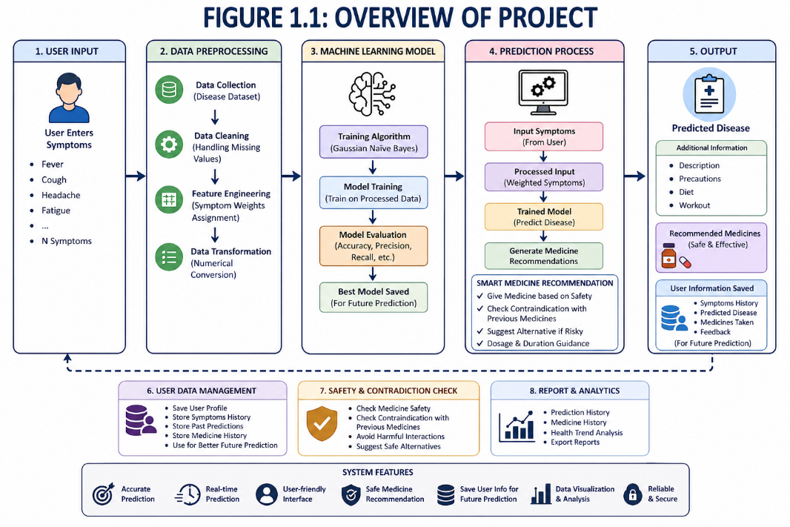

Fig 1.1 overview of project
(Source- open AI)

CHAPTER 2
OBJECTIVES OR PROBLEM STATEMENT

2.1 Introduction

In recent years, the healthcare sector has faced increasing challenges due to the growing number of patients and the limited availability of medical resources. Early disease detection is essential to reduce risks and improve treatment outcomes. However, traditional diagnosis methods are often time-consuming and highly dependent on the availability of medical experts. This chapter focuses on defining the problem addressed in this project, along with the objectives of the proposed system, the constraints involved, and the evaluation criteria used to measure system performance.

2.2 Problem Definition

The primary problem addressed in this project is the development of an intelligent system that can accurately predict diseases based on user-input symptoms. Existing systems suffer from several limitations, including treating all symptoms equally using binary representation, lack of real-time prediction capability, low accuracy due to poor feature representation, absence of symptom severity consideration, and limited accessibility for general users. To overcome these issues, there is a need for a system that incorporates machine learning techniques along with weighted symptom analysis.

2.3 Formal Problem Statement

Given a set of symptoms entered by a user, the system should process and normalize the symptom data, convert symptoms into numerical features using severity weights, and apply a machine learning model to classify the disease. The system should then predict the most probable disease accurately and provide additional information such as precautions and recommendations. It should also suggest safe medicines while checking contraindications and store user data for future predictions. The overall goal is to maximize prediction accuracy while ensuring fast and reliable performance.

2.4 Nature of the Problem

The disease prediction problem has several inherent complexities. Users may not provide all symptoms, leading to incomplete input data, which can negatively affect prediction accuracy. Additionally, the dataset contains a large number of symptoms, increasing dimensionality and making model training more complex. The system is also required to provide real-time responses, which demands efficient algorithms and optimized data processing. Furthermore, different symptoms have varying levels of importance, and treating them equally reduces model effectiveness; therefore, this project addresses the issue using weighted symptom representation.

2.4.1 Incomplete Symptom Data

Not everyone who uses a disease prediction system will know exactly what they are feeling or be able to describe it clearly. People often miss out on mentioning certain symptoms — sometimes because they do not think they are important, and sometimes simply because they have not noticed them yet. This creates a problem because the model receives only a partial picture of what the patient is actually going through. Building a system that can still make a reasonable prediction even when the input is incomplete is one of the more practical challenges this project addresses.

2.4.2 High Dimensional Data

The dataset used in this project includes a very large number of symptoms — far more than what any single disease would typically involve. While having more data is generally a good thing, too many features can actually slow the model down and confuse it. The model may start picking up on patterns that do not really exist, which hurts its ability to make accurate predictions on new inputs. Carefully selecting the most relevant symptoms and reducing unnecessary features was therefore an important part of building this system.

2.4.3 Real-Time Response Requirement

When someone is worried about their health, they do not want to wait. The system needs to take a user's symptoms and return a prediction almost immediately. This means the underlying algorithms have to be fast and efficient — not just accurate. Striking the right balance between speed and reliability was a key consideration when choosing the machine learning models for this project.

2.4.4 Variation in Symptom Severity

Not all symptoms are equal. A high fever means something very different from a mild headache, and treating them the same way during model training would lead to poor predictions. Some symptoms are strong indicators of a particular disease while others are quite common across many conditions. This project tackles that issue by giving different symptoms different weights based on how strongly they are associated with specific diseases, which helps the model make much more meaningful and accurate predictions.

2.5 Objectives of the Proposed System

The primary objectives of the proposed system are to develop a disease prediction system using machine learning, improve prediction accuracy using symptom severity weights, implement Gaussian Naïve Bayes for classification, and provide real-time disease prediction. In addition to these, the secondary objectives include preprocessing and cleaning medical datasets, handling missing values effectively, building a user-friendly interface using Streamlet, recommending safe medicines based on predicted diseases, checking contraindications with previously taken medicines, and storing user history for future predictions.

2.5.1 Primary Objectives

At its heart, this system exists to do one thing well — help people figure out what might be wrong with them based on the symptoms they are experiencing. But doing that well requires more than just running a basic prediction. The system has been built to predict diseases using machine learning in a way that actually makes sense medically, not just statistically. Rather than treating every symptom the same way, it pays more attention to symptoms that are stronger indicators of specific diseases, which makes the predictions far more meaningful. Gaussian Naïve Bayes was chosen as the classification method because it handles this kind of symptom-based data really well and does so quickly — which brings us to another core goal. Nobody wants to wait around when they are worried about their health, so the system is designed to give predictions instantly, the moment a user submits their symptoms.

2.5.2 Secondary Objectives

The secondary objectives are what turn a functional system into a truly helpful one. A lot of work went into cleaning and preparing the medical dataset before it ever touched the model, because even the best algorithm will struggle if the data it learns from is messy or inconsistent. The system was also built with the understanding that real users will not always report every symptom they have — sometimes they forget, sometimes they do not realize something is relevant — so it handles incomplete inputs without falling apart. The interface was kept as simple and clean as possible using Streamlet, because the people who need this kind of tool most are not always the most tech-savvy. Once a disease is predicted, the system does not just stop there — it suggests medicines that are typically used to treat that condition and also checks whether any of them might clash with something the user has taken before. And because health is an ongoing concern rather than a one-time question, the system keeps track of user history so that future predictions can be smarter and more personalized.

2.6 System Constraints
The system operates under several constraints related to data, computation, and time. From a data perspective, the dataset may contain missing or inconsistent values, there may be limited availability of labelled medical data, and there may be variability in symptom naming and representation. From a computational perspective, there may be limited processing power for real-time predictions, memory limitations when handling large datasets, and the need for efficient model training and inference. From a time perspective, the system must provide instant predictions, minimize training time, and maintain low response latency.

2.6.1 Data Constraints

Working with medical data is rarely straightforward. The dataset used in this project is not perfect — some entries have missing values; others contain inconsistencies that had to be carefully cleaned before the model could learn from them. There is also the broader challenge of limited availability of properly labelled medical data, which makes it harder to train a model that generalises well across a wide range of conditions. On top of that, the way symptoms are named and described can vary quite a bit depending on the source, which means the system had to account for different representations of essentially the same symptom to avoid confusing the model.

2.6.2 Computational Constraints

The system was built to run on standard hardware, which means it had to be designed with efficiency in mind from the start. Real-time predictions sound simple, but they require the model to process input and return a result almost instantly — and doing that on limited processing power is not always easy. Handling large datasets also puts pressure on available memory, so the approach to data loading and model training had to be optimised carefully. The algorithms chosen for this project were selected partly because they are lightweight and fast, making them a practical fit for the hardware environment this system runs in.

2.6.3 Time Constraints

From the user's perspective, waiting for a prediction is frustrating — especially when the question involves their health. The system is therefore designed to respond instantly the moment a user submits their symptoms, with response latency kept as low as possible. On the development side, keeping training time short was equally important, since a model that takes too long to train is difficult to iterate on and improve. Balancing speed with accuracy was a constant consideration throughout, and the final design reflects that trade-off as practically as possible.

2.7 Assumptions

The project is based on several assumptions. It assumes that users provide correct and relevant symptoms, the dataset used for training is reliable and properly labelled, and symptom severity values are accurate. It also assumes that the machine learning model generalizes well to new data and that users follow the recommended precautions and medicines responsibly.

2.8 Proposed Solution Overview

The proposed system is a machine learning-based disease prediction system that utilizes weighted symptom analysis. In this system, the user inputs symptoms, after which the data is pre-processed and normalized. The symptoms are then converted into weighted numerical values, and a Gaussian Naïve Bayes model is applied to predict the disease. The system further recommends safe medicines, checks contraindications with previously taken medicines, and stores user data for future predictions. The system includes features such as weighted symptom analysis, real-time prediction, safe medicine recommendation, user data management, and high accuracy and efficiency.

2.9 Evaluation Criteria

The performance of the system is evaluated using multiple metrics. Accuracy is used to measure the overall correctness of predictions, precision evaluates the correctness of positive predictions, recall measures the system’s ability to detect actual cases, and the F1 score provides a balance between precision and recall. Additionally, a confusion matrix is used to provide detailed classification results. Apart from these metrics, the system is also evaluated based on response time, scalability, user experience, and reliability.

CHAPTER 3

LITERATURE REVIEW
3.1 Introduction

This chapter presents a comprehensive review of various techniques used in disease prediction systems, with a focus on methods relevant to the proposed model. It includes traditional approaches, statistical models, machine learning techniques, and advanced artificial intelligence methods. The objective is to analyse their strengths and limitations in order to identify research gaps and justify the selection of algorithms used in this project.

3.2 Traditional Disease Prediction Methods

Traditional disease prediction methods rely on predefined rules and expert knowledge. These systems are simple and easy to implement but lack flexibility and adaptability when dealing with large and complex medical datasets. They treat symptoms in a rigid manner and do not consider their varying importance, which limits their effectiveness in real-world applications.

3.2.1 Rule-Based Systems

Rule-based systems operate using predefined “if-then” rules to diagnose diseases based on symptoms. These systems depend heavily on domain experts for rule creation and updating. Although they are easy to understand and implement, they cannot effectively handle uncertainty, variability, and overlapping symptoms. As a result, their accuracy decreases in complex scenarios, highlighting the need for more advanced approaches such as machine learning.

3.3 Statistical Methods

Statistical methods have been widely used in disease prediction to identify relationships between symptoms and diseases using mathematical models. These approaches provide a strong theoretical foundation and are useful for analysing structured data. However, they often struggle with high-dimensional datasets and non-linear relationships, which are common in healthcare data.

3.3.1 Probabilistic Models

Probabilistic models, such as Gaussian Naïve Bayes, are commonly used for classification tasks in disease prediction. These models apply Bayes’ Theorem to calculate the probability of a disease based on given symptoms. Gaussian Naïve Bayes assumes that features follow a normal distribution and are independent of each other. It is computationally efficient, requires less training time, and performs well even with smaller datasets. However, the assumption of feature independence may not always hold true in real-world medical data.

3.4 Machine Learning Approaches

Machine learning approaches have significantly improved disease prediction systems by enabling models to learn patterns from data. These approaches can handle large datasets and complex relationships between symptoms and diseases, resulting in higher accuracy compared to traditional and statistical methods.

3.4.1 Supervised Learning Models

Supervised learning models are trained using labelled datasets to predict outcomes. Algorithms such as Logistic Regression are widely used due to their simplicity, efficiency, and interpretability. Logistic Regression models the probability of a disease using a sigmoid function and can capture relationships between input features and output classes. In this project, Logistic Regression is used to enhance prediction accuracy and validate the results obtained from other models.

3.4.2 Unsupervised Learning Models

Unsupervised learning models are used to identify hidden patterns and structures in data without labelled outputs. These models are useful for clustering and exploratory analysis. However, they are not directly suitable for disease prediction tasks in this project, which require supervised classification for accurate results.

3.5 Advanced AI Approaches

Advanced artificial intelligence approaches, including deep learning techniques, have shown promising results in healthcare applications. These methods can process large volumes of structured and unstructured data and capture complex patterns. However, they require large datasets, high computational resources, and longer training times, which may not be practical for all systems.

3.5.1 Neural Networks

Neural networks are powerful models inspired by the human brain that consist of multiple layers of interconnected nodes. They are capable of learning complex patterns and achieving high accuracy in prediction tasks. However, due to their high computational cost and requirement for large datasets, they are not selected for this project. Instead, lightweight models such as Gaussian Naïve Bayes and Logistic Regression are preferred for efficiency and real-time performance.

3.6 Challenges Identified from Literature

The literature highlights several challenges in disease prediction systems, including data inconsistency, missing values, high dimensionality, and overlapping symptoms. These issues make it difficult to achieve high accuracy. Another major challenge is the lack of real-time prediction capability in many systems. Additionally, most existing models treat all symptoms equally, which reduces the effectiveness of predictions.

3.7 Research Gap

Despite advancements in machine learning, many existing systems fail to consider the importance or severity of symptoms and rely on binary encoding, where all symptoms are treated equally. Furthermore, many systems either focus on improving accuracy or ensuring speed but fail to achieve both simultaneously. There is also a lack of user-friendly systems that are accessible to a wide range of users.

3.8 Proposed Approach Justification

The proposed system addresses the identified research gaps by combining Gaussian Naïve Bayes and Logistic Regression with a severity-based weighted symptom model. This approach improves feature representation by assigning importance to symptoms, leading to better prediction accuracy. Gaussian Naïve Bayes is used for fast and efficient predictions, while Logistic Regression enhances accuracy and validates results. The combination of these models ensures a balance between speed and accuracy, making the system suitable for real-time and practical healthcare applications.

Parameter | Naïve Bayes | SVM (Support Vector Machine) | Decision Tree | Random Forest | Logistic Regression
Type | Probabilistic | Margin-based classifier | Tree-based model | Ensemble (multiple trees) | Linear classifier
Working Principle | Based on Bayes’ Theorem | Finds optimal hyperplane | Splits data into decision nodes | Combines multiple decision trees | Uses sigmoid function
Accuracy | Good for weighted data | High accuracy | Moderate | High accuracy | High (for linear data)
Training Speed | Very fast | Slow (for large data) | Fast | Moderate | Moderate

Fig 3.1 showing comparisons of algorithm

CHAPTER 4
SYSTEM REQUIREMENTS AND SPECIFICATION

4.1 Introduction

This chapter provides a detailed description of the system requirements and specifications of the proposed disease prediction system. It includes both functional and non-functional requirements, hardware and software needs, system architecture, and data flow. The purpose of this chapter is to define how the system will operate, the resources it requires, and the constraints under which it will function. Proper specification ensures that the system is efficient, scalable, reliable, and capable of delivering accurate predictions in real time.

4.2 System Overview

The proposed system is a web-based machine learning application designed to predict diseases based on user-input symptoms. The system incorporates a severity-based weighted symptom model, which assigns importance to each symptom rather than treating all symptoms equally. Machine learning algorithms such as Gaussian Naïve Bayes and Logistic Regression are used to analyse the processed data and generate predictions.
The system follows a structured workflow that begins with user input, followed by preprocessing, feature transformation, model prediction, and result display. Additionally, the system provides supplementary information such as disease descriptions, precautions, and recommendations to assist users in making informed decisions. The design ensures that the system is interactive, responsive, and accessible to a wide range of users.

4.3 Hardware Requirements

The hardware requirements for the system are minimal, making it suitable for deployment on standard computing devices.

4.3.1 Development Environment

The development environment requires a system with at least 4 GB RAM, a dual-core processor, and sufficient storage capacity. However, for efficient model training and handling large datasets, a system with 8 GB RAM or higher is recommended. The system should also support modern development tools and have stable internet connectivity for downloading libraries and datasets.

4.3.2 Deployment Environment

The deployment environment can be either a local system or a cloud-based platform such as a web server. The system should support multiple concurrent users and provide stable performance under varying loads. Cloud deployment can improve scalability, availability, and accessibility, allowing users to access the system from different devices and locations.

4.4 Software Requirements

The system is developed using a combination of programming languages, libraries, and tools that support machine learning and web application development.

4.4.1 Programming Language

Python is used as the primary programming language due to its simplicity, readability, and extensive support for machine learning and data analysis. It also provides a large ecosystem of libraries and frameworks.

4.4.2 Libraries and Frameworks

The system uses NumPy and Pandas for data manipulation and preprocessing, Scikit-learn for implementing machine learning algorithms such as Gaussian Naïve Bayes and Logistic Regression, and Streamlet for building the web-based user interface. Additional libraries may include Matplotlib and Seaborn for data visualization.

4.4.3 Development Tools

Development tools such as Visual Studio Code and Jupiter Notebook are used for coding, debugging, and testing. These tools provide features like code completion, error detection, and interactive execution, which improve development efficiency.

4.4.4 Platform

The system is designed as a web application that runs on modern web browsers. It can be deployed locally or on cloud platforms, making it platform-independent and easily accessible.

4.5 Functional Requirements

Functional requirements define the core functionalities that the system must perform.

4.5.1 User Input

The system must provide an intuitive interface that allows users to input symptoms easily. It should support multiple symptom selections and ensure that the input process is simple and user-friendly.

4.5.2 Data Processing

The system must preprocess the input data by cleaning, normalizing, and transforming it into a suitable format for model input. This includes handling missing values and converting symptoms into severity-based numerical weights.

4.5.3 Model Training

The system must train machine learning models using historical medical datasets. The training process should include feature selection, model fitting, and evaluation to ensure optimal performance.

4.5.4 Disease Prediction

The system must analyse the processed data and predict the most probable disease using trained machine learning models. The prediction should be accurate and generated in real time.

4.5.5 Result Display

The system must display the prediction results in a clear and understandable format. It should also provide additional information such as disease descriptions, precautions, and possible remedies.

4.6 Non-Functional Requirements

Non-functional requirements define the quality attributes of the system.

4.6.1 Performance

The system must provide fast and efficient predictions with minimal response time. Optimization techniques should be used to ensure real-time performance.

4.6.2 Scalability

The system should be capable of handling an increasing number of users and large datasets without degradation in performance.

4.6.3 Reliability

The system must provide consistent and accurate results under different conditions. It should be robust against errors and failures.

4.6.4 Security

The system must ensure data privacy and protect user information. Secure data handling practices should be followed to prevent unauthorized access.

4.6.5 Usability

The system must have a simple and intuitive user interface that can be easily used by both technical and non-technical users.

4.7 System Requirement Specification

The system requirements specify the expected behaviour and performance of the application. The system must support user interaction, data preprocessing, model execution, and result generation. It should be compatible with different platforms and ensure efficient use of resources. The system must also maintain high standards of accuracy, reliability, and usability.

4.8 System Architecture Description

The system architecture is designed using a layered approach to ensure modularity, scalability, and maintainability.

4.8.1 Data Layer
The data layer is responsible for storing and managing datasets, including training data and user input. It ensures data availability and consistency.

4.8.2 Processing Layer

The processing layer performs data preprocessing tasks such as cleaning, normalization, and feature engineering. It converts raw input into a structured format suitable for model input.

4.8.3 Model Layer

The model layer contains machine learning algorithms such as Gaussian Naïve Bayes and Logistic Regression. It is responsible for training, prediction, and evaluation of the model.

4.8.4 Application Layer

The application layer provides the user interface and handles user interactions. It integrates all system components and ensures smooth communication between layers.

4.9 Data Flow Description

The data flow begins when the user inputs symptoms through the application interface. The input data is passed to the processing layer, where it is cleaned, normalized, and converted into severity-based numerical features. The processed data is then sent to the model layer, where the trained machine learning model predicts the most probable disease. Finally, the results are displayed to the user along with additional information such as precautions, descriptions, and recommendations. The entire process is designed to be fast, efficient, and user-friendly.
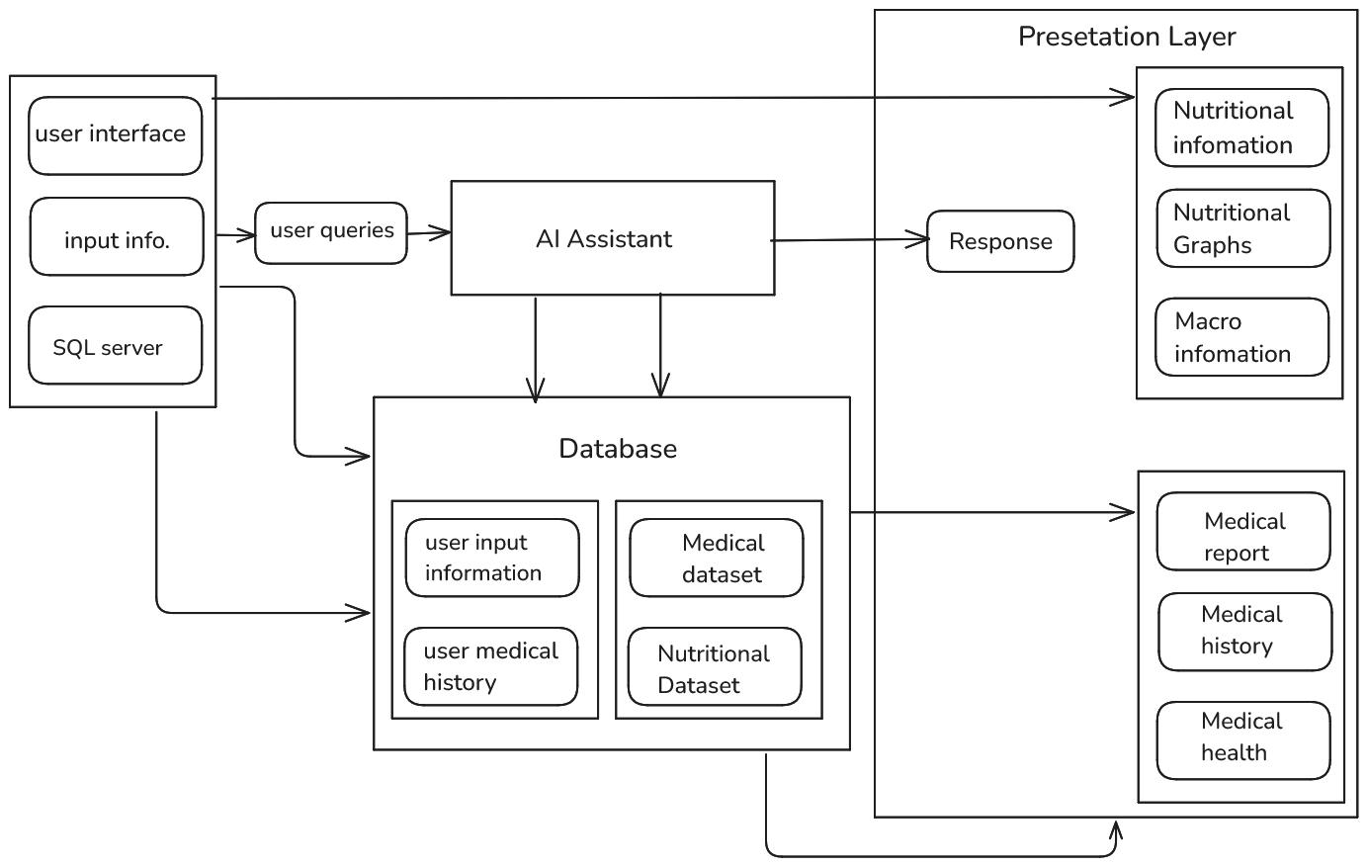
FIG 4.1 Representation of system architecture
(source – open AI)

CHAPTER 5
PROJECT METHODOLOGY AND DESIGN
5.1 Introduction
This chapter describes the methodology and design of the proposed disease prediction system. It explains how data is collected, processed, transformed, and used for training machine learning models. The chapter also highlights feature engineering techniques, handling of data issues, and the strategy used for training and evaluating multiple machine learning algorithms to ensure accuracy and efficiency.
5.2 Overall System Workflow
The system follows a structured workflow that begins with user input and ends with result generation. Initially, the user provides symptoms through the interface. The input data is pre-processed and converted into numerical values using severity-based weighting. The processed data is then passed to trained machine learning models including Naïve Bayes, Logistic Regression, SVM, Decision Tree, and Random Forest. These models analyse the input and predict the most probable disease. Finally, the results are displayed along with additional information such as precautions and recommendations.
5.3 Data Collection
The dataset used in this project is collected from publicly available medical datasets and online sources. It contains information about symptoms and their corresponding diseases. The dataset is structured in a tabular format where each row represents a disease and each column represents a symptom. The data is carefully selected to ensure relevance and reliability.
5.4 Data Preprocessing

Data preprocessing is an essential step that ensures the dataset is clean, consistent, and suitable for machine learning.

5.4.1 Handling Missing Values

Missing values are handled by either filling them with appropriate default values or removing incomplete records. This ensures that the dataset remains consistent and does not negatively impact model performance.

5.4.2 Data Cleaning

Data cleaning involves removing duplicate entries, correcting inconsistencies, and standardizing symptom names. This step ensures uniformity across the dataset.
5.4.3 Normalization

Normalization is applied to scale numerical values to a standard range. This improves the performance of algorithms such as Logistic Regression and SVM, which are sensitive to feature scaling.
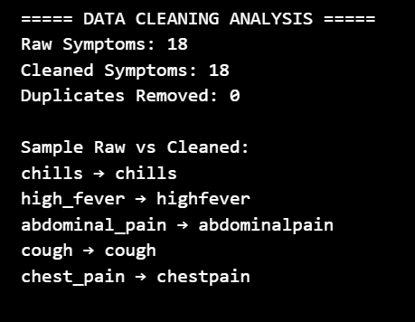
Fig5.1 showing data cleaning
(source- model trained result)

5.5 Feature Engineering
Feature engineering is performed by assigning severity-based weights to symptoms instead of using simple binary values. This approach improves the representation of features and helps the model understand the importance of different symptoms, leading to better prediction accuracy.
5.6 Handling Data Issues
Various data-related issues such as imbalance, noise, and inconsistencies are addressed using preprocessing techniques. Proper handling of these issues ensures better generalization and reduces errors in prediction.
5.7 Model Training Strategy
The dataset is divided into training and testing sets. Multiple machine learning models are trained using the training data. Cross-validation techniques are used to improve generalization and avoid overfitting. Hyperparameter tuning is performed where necessary to optimize model performance.
5.8 Algorithms Used
5.8.1 Gaussian Naïve Bayes
Gaussian Naïve Bayes is a probabilistic classifier based on Bayes’ Theorem. It assumes that features follow a Gaussian distribution and are independent. It is fast, efficient, and suitable for real-time predictions.
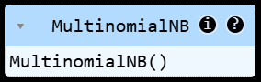
Fig5.2 showing algorithm in which model is trained
5.8.2 Logistic Regression

Logistic Regression is a supervised learning algorithm that models the probability of a disease using a sigmoid function. It is effective for structured data and provides good accuracy.
5.8.3 Support Vector Machine (SVM)

Support Vector Machine is a powerful classification algorithm that finds the optimal hyperplane to separate data into different classes. It performs well with complex and non-linear data.

5.8.4 Decision Tree

Decision Tree is a tree-based model that splits data into nodes based on feature values. It is easy to interpret but may suffer from overfitting.

5.8.5 Random Forest
Random Forest is an ensemble learning method that combines multiple decision trees to improve accuracy and reduce overfitting. It provides robust performance for complex datasets.
5.9 Model Evaluation Strategy
The performance of all algorithms is evaluated using metrics such as accuracy, precision, recall, and F1-score. The models are compared based on their prediction accuracy, computational efficiency, and generalization ability. The best-performing model is selected for deployment.
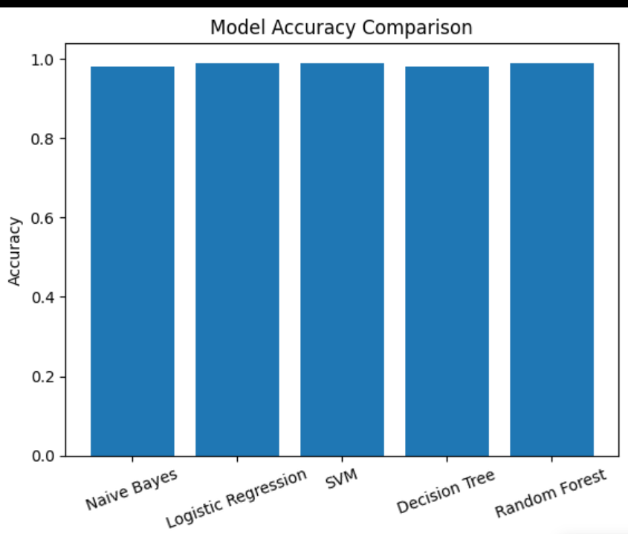
FIG 5.3 SHOWING VISUAL REPRESNTATION OF COMPARISION
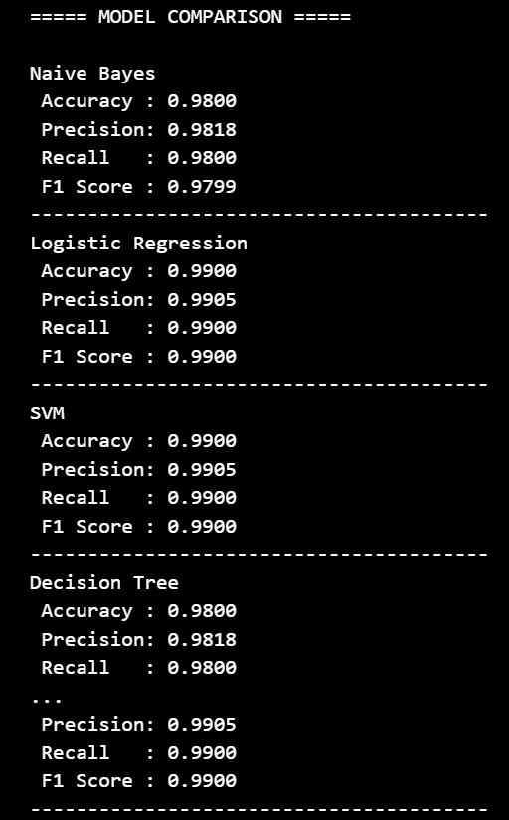
Fig 5.4 showing different result of different model trained

CHAPTER 6

IMPLEMENTATION

6.1 Introduction
This chapter describes the practical implementation of the proposed disease prediction system. It explains how the system is developed using various tools, technologies, and machine learning techniques. The implementation phase focuses on converting the designed methodology into a working application.
The chapter covers important aspects such as the development environment, tools and libraries used, dataset loading and exploration, data preprocessing techniques, and model implementation. Multiple machine learning algorithms, including Gaussian Naïve Bayes, Logistic Regression, Support Vector Machine (SVM), Decision Tree, and Random Forest, are implemented and evaluated to achieve accurate predictions.
Additionally, this chapter describes how the trained models are saved and integrated into a web-based application using Streamlet. The user interface is designed to allow users to input symptoms easily and receive real-time disease predictions along with relevant information.
Overall, this chapter provides a step-by-step explanation of how the system is built, tested, and deployed, ensuring that the final application is efficient, user-friendly, and capable of delivering reliable results.
6.2 Development Environment
Building this system required the right set of tools and libraries — ones that could handle everything from raw data processing to a live web interface. The choices made here were not arbitrary; each tool was picked because it genuinely made the development process smoother and the final product better.
6.2.1 Tools Used
The system is developed using a combination of modern development tools that support coding, testing, and deployment. Visual Studio Code is used as the primary code editor due to its lightweight nature, powerful extensions, and debugging capabilities. Jupiter Notebook is utilized for data analysis, experimentation, and model training, as it allows interactive execution of code and easy visualization of results.
In addition, SQL is used for managing and querying structured data, enabling efficient storage and retrieval of datasets. Streamlet is used for developing the web-based user interface, providing an interactive and user-friendly platform for users to input symptoms and view prediction results in real time.

6.2.2 Libraries Used

The project uses multiple Python libraries to support data processing, machine learning, visualization, and application development. NumPy is used for numerical computations and handling arrays, while Pandas is used for data manipulation, cleaning, and analysis of datasets.
Scikit-learn is used for implementing machine learning algorithms such as Gaussian Naïve Bayes, Logistic Regression, Support Vector Machine (SVM), Decision Tree, and Random Forest, as well as for model evaluation and preprocessing techniques.
Matplotlib and Seaborn are used for data visualization and graphical representation of model performance and dataset distribution.
Jabil and Pickle are used for saving and loading trained machine learning models, enabling reuse without retraining.
Streamlet is used to build the web-based user interface, allowing users to input symptoms and receive real-time predictions.
Additionally, libraries such as OS are used for file handling operations, warnings are used to suppress unnecessary runtime warnings, and re (regular expressions) may be used for text processing if required.
6.3 Dataset Loading and Exploration

The dataset used in this project is composed of multiple structured files rather than a single dataset. These files include symptom severity data, disease descriptions, precaution information, and encoded symptom lists. The datasets are loaded using the Pandas library for CSV files and Job lib for serialized files such as trained models and encoders.
The symptom severity dataset contains symptoms along with their corresponding weights, which represent the importance of each symptom. These weights are used to transform user-input symptoms into numerical values. The symptom description dataset provides detailed information about each disease, while the precaution dataset includes recommended preventive measures.
Additionally, pre-processed files such as the symptom list and label encoder are loaded to ensure consistency between training and prediction phases. The symptom list defines all possible input features, while the label encoder maps predicted numerical outputs to actual disease names.
During dataset exploration, the structure and content of each dataset are analysed to ensure consistency and correctness. Operations such as checking column names, verifying data types, and identifying missing or inconsistent values are performed. The symptom severity data is further processed to create a dictionary that maps each symptom to its corresponding weight. This multi-dataset approach allows the system to integrate prediction, explanation, and precaution modules effectively, resulting in a more comprehensive and intelligent healthcare prediction system.
6.4 Data Preprocessing Implementation

Data preprocessing is a crucial step in the implementation of the disease prediction system, as it ensures that raw input data is converted into a structured format suitable for machine learning models. In this project, preprocessing is implemented using Python libraries such as Pandas, NumPy, and regular expressions.
Initially, the datasets are cleaned by removing inconsistencies, handling missing values, and standardizing symptom names. Since symptom data may contain variations in formatting, a normalization function is applied to convert all symptom names into a consistent lowercase alphanumeric format by removing spaces and special characters. This ensures uniformity between user input and dataset features.
A key preprocessing step in this system is the transformation of symptoms into severity-based numerical values. Instead of using binary encoding, each symptom is assigned a weight based on its importance using the symptom severity dataset. A dictionary is created to map each symptom to its corresponding severity value, which is then used during prediction.
The user-input symptoms are processed and converted into a fixed-length feature vector based on the predefined list of all symptoms. For each symptom present in the input, the corresponding index in the vector is assigned its severity weight, while all other values remain zero. This results in a structured numerical representation suitable for machine learning models.
Additionally, missing values in datasets are handled appropriately to ensure consistency, and unnecessary or irrelevant data is removed. These preprocessing steps collectively improve the quality of input data, enhance model performance, and ensure accurate and reliable disease prediction.

6.5 Model Implementation
Machine learning models are implemented using the Scikit-learn library to perform disease prediction based on symptom data. In this project, multiple algorithms including Gaussian Naïve Bayes, Logistic Regression, Support Vector Machine (SVM), Decision Tree, and Random Forest are trained and evaluated to compare their performance.
Initially, the pre-processed dataset is divided into training and testing sets. Each model is trained using the training data, where symptoms are represented as numerical feature vectors based on severity weights. The models learn the relationship between symptom patterns and corresponding diseases during this phase.
Among all the implemented models, Gaussian Naïve Bayes is selected as the primary model for deployment due to its fast computation and efficient performance with continuous input data. The trained Naïve Bayes model is saved and later loaded in the application for real-time prediction.
Other models such as Logistic Regression, SVM, Decision Tree, and Random Forest are used for performance comparison and validation. These models help in analysing accuracy, precision, and overall effectiveness of different approaches. Although some models provide higher accuracy, they require more computational resources and are less efficient for real-time predictions.
Hyperparameter tuning is performed where necessary to improve model performance and avoid overfitting. The final selected model is integrated into the system to provide fast, accurate, and reliable disease predictions.
6.6 Model Saving
After training the machine learning models, the final selected model is saved to avoid retraining every time the application runs. In this project, the Gaussian Naïve Bayes model is saved using the Joblib library in a serialized file format (.pkl). This allows the model to be stored efficiently and loaded quickly during runtime.
Along with the trained model, additional components such as the label encoder and symptom list are also saved as serialized files. These components are essential for maintaining consistency between the training and prediction phases. The label encoder is used to convert numerical predictions back into disease names, while the symptom list ensures that the input feature vector is correctly aligned with the model.
During the deployment phase, these saved files are loaded using Joblib, enabling the system to perform real-time predictions without the need for retraining. This approach improves system performance, reduces computation time, and ensures efficient utilization of resources.

6.7 Streamlit Application
The front-end of the proposed disease prediction system is developed using the Streamlit framework, which enables the creation of interactive and user-friendly web applications using Python. The Streamlit application acts as the interface between the user and the machine learning model, allowing seamless interaction and real-time prediction.
The application integrates multiple components, including user input, preprocessing, model prediction, and result display. It is designed to be simple, efficient, and accessible, ensuring that even non-technical users can easily interact with the system.

6.7.1 UI Design

The user interface is designed to provide a clean, intuitive, and interactive experience. It allows users to input symptoms easily through selection options such as dropdown menus or multi-select lists. The design focuses on simplicity and clarity, ensuring that users can navigate the system without any difficulty.
The interface includes input fields for selecting symptoms, buttons to trigger prediction, and sections to display results. Proper labeling and layout are used to enhance usability. The use of Streamlit enables dynamic updates, meaning that results are displayed instantly without requiring page reloads.
Additionally, the interface may include headings, instructions, and organized sections to guide users through the prediction process. This improves user engagement and ensures a smooth interaction with the system.

6.7.2 Prediction Flow

The prediction flow in the Streamlit application follows a structured sequence of steps. Initially, the user selects or inputs symptoms through the interface. These symptoms are then passed to the preprocessing module, where they are normalized and converted into a numerical feature vector using severity-based weighting.
The processed input is then fed into the trained machine learning model (Gaussian Naïve Bayes), which generates the predicted disease along with probability scores. The prediction is performed in real time to ensure quick response.
Finally, the results are displayed on the interface, including the predicted disease, its probability, and additional information such as description and precautions. This entire process is executed seamlessly, providing users with instant and meaningful insights.

User Input (Symptoms)
↓
Preprocessing (Normalization + Severity Weights)
↓
Feature Vector Creation
↓
Model Prediction (Naïve Bayes)
↓
Result Display (Disease + Info)

Fig6.1 showing the flow of prediction process

6.7.3 Database Integration

The system incorporates a relational database to store and manage user data efficiently. The database is used to maintain user authentication details, previous medical feedback, and prediction history. This enables personalized recommendations and ensures data persistence across sessions.
The database consists of three main tables:
- Users Table: Stores user credentials such as name, email, and password.
- Feedback Table: Stores user’s previous disease and medicines.
- Predictions Table: Stores prediction results including symptoms, predicted disease, and suggested medicines.
Structured Query Language (SQL) is used to perform database operations such as inserting, retrieving, and managing records.

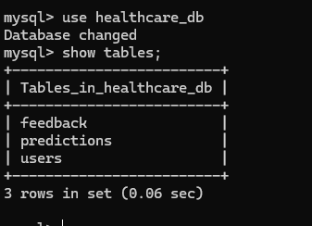
Fig 6.2 showing how data is stored

CHAPTER 7
RESULTS AND ANALYSIS

7.1 Introduction
This chapter presents the results obtained from the implementation of the disease prediction system and provides a detailed analysis of the performance of different machine learning models. The primary objective of this chapter is to evaluate how effectively the system predicts diseases based on user-input symptoms.
Multiple machine learning algorithms, including Gaussian Naïve Bayes, Logistic Regression, Support Vector Machine (SVM), Decision Tree, and Random Forest, are implemented and tested using the prepared dataset. The performance of these models is analyzed using standard evaluation metrics such as accuracy, precision, recall, and F1-score.
The chapter also focuses on comparing the performance of these algorithms to identify the most suitable model for the system. In addition, the impact of severity-based feature engineering on prediction accuracy is analyzed. Visualization techniques such as graphs and charts are used to better understand model behavior and performance differences.
Overall, this chapter highlights the effectiveness, strengths, and limitations of the implemented models and provides insights into the final model selection for real-time disease prediction.
7.2 Evaluation Metrics
To evaluate the performance of the disease prediction system, standard classification metrics are used. These metrics help in measuring how accurately and effectively the machine learning models predict diseases based on input symptoms. The main evaluation metrics used in this project are accuracy, precision, recall, and F1-score.
7.2.1 Accuracy
Accuracy measures the overall correctness of the model by calculating the proportion of correctly predicted instances out of the total number of predictions.

$$Accuracy=\frac{TP+TN}{TP+TN+FP+FN}$$
EQ 7.1 Accuracy formula
Where:
TP (True Positive) = Correctly predicted positive cases
TN (True Negative) = Correctly predicted negative cases
FP (False Positive) = Incorrectly predicted positive cases
FN (False Negative) = Incorrectly predicted negative cases
A higher accuracy indicates better overall model performance, but it may not be sufficient for imbalanced datasets.
7.2.2 Precision
Precision measures how many of the predicted positive cases are actually correct.
$$Precision=\frac{TP}{TP+FP}$$
EQ 7.2 precision formula
A high precision value indicates a low false positive rate and reliable predictions.
7.2.3 Recall
Recall measures the ability of the model to correctly identify actual positive cases.
$$Recall=\frac{TP}{TP+FN}$$
EQ 7.3 Recall formula
A high recall value means the model successfully identifies most of the actual positive cases.
7.2.4 F1-Score
F1-score is the harmonic mean of precision and recall. It provides a balanced measure of the model’s performance, especially when there is an imbalance between classes.
$$F1=2×\frac{Precision×Recall}{Precision+Recall}$$
EQ 7.4 F1-Score formula
The F1-score is useful when both precision and recall are important, as it balances false positives and false negatives.

7.3 Model Performance Results
The performance of all implemented machine learning models, including Gaussian Naïve Bayes, Logistic Regression, Support Vector Machine (SVM), Decision Tree, and Random Forest, is evaluated and compared using standard metrics such as accuracy, precision, recall, and F1-score.
The results indicate that Random Forest and SVM achieve the highest accuracy among all models due to their ability to handle complex and non-linear relationships in the dataset. Logistic Regression also performs well and provides stable and interpretable results for structured data. Gaussian Naïve Bayes, although slightly lower in accuracy compared to ensemble methods, provides very fast predictions and performs efficiently with severity-based continuous features. Decision Tree offers good interpretability but shows signs of overfitting, which affects its generalization performance.
Despite Random Forest achieving the highest numerical accuracy, Gaussian Naïve Bayes is selected for deployment due to its low computational cost, faster prediction time, and suitability for real-time applications. The comparison highlights the trade-off between accuracy and efficiency, which is critical in healthcare systems.

7.4 Visualization Analysis
Visualization techniques are used to better understand model performance and dataset characteristics. Graphs such as accuracy comparison charts, confusion matrices, and bar plots are generated using visualization libraries like Matplotlib and Seaborn.
These visualizations help in comparing the performance of different algorithms and identifying patterns in prediction results. For example, accuracy comparison graphs clearly show the performance differences between models, while confusion matrices provide insights into correct and incorrect classifications. Visualization also helps in understanding how severity-based feature engineering improves prediction accuracy.

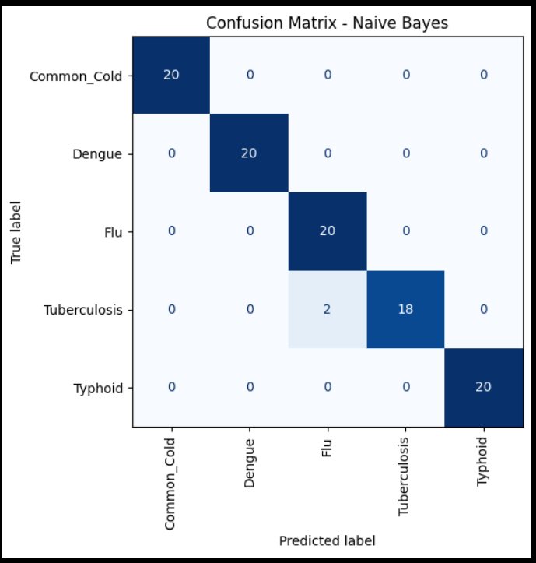
Fig 7.1 showing where the model is getting prediction right and wrong
7.5 Error Analysis
Error analysis is performed to identify the reasons behind incorrect predictions and to understand the limitations of the models. Misclassifications often occur due to overlapping symptoms among different diseases, insufficient training data, or similarities in symptom patterns.
Some models, such as Decision Trees, tend to overfit the training data, leading to poor performance on unseen data. Models like Naïve Bayes may produce errors due to the assumption of feature independence. Additionally, incorrect or incomplete user input can also affect prediction accuracy.
By analyzing these errors, improvements can be made in data preprocessing, feature engineering, and model selection to enhance overall system performance.

7.6 Key Observations
The analysis reveals that different machine learning models have varying strengths and limitations. Random Forest and SVM provide high accuracy but require more computational resources. Logistic Regression offers a good balance between accuracy and interpretability. Gaussian Naïve Bayes is highly efficient and suitable for real-time predictions, making it ideal for deployment.
Decision Tree is simple and easy to interpret but less stable due to overfitting. The use of severity-based feature engineering significantly improves model performance by providing better representation of symptom importance.
Overall, the combination and comparison of multiple algorithms help in selecting the most efficient and practical solution for the disease prediction system.

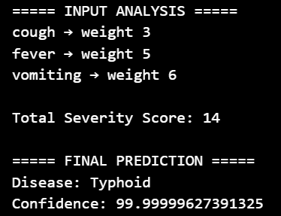

FIG 7.1 SHOWING EXAMPLE OF RESULTS

CHAPTER 8
CONCLUSION AND FUTURE SCOPE

8.1 Conclusion
The project successfully develops an AI and machine learning-based disease prediction system that provides accurate and real-time predictions based on user-input symptoms. The system effectively integrates multiple machine learning algorithms, including Gaussian Naïve Bayes, Logistic Regression, Support Vector Machine (SVM), Decision Tree, and Random Forest, to analyze and compare performance.
A key contribution of this project is the implementation of severity-based feature engineering, where symptoms are assigned weights based on their importance. This approach significantly improves prediction accuracy compared to traditional binary encoding methods. The use of Gaussian Naïve Bayes as the final deployed model ensures fast computation and efficient real-time prediction, making the system suitable for practical healthcare applications.
The system is further enhanced by a user-friendly web interface developed using Streamlit, allowing users to easily input symptoms and receive instant predictions along with additional information such as disease descriptions and precautions. The integration of multiple datasets, preprocessing techniques, and model evaluation strategies ensures that the system is reliable, efficient, and scalable.
Overall, the project demonstrates the potential of machine learning in healthcare by providing an intelligent decision-support system that assists users in early disease detection and awareness. It serves as a step toward developing smarter and more accessible healthcare solutions.
8.2 Key Achievements
The project achieves several important milestones in the development of an intelligent disease prediction system. One of the key achievements is the successful implementation of multiple machine learning algorithms, including Gaussian Naïve Bayes, Logistic Regression, Support Vector Machine (SVM), Decision Tree, and Random Forest, allowing effective comparison and selection of the most suitable model.
Another major achievement is the introduction of severity-based feature engineering, where symptoms are assigned different weights based on their importance. This approach enhances the representation of input data and improves prediction accuracy compared to traditional binary encoding methods.
The system is capable of providing accurate and real-time predictions with low computational cost, making it efficient for practical use. The use of Gaussian Naïve Bayes ensures fast processing, while other models contribute to performance evaluation and validation.
A user-friendly web interface is successfully developed using Streamlit, enabling users to input symptoms easily and receive instant results along with additional information such as disease descriptions and precautions. This improves accessibility and usability for non-technical users.
Additionally, the system integrates multiple datasets, including symptom severity, disease descriptions, and precaution information, making it a comprehensive healthcare assistance tool. The implementation of model saving and loading techniques further enhances system efficiency by avoiding repeated training.
Overall, the project demonstrates a complete end-to-end machine learning pipeline, from data preprocessing and model training to deployment and user interaction, achieving both technical and practical objectives.
8.3 Limitations of the System
Although the proposed disease prediction system provides accurate and efficient results, it has certain limitations that must be considered. One of the primary limitations is that the system heavily depends on the quality and completeness of the dataset. If the dataset contains missing values, noise, or biased information, it can affect the accuracy of predictions.
The system may not perform well for rare or uncommon diseases due to limited training data. Machine learning models tend to perform better on frequently occurring diseases, while rare conditions may be misclassified or not predicted accurately.
Another limitation is that the system relies only on symptom-based input and does not consider other important medical factors such as patient history, laboratory test results, or genetic information. This can restrict the depth and reliability of the prediction.
The assumption of feature independence in Gaussian Naïve Bayes may also reduce accuracy in cases where symptoms are highly correlated. Additionally, models like Decision Tree may suffer from overfitting, and more complex models such as SVM and Random Forest require higher computational resources.
The system also depends on user input accuracy. Incorrect or incomplete symptom input can lead to inaccurate predictions. Furthermore, the system provides only preliminary guidance and cannot replace professional medical diagnosis or consultation.
Overall, while the system is useful as a decision-support tool, it should be used with caution and in combination with expert medical advice.
8.4 Future Scope
The proposed disease prediction system provides a strong foundation for further improvements and enhancements. Several advanced features and technologies can be integrated in the future to improve accuracy, usability, and real-world applicability.
8.4.1 Advanced ML Models
Future improvements can include the use of advanced machine learning and deep learning models such as neural networks, ensemble learning techniques, and hybrid models. These models can capture more complex patterns in healthcare data and further improve prediction accuracy. Techniques such as deep learning and transfer learning can also be explored for handling large-scale medical datasets and improving generalization.
8.4.2 Real-Time Health Data
The system can be enhanced by integrating real-time health data from wearable devices such as smartwatches and fitness trackers. This would allow continuous monitoring of vital parameters such as heart rate, temperature, and activity levels. Real-time data integration can improve prediction accuracy and enable early detection of diseases
.8.4.3 Mobile Application
Developing a mobile application for the system can significantly improve accessibility and usability. A mobile-based platform would allow users to access the system anytime and anywhere, making it more practical for everyday use. Integration with cloud services can further enhance scalability and real-time performance.
8.4.4 Integration with Healthcare Systems
The system can be integrated with hospital management systems and electronic health records (EHR) to provide more personalized and accurate predictions. This would allow the system to consider patient history and clinical data for better decision-making.

8.4.5 Personalized Healthcare
Future versions of the system can include personalized recommendations based on user history, lifestyle, and medical background. This can improve the effectiveness of predictions and provide more tailored healthcare solutions.
8.5 Final Remarks
The project demonstrates the effectiveness of machine learning in healthcare applications by developing an intelligent disease prediction system that provides accurate and real-time results. The integration of severity-based feature engineering, multiple machine learning algorithms, and a user-friendly interface ensures that the system is both efficient and practical.
The system successfully combines data preprocessing, model training, evaluation, and deployment into a complete end-to-end solution. It highlights the importance of balancing accuracy, computational efficiency, and usability in real-world applications.
Although the system has certain limitations, it provides a strong foundation for future enhancements and research. With further improvements and integration of advanced technologies, the system can evolve into a comprehensive healthcare assistant capable of supporting medical professionals and users in decision-making.

REFERENCES

1) F. Pedregosa et al., “Scikit-learn: Machine Learning in Python,”
Journal of Machine Learning Research, vol. 12, pp. 2825–2830, 2011.
This library was used to implement classification algorithms such as Naïve Bayes and Logistic Regression.

2) T. M. Mitchell, “Machine Learning,” McGraw-Hill, 1997.
Provides fundamental concepts of machine learning used in disease prediction.

3) Aurélien Géron, “Hands-On Machine Learning with Scikit-Learn, Keras, and TensorFlow,”
O’Reilly Media, 2019.
Helpful for practical implementation of ML models and preprocessing techniques.

4) World Health Organization (WHO), “Artificial Intelligence in Healthcare,”
Available: https://www.who.int
Used to understand the importance of AI in modern healthcare systems.

5) Jason Brownlee, “Naive Bayes for Machine Learning,” Machine Learning Mastery, 2020.
Used for understanding probabilistic classification and model behavior.

6) Kaggle, “Healthcare and Symptom-Based Datasets,”
Available: https://www.kaggle.com
Used as a reference for dataset structure including symptoms and diseases.

7) Scikit-learn Documentation, “Naïve Bayes Algorithms,”
Available: https://scikit-learn.org
Used for implementation and understanding of Gaussian Naïve Bayes.

8) Python Software Foundation, “Python Documentation,”
Available: https://www.python.org
Used for development of the system.

9) Pandas Development Team, “Pandas Documentation,”
Available: https://pandas.pydata.org
Used for data preprocessing and dataset handling.

10) NumPy Developers, “NumPy Documentation,”
Available: https://numpy.org
Used for numerical computations and feature vector creation.

11) Streamlit Documentation, “Streamlit Web Framework,”
Available: https://streamlit.io
Used to develop the user interface of the application.

12) MySQL Documentation, “MySQL Database System,”
Available: https://dev.mysql.com
Used for storing user data and prediction history.

13) Han, Kamber, and Pei, “Data Mining: Concepts and Techniques,”
Morgan Kaufmann, 2012.
Used for understanding preprocessing, feature engineering, and data mining concepts.

14) Russell & Norvig, “Artificial Intelligence: A Modern Approach,”
Pearson, 2021.
Provides theoretical background for intelligent systems and AI applications.

APPENDIX A

A.1 Required Libraries

import streamlit as st
import sqlite3
import joblib
import numpy as np
import pandas as pd
from difflib import get_close_matches

A.2 UI Configuration and Styling

st.set_page_config(page_title="Healthcare AI", layout="wide")
st.markdown("""
<style>
[data-testid="stAppViewContainer"] {
background: linear-gradient(135deg, #0f2027, #203a43, #2c5364);
color: white;
}
</style>
""", unsafe_allow_html=True)

A.3 Database Initialization

conn = sqlite3.connect("healthcare.db", check_same_thread=False)
cur = conn.cursor()
Tables:
- Users
- Feedback
- History

A.4 Model Loading

model = joblib.load("naive_bayes_model.pkl")
le = joblib.load("label_encoder.pkl")
all_symptoms = joblib.load("symptoms_list.pkl")

A.5 Dataset Loading
medicine_df = pd.read_csv("medicine.csv")
precaution_df = pd.read_csv("datasets/symptom_precaution.csv")
interaction_df = pd.read_csv("datasets/db_drug_interactions.csv")

A.6 Session Management
if "user" not in st.session_state:
st.session_state.user = None

A.7 Prediction Algorithm

def predict(symptoms):
vec = [0]*len(all_symptoms)
for i, s in enumerate(all_symptoms):
if s in symptoms:
vec[i] = 1
probs = model.predict_proba([vec])[0]
idx = np.argmax(probs)
return le.classes_[idx], probs[idx]

A.8 Medicine Recommendation Module

def get_medicine(disease):
match = get_close_matches(disease.lower(), medicine_df["disease"].unique(), n=1, cutoff=0.5)
if match:
return medicine_df[medicine_df["disease"] == match[0]]
return pd.DataFrame()

A.9 Precaution Module

def get_precautions(disease):
match = get_close_matches(disease.lower(), precaution_df["disease"].unique(), n=1, cutoff=0.5)
if match:
row = precaution_df[precaution_df["disease"] == match[0]].iloc[0]
return [row[c] for c in precaution_df.columns if "precaution" in c]
return []

A.10 Drug Interaction Detection

def check_interactions(predicted_meds, current_meds):
warnings = []
for m in predicted_meds:
for c in current_meds:
match = interaction_df[
((interaction_df["drug1"] == m.lower()) & (interaction_df["drug2"] == c.lower())) |
((interaction_df["drug1"] == c.lower()) & (interaction_df["drug2"] == m.lower()))
]
if not match.empty:
warnings.append(match.iloc[0]["interaction"])
return warnings

A.11 User Authentication System

if not st.session_state.user:
menu = st.sidebar.selectbox("Menu", ["Login", "Signup"])

A.12 Sidebar Navigation System

menu = st.sidebar.selectbox("Menu", ["Home", "History", "Logout"])

A.13 Prediction Workflow
symptoms = st.multiselect("Select Symptoms", all_symptoms)
if st.button("Predict"):
disease, conf = predict(symptoms)

A.14 Medicine Filtering Logic

unique_meds = meds_df["medicine"].dropna().unique()
filtered = [m for m in unique_meds if "/" not in str(m)]
top_meds = filtered[:5]

A.15 Feedback System
INSERT INTO feedback(user_id, disease, medicines)

A.16 History Storage

INSERT INTO history(user_id, symptoms, disease, medicines)

A.17 History Display

SELECT symptoms, disease, medicines, created_at

A.18 Safety & Warning Module

st.warning("⚠️ Dosage may vary. Please consult a doctor")

A.19 Advice System

if conf > 0.8:
st.success("Follow medicines properly")
elif conf > 0.5:
st.warning("Monitor condition")
else:
st.error("Consult doctor")

