AI-Driven Healthcare Management and Disease Prediction System Using Hybrid Machine Learning.
Priyansu Dhami
Dept. of Computer Science and Engineering
Graphic Era Hill University
Dehradun, India

Abstract— Disease detection in its early stage is among the most important issues in today's healthcare systems because any delay in diagnosing may result in complications, expensive treatment, and low rates of recovery. In some places, there are no doctors available nearby to provide immediate assistance, thus creating a need for advanced technology to give preliminary health care instructions. Artificial Intelligence (AI) and Machine Learning (ML) have proven their worth in handling big data sets in a reasonable period and aiding decision-making.
This research paper presents an AI and ML Powered Healthcare Management and Disease Prediction System that aims at predicting probable diseases depending on symptoms entered by the users through the web interface. While conventional disease prediction software considers symptoms with equal significance through binary encoding, the new algorithm takes into account the weight of every symptom considering its severity, frequency, and medical relevance. By assigning different weights, the algorithm gives more attention to serious symptoms such as chest pain, respiratory problems, and high fever than minor symptoms like headaches or tiredness.
The proposed algorithm uses a hybrid machine learning system that integrates Naïve Bayes' probabilistic learning and weighted symptom ranking to produce reliable and meaningful outputs. The program does not provide only one prediction; rather, it gives the top K number of diseases along with a probability value. Apart from predicting disease, the system also includes the medicine recommendation module that recommends medications by cross-matching the disease from the disease dataset with the drugs database. Furthermore, the algorithm also includes a drug interaction safety validation module to check whether the medicines recommended interact harmfully with each other.
Moreover, to increase the long-term usability of the system, patient history, medicine consumption, symptom input, and diagnoses are stored in the MySQL server. The entire project is implemented using the Flask framework and can be accessed by patients through a healthcare portal to get predictions on time.
The experimental analysis and comparison with traditional models like the random forest model reveal that while conventional algorithms achieve high numerical precision, the proposed algorithm achieves practical relevancy and good symptom-sensitive prediction. The developed system can be used as an intelligent healthcare assistant for preventive diagnostics and consultation purposes. In the future, the application can also be integrated with wearables, mobile health-care applications, hospital information systems, and personalized treatment recommendation engine.

Keywords— : Healthcare AI, Disease Prediction, Naïve Bayes, Symptom Weighting, Machine Learning, Medicine Recommendation, Flask, MySQL.

I. Introduction
Healthcare is undoubtedly one of the key pillars of human society. Its effectiveness influences human life expectancy and quality of living. Early identification and treatment of diseases prevent complications and minimize expenditures on treatments. Nevertheless, people neglect visiting specialists due to different reasons such as insufficient knowledge or absence of medical facilities and health professionals, long queues, financial difficulties, etc. These problems are especially evident in developing countries like India where access to healthcare is still rather challenging in rural or semi-urban areas.
With the development of digital technology, AI and ML have become very efficient in analyzing large databases, detecting concealed patterns, and helping make decisions quicker. Machine learning is extremely effective for predictive modeling when it learns relationships between the input variables and targets. Although such models cannot completely replace a specialist, they can serve as supportive tools for patients or healthcare professionals.
Diagnosis of the disease in traditional healthcare system is based on the skills and experience of a doctor, patient's examination, and tests. Though it is necessary, sometimes it takes time, and a patient may not visit his/her physician. It is typical that people first look for advice online, and, if the symptom gets worse, start searching for information about it. This is why there is currently an increased demand for the development of smart healthcare assistants that would recommend patients to seek consultation.
There are many research papers proposing different machine learning solutions for healthcare diagnostics. For example, several scientists have implemented disease prediction using machine learning techniques such as Random Forest, Support Vector Machine, Logistic Regression, Decision Tree, Naïve Bayes, Neural Networks, etc. Usually, such models operate with binary representation of symptoms:
Symptom Present = 1
Symptom Absent = 0
Though such methods usually achieve significant statistical accuracy, they cannot provide reliable healthcare prediction for the following reason: each symptom has equal value in binary presentation, e.g., headache and chest pain get the same weight. Similarly, fever and mild fatigue can be evaluated identically, thus, being ineffective for diagnostics.
The idea of current research is to develop an AI/ML Powered Healthcare Management and Disease Prediction System based on weighted symptom mechanism. Herein, each symptom is scored according to its severity, occurrence rate, etc. Thus, critical symptoms will have high numbers, whereas non-critical ones – lower. Besides, such scores are combined with probabilistic learning techniques, such as Naïve Bayes, which makes predictions more precise.
One more problem in existing systems is that they usually give only one disease as output. But, in practice, different diseases may have identical symptoms. That is why a patient should know several diseases he/she may have, and not just a single one. Current project provides an answer to the problem in terms of generation of Top-K ranked disease predictions, i.e., the number of top diseases that are sorted according to their possibility.
Apart from prediction of diseases, a modern healthcare assistant system should give suggestions about drugs to take. This is why the current project also includes a recommendation module for medicines. Predicted diseases are compared against a dataset of drugs, which determines possible treatment. Moreover, it is vital to validate possible drugs' interactions to avoid adverse consequences for a patient's health.
As for disease prediction, the system also includes a module for management of healthcare. Namely, the patient data will be kept in the database. It is about patient records, symptoms, medicine usage statistics, user feedback, etc. In the future, the data can be used for analytics, model retraining, recommendations, and reporting. Also, a user interface that facilitates communication between a user and prediction engine will be implemented using Flask library.
Current project was inspired by the wish to develop an efficient healthcare assistant, which will cost less money than traditional systems and allow people to diagnose themselves and seek medical advice. Since the main purpose of any such system is preventive healthcare, it is particularly important that people were warned about possible diseases.
Thus, current paper suggests developing an AI/ML model for healthcare that would combine weighted symptom mechanism, Naïve Bayes disease prediction, ranked outputs, medicine recommendation, safety validation, and healthcare data management.

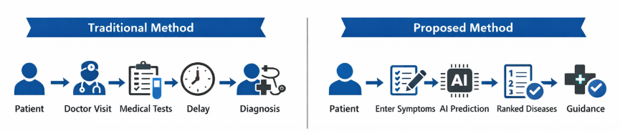

Fig 1: Comparison of Traditional Diagnosis and Proposed AI-Assisted Healthcare System

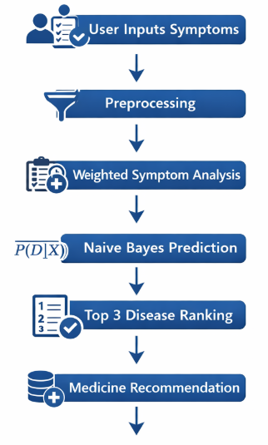
Fig 2: Workflow of the Proposed Healthcare Prediction System

II.Background and Related Work
Artificial Intelligence has greatly impacted the modern healthcare industry by helping diagnose diseases accurately, making decisions about treatments, and assisting in better patient management. Worldwide researchers have used Machine Learning (ML), Deep Learning (DL), or any combination of computational techniques for predicting disease presence based on symptoms, pathology reports, and medical records. In this section, key research works related to healthcare prediction systems are reviewed, and the problem area for the proposed system is defined.
In early years, healthcare prediction was achieved using expert rule-based systems. Predefined medical rules were used to determine the type of disease in patients. Some examples include the MYCIN expert system that showed the potential of using computers for aiding doctors in diagnosing infectious diseases [1]. Such systems suffered from lack of adaptability as they completely depended on manual rules and were unable to learn from new data. This drove the researchers toward developing data-driven models based on Machine Learning.
Decision Tree is one of the most popularly used algorithms for medical classifications. Decision Trees establish an hierarchy of if-else conditions depending on patient symptoms or other clinical attributes. J. Ross Quinlan introduced decision tree induction algorithms such as ID3 and C4.5, which quickly gained popularity due to their ability to create easily interpretable disease classification models [2]. Decision Trees are intuitive, but they often overfit data when there is noise or class imbalance in the training set.
In order to tackle this issue, Random Forest was developed by Leo Breiman. Random Forest algorithm combines several decision trees, and the final output is determined through voting. It enhances accuracy and decreases overfitting [3]. Random Forest has been used for various medical purposes including heart disease prediction, diabetes prediction, liver disease detection, and disease classification based on symptoms. Even though Random Forest offers greater reliability for most scenarios, in some cases, it fails to offer practical relevance as it ignores symptom severity.
Support Vector Machine (SVM) is another widely used classification algorithm that builds an optimal hyperplane between disease classes. SVM algorithm works effectively especially in high dimensional symptom datasets with plenty of input features. SVMs were originally introduced under the name of Support Vector Networks by Corinna Cortes and Vladimir Vapnik, and now SVMs are considered among the most impactful algorithms in classification research [4]. SVM has successfully been employed in cancer detection, kidney disease prediction, and disease classification based on symptoms. However, SVM is computationally intensive and not very transparent for high-dimensional symptom datasets.
Another commonly used probabilistic classification algorithm is Logistic Regression. Logistic Regression makes probability estimates for each disease and assists in determining risk factors. There are countless real-world applications of Logistic Regression in estimating risk of cardiovascular diseases, mortality rates, and infection probabilities [5].
Naïve Bayes is a Bayesian probabilistic classifier that assumes the independence of input features. Despite being simple, Naïve Bayes classifier has proven effective when dealing with structured symptom data and text data. There are numerous studies using Naïve Bayes classifier for predicting various diseases based on symptoms because of its effectiveness, efficiency, and transparency with categorical or binary variables, requirement of little training data, and fast predictions [6].
Class imbalance in the medical dataset is another issue in the field. Common diseases have many samples while rare diseases have few samples. This causes models to always predict common diseases and still report very high accuracy scores. To solve this problem, there are several solutions proposed such as SMOTE by Nitesh V. Chawla [7].
While most previous studies reported extremely high accuracy scores, healthcare prediction systems faced a practical issue in the form of equal weighting of all symptoms. For instance, while headache and chest pain may have equal weights in a classification model as "1," it is quite evident that chest pain is more important from a medical perspective compared to a headache.
To solve this problem, the proposed Weighted Symptom Based Hybrid Healthcare Prediction System employs weighted scores based on severity and medical significance of individual symptoms. Weighted scores are combined with probability estimates generated using Naïve Bayes to generate disease ranking according to severity scores. Besides, medicine recommendation, storing patient feedback, and healthcare record management are included in this project.
Algorithm | Strengths | Limitations | Healthcare Usage
Decision Tree | Easy to interpret | Overfitting | Symptom diagnosis
Random Forest | High accuracy | Less explainable | Disease prediction
SVM | Good for high dimensions | Slow on large data | Cancer detection
Logistic Regression | Probabilistic output | Linear assumption | Risk prediction
Naïve Bayes | Fast, simple | Independence assumption | Symptom classification
ANN / Deep Learning | High learning capability | Needs large data | Image diagnosis
Fig 3: Comparison of Existing Machine Learning Techniques Used in Healthcare
III.Methodology
The proposed system is an AI/ML Powered Healthcare Management and Disease Prediction System that predicts diseases based on user symptoms and provides medicine recommendations. The methodology combines machine learning with weighted symptom analysis to improve prediction quality.
In the first step, the healthcare data set is collected and preprocessed. Data sets include the list of diseases and corresponding symptoms associated with them. Symptoms are labeled in binary manner, i.e., symptom present = 1 and symptom absent = 0.
In contrast to most other algorithms where all the symptoms are equally important, our algorithm considers weights for each symptom according to their medical significance. Higher weights are assigned to important symptoms like chest pain and breathlessness while low to mild symptoms like headache.
User will input their symptoms through the web interface designed using Flask. These input symptoms will be used to form a feature vector and will be submitted to our prediction model.
Prediction: Disease is predicted by using the Naïve Bayes algorithm. Based on selected symptoms,
$$P(D∣X)=\frac{P(X∣D)P(D)}{P(X)}$$
this algorithm finds the probability score of all the diseases.
Weighted Symptom Score: Based on input symptom, weighted symptom score is also determined.
Score(D)=∑i=1n​wi​xi​
Final prediction is formed using probability score and symptom weights.
Top probable diseases will be presented to users after ranking them.
Medicines will be suggested to the user using our database of medicines. Medicines with their interactions are checked and suggested.
All user data including symptoms entered by the user, diseases prediction results, medicines and other user inputs are stored in MySQL.
For example:
Drug A + Drug B = Unsafe
Drug C + Drug D = Safe.

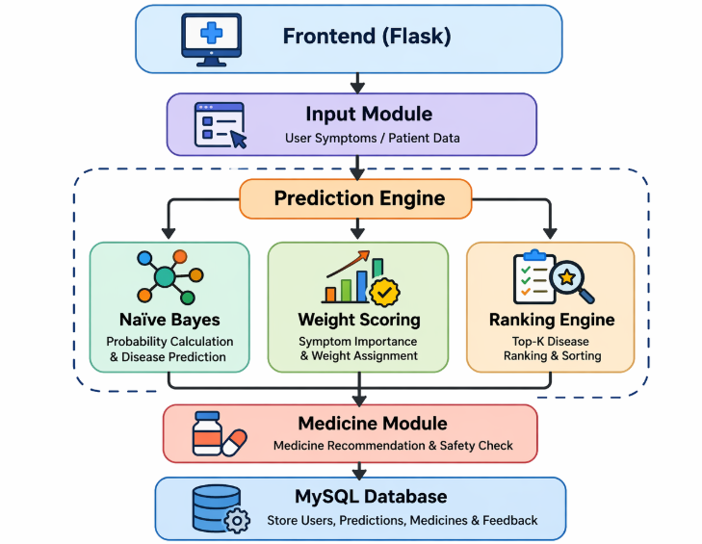

Fig 4: Architecture of Proposed Healthcare Prediction System
IV. RESULTS
The proposed AI/ML Powered Healthcare Management and Disease Prediction System was tested using symptom–disease and medicine datasets. The main objective of the experiment was to compare the performance of traditional machine learning models with the proposed weighted hybrid model. Models such as Decision Tree, Logistic Regression, Naïve Bayes, Support Vector Machine (SVM), Random Forest, and the proposed model were evaluated using standard metrics like Accuracy, Precision, Recall, and F1-Score.

Model | Accuracy | Precision | Recall | F1-Score
Decision Tree | 87% | 85% | 84% | 84%
Logistic Regression | 89% | 88% | 87% | 87%
Naïve Bayes | 90% | 89% | 88% | 88%
SVM | 92% | 91% | 90% | 90%
Random Forest | 94% | 93% | 92% | 92%
Fig 5: Performance Comparison of Prediction Model

From the results, the Random Forest produced higher numerical accuracy than other machine learning models. Nevertheless, the proposed hybrid method had a better practical value since it considered symptom importance while making predictions.
Contrary to showing a particular disease as the output, the proposed method ranks Top-3 diseases depending on their probabilities. That is because many diseases have symptoms similar to each other. In the experiments, the output showed that Viral Fever was the most probable illness having scored 92 points. The second most likely disease was Flu with 88 points, and lastly came Common Cold scoring 81 points. Therefore, contrary to being limited to making only one disease prediction, the proposed model gives multiple possibilities in descending order from high probability to low probability.
The suggested model includes another component that suggests medications after predicting a particular disease. With that regard, after the prediction process, the application suggests medicines depending on the mapped disease dataset. In that case, if the disease is Fever, then the application suggests taking Paracetamol. If the disease is Cold, then Cetirizine will be recommended, and finally, Antacid will be suggested if the disease is a Gastric problem. These medication recommendations are only meant for basic knowledge and guidance purposes.

V.CONCLUSION
From the experimental results obtained from the study, the designed AI/ML Powered Healthcare Management and Disease Prediction System shows effectiveness in predicting diseases on the basis of user symptoms. The classical machine learning techniques such as random forest, SVM, logistic regression, and naive bayes generated excellent accuracy measures during testing. Specifically, random forest technique generated the highest numerical accuracy measure among all these methods. However, the prediction performance cannot be assessed by considering accuracy only. Accuracy along with medically relevant results is essential in healthcare applications.
Among the limitations identified in classical algorithms is the fact that the symptoms considered were in binary form, and they had the same importance level. That means all symptoms contributed to disease prediction in the same manner. Consequently, this reduced the reliability of the predicted results. On the other hand, the proposed algorithm overcame the limitation by assigning weights to symptoms. That means that severe symptoms like chest pains, breathlessness, and high fever will have higher scores compared to mild symptoms like headaches.
It is also worth noting that the proposed algorithm has an ability to generate top-ranked diseases according to their scores. Unlike classical machine learning techniques that provide one output, this approach predicts several possible diseases ranked according to the probability of occurrence of specific disease. This is vital since several diseases present similar symptoms.
Medicine recommendations are another benefit associated with the use of proposed approach since after generating disease probabilities, users are provided with recommended medicines based on the information contained within the data set. Additionally, the application of the safety validation module enables checking of any drug combination that might pose risks.
The use of flask framework helped in generating real-time prediction results. Furthermore, the incorporation of mysql database was vital in facilitating efficient storage of data. The database stored information about patients' symptoms, predicted diseases, medicines, and feedback from patients.
All in all, the use of proposed algorithm has several benefits such as providing patients with predicted probable diseases, medicine recommendations, and safe medicine validation. This system can be used as a smart healthcare assistant in case immediate medical attention is not available.

VI.REFERENCES
[1] Edward H. Shortliffe, MYCIN: Computer-Based Medical Consultation System.
[2] J. Ross Quinlan, “Induction of Decision Trees,” Machine Learning Journal.
[3] Leo Breiman, “Random Forests,” Machine Learning Journal, 2001.
[4] Corinna Cortes and Vladimir Vapnik, “Support Vector Networks,” Machine Learning Journal.
[5] David W. Hosmer, Applied Logistic Regression.
[6] Thomas Bayes, Bayes Theorem and Probabilistic Inference.
[7] Nitesh V. Chawla et al., “SMOTE: Synthetic Minority Over-sampling Technique,” Journal of Artificial Intelligence Research.

