**Question 1:**

1. **Create table**

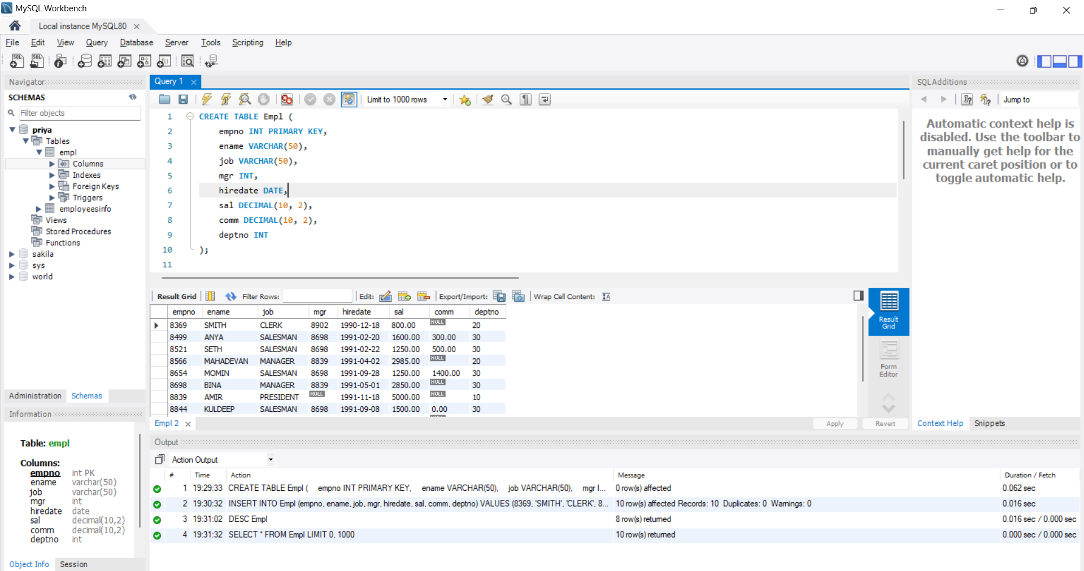

1. **Insert the given values as per screenshot**

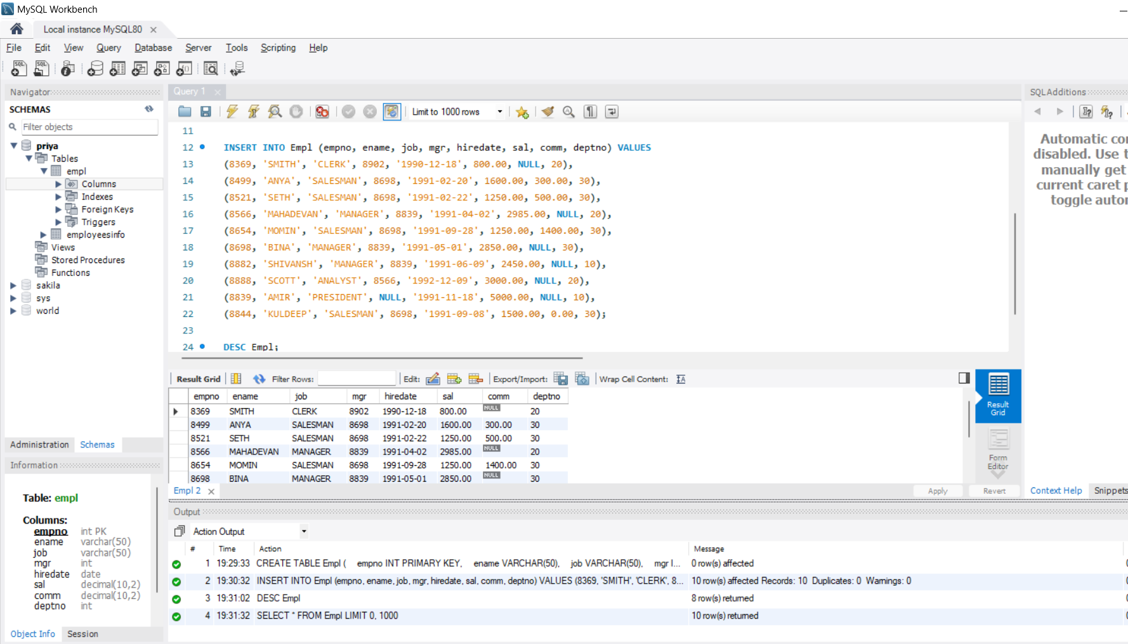

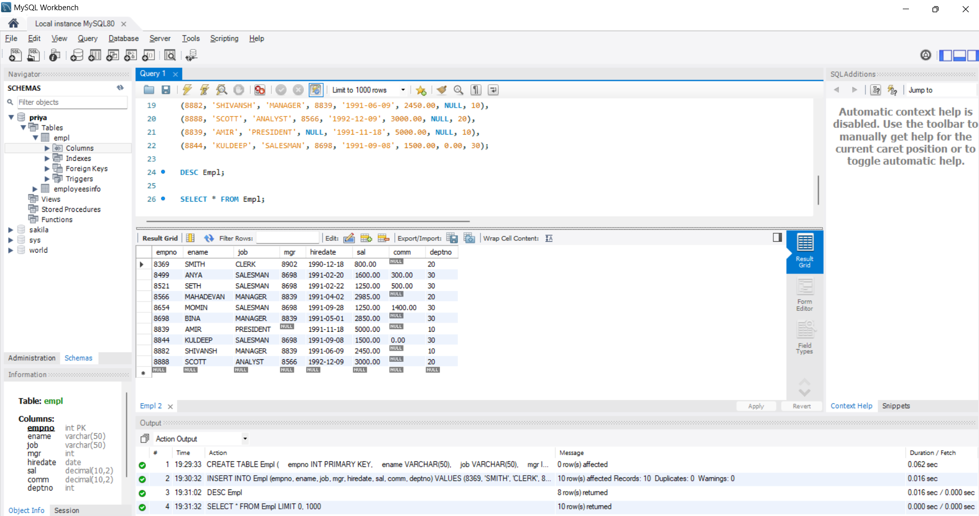

**A. Write a query to display EName and Sal of employees whose salary is greater than or equal to 2200:**

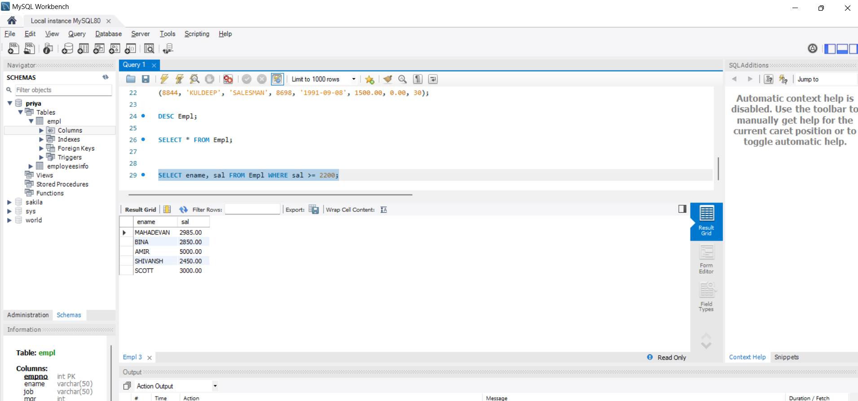

**B. Write a query to display details of employees who are not getting a commission:**

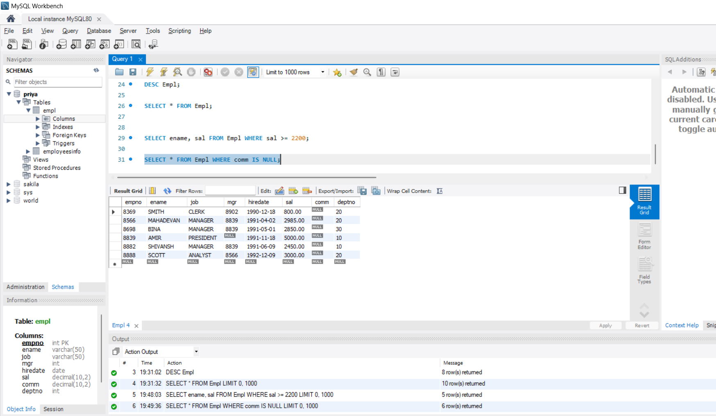

**C. Write a query to display employee name and salary of those employees who don’t have a manager and have their salary in the range of 2500 to 4000:**

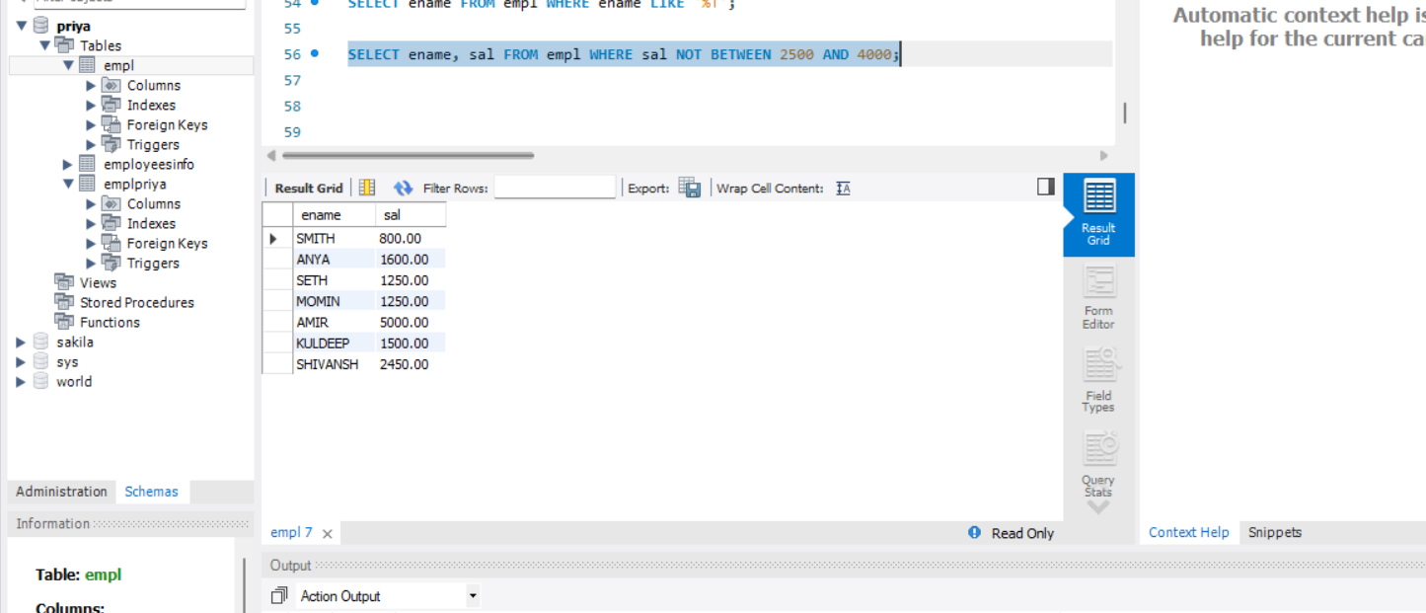

**D. Write a query to display the name, job title, and salary of employees who don’t have a manager:**

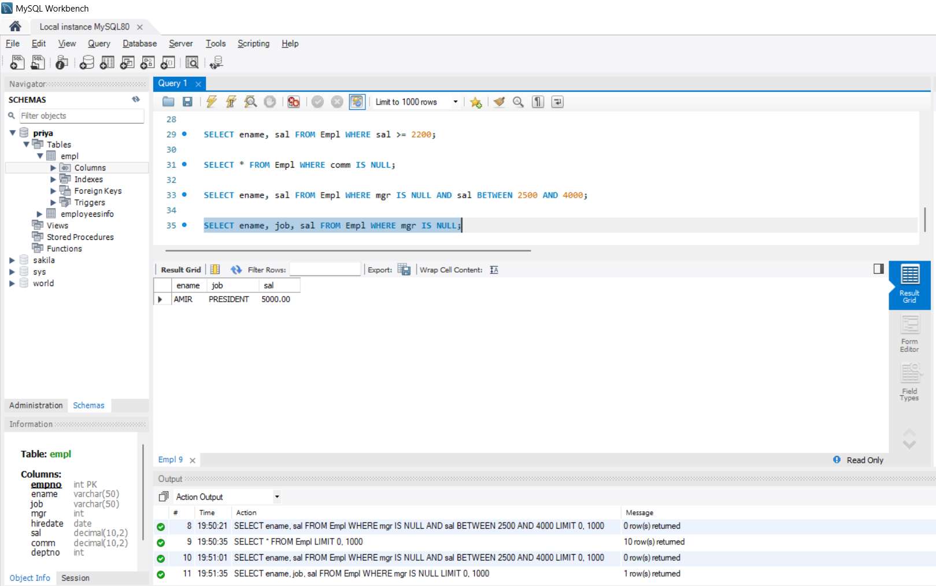

**E. Write a query to display the name of an employee whose name contains "A" as the third alphabet:**

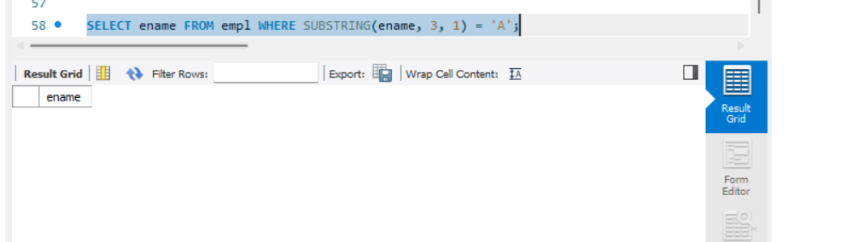

**F. Write a query to display the name of an employee whose name contains "T" as the last alphabet:**

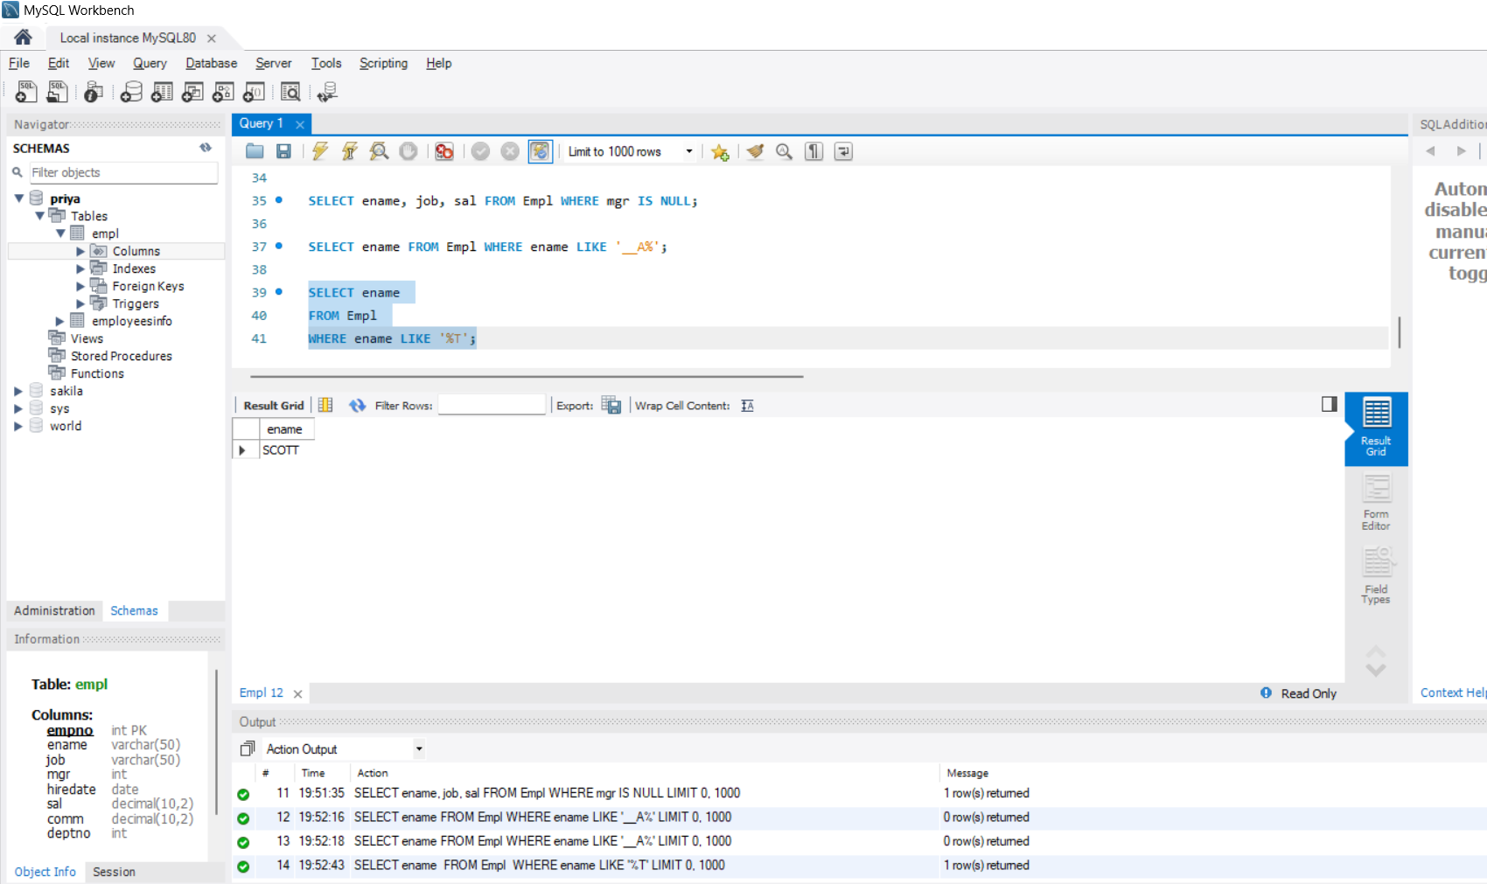

**Question 2: Code committed in Git repo**

