RETAIL SALES ANALYSIS

BUSINESS REQUIREMENTS

DATA CLEANING & VALIDATION

The retail sales dataset was already clean and suitable for analysis. The data was reviewed to ensure that the required fields were available and consistent for reporting and dashboard development.

The dataset contains the necessary information for:
- Sales transactions
- Customer details
- Product details
- Order dates
- Sales and profit values
- Quantity and discount information
- Customer ratings
- Payment methods
- Regions
- Product categories and brands

Since the source data was already clean, no major data-cleaning or duplicate-removal operations were required. The dataset was directly prepared for dimensional modelling and Power BI analysis.

DIMENSIONAL MODELLING — STAR SCHEMA
Dimensional modelling helps organize retail sales data in a structured way that makes analysis simple, consistent, and efficient. Instead of keeping customer, product, date, and sales information together in one large table, the Star Schema separates descriptive information into dimension tables and keeps measurable business transactions in a central fact table. This structure reduces data duplication, improves data organization, and makes the dataset easier to understand. It also supports efficient reporting and accurate aggregations in Power BI by establishing clear relationships between the fact and dimension tables.
To optimize analytics and reporting, build a Star Schema with the following dimension tables:
- Dim_calendar_date → Date, Month Number, Month-Year
- dim_customer → CustomerID, CustomerName, CustomerSegment, Gender, AgeGroup, MembershipYears, Region
- dim_product → ProductID, Product, Brand, Category, Supplier, UnitPrice

Central Fact Table
- fact_sales → OrderID, CustomerID, ProductID, OrderDate, PaymentMethod, Quantity, Discount%, Profit, CustomerRating, Sales
The dimension tables contain descriptive attributes used for filtering, grouping, and analysis, while the central fact table contains transactional and measurable values. The fact table is connected to the customer, product, and date dimensions through their respective keys.
This Star Schema provides a clean and scalable foundation for the Retail Sales Power BI dashboard and supports analysis of sales, profit, products, customers, regions, dates, and payment methods.
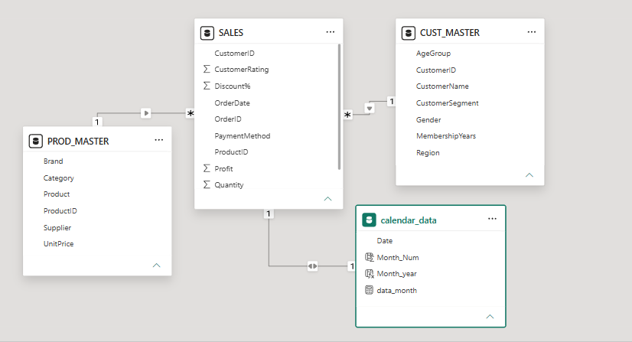
KPI DEVELOPMENT
Once the schema is built, compute core performance indicators to evaluate overall retail business performance.
Basic KPIs
- Total Sales
- Total Profit
- Profit Margin %
- Total Orders
- Average Customer Rating
These KPIs provide a high-level overview of sales performance, profitability, order volume, and customer satisfaction.
DEEP-DIVE BUSINESS ANALYSIS
Date-Based Analysis
- Sales and profit trends over time
Region-Based Analysis
- Total sales by region
- Regional sales contribution
- Comparison of East, West, North, and South regions
- Sales performance by gender and region
Product Performance
- Profit by product
- Sales by product
- Top-performing products
- Product contribution to total sales
- Sales by product and category
Category Analysis
- Profit distribution by category
- Sales performance by category
- Category contribution to overall business
- Comparison of Electronics, Furniture, Grocery, and Clothing categories

Brand Performance
- Profit by brand
- Brand-wise profit by month
- Profit margin by brand
- Sales count by brand
- Comparison of brand performance
Customer Analysis
- Average customer rating by age group
- Customer performance by gender
- Customer segmentation analysis
- Customer behaviour across different regions
Payment Method Analysis
- Orders by payment method
- Comparison of Credit Card, UPI, Cash, and Debit Card
- Identification of the most frequently used payment method

Drill-Through Analysis
A dedicated Region Drill-through page was created to provide a detailed view of a selected region. Users can select a region from the main dashboard and drill through to analyze its sales, profit, profit margin, brands, categories, products, and suppliers. This helps users understand regional performance in detail and identify the products and brands that contribute most to sales and profitability.

Business Performance Insights
- Identify the highest-performing region based on sales.
- Identify the most profitable products and brands.
- Analyze category-wise contribution to profit.
- Compare customer ratings across different age groups.
- Evaluate the distribution of orders across payment methods.
- Analyze sales and profit trends to understand overall business performance.

Business Recommendations
Based on the analysis, the following types of recommendations can be generated:
1. Focus on High-Performing Regions
Prioritize inventory, marketing, and customer acquisition strategies in regions generating strong sales and profitability.
2. Improve Low-Margin Products
Products generating high sales but relatively low profit margins should be investigated for:
- Pricing issues
- Discount levels
- Supplier costs
- Product costs
- Operational expenses
3. Strengthen High-Performing Brands
High-performing brands can be given greater visibility through targeted promotions, inventory planning, and marketing campaigns.
4. Optimize Category Performance
Business teams can compare category-level sales and profitability to identify categories that require:
- Increased investment
- Pricing optimization
- Promotion adjustments
- Inventory optimization
5. Improve Customer Engagement
Customer segmentation and rating analysis can be used to design targeted customer engagement strategies.

