**System**

**Specifications**

**Document of**

**URL Shortener**

**Web Application**

-Prepared by

* Shanthi Priya

**Abstract**

Any business that does not have a website is missing out on one of the most powerful marketing tools available to them. The main reason that it is important for businesses to have a website is how people are likely to find you. These days most people will go online and research products and companies before they make a purchase. For this reason of dependency on online, website URL is mandatory. We can share the URL link for easy convenience and shortening the long URL also increase higher. A front-end application is developed to shorten the LONG URL and user is provided a SHORT url.

Contents

1.Introduction to URL Shortener 4

2. Project objectives 4

2.1 Introduction 4

2.2 Qualitative objectives 4

2.3 Quantitative objectives 4

3. Project presentation 4

4. System Analysis and Design 4

4.1System Analysis of requirements 5

4.1.1Functional Requirements 5

4.1.2 Non-Functional Requirements 5

4.2System Design of requirements 5

4.2.1 System Context Diagram 5

4.2.2 Use Case Diagram 5

5. Modules & Features 5

5.1 Conversion Module 5

5.2 Short URL Module 8

6.Application Requirements 9

6.1 User Interface: 9

6.2 Application: 9

7.Future Requirements 9

# **1.Introduction to URL Shortener**

“URL” is an abbreviation for Uniform Resource Locator — also known as a link or web address. A URL shortener is a tool that takes a full-length web link and compresses this web address into a shorter URL. It gains popularity among social network users when the social network limits tweets on length. However, compressing URLs remains a best practice for content distribution across social networks and other channels. A URL shortener is a tool that takes a full-length web link and compresses this web address into a shorter URL.

# **2. Project objectives**

## **2.1 Introduction**

URL Shortener is used for converting the long website URL into Short URL. The objective of URL shortener is to address the convenience and tracking issues in the URL. Some of the major objectives include,

## **2.2 Qualitative objectives**

The goal of the application is to provide convenience to users. Major qualitative objectives include,

* Convenience- It is much simpler to share a shorter link than a long, complicated one.
* Increased sharing-A shortened link is easier for your readers to click, copy, and
* share in their own post, which can help your content gain organic exposure on
* social networks.

## **2.3 Quantitative objectives**

Some of the quantitative objectives are,

* Insight-. One of the most important benefits of a URL shortener is the ability to track clicks on each link you share.
* Stronger engagement- Shortened URLs can increase engagement by 39%.

# **3. Project presentation**

The project is a web application, which can also be consulted on mobile phones and tablets. Access to the site and registration are free: URL shortener makes money by the storage period of the short URLs in the database through the application. Reservation and payment are made via the application. The objective is to release an operational v1 to be presented initially.

# **4. System Analysis and Design**

Users are divided into two categories: we will call here

* Web users who uses the services on the Website platform,
* Mobile users who uses the service on mobile devices.

## **4.1System Analysis of requirements**

## **4.1.1Functional Requirements**

* Creation of "Convert URL module" pages
* Users should be able to view short URL.
* Add header/footer to the pages.

## **4.1.2 Non-Functional Requirements**

* System should be available to web and mobile users.
* Short URL duplication should be avoided.
* Frequency of usage is also monitored several times a week.

## **4.2System Design of requirements**

## **4.2.1 System Context Diagram**

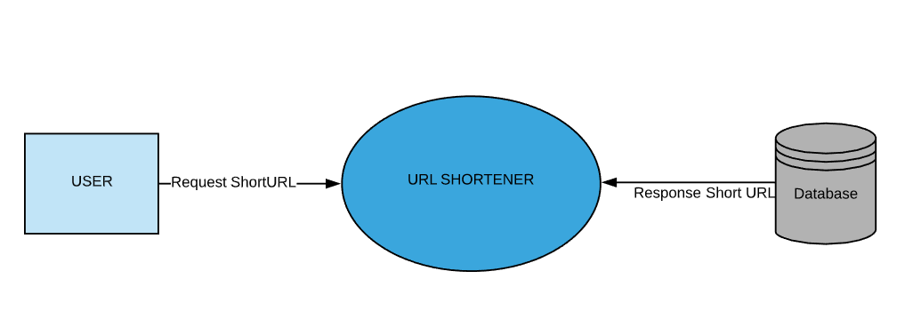

## **4.2.2 Use Case Diagram**

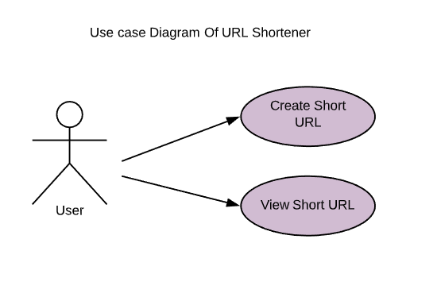

# **5. Modules & Features**

## **5.1 Conversion Module**

Conversion module will take the user input string “Long URL” and check if it is a valid URL.IF Valid URL and retrieve from the database if short URL is already created for this long URL to avoid duplication. If result is empty, then short URL is generated and saved in the database and return the short new URL to the User.

**WEB UI:**

STEP1:

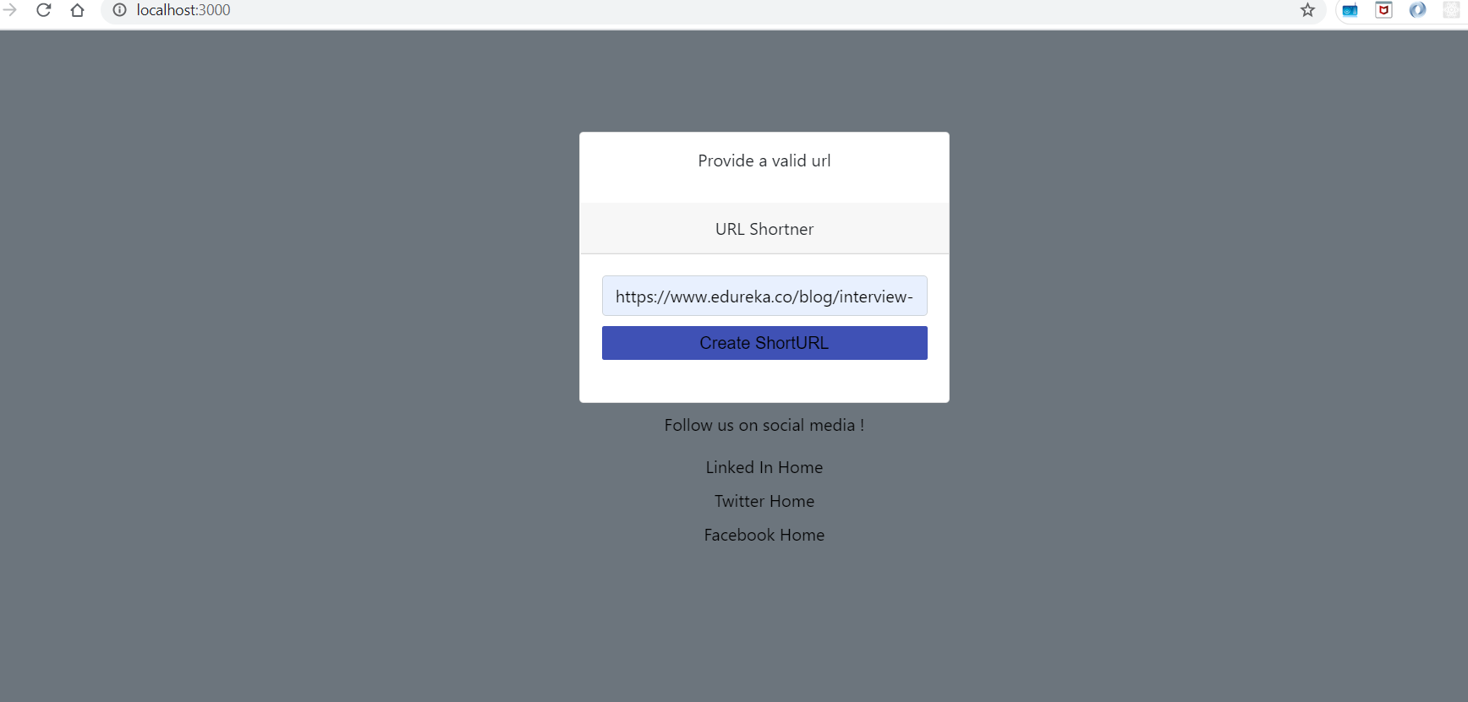

STEP2:

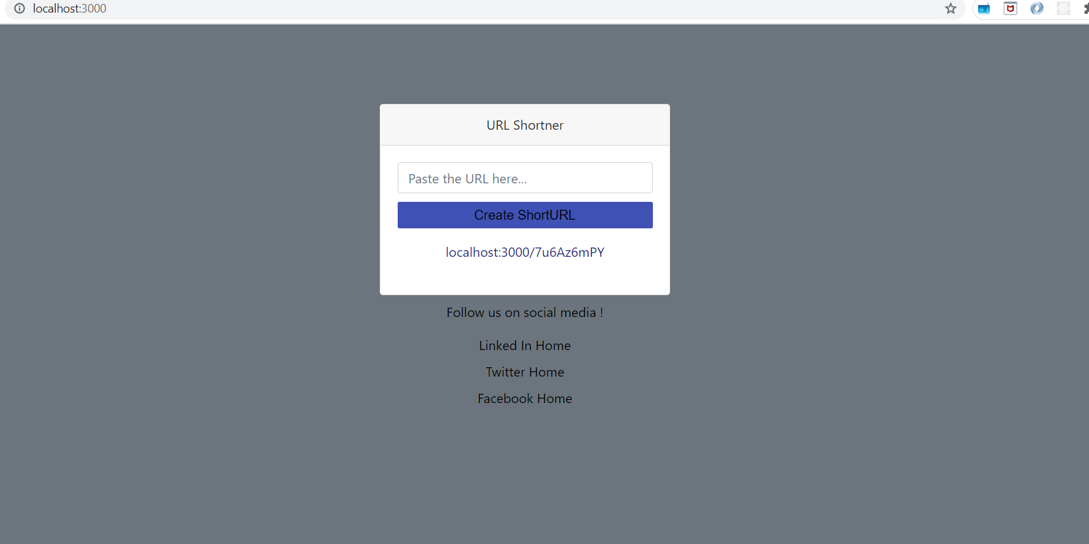

**MOBILE UI:**

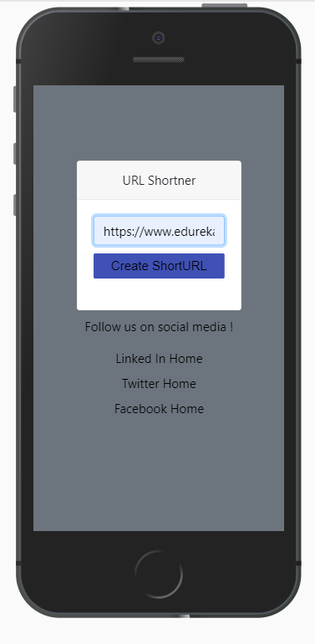 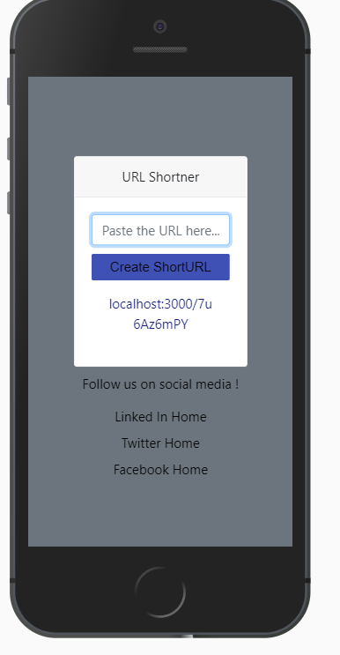

**SEQUENCE DIAGRAM:**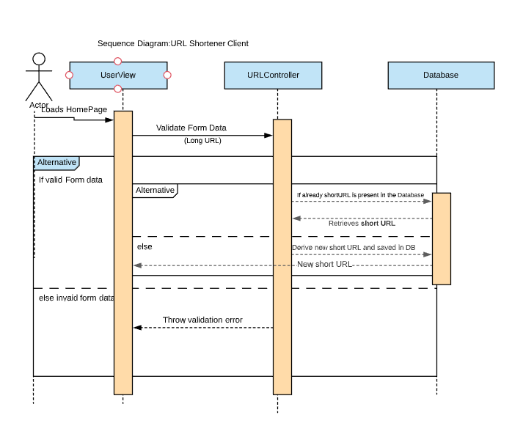

**SOURCE FILES:**

|  |  |  |  |
| --- | --- | --- | --- |
| FILES | NAME | LOCATION | DESCRIPTION |
| MODELS | urlModel | C:\Users\spriy\Neuda\URL-Shortener\models\urlModel.js | This model defines the schema for the database “url-shortner” in local MongoDB host. |
| VIEWS | Main.hbs | C:\Users\spriy\Neuda\URL-Shortener\views\layouts\main.hbs | This is the home page in single page web application. We replace the templates in body section using handlebars template engine. |
| Index.hbs | C:\Users\spriy\Neuda\URL-Shortener\views\index.hbs | This is the view for URL shortener form which submits the form to convert long URL into short URL. |
| CSS | Styles.css | C:\Users\spriy\Neuda\URL-Shortener\public\style.css | This file is used for designed the main and index webpage and also used Bootstrap classes. |
| CONTROLLERS | app.js | C:\Users\spriy\Neuda\URL-Shortener\app.js | Server file which holds all the configurations such as app and  Database initialization, setting up view engine, error handlers and router mappings. |

## **5.2 Short URL Module**

User can open/share the short URL by defining a separate route for the new URL. New web page is opened on click of short URL.

|  |  |  |  |
| --- | --- | --- | --- |
| FILES | NAME | LOCATION | DESCRIPTION |
| MODELS | urlModel | C:\Users\spriy\Neuda\URL-Shortener\models\urlModel.js | This model defines the schema for the database “url-shortner” in local MongoDB host. |
| VIEWS | Main.hbs | C:\Users\spriy\Neuda\URL-Shortener\views\layouts\main.hbs | This is the home page in single page web application. We replace the templates in body section using handlebars template engine. |
| Index.hbs | C:\Users\spriy\Neuda\URL-Shortener\views\index.hbs | This is the view for URL shortener form which submits the form to convert long URL into short URL. |
| CSS | Styles.css | C:\Users\spriy\Neuda\URL-Shortener\public\style.css | This file is used for designed the main and index webpage and also used Bootstrap classes. |
| CONTROLLERS | app.js | C:\Users\spriy\Neuda\URL-Shortener\app.js | Server file which holds all the configurations such as app and  Database initialization, setting up view engine, error handlers and router mappings. |

## **6.Application Requirements**

## **6.1 User Interface:**

HTML has been used for developing the user layout for the system.

JavaScript has been used for creating all the validations and client-side scripting functionality.

CSS and Bootstrap has been used for designing the web page of the system.

## **6.2 Application:**

Client on Internet: Web Browser, Operating System (Any)

Web Server: Node JS

Database: MongoDB-to enable the future modifications in a convenient way.

Mark-up Language: HTML, CSS

Scripting Language: JavaScript

## **7.Future Requirements**

* Users can bookmark the short URL
* Users can share through mail and social sites.
* Storage of short URLs in database should be membership based.
* Renewal and payment should be done by administration