When loantypeid = 1 or , under producttype, only 5 options are shown

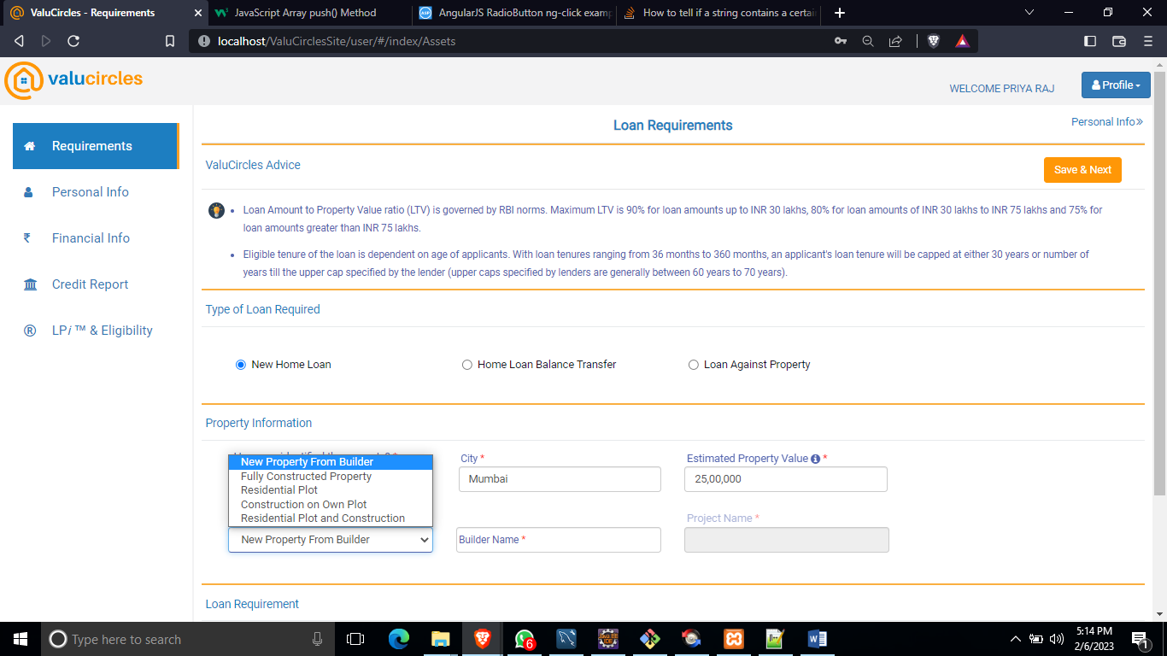

But when loantypeid = 3, all 7 options are shown

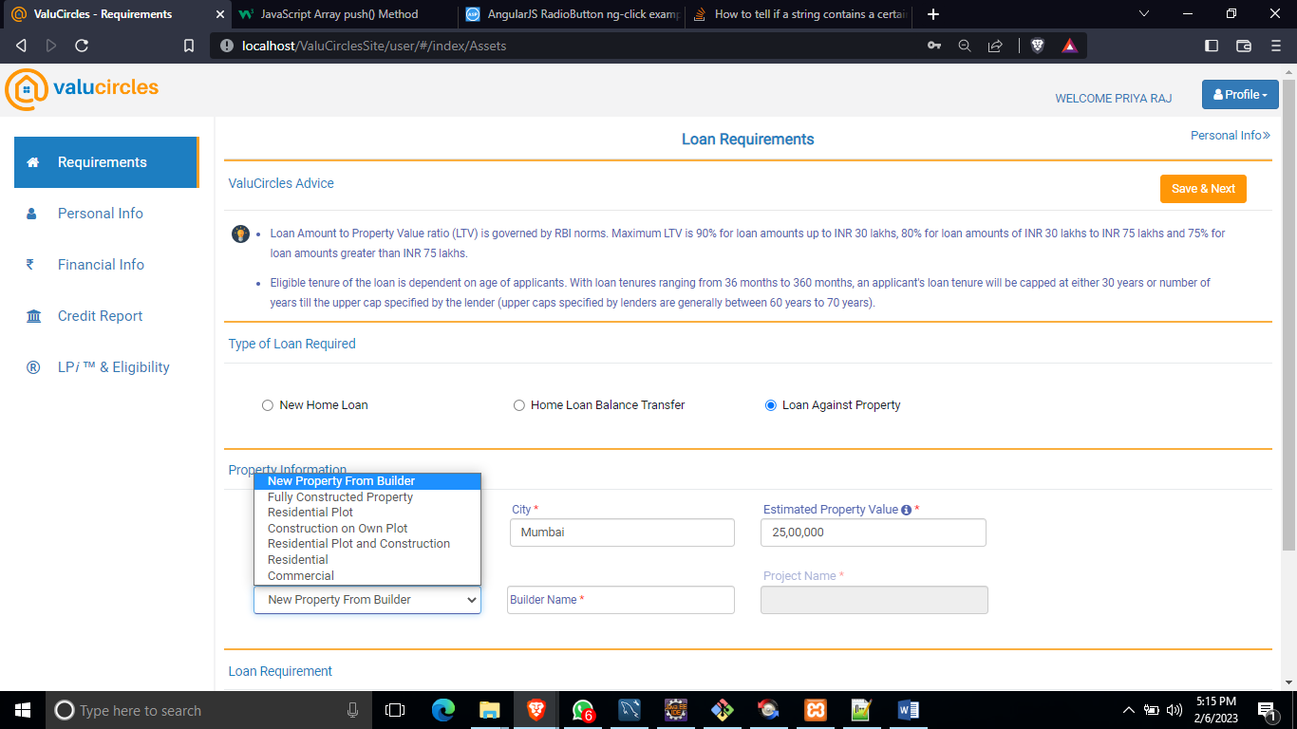

Necessary javascript changes are done. Testing is in progress. In case of any further more changes, it will be done later.

**Vastu offer page :**

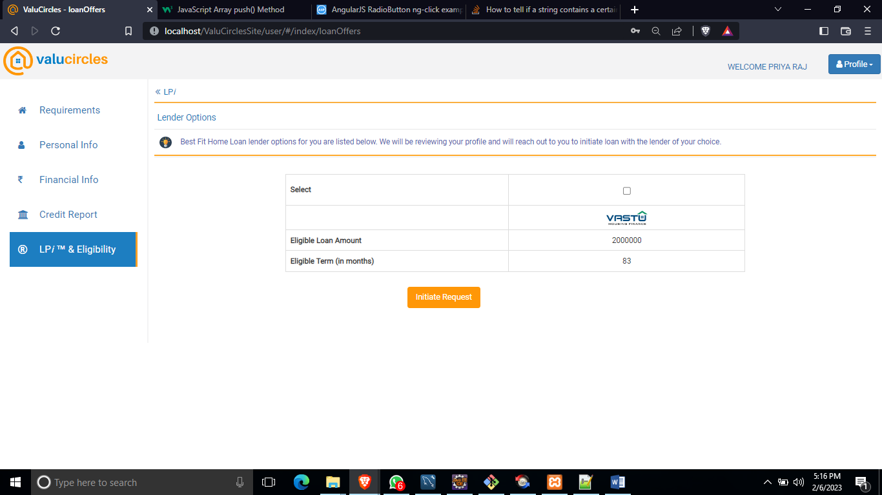

Testing has been carried for userid 986([tltpriya2003+08@gmail.com/Sairam25@](mailto:tltpriya2003+08@gmail.com/Sairam25@)) by keeping

Different combinations under loantypeid = 1

Rest will be carried out tomorrow.

Frontend File changes :

\user\assets\images\Vastu.jpg (for logo)

\user\scripts\assets\assets-controller.js

assets-controller\assets.html

Database queries to be checked against user 986

select * from staging.user_lpi_lenders where userid= 986 and lpicount >= 3 and lenderId = 10;

For producttypeid = 99 and producttypeid = 3, with different users it has been tested.

Tomorrow testing will be done by keeping loantypeid = 2

Changes related to “getmyLPi_ALL_Lenders” with related to lenderid = 10 for all loan types are handled and it is in git “https://github.com/Priyaraj12/DatabaseScripts.git”