[**Code Challenge**](https://github.com/Priyaraj17/Chat-App)

I developed a real-time chat-application using socket.io, Node.js and Express with Vanilla.js on the frontend.

**Server.js:**

* I started with setting up the server for the application and installed all the npm packages such as express, socket.io etc. Socket.io is a library that enables real-time, bidirectional and event based connection between the browser and server

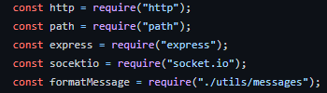

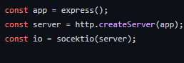

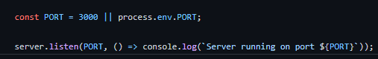

* As soon as the client connects to the server, two messages are broadcasted to the chat room.
  + “Welcome to ChatCord”.
  + “Alex has joined the chat”.

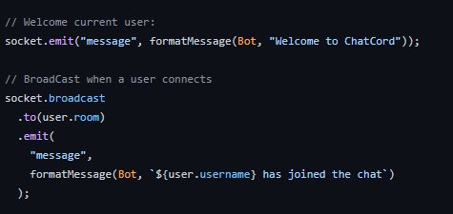

* When a client leaves the chat, a message is broadcasted that a user has left the chat.

**User.js:**

* I created a separate file for users which handles all the functionalities of a user such as joining the **server**, **leaving the server**, **getting the current user** etc.
* For the challenge, instead of using databases, I stored the user information in an array called **users.**
* Every time a new user enters a chatroom, an object is created which contains the information : **username, id, room.** This object is then **pushed** to the **users** array.

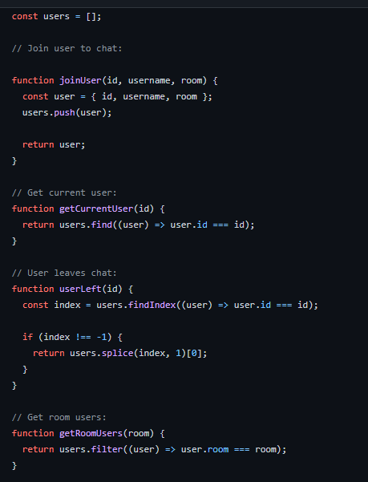

**Main.js:**

It is the client side javascript file which acts as an interface between the server and the user.

* Outputs the message to the DOM.

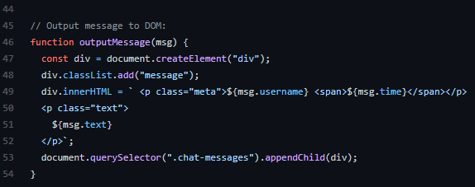

* Add room names and usernames to the DOM.
  + 