**Student Management System**

Name: PRIYA SHAH

University Name: Indira Gandhi Delhi Technical University for Women

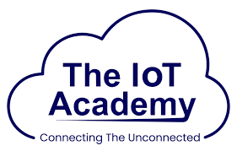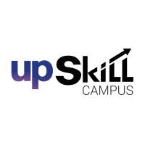



Internship Partners: Upskill Campus (USC), The IoT Academy, UniConverge Technologies (UCT)

Email: info@upskillcampus.com

**Acknowledgment**

I would like to express my heartfelt gratitude to **Upskill Campus (USC)**, **The IoT Academy**, and **UniConverge Technologies (UCT)** for providing me with this valuable internship opportunity in **Full Stack Development**.

My sincere thanks to my mentors and trainers, who guided me with patience and encouragement throughout the internship. Their feedback and support helped me strengthen my technical and problem-solving skills.

I am also grateful to my peers and teammates for their collaboration and knowledge-sharing, which made this journey enriching and enjoyable.

Lastly, I thank my family and friends for their constant motivation and support, without which this internship would not have been as fulfilling.

Priya Shah



|  |  |  |
| --- | --- | --- |
| **Sr. No.** | **Topic** | **Page No.** |
| **#** | **Executive Summary** | 3 |
|  | **Preface** | 4 |
|  | **Introduction** | 4 |
|  | **Problem Statement** | 5 |
|  | **Existing and Proposed Solution** | 5 |
|  | **Proposed Design/Model** | 5 |
|  | **Performance Test** | 6 |
|  | **Weekly Contributions** | 6 |
|  | **My Learnings** | 6 |
|  | **Future Work Scope** | 6 |
| **10.** | **Submission Links (GitHub)** | 7 |

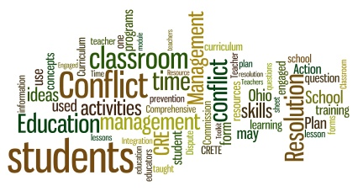

**# Executive Summary**

This internship, facilitated by Upskill Campus (USC) and The IoT Academy in collaboration with Uni Converge Technologies (UCT), provided me with a valuable opportunity to explore Full Stack Development in a real-world industrial context. Over the course of the program, I worked across the frontend, backend, and database layers and developed a simple yet complete Student Management System (SMS). The project delivers REST APIs for CRUD, a lightweight web interface, and persistent storage in MongoDB. The internship strengthened my problem-solving, debugging, collaboration, and documentation skills

1. **Preface**

The internship acted as a bridge between academic knowledge and industry expectations. My work was structured to first grasp core backend concepts, progress to database integration, and finally connect them with a responsive frontend. I am grateful to USC, UCT mentors, and peers for guidance and feedback throughout the journey.

1. **Introduction**

**2.1 About UniConverge Technologies Pvt Ltd**

A company established in 2013 and working in Digital Transformation domain and providing Industrial solutions with prime focus on sustainability and RoI.For developing its products and solutions it is leveraging various Cutting Edge Technologies e.g., Internet of Things (IoT), Cyber Security, Cloud computing (AWS, Azure), Machine Learning, Communication Technologies (4G/5G/LoRaWAN), Java Full Stack, Python, Front end etc.

**2.2 About Upskill Campus (USC)**

USC is a career development platform enabling hands-on internships and industry projects.

**2.3 About The IoT Academy**

EdTech division associated with executive programs and applied tech learning.

**2.4 Objectives of Internship Program**

• Gain hands-on exposure to full stack development.

• Strengthen knowledge across frontend, backend, and databases.

• Deliver a small end-to-end application.

• Improve debugging, testing, and collaboration skills.

1. **Problem Statement**

Design and implement an Internal Student Management System with the ability to add, list, update, and delete student records via a web interface backed by RESTful APIs and a database. The solution should be modular, secure, and easy to deploy locally for demonstration.

1. **Existing and Proposed Solution**

Existing: Many lightweight demos lack persistence or are tightly coupled to a single layer. Proposed: A modular full stack (Node.js + Express + MongoDB + HTML/CSS/JS) with REST APIs and a clean UI.Value: Simplicity, clear separation of concerns, and easy extensibility (auth, pagination, validations).

1. **Proposed Design/Model**

• Frontend: Static HTML/CSS/JS that consumes REST APIs.

• Backend: Express server exposing /student’s endpoints for CRUD.

• Database: MongoDB collection with Student schema (name, rollNumber, course, email).

• API Flow: Client → Express routes → Mongoose model → MongoDB.

1. **Performance Test**

Constraints: response time, correctness, and stability for basic CRUD. Plan: Test CRUD via browser and API calls; verify validation and error handling. Outcome: Stable for small datasets with fast local response times; no data loss observed during repeated operations.

1. **Weekly Contributions**

Week 01: USC_TIA familiarization, Flask basics, HTML/CSS/JS forms; auth and sync debugging.

Week 02: Java fundamentals, OOP, file I/O, exception handling, practice problems.

Week 03: JDBC + MySQL CRUD, Prepared Statement, CLI student app, driver/config debugging.

Week 04: MEAN concepts, HTML structure, Node.js setup, MongoDB Atlas, toolchain installation.

1. **My Learnings**

• End-to-end understanding of full stack layers and their interactions.

• Improved coding habits: modularity, comments, and error handling.

• Hands-on with Git/GitHub, debugging, and basic deployment.

• Confidence in designing small RESTful services and integrating a database.

1. **Future Work Scope**

• Add authentication and role-based access control.

• Introduce pagination, search, and input validation.

• Containerize with Docker and deploy to a cloud service.

• Convert frontend into a React SPA and enhance UX.

1. **Submission Links (GitHub)**

Repository Name: Upskillcampus

Code Link (placeholder): [Upskill/StudentManagementSystem.java.zip at main · Priyashah15/Upskill](https://github.com/Priyashah15/Upskill/blob/main/StudentManagementSystem.java.zip)

Report Link (placeholder): [Upskill/StudentManagementSystem_PriyaShah_USC_UCT.docx at main · Priyashah15/Upskill](https://github.com/Priyashah15/Upskill/blob/main/StudentManagementSystem_PriyaShah_USC_UCT.docx)