**Lab worksheet 1: Introduction to Program Components**

1. **Write a program that displays a frame window 800 pixels wide and 600 pixels high. Set the title of the frame to Welcome to Java.**

**CODE:**

|  |
| --- |
| import javax.swing.*;   class Welcome {  public static void main(String[] args) {    JFrame frame = new JFrame();   frame.setTitle("Welcome to Java");     frame.setSize(800, 600);     frame.setDefaultCloseOperation(JFrame.*EXIT_ON_CLOSE*);     frame.setVisible(true);  } } |

**OUTPUT:**

1. **Input the user’s first and last name as two separate strings. Then display a frame window with its title set to the input values (User’s full name). For example, if the input values are James and Bond, the title would be James Bond.**

**Code:**

|  |
| --- |
| package Q_02;  import javax.swing.*; import java.util.Scanner;  public class userframe {  public static void main(String[] args) {   Scanner scanner = new Scanner(System.*in*);    System.*out*.print("Enter your first name: ");  String firstName = scanner.nextLine();   System.*out*.print("Enter your last name: ");  String lastName = scanner.nextLine();    String fullName = firstName + " " + lastName;    JFrame frame = new JFrame(fullName);    frame.setSize(800, 600);    frame.setDefaultCloseOperation(JFrame.*EXIT_ON_CLOSE*);    frame.setVisible(true);    scanner.close();  } } |

**Output:**

1. **Input the user’s first, middle, and last name as three separate strings and display the name in the order of the first name, the middle initial, and the last name. Include the period after the middle initial. If the input strings are Jonathan, John, and Wick, for example, the output would be Jonathan J. Wick. Use the console window for output.**

**Code:**

|  |
| --- |
| import java.util.Scanner;  public class name {  public static void main(String[] args) {   Scanner scanner = new Scanner(System.*in*);   System.*out*.print("Enter your first name: ");  String firstName = scanner.nextLine();   System.*out*.print("Enter your middle name: ");  String middleName = scanner.nextLine();   System.*out*.print("Enter your last name: ");  String lastName = scanner.nextLine();   String formattedName = firstName + " " + middleName.charAt(0) + ". " + lastName;   System.*out*.println("Formatted Name: " + formattedName);   scanner.close();  } } |

**Output:**

1. **Write a program to display today’s date in this format: 17 May 2023. Use the console window for output.**

**Code:**

|  |
| --- |
| package Q_04;  import java.time.LocalDate; import java.time.format.DateTimeFormatter;  public class date {  public static void main(String[] args) {   LocalDate today = LocalDate.*now*();   DateTimeFormatter formatter = DateTimeFormatter.*ofPattern*("d MMM yyyy");    System.*out*.println("Today's Date: " + today.format(formatter));  } } |

**Output:**

1. **Repeat Exercise 4, but this time use this format: Wednesday, May 10, 2023**

**Code:**

|  |
| --- |
| package Q_05;  import java.time.LocalDate; import java.time.format.DateTimeFormatter;  public class Date {  public static void main(String[] args) {   LocalDate today = LocalDate.*now*();   DateTimeFormatter formatter = DateTimeFormatter.*ofPattern*("EEEE, MMM d, yyyy");    System.*out*.println("Today's Date: " + today.format(formatter));  } } |

**Output:**

1. **Write a program that displays a frame window W pixels wide and H pixel high. Use the Scanner to enter the values for W and H. The title of the frame is also entered by the user**

**Code:**

|  |
| --- |
| package Q_06;  import javax.swing.*; import java.util.Scanner;  public class userinput {  public static void main(String[] args) {   Scanner scanner = new Scanner(System.*in*);   System.*out*.print("Enter the width (W) of the frame: ");  int width = scanner.nextInt();   System.*out*.print("Enter the height (H) of the frame: ");  int height = scanner.nextInt();  scanner.nextLine();   System.*out*.print("Enter the title of the frame: ");  String title = scanner.nextLine();   JFrame frame = new JFrame(title);   frame.setSize(width, height);   frame.setDefaultCloseOperation(JFrame.*EXIT_ON_CLOSE*);   frame.setVisible(true);   scanner.close();  } **}** |

**Output:**

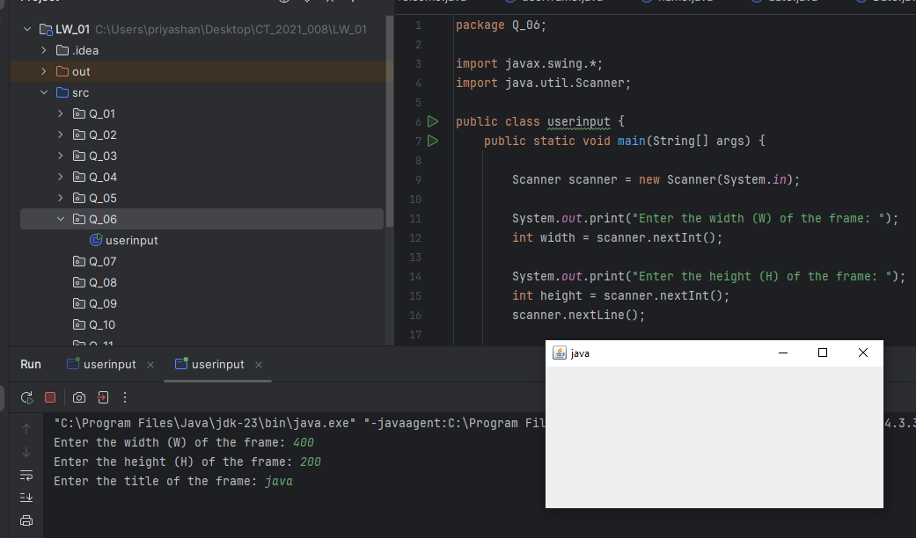

1. **Display the current time in the title of a frame window using this format: 12:45:43 PM.**

**Code:**

|  |
| --- |
| import javax.swing.*; import java.time.LocalTime; import java.time.format.DateTimeFormatter;  public class time {  public static void main(String[] args) {   LocalTime now = LocalTime.*now*();   DateTimeFormatter formatter = DateTimeFormatter.*ofPattern*("hh:mm:ss a");   String timeString = now.format(formatter);   JFrame frame = new JFrame(timeString);   frame.setSize(400, 300);   frame.setDefaultCloseOperation(JFrame.*EXIT_ON_CLOSE*);   frame.setVisible(true);  } } |

**Output:**

1. **Using the Scanner, input a string that contains a single exclamation mark. Divide the input string into two strings, one before and the other after the exclamation mark, and output them. Do not include the exclamation mark in the output.**

**For example, if the input string is one potato two potato ! three potato, then the output would be,**

**one potato two potato**

**three potato**

**Code:**

|  |
| --- |
| package Q_08;  import java.util.Scanner;  public class potato {  public static void main(String[] args) {   Scanner scanner = new Scanner(System.*in*);   System.*out*.print("Enter a string containing a exclamation mark: ");  String input = scanner.nextLine();  int index = input.indexOf('!');   if (index != -1){  String before = input.substring(0,index);  String after = input.substring(index+1);   System.*out*.println(before);  System.*out*.println(after);  }  else{  System.*out*.print("No exclamation mark found in the input.");  }  scanner.close();  } |
|  |

**Output:**

1. **Write a program that accepts a string input and outputs the number of characters in the string and the first and last characters in separate lines. For example, if the input is I like Java, then the output would be,**

**11**

**I**

**a**

**Code:**

|  |
| --- |
| package Q_09;  import java.util.Scanner;  public class letter {  public static void main(String[] args) {  Scanner scanner= new Scanner(System.*in*);  System.*out*.println("Enter a string: ");  String input = scanner.nextLine();   int length = input.length();   char fristChar = input.charAt(0);  char lastChar = input.charAt(length - 1);   System.*out*.println(length);  System.*out*.println(fristChar);  System.*out*.println(lastChar);   scanner.close();   } } |

**Output:**

1. **Write a program that accepts an odd-length word and prints out the middle character. For example, if the input is magnificent, which has 11 characters, you output the sixth character “f”**

**Code:**

|  |
| --- |
| package Q_10;  import java.util.Scanner;  public class middle {  public static void main(String[] args) {  Scanner scanner = new Scanner(System.*in*);  System.*out*.println("Enter an odd length word: ");  String input = scanner.nextLine();   if (input.length()% 2==1){  char middleChar = input.charAt(input.length()/2);  System.*out*.println(middleChar);  }else {  System.*out*.println("Enter a word with an odd number of characters");  }  scanner.close();  } } |

**Output:**

1. **Write a program that asks the user for her or his full name in the format first middle last and replies with the name in the format last, first middle-initial. where the last name is followed by a comma and the middle initial is followed by a period. For example, if the input is Anthony Edward Stark then the output is Stark, Anthony E.**

**Code:**

|  |
| --- |
| package Q_11;  import java.util.Scanner;  public class nameformat {  public static void main(String[] args) {  Scanner scanner = new Scanner(System.*in*);   System.*out*.println("Enter your full name (First Middle Last): ");  String fristName = scanner.next();  String middleName = scanner.next();  String lastName = scanner.next();   System.*out*.println(lastName + ","+fristName+" "+middleName.charAt(0)+ ".");  scanner.close();  } } |

**Output:**

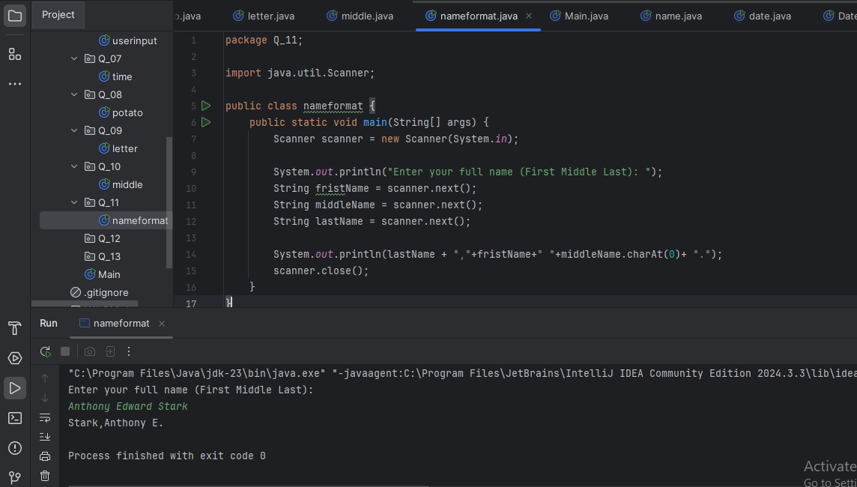

1. **Write a Java program that displays a frame window 300 pixels wide and 200 pixels high with the title My First Frame. Place the frame so that its top left corner is at a position 50 pixels from the top of the screen and 100 pixels from the left of the screen.**

* **To position a window at a specified location, you can use the setLocation method like this, frame.setLocation( 50, 50 );**
* **Through experimentation, determine how the two arguments in the setLocation method affect the positioning of the window.**

**Code:**

|  |
| --- |
| package Q_12;  import javax.swing.*;  public class myfristframe {  public static void main(String[] args) {    JFrame frame = new JFrame("My First Frame");  frame.setSize(300,200);  frame.setLocation(100,50);   frame.setDefaultCloseOperation(JFrame.*EXIT_ON_CLOSE*);  frame.setVisible(true);   } } |

**Output:**

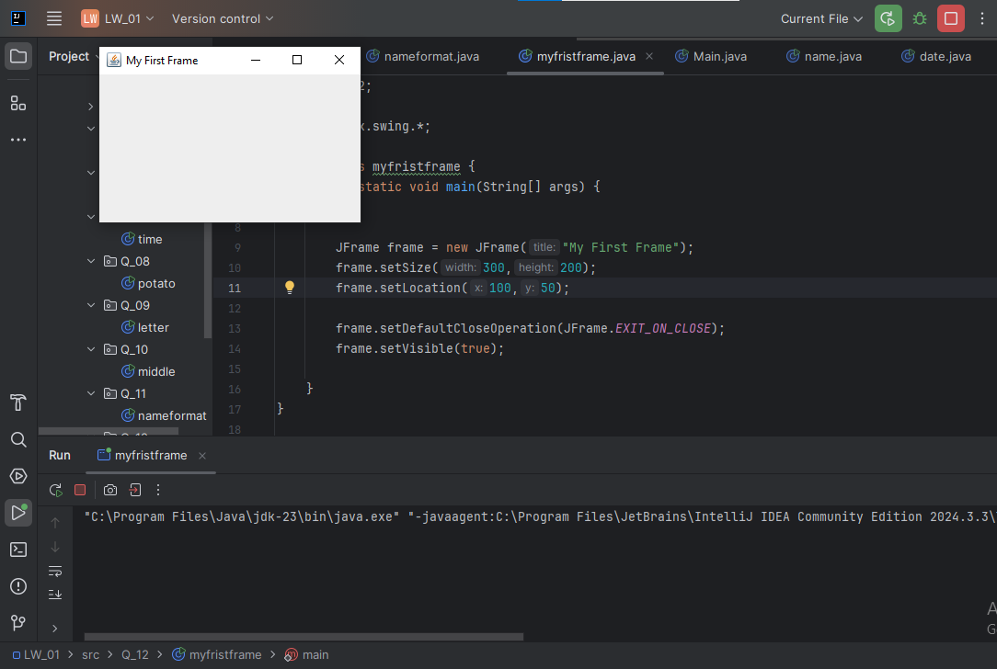

1. **Execute the following code and make sure you understand how it works.**

**Code:**

|  |
| --- |
| import javax.swing.*; class SampleWindow {  public static void main(String[] args) {  JFrame myWindow;  myWindow = new JFrame();  myWindow.setSize(500, 250);  myWindow.setTitle("UOK");  myWindow.setVisible(true);  try {Thread.*sleep*(500);} catch(Exception e) { }  myWindow.setVisible(false);  try {Thread.*sleep*(500);} catch(Exception e) { }  myWindow.setVisible(true);  } } |

**Output:**

