**Lab worksheet 4: Selection Statements**

1. **Question**

**CODE:**

|  |
| --- |
| package Q_01;  import java.util.Scanner; public class question1 {  public static void main(String[] args) {  Scanner input = new Scanner(System.*in*);  System.*out*.println("Enter three integers:");  int num1 = input.nextInt();  int num2 = input.nextInt();  int num3 = input.nextInt();  int smallest = num1;    if (num2 < smallest) { smallest = num2;  }   if (num3 < smallest) { smallest = num3;  }  System.*out*.println("The smallest number is: " + smallest);  } } |

**OUTPUT:**

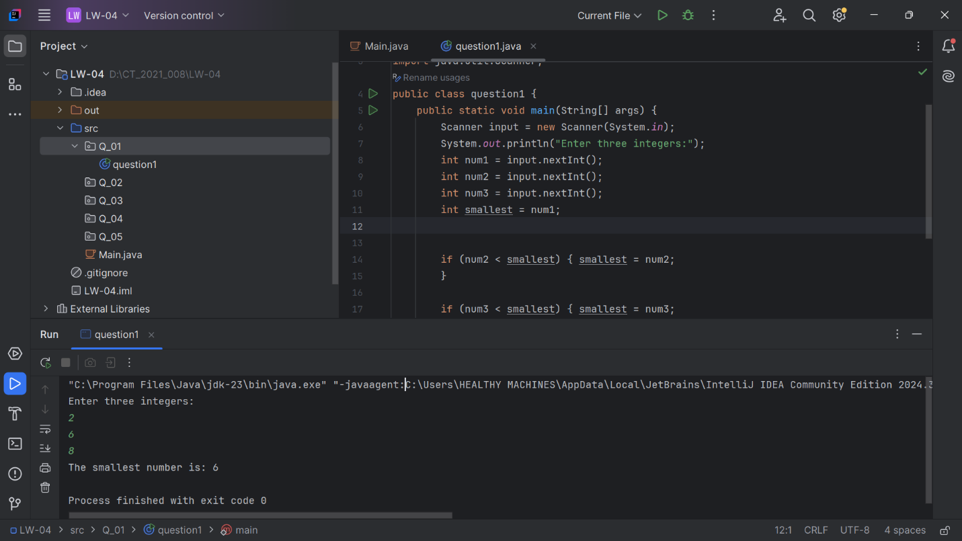

1. **Question**

**Code:**

|  |
| --- |
| package Q_02; import java.util.Scanner; public class main{  public static void main(String[] args) {  Scanner scanner = new Scanner(System.*in*);  System.*out*.println("0.Magenta");  System.*out*.println("1.Cyan");  System.*out*.println("2.Red");  System.*out*.println("3.Blue");  System.*out*.println("4.Green");  System.*out*.println("Select one color from the above list:");  int selection = scanner.nextInt();  String color;  switch (selection) {  case 0:  color = "Magenta";  break;  case 1:  color = "Cyan";  break;  case 2:  color = "Red";  break;  case 3:  color = "Blue";  break;  case 4:  color = "Green";  break;  default:  color = null;  break;  }  if (color != null) {  System.*out*.println("You selected " + color);  } else {  System.*out*.println("Invalid selection");  }  } } |

**Output:**

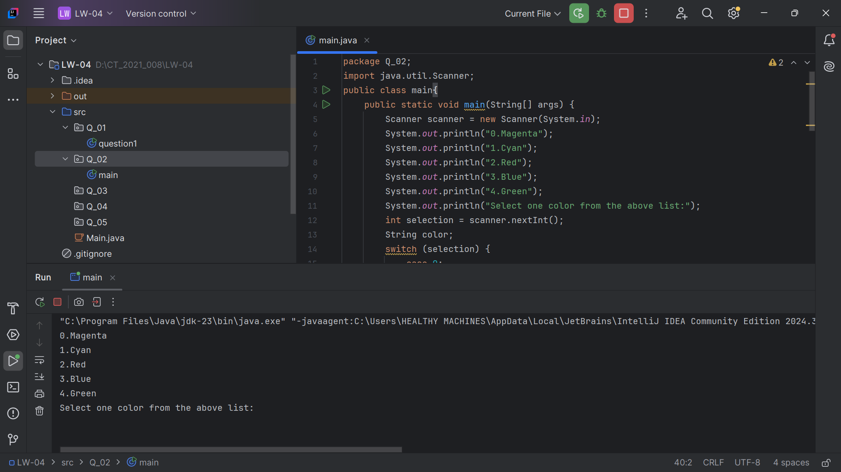

1. **Question**

**Code:**

|  |
| --- |
| package Q_03;  import java.util.Scanner; public class question3 {  public static void main(String[] args) {  Scanner scanner = new Scanner(System.*in*);  System.*out*.println("Enter the power of 10:");  int power = scanner.nextInt();  String magnitude;  switch (power) {  case 6:  magnitude = "Million";  break;  case 9:  magnitude = "Billion";  break;  case 12:  magnitude = "Trillion";  break;  case 15:  magnitude = "Quadrillion";  break;  case 18:  magnitude = "Quintillion";  break;  case 21:  magnitude = "Sextillion";  break;  case 30:  magnitude = "Nonillion";  break;  case 100:  magnitude = "Googol";  break;  default:  magnitude = "Unknown";  break;  }  if (magnitude.equals("Unknown")) {  System.*out*.println("There is no corresponding word for the power of 10 you entered.");  } else {  System.*out*.println("The number is: " + magnitude);  }  } } |

**Output:**

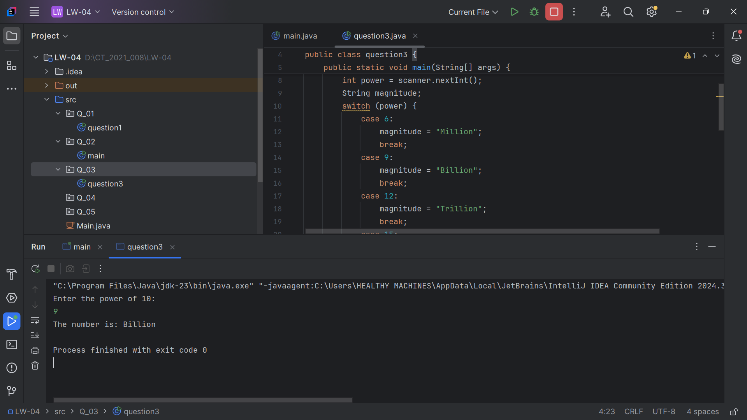

1. **Question**

**Code:**

|  |
| --- |
| package Q_04;  import java.util.Scanner; public class question4{  public static void main(String[] args) {  Scanner scanner = new Scanner(System.*in*);  System.*out*.println("Enter a year:");  int year = scanner.nextInt();  boolean isLeapYear = false;  if (year % 4 == 0) {  if (year % 100 != 0 || year % 400 == 0) {  isLeapYear = true;  }  }  if (isLeapYear) {  System.*out*.println(year + " is a leap year.");  } else {  System.*out*.println(year + " is not a leap year.");  }  } } |

**Output:**

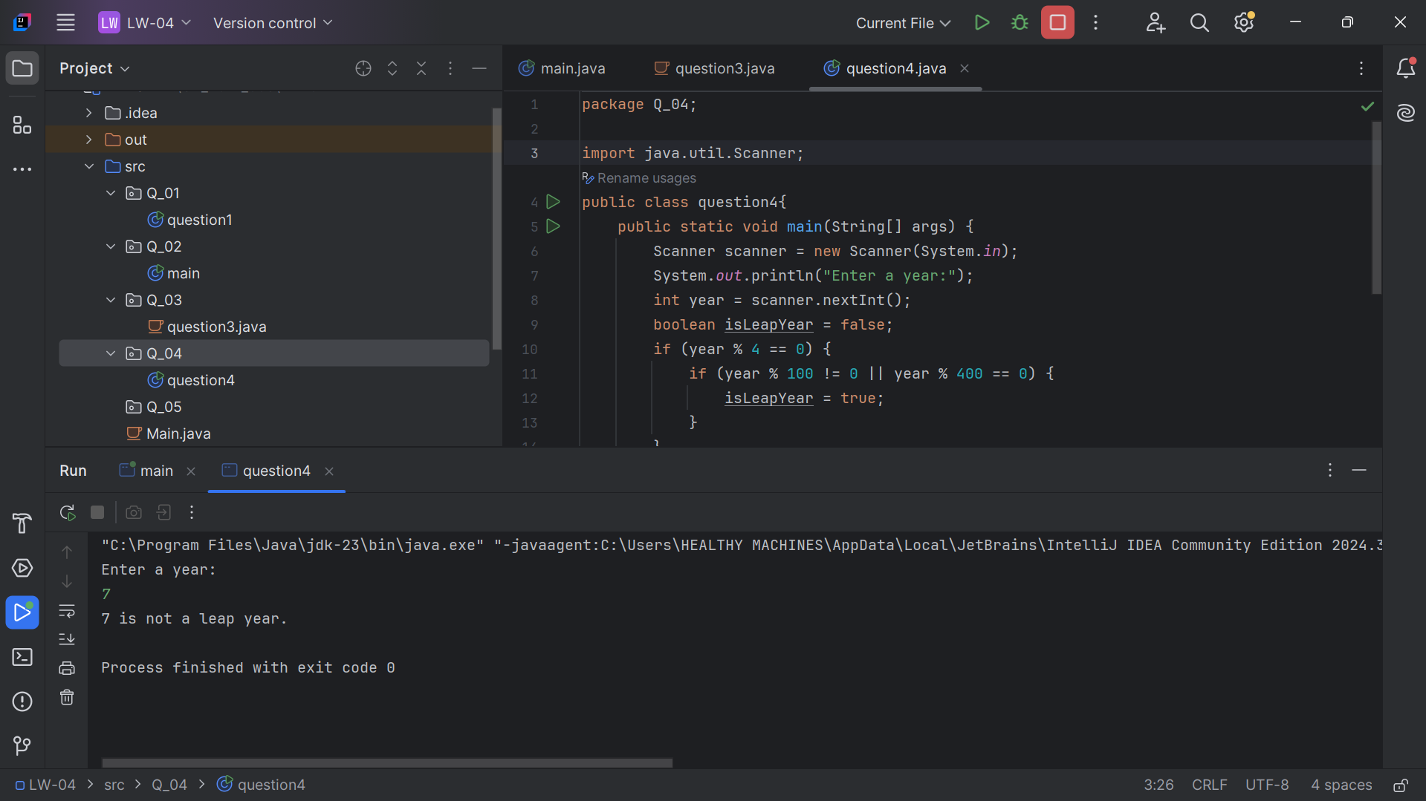

1. **Question**

**Code:**

|  |
| --- |
| package Q_05;  import java.util.Scanner;  public class question5 {  public static void main(String[] args) {  displayMenu();  Scanner scanner = new Scanner(System.in);  System.out.print("Enter the category (1-Entree, 2-Side Dish, 3-Drink): ");  int category = scanner.nextInt();  switch (category) {  case 1:  displayEntreeMenu();  break;  case 2:  displaySideDishMenu();  break;  case 3:  displayDrinkMenu();  break;  default:  System.out.println("Invalid category selection.");  scanner.close();  return;  }  System.out.print("Enter the item number: ");  int item = scanner.nextInt();  scanner.close();  double price = 0.0;  switch (category) {  case 1:  price = getEntreePrice(item);  break;  case 2:  price = getSideDishPrice(item);  break;  case 3:  price = getDrinkPrice(item);  break;  }  if (price == 0.0) {  System.out.println("Invalid item selection.");  } else {  System.out.printf("The price is: $%.2f%n", price);  }  }  public static void displayMenu() {  System.out.println("Menu Categories:");  System.out.println("1. Entree");  System.out.println("2. Side Dish");  System.out.println("3. Drink");  }  public static void displayEntreeMenu() {  System.out.println("Entree Menu:");  System.out.println("1. Tofu Burger - $3.49");  System.out.println("2. Cajun Chicken - $4.59");  System.out.println("3. Buffalo Wings - $3.99");  System.out.println("4. Rainbow Fillet - $2.99");  }  public static void displaySideDishMenu() {  System.out.println("Side Dish Menu:");  System.out.println("1. Rice Cracker - $0.79");  System.out.println("2. No-Salt Fries - $0.69");  System.out.println("3. Zucchini - $1.09");  System.out.println("4. Brown Rice - $0.59");  }  public static void displayDrinkMenu() {  System.out.println("Drink Menu:");  System.out.println("1. Cafe Mocha - $1.99");  System.out.println("2. Cafe Latte - $1.98"); // Fixed to match getDrinkPrice  System.out.println("3. Espresso - $2.49");  System.out.println("4. Oolong Tea - $0.99");  }  public static double getEntreePrice(int item) {  switch (item) {  case 1: return 3.49;  case 2: return 4.59;  case 3: return 3.99;  case 4: return 2.99;  default: return 0.0;  }  }  public static double getSideDishPrice(int item) {  switch (item) {  case 1: return 0.79;  case 2: return 0.69;  case 3: return 1.09;  case 4: return 0.59;  default: return 0.0;  }  }  public static double getDrinkPrice(int item) {  switch (item) {  case 1: return 1.99;  case 2: return 1.98; // Matches displayDrinkMenu now  case 3: return 2.49;  case 4: return 0.99;  default: return 0.0;  }  }  } |

**Output:**

