

Bachelor of Computer Applications (BCA)
Programme

Project Report

BCA Sem IV
AY 2021-22

Hotel Management System

by

Roll No. | Name of Student
502 | Savaliya Priyasmi B.

Project Guide by :
Prof.Nidhi Desai

I N D E X

Sr No | Description | Page No.
1 | Introduction | 3
 | 1.1 Project Summary | 3
 | 1.2 Project Technical Profile | 3
2 | Scope & Planning | 4
 | 2.1 Requirement Analysis | 5
 | 2.2 Technology Details | 6
3 | Designing | 7
 | 3.1 Data Flow Diagram | 7
 | 3.2 Use Case Diagram | 12
 | 3.3 ER Diagram | 13
 | 3.4 Database Design | 13
 | 3.5 Data Dictionary | 15
 | 3.6 User Interface & Coding | 17
4 | Testing | 37
 | 4.1 Unit Testing | 37
 | 4.2 Integration Testing | 38
 | 4.3 System Testing | 39
5 | Conclusion | 39
6 | Bibliography & Reference | 40

1.Introduction

1.1Project Summary:-
My project title is Resort Management System. I have tried my best to make the complicated process of Resort Management System as simple as possible using Structured & Modular technique & Menu oriented interface. I have tried to design the Project in such a way that user may not have any difficulty in using this package & further expansion is possible without much effort. Even though I cannot claim that this work to be entirely exhaustive, the main purpose of my exercise is perform each Employee’s activity in computerized way rather than manually which is time consuming.
I am confident that this software package can be readily used by non-programming personal avoiding human handled chance of error.
Admin can see the required articles or news Administrator can maintain daily updates in the Resort records. Administrator is must be an authorized user. He can further change the password. There is the facility for password recovery, logout etc.
The main aim of the entire activity is to automate the process of day to day activities of Resort like Room activities, Admission of a New Customer, Assign a room according to customer’s demand, checkout of a computer and releasing the room and finally compute the bill etc.
The limited time and resources have restricted us to incorporate, in this project, only a main activities that are performed in a Resort Management System, but utmost care has been taken to make the system efficient and user friendly.

1.2 Project Technical Profile:-

Software Requirements:-
 | Software Configuration
Operating  System | Windows 10
Language | Vb.net
Database | Microsoft Office Access 2007
IDE | Microsoft Visual Studio 2022

Hardware Requirements:-
 | Software Configuration
Processoer | AMD Ryzen 5 5500U with Radeon Graphics 2.10 GHz
RAM | 8.00 GB
Hard disk | 200 GB
System Type | 64-bit operating system, x64-based processor

2.Scope & Planning

SCOPE:-

The software to be developed deals with creating a Hotel Management system which will automate the major Resort operations such as generating COD, billing and keeping track of records of daily transaction.
Admin have the authority to control and modify the database.

OBJECTIVE:-

• Room activities,
• Admission of a New Customer,
• Assign a room according to customer’s demand,
• Checkout of a computer and releasing the room
• Finally compute the bill etc.
• Packages available.
• Advance online bookings.
• Online Cancellation.
• List of Regular customers.
• Email facility.
• Feedbacks

2.1 Requirement Analysis:-

➢ Success of any system depends mostly on how well Data/Requirement gathering are done. It provides direction to system analyst and designers to design a
system that is efficient.
➢ To gather requirement for Resort managementSystem, following steps were carried out:
• We got several information from Prof. Mrs. Nidhi Desai (as our Project Guide). She helped us to understand required functionalities, also noted down some useful features to be included and also to know what about
input and output.
• We also consulted senior experts for technical problems.
• We also visited websites for getting knowledge about existing system.
E.g. https://www.tutorialspoint.com
https://www.w3schools.com etc.

Understanding the Process of System:
• How to Manage all Forms?
• How to Manage Login Process?
• How to know How Many users are Created and How many Queries are Generated on the Particular Day?
• How to Manage All Forms linked with Each Other?
• How to Manage the Bunch of a Particular Member So that It can have the Security purpose and Keep the Data Private?
• How to Perform All User Security Level and Perform A Authentication and Give Personal Account to each User for Security Purpose?
ADMIN SIDE:
System should provide following information to Admin.
• Registered User
• Add Check in Details
• Add Guest Details
• Add Discount Details
• Add Sub-admin
• View Room Details
• View User Review

2.2 Technology Details:-

Technology used:

- Maintenance is required at given fixed time duration.
- Power failure may happen so UPS is required.
- Data may be loss at some time because of virus or any take backup at some regular.
- It is a general system; hence there is unique form layout & format.

- This Project is to be developed as a part of curriculum & to be submitted within a period of 3 months.

Hardware Specification:

1. Processor : | AMD Ryzen 5 5500U with Radeon Graphics 2.10 GHz
2. Memory : | 8.00 GB
3. Hard Disk : | 200 GB

Software Specification:

1. Operating System : | Windows 10
2. Front End : | Microsoft Office Access 2007
3. Back End : | Microsoft Visual Studio 2022
4. Input Device : | Keyboard, Mouse
5. Output Device : | Monitor, Printer

3. Designing

3.1 Data Flow Diagram:

Context Level:-

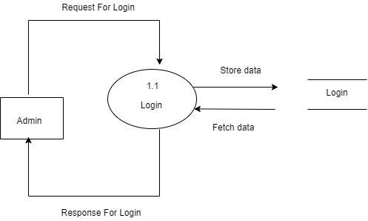

1st Level For Admin

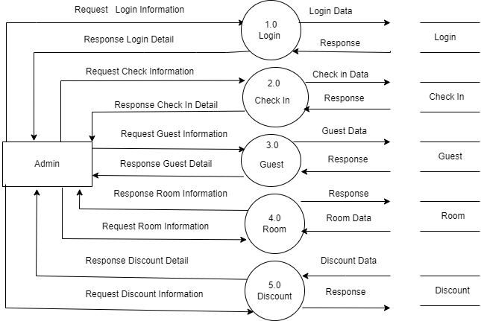

2st Level For Check In:-

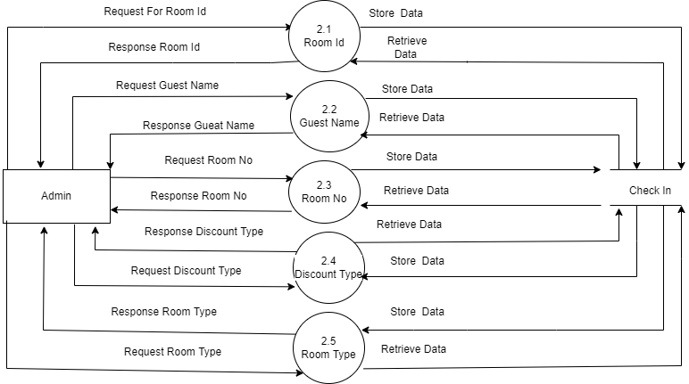

2st Level For Guest:-

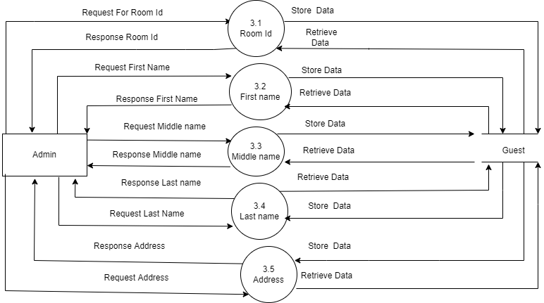

2st Level For Room:-

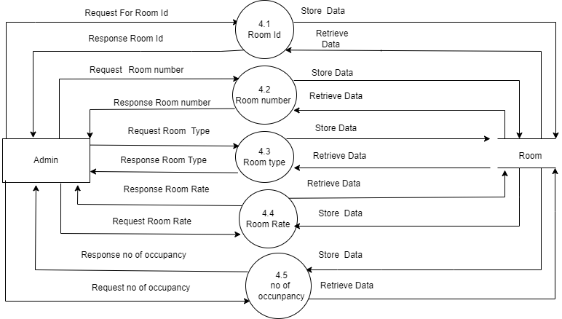
2st Level For Discount:-

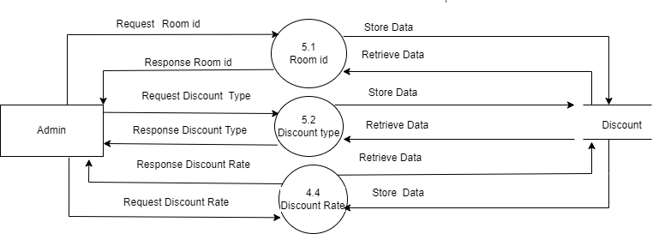

3.2 Use Case Diagram:-

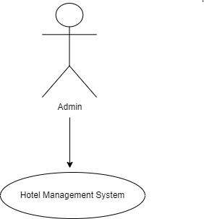

Admin Functionality:-

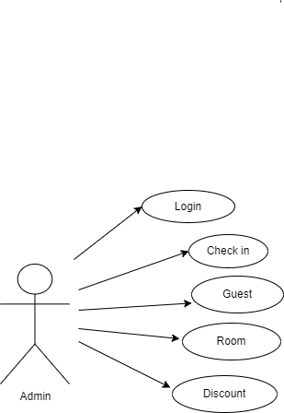

3.3 ER Diagram:-

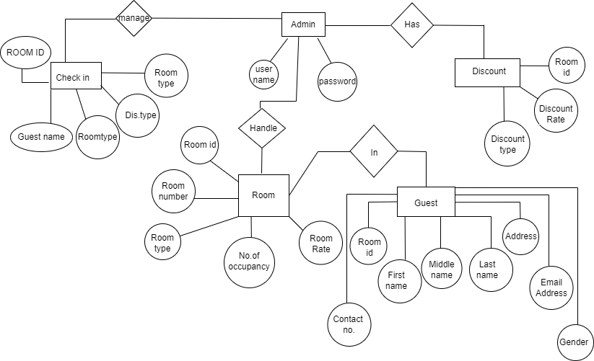

3.4 Database Design:-

Table Name : Login
Description : This table gives detail about login Information.

FIELD NAME

FIELD TYPE

CONSTRAINT

DESCRIPTION

Usernm
Text

Not Null

UserName

Password

Number

Not Null

Password

Table Name : Check In
Description : This table gives detail about Check In Information.

FIELD NAME | FIELD TYPE | CONSTRAINT | DESCRIPTION
Roomid | number | Primary Key | Room ID
Guestname | text | Not Null | Guest Name
Roomno | number | Not Null | Room Number
Noofdays | number | Not Null | No.of Days
Noofadults | number | Not Null | No.Of.Adults
Discounttype | text | Not Null | Discount Type
Roomtype | text | Not Null | Room Type
Noofchildren | Number | Not Null | No.Of Children
Advancepayment | number | Not Null | Advance Payment
Subtotal | number | Not Null | Sub Total
Totalbalance | number | Not Null | Total Balance

Table Name : Guest
Description : This table gives detail about Guest Information.

FIELD NAME | FIELD TYPE | CONSTRAINT | DESCRIPTION
Roomid | number | Primary Key | Room ID
firstname | text | Not Null | first Name
Middlename | text | Not Null | Middle Name
Lastname | text | Not Null | Last Name
Address | text | Not Null | Address
Emailaddress | text | Not Null | Email Address
contactnumber | number | Not Null | Contact Number

Table Name : Room
Description : This table gives detail about Room Information.

FIELD NAME | FIELD TYPE | CONSTRAINT | DESCRIPTION
Roomid | number | Primary Key | Room ID
Roomnumber | number | Not Null | Room number
Roomtype | text | Not Null | Room Type
Roomrate | text | Not Null | Room Rate
noofoccupancy | number | Not Null | No.of.occupancy

Table Name : Discount
Description : This table gives detail about Discount Information.

FIELD NAME | FIELD TYPE | CONSTRAINT | DESCRIPTION
Roomid | number | Primary key | Room id
Discouunttype | text | Not Null | Discount type
Discountrate | number | Not Null | Discount rate

3.5 Data Dictionary:-

Name:Login
Alias | Not Null
Where used/how used | To retrive or store login In detail
Description | Username+Password

Name:CheckIn
Alias | Not Null
Where used/how used | To retrive or store Check In detail
Description | Roomid+Guestname+Roomnumber+Discounttype+  Roomtype
Supplementary information | Roomid must be unique

Name:Guest
Alias | Not Null
Where used/how used | To retrive or store Guest In detail
Description | Roomid+Firstname+Middlename+Lastname+Address  +Emailaddress+Contactno+Gender
Supplementary information | Roomid must be unique

Name:Room
Alias | Not Null
Where used/how used | To retrive or store Room In detail
Description | Roomid+Roomnumber+Roomtype+Roomrate+Noof  occunpancy
Supplementary information | Roomid must be unique

Name:Discount
Alias | Not Null
Where used/how used | To retrive or store Discount In detail
Description | Roomid+Discounttype+Discountrate
Supplementary information | Roomid must be unique

3.6 User Interface & Coding;-

Splashscreen:-

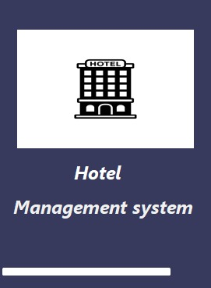
Coding:-

Public Class SplasScreenForm
Private Sub Timer1_Tick(sender As System.Object, e As System.EventArgs) Handles Timer1.Tick
Try
RectangleShape1.Width += 1
If RectangleShape1.Width >= 425 Then
Timer1.[Stop]()
Loginform.Show()
Me.Hide()

End If

Catch generatedException As Exception
Return
End Try
End Sub
End Class

Login:-

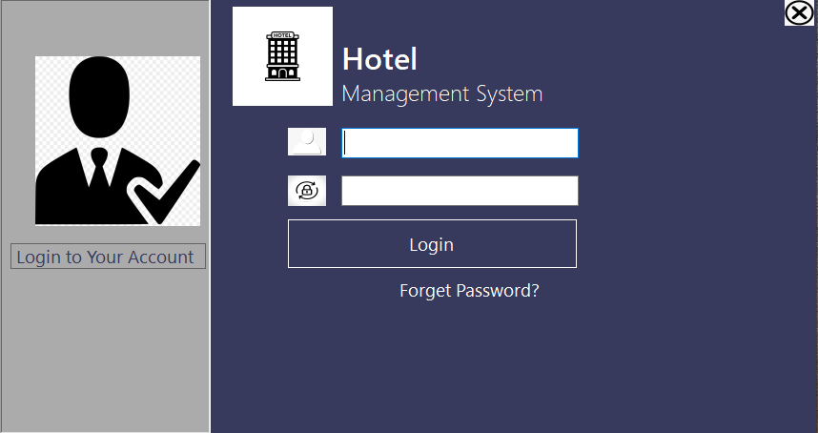

Description:- This is an admin login page and this page is used to login .

Coding:-

Imports System.Data.OleDb
Public Class Loginform
Dim cn As New OleDbConnection
Dim cmd As OleDbCommand
Dim dr As OleDbDataReader
Dim adp As New OleDbDataAdapter
Dim strcn As String
Dim ds As New DataSet

Public Sub display()
ds.Clear()
adp = New OleDbDataAdapter("select*from login", cn)
adp.Fill(ds)
End Sub
Private Sub btnclose_Click(sender As System.Object, e As System.EventArgs) Handles btnclose.Click
Application.Exit()
End Sub

Private Sub Button1_Click(sender As System.Object, e As System.EventArgs) Handles loginButton1.Click

Dim strUsername As String = txtUsername.Text
Dim strPassword As String = txtPassword.Text
Try
cn.Open()
Dim str As String
str = "select*from LOGIN where USERNAME='" + strUsername + "' and PASSWORD='" + strPassword + "'"
cmd = New OleDbCommand(str, cn)
dr = cmd.ExecuteReader()
If dr.HasRows Then
MsgBox("login success")
Dim obj = New HomeForm1
obj.Show()
Me.Hide()
Else
MsgBox("login not found")
End If
Catch ex As Exception
MsgBox("Error:" + ex.Message)
End Try
cn.Close()
End Sub
Private Sub Loginform_Load(sender As System.Object, e As System.EventArgs) Handles MyBase.Load
cn.ConnectionString = "Provider=Microsoft.ACE.OLEDB.12.0;Data Source=C:\Users\Shruti\OneDrive\Documents\hotelmanagementsytem.accdb"
cn.Open()
display()
cn.Close()
End Sub
End Class

Home:-

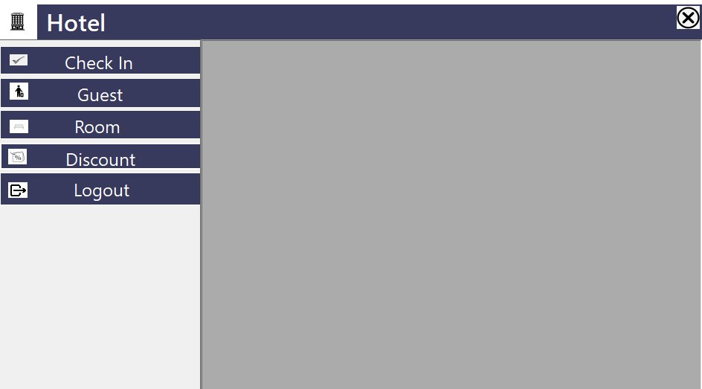

Description:- This is an Home page and this page is used to show list .

Coding:-

Public Class HomeForm1
Private Sub btnlogout_Click_1(sender As System.Object, e As System.EventArgs) Handles btnlogout.Click
Application.Exit()

End Sub
Private Sub btnclose2_Click(sender As System.Object, e As System.EventArgs) Handles btnclose2.Click
Application.Exit()
End Sub
Private Sub btnCheckin_Click(sender As System.Object, e As System.EventArgs) Handles btnCheckin.Click
Me.Show()
checkin1form.Instance.Dock = DockStyle.Fill
checkin1form.Instance.BringToFront()
checkin1form.Instance.Visible = True
checkin1form.Instance.BringToFront()
checkin1form.Instance.Visible = True
End Sub

Private Sub btnroom_Click(sender As System.Object, e As System.EventArgs) Handles btnroom.Click
Me.Show()
Roomform1.Instance.Dock = DockStyle.Fill
Roomform1.Instance.BringToFront()
Roomform1.Instance.Visible = True
Roomform1.Instance.BringToFront()
Roomform1.Instance.Visible = True
End Sub

Private Sub btndiscount_Click(sender As System.Object, e As System.EventArgs) Handles btndiscount.Click
Me.Show()
Discountform2.Instance.Dock = DockStyle.Fill
Discountform2.Instance.BringToFront()
Discountform2.Instance.Visible = True
Discountform2.Instance.BringToFront()
Discountform2.Instance.Visible = True
End Sub
Private Sub btnguest_Click(sender As System.Object, e As System.EventArgs) Handles btnguest.Click
Me.Show()
Guestform.Instance.Dock = DockStyle.Fill
Guestform.Instance.BringToFront()
Guestform.Instance.Visible = True
Guestform.Instance.BringToFront()
Guestform.Instance.Visible = True
End Sub
End Class

Checkin-

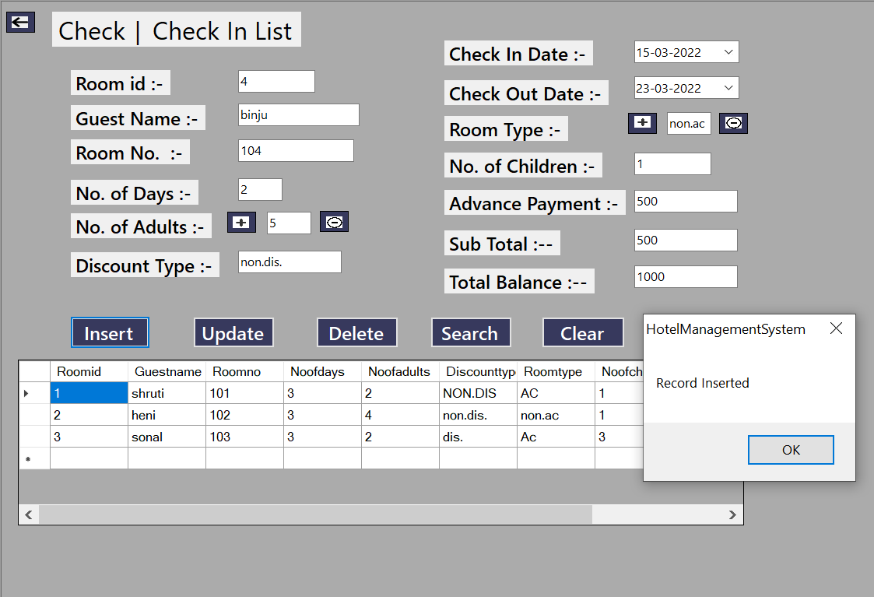

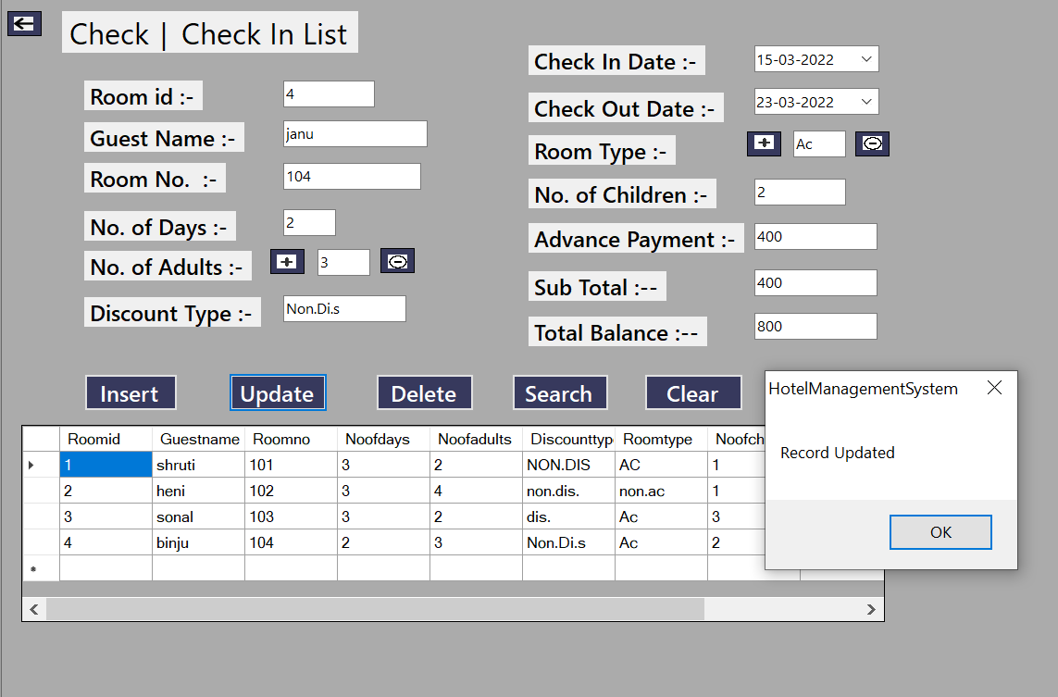

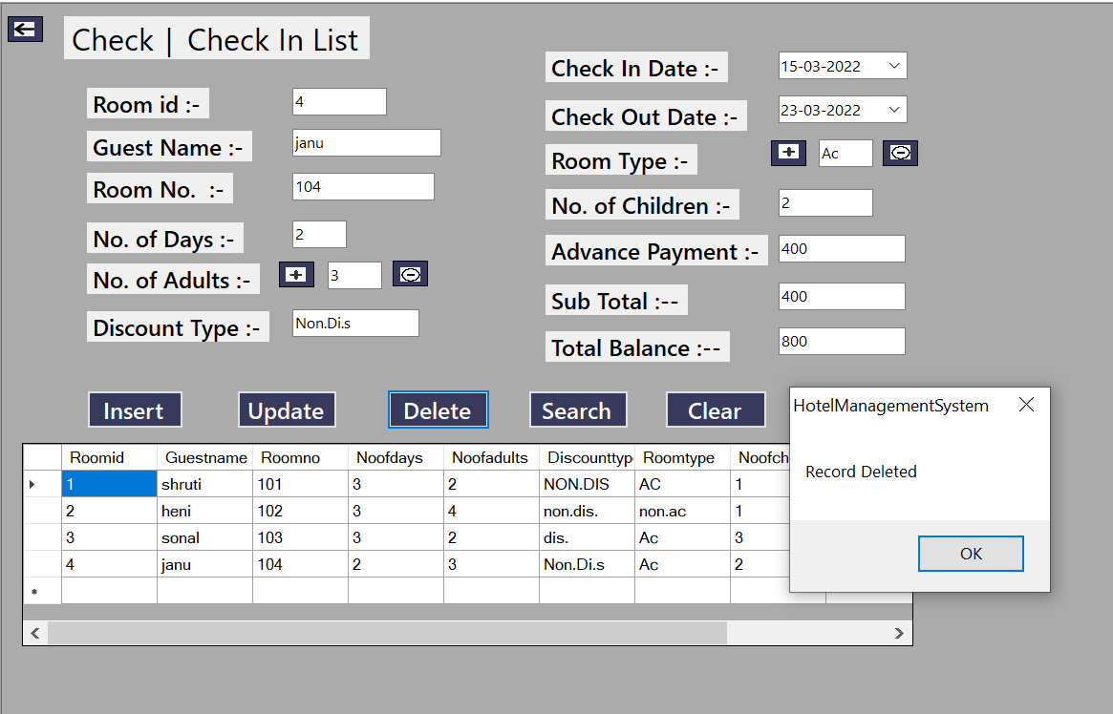

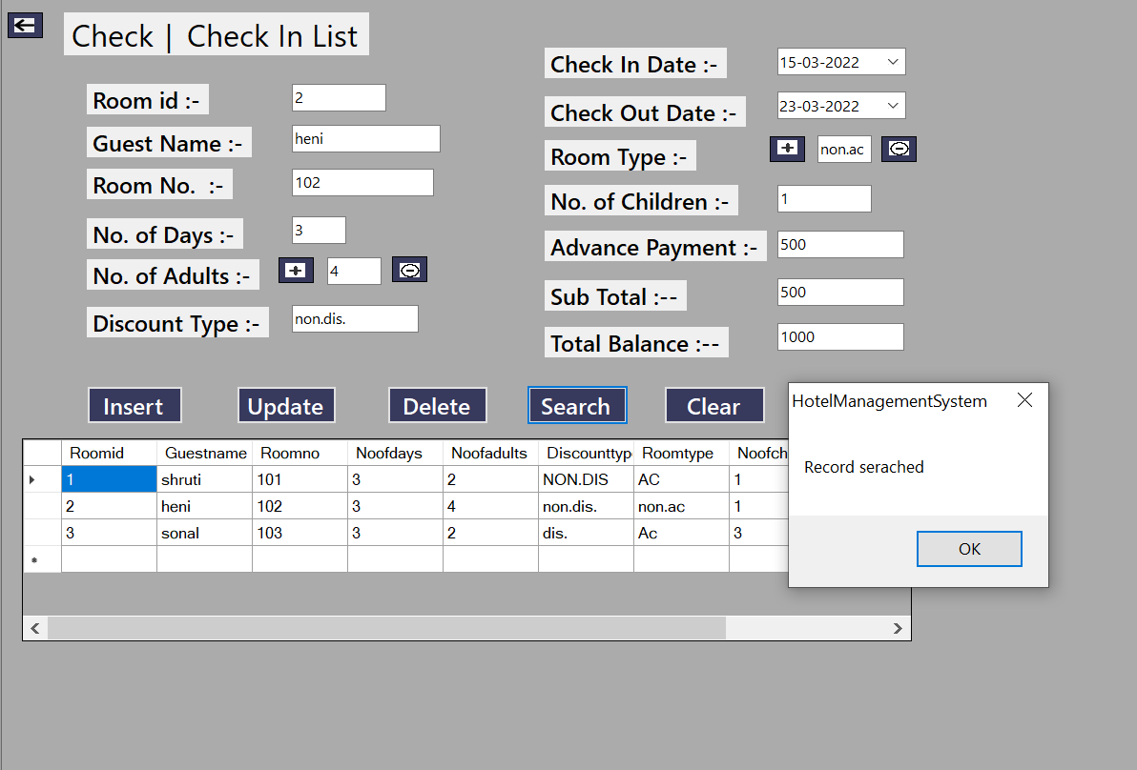

Description:- This is an Check In page and this page is used to show check in details.

Coding:-

Imports System.Data.OleDb
Public Class checkin1form
Dim cn As New OleDbConnection
Dim cmd As OleDbCommand
Dim dr As OleDbDataReader
Dim adp As New OleDbDataAdapter
Dim ds As New DataSet
Private Shared _instance As checkin1form
Public Shared ReadOnly Property Instance() As checkin1form
Get
If _instance Is Nothing Then
_instance = New checkin1form()
End If
Return _instance
End Get
End Property

Public Sub display()
ds.Clear()
adp = New OleDbDataAdapter("select*from checkinform", cn)
adp.Fill(ds)
DataGridView1.DataSource = ds.Tables(0)
End Sub

Private Sub checkin1form_Load(sender As System.Object, e As System.EventArgs) Handles MyBase.Load
cn.ConnectionString = "Provider=Microsoft.ACE.OLEDB.12.0;Data Source=C:\Users\Shruti\OneDrive\Documents\hotelmanagementsytem.accdb"
cn.Open()
display()
cn.Close()
End Sub

Private Sub btnback_Click(sender As System.Object, e As System.EventArgs) Handles btnback.Click
Me.Hide()
End Sub

Private Sub btninsert_Click(sender As System.Object, e As System.EventArgs) Handles btninsert.Click
Try
cn.Open()
Dim str As String
str = "insert into checkinform values(" & txtroomid.Text & ",'" & txtguestname.Text & "'," & txtroomno.Text & "," & txtnoofdays.Text & "," & txtnoofadults.Text & ",'" & txtdiscounttype.Text & "','" & txtroomtype.Text & "'," & txtnoofchildren.Text & "," & txtadvancepayment.Text & "," & txtsubtotal.Text & "," & txttotalbalance.Text & ")"
cmd = New OleDbCommand(str, cn)
cmd.ExecuteNonQuery()
MsgBox("Record Inserted")
display()
Catch ex As Exception
MsgBox("Insert Details")
End Try
cn.Close()
End Sub

Private Sub btnupdate_Click(sender As System.Object, e As System.EventArgs) Handles btnupdate.Click
Try
cn.Open()
Dim str As String
str = "update checkinform set Guestname='" & txtguestname.Text & "', Discounttype='" & txtdiscounttype.Text & "', Roomtype='" & txtroomtype.Text & "' where Roomno=" & txtroomno.Text & ""
cmd = New OleDbCommand(str, cn)
cmd.ExecuteNonQuery()
MsgBox("Record Updated")
display()
Catch ex As Exception
MsgBox("Update Details")
End Try
cn.Close()
End Sub

Private Sub btndelete_Click(sender As System.Object, e As System.EventArgs) Handles btndelete.Click
Try
cn.Open()
Dim str As String
str = "delete from checkinform where Guestname= '" & txtguestname.Text & "'"
cmd = New OleDbCommand(str, cn)
cmd.ExecuteNonQuery()
MsgBox("Record Deleted")
display()
Catch ex As Exception
MsgBox("Delete Details")
End Try
cn.Close()
End Sub

Private Sub btnsearch_Click(sender As System.Object, e As System.EventArgs) Handles btnsearch.Click
Try
cn.Open()
Dim str As String
str = "select*from checkinform where Roomid=" & txtroomid.Text & ""
cmd = New OleDbCommand(str, cn)
dr = cmd.ExecuteReader()
While dr.Read()
txtguestname.Text = dr.Item(1)
txtroomno.Text = dr.Item(2)
txtnoofdays.Text = dr.Item(3)
txtnoofadults.Text = dr.Item(4)
txtdiscounttype.Text = dr.Item(5)
txtroomtype.Text = dr.Item(6)
txtnoofchildren.Text = dr.Item(7)
txtadvancepayment.Text = dr.Item(8)
txtsubtotal.Text = dr.Item(9)
txttotalbalance.Text = dr.Item(10)
End While
MsgBox("Record serached")
Catch ex As Exception
MsgBox(ex.ToString, MsgBoxStyle.Information, "Record Not Found")
End Try
cn.Close()
End Sub
Private Sub btnclear_Click(sender As System.Object, e As System.EventArgs) Handles btnclear.Click
txtroomid.Clear()
txtguestname.Clear()
txtroomno.Clear()
txtnoofdays.Clear()
txtnoofadults.Clear()
txtdiscounttype.Clear()
txtroomtype.Clear()
txtnoofchildren.Clear()
txtadvancepayment.Clear()
txtsubtotal.Clear()
txttotalbalance.Clear()
End Sub

Private Sub btnclose_Click(sender As System.Object, e As System.EventArgs) Handles btnclose.Click
Me.Close()
End Sub
End Class

Guest:-

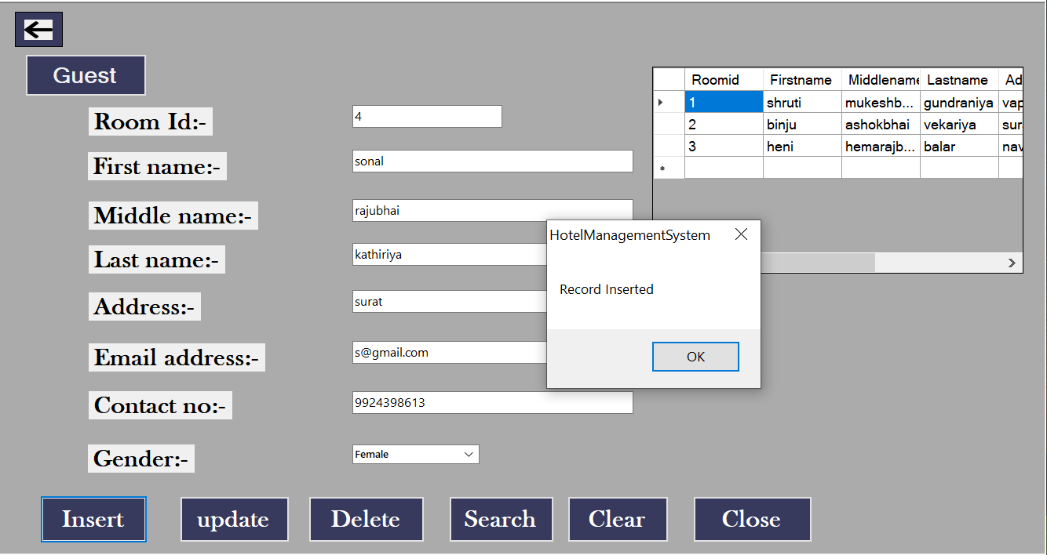

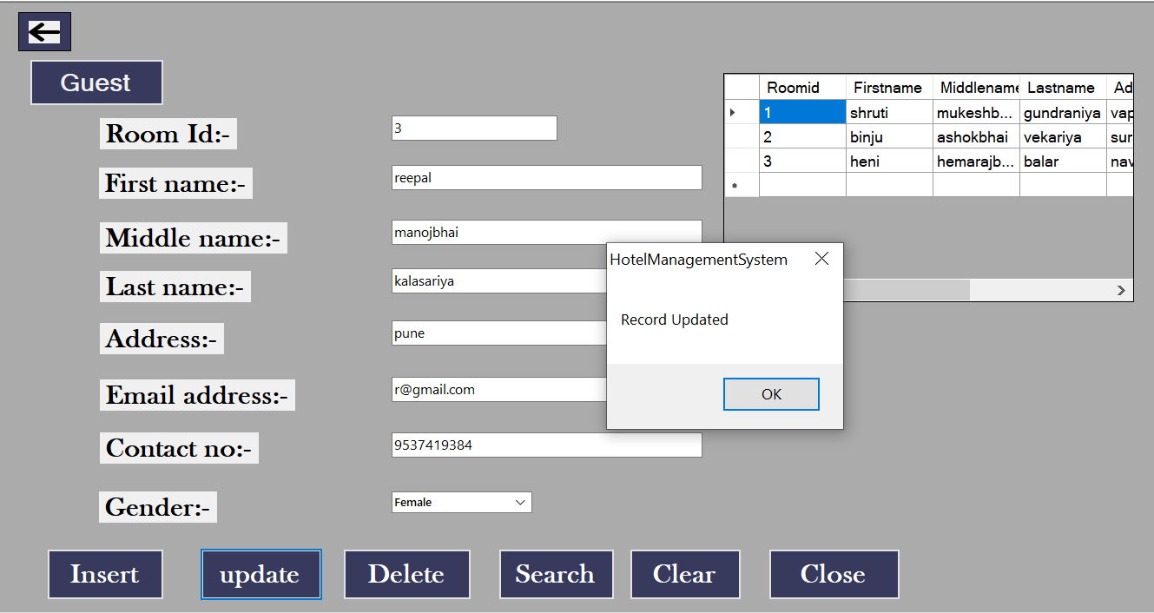

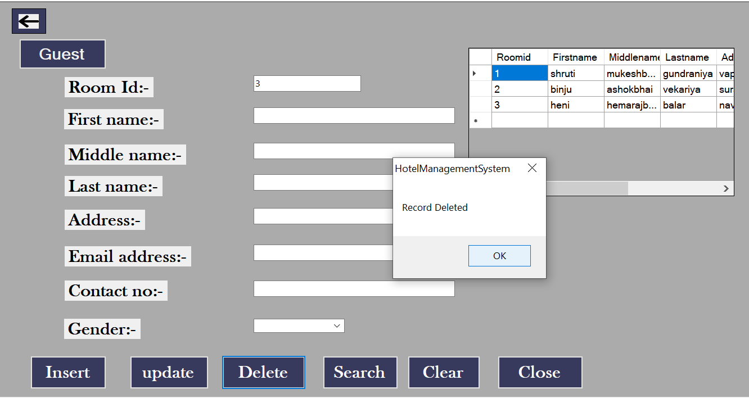

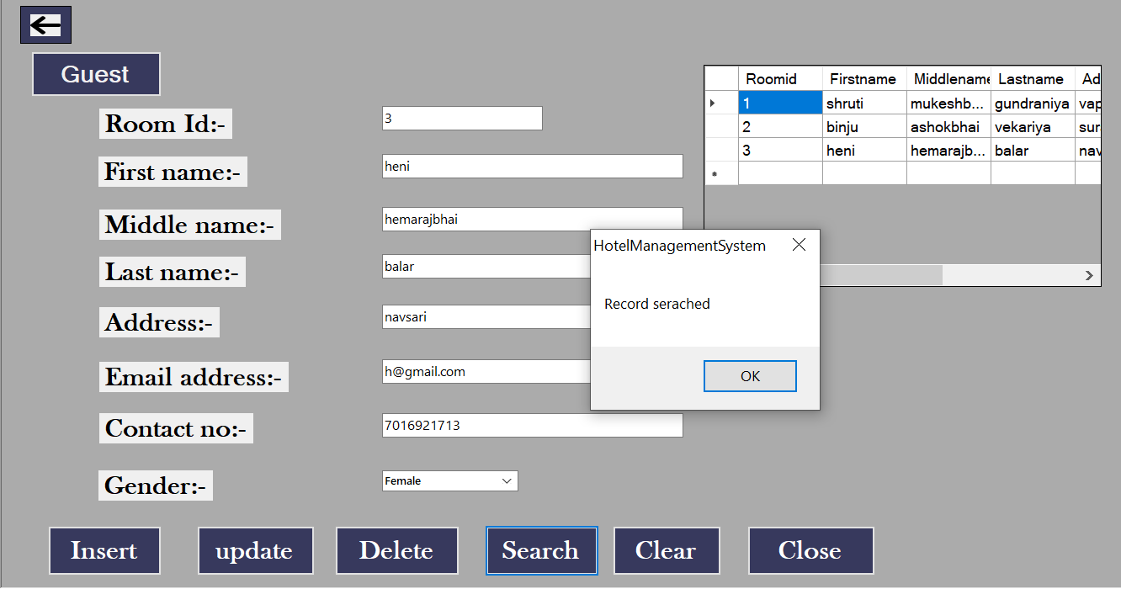

Description:- This is an page Guest and this page is used to show Guest details.

Coding:-
Imports System.Data.OleDb
Public Class Guestform
Dim cn As New OleDbConnection
Dim cmd As OleDbCommand
Dim dr As OleDbDataReader
Dim adp As New OleDbDataAdapter
Dim ds As New DataSet
Private Shared _instance As Guestform
Public Shared ReadOnly Property Instance() As Guestform
Get
If _instance Is Nothing Then
_instance = New Guestform()
End If
Return _instance
End Get
End Property
Public Sub display()
ds.Clear()
adp = New OleDbDataAdapter("select*from guestform ", cn)
adp.Fill(ds)
DataGridView1.DataSource = ds.Tables(0)
End Sub
Private Sub btnback_Click(sender As System.Object, e As System.EventArgs) Handles btnback.Click
Me.Hide()
End Sub

Private Sub Guestform_Load(sender As System.Object, e As System.EventArgs) Handles MyBase.Load
cn.ConnectionString = "Provider=Microsoft.ACE.OLEDB.12.0;Data Source=C:\Users\Shruti\OneDrive\Documents\hotelmanagementsytem.accdb"
cn.Open()
display()
cn.Close()
End Sub
Private Sub btninsert_Click(sender As System.Object, e As System.EventArgs) Handles btninsert.Click
Try
cn.Open()
Dim str As String
str = "insert into guestform values(" & txtroomid.Text & ",'" & txtfirstname.Text & "','" & txtmiddlename.Text & "','" & txtlastname.Text & "','" & txtaddress.Text & "','" & txtemailaddress.Text & "'," & txtcontactno.Text & ")"
cmd = New OleDbCommand(str, cn)
cmd.ExecuteNonQuery()
MsgBox("Record Inserted")
display()
Catch ex As Exception
MsgBox("Insert Details")
End Try
cn.Close()
End Sub
Private Sub btnupdate_Click(sender As System.Object, e As System.EventArgs) Handles btnupdate.Click
Try
cn.Open()
Dim str As String
str = "update guestform set Firstname='" & txtfirstname.Text & "', Address='" & txtaddress.Text & "' , Contactno=" & txtcontactno.Text & " where Roomid=" & txtroomid.Text & ""
cmd = New OleDbCommand(str, cn)
cmd.ExecuteNonQuery()
MsgBox("Record Updated")
display()
Catch ex As Exception
MsgBox("Update Details")
End Try
cn.Close()
End Sub

Private Sub btndelete_Click(sender As System.Object, e As System.EventArgs) Handles btndelete.Click
Try
cn.Open()
Dim str As String
str = "delete from guestform where Firstname= '" & txtfirstname.Text & "'"
cmd = New OleDbCommand(str, cn)
cmd.ExecuteNonQuery()
MsgBox("Record Deleted")
display()
Catch ex As Exception
MsgBox("Delete Details")
End Try
cn.Close()
End Sub

Private Sub btnsearch_Click(sender As System.Object, e As System.EventArgs) Handles btnsearch.Click
Try
cn.Open()

Dim str As String
str = "select*from guestform where Roomid=" & txtroomid.Text & ""
cmd = New OleDbCommand(str, cn)
dr = cmd.ExecuteReader()
While dr.Read()
txtfirstname.Text = dr.Item(1)
txtmiddlename.Text = dr.Item(2)
txtlastname.Text = dr.Item(3)
txtaddress.Text = dr.Item(4)
txtemailaddress.Text = dr.Item(5)
txtcontactno.Text = dr.Item(6)
End While
MsgBox("Record serached")
Catch ex As Exception
MsgBox(ex.ToString, MsgBoxStyle.Information, "Record Not Found")
End Try
cn.Close()
End Sub
Private Sub btnClear_Click(sender As System.Object, e As System.EventArgs) Handles btnClear.Click
txtroomid.Clear()
txtfirstname.Clear()
txtmiddlename.Clear()
txtlastname.Clear()
txtaddress.Clear()
txtemailaddress.Clear()
txtcontactno.Clear()
End Sub
Private Sub btnclose_Click(sender As System.Object, e As System.EventArgs) Handles btnclose.Click
Me.Close()
End Sub
End Class

Room:-

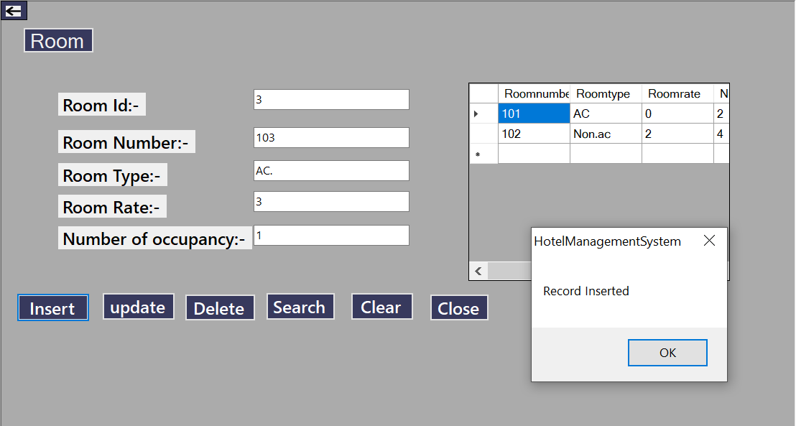

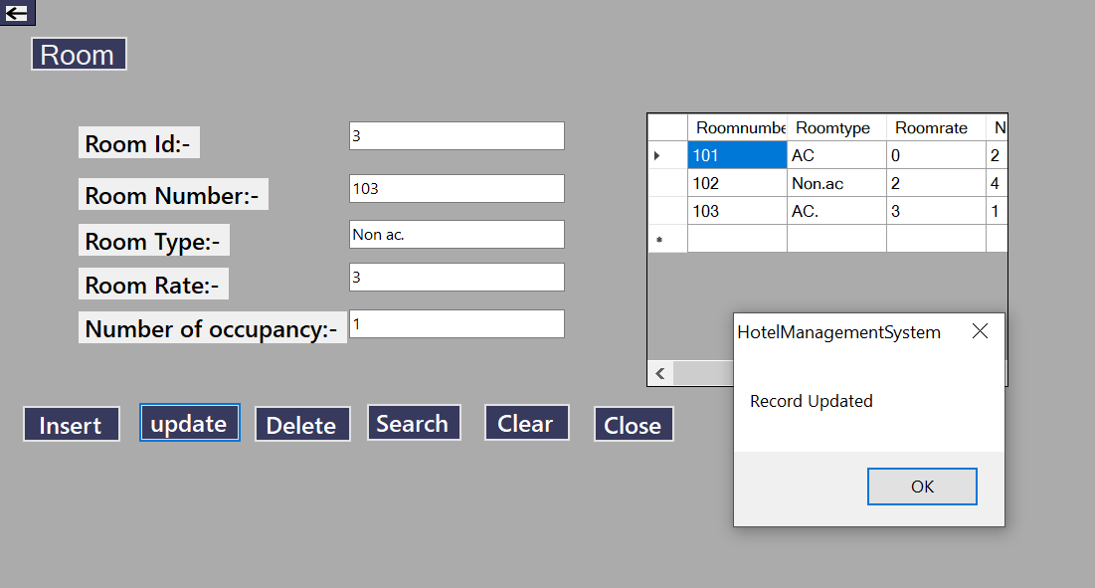

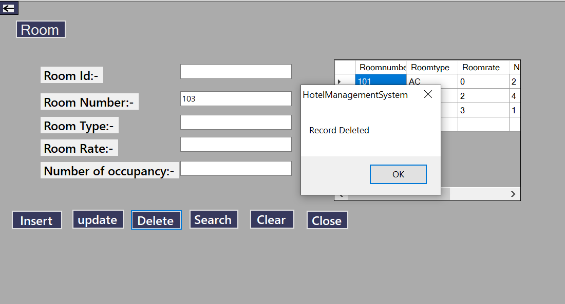

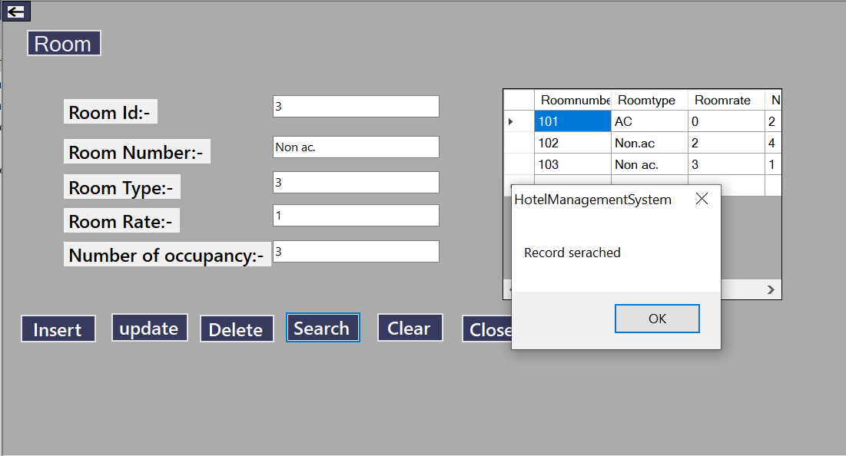

Description:- This is an Room page and this page is used to show Room details.

Coding:-

Imports System.Data.OleDb
Public Class Roomform1
Dim cn As New OleDbConnection
Dim cmd As OleDbCommand
Dim dr As OleDbDataReader
Dim adp As New OleDbDataAdapter
Dim ds As New DataSet
Private Shared _instance As Roomform1
Public Shared ReadOnly Property Instance() As Roomform1
Get
If _instance Is Nothing Then
_instance = New Roomform1()
End If
Return _instance
Sub End Get
End Property

Public display()
ds.Clear()
adp = New OleDbDataAdapter("select*from Roomform ", cn)
adp.Fill(ds)
DataGridView1.DataSource = ds.Tables(0)
End Sub
Private Sub btnback_Click(sender As System.Object, e As System.EventArgs) Handles btnback.Click
Me.Hide()
End Sub
Private Sub Roomform1_Load(sender As System.Object, e As System.EventArgs) Handles MyBase.Load
cn.ConnectionString = "Provider=Microsoft.ACE.OLEDB.12.0;Data Source=C:\Users\Shruti\OneDrive\Documents\hotelmanagementsytem.accdb"
cn.Open()
display()
cn.Close()
End Sub

Private Sub btninsert_Click(sender As System.Object, e As System.EventArgs) Handles btninsert.Click
Try
cn.Open()
Dim str As String
str = "insert into Roomform values(" & txtroomnumber.Text & ", '" & txtroomtype.Text & "'," & txtroomrate.Text & "," & txtnumberofoccupancy.Text & "," & txtroomid.Text & ")"
cmd = New OleDbCommand(str, cn)
cmd.ExecuteNonQuery()
MsgBox("Record Inserted")
display()
Catch ex As Exception
MsgBox("Insert Details")
End Try
cn.Close()
End Sub

Private Sub btnupdate_Click(sender As System.Object, e As System.EventArgs) Handles btnupdate.Click
Try
cn.Open()

Dim str As String
str = "update Roomform set Roomtype= '" & txtroomtype.Text & "', Roomrate= '" & txtroomrate.Text & "', Numberofoccupancy= " & txtnumberofoccupancy.Text & " where Roomnumber=" & txtroomnumber.Text & ""
cmd = New OleDbCommand(str, cn)
cmd.ExecuteNonQuery()
MsgBox("Record Updated")
display()
Catch ex As Exception
MsgBox("Update Details")
End Try
cn.Close()
End Sub

Private Sub btndelete_Click(sender As System.Object, e As System.EventArgs) Handles btndelete.Click
Try
cn.Open()
Dim str As String
str = "delete from Roomform where Roomnumber = " & txtroomnumber.Text & ""
cmd = New OleDbCommand(str, cn)
cmd.ExecuteNonQuery()
MsgBox("Record Deleted")
display()
Catch ex As Exception
MsgBox("Delete Details")
End Try
cn.Close()
End Sub

Private Sub btnsearch_Click(sender As System.Object, e As System.EventArgs) Handles btnsearch.Click
Try
cn.Open()
Dim str As String
str = "select*from Roomform where Roomid=" & txtroomid.Text & ""
cmd = New OleDbCommand(str, cn)
dr = cmd.ExecuteReader()
While dr.Read()
txtroomnumber.Text = dr.Item(1)
txtroomtype.Text = dr.Item(2)
txtroomrate.Text = dr.Item(3)
txtnumberofoccupancy.Text = dr.Item(4)
End While
MsgBox("Record serached")
Catch ex As Exception
MsgBox(ex.ToString, MsgBoxStyle.Information, "Record Not Found")
End Try
cn.Close()
End Sub
Private Sub btnClear_Click(sender As System.Object, e As System.EventArgs) Handles btnClear.Click
txtroomnumber.Clear()
txtroomtype.Clear()
txtroomrate.Clear()
txtnumberofoccupancy.Clear()
txtroomid.Clear()
Me.Close()
End Sub
End Class

Discount:-

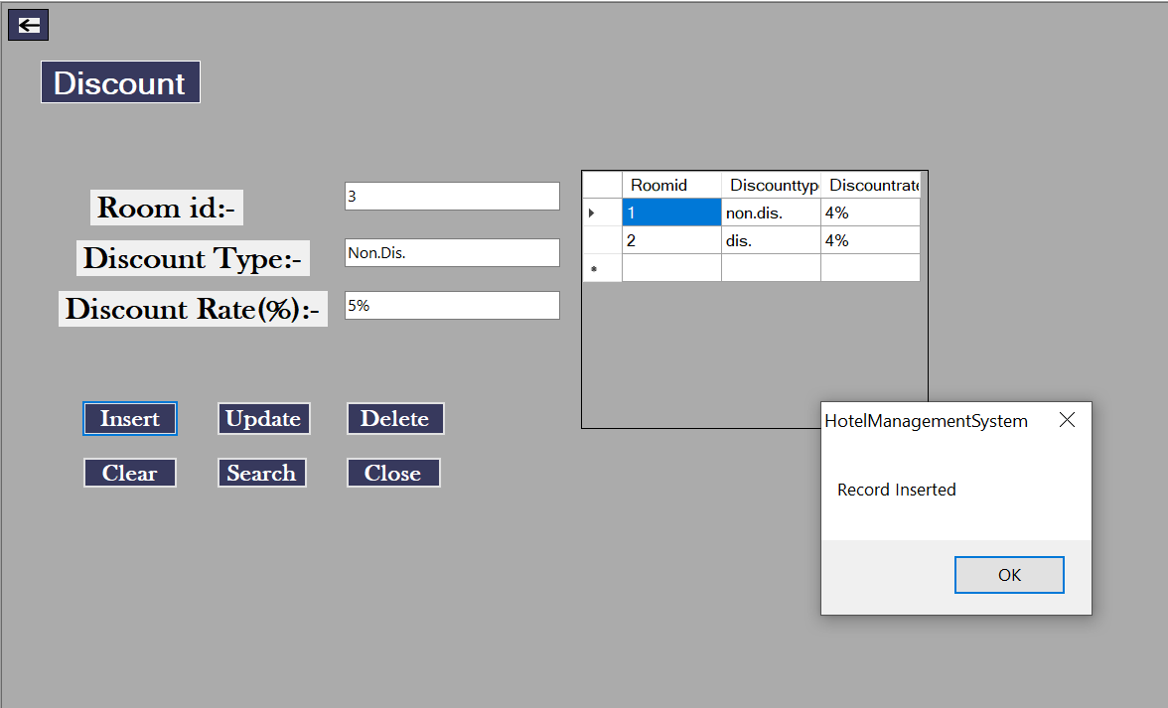

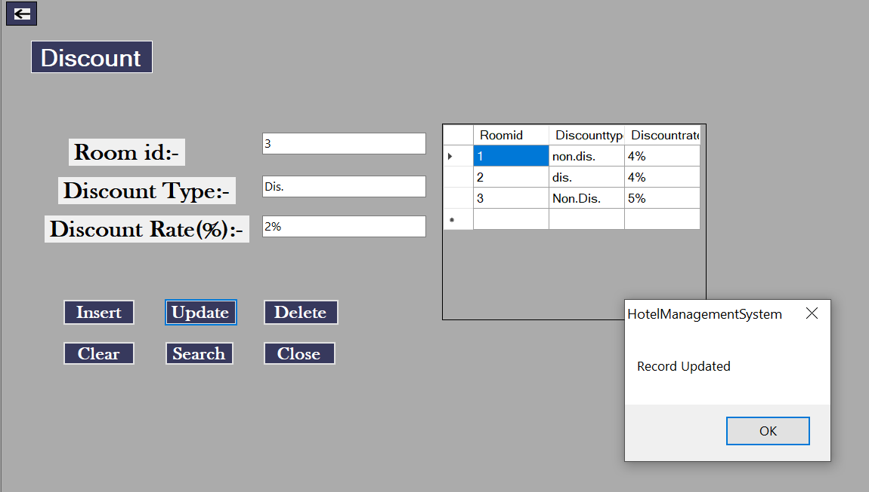

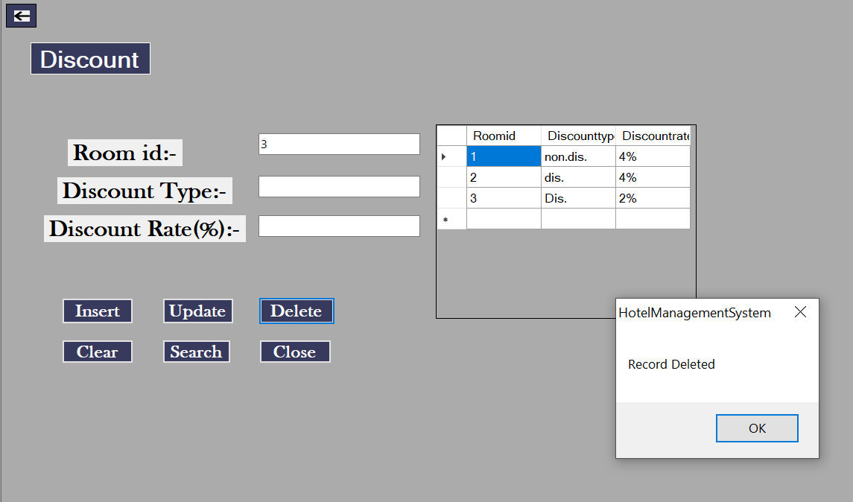

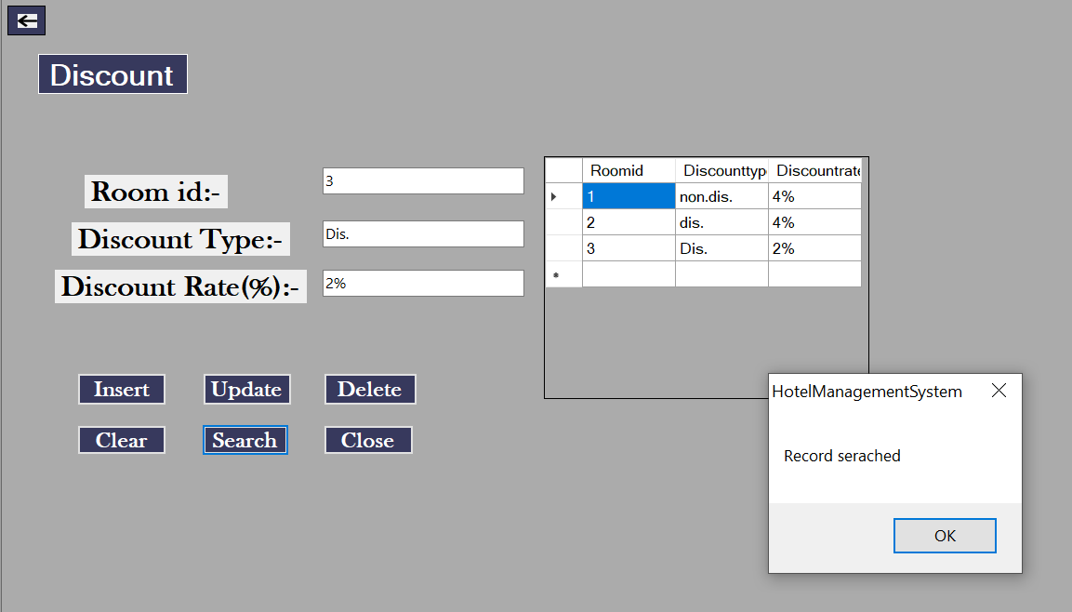

Description:- This is an Discount page and this page is used to show Discount details.

Coding:-
Imports System.Data.OleDb
Public Class Discountform2
Dim cn As New OleDbConnection
Dim cmd As OleDbCommand
Dim dr As OleDbDataReader
Dim adp As New OleDbDataAdapter
Dim ds As New DataSet
Private Shared _instance As Discountform2
Public Shared ReadOnly Property Instance() As Discountform2
Get
If _instance Is Nothing Then
_instance = New Discountform2()
End If
Return _instance
End Get
End Property

Public Sub display()
ds.Clear()
adp = New OleDbDataAdapter("select*from discountform", cn)
adp.Fill(ds)
DataGridView1.DataSource = ds.Tables(0)
End Sub

Private Sub Discountform2_Load(sender As System.Object, e As System.EventArgs) Handles MyBase.Load
cn.ConnectionString = "Provider=Microsoft.ACE.OLEDB.12.0;Data Source=C:\Users\Shruti\OneDrive\Documents\hotelmanagementsytem.accdb"
cn.Open()

display()
cn.Close()
End Sub

Private Sub btnback_Click(sender As System.Object, e As System.EventArgs) Handles btnback.Click
Me.Hide()
End Sub

Private Sub btninsert_Click(sender As System.Object, e As System.EventArgs) Handles btninsert.Click
Try
cn.Open()
Dim str As String
str = "insert into discountform values(" & txtroomid.Text & ",'" & txtdistype.Text & "','" & txtdisrate.Text & "')"
cmd = New OleDbCommand(str, cn)
cmd.ExecuteNonQuery()
MsgBox("Record Inserted")
display()
Catch ex As Exception
MsgBox("Insert Details")
End Try
cn.Close()
End Sub

Private Sub btnupdate_Click(sender As System.Object, e As System.EventArgs) Handles btnupdate.Click
Try
cn.Open()
Dim str As String
str = "update discountform set Discounttype='" & txtdistype.Text & "' , Discountrate= '" & txtdisrate.Text & "' where Roomid=" & txtroomid.Text & ""
cmd = New OleDbCommand(str, cn)
cmd.ExecuteNonQuery()
MsgBox("Record Updated")
display()
Catch ex As Exception
MsgBox("Update Details")
End Try
cn.Close()
End Sub

Private Sub btndelete_Click(sender As System.Object, e As System.EventArgs) Handles btndelete.Click
Try
cn.Open()
Dim str As String
str = "delete from discountform where Roomid = " & txtroomid.Text & ""
cmd = New OleDbCommand(str, cn)
cmd.ExecuteNonQuery()
MsgBox("Record Deleted")
display()
Catch ex As Exception
MsgBox("Delete Details")
End Try
cn.Close()
End Sub

Private Sub btnsearch_Click(sender As System.Object, e As System.EventArgs) Handles btnsearch.Click
Try

cn.Open()
Dim str As String
str = "select*from discountform where Roomid=" & txtroomid.Text & ""
cmd = New OleDbCommand(str, cn)
dr = cmd.ExecuteReader()
While dr.Read()
txtdistype.Text = dr.Item(1)
txtdisrate.Text = dr.Item(2)
End While
MsgBox("Record serached")
Catch ex As Exception
MsgBox(ex.ToString, MsgBoxStyle.Information, "Record Not Found")
End Try
cn.Close()
End Sub

Private Sub btnClear_Click(sender As System.Object, e As System.EventArgs) Handles btnClear.Click
txtroomid.Clear()
txtdistype.Clear()
txtdisrate.Clear()
End Sub
Private Sub btnclose_Click(sender As System.Object, e As System.EventArgs) Handles btnclose.Click
Me.Close()
End Sub
End Class

4. Testing

4.1 Unit Testing:-

- A unit is the smallest testable part of software. It usually has one or a few inputs and usually a single output.

- In procedural programming a unit may be an individual program, function, procedure, etc.

- In object-oriented programming, the smallest unit is a method, which may belong to a base/super class, abstract class or derived/child class.

- Some treat a module of an application as a unit. This is to be discouraged as there will probably be many individual units within that module.

- Unit testing is the first level of testing and is performed prior to Integration Testing.

- Unit Testing is normally performed by software developers themselves or their peers. In rare cases it may also be performed by independent software testers.

Test Case:-

Name | Valid Admin Login Test
Description | This Test case will check weather username and password is valid or not. If not then it will not allow the admin to Login.
Input Data | - Valid Username and password which is already define.  - Valid Username but Wrong Password.  - Wrong Username and Valid Password.  - Wrong Username and Password.
Excepted Output | ✓ System always Login.  - System Prompt error that Invalid Username Or Password.  - System Prompt error that Enter Username and Password.  - System Prompt error that Invalid Username Or  Password
Actual Output | System allows Login.

4.2 Integration Testing:-

Link | Expected Page | Result of Page
My profile | Profile Page of Admin | Profile Page of Admin
Logout | Login Page of Admin | Login Page of Admin
Admin | Add Admin and View  Admin Page | Add Admin and View  Admin Page

4.3 System Testing:-

- System Testing is a level of the software testing where complete and integrated software is tested.

- The purpose of this test is to evaluate the system’s compliance with the specified requirements.

- The process of testing an integrated system to verify that it meets specified requirements.

- System Testing performed after Integration Testing and before Acceptance Testing.

- Normally, independent Testers perform System Testing.

- Firefox browser, Internet explorer and chrome consider testing for environment operability of software.

- Database – Microsoft access 2007
- OS – Windows 10
- Purpose of this software is to make the work easier for customers.
- Automation of the system improves the efficiency level.
- It is a friendly graphical user interface when compared to the system that already exists.
- It give authenticate access to the authorized users depending upon their user type.
- It effectively overcomes the delay in communications.
- The System has adequate scope for modification in future if it is necessary.

5.Conclusion

CONCLUSION While learning from experience is powerful thing, it is an expensive pedagogical technique in the business world.
It is therefore helpful to understand the different types of mistakes that users usually make while constructing the DFD model of systems.

6. Bibliography & Reference

> https://www.tutorialspoint.com
> http://www.w3school.com
> http://m.youtube.com etc..

