**Improvements On suits supply web page:**

Currently when user selects any custom made product, the first section is always displayed with filter options. These filter always have options which are always constant. They can be more responsive. This will help user filter appropriate products and avoid error message product not found.

**Example:**

**Herringbone** Design has only one product but the color filter still show all the colors as option for the user. If the user select any other color other than Red, error message will be displayed.

The one filter is selected by the customer, other filters can be improved to display only the relevant options, so that the customer can avoid error combinations.

Select “HERRINGBONE” design filter

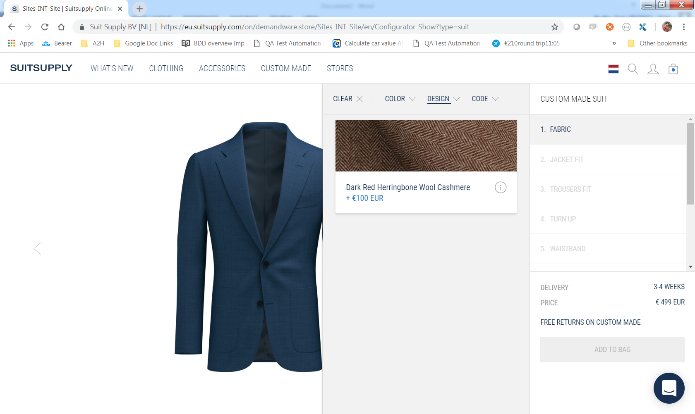

Select “Green” Color

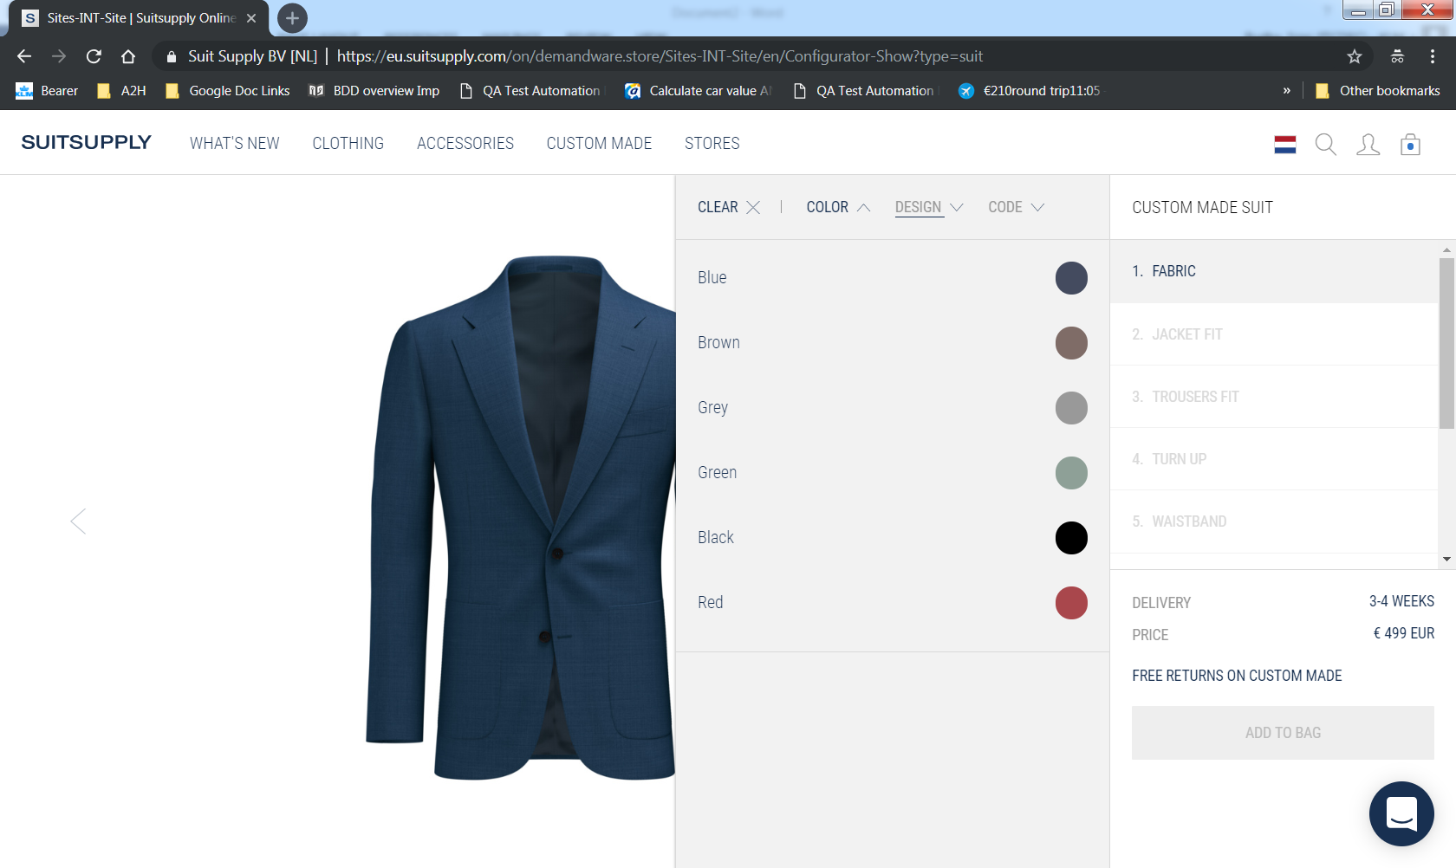

Error is displayed

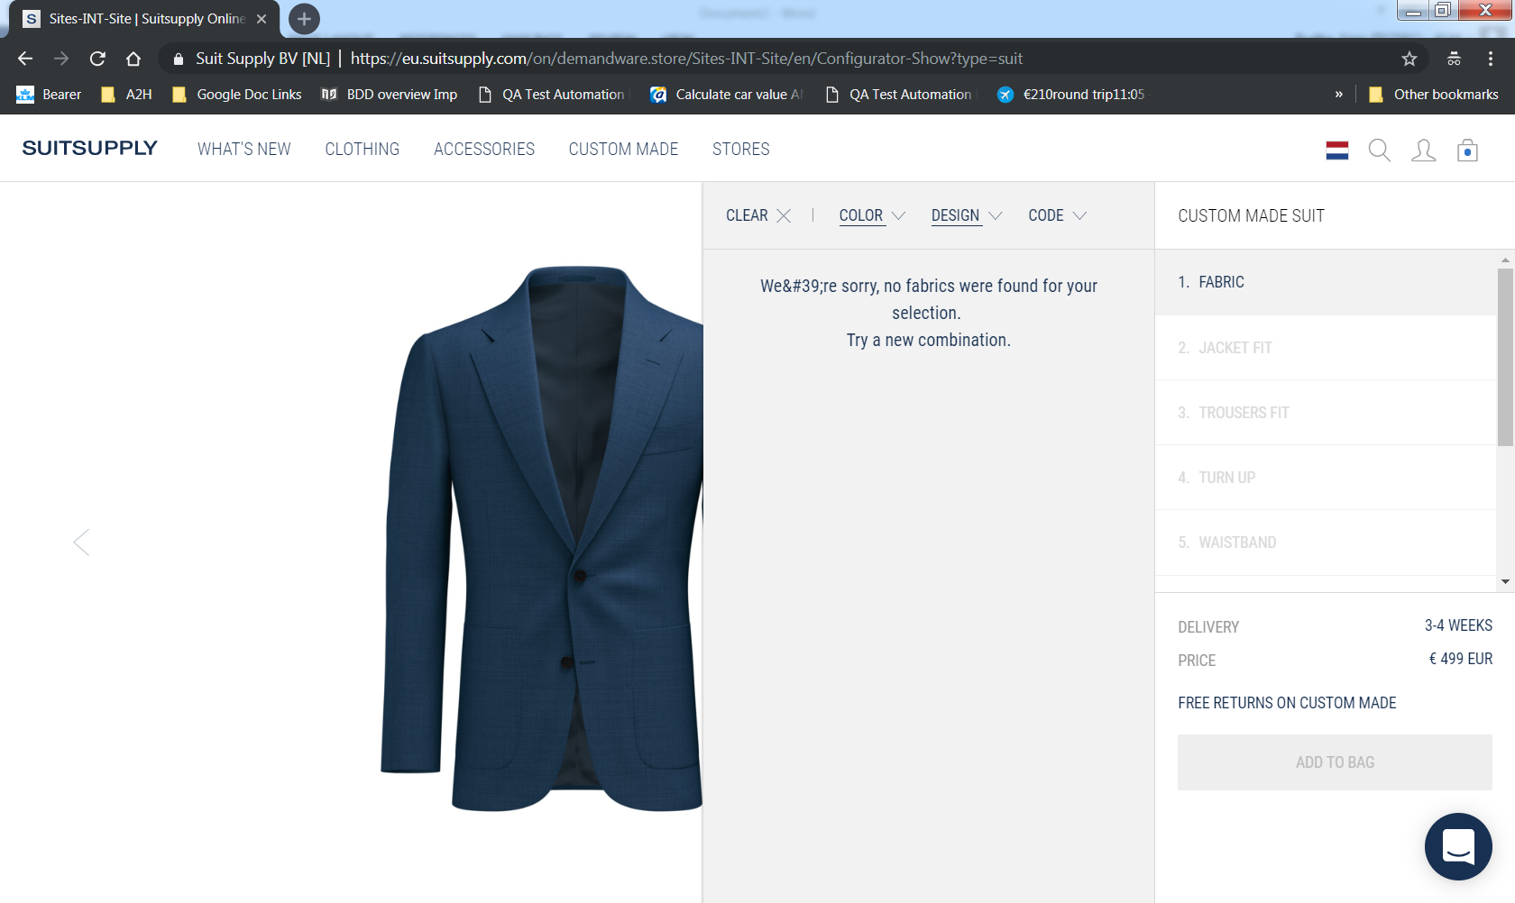

**Observation:**

Above Error message is not correct.

The error message displayed is “**We&#39;re sorry, no fabrics were found for your selection.   
Try a new combination.”**

Error message should be displayed as “We are sorry, no fabrics were found for your selection.   
Try a new combination.”