**Assignment No:01**

**Title: Create an account in AWS and configure budget**

**Step-1:**

Open the AWS Management Console and click on the user name in the top right corner and click on the Billing and cost management.

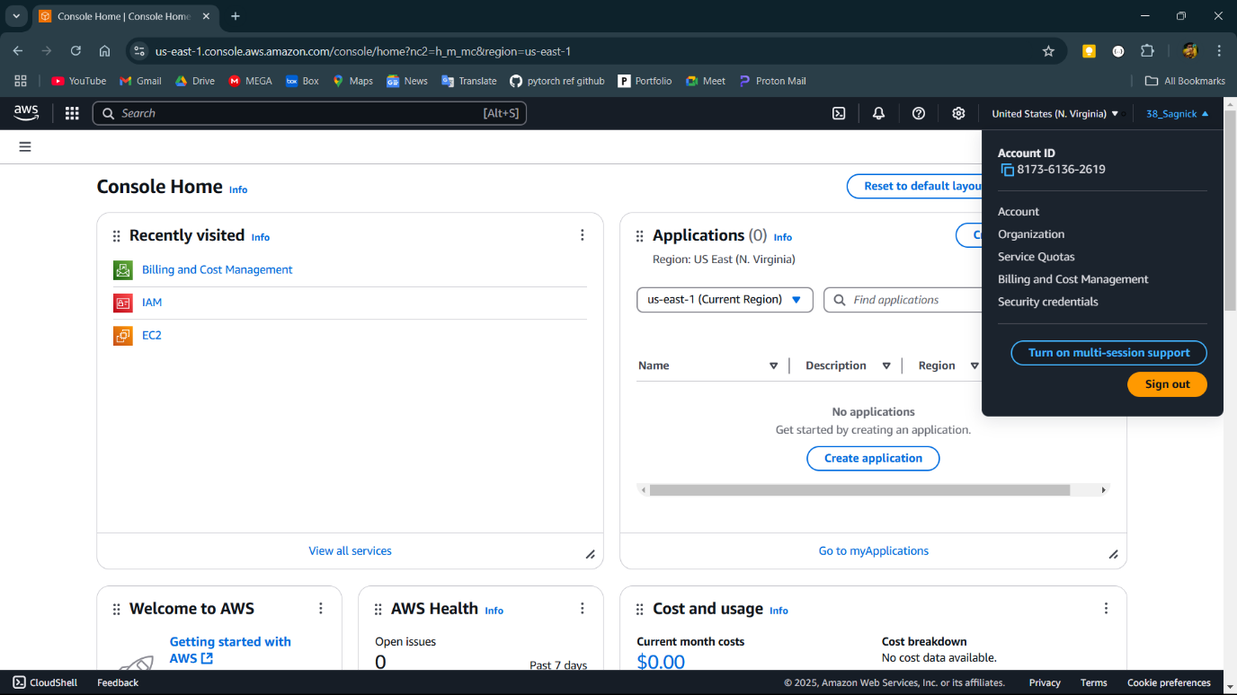

**Step-2:**

Select the Budgets option from the right side.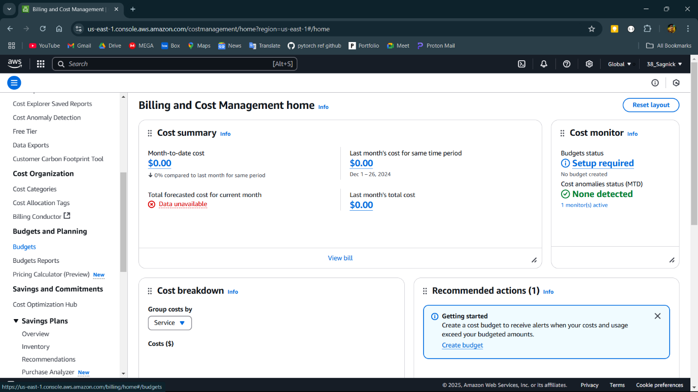

**Step-3:**

Click on the Create a budget button to create a new budget.

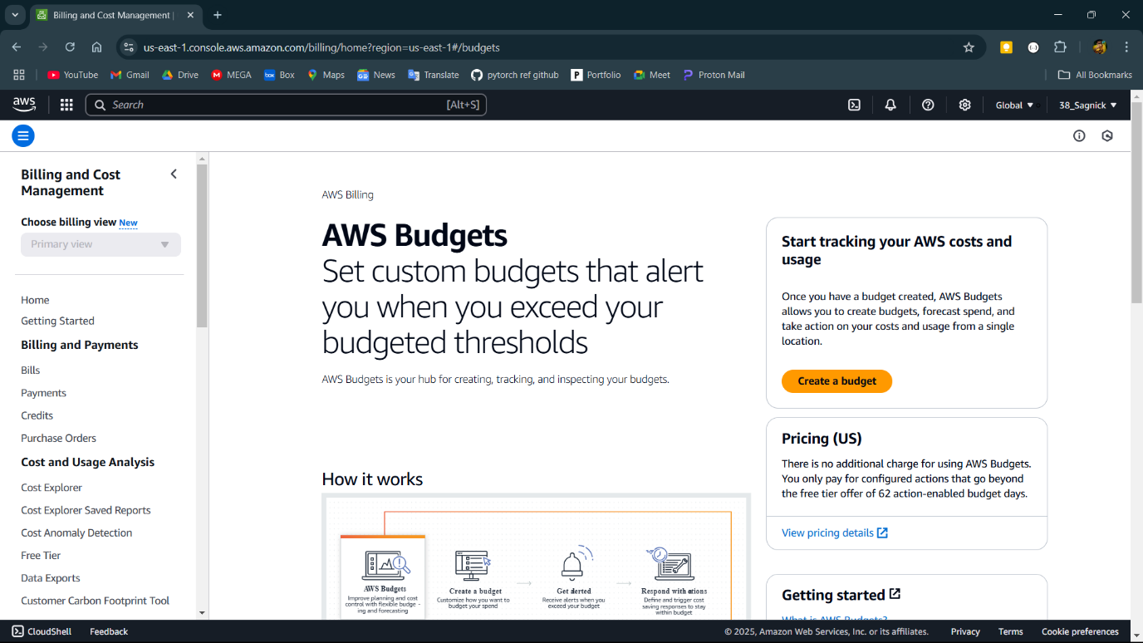

**Step-4:**

Choose the Customize to customize the budget.

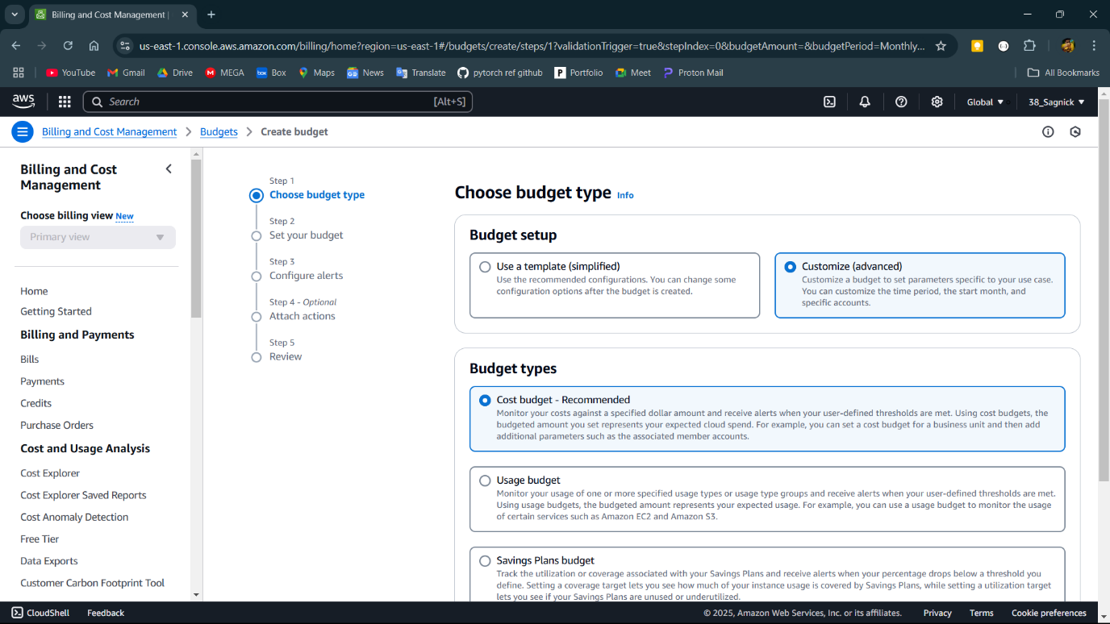

**Step-5:**

Write essential details here like name of the budget, period, budget .

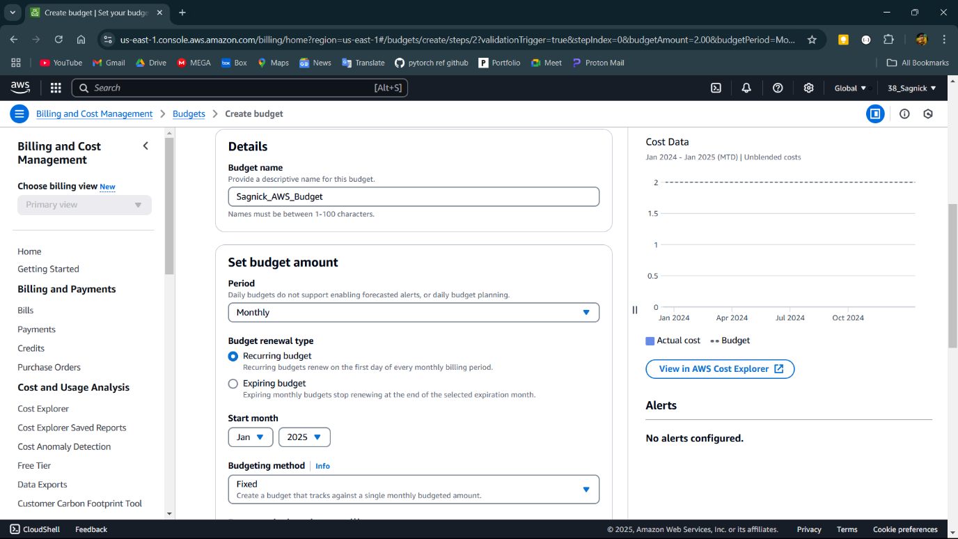

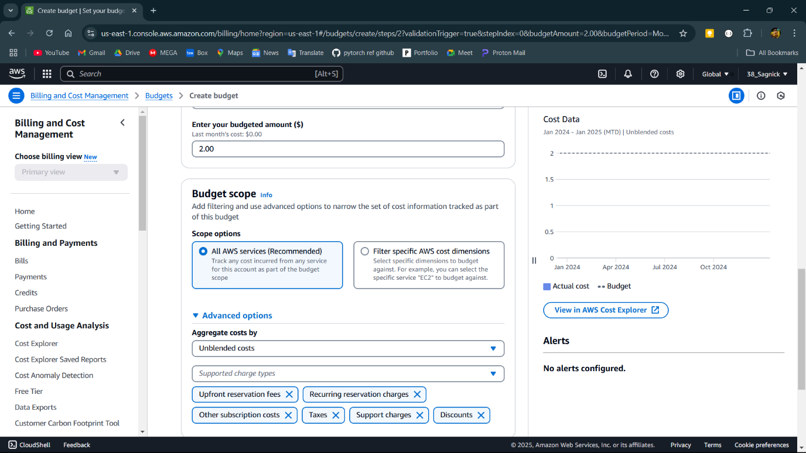

**Step-6:**

Click on the Add an alert threshold.

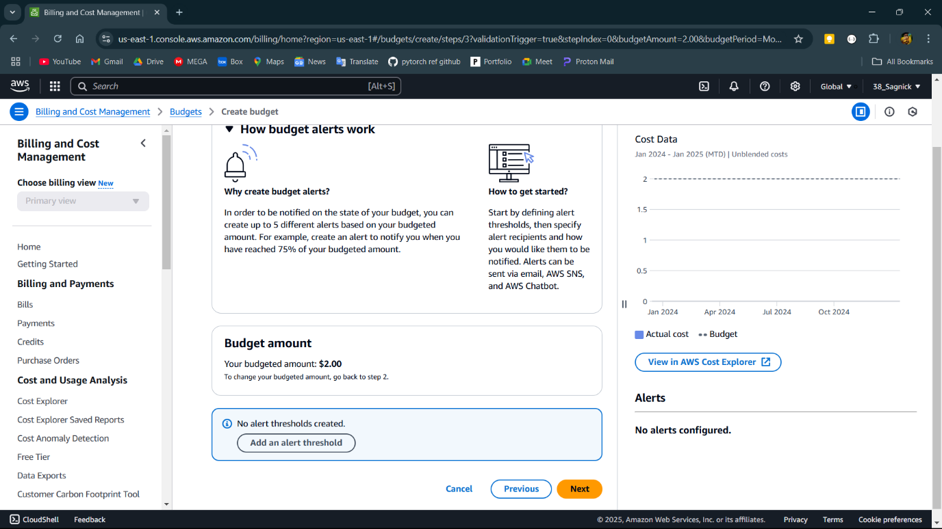

**Step-7:**

Add the threshold value and email to send notification.

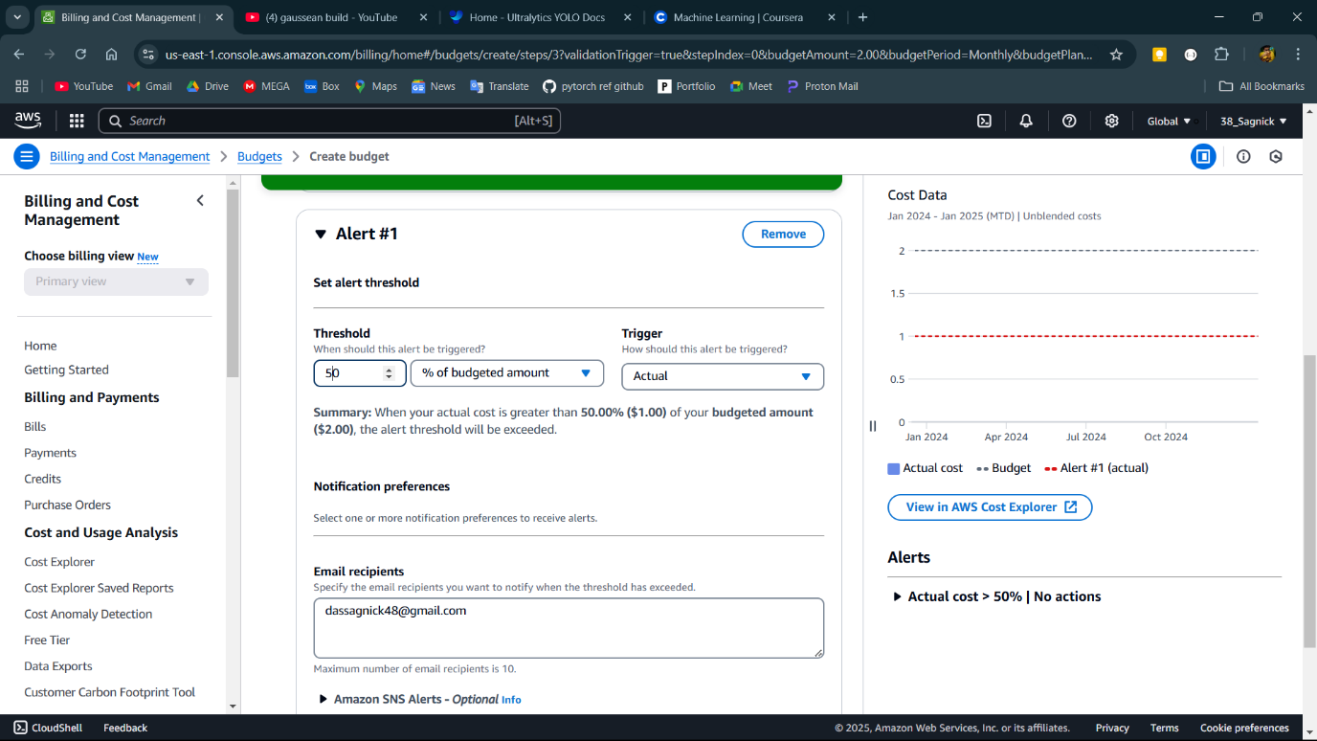

**Step-8:**

Review all the information and click Create Budget to create budget.

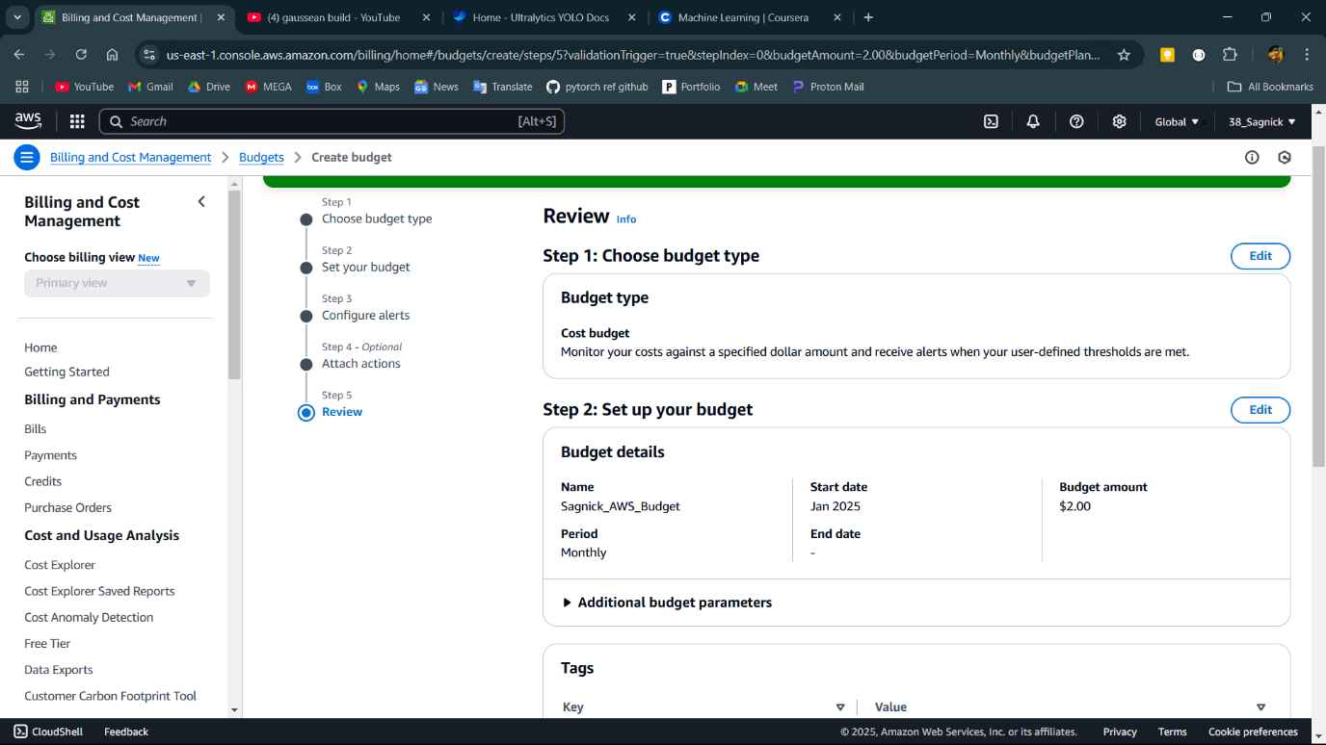

**Step-9:**

Budget has been created

