**Assignment No:10**

**Title: Deploy a project from GitHub to EC2 by creating a new security group and user data.**

**Step-1:**

Upload required files to github

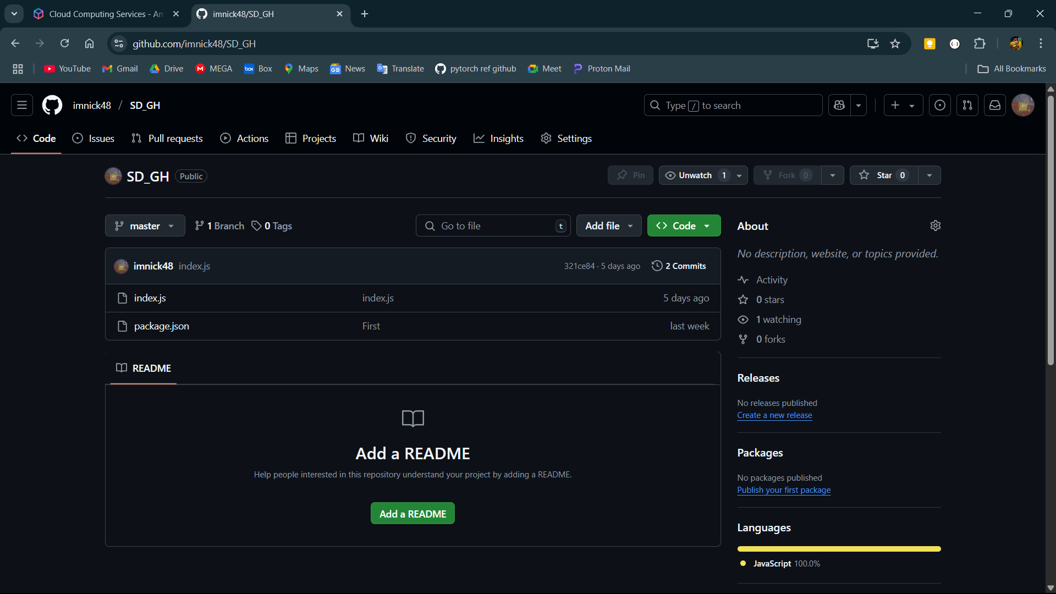

**Step-2:**

Log into AWS and open EC2.

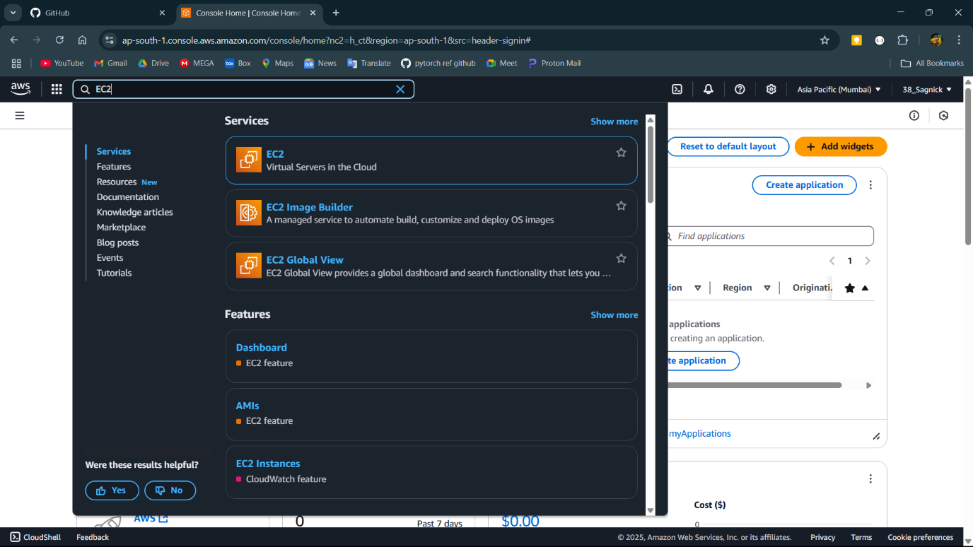

**Step-3:**

Then open the security groups from network and security in the left side and select all the security group except default and delete them then click on create security group

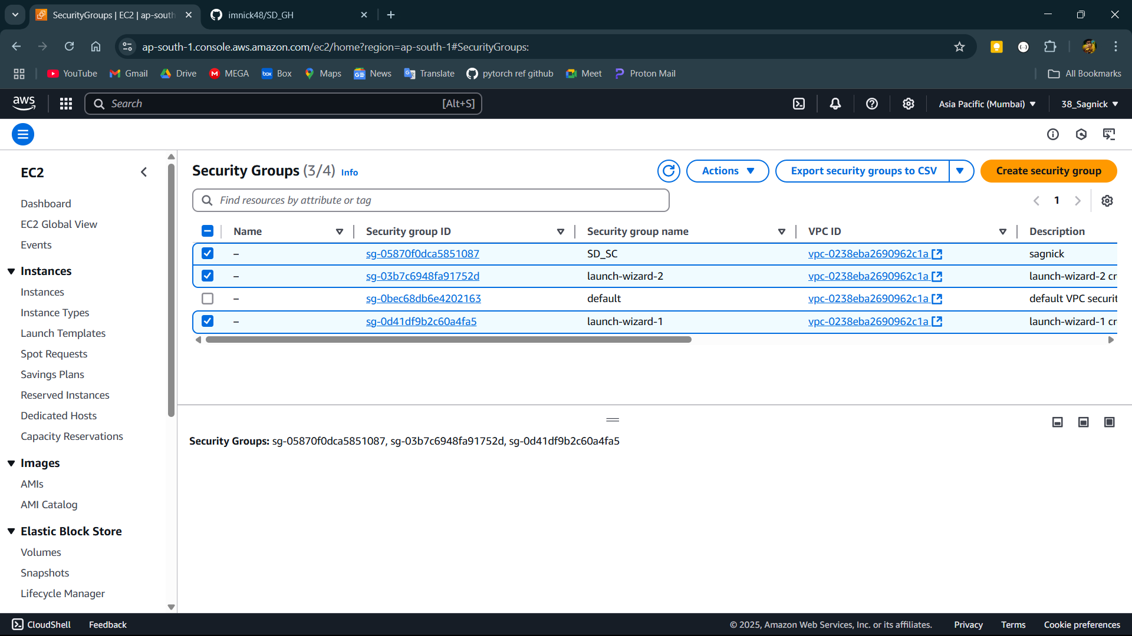

**Step-4:**

Click on Create security group then give a name and description of the security group and set up all inbound rules. Include SSH, HTTP, HTTPS and custom TCP then click on save rules.

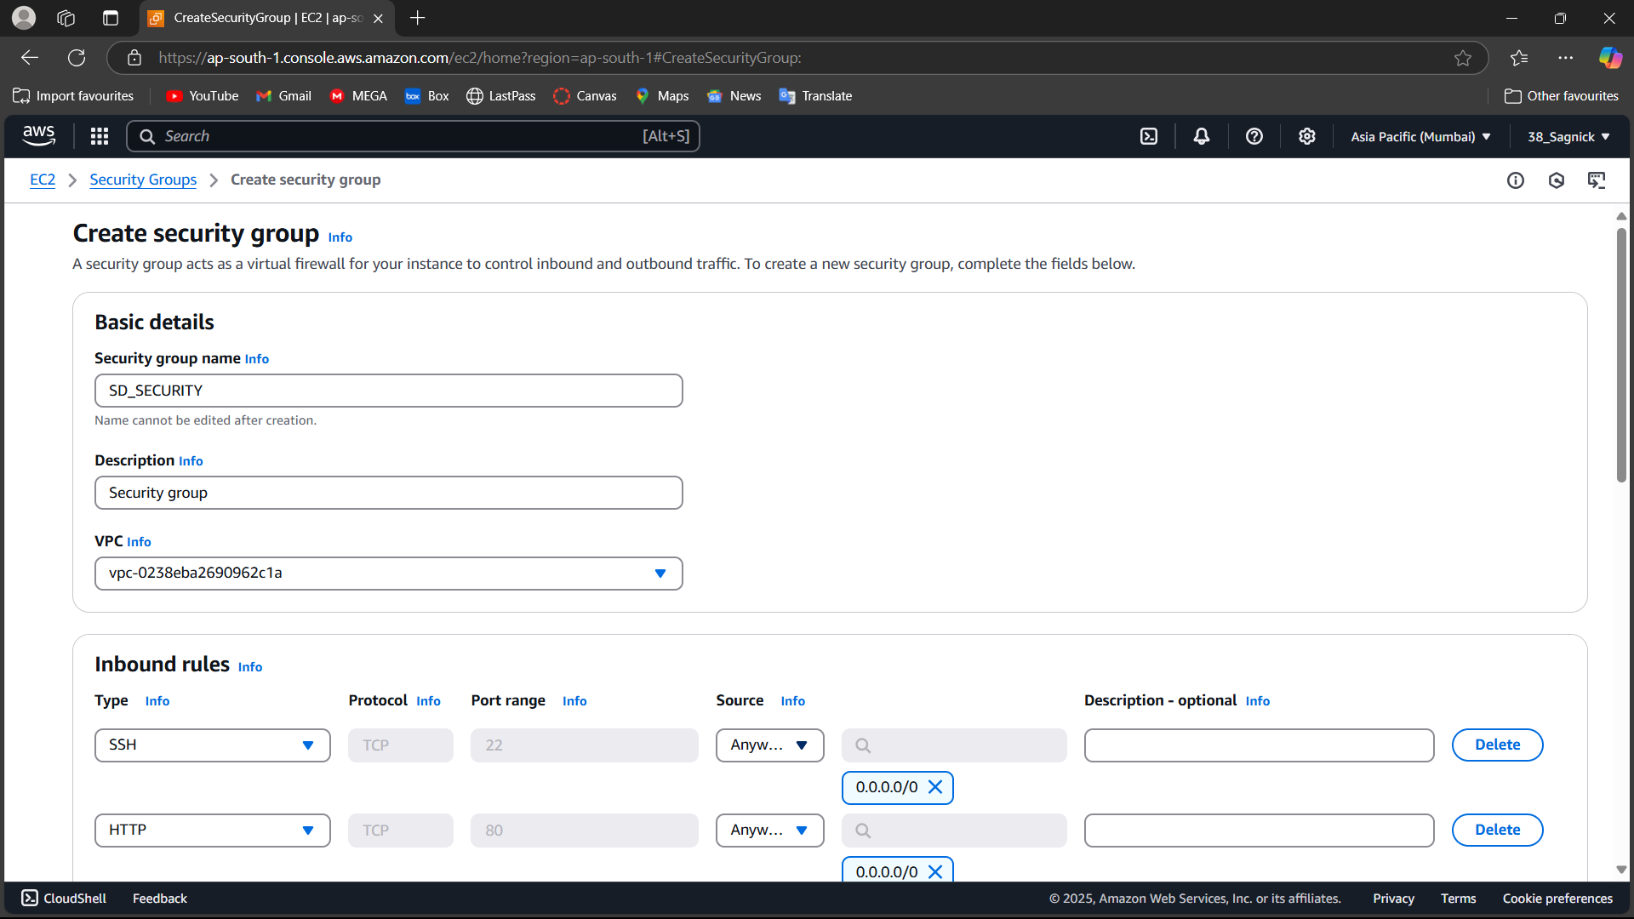

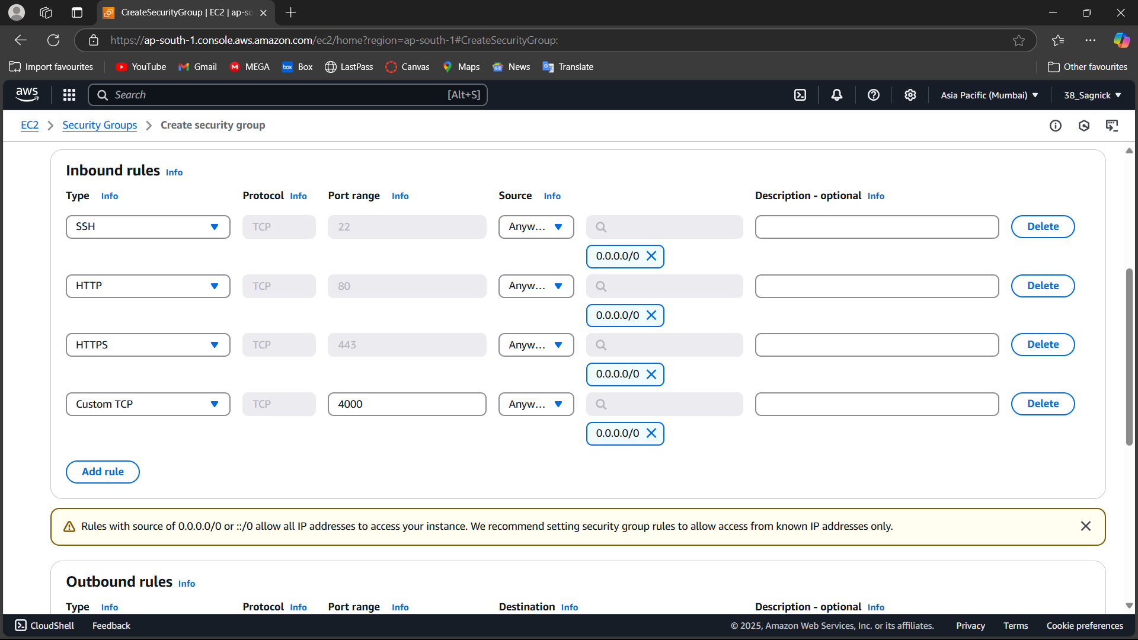

**Step-5:**

Click on launch instance.

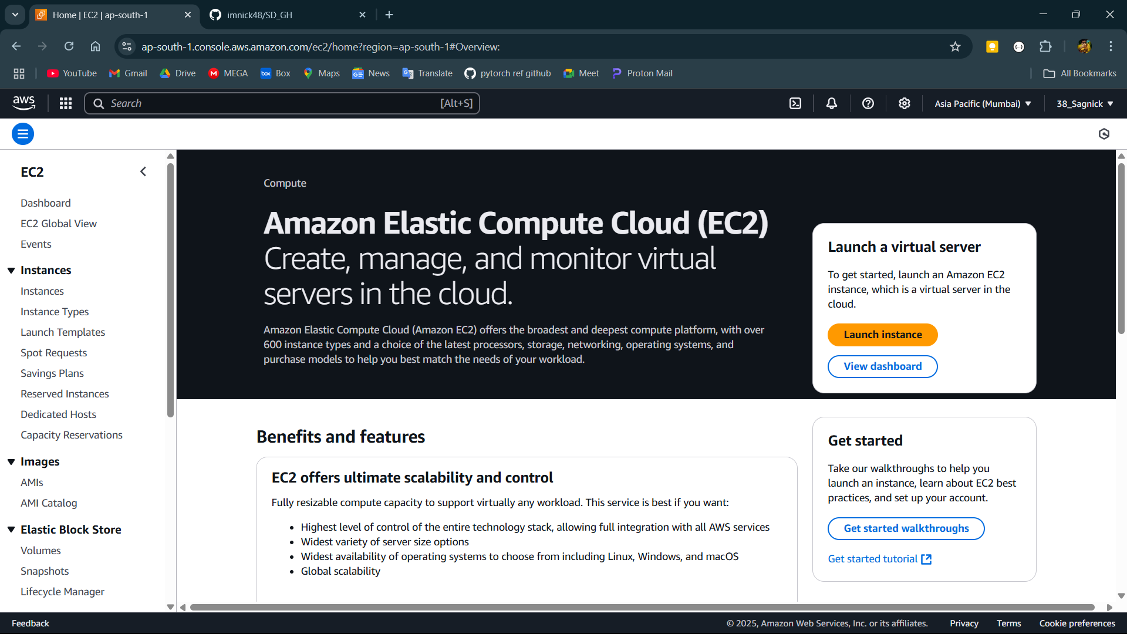

**Step-6:**

Give a name to the instance and select the operating system then in the network settings click on existing security group and select the security group just created.

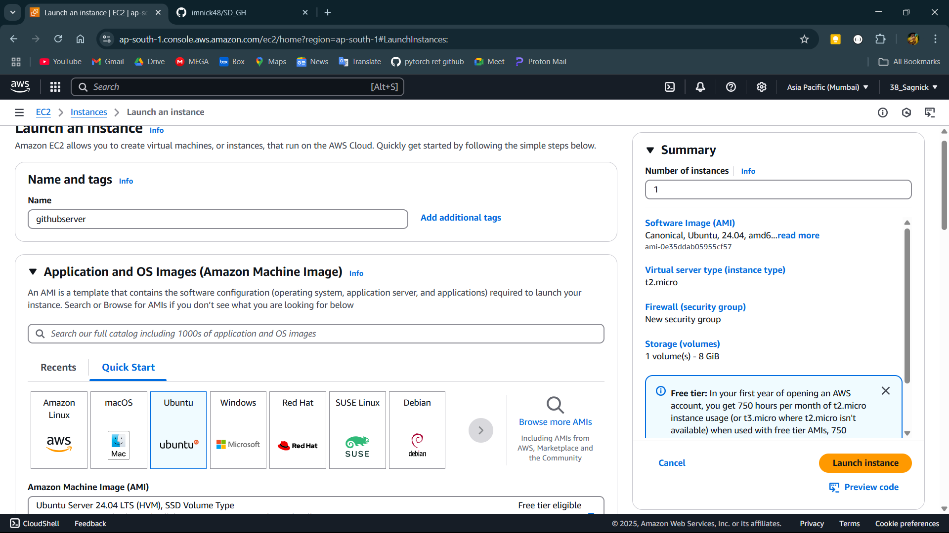

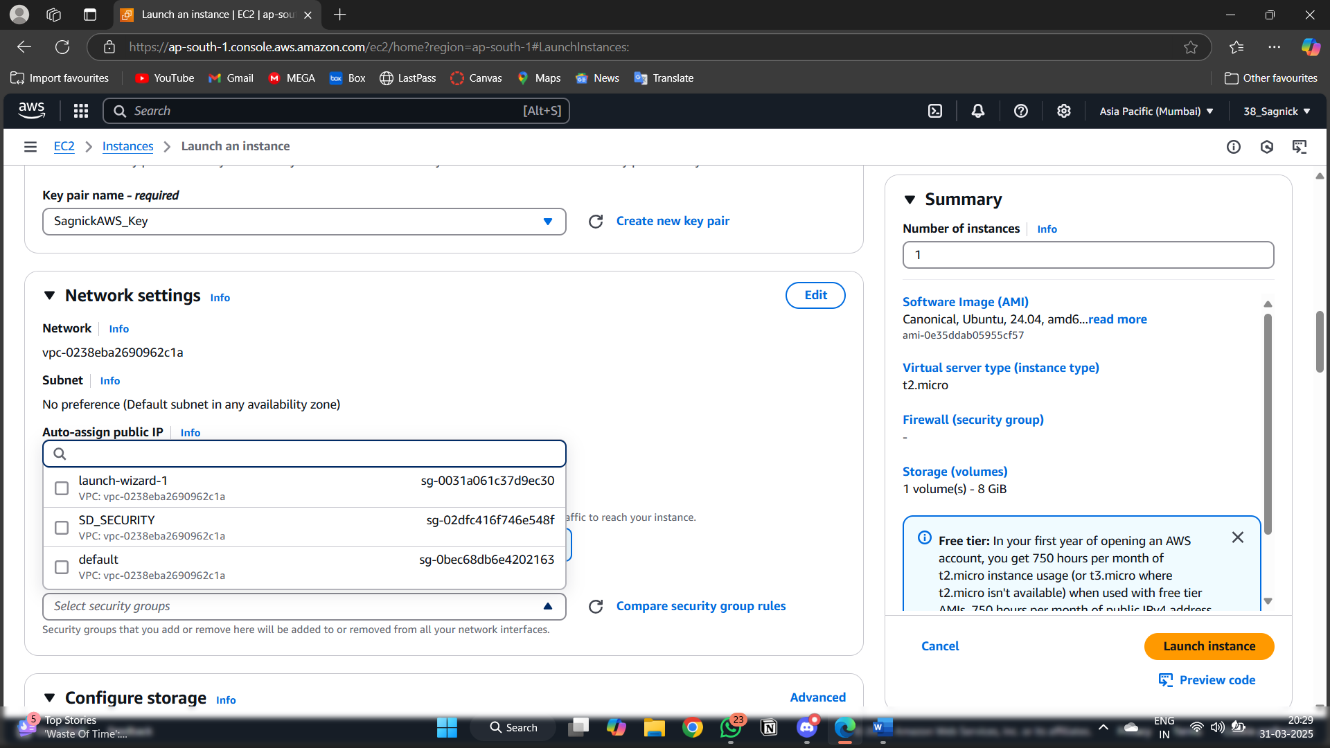

**Step-7:**

Click on the advance details and scroll down to the user data and run all required commands then press launch instance.

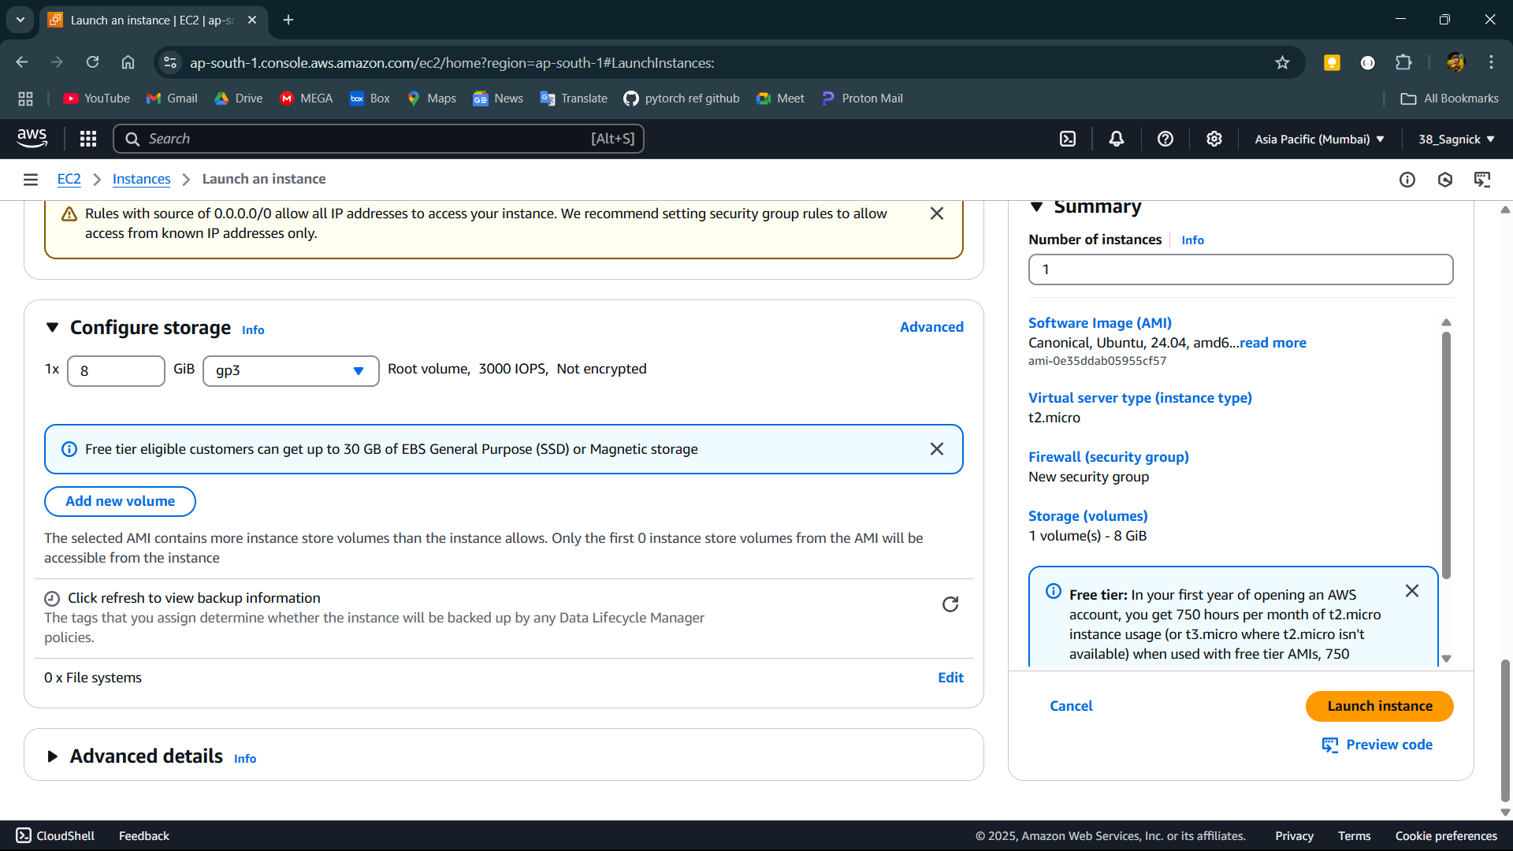

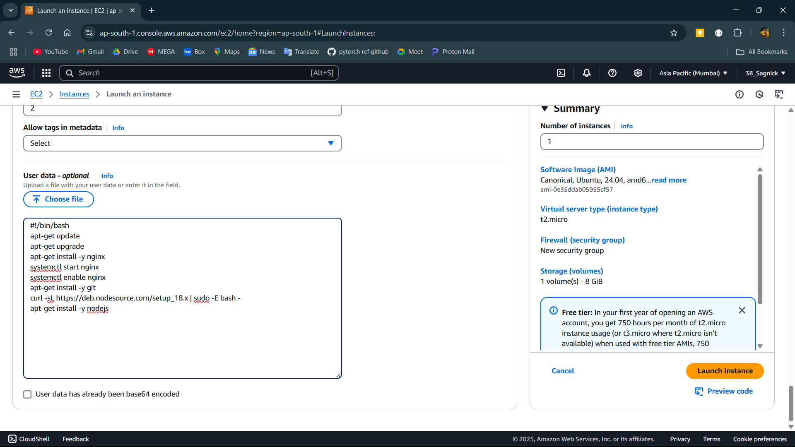

**Step-8:**

Now open instances and click of the instance Id of the instance.

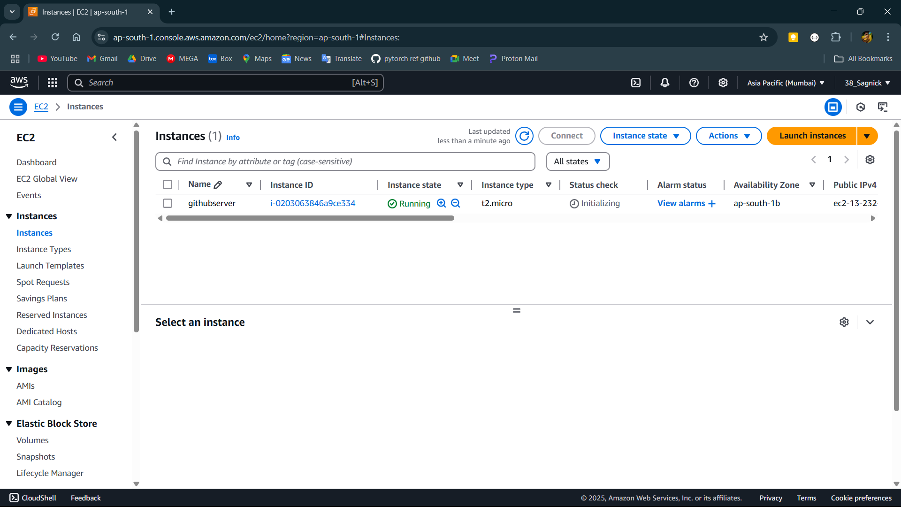

**Step-9:**

Now copy the IPv4 address.

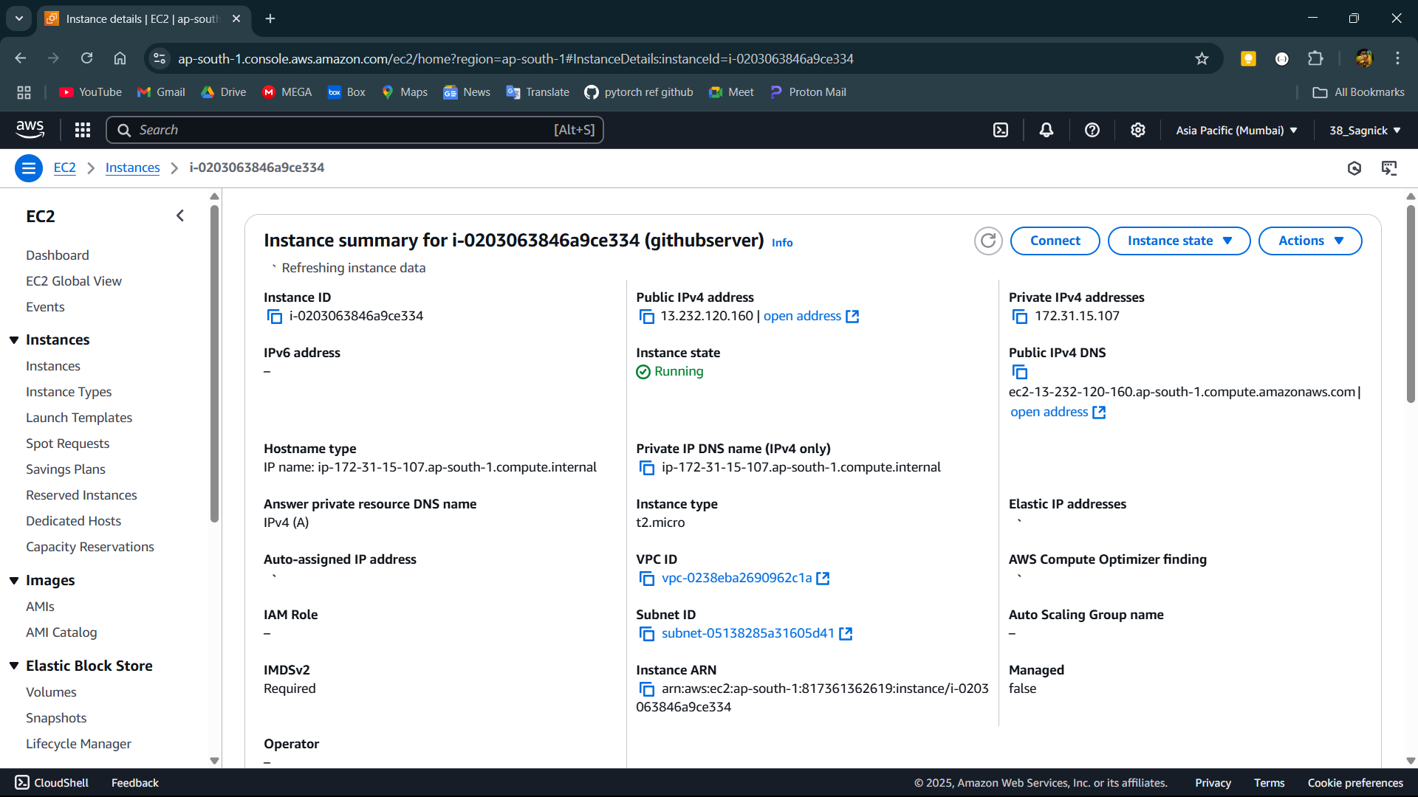

**Step-10:**

Open Bitvise and paste the IP address of the instance in the host and give required credentials in authentication and click log in .

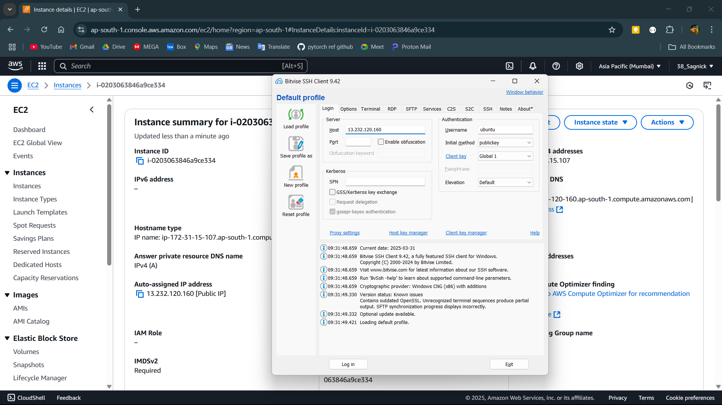

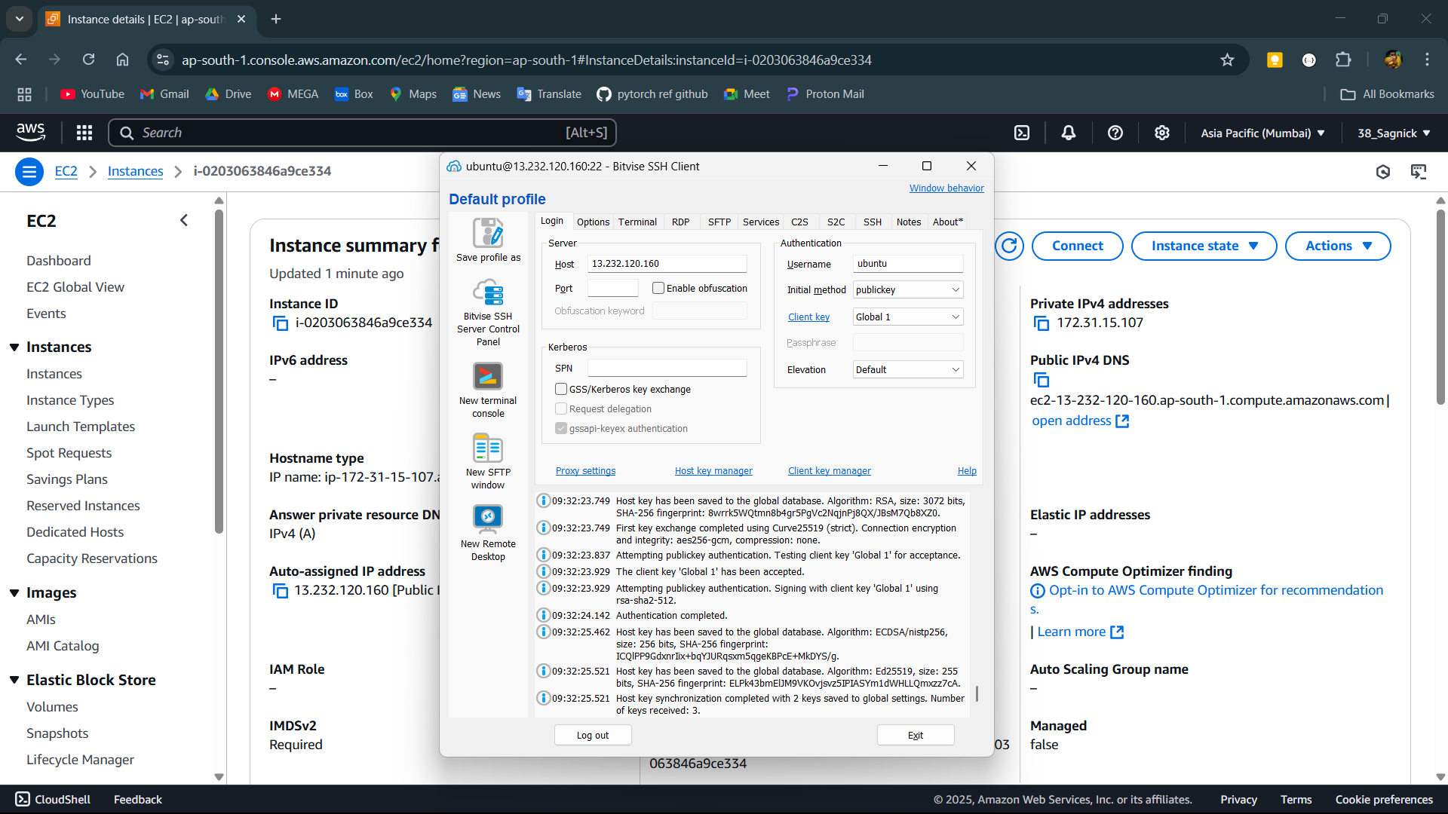

**Step-11:**

After then open a new terminal window and clone the git repository using command git clone link of the repository.

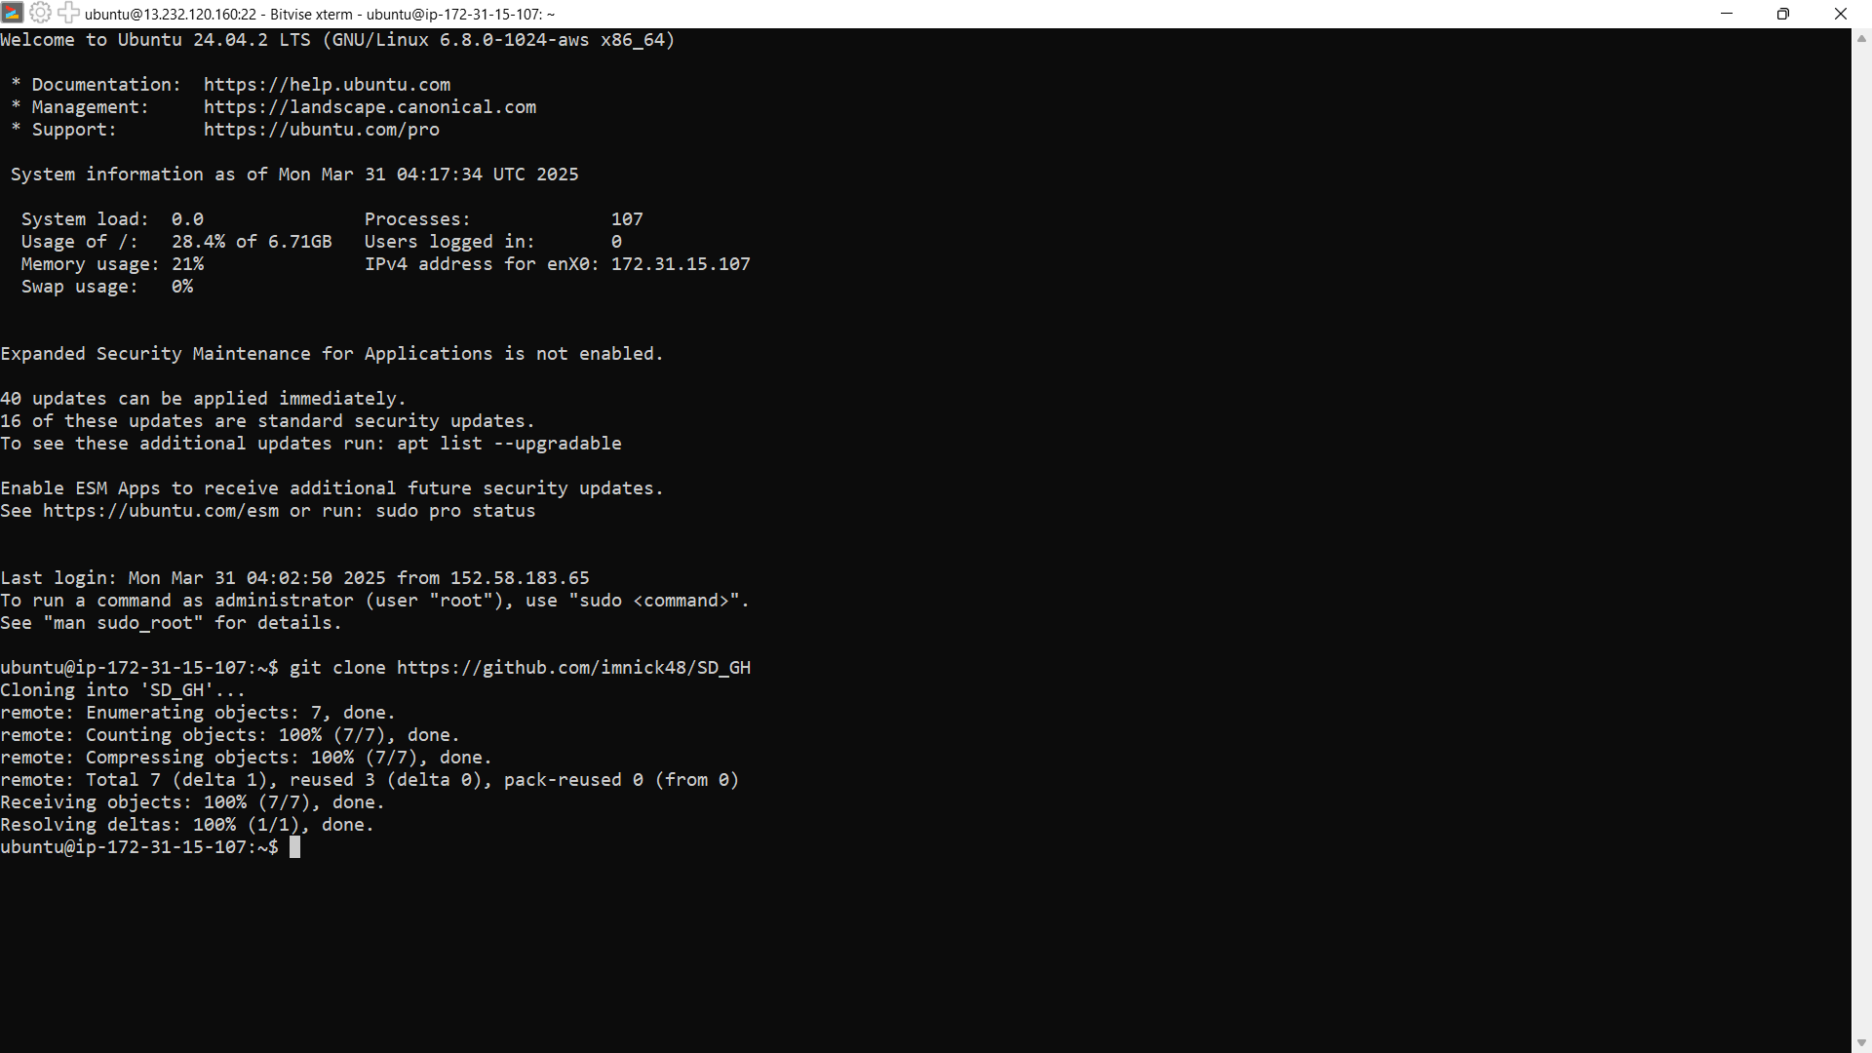

**Step-12:**

Change the directory to the github repository name and install required dependencies using command npm install.

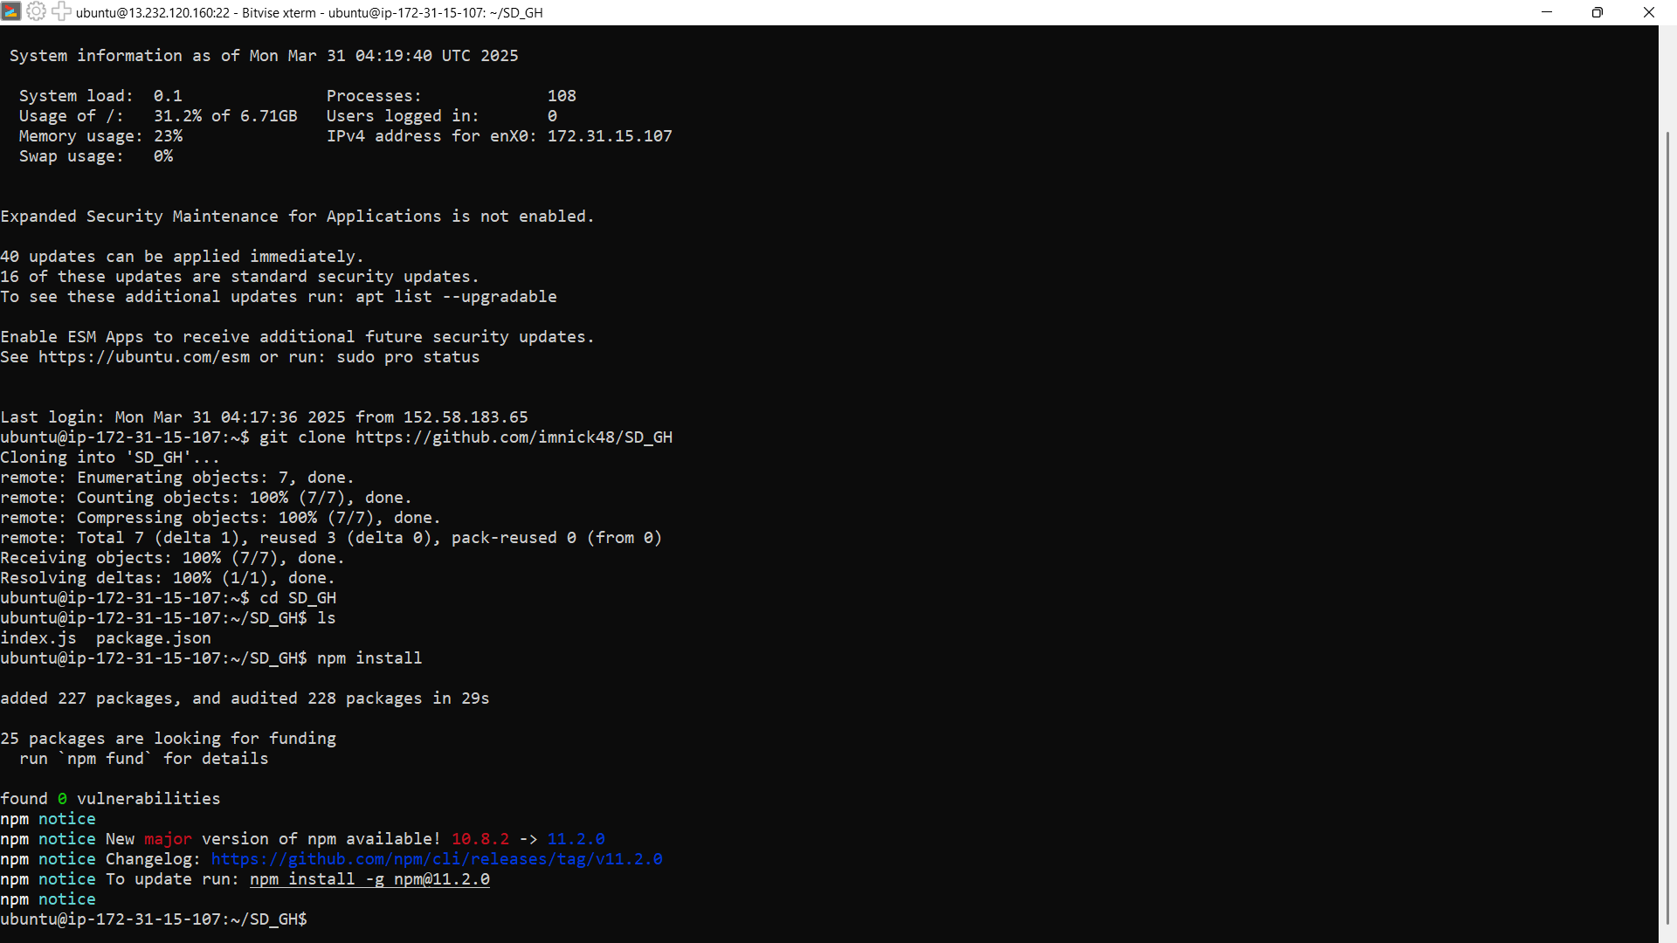

**Step-13:**

Then start the server using command node index.js .

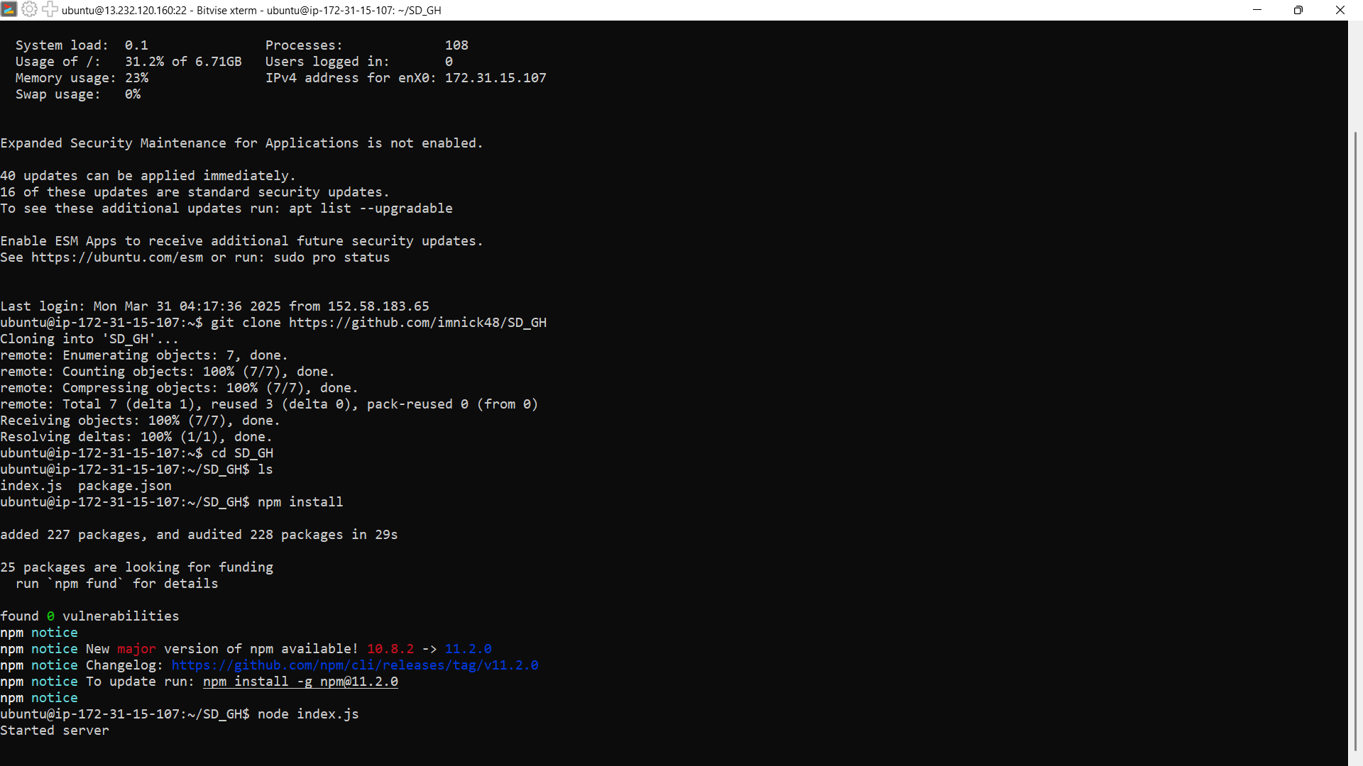

**Step-14:**

Now copy the IPv4 address of the instance and paste it and the put the port like this IP address:Port here IP address:4000 .

