**Assignment No:12**

**Title: Deploy and run the project in AWS without using the port.**

**Step-1:**

Upload required files to github

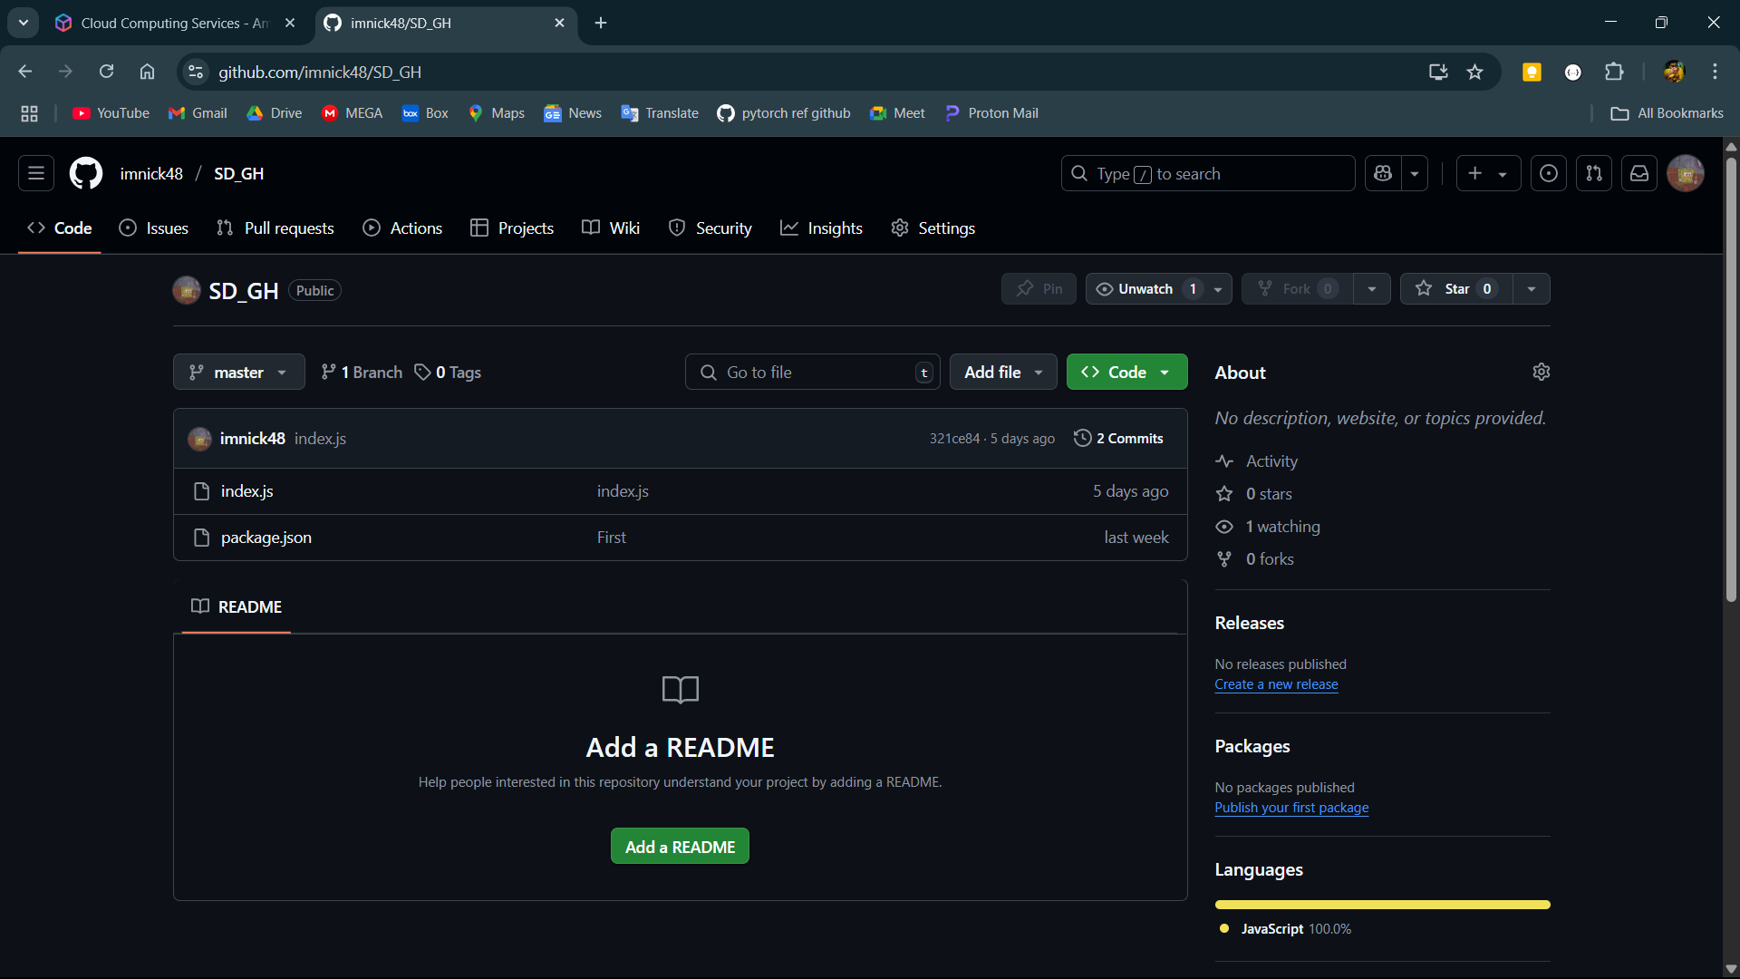

**Step-2:**

Log into AWS and open EC2.

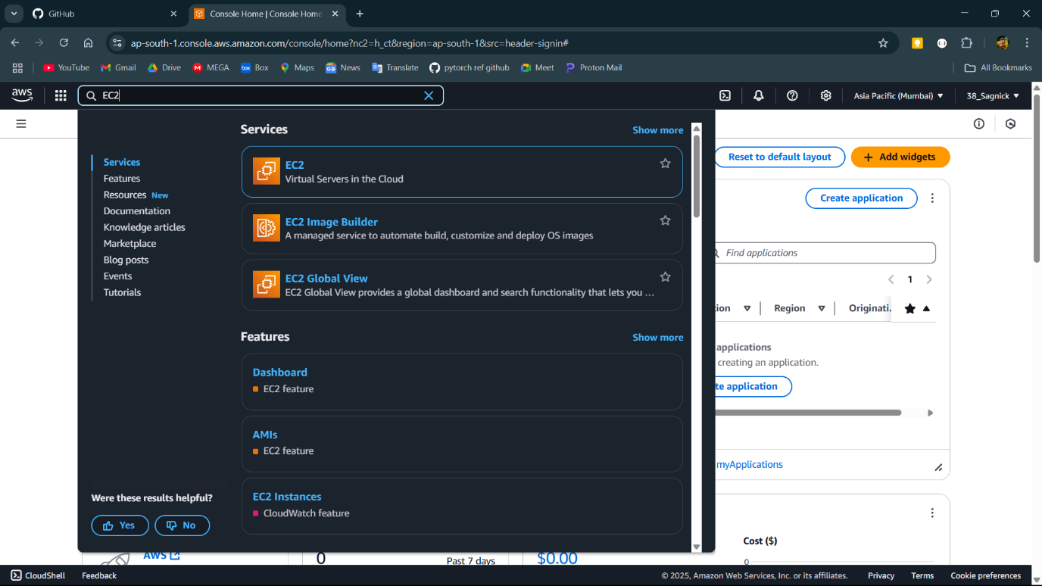

**Step-3:**

Open the EC2

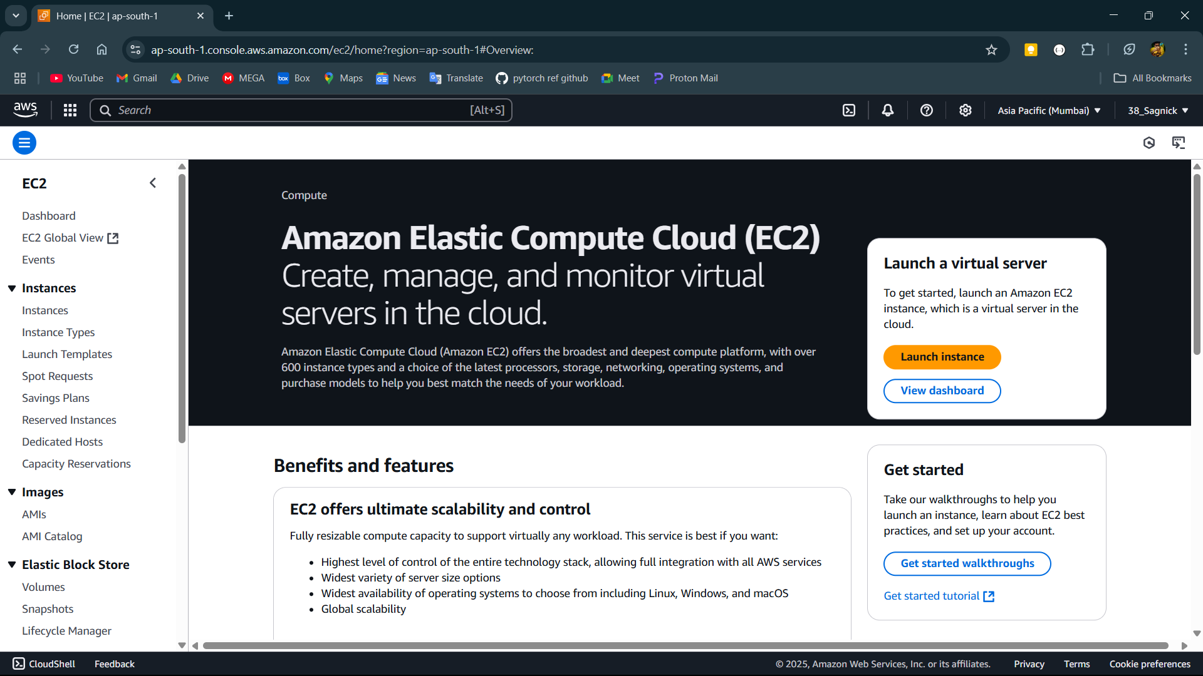

**Step-4:**

Create ec2 instance and add the below bash commands in user data section.

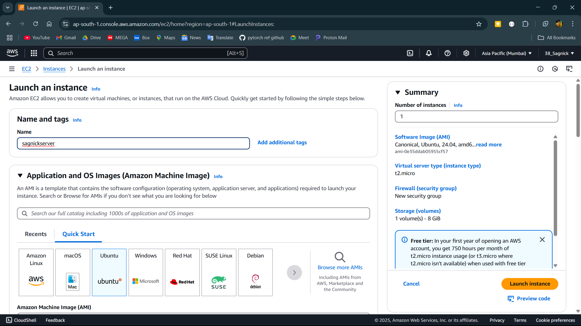

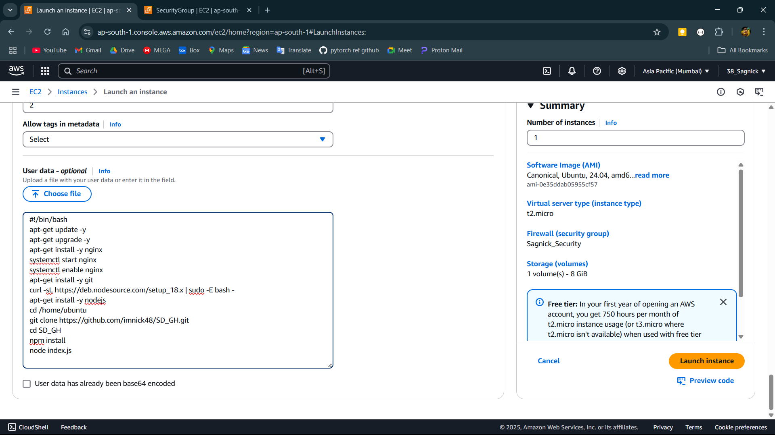

**Step-5:**

After creating instance the site should successfully run on the port 4000.

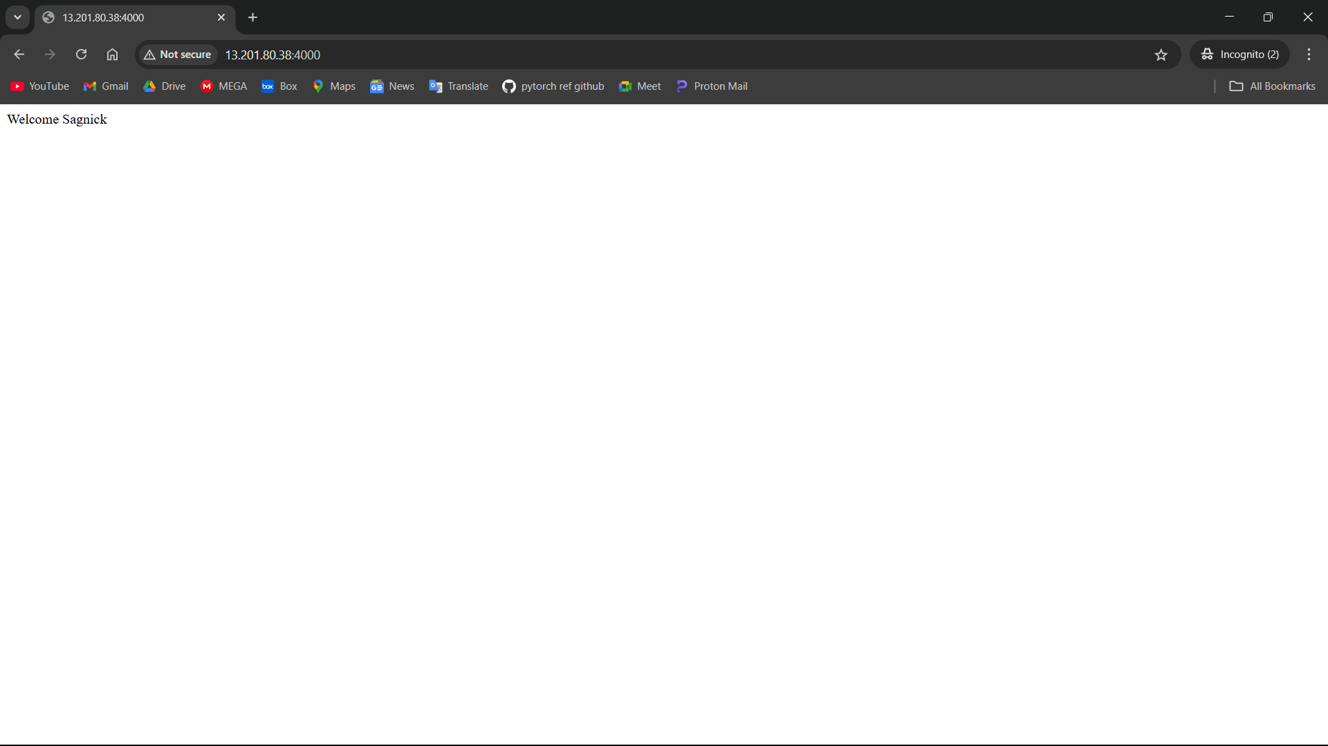

**Step-6:**

Now log into bitvise and cd ../.. to go to root directory then open etc with cd etc and nginx with cd nignx and sites-available with cd sites-available then change the permissions of the default file using sudo chmod 777 default. Then edit the default file with nano default and change the code to what is given below and close the editor then restart the nginx with sudo systemctl restart nginx.

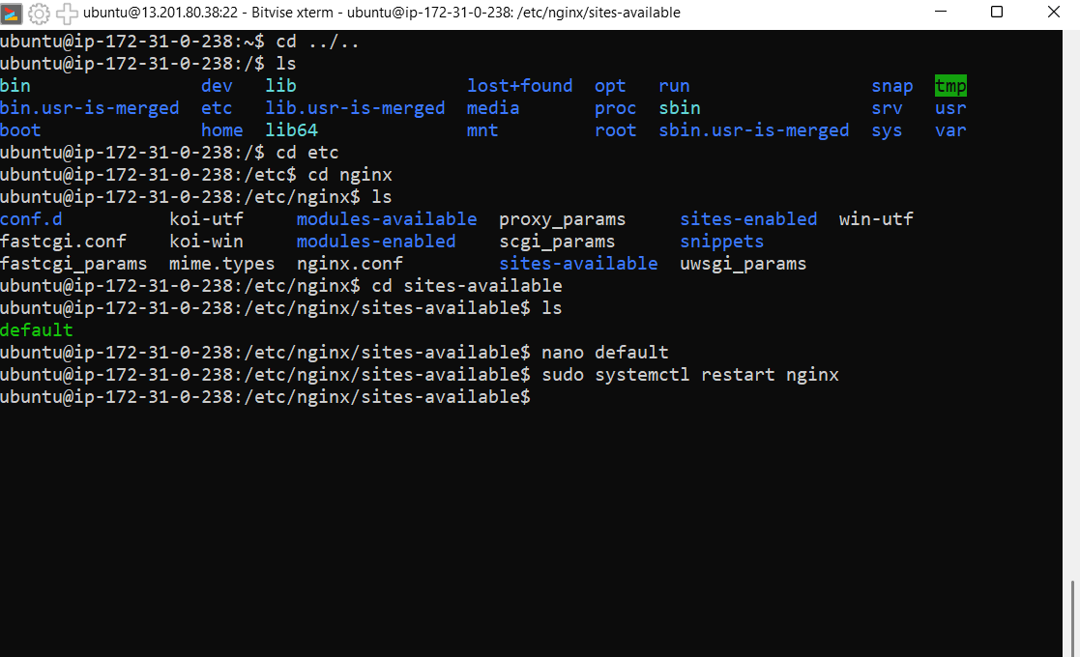

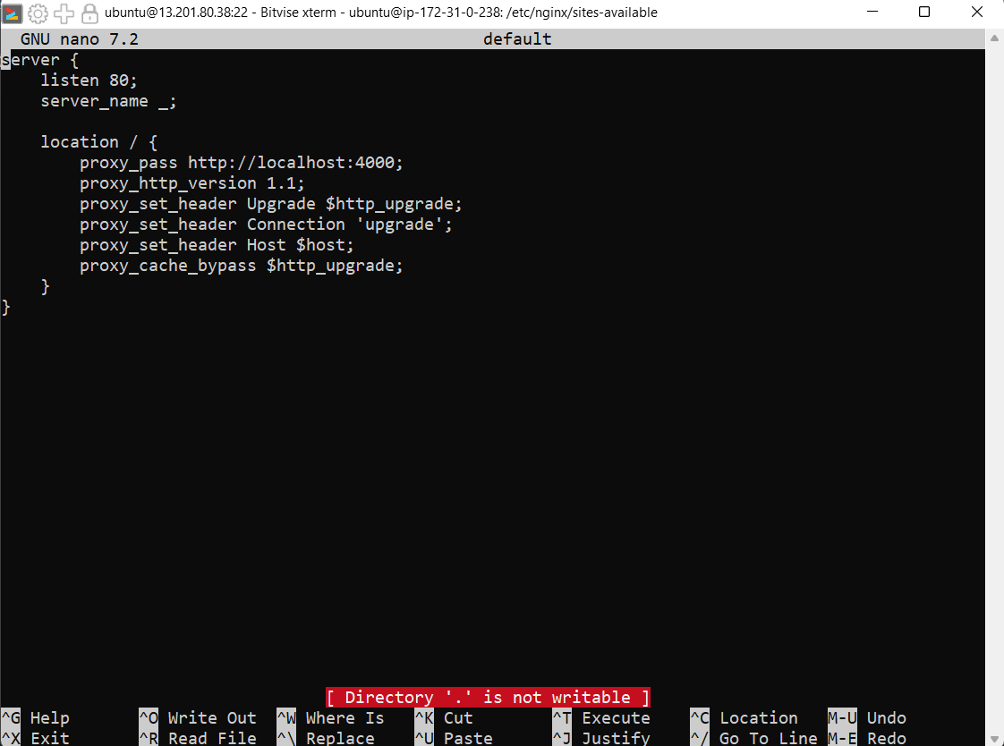

**Step-7:**

Now the site runs on IP without giving the port.

