**Assignment No:13**

**Title: Create a workmail for your organization.**

**Step-1:**

Log into AWS and open Amazon WorkMail.

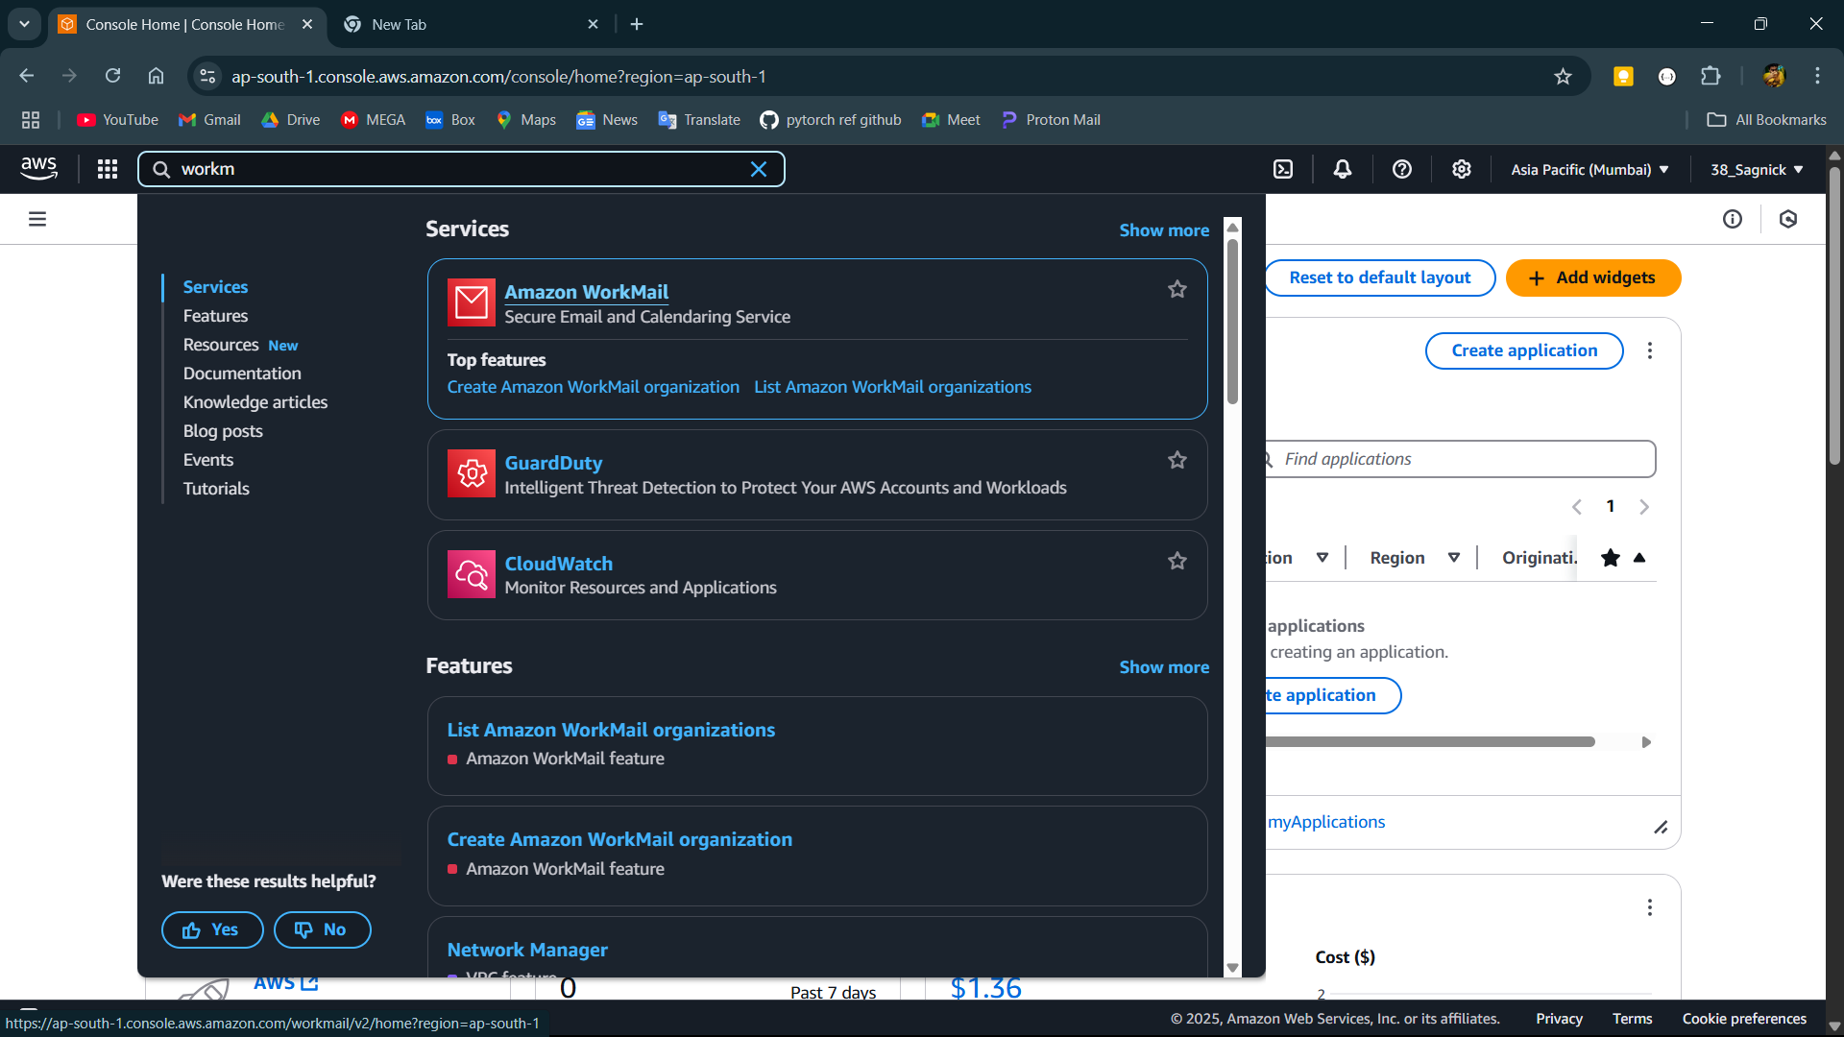

**Step-2:**

If the region is not supported shift to a supported region.

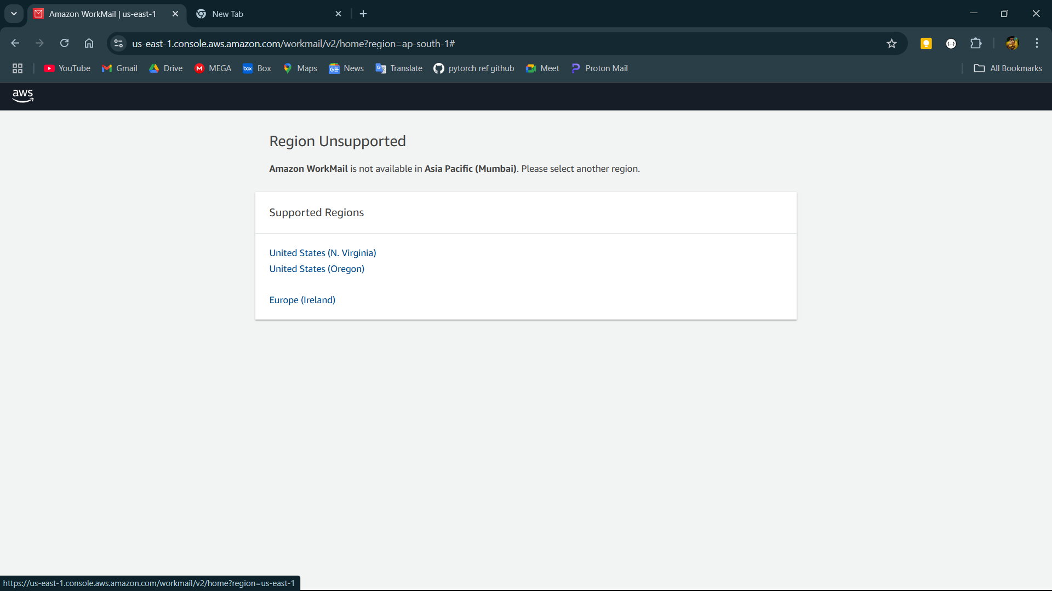

**Step-3:**

Create a new organisation.

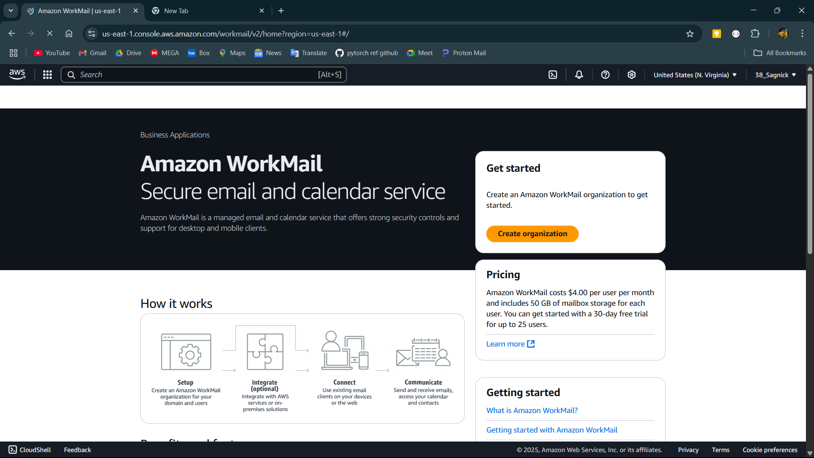

**Step-4:**

Select free test domain and name the organisation.

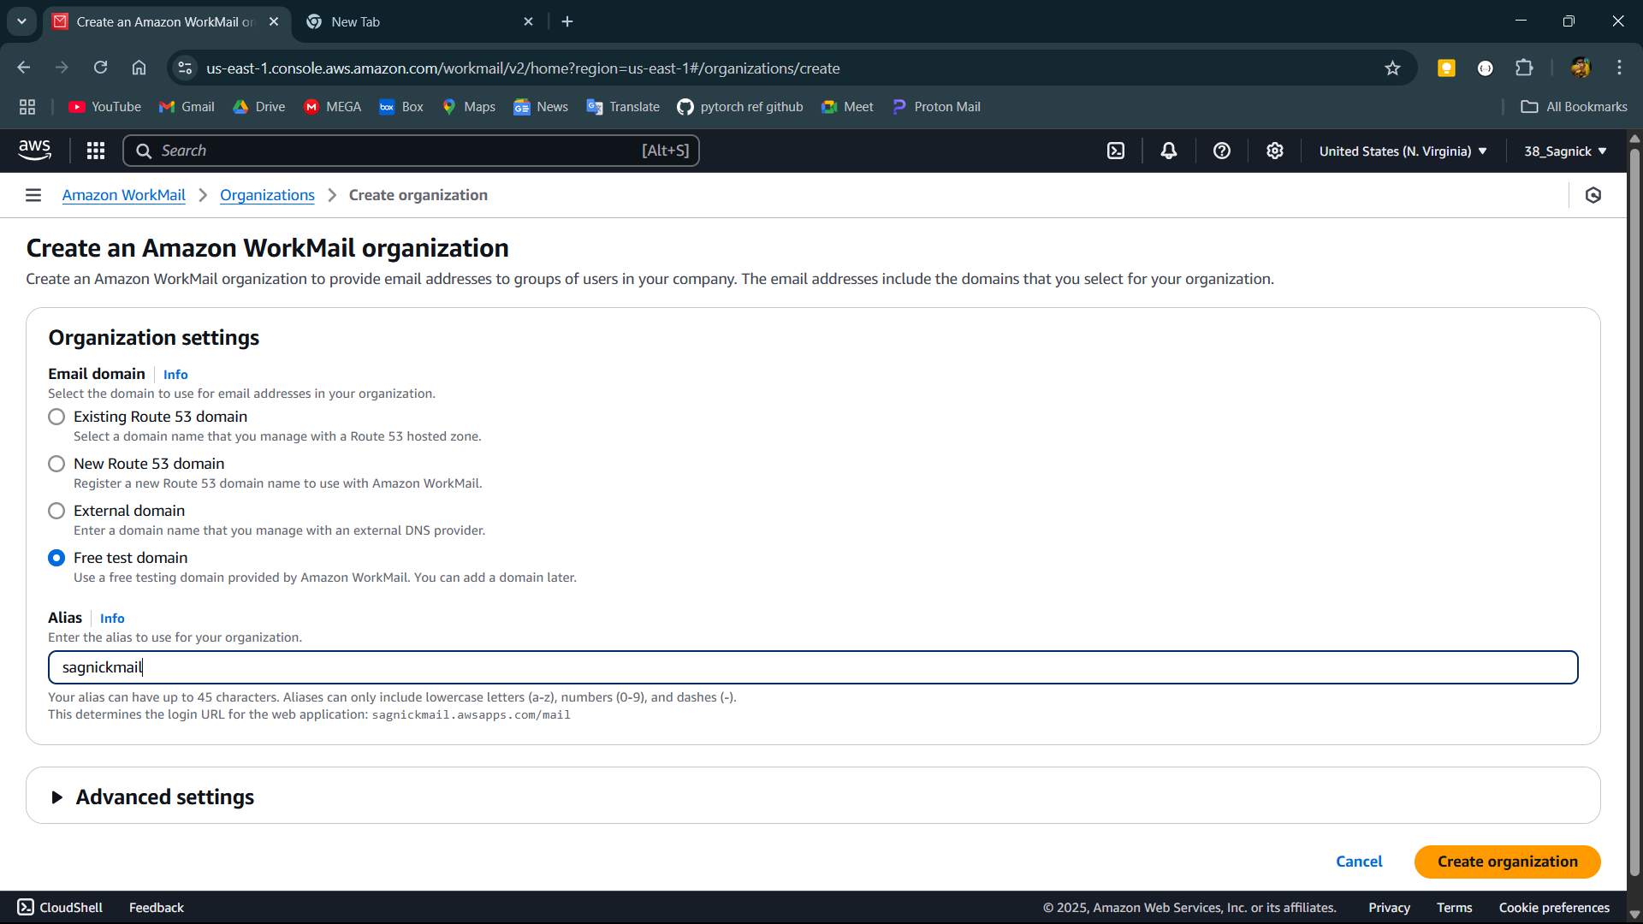

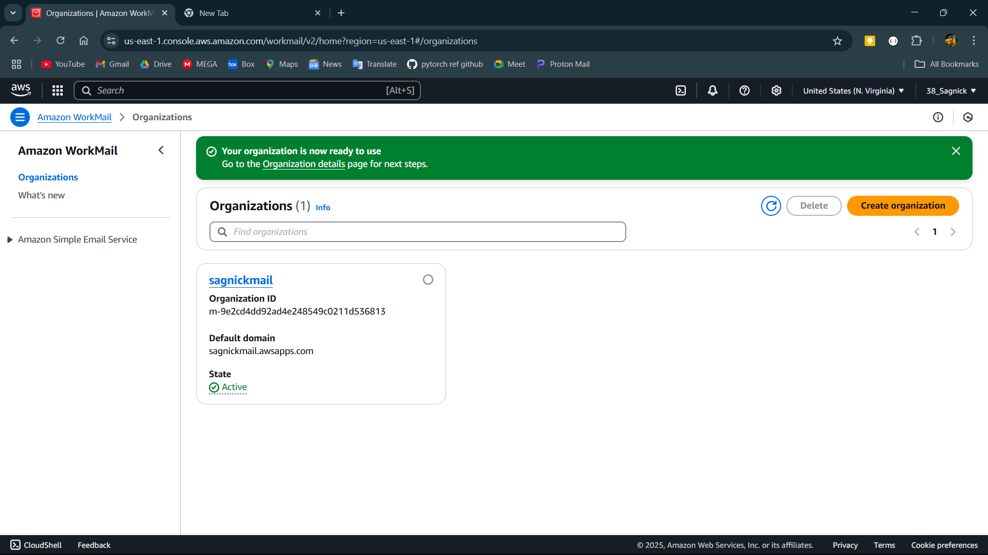

**Step-5:**

Open the organisation and goto Users then click on add user and give username,display name and password for new user.

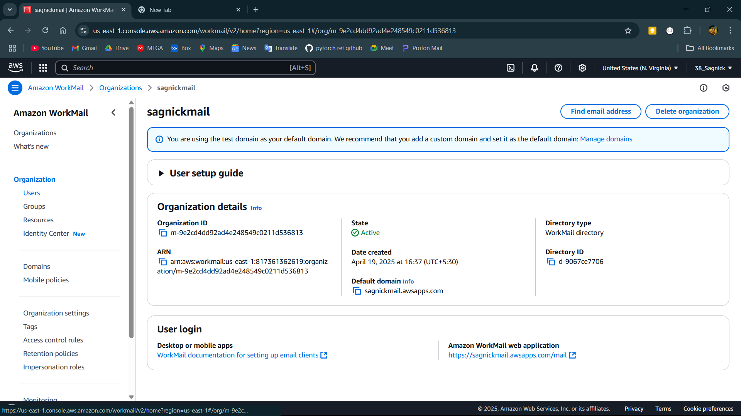

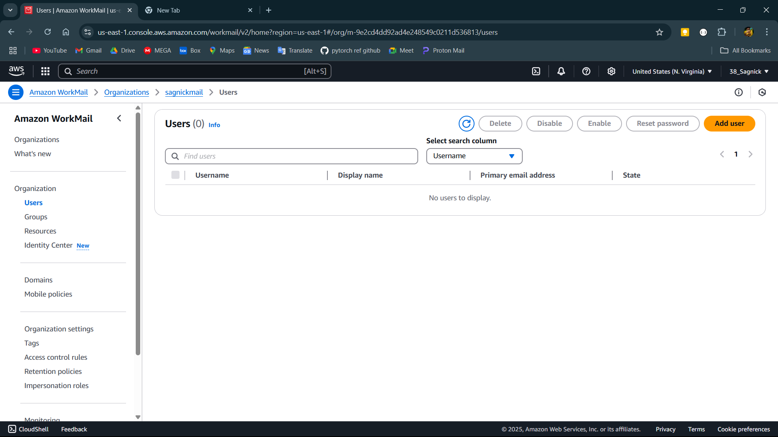

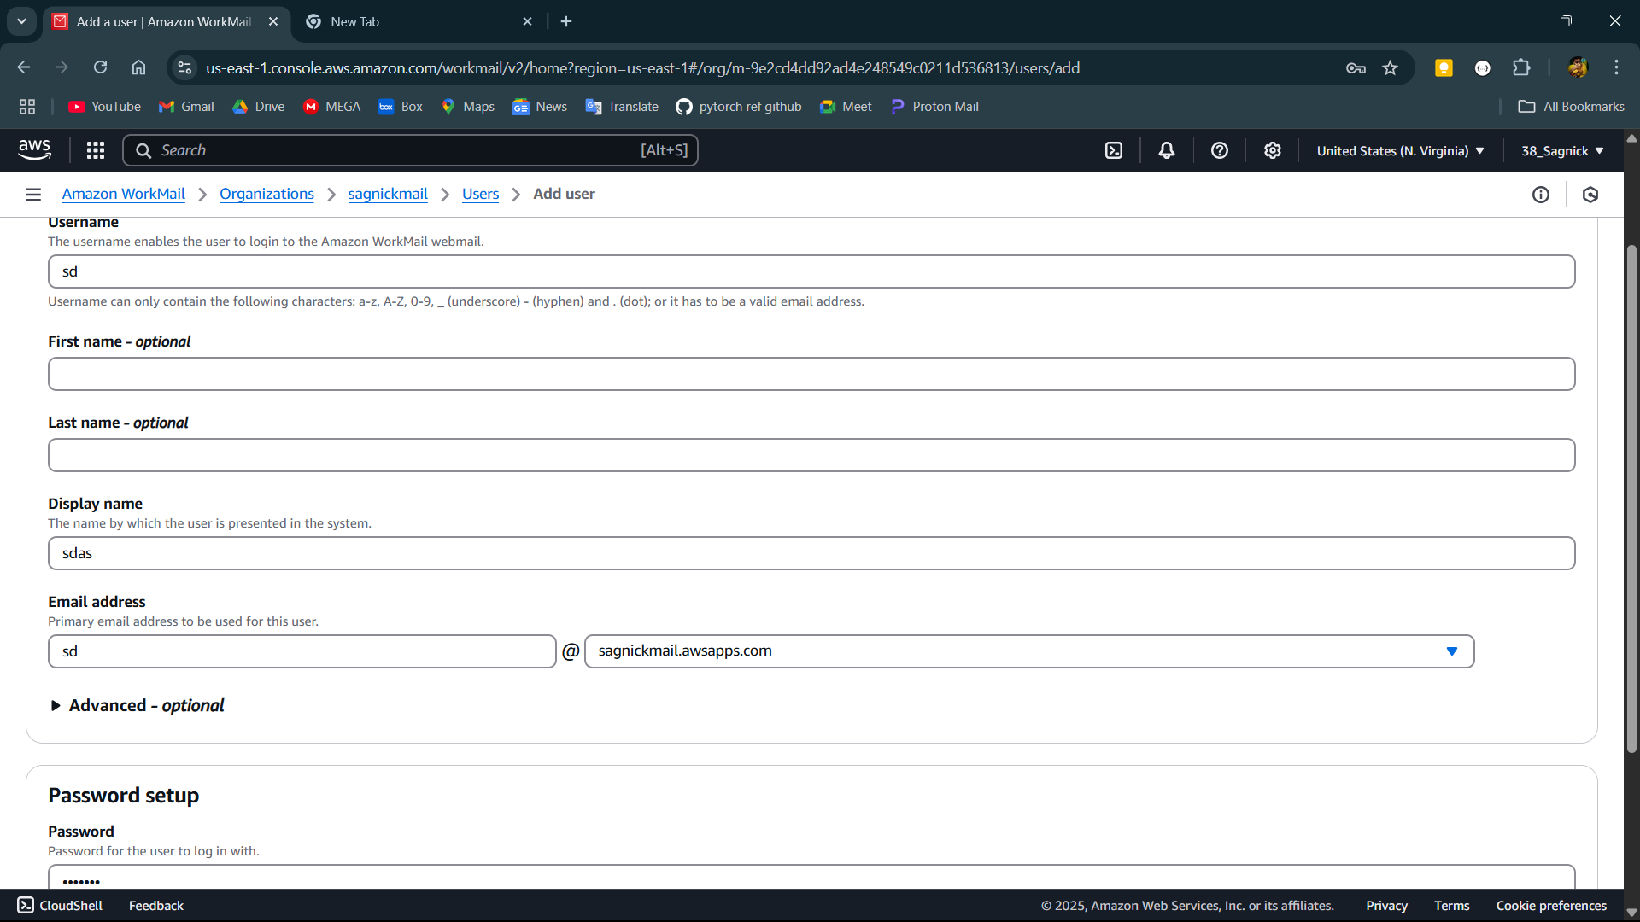

**Step-6:**

After creating user go back to the organisation page and open the link given in amazon workmail web application section.

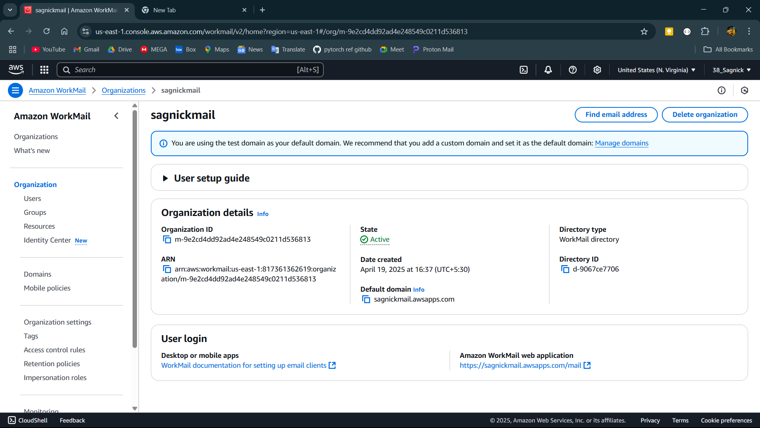

**Step-7:**

Give the password and username of the user and login.

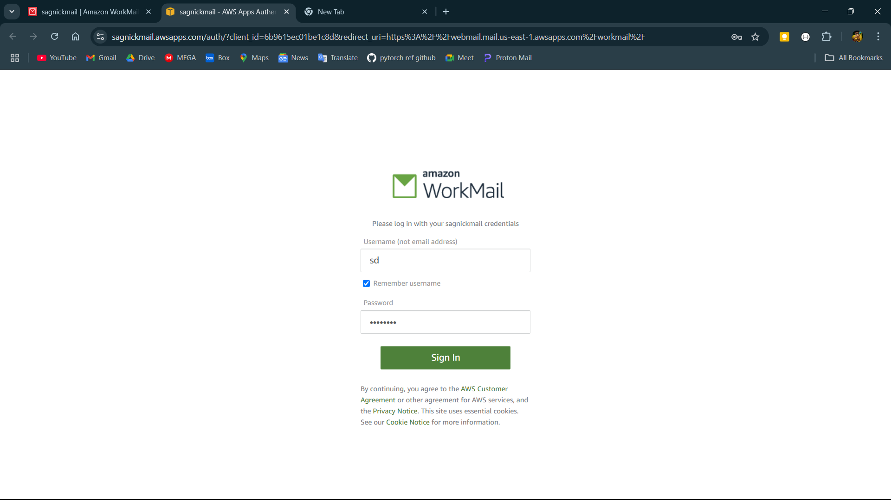

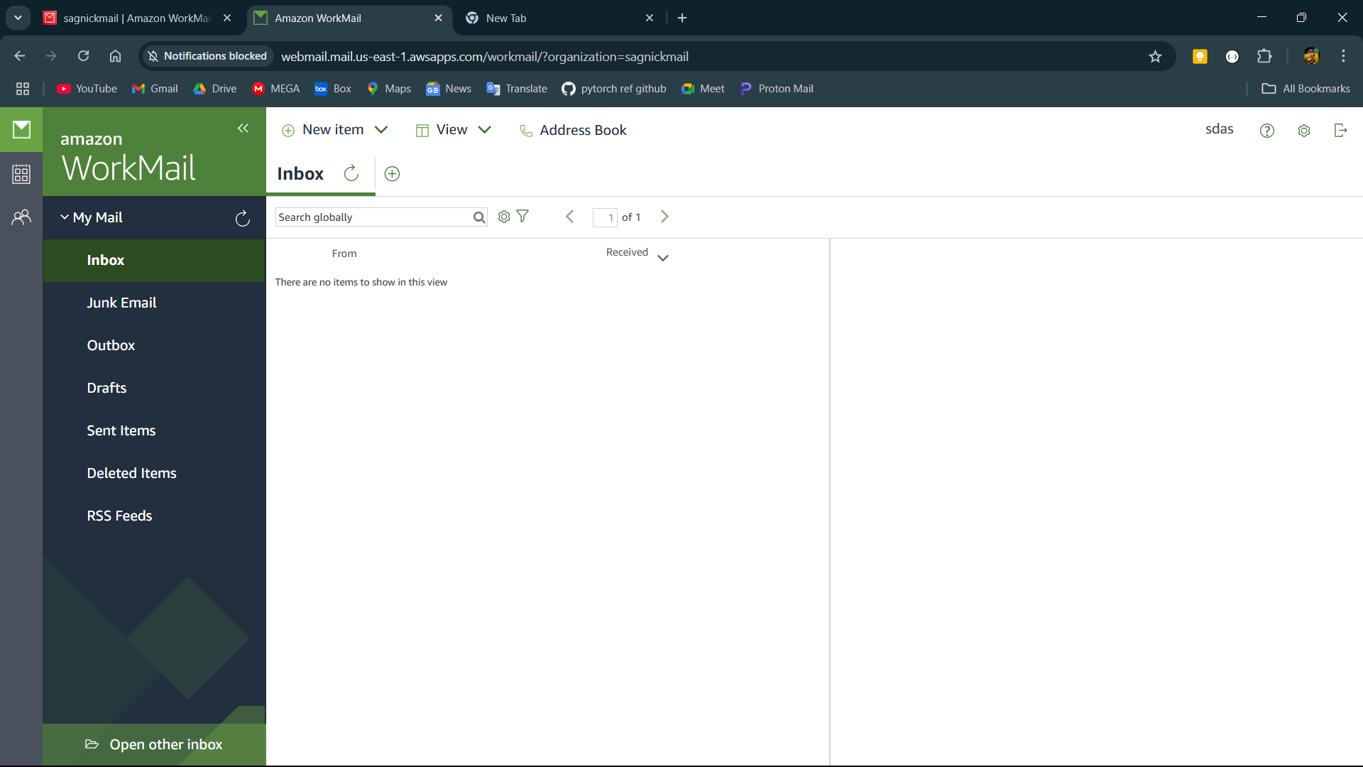

**Step-8:**

Write a mail to a email address and it will be successfully received.

