**Assignment No:15**

**Title: Create a Serverless computing service.**

**Step-1:**

Log into AWS and open Lambda.

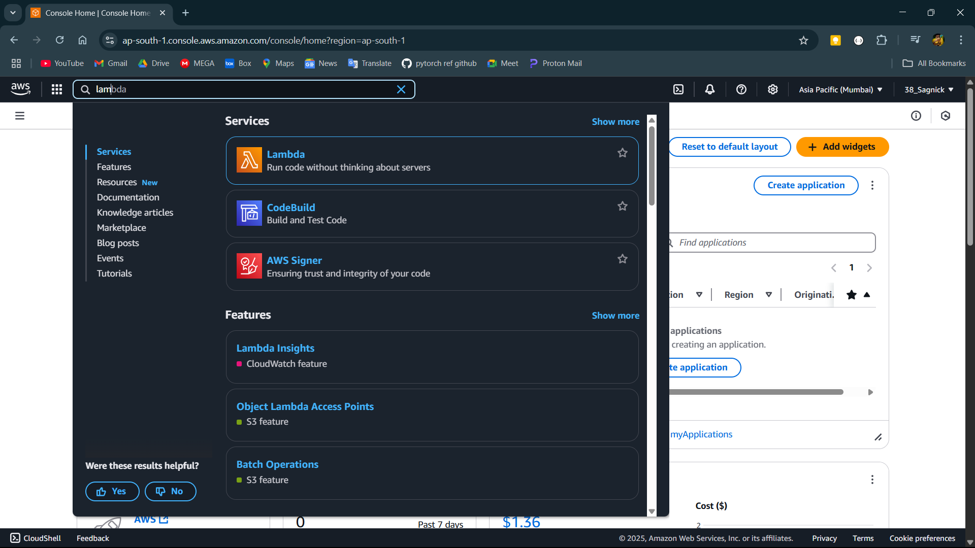

**Step-2:**

Click on create a function.

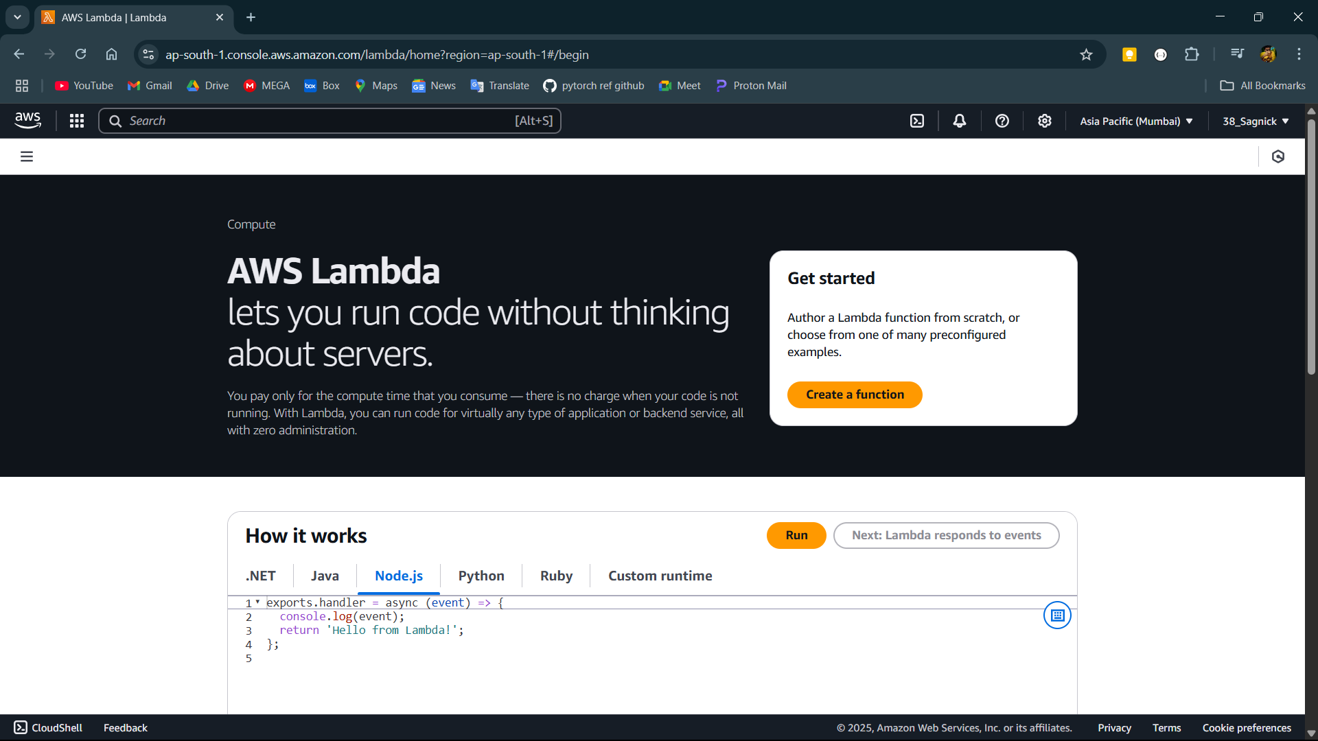

**Step-3:**

Fill in basic details like function name, runtime and architecture.

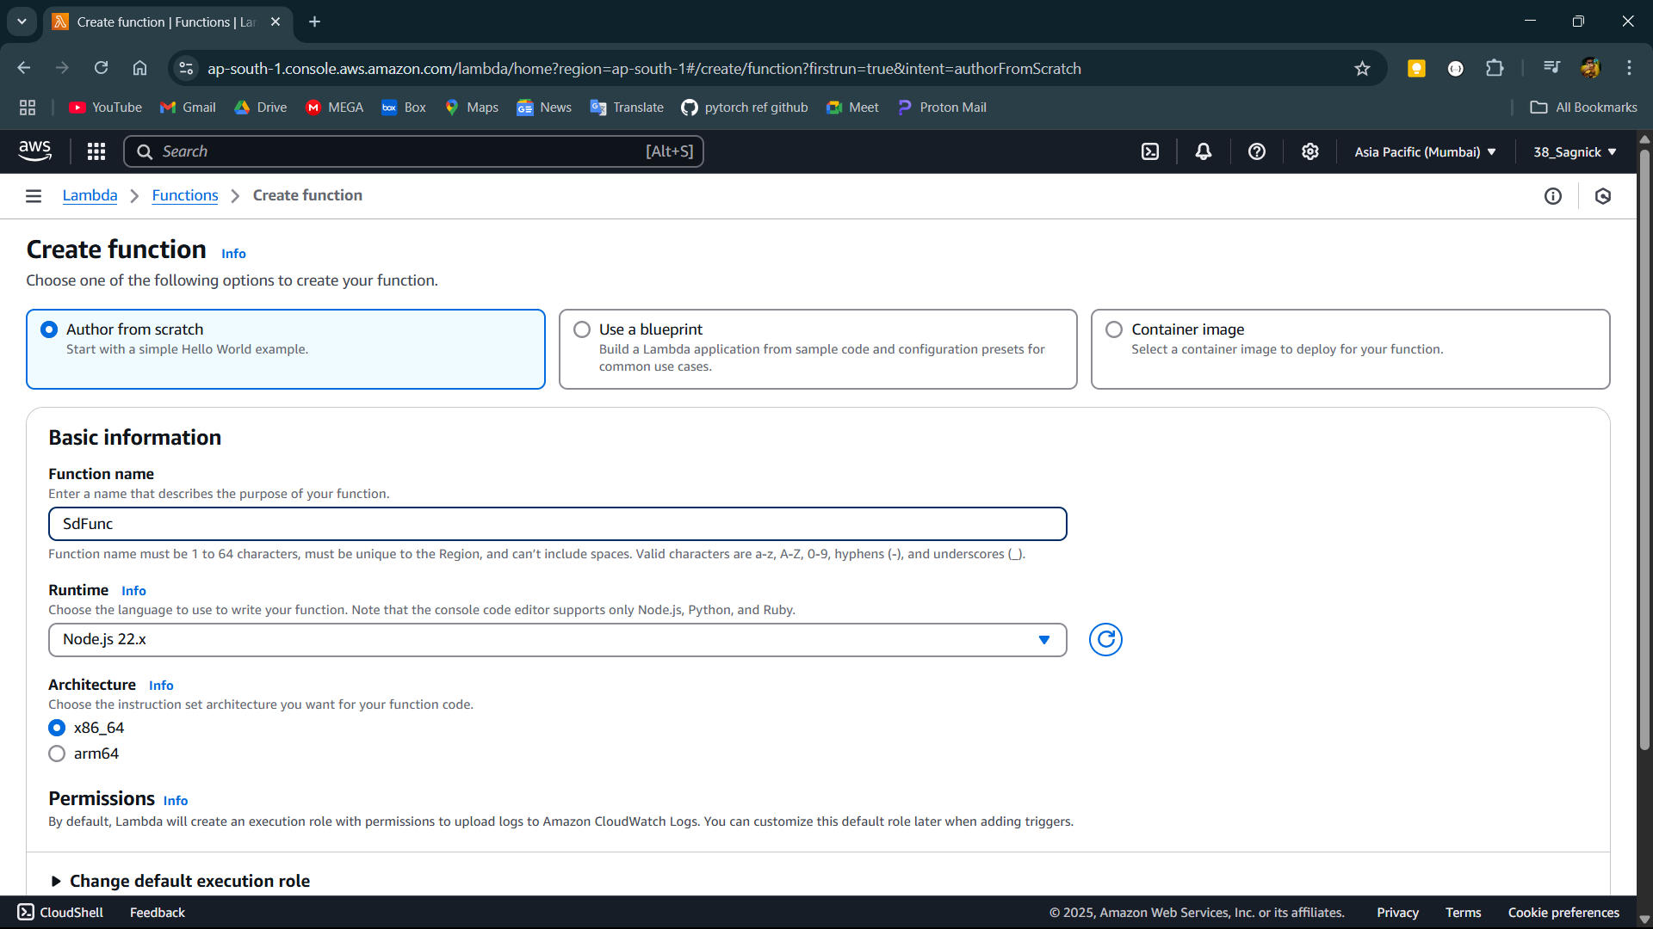

**Step-4:**

Function is created now open the function.

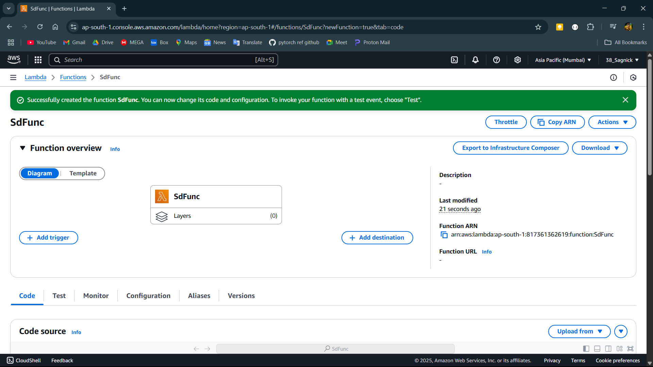

**Step-5:**

Scroll down and open the test section and create a new event. Give it a name and test the event before saving it.

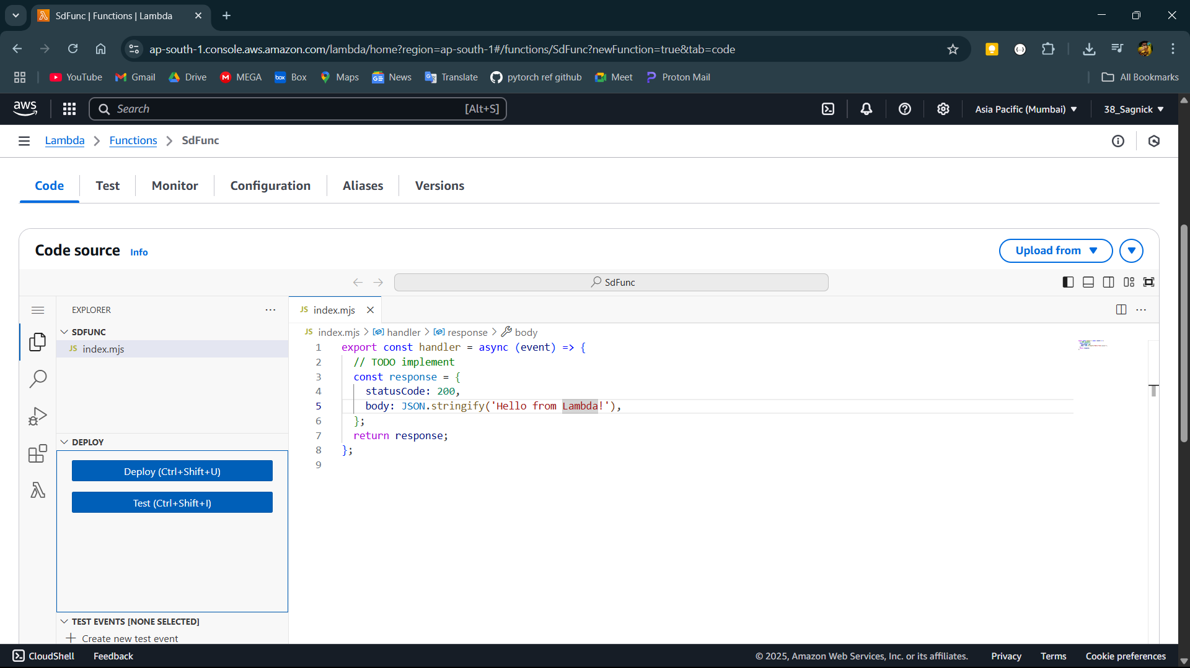

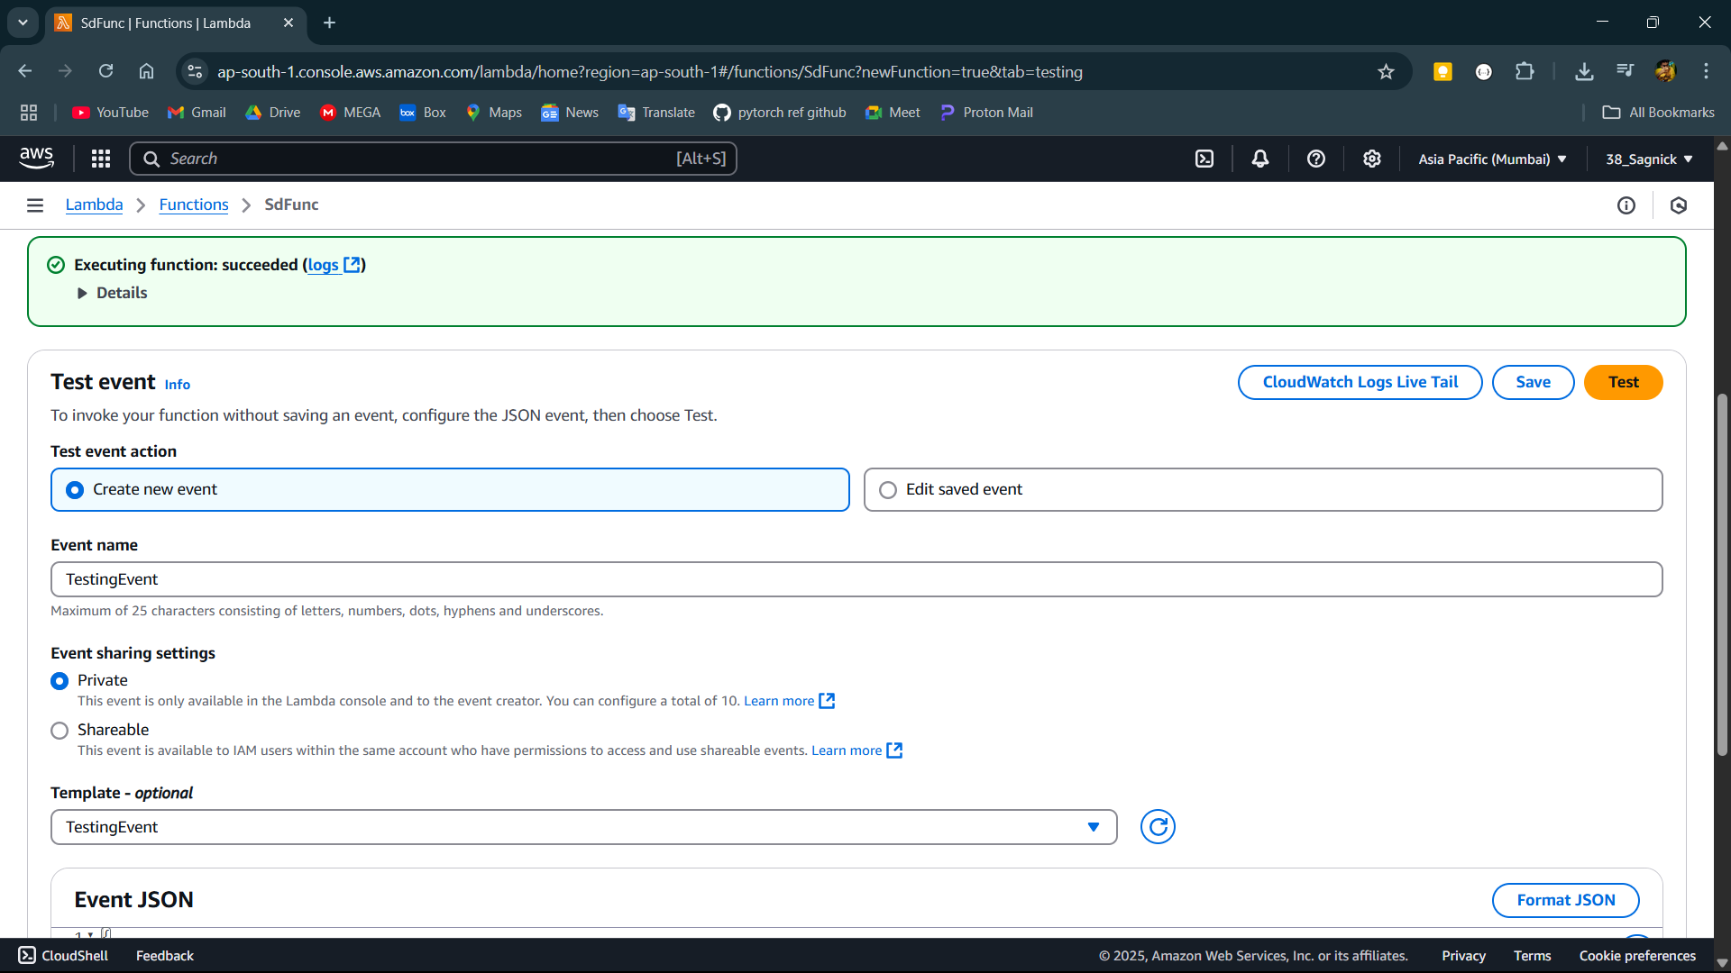

**Step-6:**

Now go back to code section and write the required function code and test the code in the event we created then deploy it.

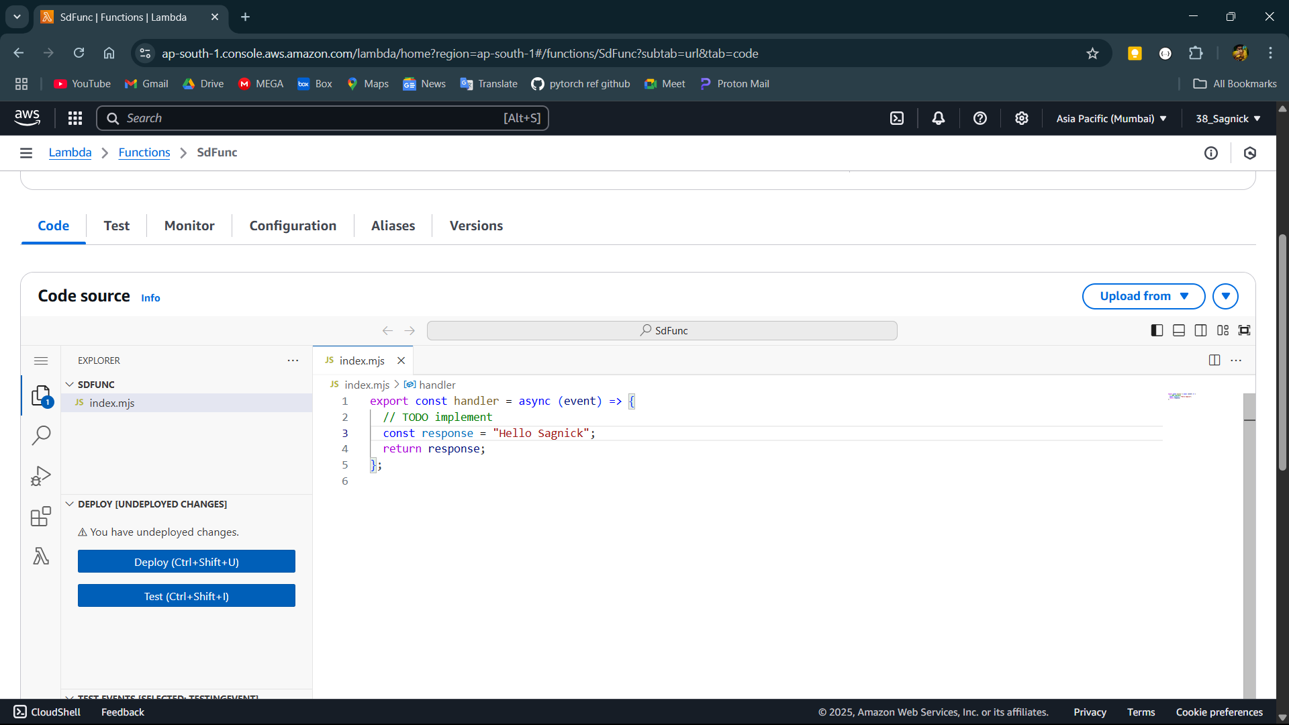

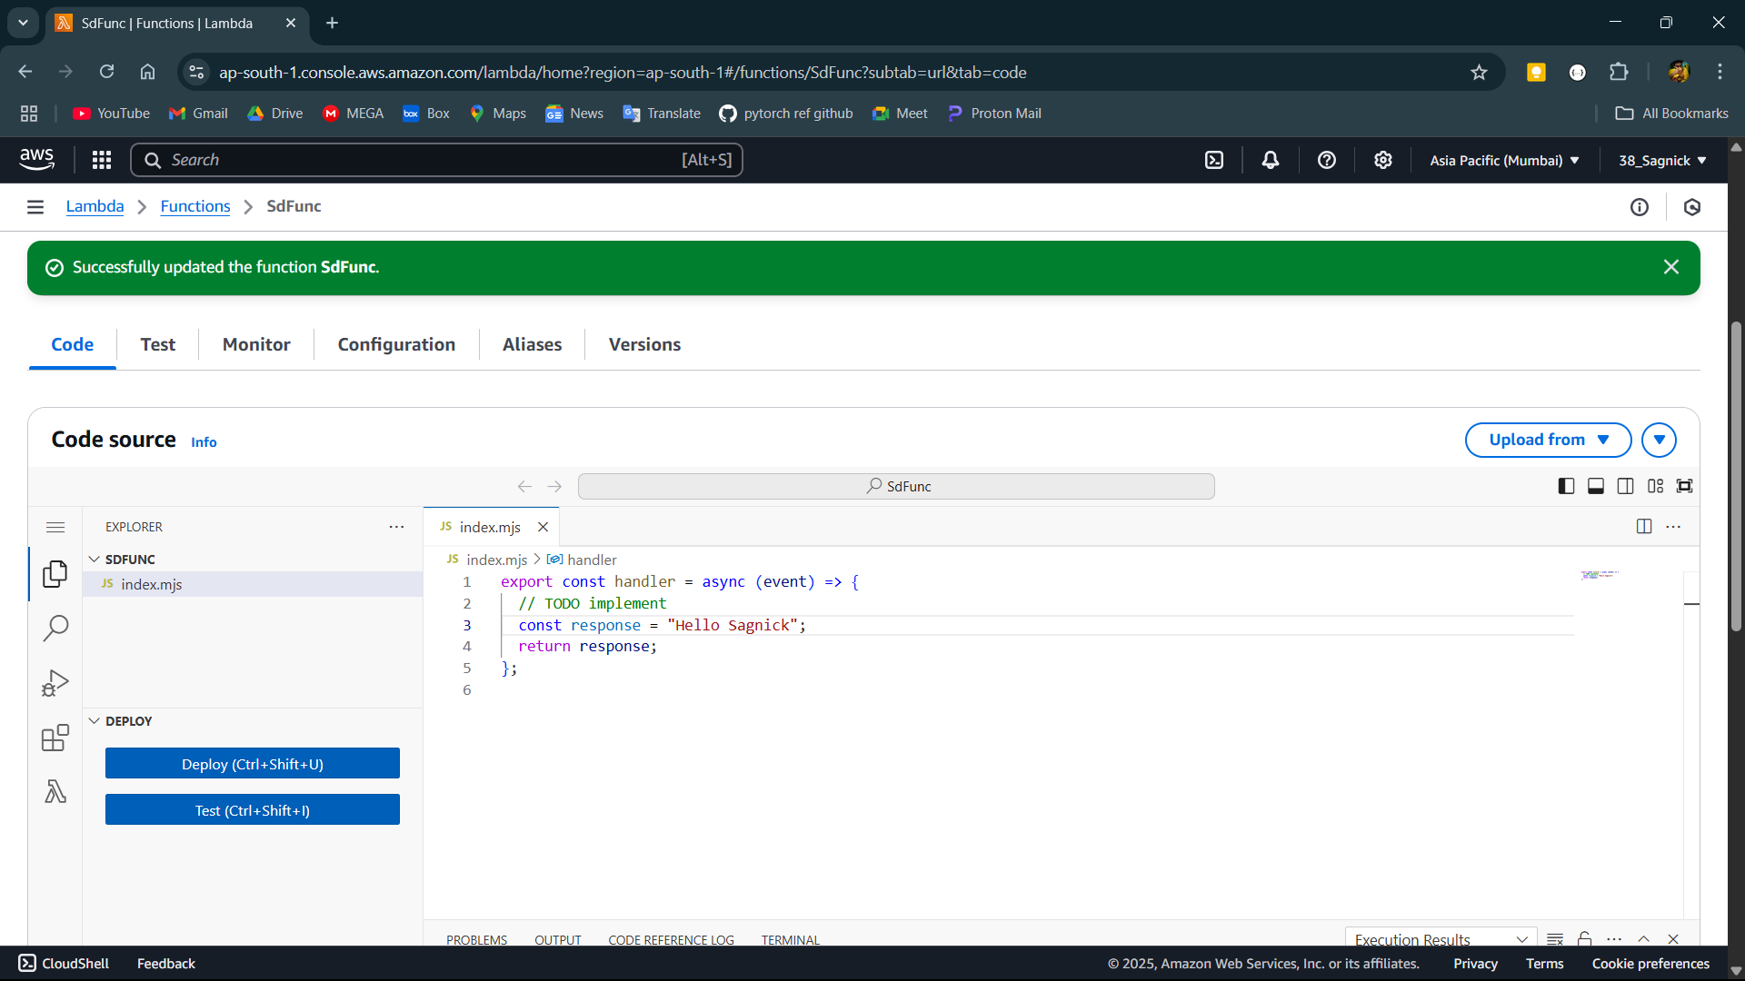

**Step-7:**

Goto configuration and function url then create function URL and choose auth type to none and save.

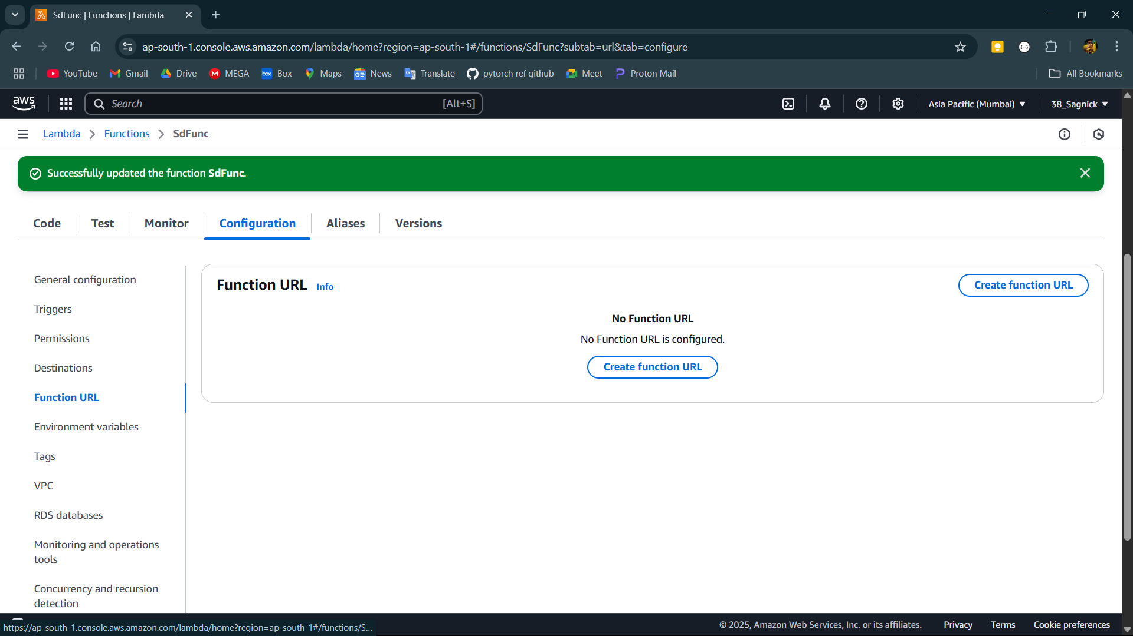

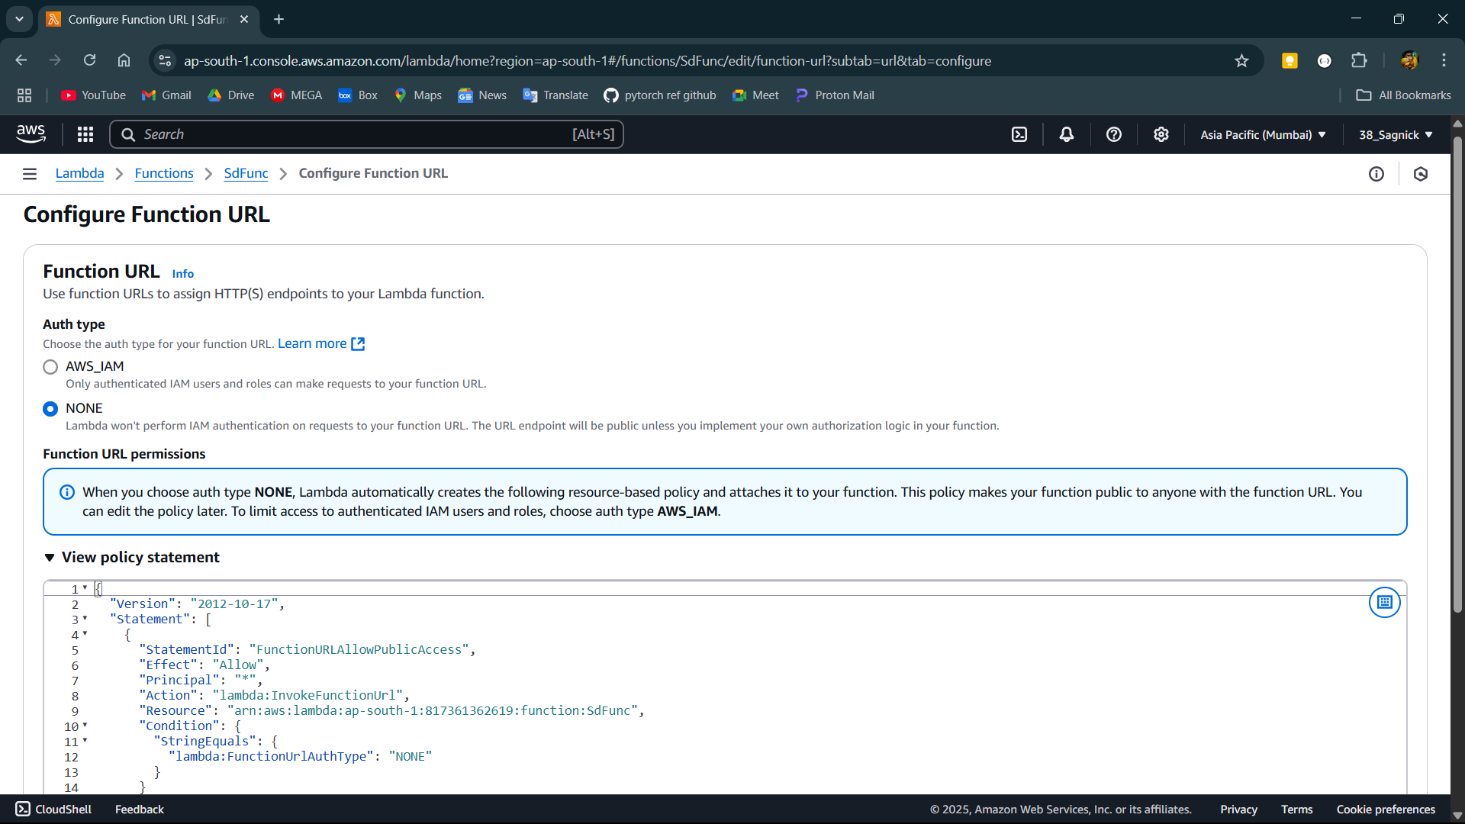

**Step-8:**

Copy the the function url and open it in incognito url.

