**Assignment No:02**

**Title: Create MFA for authentication.**

**Step-1:**

Open the AWS Management Console and click on the user name in the top right corner and click on the Security credentials.

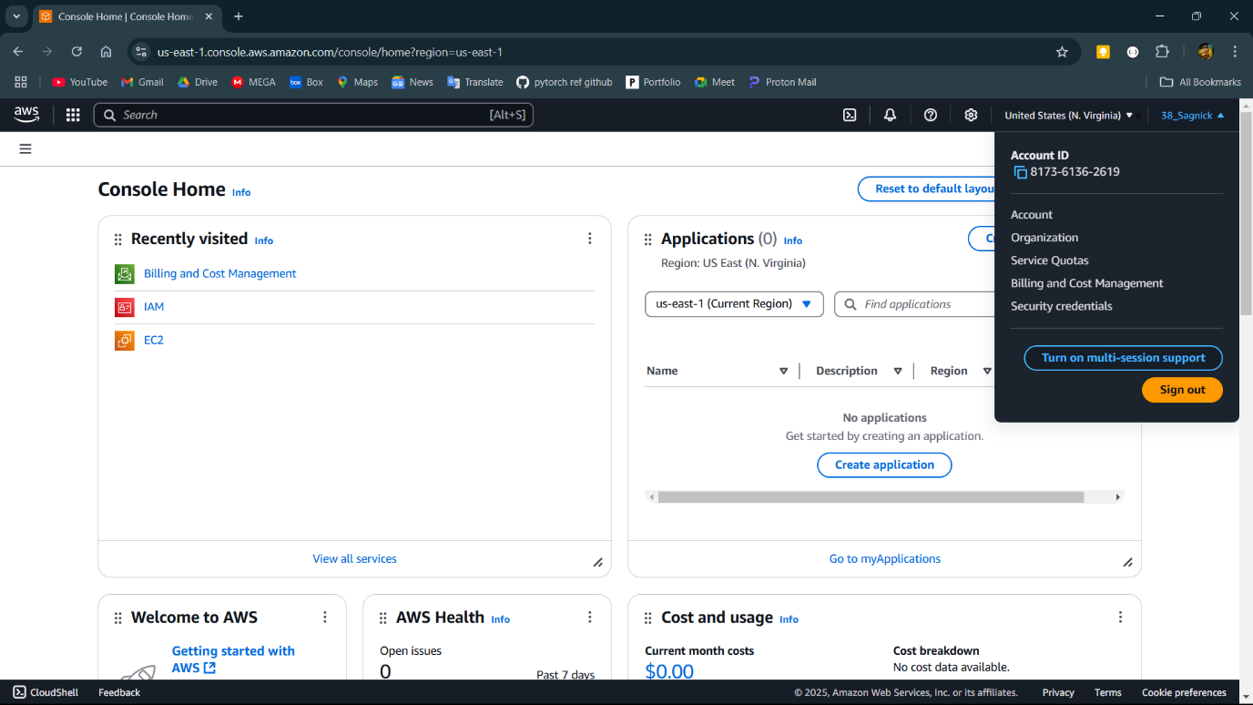

**Step-2:**

Click on the Assign MFA in the yellow box.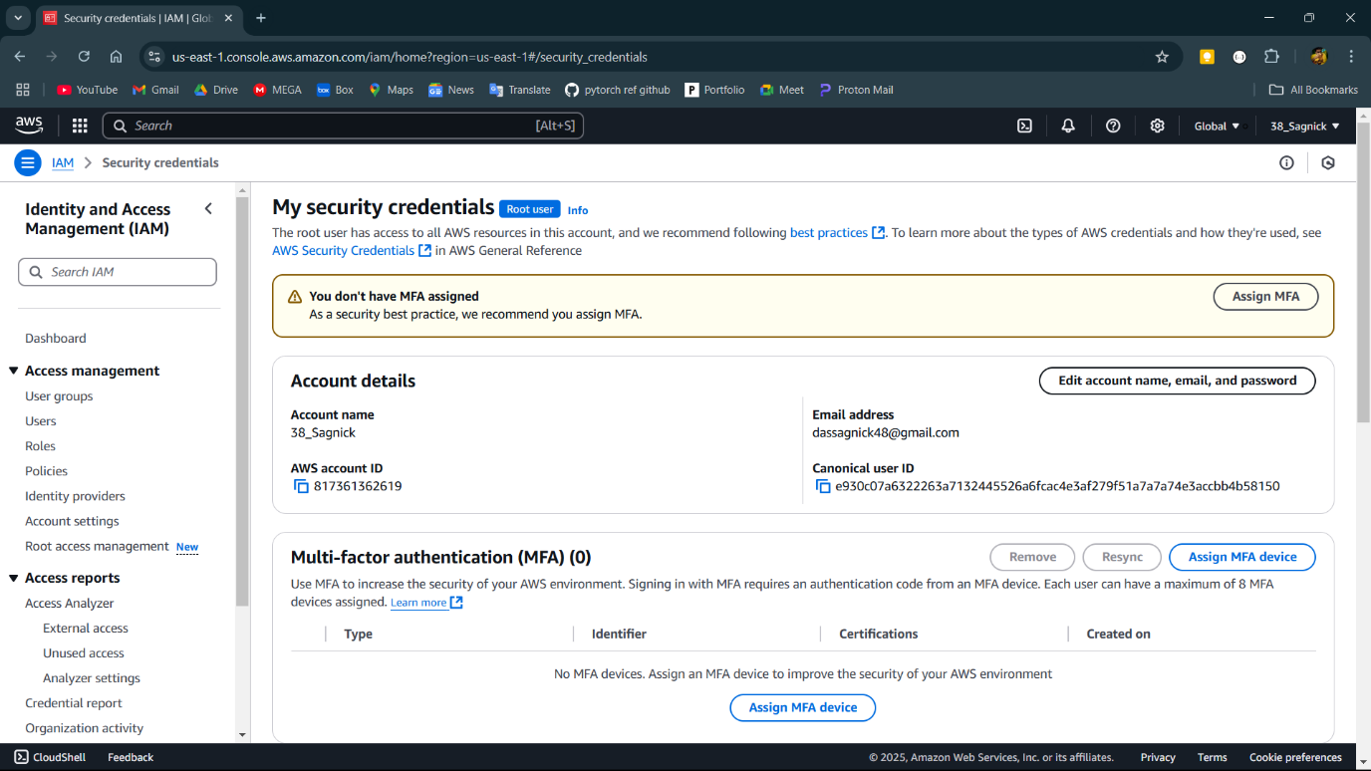

**Step-3:**

Name the device and select the device.

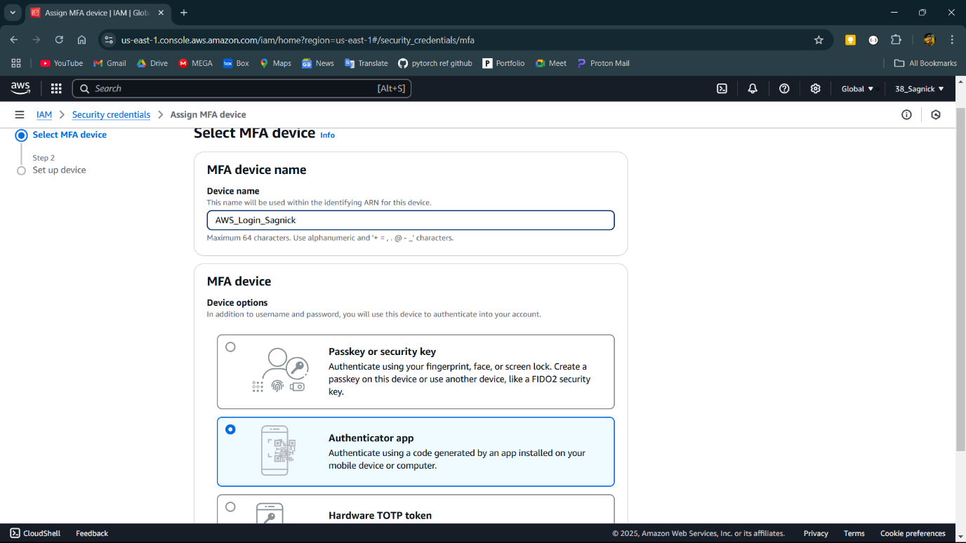

**Step-4:**

Scan the qr code using the device or a authenticator app in mobile

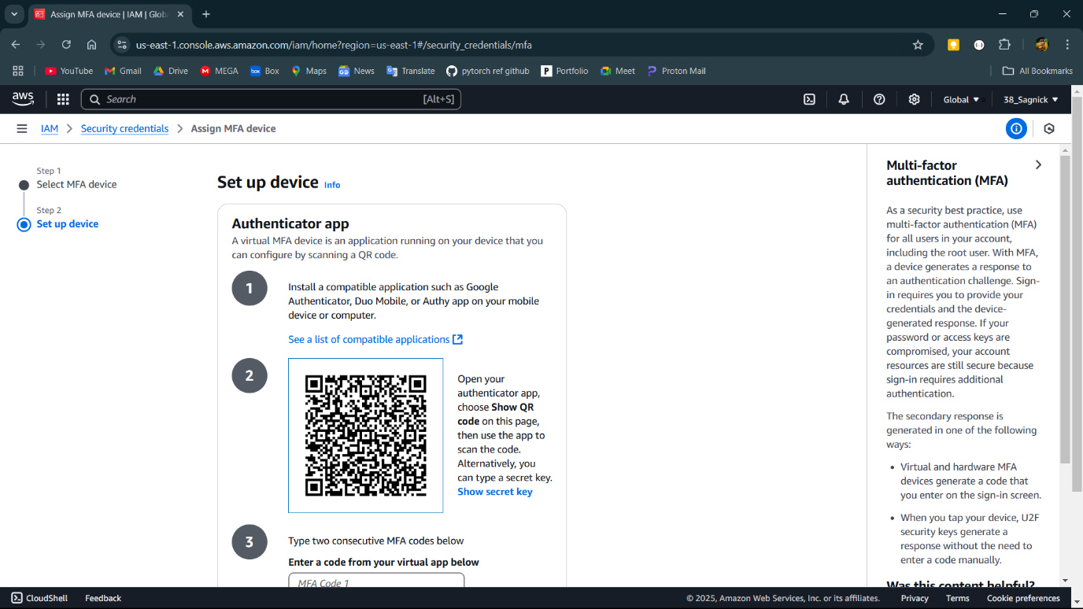

**Step-5:**

Multifactor authentication is added to the account.

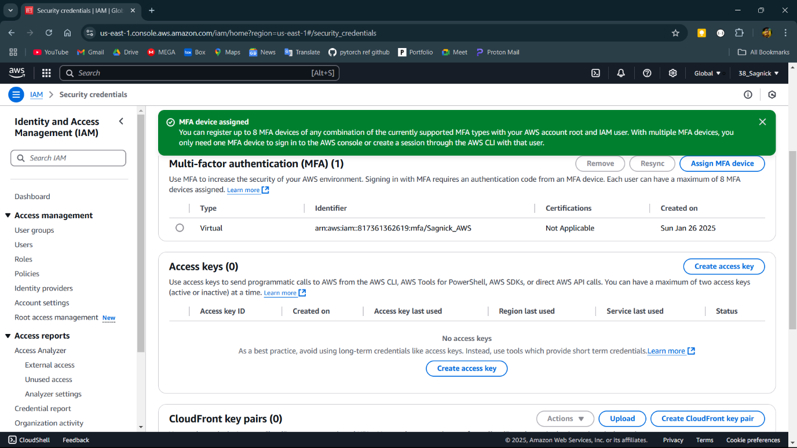

**Step-6:**

Now during login MFA code is required.

