**Assignment No:03**

**Title: Create IAM User and give full access to S3.**

**Step-1:**

Open the AWS Management Console and click on services on the top left corner.

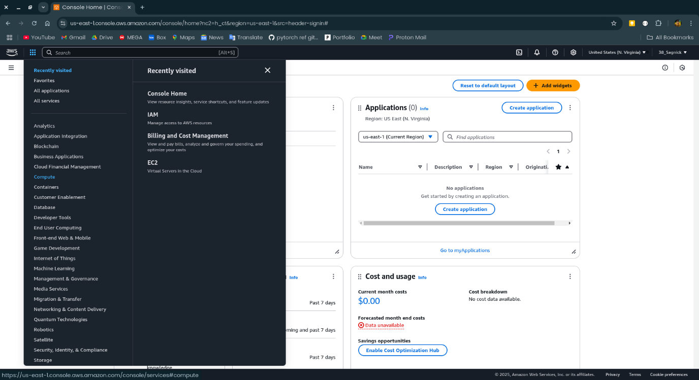

**Step-2:**

Click on all services and open the IAM.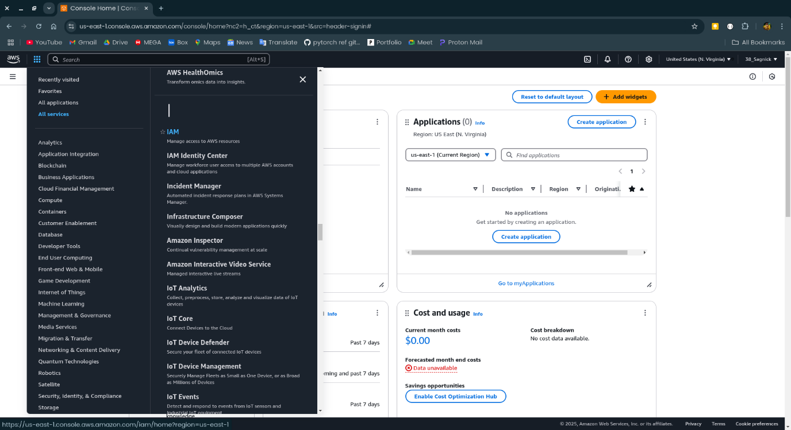

**Step-3:**

Open the Users in Access management in the left side.

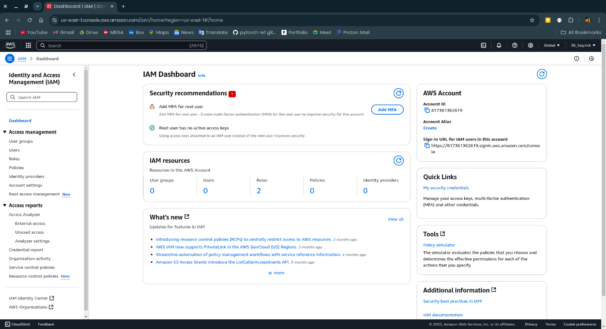

**Step-4:**

Now click on the Create user.

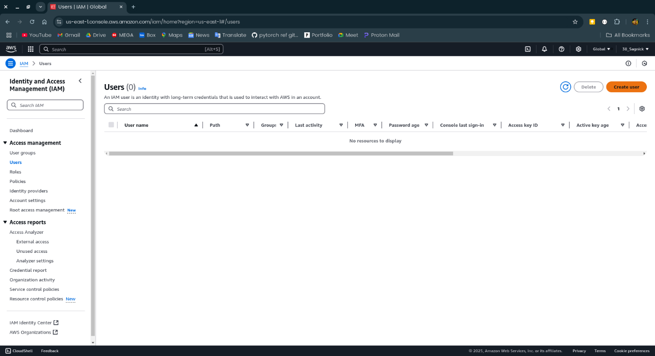

**Step-5:**

Now give IAM user a name and check the Provide user access to the AWS management console and select the user type as I want to create an IAM user then choose custom password in the console password section then choose password then click on next.

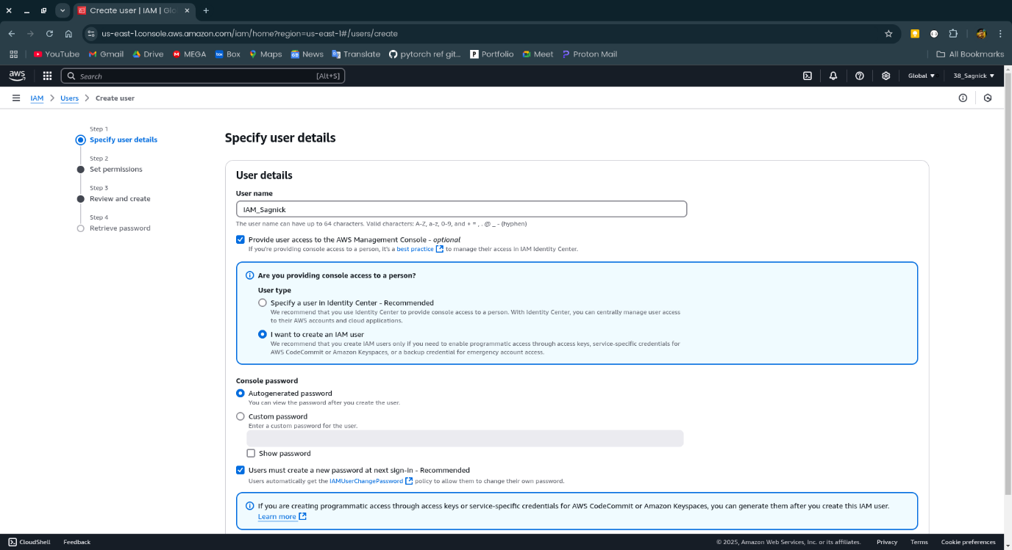

**Step-6:**

Now select Attach policies directly in the Permissions options. Now check the AmazonS3FullAccess box and click on next.

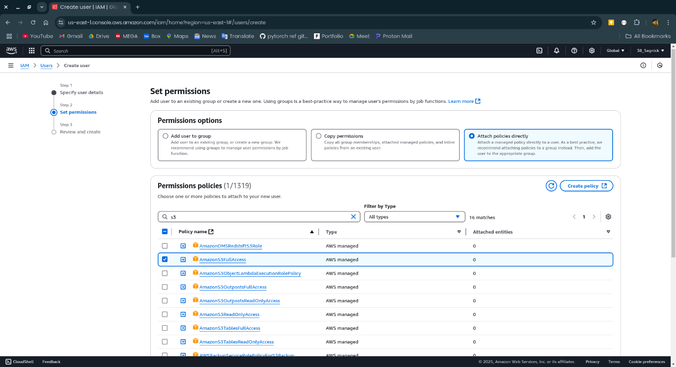

**Step-7:**

Now review the account and click on create user.

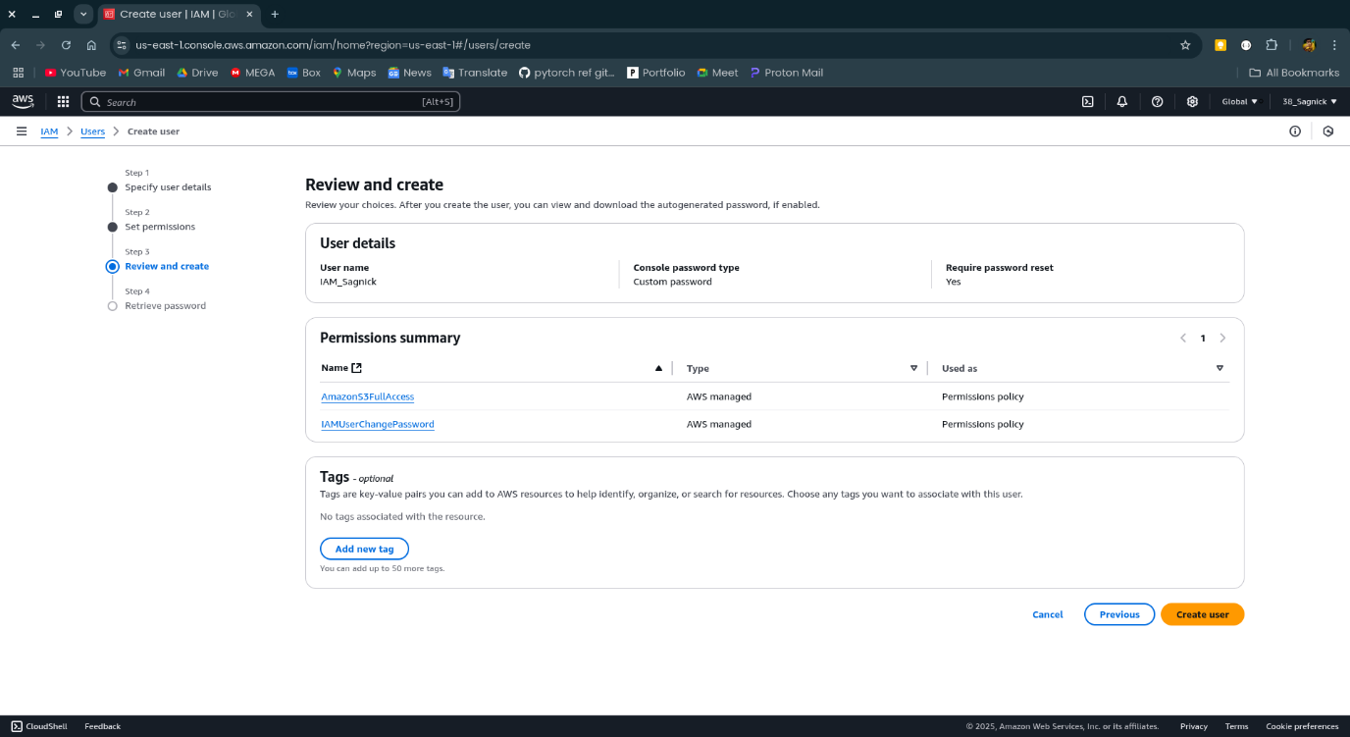

**Step-8:**

Now download the csv.

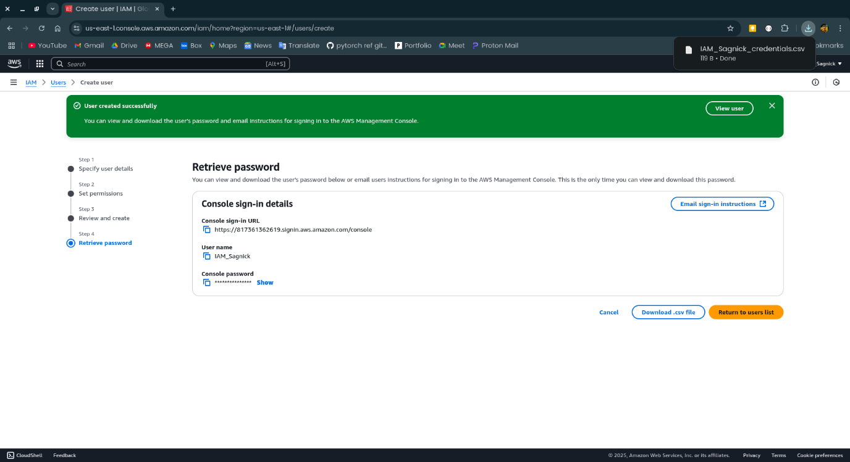

**Step-9:**

Now login to the IAM user account by giving credentials from the csv file.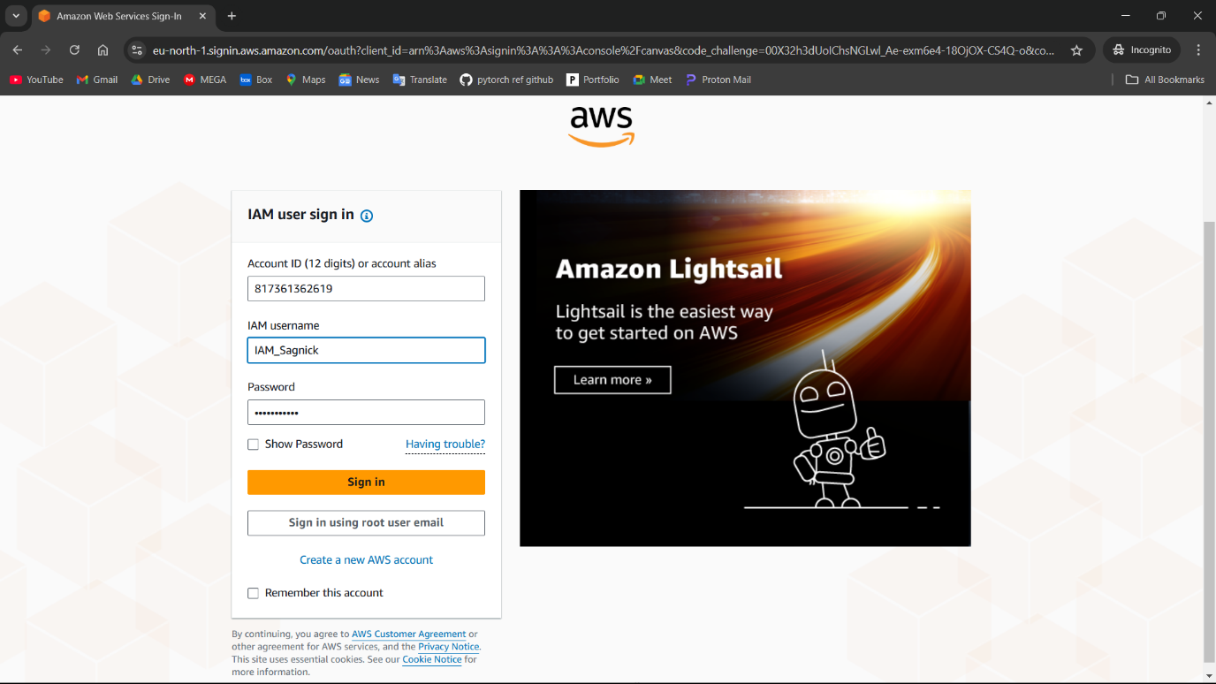

**Step-10:**

Login into the IAM user is successful.

