**Assignment No:04**

**Title: Create a private bucket in in AWS. Upload a file and check whether you can access the file or not**

**Step-1:**

Search S3 in the AWS management console

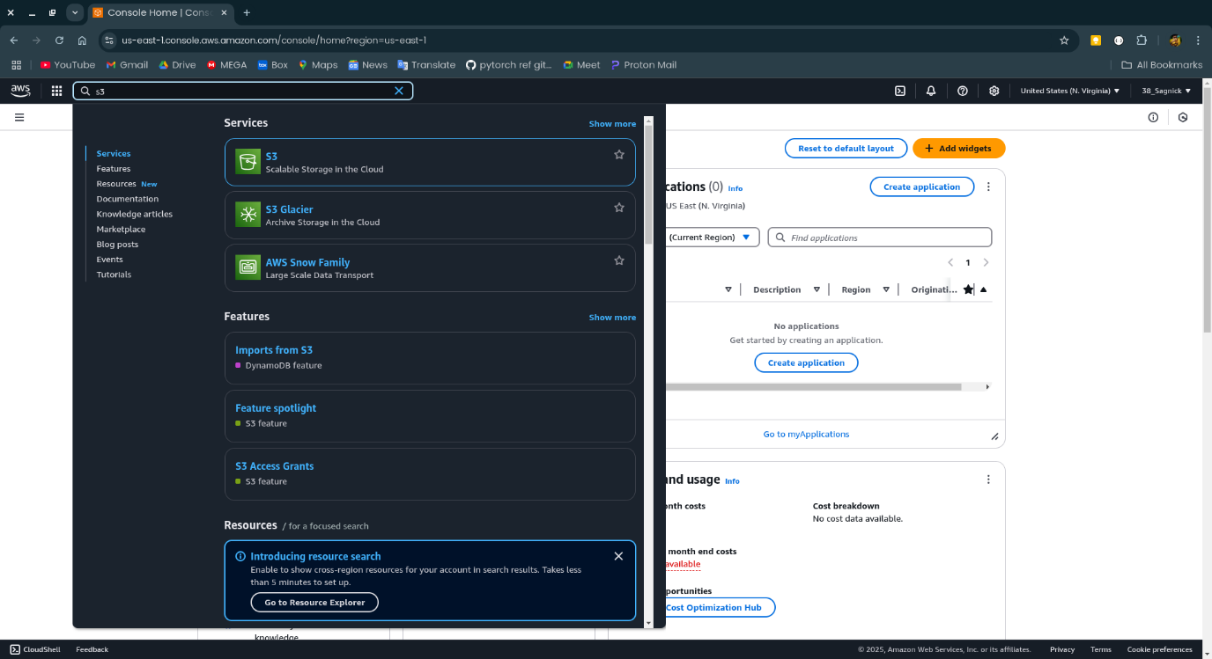

**Step-2:**

Click on the S3 and click on create bucket.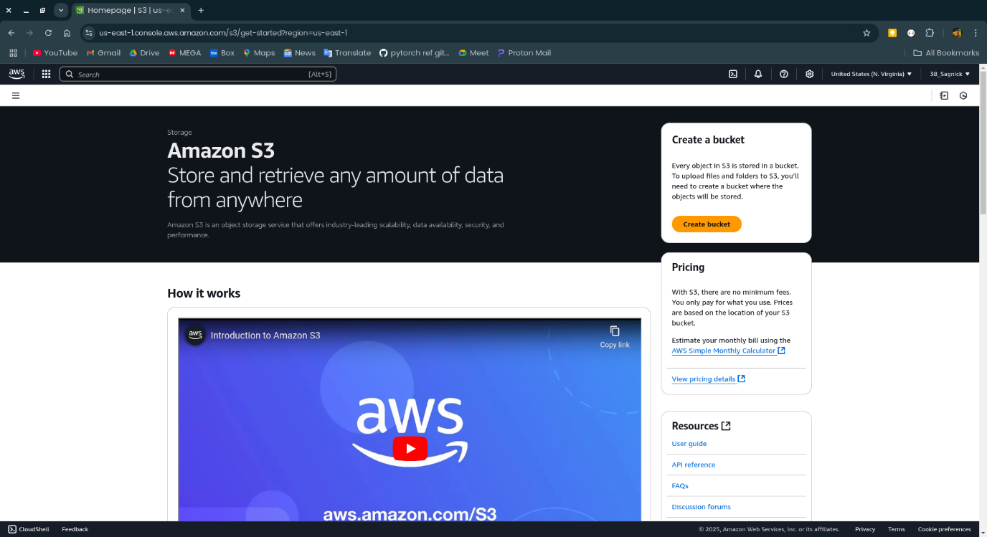

**Step-3:**

Name the bucket the select all the necessary settings uncheck “block all public access” and enable bucket versioning.

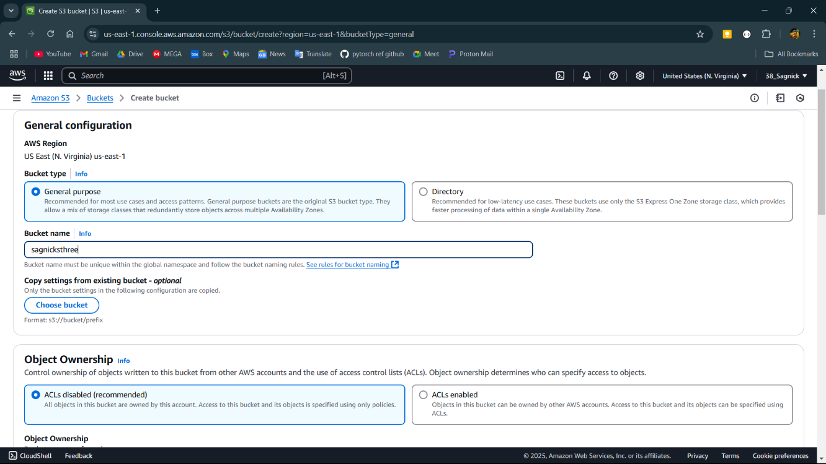

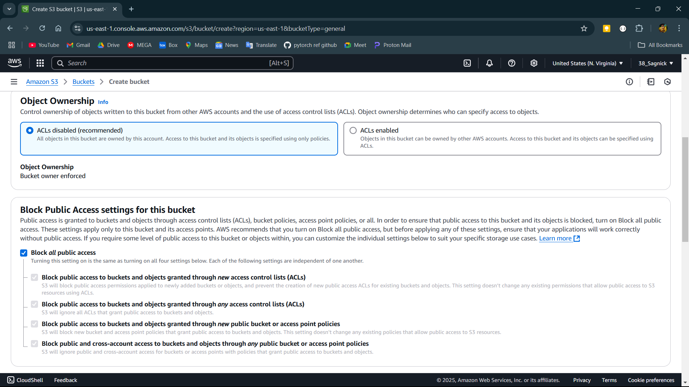

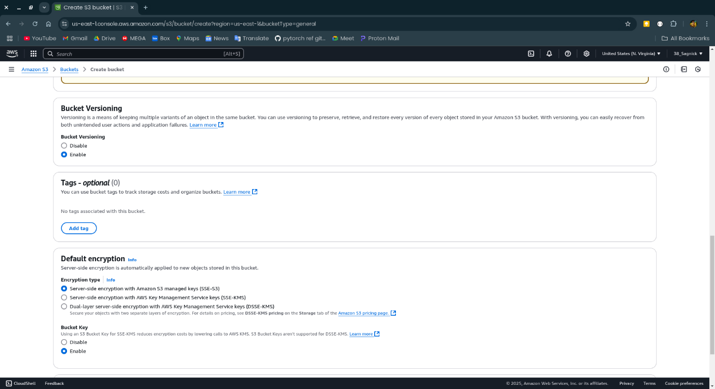

**Step-4:**

Now click on the name of the created bucket.

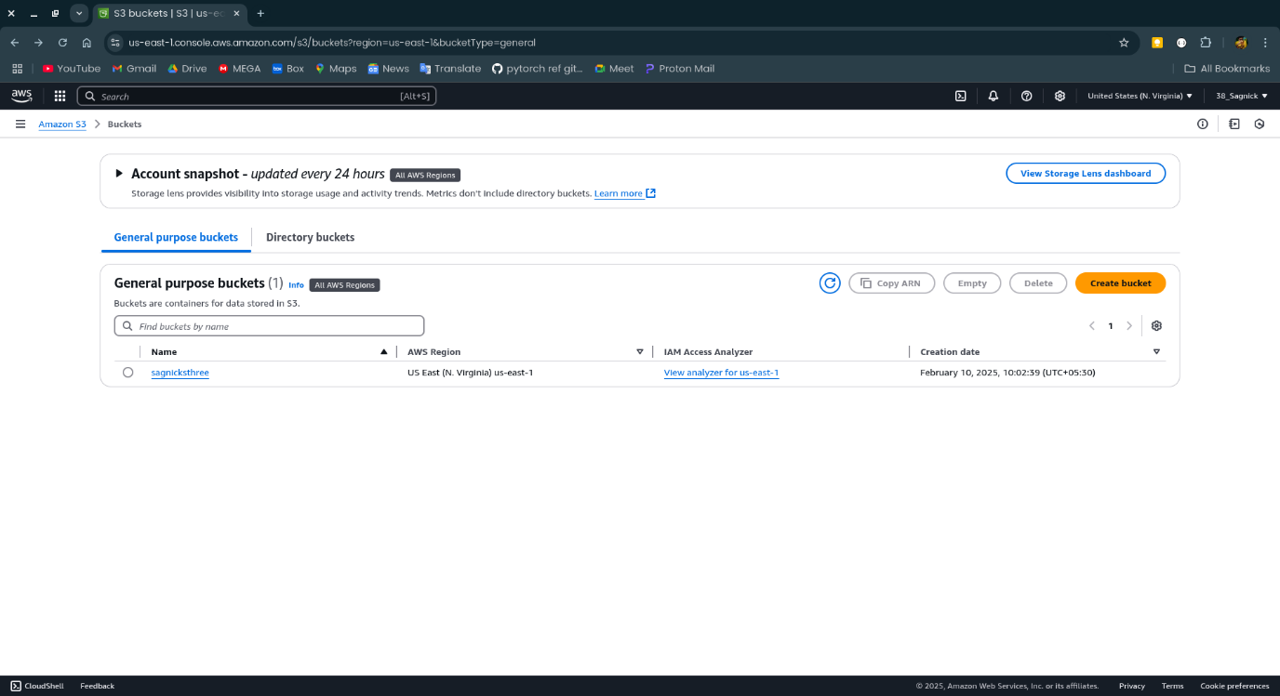

**Step-5:**

Click on upload to upload file.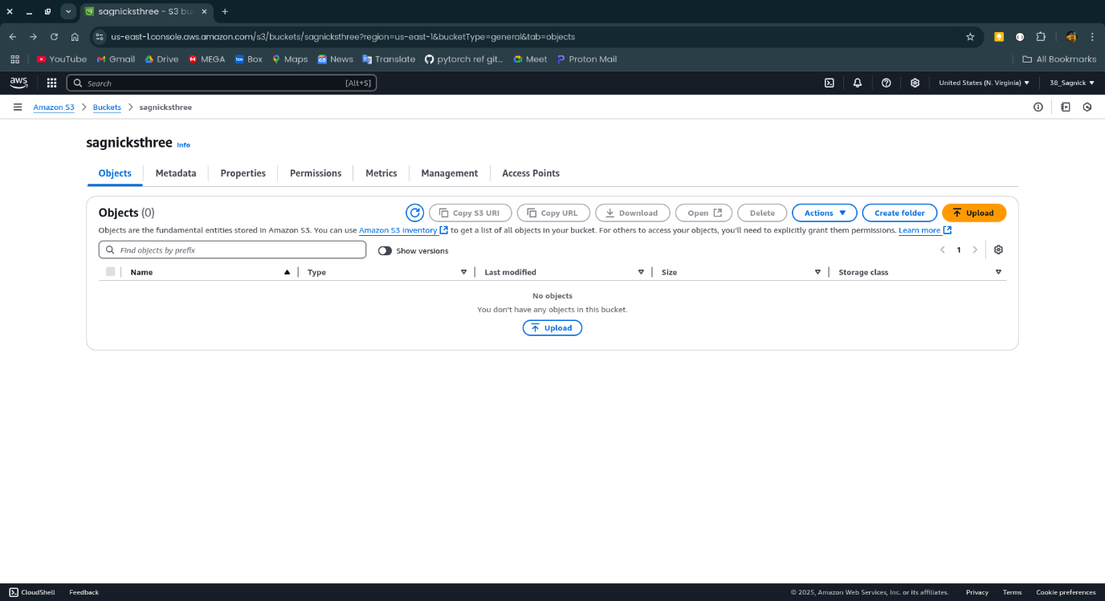

**Step-6:**

Select the file file to upload and click open. Then press upload

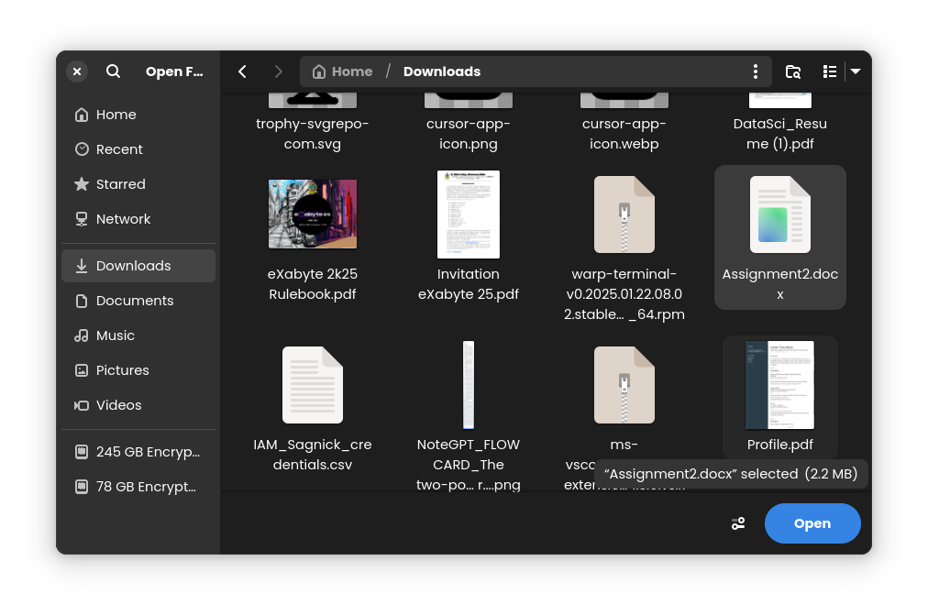

**Step-7:**

Now click on the name of the file uploaded

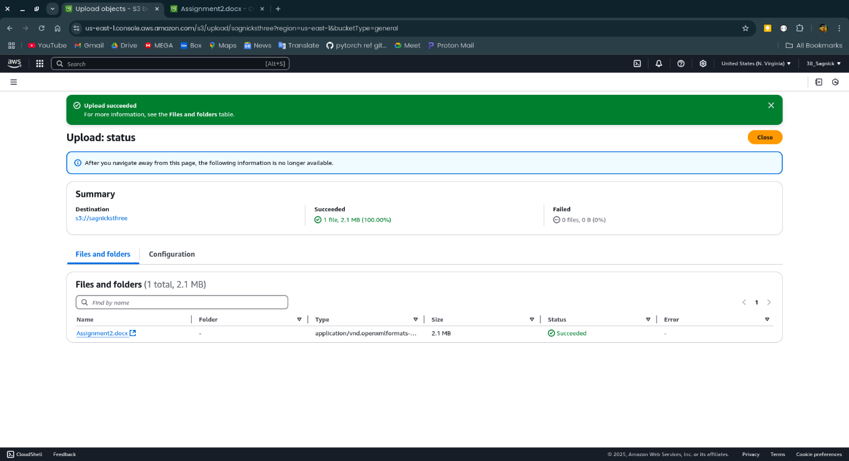

**Step-8:**

Copy the Object URL and open it in incognito mode.

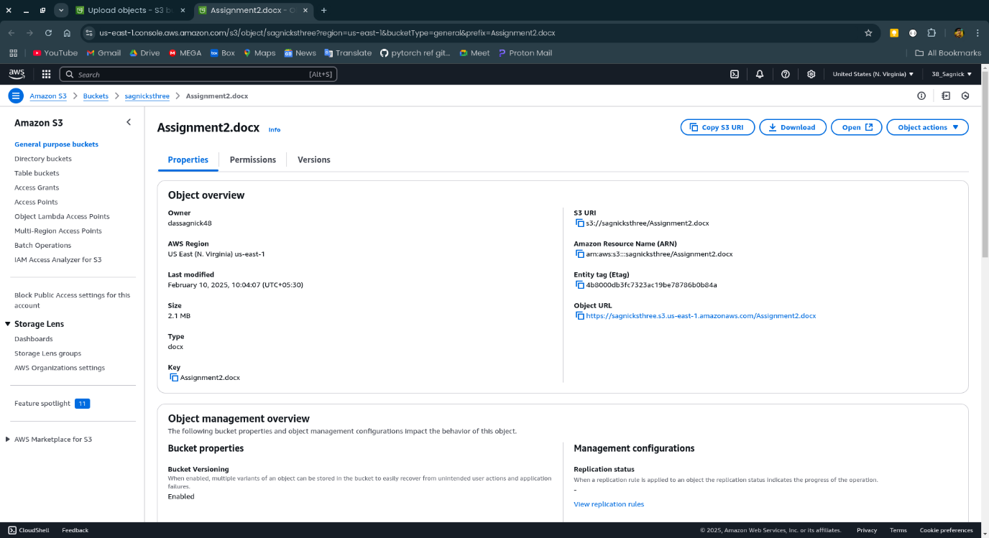

**Step-9:**

The access is denied.