**Assignment No:06**

**Title: Upload a static website on S3.**

**Step-1:**

Search S3 in the AWS management console.

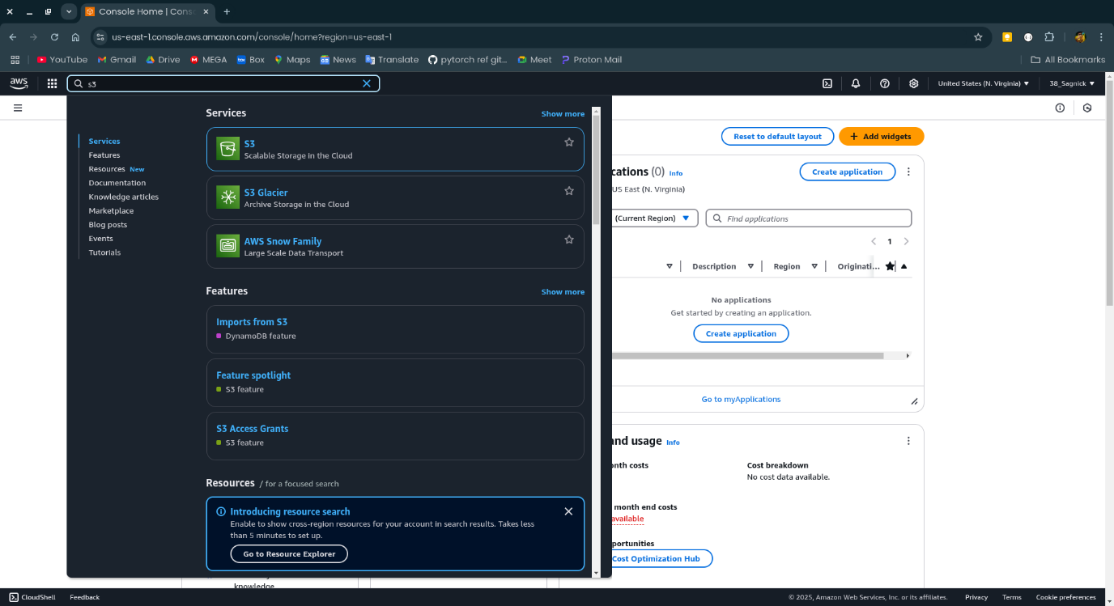

**Step-2:**

Click on the S3 and click on create bucket.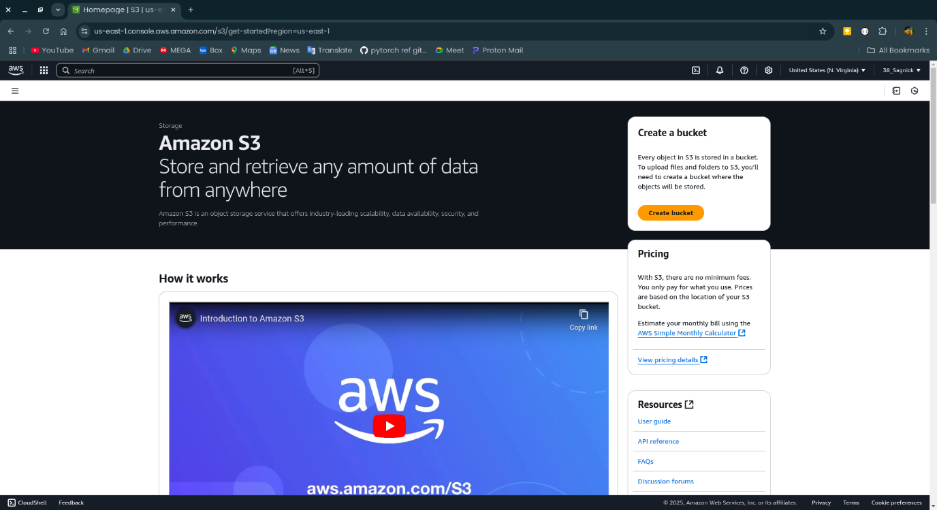

**Step-3:**

Name the bucket the select all the necessary settings uncheck “block all public access” and enable bucket versioning.

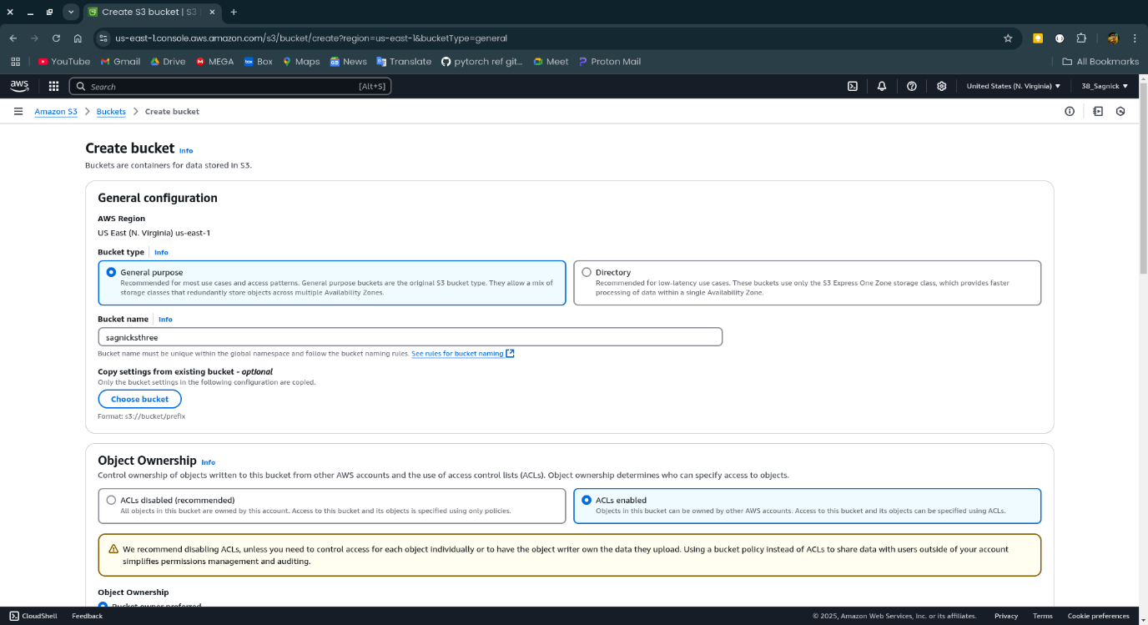

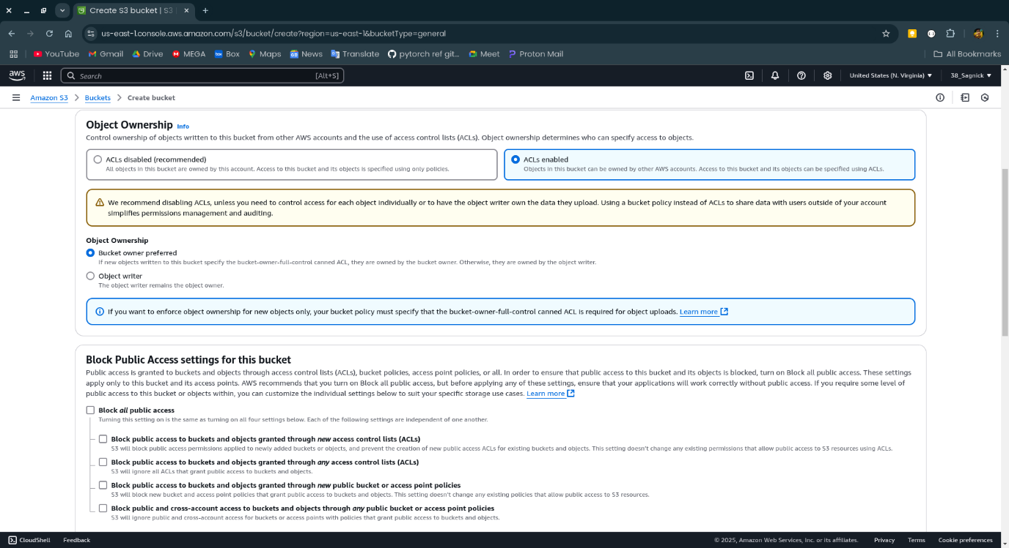

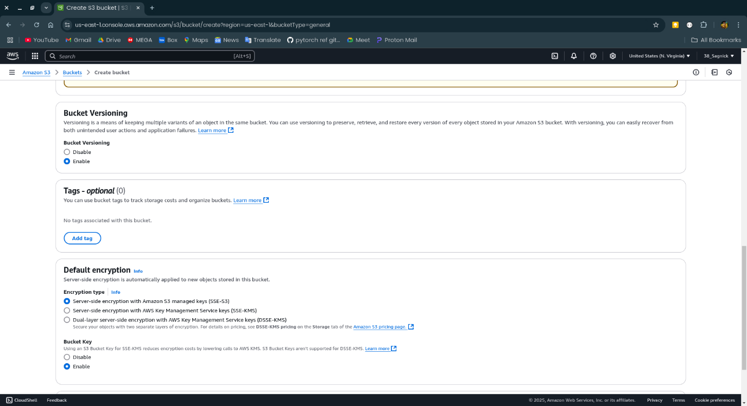

**Step-4:**

Now click on the name of the created bucket.

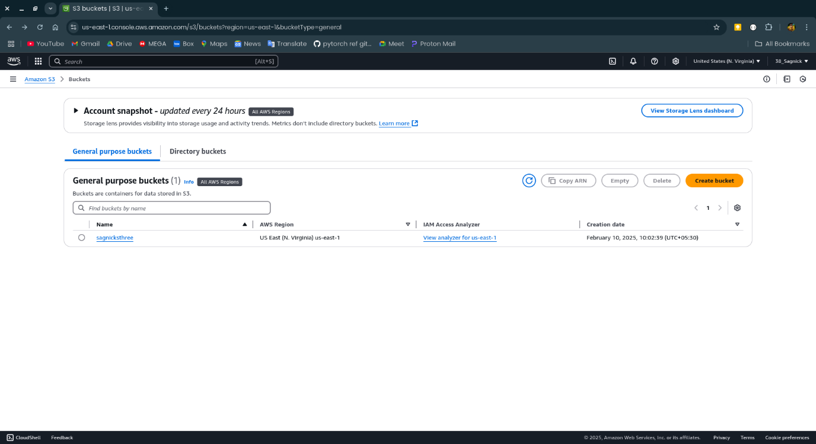

**Step-5:**

Open the properties and scroll down to Static website hosting then click on edit.

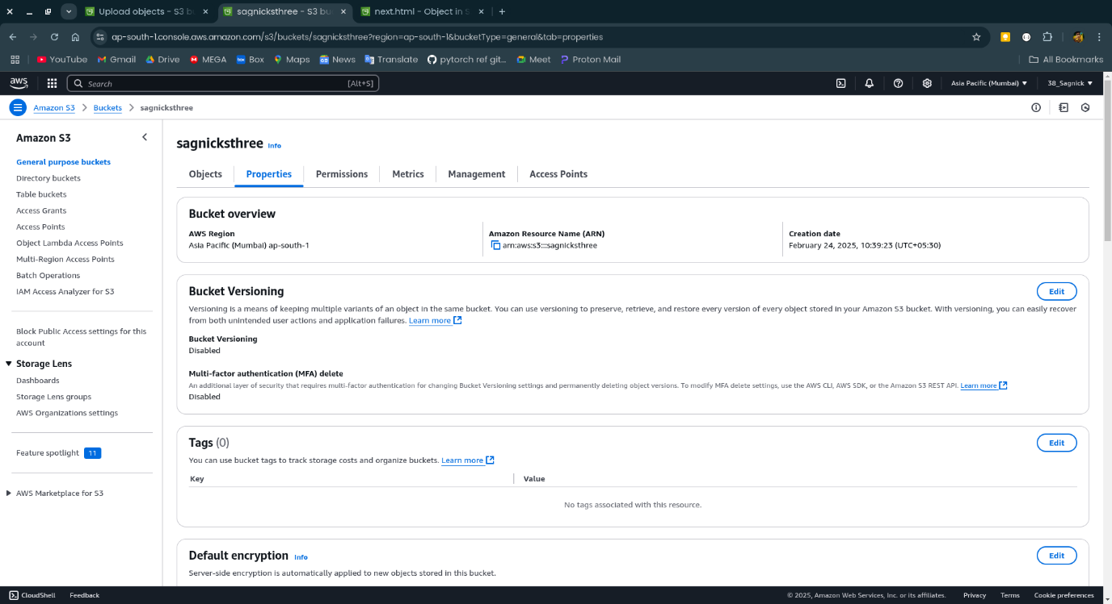

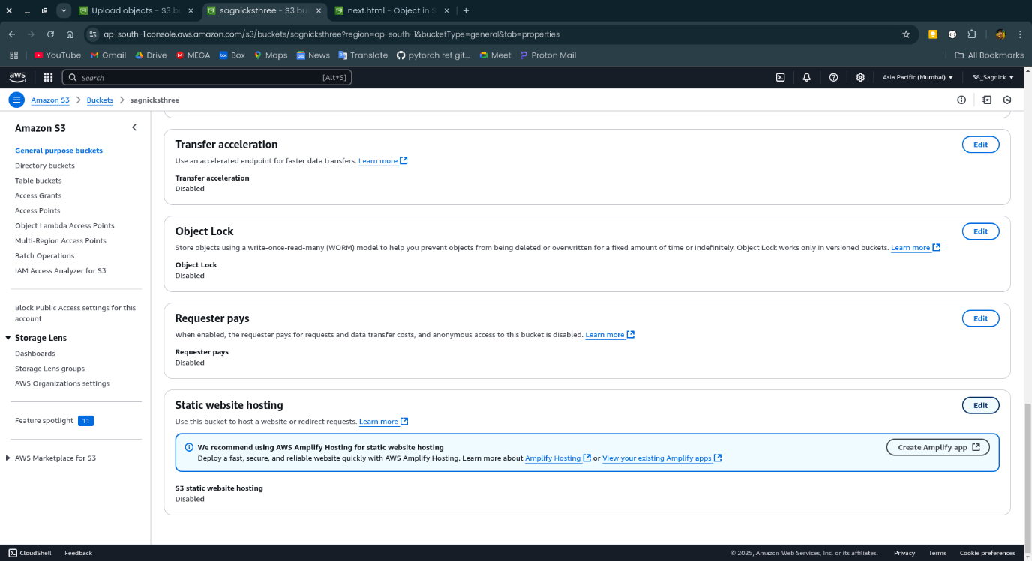

**Step-6:**

Click on enable and give the name of the home page in index document and click save changes.

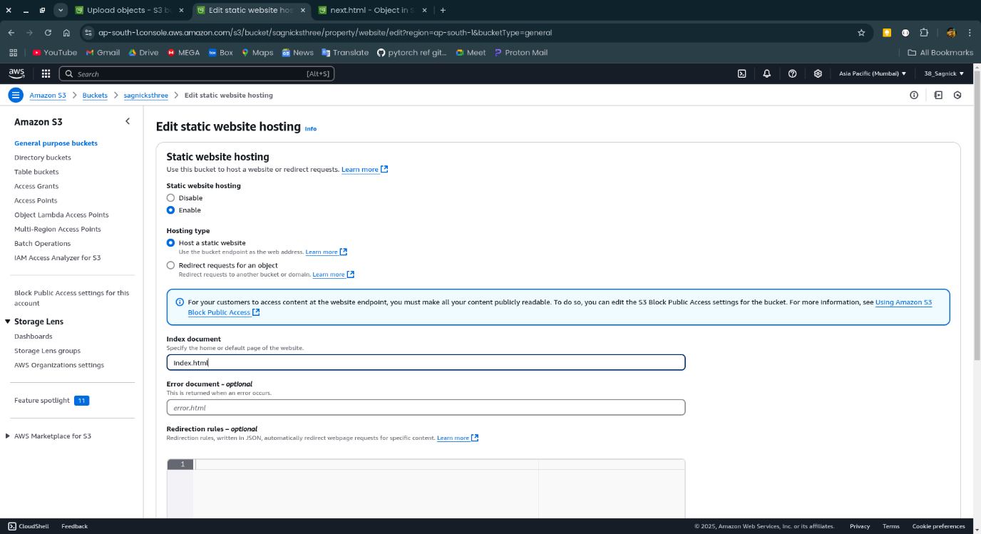

**Step-7:**

Click on upload to upload file.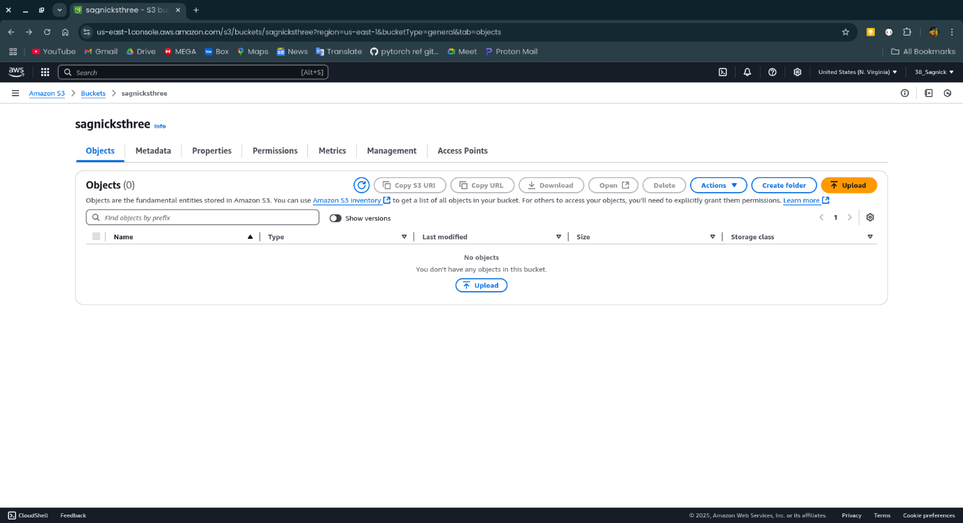

**Step-8:**

Select the files to be uploaded and click on open.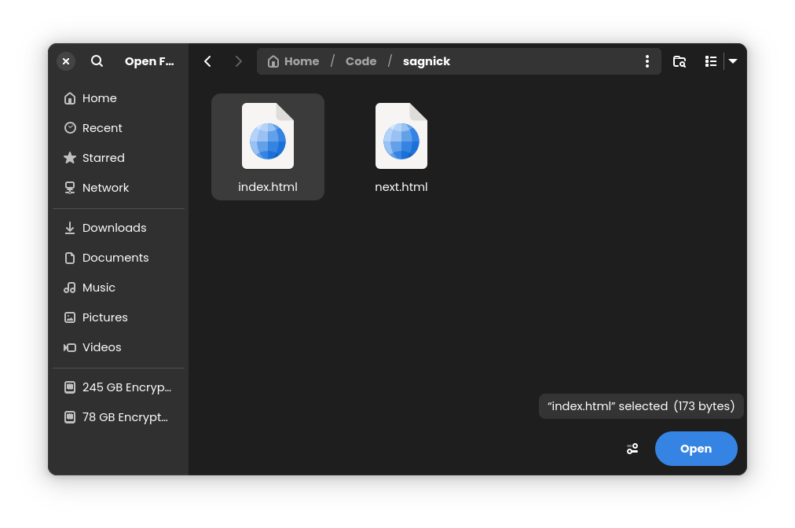

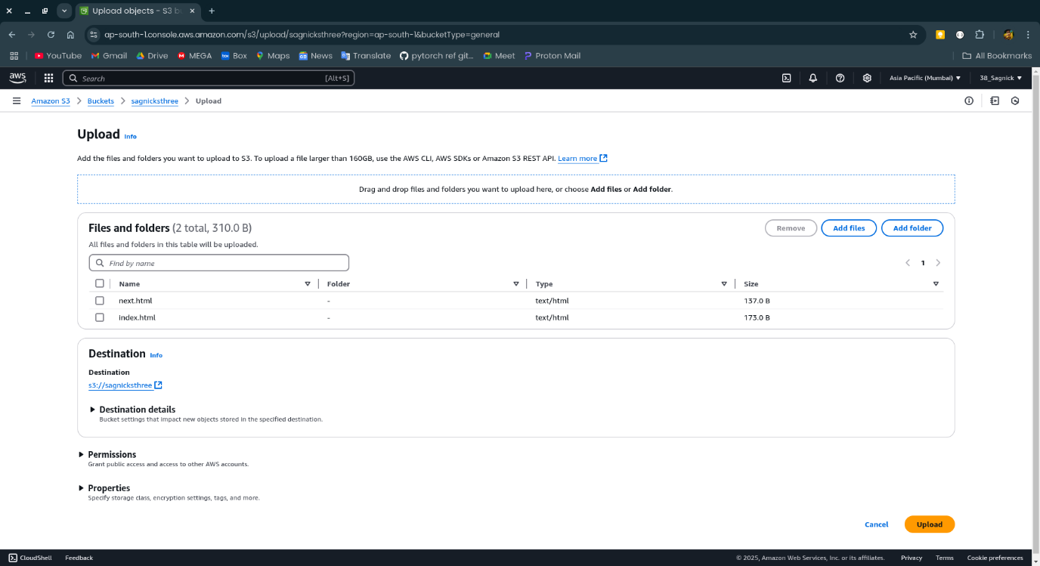

**Step-9:**

Now click on the name of the file uploaded

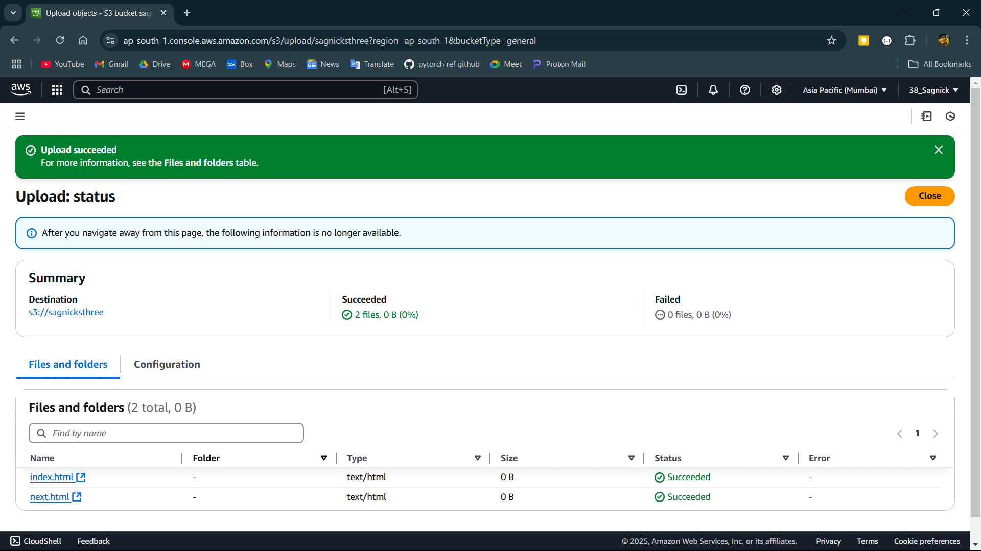

**Step-10:**

Open the permissions and edit

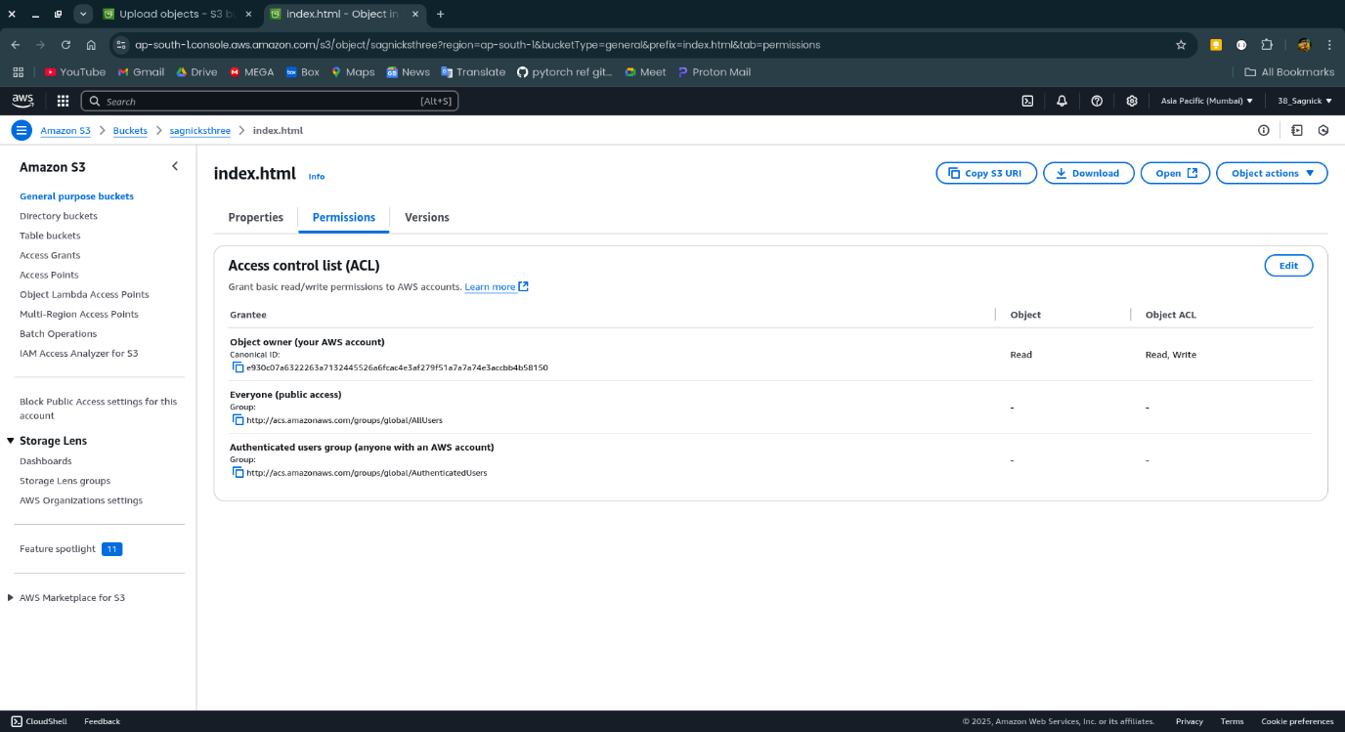

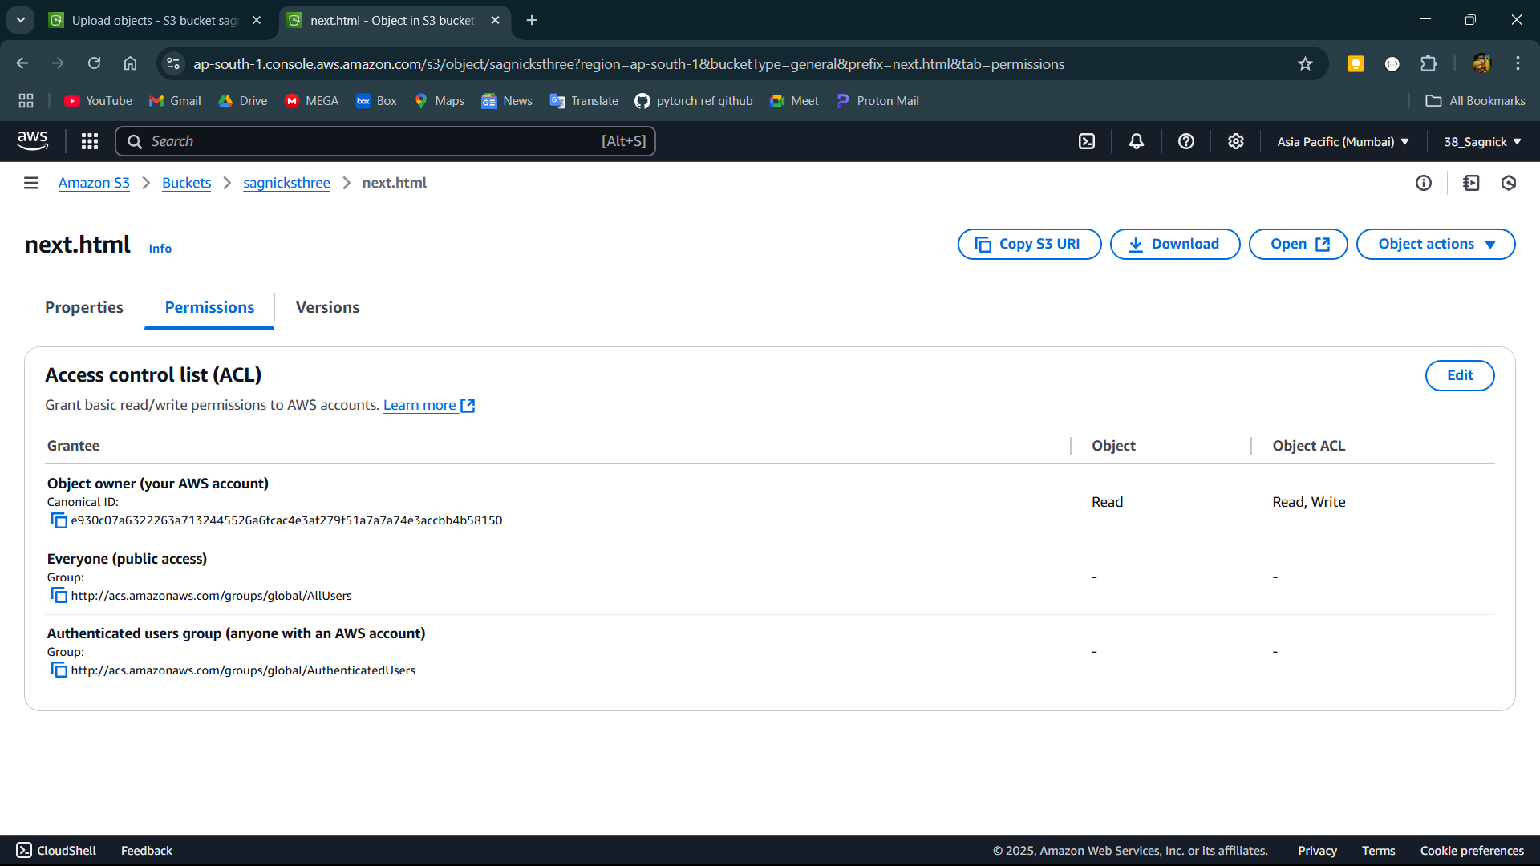

**Step-11:**

Edit the ACL set everyone to read.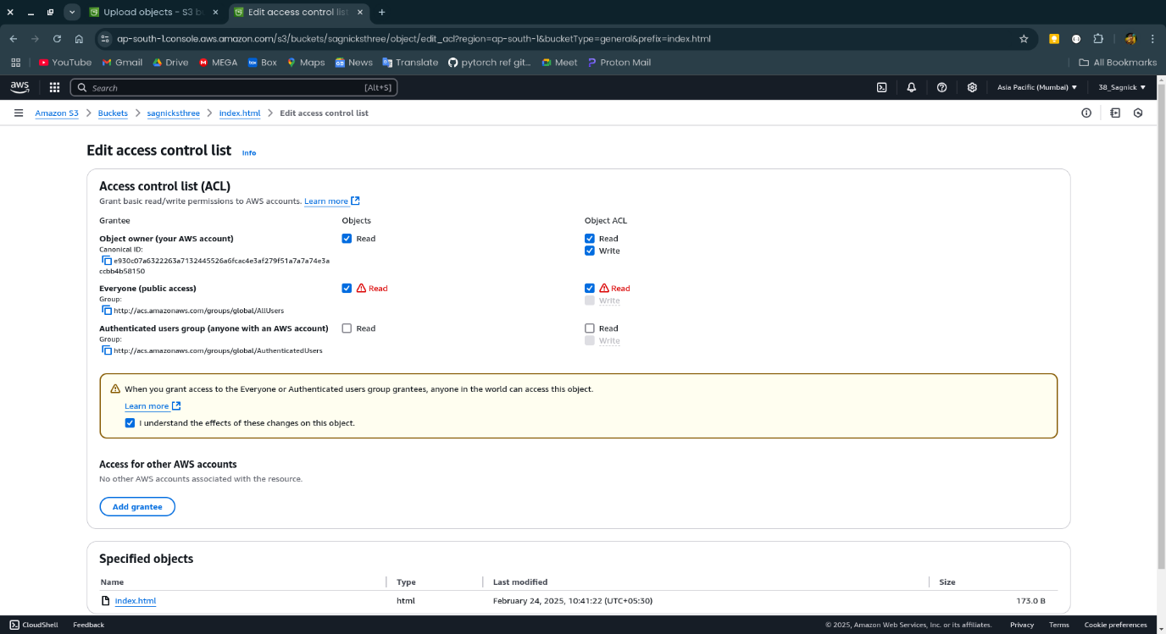

**Step-12:**

Copy the Object URL of the home page and open it in incognito mode.

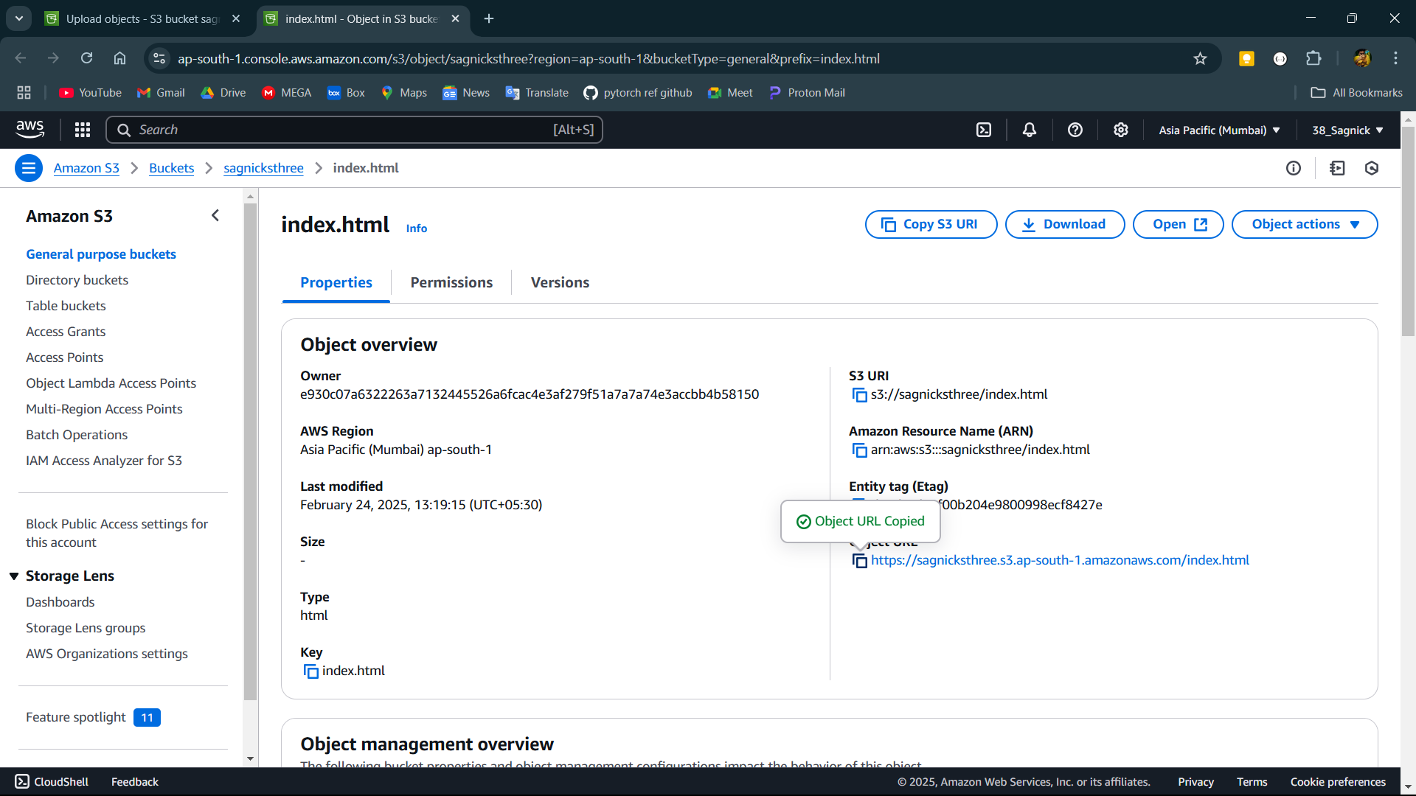

**Step-13:**

Open the permissions and click on edit.

