**Assignment No:07**

**Title: Hosting a website on EC2.**

**Step-1:**

Search EC2 in the AWS management console.

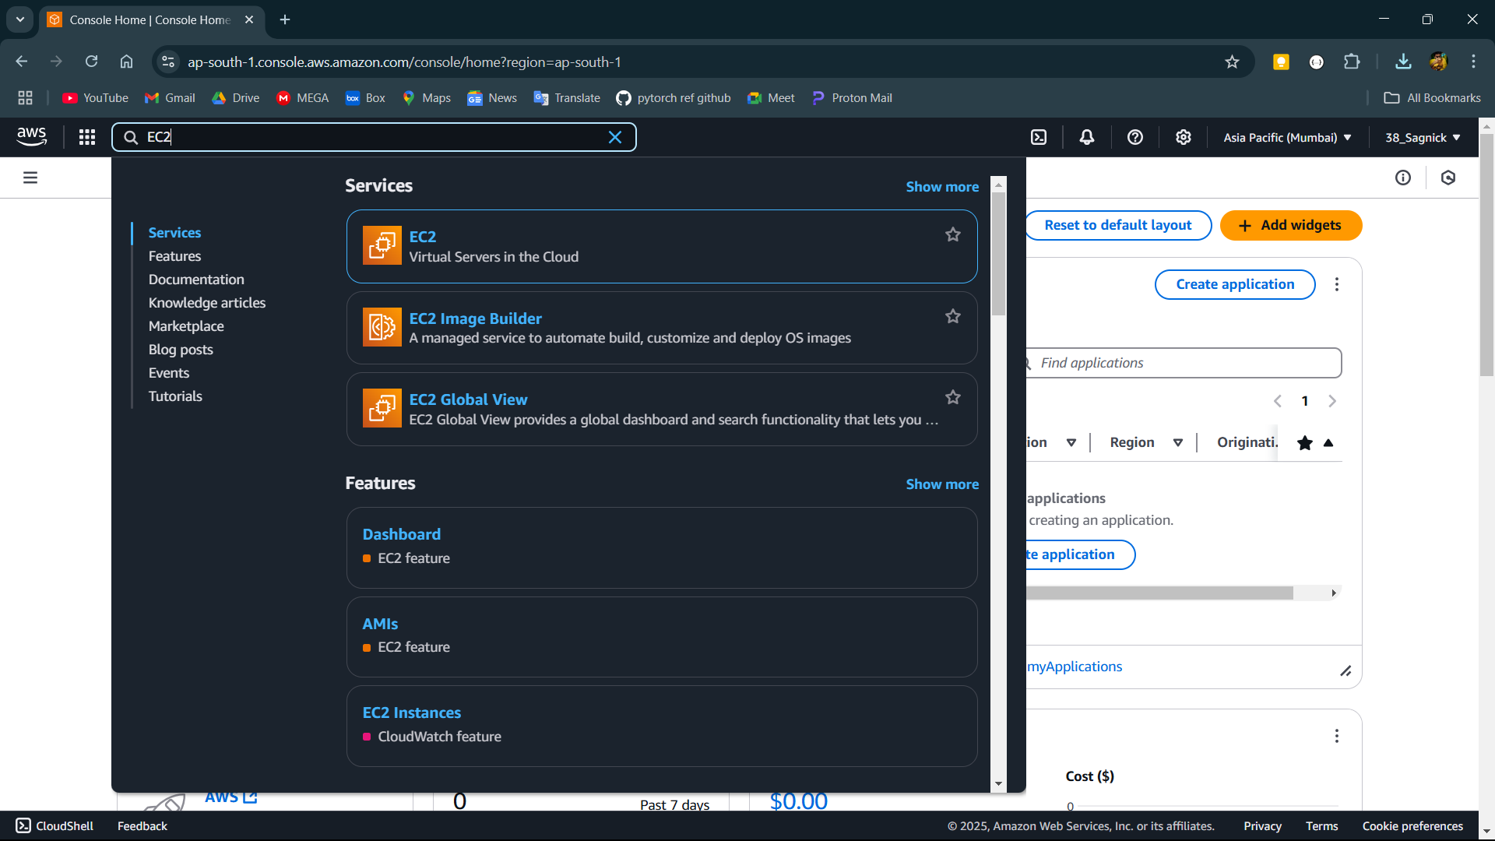

**Step-2:**

Click on the EC2 and click on Launch Instance.

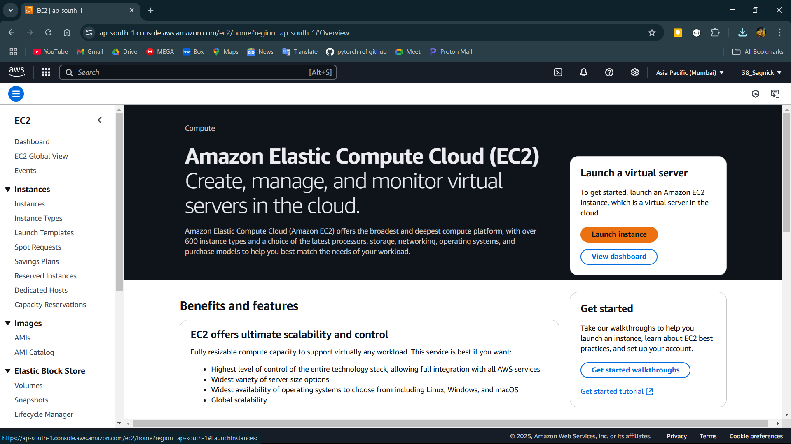

**Step-3:**

Name the Instance then Select the OS for the instance.

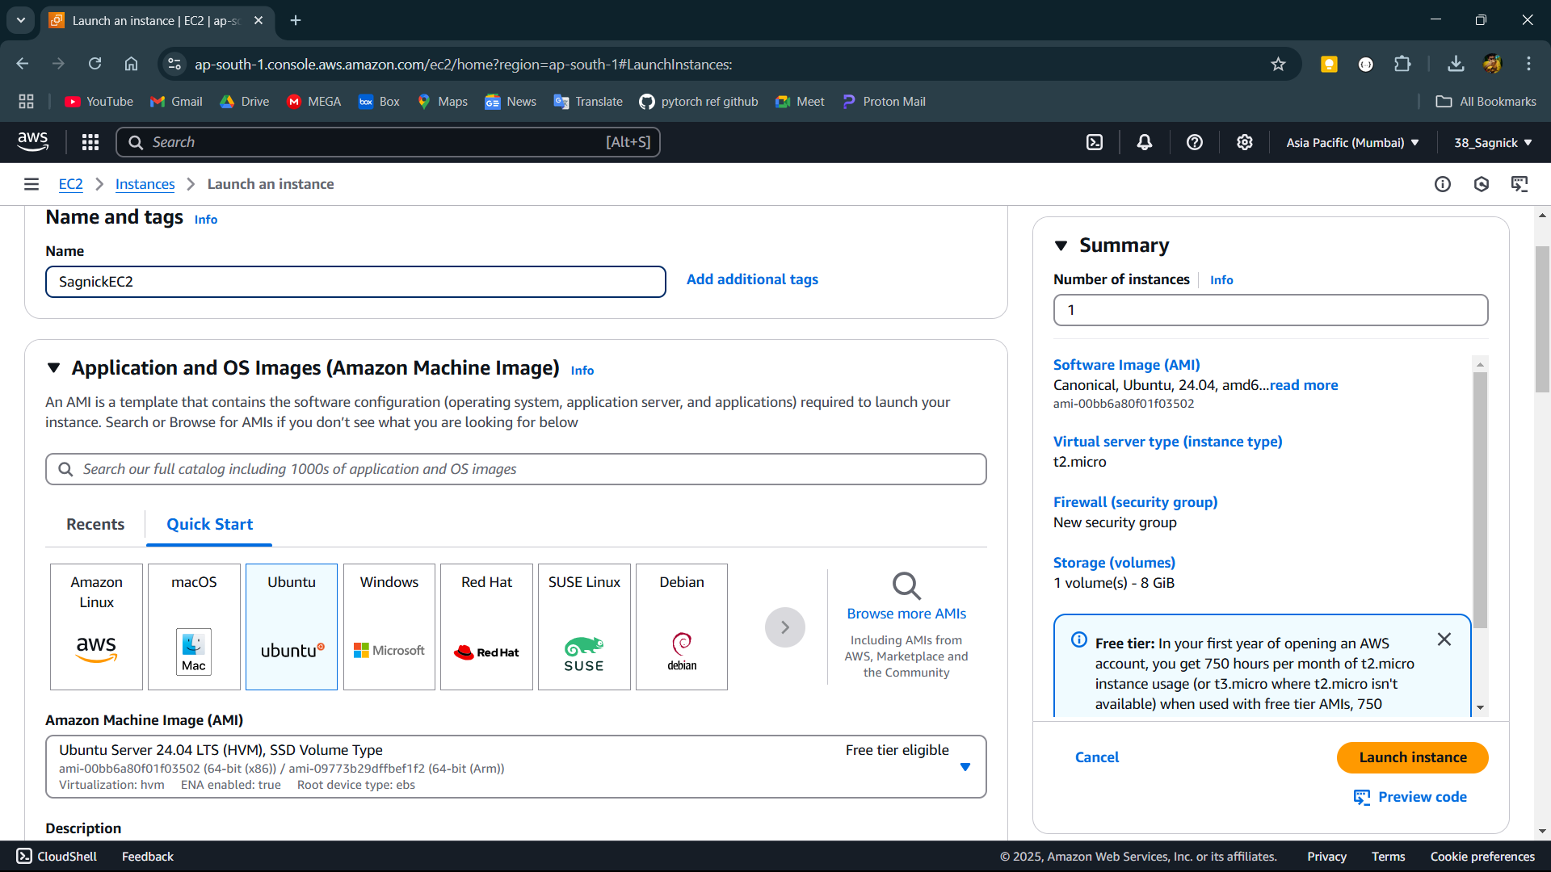

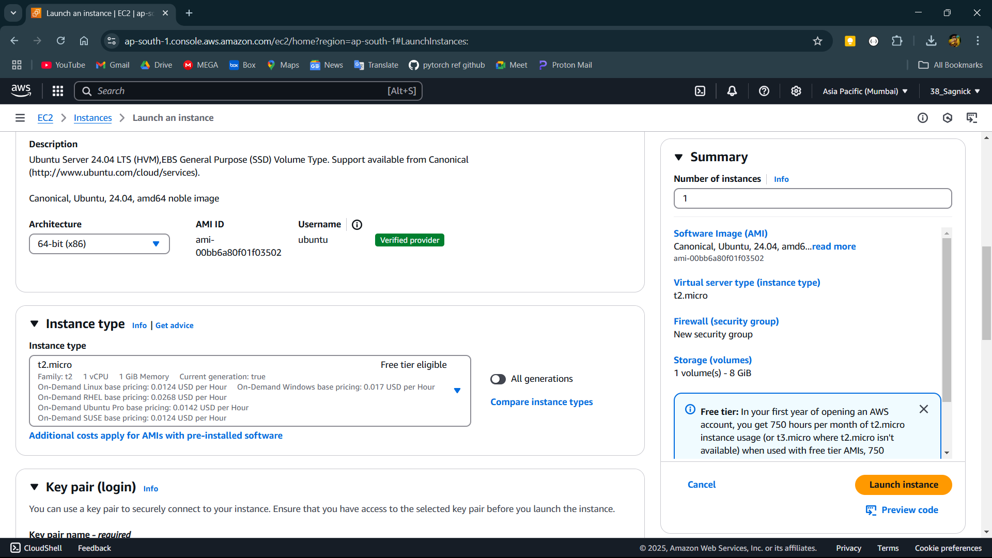

**Step-4:**

Now click on key pairs select an existing key pair or click on create new key pair then name the key pair and select newly created key pair. Then allow SSH traffic from anywhere and allow http and https traffic from internet by checking the boxes below. Then configure storage and click on Launch Instance.

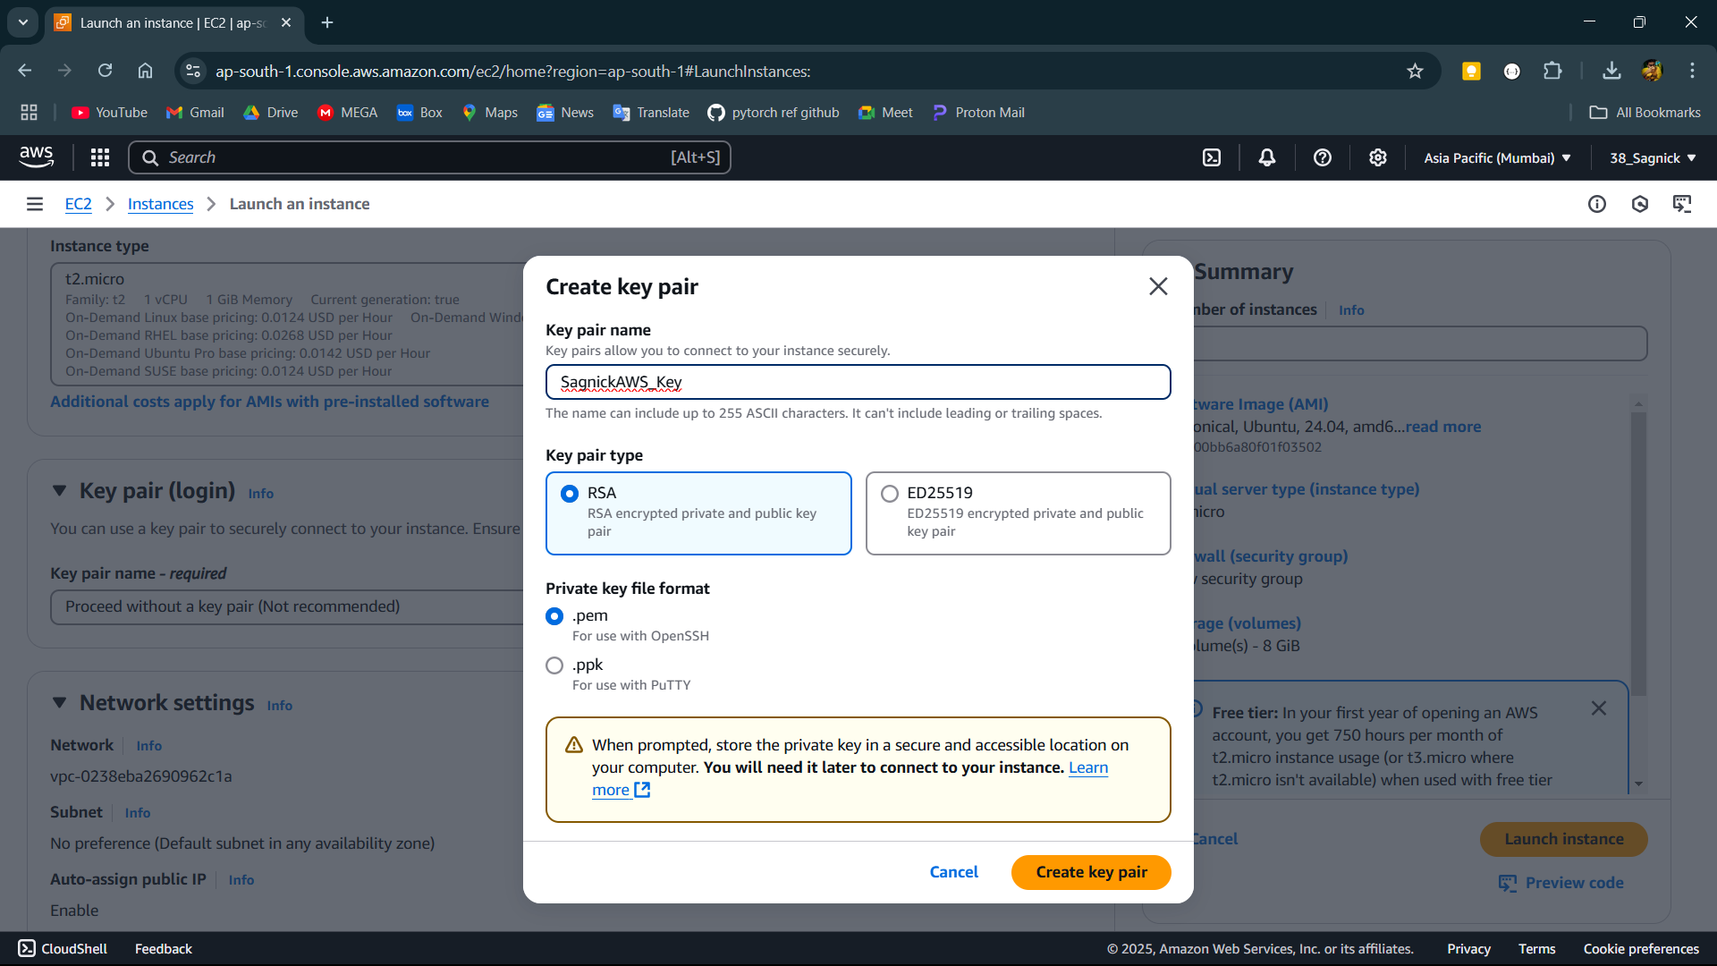

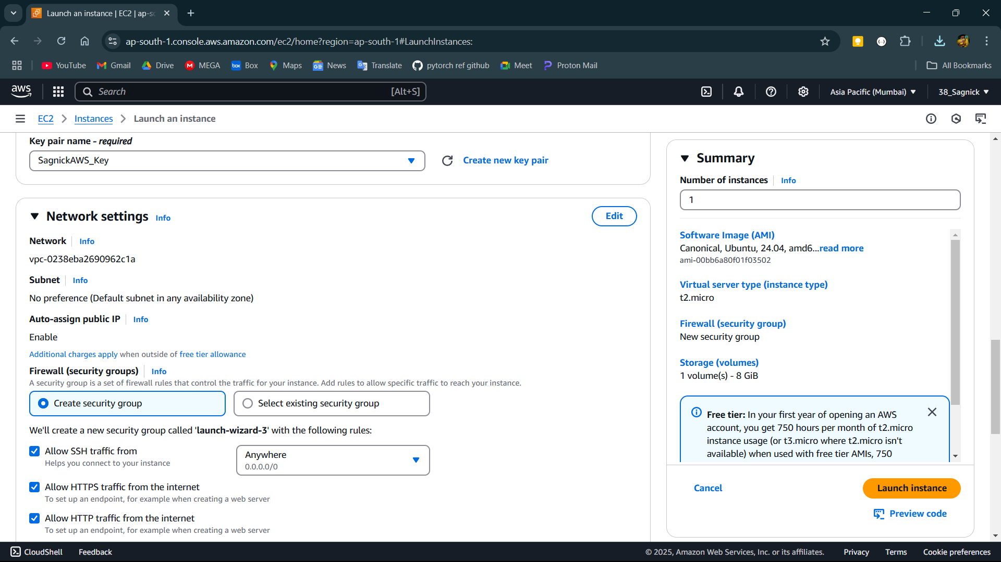

**Step-5:**

After the Instance created goto Instances using the window in left side and click on the Instance id of the instance.

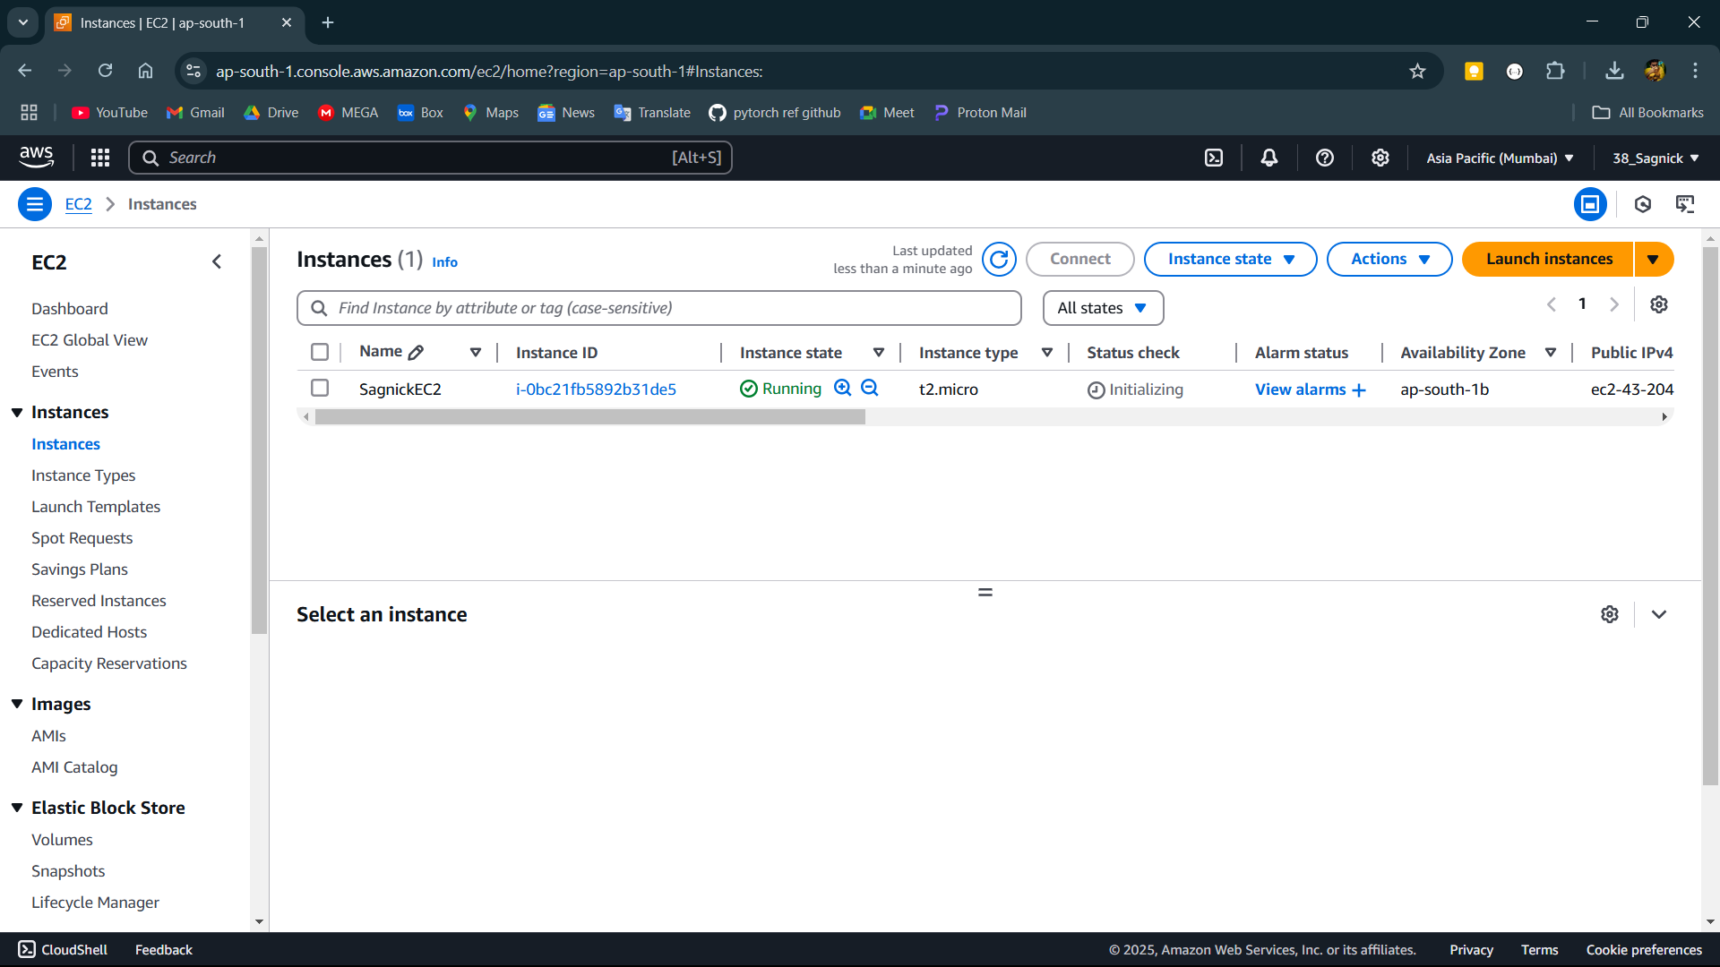

**Step-6:**

Copy the Public IPv4 address of the instance.

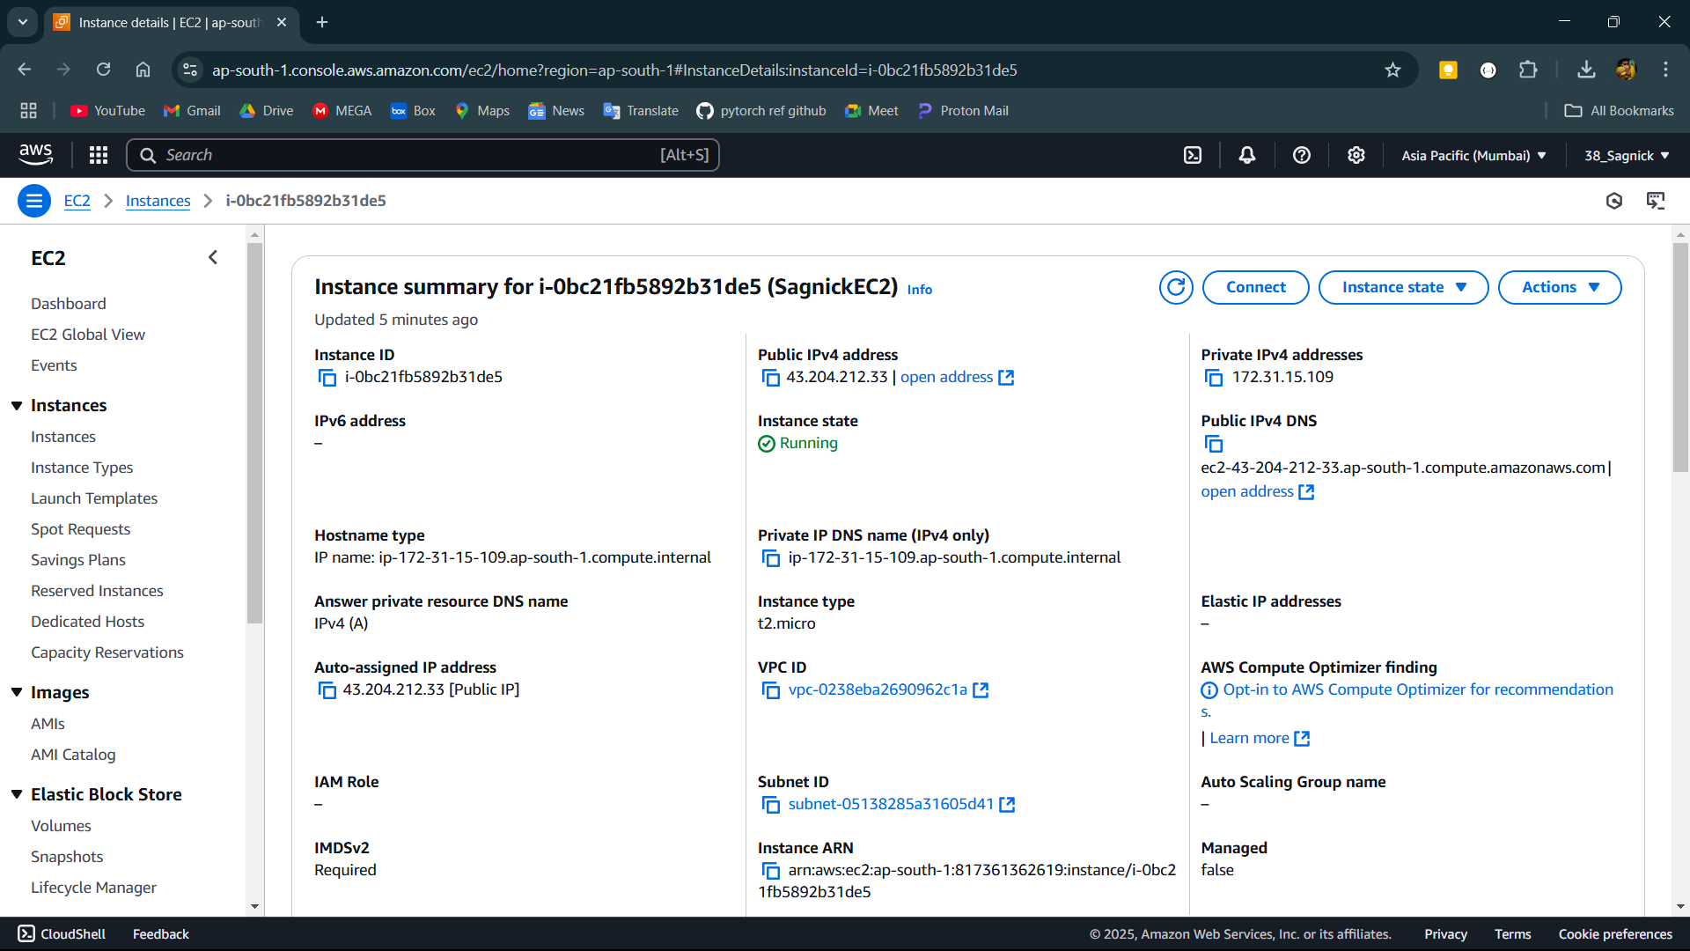

**Step-7:**

Then open Bitvise SSH client and open the client key manager and import the .pem file downloaded after creating the key pair. Then paste the Public IPv4 address in Host IP. In the authentication select the initial method as public key give username and select the client key that imported using the client key manager. Then login and then open new terminal console from left side.

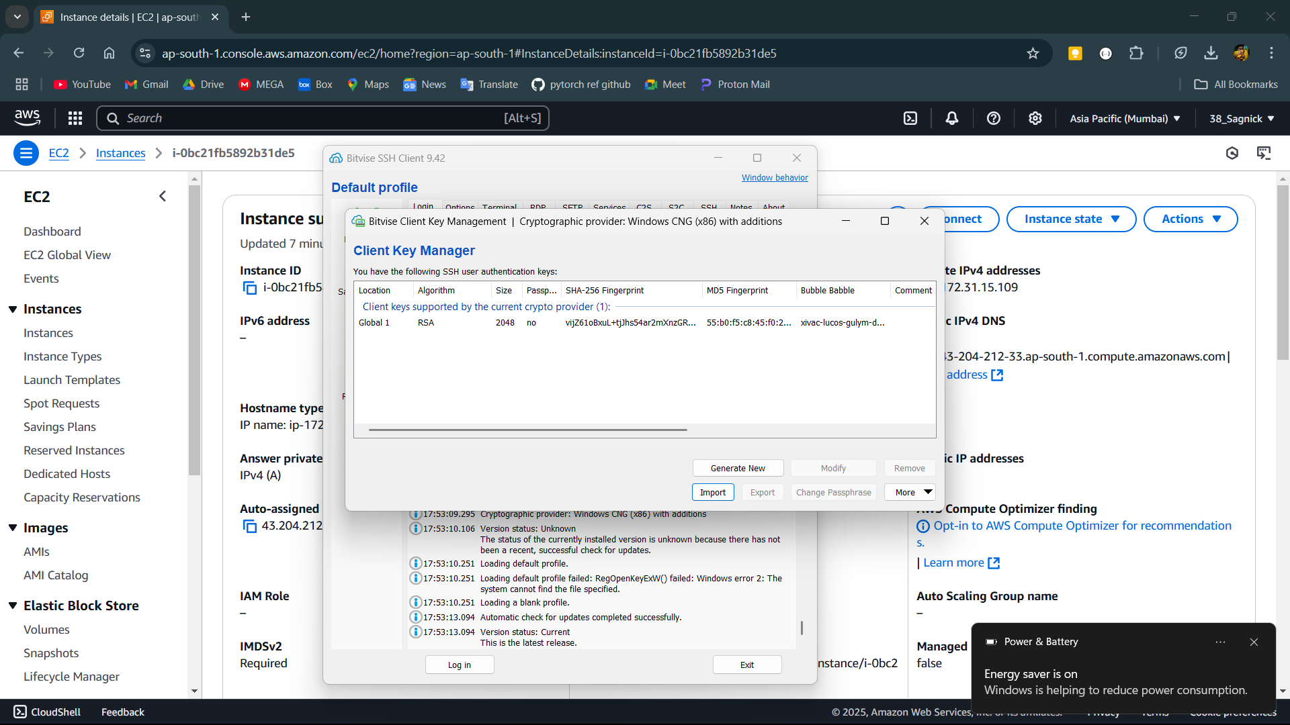

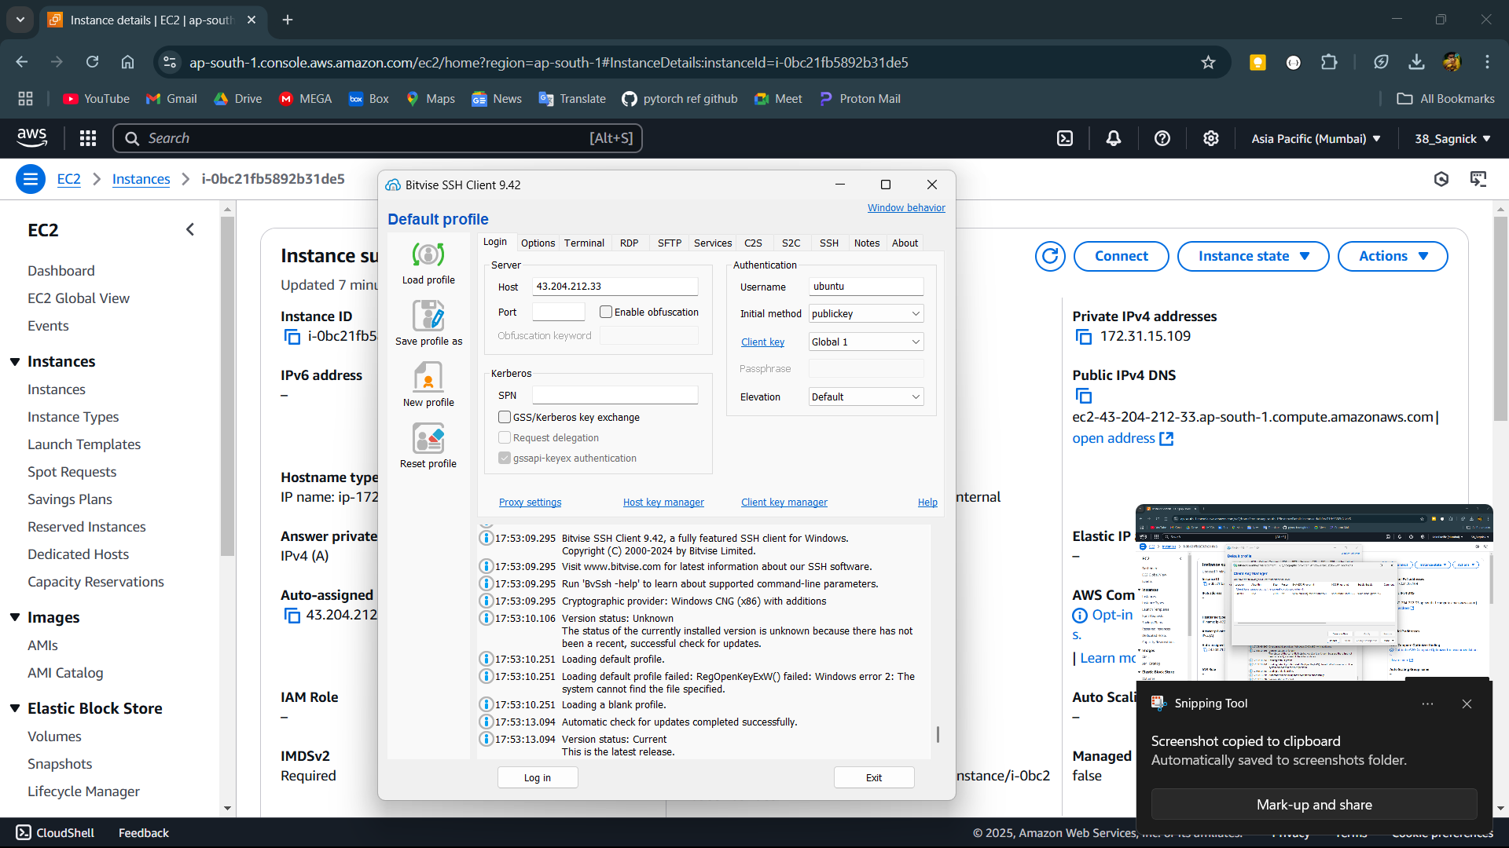

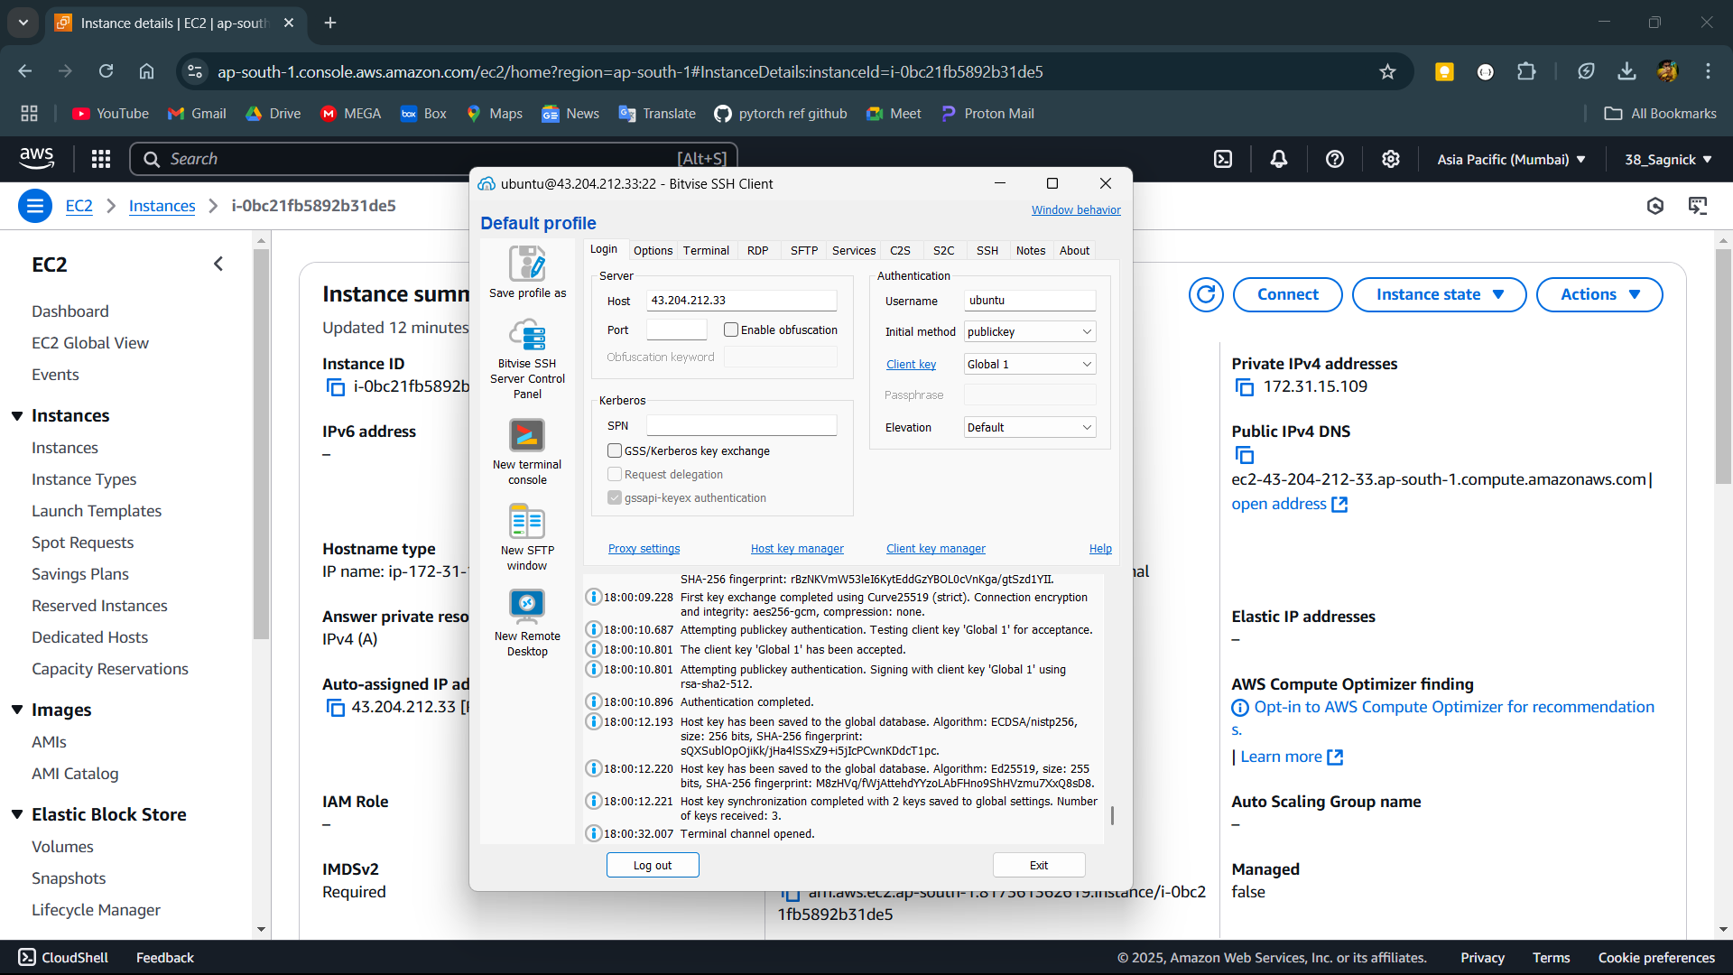

**Step-8:**

Set up the Ubuntu server by updating and upgrading it using the commands sudo apt-get update and sudo apt-get upgrade.

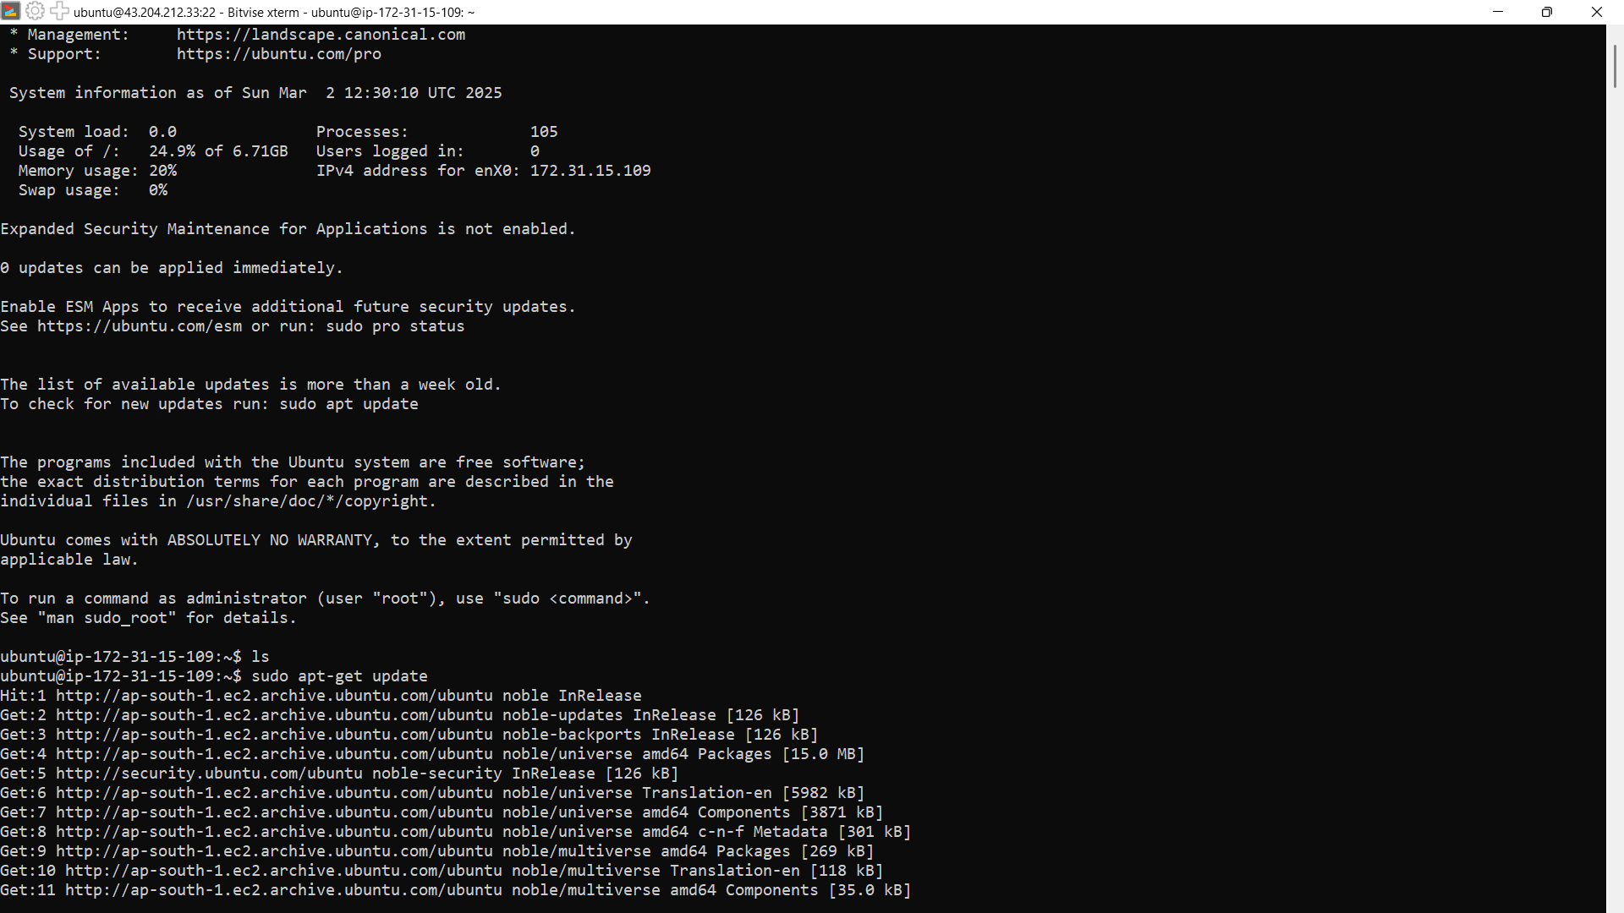

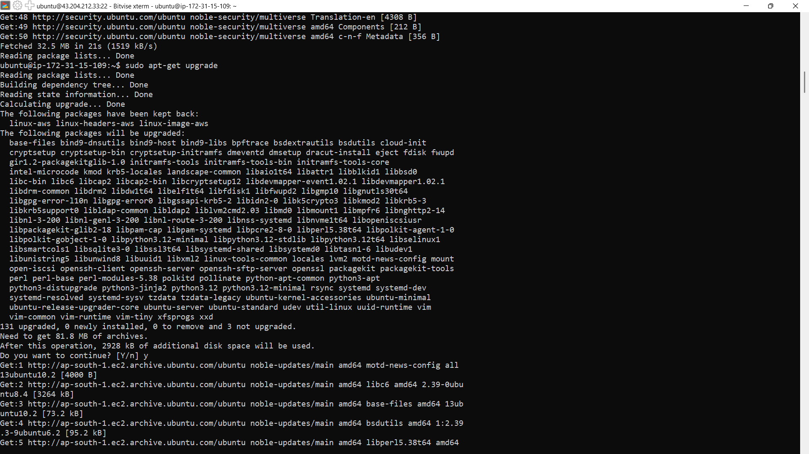

**Step-9:**

Now set up the web server by downloading nginx and ngi using commands sudo apt install nginx and sudo apt install ngi. Then open the Public IPv4 of the instance in a incognito tab to see the nginx welcome page.

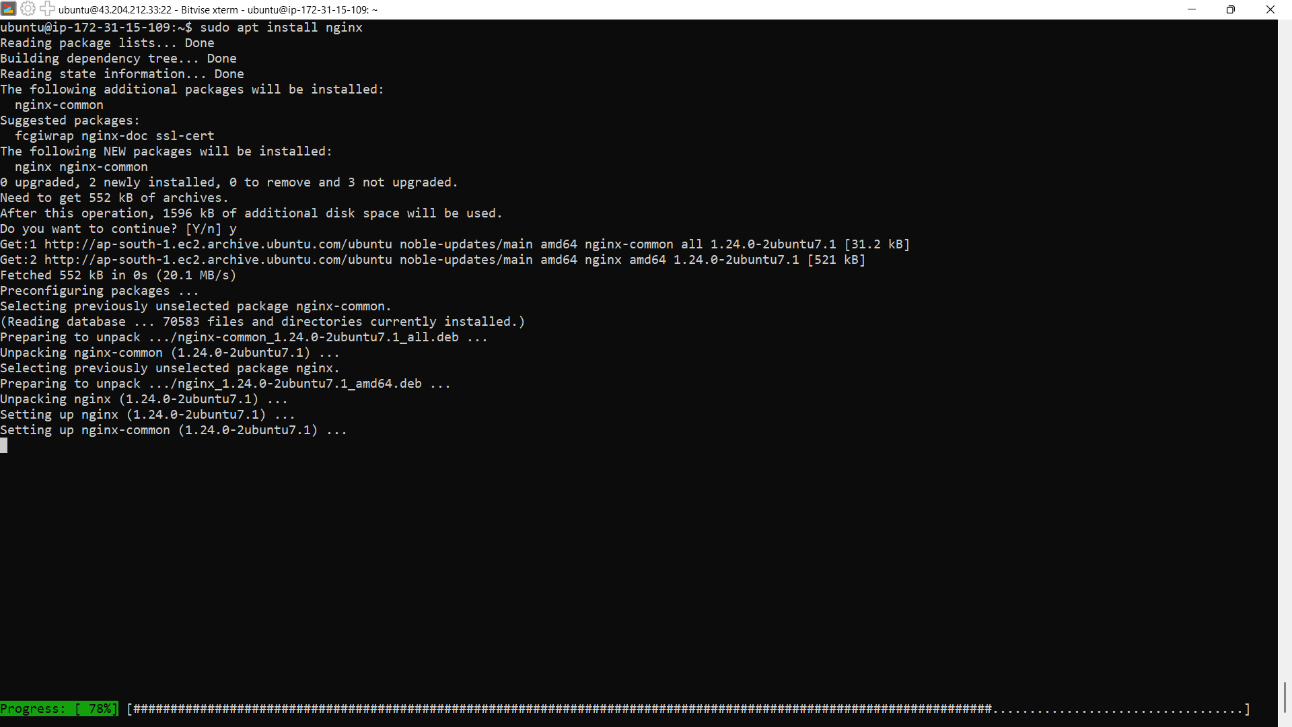

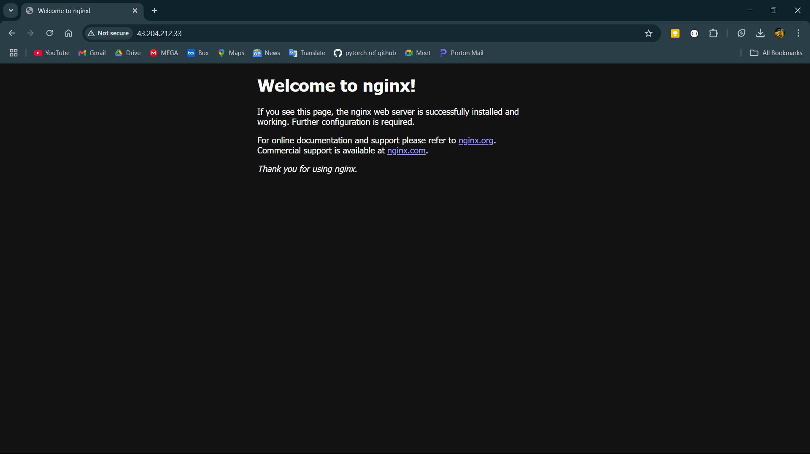

**Step-10:**

Now open the terminal again and navigate to the location /var/www using command cd ../../var/www and then change the permission of the html directory using command sudo chmod 777 html to give it full permission.

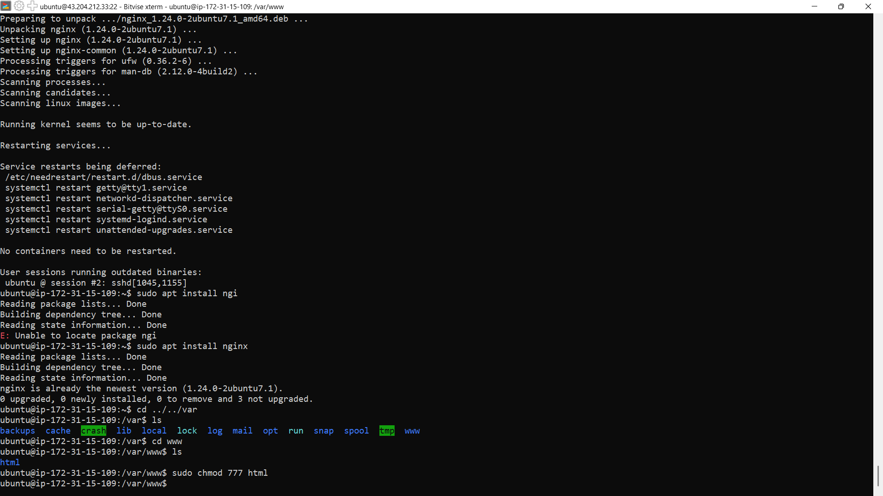

**Step-11:**

Then open the bitvise and open the New SFTP window and navigate to /var/www/html of the remote files section using the top bar then just drag and drop the html files from local files section to remote files section.

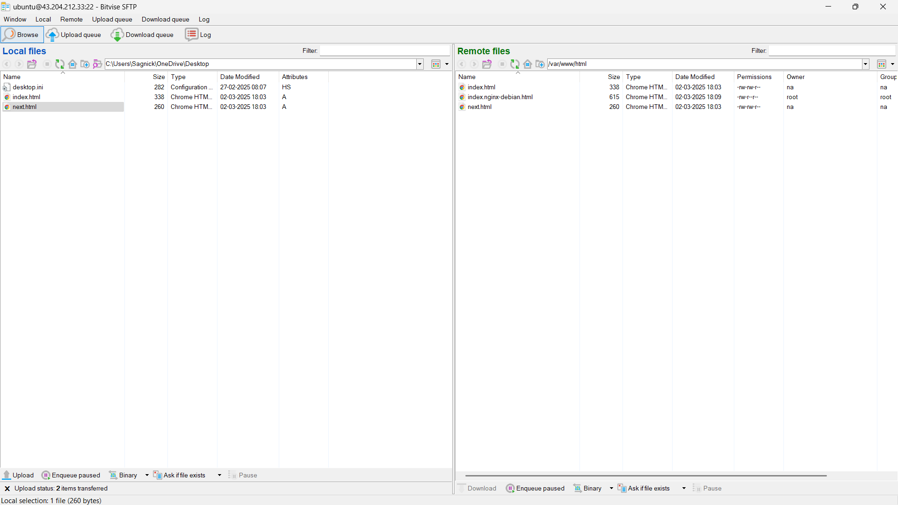

**Step-12:**

Open the Public IPv4 of the instance in incognito mode.

