**Assignment No:08**

**Title: Deploy a project from a local machine to GitHub and vice versa.**

**Step-1:**

Open github in browser and click on login.

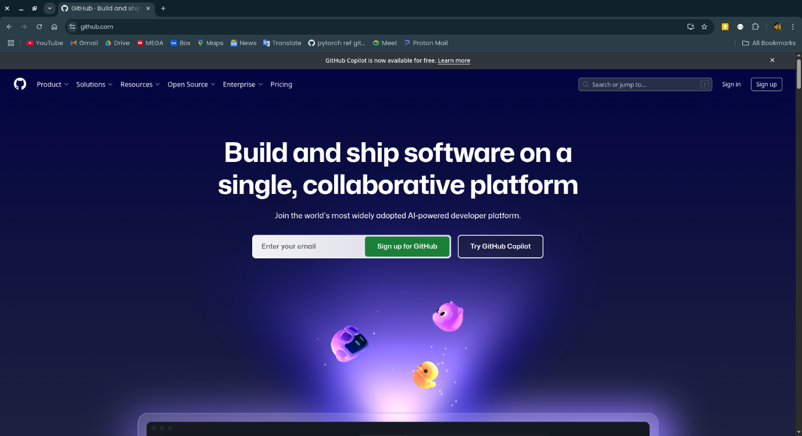

**Step-2:**

Log into github using your username or email and password.

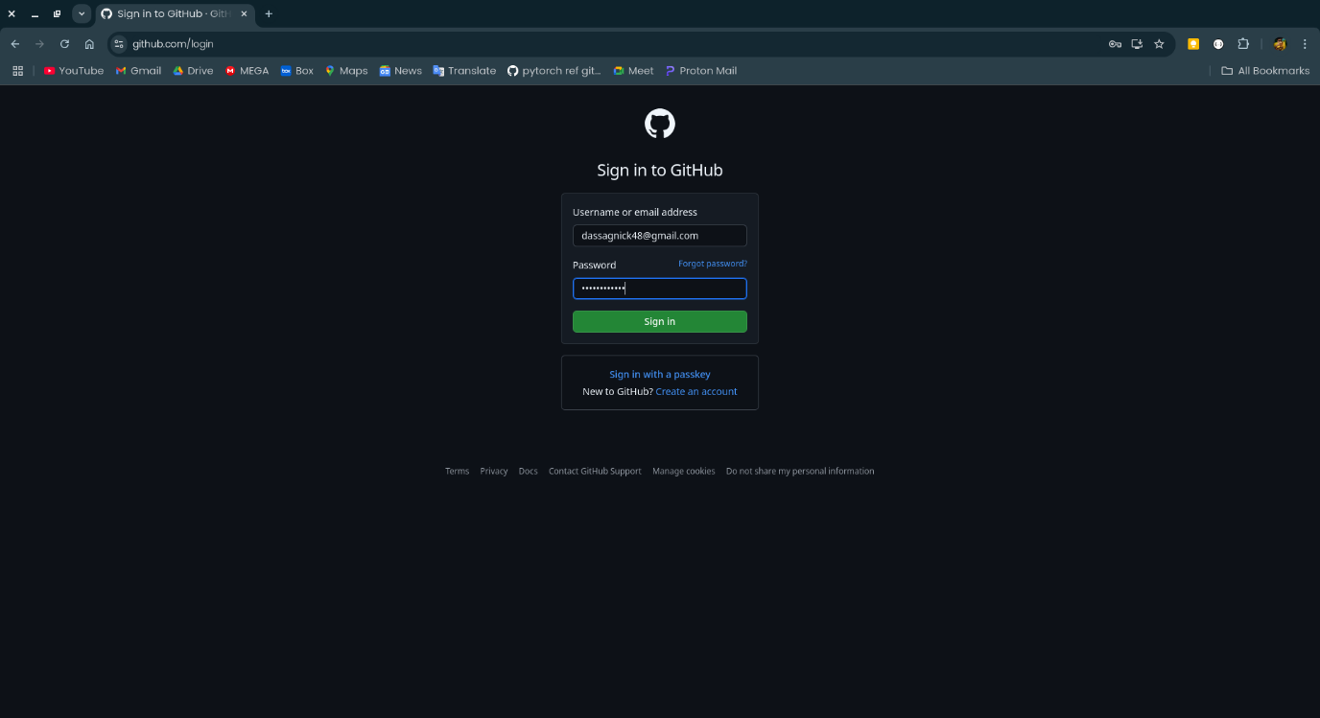

**Step-3:**

At the left side click on the New button to create new repository.

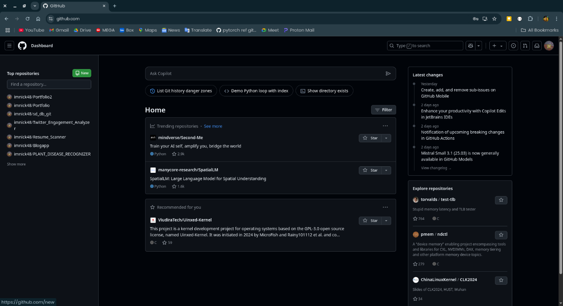

**Step-4:**

Give a name to the repository and click on create repository.

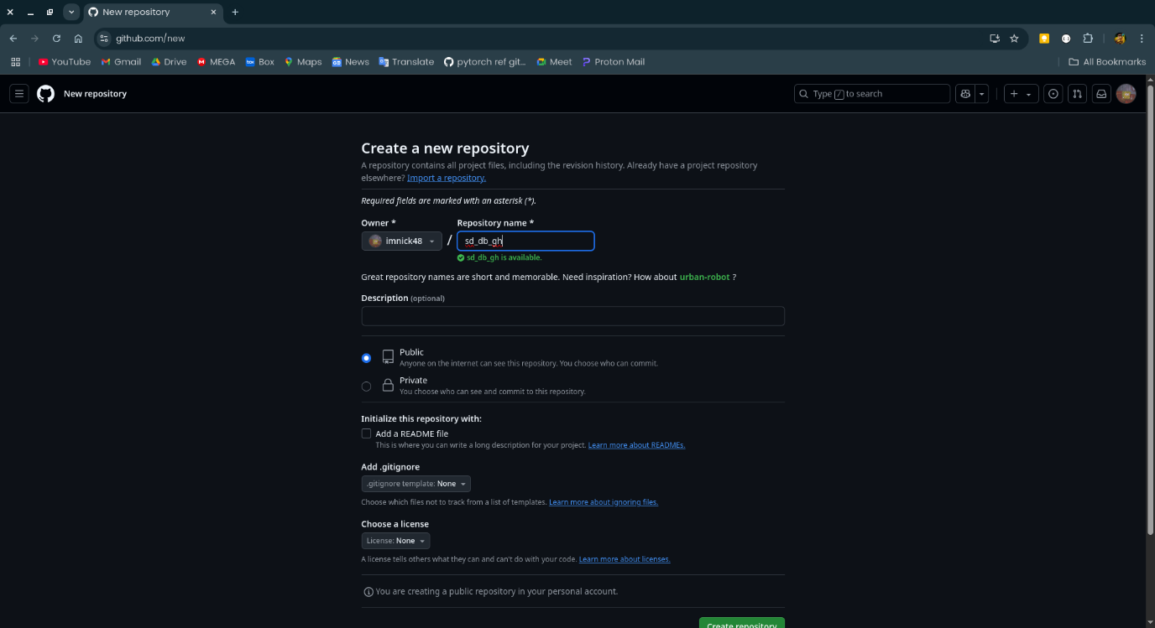

**Step-5:**

Now copy the link of the repository from quick setup.

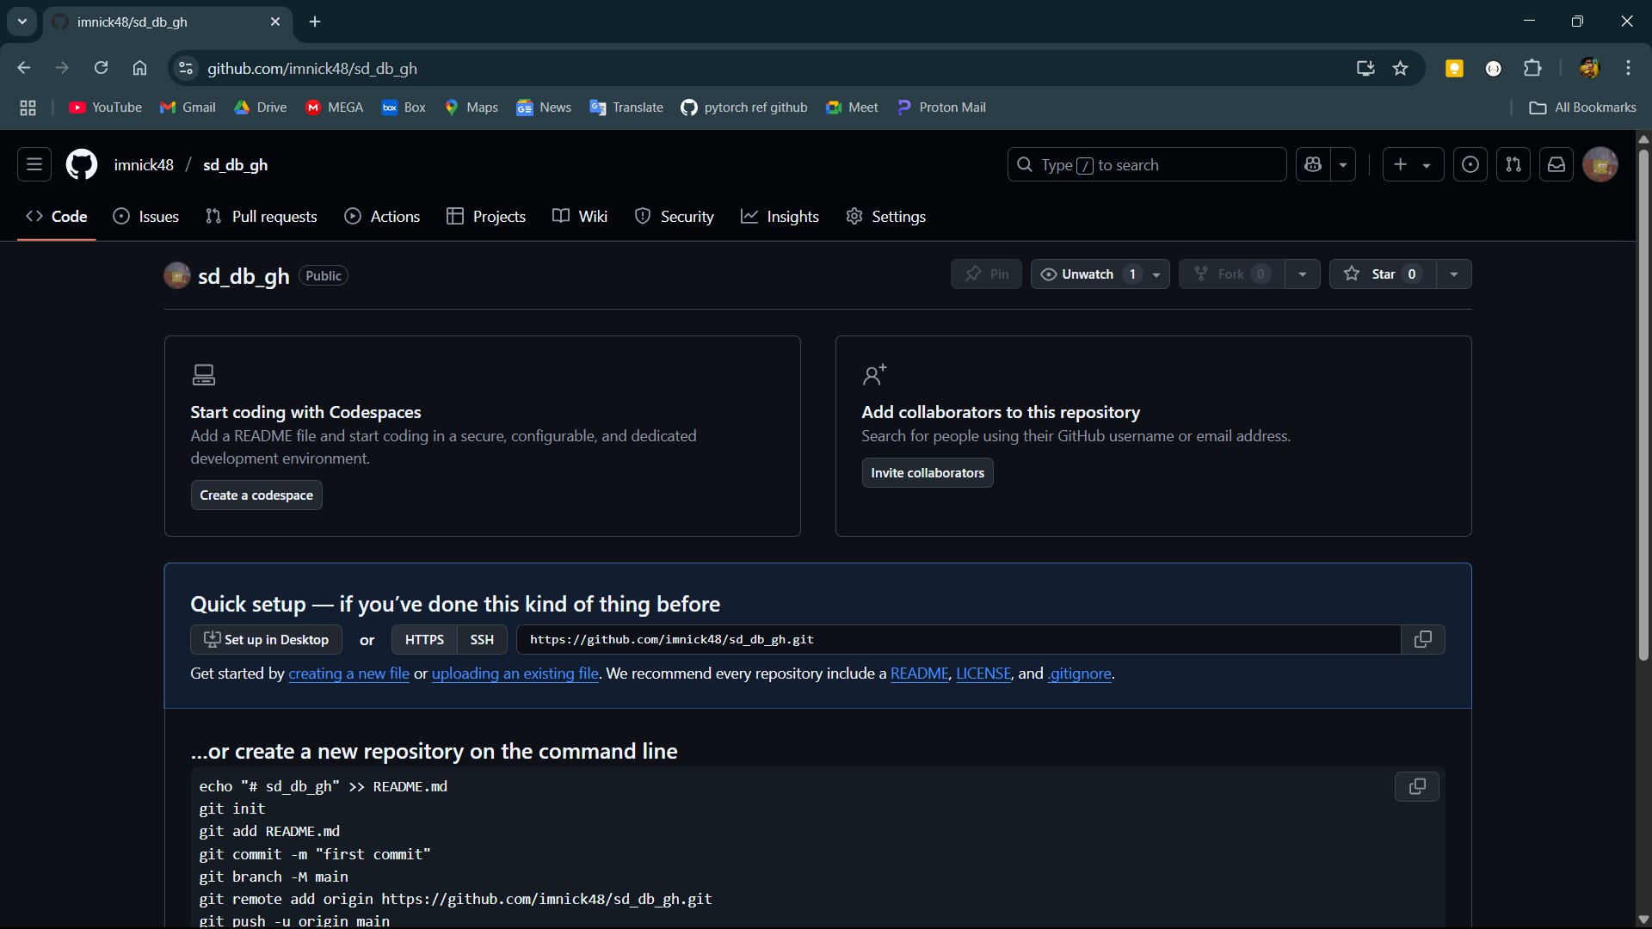

**Step-6:**

Open the local folder and right click then click on Open Git Bash here.

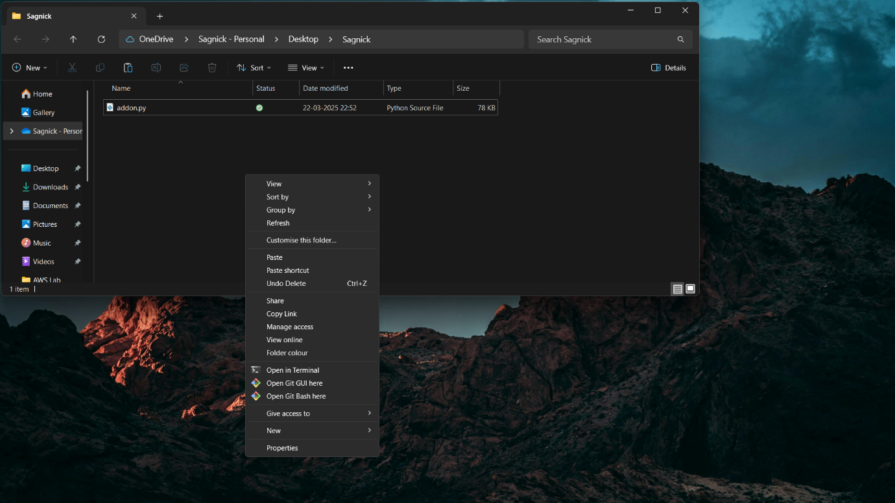

**Step-7:**

Initialize an empty git repository using the command git init.

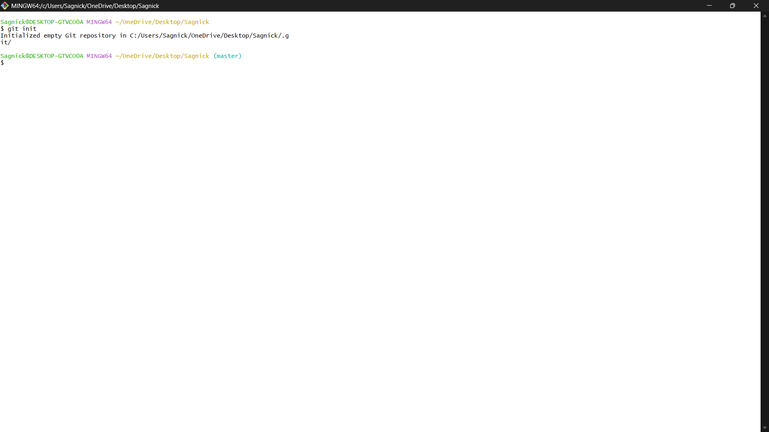

**Step-8:**

Then add the origin using command git remote add origin and paste the link copied from github.

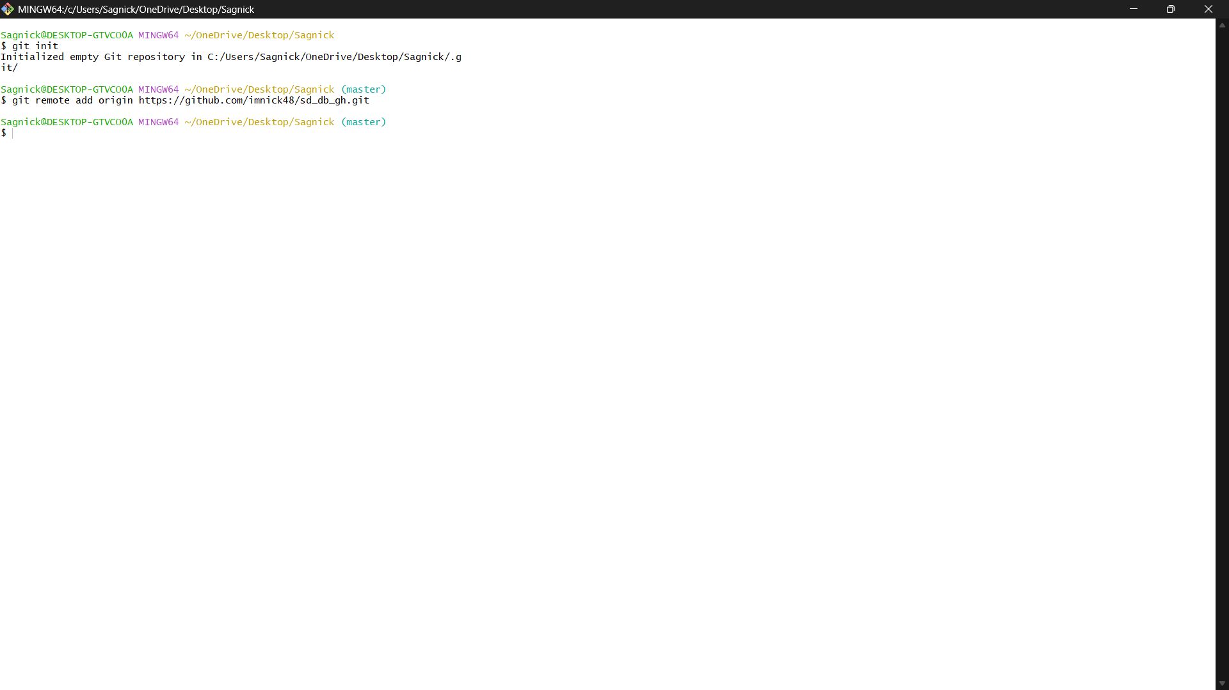

**Step-9:**

Add all the files in the folder using the command git add .

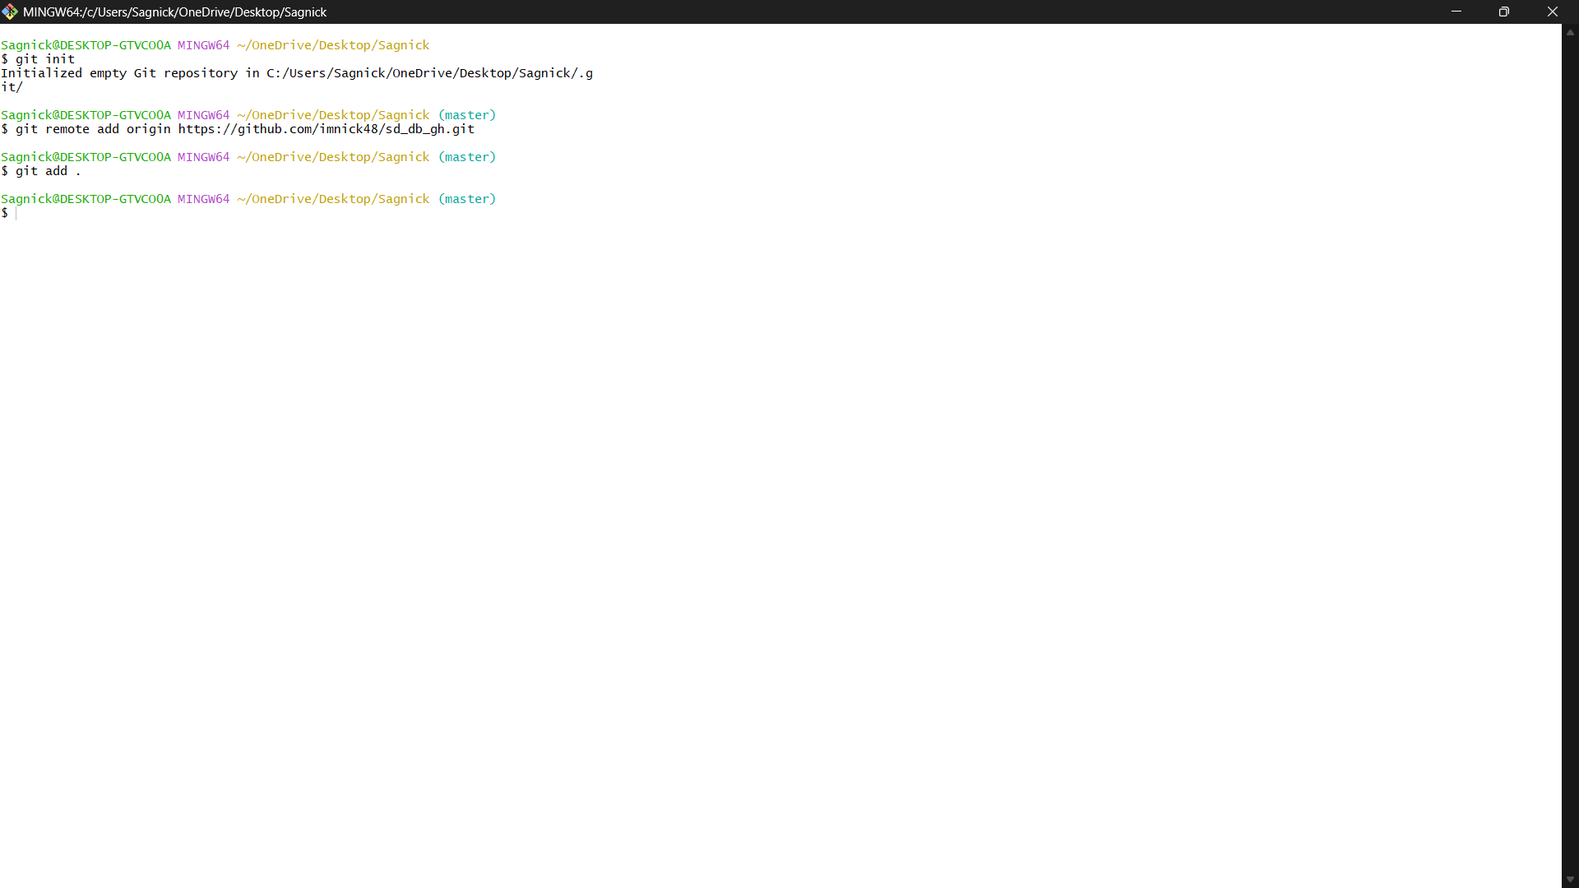

**Step-10:**

Now commit the changes with a message using command git commit -m “message”.

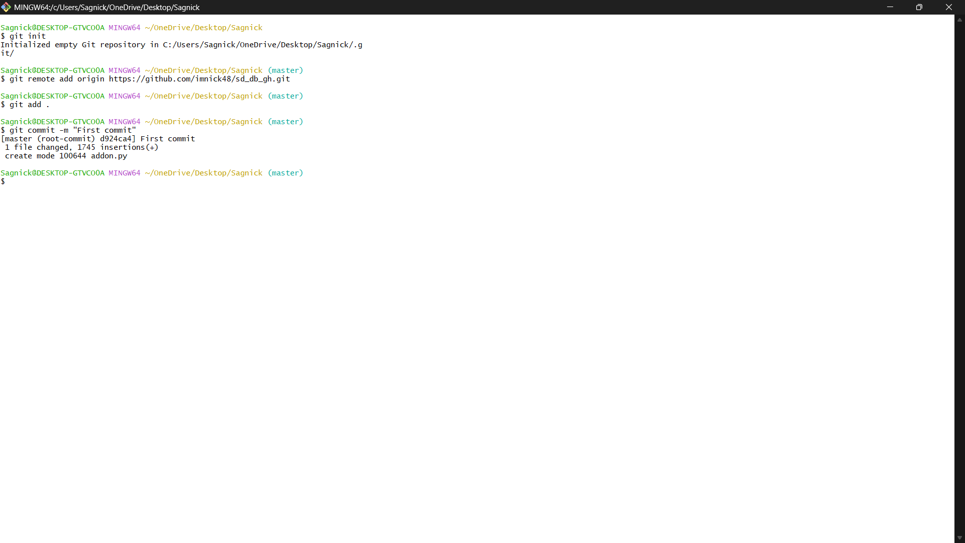

**Step-11:**

Select the branch of the repository to master using the command git branch -M master.

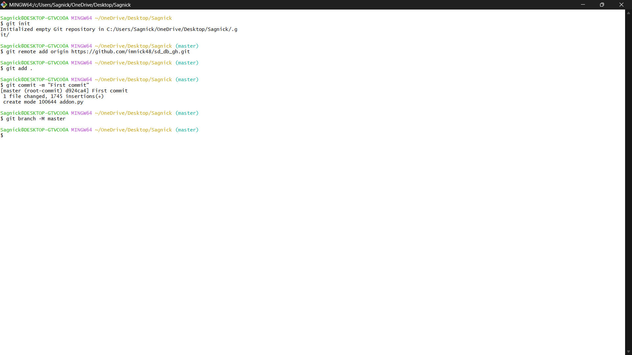

**Step-12:**

Now push the code to the github repository using command git push -u origin master.

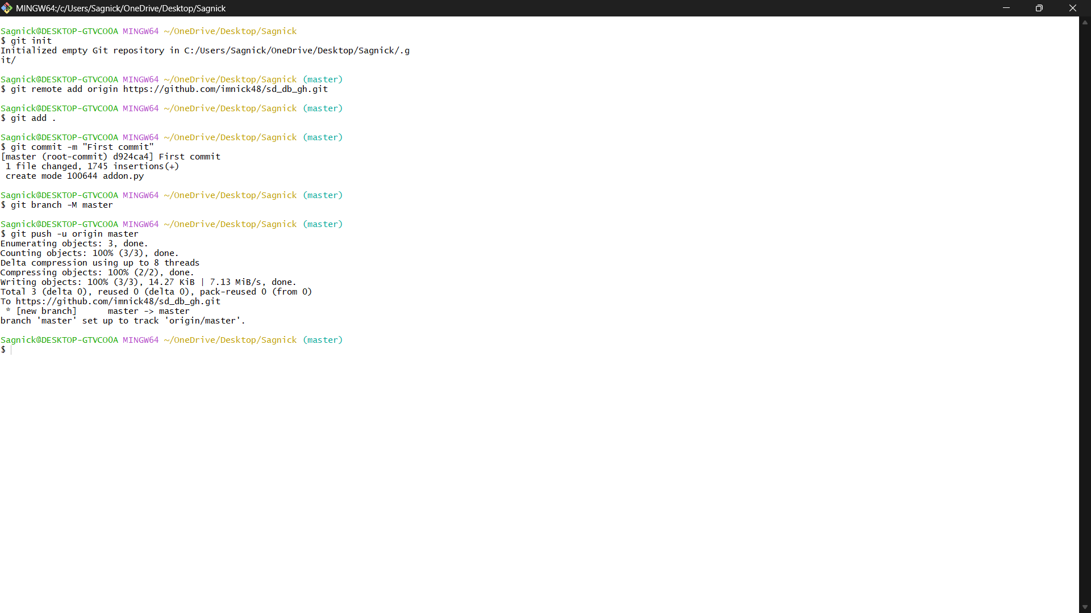

**Step-13:**

Now refresh the github page to find the code .

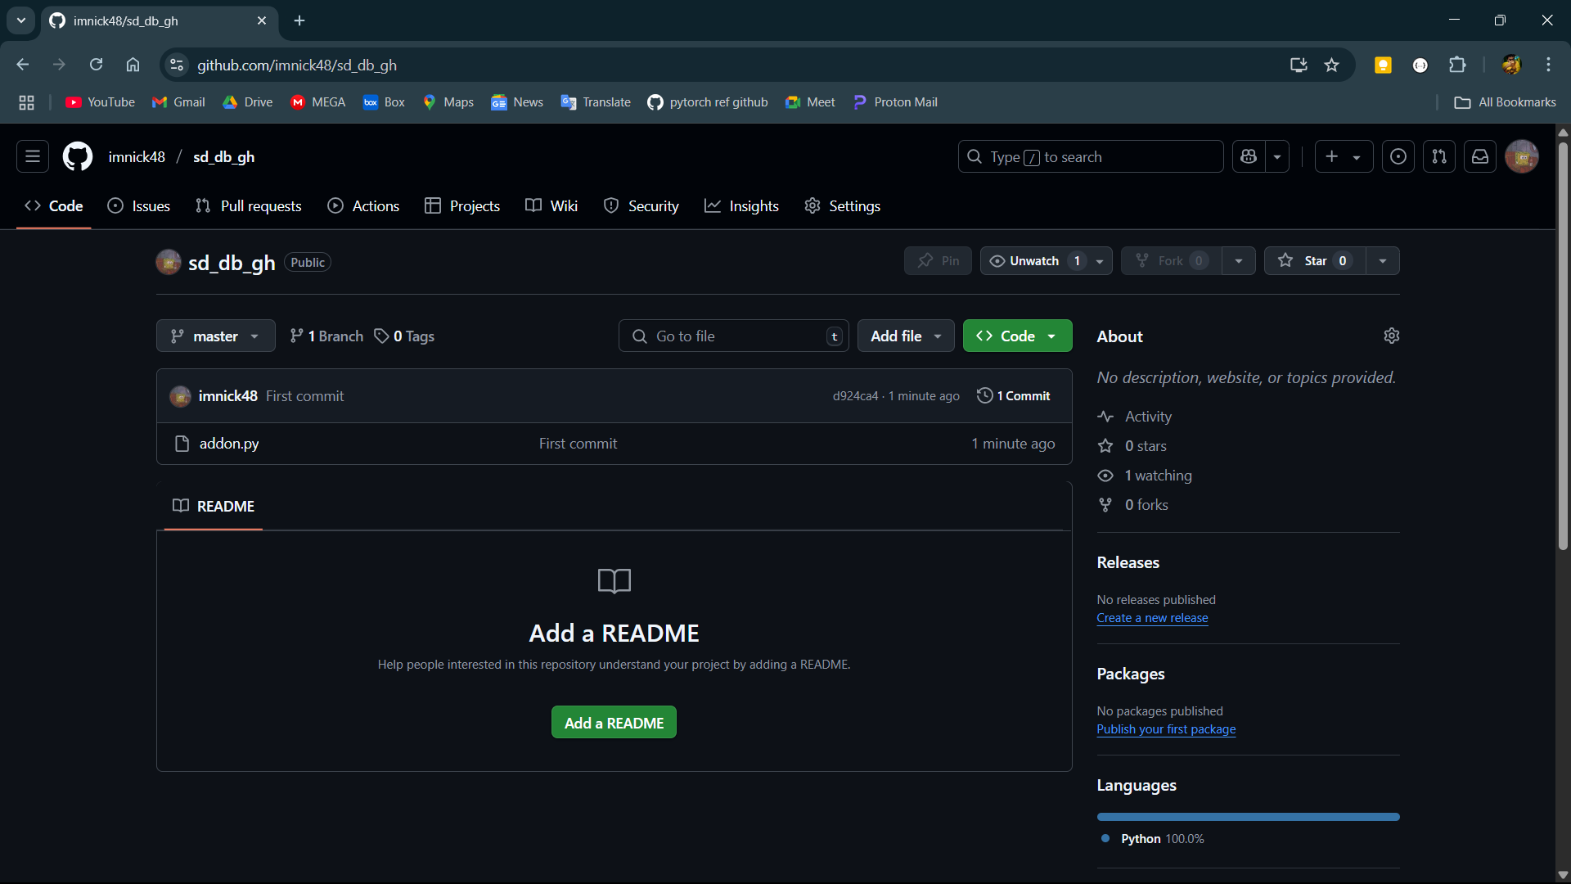

**Step-14:**

Now to pull the code from github to a local directory open the github page and click on the code button and copy the link of the repository.

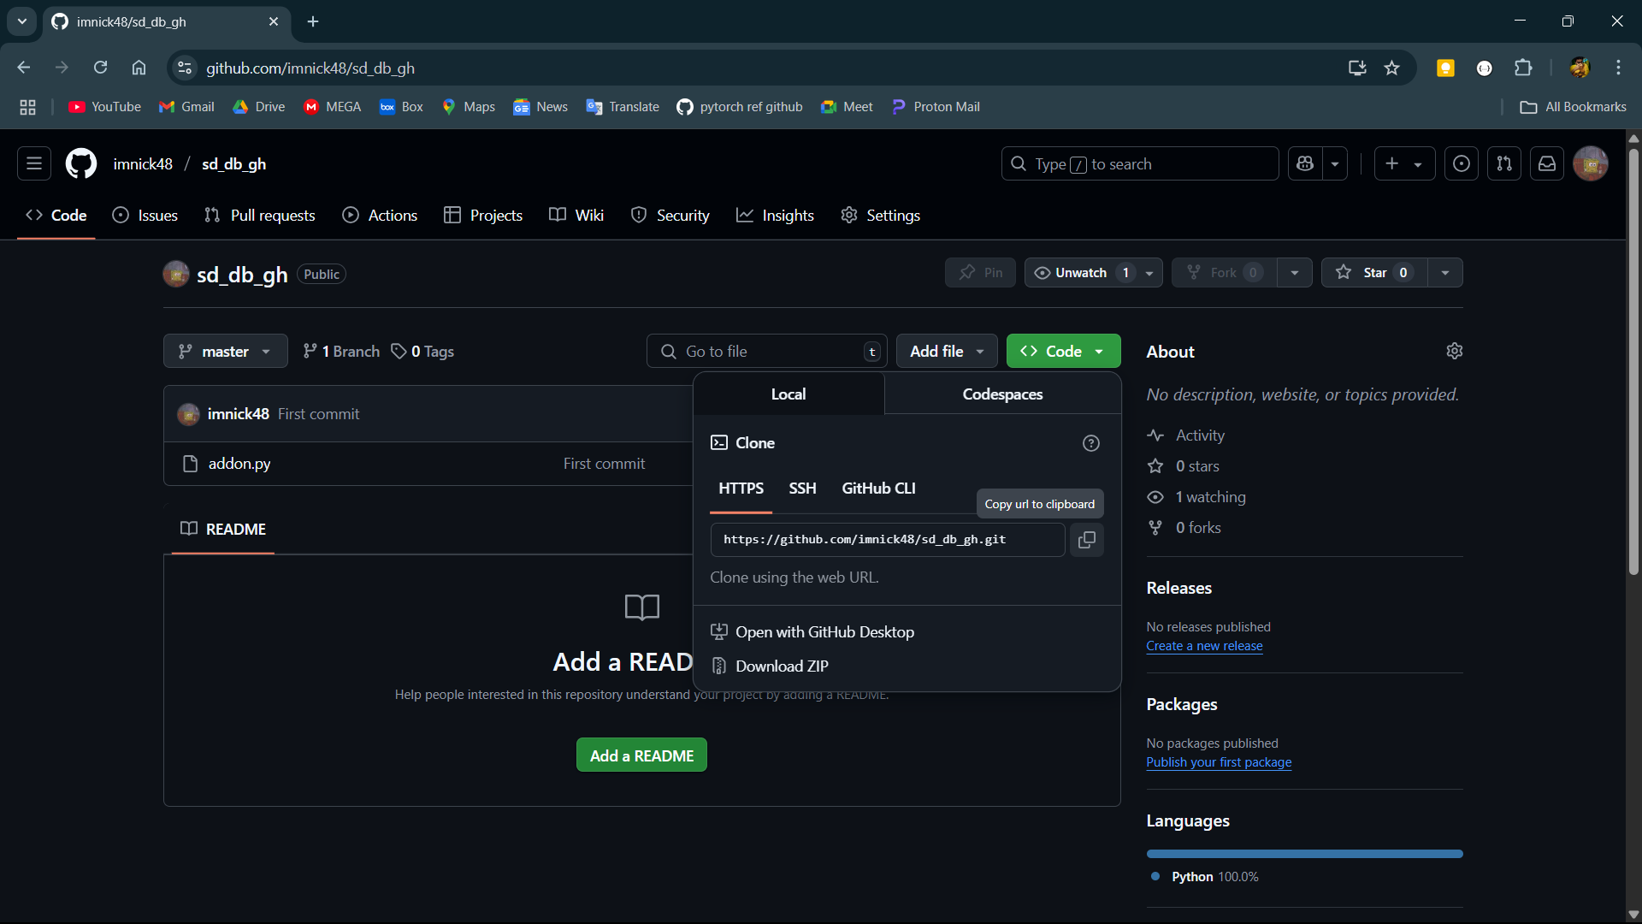

**Step-15:**

Open another folder and open git bash there and initialize a empty git repository.

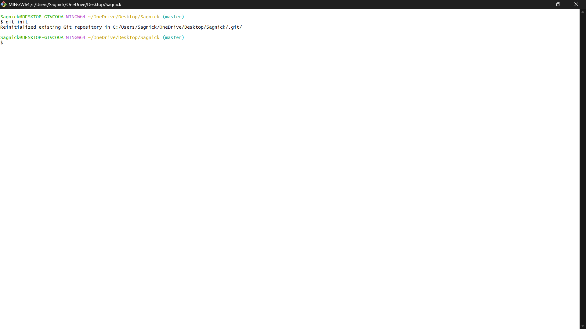

**Step-16:**

Then run use the command git clone and paste the link copied from github.

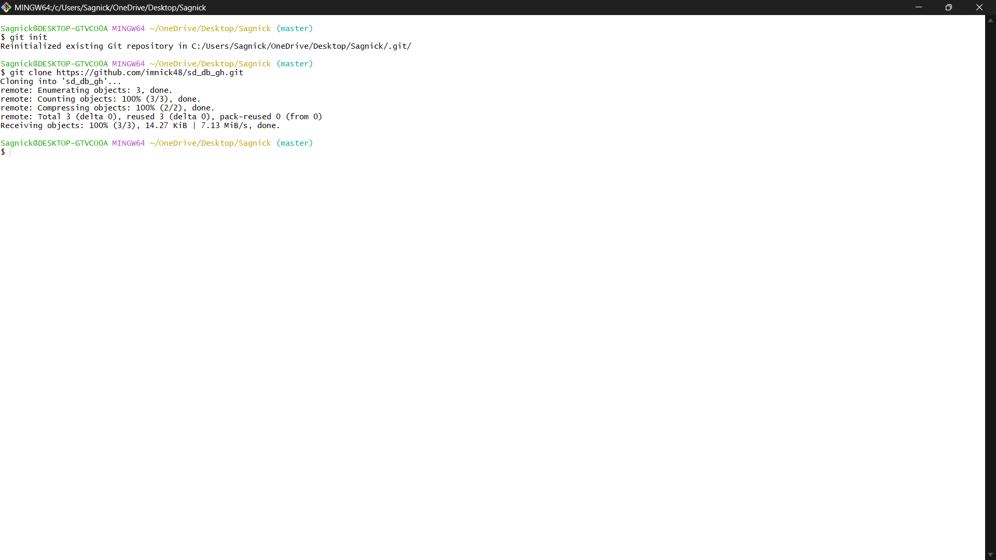**Step-17:**

Now open the folder and the code is cloned from github.

