**A**

**Project report**

**On**

**“SCHOOL MANAGEMENT SYSTEM”**

**Prepared By**

Sravan Rao Poladi

Dilip Reddy Merugu

Sai priyatham varma

**Submitted to**

Yash

**Under the guidance of**

Yash



Contents

CHAPTER 1 INTRODUCTION 4

1.1 Overview Of Project 4

1.2 Literature Survey 4

1.3 Objective 5

CHAPTER 2 PROJECT DESCRIPTION 6

2.1Block diagram and Description of the project 6

CHAPTER 3 SYSTEM DESIGN 9

3.1 DESIGN: 9

3.2GUI of the project 10

CHAPTER 4 CONCLUSION 13

4.1 Conclusion 13

4.2 Future scope 13

List of Figures

Figure 1TEACHER PORTAL 6

Figure 2 Student portal 6

Figure 3 Flowchart 7

Figure 4 Login View 10

Figure 5 Student Controls 11

Figure 6 Admin Controls 12

# CHAPTER 1 INTRODUCTION

## Overview Of Project

This aims to provide a platform to schools to use technology in tracking the students record at lower price. This also provides the students to have the access to their study material all at one place and also to check their attendance at any point of their time. As there is no proper scope for the school to maintain the track the records of the students in the small rural areas

, students do not have the access to learn their subjects all at one place and students are not aware of their attendance till the last day of the term.

## Literature Survey

The system has come up with many functionalities for educational institutions to track the student progress and managing attendance. It helps both student and guardian to keep track of student progress without visiting to the college. It also notifies student and guardian during the time of important events which are happening in institution. One more feature is guardian get alerted whenever student get failed in the exam or student not able to meet the expected attendance average All these particulars is stored in the database. SIRS application is trouble free to use in schools, colleges, universities, and any other educational institutions. It can be customized as per the need. It can be used in private and government educational institutions also. SIRS application is an internet based application we can login to the system from anywhere irrespective of geographical area it will give seamless navigation. This provides the particulars to carry out the performance, management and decision-making functions of enterprises or organizations. Enormous grow of students is caused to expand the functionality in the respective educational institutions. As student added to the educational system it is difficult to manage and track student details. To overcome difficulties we come up with this new approach student information management system with additional features. This new approach will provide fast processing, efficient student tracking, and produces desired result. This approach will allow students to save their personal details. It is more secure, reliable and easy to use. Attendance is part of any system to keep track of the particular person. It is mandatory process in educational system which directly reflects the student progress. In educational institutes attendance management is normally a manual process. As we are using the smart phones we not require maintaining attendance register. It can be easily done in mobile application. Faculty will be going to take the attendance when class gets started. They will initially login to the system through mobile application. Once attendance has been taken successfully for the class it will sent to sever through GPRS. The faculties can also do the necessary functions like registering new students, deleting the information about a particular student, modifying the information regarding the student etc. The main intention of this process is to reduce the risk of manual efforts. It also reduces the time consumption. Also we want to give importance to reduce the paper wastage that daily happens.

## 1.3 Objective

The objectives of this project include:

* To provide a platform to schools to use technology in tracking the students record at lower price.
* To provides the students to have the access to their study material all at one place and also to check their attendance at any point of their time.

# CHAPTER 2 PROJECT DESCRIPTION

## 2.1Block diagram and Description of the project

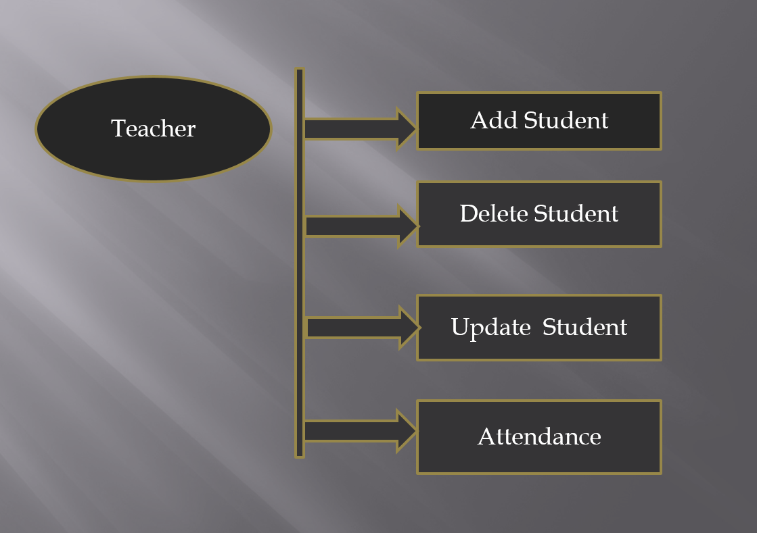

Figure 1TEACHER PORTAL

The main functioning of the system is that as an Admin you need to have the controls of adding, viewing and deletion of the student data. He should also add the daily attendance of the student to the database

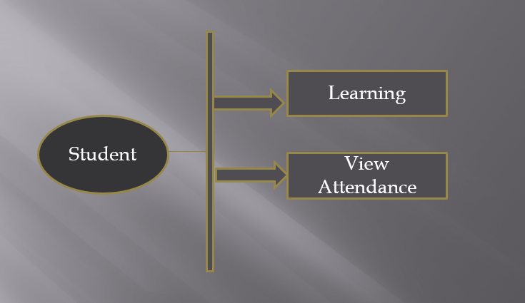

Figure 2 Student portal

As a student it will fetch the records of the attendance and will display on the screen and he will be able to read the collection of subjects directly from the online.



Figure 3 Flowchart

Figure 3 shows the structural design of the student management system. Users will login to the student management system. If the logged in user is an admin user he will be able to register the students and faculties in the system, admin can only have the complete privileges on the system. He will be sending circular to the students as well as faculties regarding the upcoming events that will appear in the college. Admin can set the time table and also he will generate the report of

faculty as well as student. When faculty user login to the system, his work is to manipulate the attendance and internal assessment marks as well as he is going to send circular to his students regarding his subject notifications like class test etc. Also faculty will be able to generate the report of his students based on their progress in his class. When student user login to the system he can visit only to his pages and he will be able to check his academic progress as well as attendance. Also he will generate report of his performance in internal assessments and in attendance. All these information is stored in the database.

# CHAPTER 3 SYSTEM DESIGN

## 3.1 DESIGN:

This application is designed by using Oracle Forms and Reports 10g and Oracle Express Edition database 11g. It also includes Oracle programming languages like SQL and PL/SQL. In this project application server is Oracle 11g. The Front end is designed by using Oracle Forms and Reports 10g supported by back end as Oracle XE. We have used Oracle Application Server to deploy the application. Forms and Reports is a third generational language programming tool which was developed by Oracle which supports GUI. To develop an application using Oracle Forms and Reports much easier because it is a GUI tool which was designed by using C-programming linked list. Oracle Forms is used for generating screens that communicate together with oracle database. It has an IDE, object navigator, property sheet, code editor, canvas, menus, libraries, PLL.

Oracle Report is used for retrieve the data which is stored in the database. In Oracle report we can generate the reports like graphs, pie charts, web layout, paper layout etc. We can generate different type of reports like tabular, matrix, form, form letter and mailing label. Oracle database we use to store the data. Since Oracle is user-friendly, secure and stable product.

In Oracle database we are using schemas to store the data. We have implemented backup strategy to restore the data which is lost accidentally. User management like password expire, password protection, password encryption will be taken care in the project. Data protection is a major concern, Oracle provides 100% data protection. It prevents unauthorised data access and it restrict data hacking or manipulation. Oracle application server is used to deploy the Oracle application on an internet based environment. The end user will connect to the Oracle application server then it will route to the Oracle database and he will get the result as per his request. In application server end user sessions will be handled. We have used load balancer to distribute the connections coming to the application server.

## **3.2** GUI of the project

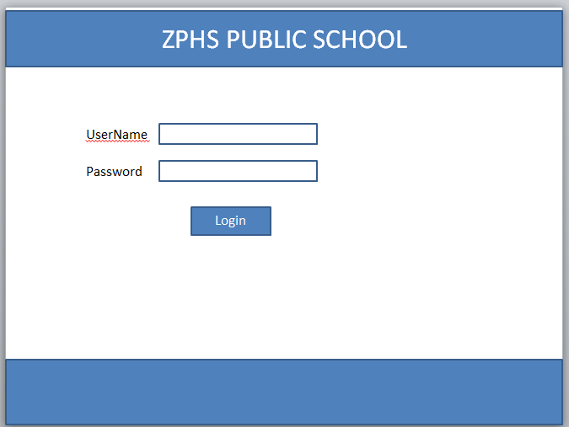

Figure 4 Login View

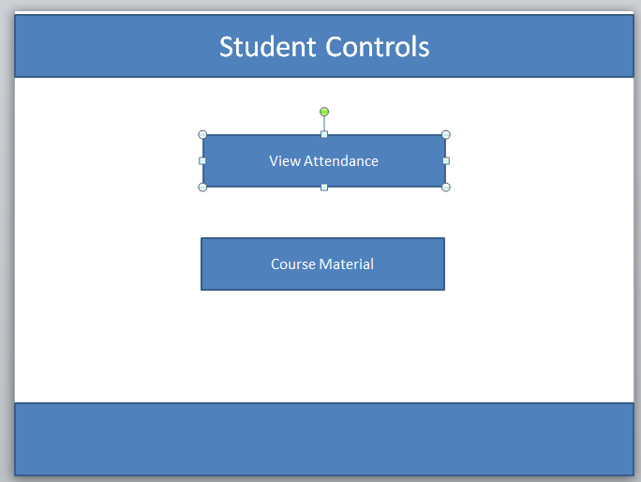

Figure 5Student Controls

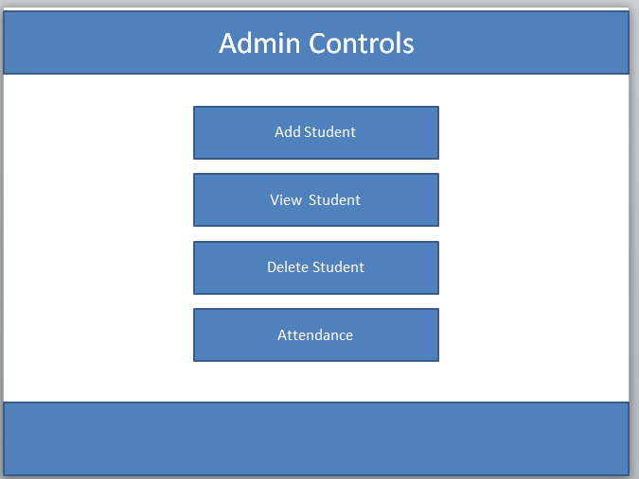

Figure 6 Admin Controls

# CHAPTER 4 CONCLUSION

## 4.1 Conclusion

Student Management System is very useful in an institution or in college or in universities. There is no paper work in this proposed system. Supervision can be done from anywhere. This project especially minimizes human effort necessary. This application is handled by the college so there is no information leak and data will be secured. Since it is a web based application anyone can use the system anywhere at any time and it is very easy to get the necessary information without the latency. It is very useful to the students to get their report on attendance and internal assessments. Parents also get benefited more since college is going to send the notification of the student via the SMS or email will be sent to get the recent activities happen in the college. Since this application will be handled by the college whenever they need any changes in an application they can make it without the upfront investment, and the system will be more secure when it is handled by the own college.

## 4.2 Future scope

Nothing is perfect in this world. So, we are also no exception. Although, we have tried our best to present the information effectively, yet, there can be further enhancement in the Application. We have taken care of all the critical aspects, which need to take care of during the development of the Project. Like the things this project also has some limitations and can further be enhances by someone, because there are certain drawbacks that do not permit the system to be 100% accurate.

For the current project we also have the thought to add the Viewing marks module to the student for checking his grades of the internal exam and improve himself constantly. We can also add sample online test modules for student portal.