3

.NET PRACTICA
160470107061
Priya vaghasia

Contents
AIM : Introduction to C# 1
Program 1 1
AIM: Inheritance 9
Program 1 9
Program 2 10
Program 3 12
Program 4 13
AIM: Method & constructor overloading 16
Program 1 16
Program 2 21
AIM: Reflection 24
Program 1 24
AIM: Files Operations 28
Program 1 28
Program 2 30
Program 3 32
AIM: Student Registration 36
Program 1 36
AIM: Validation Controls 39
Program 1 39
AIM: Master Page 42
Program 1 42

Practical 1

AIM : Introduction to C#
Variables:
Initialization
Scope
Constant
Predefined Data Types
Value Types
Reference TYpes
Flow Control
Conditional Statements(if, switch)
Loop(for, while, dowhile, foreach)
Jump(goto, break, continue, return)
Eumerations
Passing Arguments

Program 1

using System;
using System.Collections.Generic;
using System.Linq;
using System.Text;
using System.Threading.Tasks;

namespace aim
{
class Program
{
static int newint=100;
public enum TimeOfDay
{
Morning = 0,
Afternoon = 1,
Evening = 2
}
public static void Main(string[] args)
{
Console.WriteLine("\n integer types");
sbyte sb = 10;
short s = 33;
int i = 10;
long l = 33L;
byte b = 22;
ushort us = 33;
uint ul = 33u;
ulong ulo = 33ul;
Console.WriteLine("{0},{1},{2},{3},{4},{5},{6},{7}", sb, s, i, l, b, us, ul, ulo);
float f = 1.122345656767f;
double d = 12.1234455657878797;
Console.Write("\nFloat and Double:\n");
Console.WriteLine("{0} and \n{1}", f, d);
decimal dec=111.666666666666666666666M;
Console.WriteLine("decimal:\n{0} ",dec);
Console.WriteLine("\nBoolean:");
bool boolean =true;
Console.WriteLine("Status: " + boolean);
// Console.ReadLine();
char character ='d';
Console.WriteLine(character);
character = '\0';
Console.WriteLine("Now null: " + character);
object o1 = "Hi, I am ALICE";
object o2 = 15.3454365;
string strObj = o1 as string;
Console.WriteLine(strObj);
Console.WriteLine(o1.GetHashCode() + " " + o1.GetType());
Console.WriteLine(o2.GetHashCode() + " " + o2.GetType());
Console.WriteLine(o1.Equals(o2));
string s1, s2;
s1 = "this is string";
s2 = s1;
Console.WriteLine("S1 is: {0} and s2 is {1}", s1, s2);
s2 = "other string";
Console.WriteLine("S1 is: {0} and s2 is {1}", s1, s2);
s1 = "c:C:\\Users\\Dell\\source\\repos\\aim";
Console.WriteLine(s1);
s1 = @"c:C:\Users\Dell\source\repos\aim\aim";
Console.WriteLine(s1);
s1 = @"We can also write
like this";
Console.WriteLine(s1);
bool isZero;
Console.WriteLine("\nFlow Control: (if)\ni is " + i);
if (i == 10)
{
isZero = true;
Console.WriteLine("i is Zero {0}",isZero);
}
else
{
isZero = false;
Console.WriteLine("i is Non - zero");
}
int integerA = 1;
Console.WriteLine("\nSwitch:");
switch (integerA)
{
case 1:
Console.WriteLine("integerA = 1");
break;
case 2:
Console.WriteLine("integerA = 2");
//goto case 3;
break;
case 3:
Console.WriteLine("integerA = 3");
break;
default:
Console.WriteLine("integerA is not 1, 2, or 3");
break;}
WriteGreeting(TimeOfDay.Morning);
Console.WriteLine("Argument is: {0}",args[1]);

void WriteGreeting(TimeOfDay timeOfDay)
{
switch (timeOfDay)
{
case TimeOfDay.Morning:
Console.WriteLine("Good morning!");
break;
case TimeOfDay.Afternoon:
Console.WriteLine("Good afternoon!");
break;
case TimeOfDay.Evening:
Console.WriteLine("Good evening!");
break;
default:
Console.WriteLine("Hello!");
break;

}}
Console.WriteLine("Scope of Variables.\n1:");
int newint=0;
int j;
for (/*int*/ j = 0; j < 2; j++) //removing comment from for loop will raise error
{
//int j;
//uncomment above line to error "A local variable named 'j' cannot be declared in this
//scope because it would give a different meaning to 'j', which is already
//used in a 'parent or current' scope to denote something else"
Console.Write("{0} {1}\n", newint, Program.newint);
}
Console.WriteLine("2:");
for (int k = 0; k < 3; k++)
{
Console.Write("{0} ", k);
}//Scope of k ends here
Console.Write("\n");
//Console.Write(k);
//uncomment above line to see error "The name 'k' does not exist in the current context"
for (int k = 3; k > 0; k--)
{
Console.Write("{0} ", k);
}//scope of k ends here again

Console.WriteLine("Constants");
const int valConst = 100; // This value cannot be changed.
Console.WriteLine("{0} is constant value", valConst);
//valConst = 45;
//uncomment above line to see error "The left-hand side of an assignment must be a variable, property or indexer"

//const only allow constant variables into the expression
const int valConst2 = valConst + 9 /* + j*/;
//remove comments from the above line to see error "The expression being assigned to 'valConst2' must be constant"
Console.WriteLine("Another Constant: {0}", valConst2);

Console.WriteLine("\nPredefined Data Types\n\nValue Types and Reference Types");
//Value Types
int vali = 2, valj = vali;
Console.WriteLine("vali is: {0} and valj is: {1}", vali, valj);
valj = 90;
Console.WriteLine("vali is: {0} and valj is: {1}", vali, valj);
//Referece Types
Vector x, y;
x = new Vector();
x.value = 3;

y = x;

Console.WriteLine("x is: {0} and y is:{1}", x.value, y.value);
y.value = 234;
Console.WriteLine("x is: {0} and y is:{1}", x.value, y.value);
//If a variable is a reference, it is possible to indicate that it does not refer to any object by setting its value to null:
y = null;
//Console.Write("Value for y is: " + y.value);
//uncomment above line to see runtime exception "System.NullReferenceException: Object reference not set to an instance of an object."
//CTS

}

public class Vector
{
public int value;
}
}
}

OutPut:

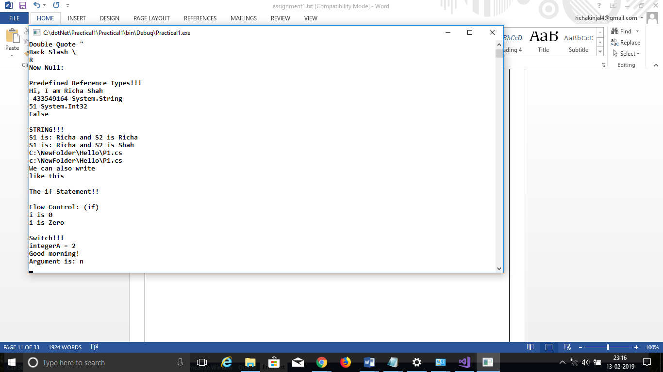
Practical 2

AIM: Inheritance

Program 1
Perform following programs in c#.
1. Write console based program in code behind language VB or C# to print following pattern.
@ @ @ @ @
@ @ @ @
@ @ @
@ @
@
using System;
using System.Collections.Generic;
using System.Linq;
using System.Text;
using System.Threading.Tasks;

namespace practical2
{
class Program
{
static void Main(string[] args)
{
for(int i=5;i>0;i--)
{
for (int j = i; j > 0; j--)
{
Console.Write("@");

}
Console.WriteLine(" ");
}
Console.ReadKey();
}
}
}
OutPut:
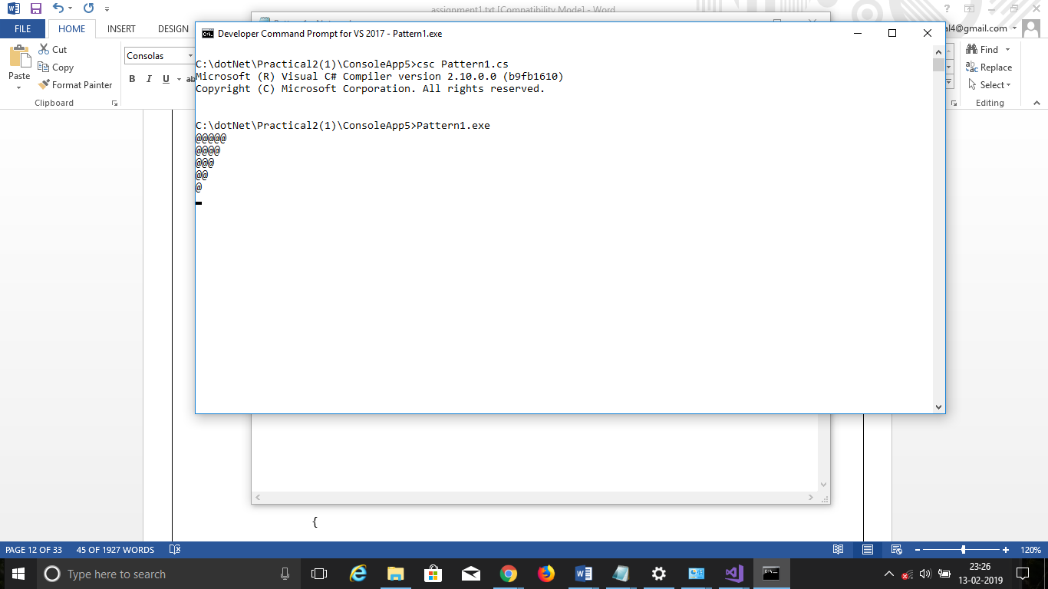

Program 2
2. Write console based program in code behind language VB or C# to print following pattern.
1
1 2
1 2 3
1 2 3 4

using System;
using System.Collections.Generic;
using System.Linq;
using System.Text;
using System.Threading.Tasks;

namespace practical2._1
{
class Program
{
static void Main(string[] args)
{
for(int i=1;i<5;i++)
{
for(int j=1;j<=i;j++)
{
Console.Write(j+” ”);
}
Console.WriteLine();
}
Console.ReadKey();
}
}
}
OutPut:
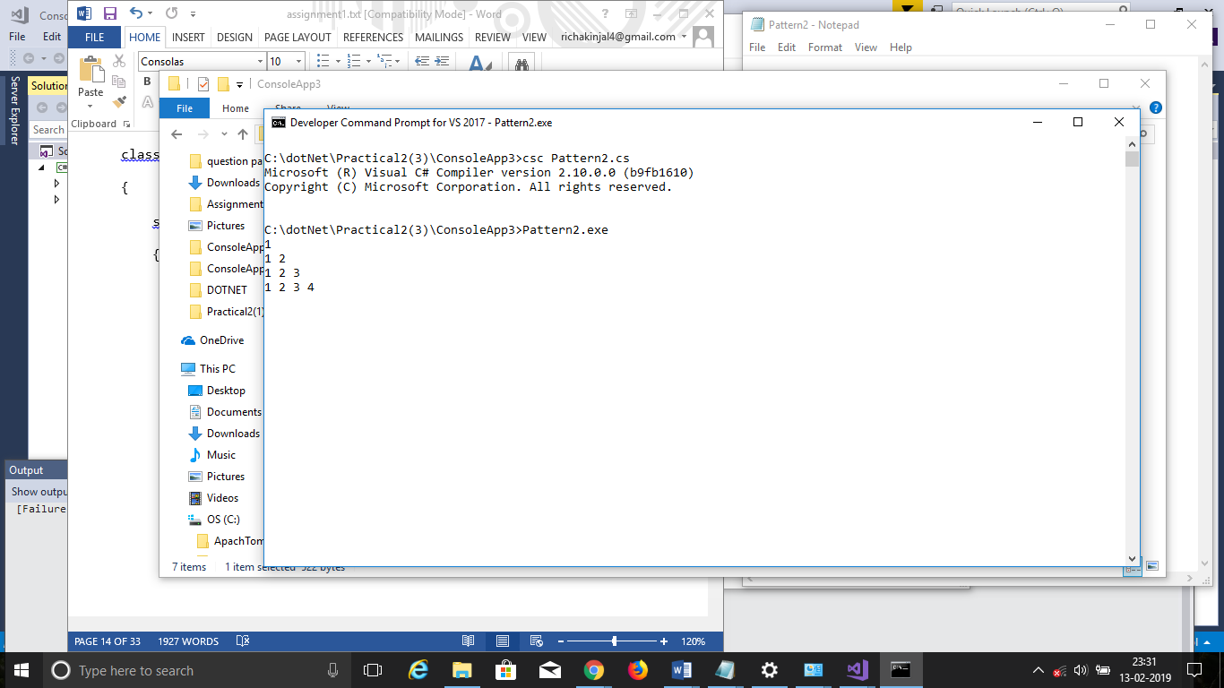

Program 3
3. Write C# code to prompt a user to input his/her name and country name and then the output will be shown as an example below:
Hello Ram from country India
using System;
using System.Collections.Generic;
using System.Linq;
using System.Text;
using System.Threading.Tasks;

namespace practical2._2
{
class Program
{
static void Main(string[] args)
{
string name;
string country;
Console.WriteLine("enter your name:");
name=Console.ReadLine();
Console.WriteLine("enter your country:");
country = Console.ReadLine();
Console.WriteLine("hello {0} from country {1}",name,country);
Console.ReadKey();
}

}
}

OutPut:
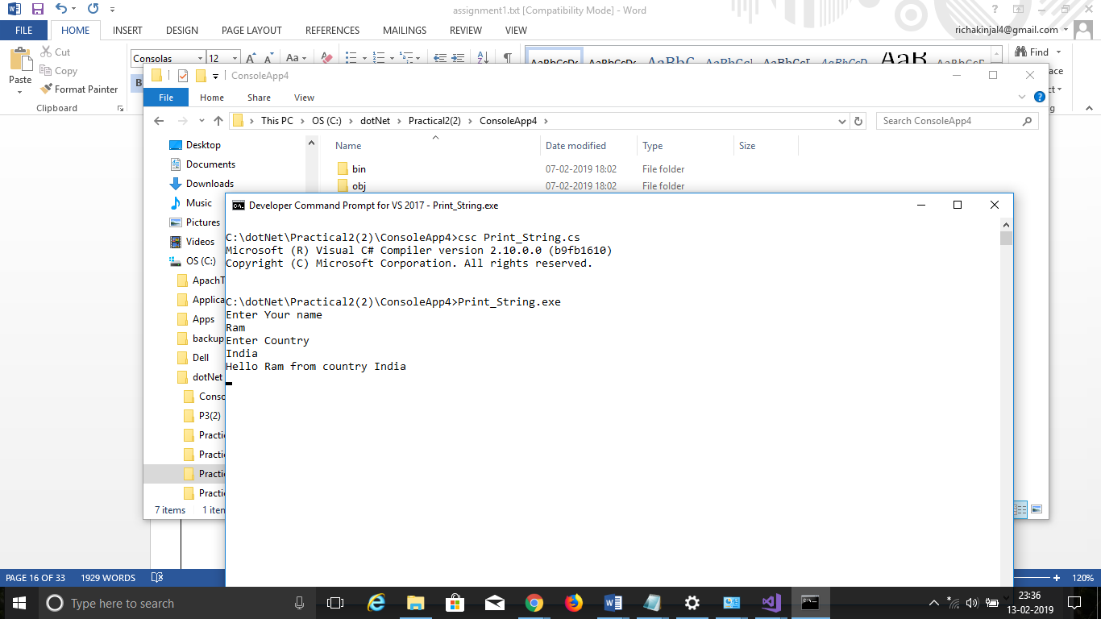

Program 4
4. What is inheritance? Create C# console application to define Car class and derive Maruti and Mahindra from it to demonstrate inheritance.

using System;
using System.Collections.Generic;
using System.Linq;
using System.Text;
using System.Threading.Tasks;

namespace practical2._3
{
class car
{
public void Method1()
{
Console.WriteLine("this is the method of car class");
}
}
class maruti:car
{
public void method2()
{
Console.WriteLine("this is the method of maruti");
Console.ReadKey();
}
}
class mahindra:car
{
public void method3()
{
Console.WriteLine("this is the method of mahindra");
}
}
class Program
{
static void Main(string[] args)
{
mahindra m = new mahindra();
maruti m1 = new maruti();
m.Method1();
m1.Method1();
Console.ReadKey();
}
}
}
OutPut:

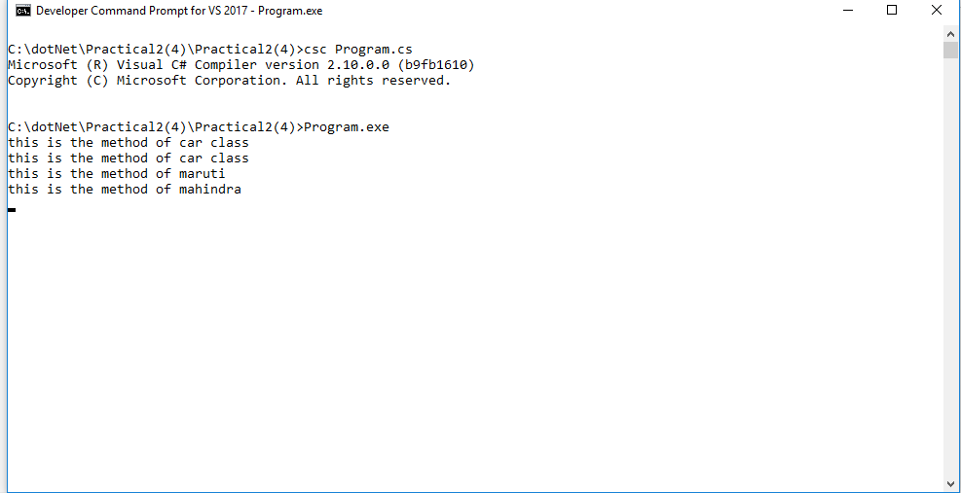
Practical 3

AIM: Method & constructor overloading

Program 1

Write a c# program to add two integers, two vectors and two metric using method overloading.
using System;
using System.Collections.Generic;
using System.Linq;
using System.Text;
using System.Threading.Tasks;

namespace Practical3
{
class Program
{
public void add(int a, int b)
{
int sum = a + b;
Console.WriteLine("Addition is:{0}", sum);
}
public void add()
{
int i, j, n;
int[,] arr1 = new int[50, 50];
int[,] brr1 = new int[50, 50];
int[,] crr1 = new int[50, 50];
Console.Write("Input the size of the square matrix: ");
n = Convert.ToInt32(Console.ReadLine());
Console.Write("Input elements in the first matrix :\n");
for (i = 0; i < n; i++)
{
for (j = 0; j < n; j++)
{
Console.Write("{0},{1}:", i, j);
arr1[i, j] = Convert.ToInt32(Console.ReadLine());
}
}
Console.Write("Input elements in the Second matrix :\n");
for (i = 0; i < n; i++)
{
for (j = 0; j < n; j++)
{
Console.Write("{0},{1}:", i, j);
brr1[i, j] = Convert.ToInt32(Console.ReadLine());
}
}
Console.Write("\nThe First matrix is :\n");
for (i = 0; i < n; i++)
{
Console.Write("\n");
for (j = 0; j < n; j++)
Console.Write("{0}\t", arr1[i, j]);
}
Console.Write("\nThe Second matrix is :\n");
for (i = 0; i < n; i++)
{
Console.Write("\n");
for (j = 0; j < n; j++)
Console.Write("{0}\t", brr1[i, j]);
}
for (i = 0; i < n; i++)
{
for (j = 0; j < n; j++)
{
crr1[i, j] = arr1[i, j] + brr1[i, j];
}
}
Console.Write("\nAddition of Two Matrix:\n");
for (i = 0; i < n; i++)
{
Console.Write("\n");
for (j = 0; j < n; j++)
{
Console.Write("{0}\t", crr1[i, j]);
}
}
}
public void add(Vector a, Vector b)
{
Vector result=new Vector();
result.x = a.x + b.x;
result.y = a.y + b.y;
result.z = a.z + b.z;
Console.WriteLine("Addition of Two vectors is:");
Console.WriteLine("<" + result.x + "," + result.y + "," + result.z + ">");
}
static void Main(string[] args)
{
Program p = new Program();
Console.WriteLine("Value of a:");
int a = Convert.ToInt32(Console.ReadLine());
Console.WriteLine("Value of b:");
int b = Convert.ToInt32(Console.ReadLine());
p.add(a, b);
p.add();
Vector v1 = new Vector();
Vector v2 = new Vector();
// float x, y, z;
Console.WriteLine("Enter 1st vector");
Console.WriteLine("X:", v1.x);
v1.x=Convert.ToInt32( Console.ReadLine());
Console.WriteLine("Y:", v1.y);
v1.y= Convert.ToInt32(Console.ReadLine());
Console.WriteLine("Z:", v1.z);
v1.z= Convert.ToInt32(Console.ReadLine());
Console.WriteLine("Enter 2nd vector");
Console.WriteLine("X:", v2.x);
v2.x = Convert.ToInt32(Console.ReadLine());
Console.WriteLine("Y:", v2.y);
v2.y = Convert.ToInt32(Console.ReadLine());
Console.WriteLine("Z:", v2.z);
v2.z = Convert.ToInt32(Console.ReadLine());
p.add(v1, v2);
Console.ReadLine();
}
}
public class Vector
{
public float x, y,z;
}
}
OutPut:

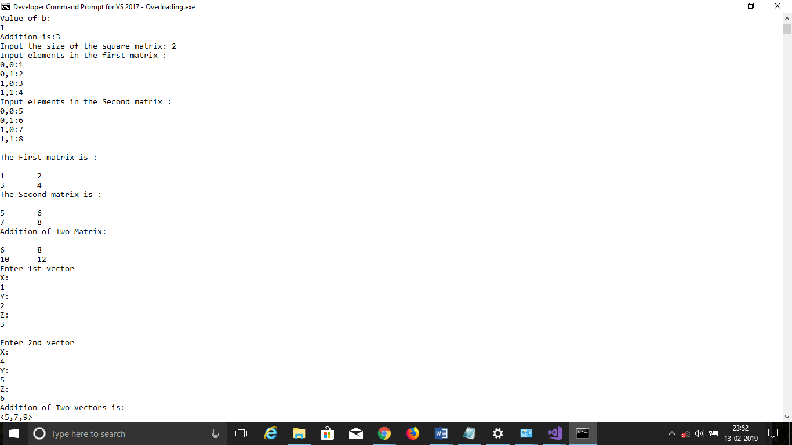

Program 2

Write a c# program that create student object. Overload constror to create new instant with following details.
1. Name
2. Name, Enrollment
3. Name, Enrollment, Branch
using System;
using System.Collections.Generic;
using System.Linq;
using System.Text;
using System.Threading.Tasks;

namespace P3_2_
{
class Program
{
public int ID { get; set; }
public string Name { get; set; }
String name, branch;
int enroll;
Program(String Stname)
{
name = Stname;
Console.WriteLine("1st Constructor:");
Console.WriteLine("Student Name is "+Stname);
}
Program(String Stname,String Stbranch)
{
name = Stname;
branch = Stbranch;
Console.WriteLine("2nd Constructor:");
Console.WriteLine(Stname+" is in "+Stbranch+" branch");
}
Program(String Stname, String Stbranch ,int Stenroll)
{
name = Stname;
branch = Stbranch;
enroll = Stenroll;
Console.WriteLine("3rd Constructor:");
Console.WriteLine(Stname + " is in " + Stbranch+" having "+Stenroll+" Enrollment ");
}
static void Main(string[] args)
{
Program p = new Program("richa");
Program p1 = new Program("richa","Computer");
Program p2 = new Program("richa","Computer",51);
Console.ReadLine();

}
}
}

OutPut:
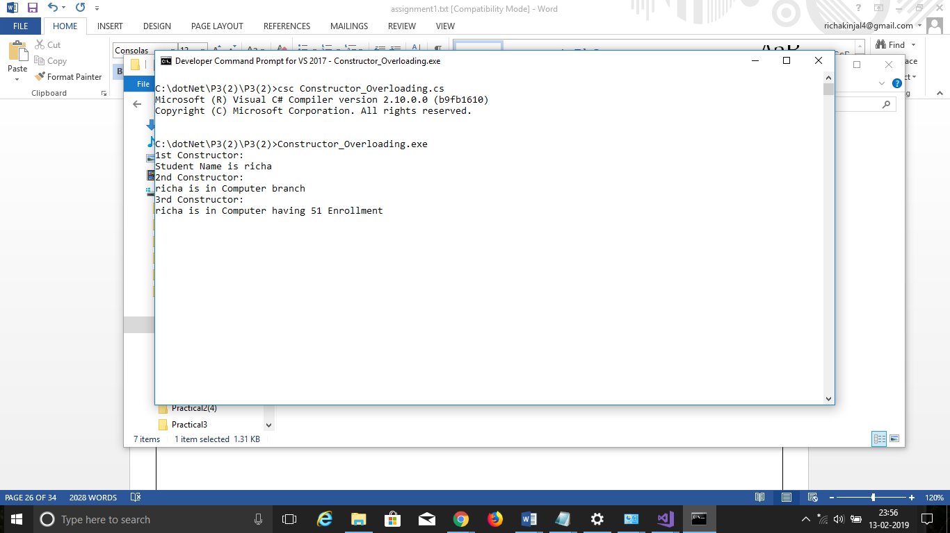

Practical 4

AIM: Reflection

Program 1

using System;
using System.Collections.Generic;
using System.Linq;
using System.Text;
using System.Threading.Tasks;
using System.Reflection;

namespace p3a1
{
class Program
{
public int ID { get; set; }
public string Name { get; set; }
String name, branch;
int enrol;
public void printID()
{
Console.WriteLine("ID is: {0}", this.ID);
}
public void printName()
{
Console.WriteLine("Name is: {0}", this.Name);
}
public Program(String name)
{
this.name = name;
Console.WriteLine("constructor 1:" + name);
}
public Program(String name, int enrol)
{
this.name = name;
this.enrol = enrol;
Console.WriteLine("constructor 2:" + name + " " + enrol);

}
public Program(String name, int enrol, String branch)
{
this.name = name;
this.enrol = enrol;
this.branch = branch;
Console.WriteLine("constructor 3:" + name + " " + enrol + " " + branch);

}
static void Main(string[] args)
{
try
{
Type T = Type.GetType("p3a1.Program");
MethodInfo[] methods = T.GetMethods();
foreach (MethodInfo method in methods)
{
Console.WriteLine(method.ReturnType + " " + method.Name);
}

PropertyInfo[] properties = T.GetProperties();

Console.WriteLine("\nProperties");
foreach (PropertyInfo property in properties)
{
Console.WriteLine(property.PropertyType + " " + property.Name);
}

Console.WriteLine("\nConstructors");
ConstructorInfo[] constructors = T.GetConstructors();
foreach (ConstructorInfo constructor in constructors)
{
Console.WriteLine(constructor.ToString());
}

Program p1 = new Program("bob");
Program p2 = new Program("bob", 1);
Program p3 = new Program("bob", 1, "computer");

Console.ReadLine();

catch (Exception e)
{
Console.WriteLine(e);
Console.ReadLine();

}
}
}
}

Practical 5

AIM: Files Operations

Program 1

1. Write a C# program to copy data from one file to another using StreamReader and StreamWriter class.
using System;
using System.Collections.Generic;
using System.Linq;
using System.Text;
using System.Threading.Tasks;
using System.IO;

namespace Practical5
{
class Program
{
static void Main(string[] args)
{
CopyFile cp = new CopyFile();
String file1= @"C:\dotNet\file1.txt";
String file2 = @"C:\dotNet\richa\file2.txt";
cp.copyFile(file1, file2);
}
}
public class CopyFile
{
public void copyFile(String file1,String file2)
{
using (StreamReader reader = new StreamReader(file1))
{
using (StreamWriter writer = new StreamWriter(file2))
{
String line = null;
while ((line = reader.ReadLine()) != null)
{
writer.WriteLine(line);

}
}
}
}
}
}
OutPut:

Program 2

2. Write a C# Program to Read Lines from a File until the End of File is Reached
using System;
using System.Collections.Generic;
using System.Linq;
using System.Text;
using System.Threading.Tasks;
using System.IO;

namespace Practical5_1_
{
class Program
{
static void Main()
{
StreamReader reader = new StreamReader("teststream.txt");
using (reader)
{
int lineNumber = 0;
String line = reader.ReadLine();
while(line!=null)
{
lineNumber++;
Console.WriteLine("Line {0}:{1}", lineNumber, line);
line = reader.ReadLine();
}
Console.ReadLine();
}
}
}
}
Output:
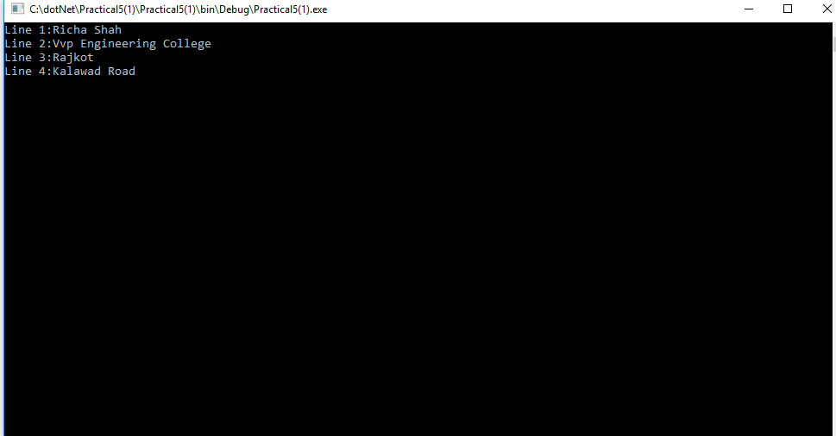

Program 3
3. Write a C# Program to List Files in a Directory.
using System;
using System.Collections.Generic;
using System.Linq;
using System.Text;
using System.Threading.Tasks;
using System.IO;

namespace Practical5_2_
{
class Program
{
static void Main(string[] args)
{
string[] Directories = Directory.GetDirectories(@"C:\Users\RICHA\source\repos");
Console.WriteLine("All the Directories are:");
foreach (string dir in Directories)
{
//Console.WriteLine("All the Directories are:");
Console.WriteLine(dir);
}
string[] files = Directory.GetFiles(@"C:\Users\RICHA\source\repos");
Console.WriteLine("All the Files are:");
foreach (string file in files)
{
// Console.WriteLine("All the Files are:");
Console.WriteLine(file);
}
Console.ReadLine();
}
}
}

Output:
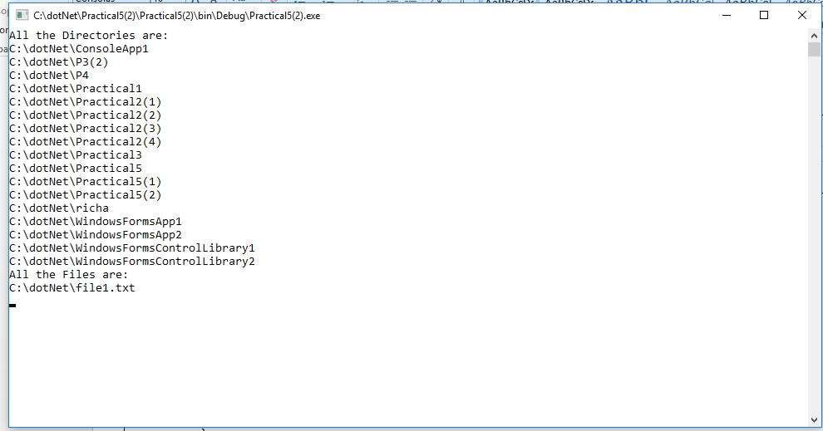

Practical 6

AIM: Student Registration

Program 1
Create Windows Form Application for Student Registration and store student Details in DataBase.
using System;
using System.Collections.Generic;
using System.ComponentModel;
using System.Data;
using System.Drawing;
using System.Linq;
using System.Text;
using System.Threading.Tasks;
using System.Windows.Forms;
using System.Data.SqlClient;
using System.IO;

namespace P6_form_
{
publicpartialclassForm1 : Form
{
string imgPath;
public Form1()
{
InitializeComponent();
}

privatevoid label1_Click(object sender, EventArgs e)
{

}

privatevoid Form1_Load(object sender, EventArgs e)
{

}

privatevoid button3_Click(object sender, EventArgs e)
{
Environment.Exit(0);
}

privatevoid button2_Click(object sender, EventArgs e)
{
string source = @"C:\DOTNET\P6(FORM)\P6(FORM)\PROPERTIES\DATABASE1.MDF";
string select = "select count(*) from tblStudent";
SqlConnection conn = new SqlConnection(source);
SqlCommand cmd = new SqlCommand(select, conn);
conn.Open();
int i = Convert.ToInt16(cmd.ExecuteScalar());
int textBox1 = i + 1;

string insert = "insert into tblStudent(Name,Email,Phone No,Gender,Address,imgStudent) values ( " + textBox1 + ",'" + textBox3 + "','" + textBox4 + "','" + radioButton1 + "','" + richTextBox1 + "','" + (imgPath == null ? "" : imgPath) + "' )";
cmd = new SqlCommand(insert, conn);

i = cmd.ExecuteNonQuery();
//object imgStudent = null;
if (imgPath != null)
imgStudent.Image.Save(imgPath);
MessageBox.Show("You are Done!!!");
InitializeComponent();
}

privatevoid button1_Click(object sender, EventArgs e)
{
openFileDialog1.Filter = "Jpg|*.jpg";
if (openFileDialog1.ShowDialog() == DialogResult.OK)
{
imgPath = @"C:\Pictures" + openFileDialog1.SafeFileName;
imgStudent.Image = Image.FromFile(openFileDialog1.FileName);
}

}
}
}

Output:
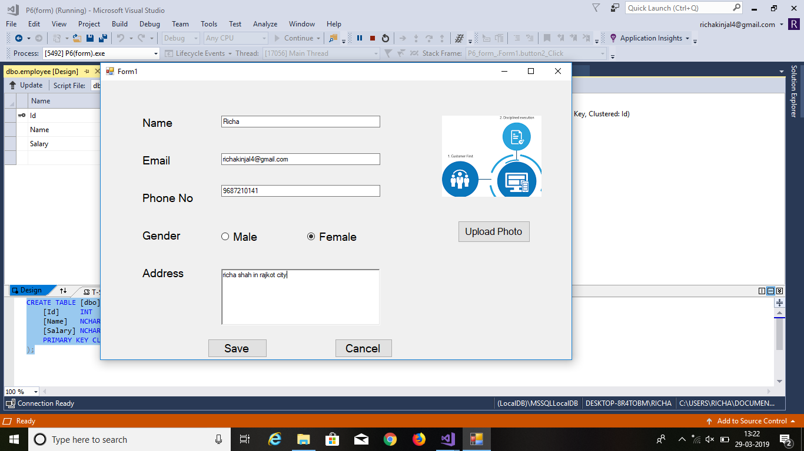

Practical 7

AIM: Validation Controls

Program 1
<%@ Page Language="C#" AutoEventWireup="true" CodeBehind="WebForm1.aspx.cs" Inherits="WebApplication1.WebForm1" %>

<!DOCTYPE html PUBLIC "-//W3C//DTD XHTML 1.0 Transitional//EN" "http://www.w3.org/TR/xhtml1/DTD/xhtml1-transitional.dtd">

<html xmlns="http://www.w3.org/1999/xhtml">
<head runat="server">
<title></title>
</head>
<body style="height: 19px">
<form id="form1" runat="server">
<p>
Name:<asp:TextBox ID="txtName" runat="server" ForeColor="Red"
ToolTip="Enter Your Name"></asp:TextBox>
<asp:RequiredFieldValidator ID="RequiredFieldValidator1" runat="server"
ControlToValidate="txtName" Display="Dynamic" ErrorMessage="Enter Your Name"
ForeColor="Red" ToolTip="Enter Your Name">*</asp:RequiredFieldValidator>
</p>
<p>
Email:<asp:TextBox ID="txtEmail" runat="server" ForeColor="Red"
ToolTip="Enter Your Email"></asp:TextBox>
<asp:RegularExpressionValidator ID="RegularExpressionValidator3" runat="server"
ControlToValidate="txtEmail" Display="Dynamic" ErrorMessage="Enter Valid Email"
ForeColor="Red" ToolTip="Enter Your Email"
ValidationExpression="\w+([-+.']\w+)*@\w+([-.]\w+)*\.\w+([-.]\w+)*">*</asp:RegularExpressionValidator>
</p>
<p>
Password:<asp:TextBox ID="txtPass" runat="server"></asp:TextBox>
&nbsp;&nbsp;&nbsp; Confirm Password:<asp:TextBox ID="txtConfirm" runat="server"></asp:TextBox>
<asp:CompareValidator ID="CompareValidator1" runat="server"
ControlToCompare="txtPass" ControlToValidate="txtConfirm"
ErrorMessage="Enter Same Password" ForeColor="Red"
ToolTip="Enter Same Password">*</asp:CompareValidator>
</p>
<p>
Semester:<asp:TextBox ID="txtSem" runat="server"></asp:TextBox>
<asp:RangeValidator ID="RangeValidator1" runat="server"
ControlToValidate="txtSem" ErrorMessage="Enter Semester between 1 to 8"
ForeColor="Red" MaximumValue="8" MinimumValue="1"
ToolTip="Enter Valid Semester" Type="Integer">*</asp:RangeValidator>
</p>
<p>
PhoneNo:<asp:TextBox ID="txtPhone" runat="server"></asp:TextBox>
<asp:RegularExpressionValidator ID="RegularExpressionValidator4" runat="server"
ControlToValidate="txtPhone" ErrorMessage="Enter Valid PhoneNo" ForeColor="Red"
ToolTip=" Enter Valid Phone Number" ValidationExpression="[0-9]{10}">*</asp:RegularExpressionValidator>
</p>
<asp:Button ID="btnSave" runat="server" Text="Save" />
<asp:ValidationSummary ID="ValidationSummary1" runat="server" />
</form>
</body>
</html>
Output:
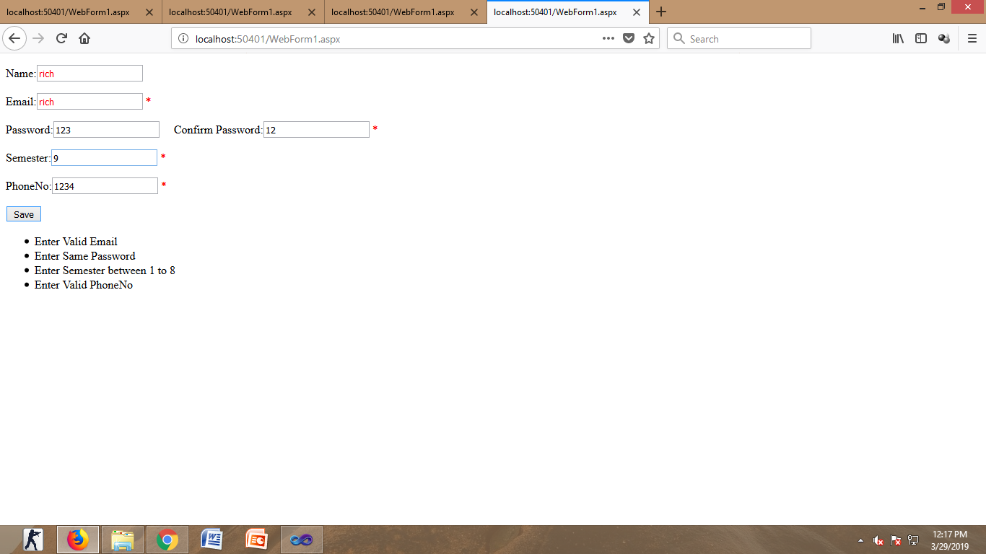

Practical 8

AIM: Master Page

Program 1

Webform2.cs:
using System;
using System.Collections.Generic;
using System.Linq;
using System.Web;
using System.Web.UI;
using System.Web.UI.WebControls;
using System.Data.SqlClient;

namespace WebApplication5
{
public partial class WebForm2 : System.Web.UI.Page
{
protected void Page_Init(object sender, EventArgs e)
{
((Site1)Master).BtnSearch.Click += new EventHandler(btnSearch_Click);
}

protected void btnSearch_Click(object sender, EventArgs e)
{
GetData();
}
protected void Page_Load(object sender, EventArgs e)
{

}
void GetData()
{
string source = @"Data Source=.\SQLEXPRESS;AttachDbFilename=C:\Users\cecomp1\Documents\emp.mdf;Integrated Security=True;Connect Timeout=30;User Instance=True";
string select ="select * from tblStudent";
SqlConnection conn = new SqlConnection(source);
SqlCommand cmd = new SqlCommand(select, conn);
conn.Open();
SqlDataReader reader = cmd.ExecuteReader();
grdEmp.DataSource = reader;
grdEmp.DataBind();
conn.Close();

}

}
}

using System;
using System.Collections.Generic;
using System.Linq;
using System.Web;
using System.Web.UI;
using System.Web.UI.WebControls;
Webform1.cs
namespace WebApplication5
{
public partial class WebForm1 : System.Web.UI.Page
{
protected void Page_Load(object sender, EventArgs e)
{

}

protected void btnHeader_Click(object sender, EventArgs e)
{
((Site1)Master).LblHeader.Text = txtHeader.Text;
}
}
}

Output:
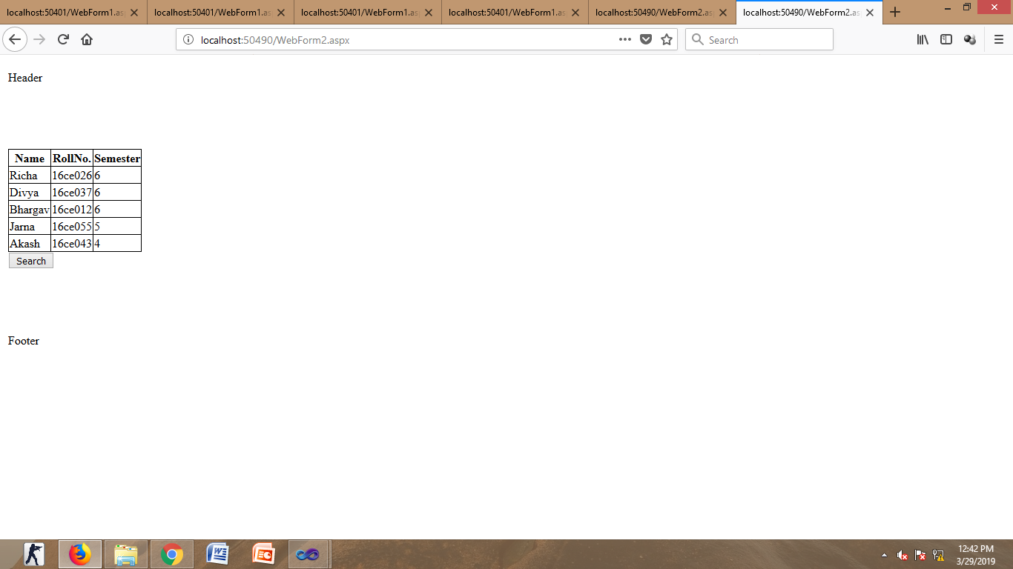
Practical 9

AIM: web services

Program:1
WebForam1.aspx
<html xmlns="http://www.w3.org/1999/xhtml">
<head runat="server">
<title></title>
</head>
<body>
<form id="form1" runat="server">
<div>

<asp:TextBox ID="txtA" runat="server"></asp:TextBox>
<asp:RegularExpressionValidator ID="RegularExpressionValidator1" runat="server"
ErrorMessage="only number is to be entered" ValidationExpression="\d" ControlToValidate="txtA"></asp:RegularExpressionValidator>
<asp:RequiredFieldValidator ID="RequiredFieldValidator1" runat="server"
ErrorMessage="Enter value" ControlToValidate="txtA"></asp:RequiredFieldValidator>
<div>

<asp:TextBox ID="txtB" runat="server"></asp:TextBox>
<asp:RegularExpressionValidator ID="RegularExpressionValidator2" runat="server"
ErrorMessage="only number is to be entered" ValidationExpression="\d" ControlToValidate="txtB"></asp:RegularExpressionValidator>
<asp:RequiredFieldValidator ID="RequiredFieldValidator2" runat="server"
ErrorMessage="Enter Value2" ControlToValidate="txtB"></asp:RequiredFieldValidator>

</div>
<p>
<asp:Button ID="btnAdd" runat="server" onclick="btnAdd_Click" Text="Add" />
<asp:Button ID="btnSub" runat="server" onclick="btnSub_Click" Text="sub" />
<asp:Button ID="btnMul" runat="server" onclick="btnMul_Click" Text="mul" />
<asp:Button ID="btnDiv" runat="server" onclick="btnDiv_Click" Text="div" />
</p>
<p>
<asp:Label ID="lblText" runat="server" Text="label"></asp:Label>
</p>
</div>
</form>
</body>
</html>

WebService1.asmx.cs

using System;
using System.Collections.Generic;
using System.Linq;
using System.Web;
using System.Web.Services;

namespace WebApplication1
{
/// <summary>
/// Summary description for WebService1
/// </summary>
[WebService(Namespace = "http://tempuri.org/")]
[WebServiceBinding(ConformsTo = WsiProfiles.BasicProfile1_1)]
[System.ComponentModel.ToolboxItem(false)]
// To allow this Web Service to be called from script, using ASP.NET AJAX, uncomment the following line.
// [System.Web.Script.Services.ScriptService]
public class WebService1 : System.Web.Services.WebService
{

[WebMethod]
public string HelloWorld()
{
return "Hello World";
}
[WebMethod]
public int Add(int a, int b)
{
return a + b;
}
[WebMethod]
public int Sub(int a, int b)
{
return a - b;
}
[WebMethod]
public int Mul(int a, int b)
{
return a * b;
}
[WebMethod]
public float Div(int a, int b)
{
return a / b;
}
}
}

WebForam1.aspx.cs
using System;
using System.Collections.Generic;
using System.Linq;
using System.Web;
using System.Web.UI;
using System.Web.UI.WebControls;

namespace webservices
{
public partial class WebForm1 : System.Web.UI.Page
{
webcalc.WebService1 calc = new webcalc.WebService1();
protected void Page_Load(object sender, EventArgs e)
{
}
protected void btnAdd_Click(object sender, EventArgs e)
{

lblText.Text = calc.Add(Convert.ToInt16(txtA.Text), Convert.ToInt16(txtB.Text)).ToString();
}

protected void btnSub_Click(object sender, EventArgs e)
{

lblText.Text = calc.Sub(Convert.ToInt16(txtA.Text), Convert.ToInt16(txtB.Text)).ToString();
}

protected void btnDiv_Click(object sender, EventArgs e)
{

lblText.Text = calc.Mul(Convert.ToInt16(txtA.Text), Convert.ToInt16(txtB.Text)).ToString();
}

protected void btnMul_Click(object sender, EventArgs e)
{

lblText.Text = calc.Div(Convert.ToInt16(txtA.Text), Convert.ToInt16(txtB.Text)).ToString();
}
}
}

