**Project Title : News Hunter**

**User_Module**

**Admin Login Page:**

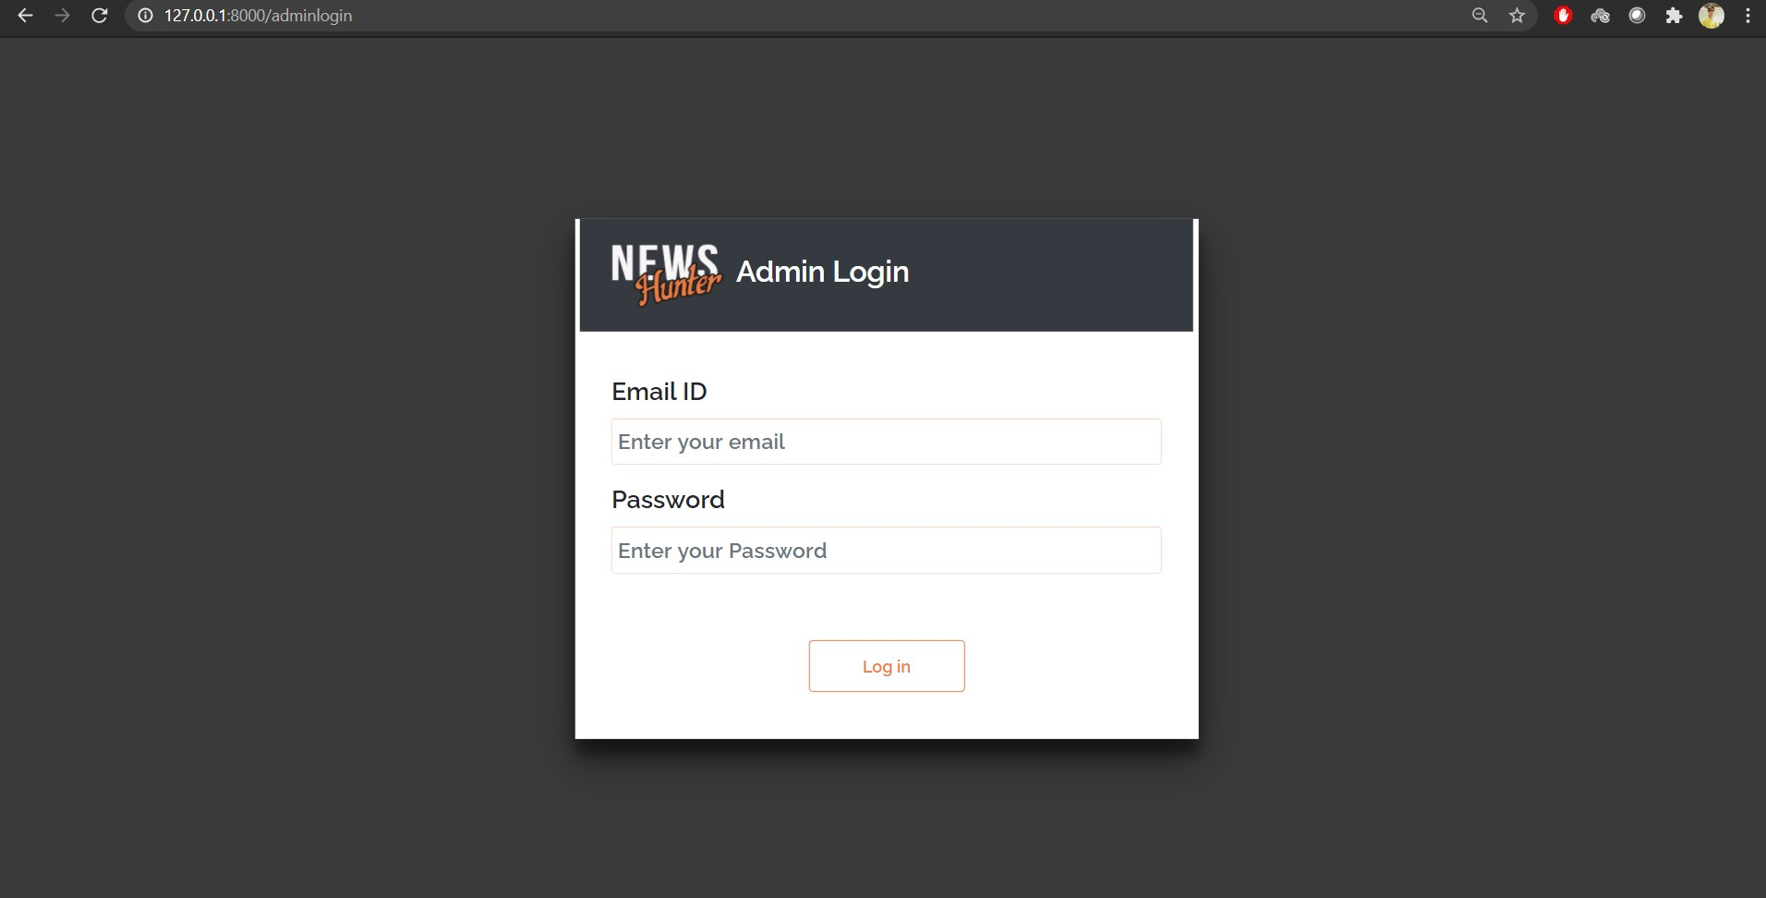

**Invalid Credentials:**

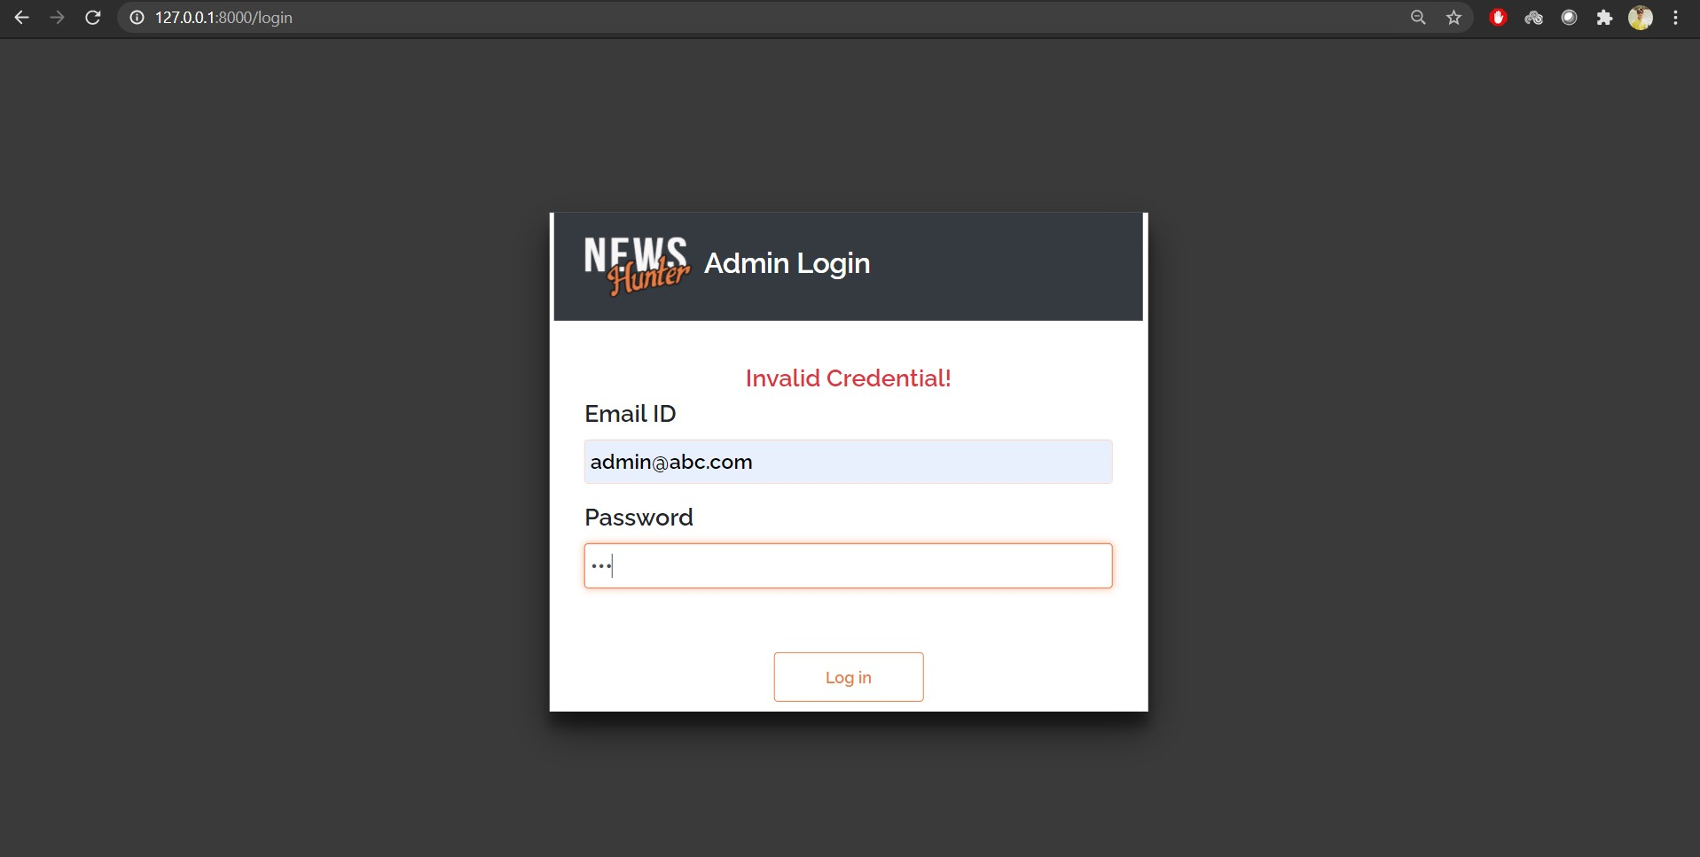

**With Valid Credentials, admin home page is displayed:**

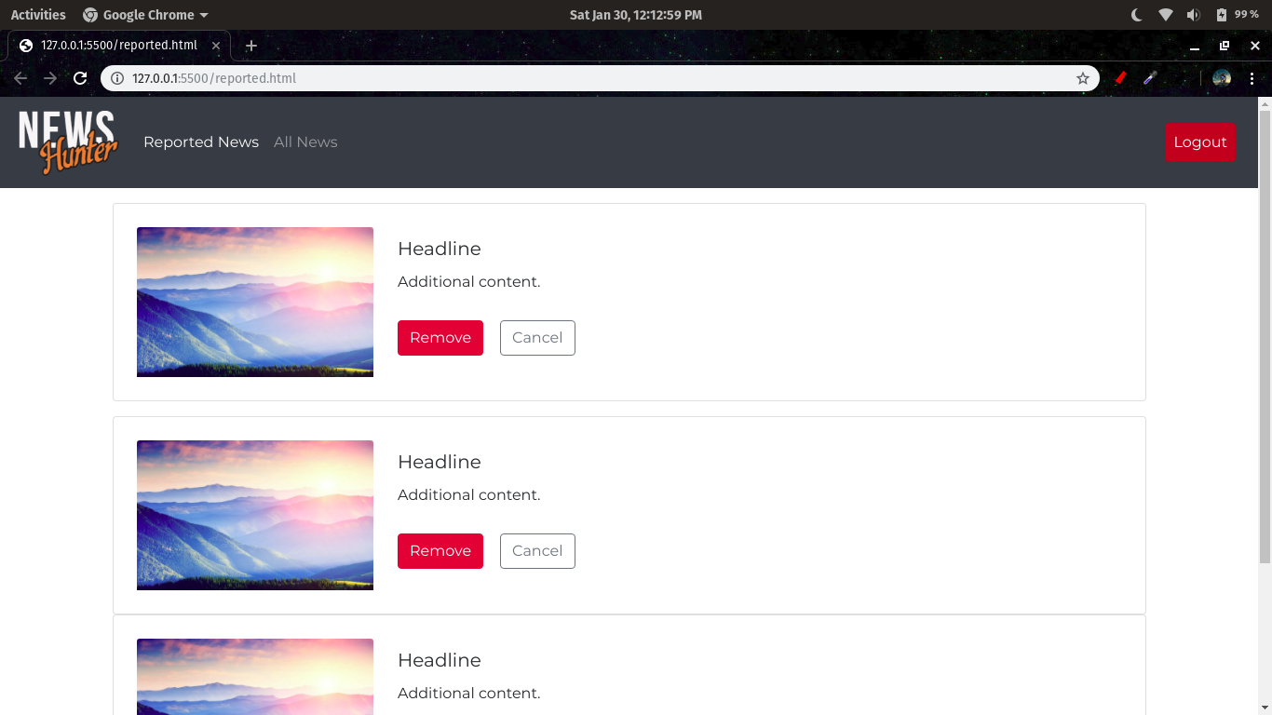

**After Logging Out, login page is displayed:**



**Admin Home page is requested but session has terminated after logging out, so it displays login page:**

