**Real-Time Notification System using AWS Simple Notification Service (SNS)**

* **Objective:**

The goal of this project is to design and implement a real-time notification system that leverages Amazon Web Services Simple Notification Service (AWS SNS) to send email alerts automatically in response to specific events.

* **List of Services Integrated:**
* Amazon SNS Core notification service to send email alerts
* **Scope and Use Case of Services Integrated:**
* Amazon SNS (Simple Notification Service)
* Scope: Acts as the primary notification mechanism.
* **Screenshots of the outputs:**
* Creating SNS Subscription

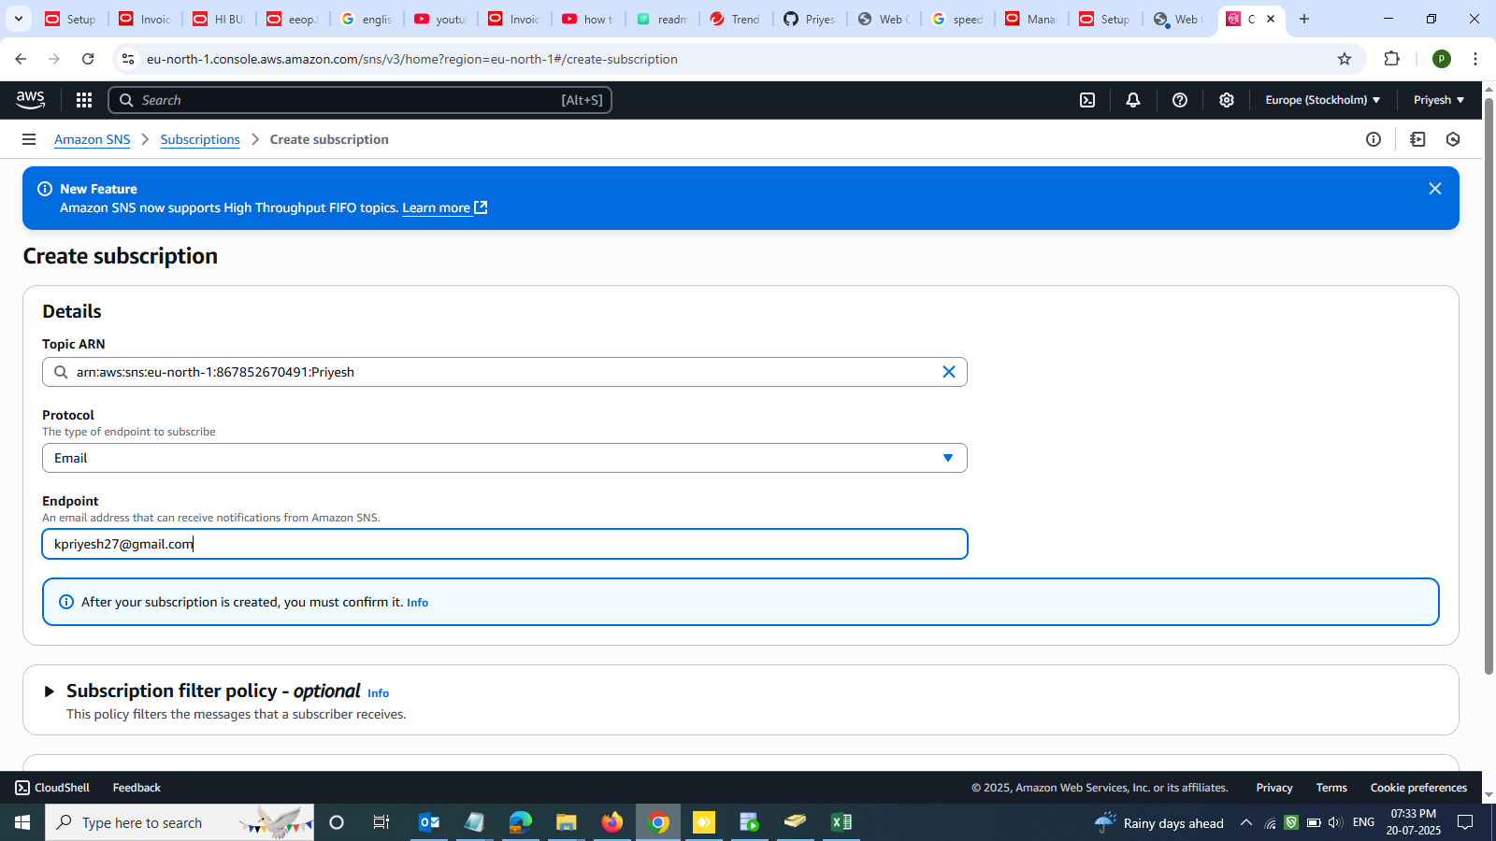

* **Subscription successfully updated**

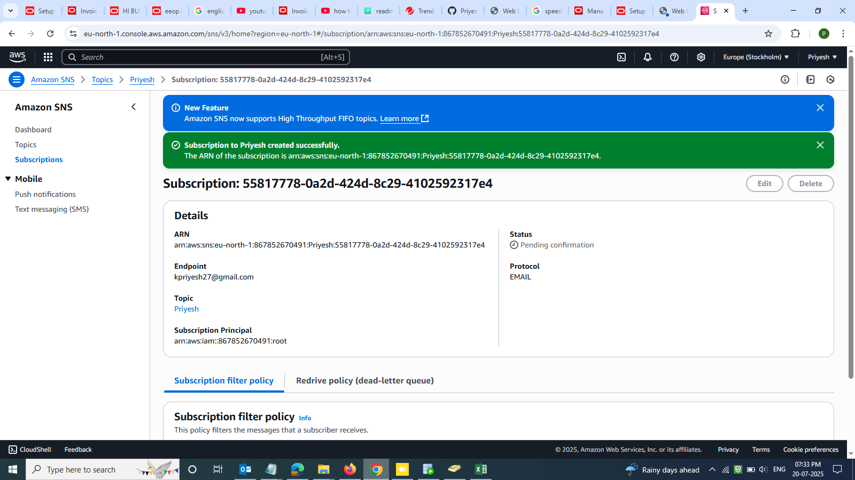

* **Subscription confirmation via Email**

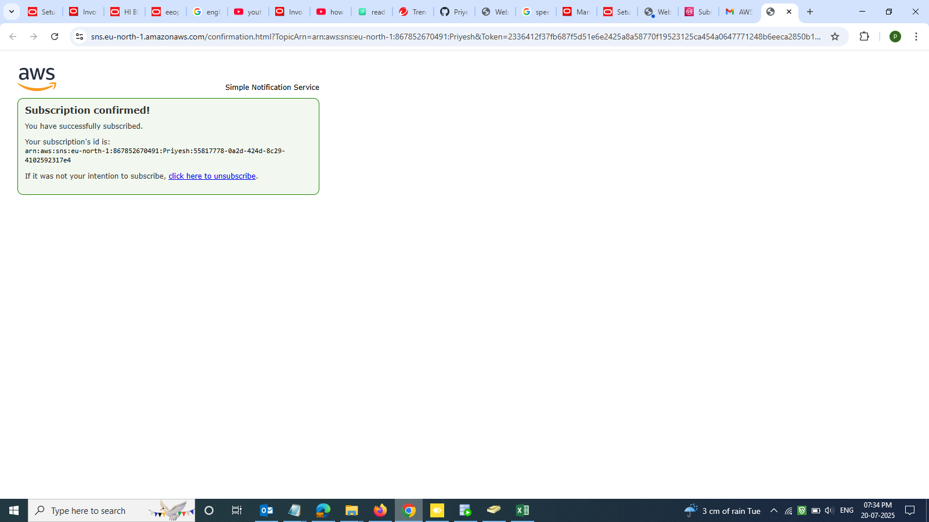

* **Subscription status confirmation**

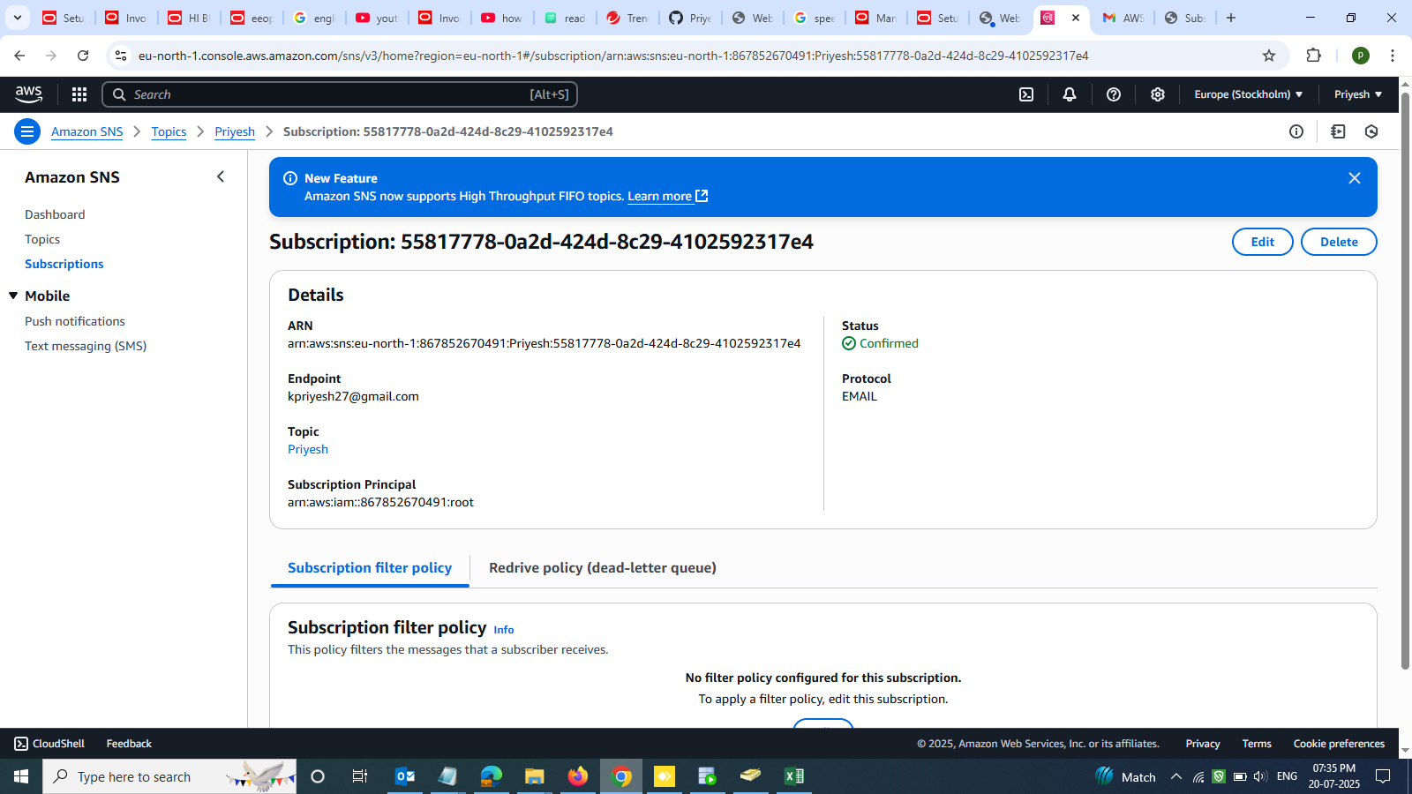

* **Edit Access policy in SNS**

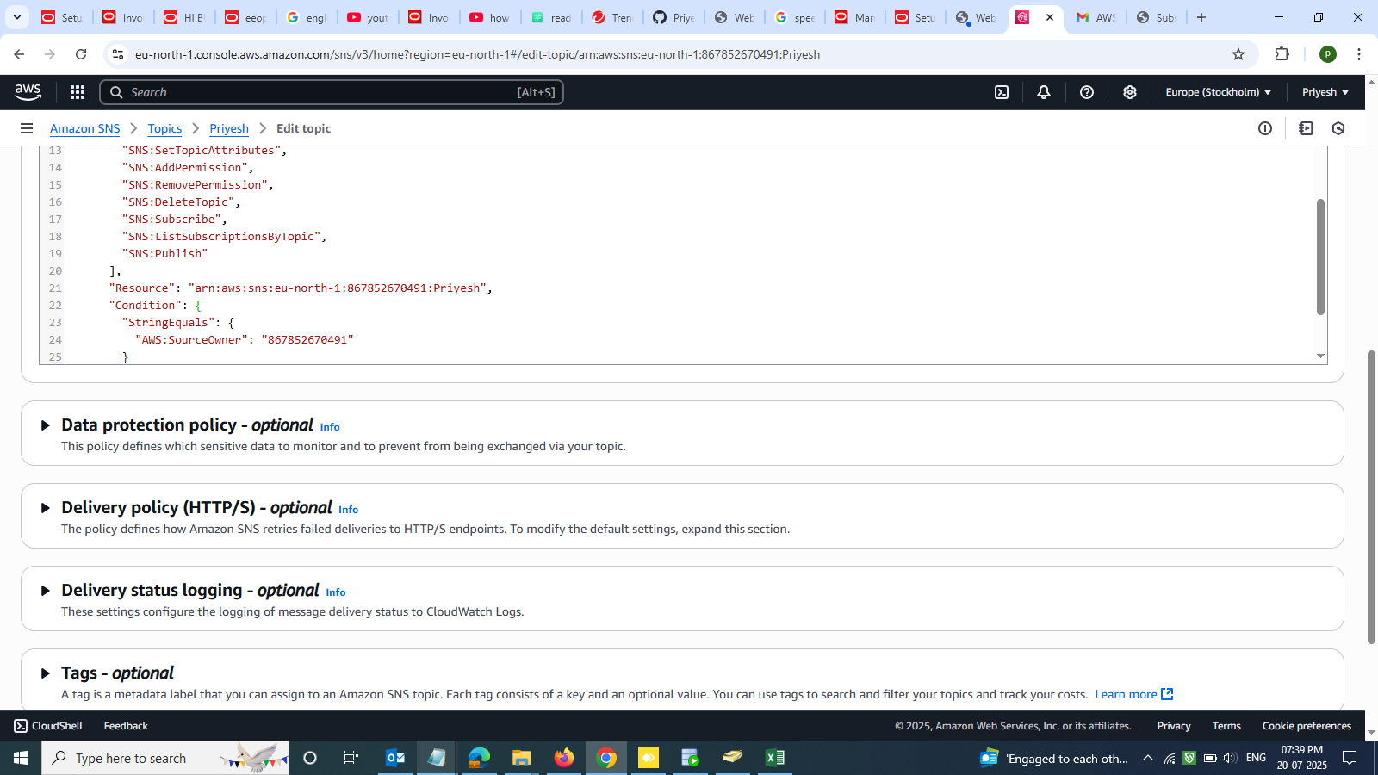

* **Create event notification**

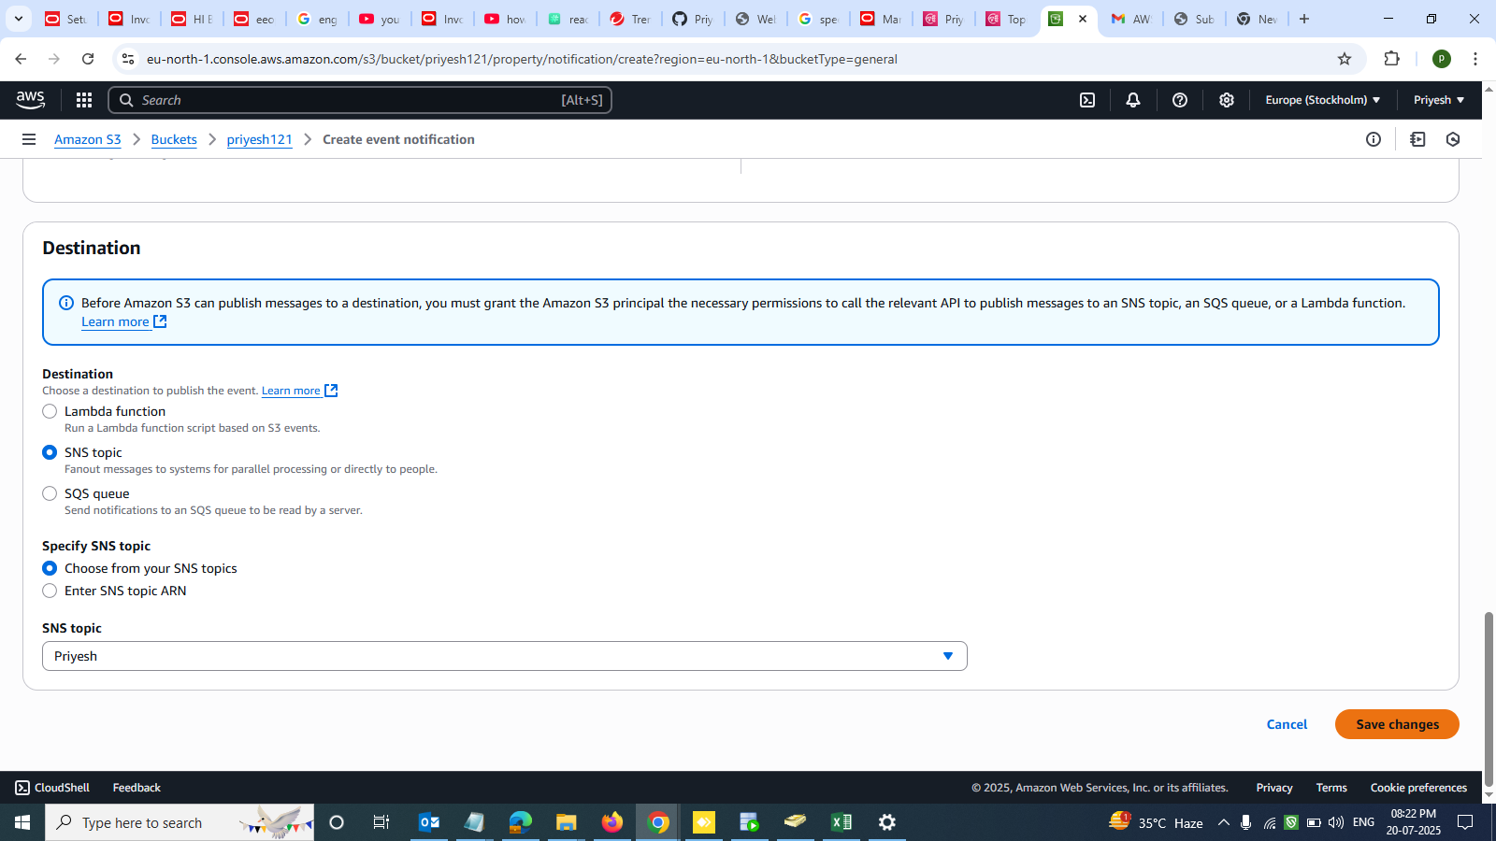

* **Creating Event notification in S3 Bucket**

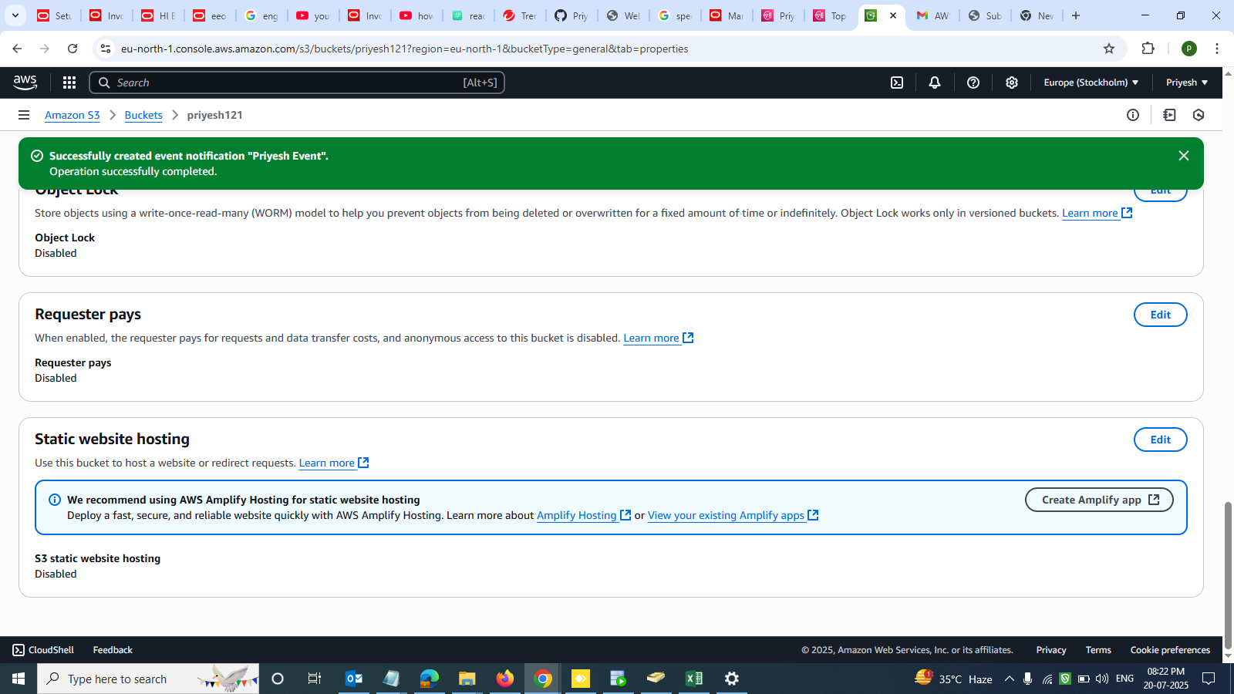

* **Upload a .txt document in S3**

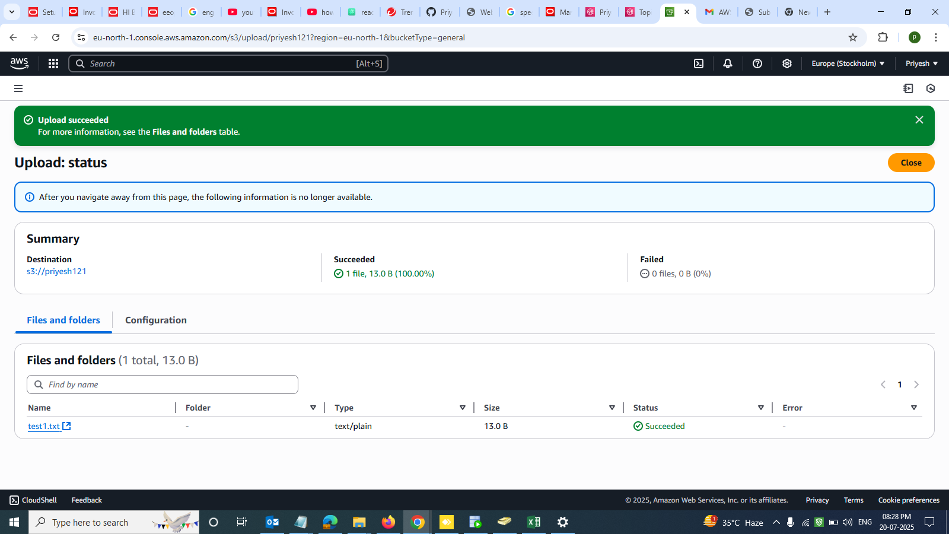

* **Successfully notification received on Email**

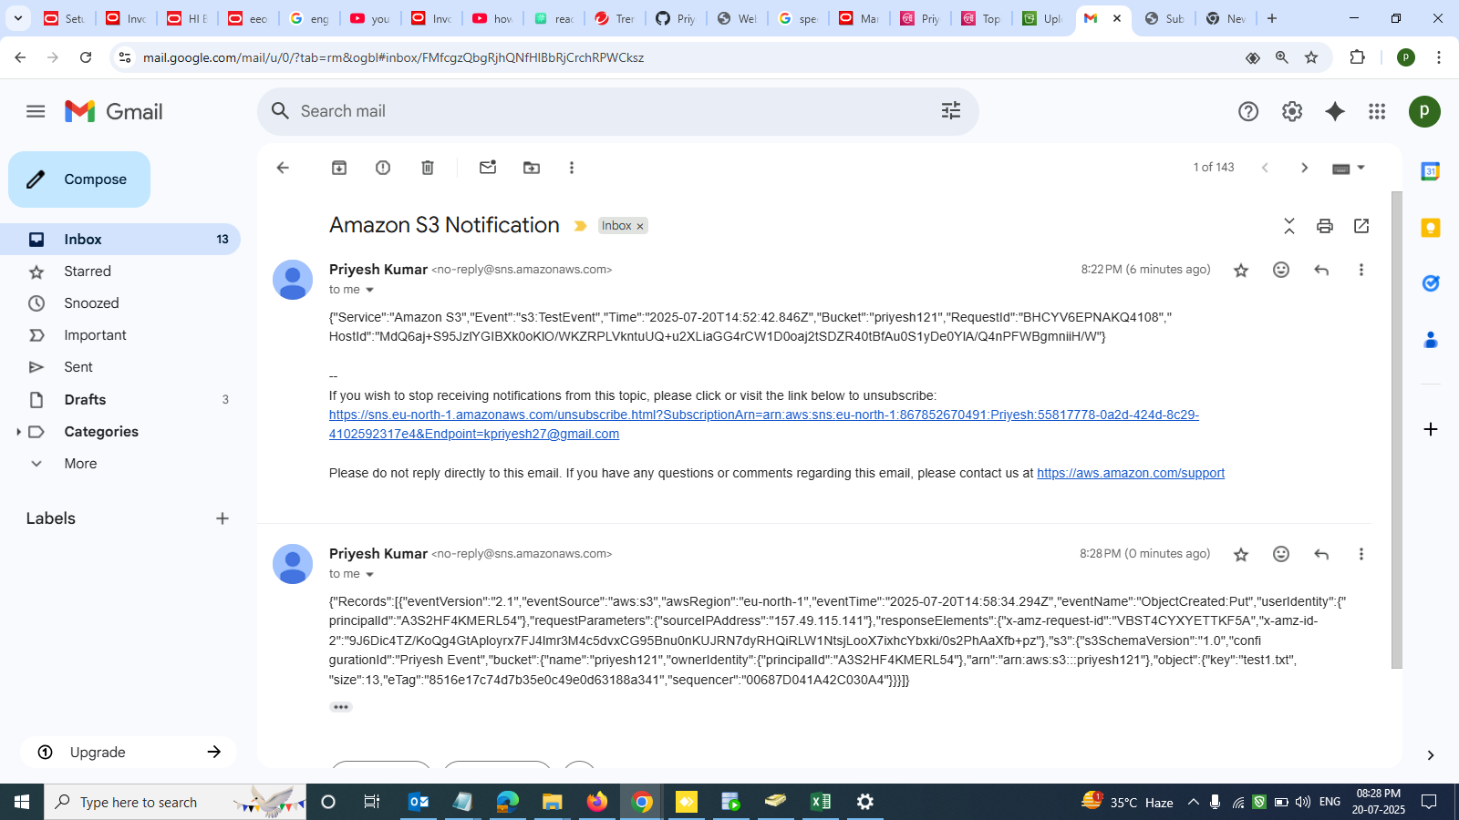

**Thankyou**