Output:

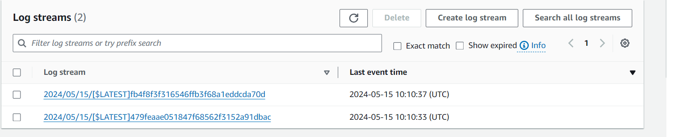

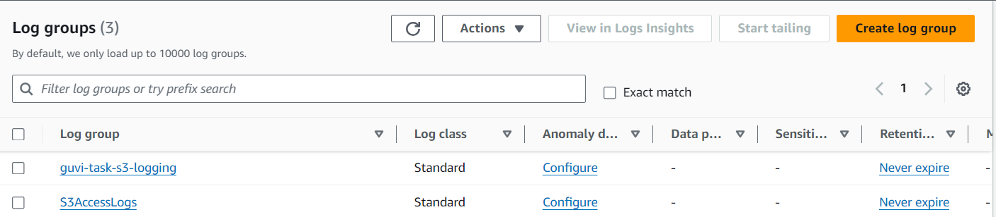

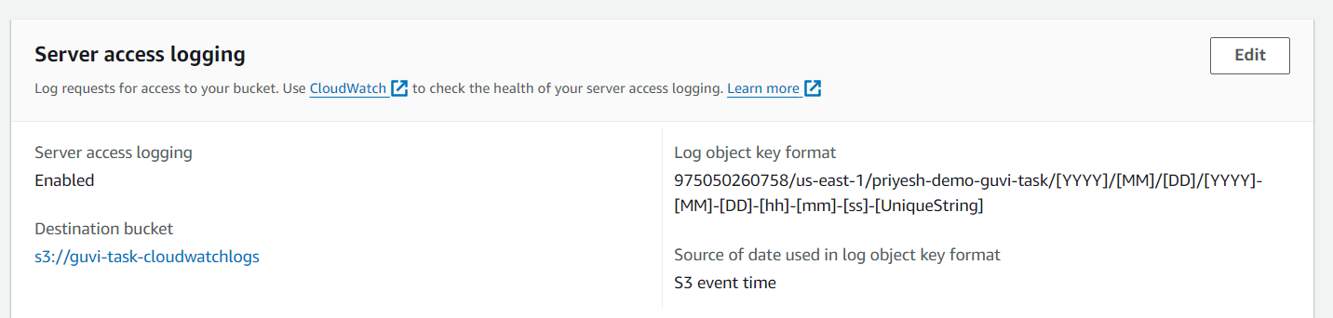

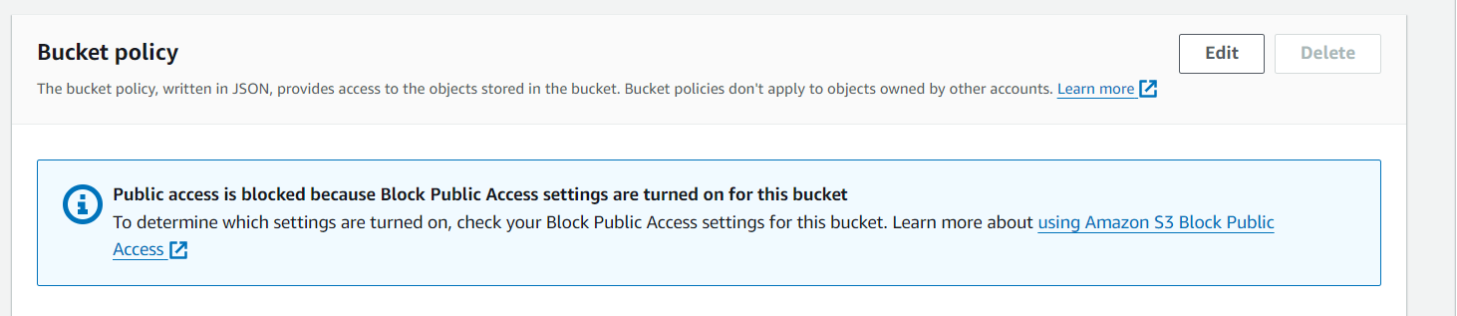

---------------------------------------------------------------------------------------------]-------------------------

Part 2

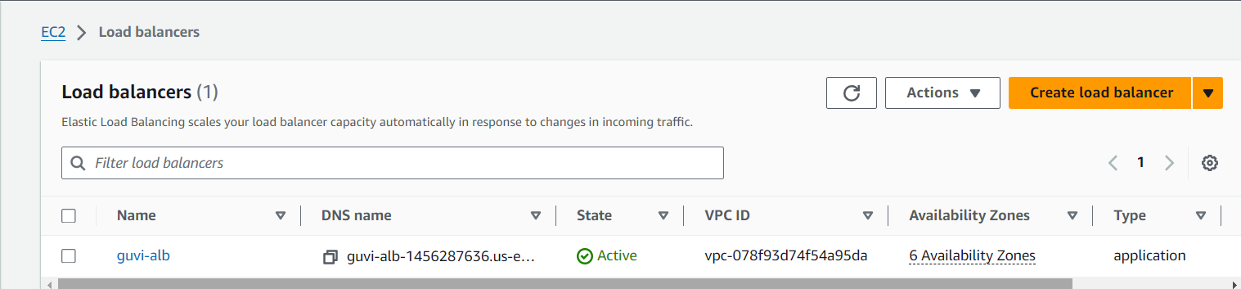

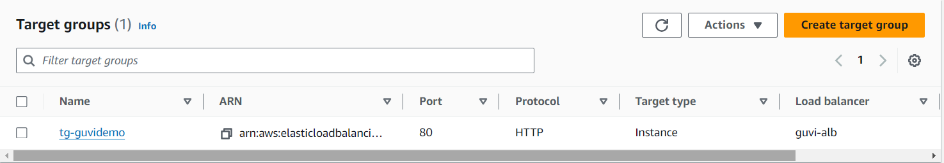

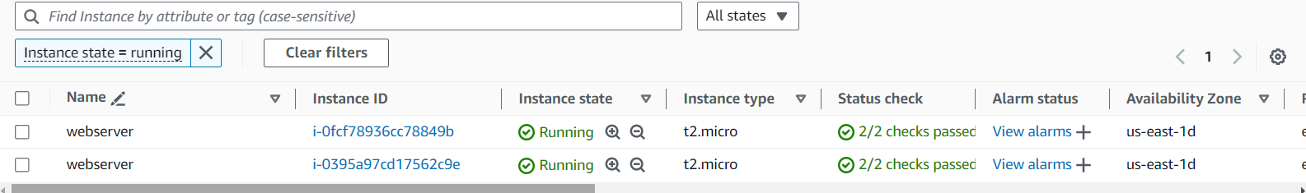

Output: 