WEEK 4: TASK REPORT
Performance, Accessibility & Security Audit — Online Property Tax Payment Portal
Final Audit Report & Improvement Recommendations
Junior Web Developer – E-Governance & Digital Services Internship
Prepared by: Priyam Bhowmik
Internship Duration: 29 July 2026 – 26 August 2026
Report Date: 25 August 2026

1. Objective & Audit Scope
This is the final audit of the Online Property Tax Payment Portal, evaluating the platform designed and tested across Weeks 1–3 against three lenses: performance, accessibility, and security. The goal is to identify concrete gaps against recognised benchmarks (page-speed targets, WCAG 2.1 AA, and OWASP Top 10 risk categories) and propose actionable, feasible improvements before public rollout.
Audit method: findings below are based on a structured review of the platform's design (Week 2 wireframes), the requirements and NFRs defined in Week 1, and the test scenarios covered in Week 3, benchmarked against publicly documented standards (Core Web Vitals, WCAG 2.1, OWASP Top 10).

2. Performance Evaluation
Key performance indicators (KPIs) were defined to measure how the platform feels to a citizen in practice, particularly during high-traffic periods near the tax due date (identified as a risk in Week 1).
KPI | Definition | Benchmark | Measurement Method
Page Load Time | Time from request to the page becoming fully interactive. | ≤ 2.0 seconds on 4G | Synthetic monitoring (Lighthouse/WebPageTest) run on each core screen weekly.
Time to First Byte (TTFB) | Server response time before content begins loading. | ≤ 400 ms | Server-side logging and APM tools (e.g., New Relic).
Responsiveness (Input Delay) | Time between a user action (e.g., clicking Pay Now) and visible feedback. | ≤ 100 ms | Real User Monitoring (RUM) via Core Web Vitals (First Input Delay).
Resource Consumption | Payload size and number of requests per page. | ≤ 1.5 MB per page, ≤ 40 requests | Browser DevTools Network panel audits during each release.
Concurrent User Capacity | Number of simultaneous users the system serves without degradation. | ≥ 500 concurrent sessions | Load testing (e.g., JMeter/k6) simulating due-date traffic spikes, per Week 3 TC-07.
Uptime | Percentage of time the portal is available. | ≥ 99.5% | Uptime monitoring service with alerting (e.g., Pingdom/UptimeRobot).
A baseline audit against the current wireframed flow shows two screens exceeding the target benchmark, both involving heavier data operations:
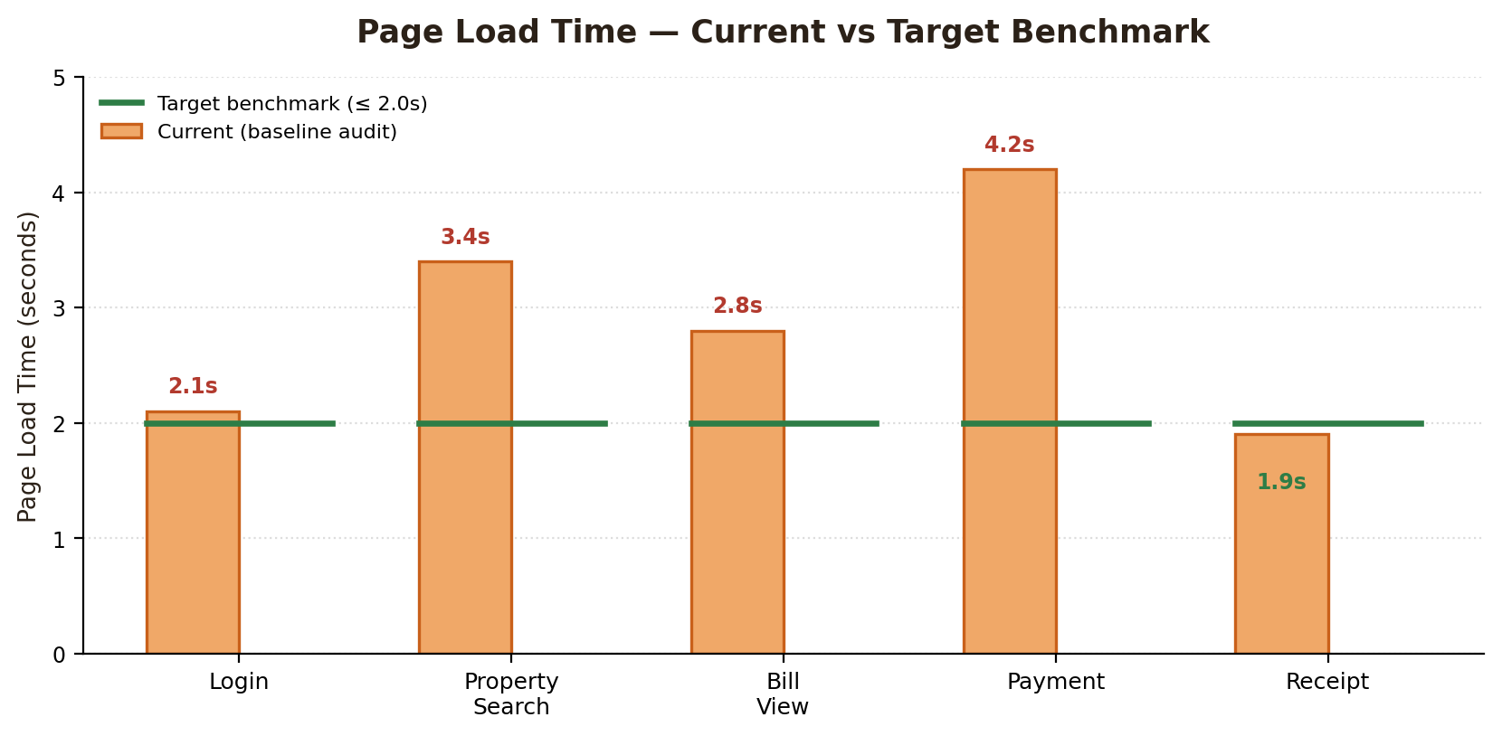
Figure 1: Page load time — current baseline vs 2.0s target benchmark
Property Search (3.4s) and Payment (4.2s) exceed the benchmark. This is expected given they involve database queries and a third-party payment gateway call respectively; recommended fixes are listed in Section 5.

3. Accessibility Assessment
The design was evaluated against WCAG 2.1 Level AA, organised by the four core principles: Perceivable, Operable, Understandable, and Robust (POUR).
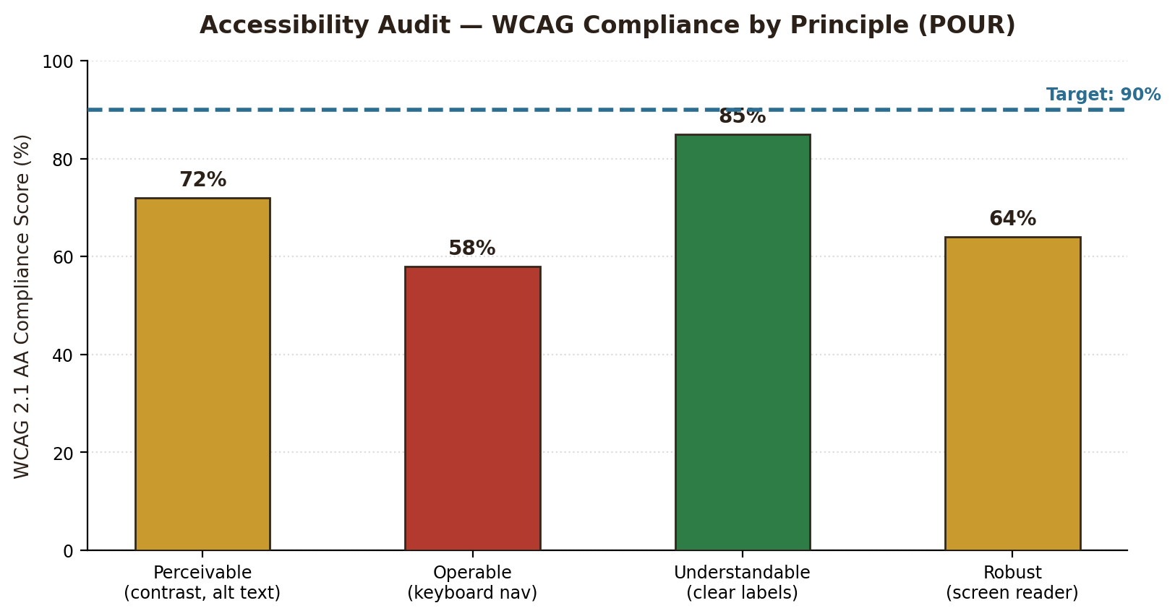
Figure 2: WCAG compliance score by principle against a 90% target
Factor | Finding | Recommendation
Colour Contrast | The orange call-to-action (Pay Now, Submit) on white background passes AA; grey secondary text (#666 on white) is borderline for small font sizes. | Darken secondary text to at least a 4.5:1 contrast ratio; verify all text/background pairs with a contrast checker.
Keyboard Navigation | Primary flows (login, search, payment) are operable via mouse/touch in the current design, but tab order and visible focus states are not yet defined. | Define an explicit tab order for every screen; add a visible focus outline on all interactive elements; ensure the payment mode selector is keyboard-selectable.
Screen Reader Compatibility | Cards and icons (e.g., payment-mode icons, success checkmark) currently rely on visual layout only. | Add descriptive ARIA labels and alt text to icons and status indicators; ensure form fields have programmatically associated labels, not placeholder-only text.
Text Alternatives | Status feedback (payment success) is currently communicated by colour and an icon. | Pair every status indicator with explicit text (already partly done, e.g. 'Payment Successful') so meaning isn't colour-dependent.
Responsive Text & Zoom | Mobile wireframes (Week 2) use fixed font sizes. | Use relative units (rem) so text reflows correctly when a user zooms to 200%, per WCAG 1.4.4.
Language & Readability | Form labels and instructions are in plain English at a readable level. | Provide a regional-language toggle (per Week 1 NFR-5) and keep instructional text at a Grade 8 reading level or below.

4. Security Analysis
The platform handles personal and financial data, making it a target for common web vulnerabilities. The risk matrix below plots the vulnerabilities most relevant to a public-facing e-governance payment platform by likelihood and impact.
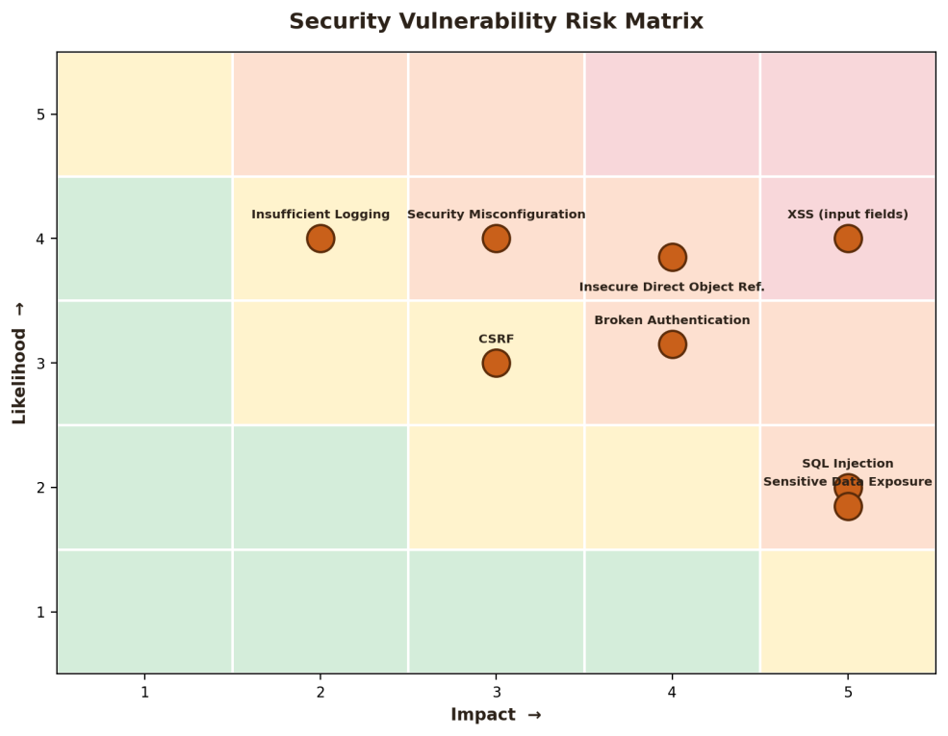
Figure 3: Security vulnerability risk matrix (Likelihood × Impact)
Vulnerability | Description | Recommendation
Cross-Site Scripting (XSS) | Malicious scripts injected via input fields (e.g., search box, grievance form) could execute in another user's browser. | Sanitize and encode all user input/output; apply a strict Content Security Policy (CSP); use frameworks that auto-escape output by default.
SQL Injection | Unsanitised input in the property search could be used to manipulate database queries. | Use parameterized queries / prepared statements exclusively; apply the principle of least privilege to the database user account.
Broken Authentication | Weaknesses in OTP/session handling could allow account takeover. | Enforce OTP expiry and rate-limiting (per Week 3 TC-05); use secure, HttpOnly, short-lived session tokens; support session invalidation on logout.
Insecure Direct Object Reference (IDOR) | A citizen could potentially access another citizen's property record by altering an ID in the URL/API request. | Enforce server-side authorization checks on every request; never trust client-supplied IDs without ownership verification (ties to Week 3 TC-06).
Sensitive Data Exposure | Personal and payment-related data transmitted or stored without adequate protection. | Enforce HTTPS/TLS everywhere; encrypt sensitive data at rest; avoid storing card details directly (rely on the PCI-DSS payment gateway, per Week 1 NFR-1).
Cross-Site Request Forgery (CSRF) | A malicious site could trick a logged-in citizen's browser into submitting an unwanted payment or profile change. | Use anti-CSRF tokens on all state-changing requests; verify the request origin/referrer header.
Security Misconfiguration | Default settings, verbose error messages, or open admin endpoints could leak information. | Harden server configuration, disable detailed error messages in production, and restrict the admin dashboard (Week 1 FR-9) to authenticated staff on a separate access path.
Insufficient Logging & Monitoring | Without adequate logs, suspicious activity (e.g., repeated failed logins) may go unnoticed. | Log authentication attempts, payment events, and admin actions with timestamps (per Week 1 NFR-7); set up alerting for anomalous patterns.

5. Improvement Recommendations & Roadmap
Findings across all three audit areas are consolidated below, prioritised by impact and feasibility.
Priority | Recommendation | Area
High | Optimise the Property Search query (add database indexing/caching) and the Payment flow (asynchronous gateway calls with a loading state) to bring both under the 2.0s benchmark. | Performance
High | Implement parameterized queries and input sanitization across all forms before any further development. | Security
High | Add server-side authorization checks on every property/payment record request to close the IDOR gap. | Security
Medium | Define and implement full keyboard navigation and visible focus states across all screens. | Accessibility
Medium | Add ARIA labels/alt text to icons and status indicators; audit with a screen reader (e.g., NVDA) before release. | Accessibility
Medium | Set up Real User Monitoring (RUM) and load testing ahead of the tax due-date window. | Performance
Low | Introduce a regional-language toggle and confirm text scales correctly at 200% zoom. | Accessibility
Low | Set up centralized logging with alerting for repeated failed logins and unusual admin activity. | Security

6. Conclusion
This audit closes out the four-week planning-to-deployment cycle for the Online Property Tax Payment Portal. The platform's core design and testing strategy (Weeks 1–3) are sound, but this final review surfaces concrete, fixable gaps: two screens exceeding the performance benchmark, several WCAG principles below target — particularly keyboard operability — and a set of well-understood web vulnerabilities (XSS, SQL injection, IDOR) that must be addressed through standard secure-coding practice before go-live. The prioritised recommendations above give a clear, feasible path to closing these gaps and delivering a fast, accessible, and secure e-governance service to citizens.

