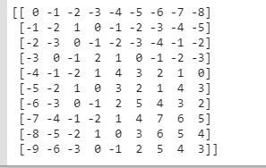

E:\Bio_Informatics\final\assignment3\Capture1.PNG