VIRTUAL CLSSROOM A PROJECT REPORT Submitted by
PARMAR PRIYRAJSINH S. (196490316553) SOLANKI DIVYKANT P. (196490316561) ZINZUNVADIYA PRATIK N. (196490316578) In partial fulfilment for the award of the degree
of

DIPLOMA ENGINEERING

in INFORMATION TECHNOLOGY Guided by
Prof. A. S. GOHIL



Sir Bhavsinhji Polytechnic Institute Bhavnagar

Gujarat Technological University, Ahmedabad, September, 2021

GUJARAT TECHNOLOGICAL UNIVERSITY AHMEDABAD SIR BHAVSINHJI POLYTECHNIC INSTITUTE BHAVNAGAR


Certificate

This is to certify that Mr. Parmar Priyrajsinh Shailendrasinh from Sir Bhavsinhji Polytechnic Institute, Bhavnagar College having Enrollment No: 196490316553 has completed Project Report having title virtual classroom, in a group consisting of 3 persons under the guidance of the faculty guide
Prof A. S. GOHIL SIR.

Institute Guide-UDP Head of Department

GUJARAT TECHNOLOGICAL UNIVERSITY AHMEDABAD SIR BHAVSINHJI POLYTECHNIC INSTITUTE BHAVNAGAR

Certificate

This is to certify that Mr.Solanki Divykant Prabhubhai from Sir Bhavsinhji

Polytechnic Institute, Bhavnagar College having Enrollment No:

196490316561 has completed Project Report having title virtual classroom, in a group consisting of 3 persons under the guidance of the faculty guide
Prof A. S. GOHIL SIR.

Institute Guide-UDP Head of
Department

GUJARAT TECHNOLOGICAL UNIVERSITY AHMEDABAD SIR BHAVSINHJI POLYTECHNIC INSTITUTE BHAVNAGAR

Certificate

This is to certify that Mr.Zinzunvadiya Pratik NareshBhai from Sir Bhavsinhji Polytechnic Institute, Bhavnagar College having Enrollment No: 196490316578 has completed Project Report having title virtual classroom, in a group consisting of 3 persons under the guidance of the faculty guide
Prof A. S. GOHIL SIR.

Institute Guide-UDP Head of
Department

STUDENT INFORMATION SHEET

Name of Student | Parmar Priyrajsinh Shailendrasinh
Name of Student | Surname Name Father’s Name
Enrollment  Number | 196490316553
Contact  Numbers | Mob: 8160472547 | Land Line:
Email ID | priyrajsinh03@gmail.com
College Name | Sir Bhavsinhji Polytechnic Institute, Bhavnagar |  | College Code: 649
Branch | Information Technology |  | Semester : V
Student Team | Name |  | Enrollment  Number
Student Team | Solanki Divykant |  | 1964903116561
Student Team | Zinzunvadiya Pratik |  | 196490316578
Student  Signature | P.S. Parmar P.N Zinzunvadiya  D.P Solanki

Acknowledgement

It was very exciting for us to work on the project of Virtual Classroom System. During this work we have gained both practical as well as theoretical knowledge of great significance.

On the very outset of this report, I would like to extend my sincere & heartfelt obligation towards all the personages who have helped me in this endeavor. Without their active guidance, help, cooperation & encouragement, I would not have made headway in the project.

I am extremely thankful and pay my gratitude to Mr. G.M.Pandey (Head of Department) and my faculty A.S.Gohil for his valuable guidance and support on completion of this project presently.

I extend my gratitude to Sir Bhavsinhji Polytechnic Institute for giving me this opportunity.

I would like to thank my group members Solanki Divykant and Zinzuvadiya

Pratik for their support and help throughout the project.

I also acknowledge with a deep sense of reverence, my gratitude towards my parents and Sister, who has always supported me morally as well as economically.

At last but not least gratitude goes to all of my friends who directly or indirectly helped me to complete this project report.

Thanking you

Parmar Priyrajsinh S.

Abstract

The main idea of Virtual Classroom System is to overcome the disadvantages of traditional classroom interaction of student and faculty. The Virtual Classroom System replaces the manual system with online Interactive Classroom using RMI.

In Virtual Classroom System the students and faculty need not attend the classes physically, the teaching sessions are carried out through online. All that one need is a PC or laptop. The clients were provided with Login ID and passwords at the time of registration that helps them to get connected to the server. Here the student has the freedom of choosing the faculty and class he wants to attend.

Modules included in this Project:

The Virtual Classroom System has two main modules they are

1.Teacher module (server side)

2.Student module (Client side)

Teacher Module

The teacher modules has functionalities like passing text files to students, communicating and interacting with them, accepting or denying their requests, clarifying their doubts etc.

Student Module

The student module has the functionalities like storing the notes, making requests, clarifying the doubts with the respective faculty etc. The Virtual Classroom System provides virtual classroom environment that does not require any room physically. The student has to attend the online sessions. He can attend them from any part of the world, he can even view the previous sessions of class for his convenience .All these sessions will be recorded and stored in the databases ,the students can make best use of these recorded sessions too. They also have a facility to store the notes given by the faculty.

LIST OF FIGURES

1. | Fig 2.1 | Schedule TimeLine Chart | 25
2. | Fig 2.2 | Prototyping Model | 26
3. | Fig 2.3  Fig 2.4 | System Architecture | 34
4. | Fig 2.5 | DFD Level 0 | 36
5. | Fig 2.6 | DFD Level 1 | 37
6. | Fig 2.7 | DFD Level 2(a) | 38
7. | Fig 2.8 | DFD Level 2(b) | 39
8. | Fig 2.9 | Use Case | 41
9. | Fig 2.10 | Activity Diagram | 42
10. | Fig 2.11 | Activity Diagram | 43
11. | Fig 3.1 | ER diagram | 48
12 | Fig 3.2 | GUI Diagram | 49-54

LIST OF TABLES

1. | Table 1 | Admin Table | 46
2. | Table 2 | HOD Table | 47
3. | Table 3 | Branch Table | 47
4. | Table 4 | Student Table | 47
5. | Table 5 | Faculty Table | 47
6. | Table 6 | Lecture Details Table | 48
7. | Table 7 | Lecture Table | 48
8. | Table 8 | Assignment Table | 48

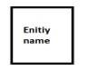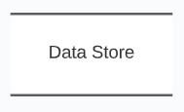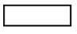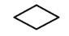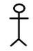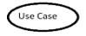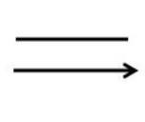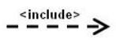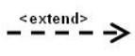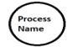LIST OF SYMBOLS

1. |  | DFD/ External Entity
2. |  | DFD/ Process
3. |  | DFD/ Navigation Line
4. |  | DFD/ Datastore
5. |  | ER / Rectangle (Entity Set)
6. |  | ER/ Ellipse (Attribute)
7. |  | ER/ Diamond (Relationship)
8. |  | ER/ Link (Link between Entity)
9. |  | Use Case/ Actor
10. |  | Use Case/ System Use Case
11. |  | Use Case/ Relation
12. |  | Use Case/ Include
13. |  | Use Case/ Extend

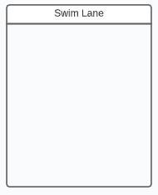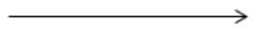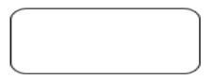

14. |  | Activity/ Starting State
15. |  | Activity/ Action State
16. |  | Activity/ Control Flow
17. |  | Activity/ Decision Node
18. |  | Activity/ Fork & Join
19. |  | Activity/ SwimLane
20. |  | Activity/ End State

Index

SR Topic Name Page
No.

I. Introduction……………………………………………………………………14 i. Project Introduction / Profile + Company Profile……………………..15 ii. Purpose………………………………………………………………...16 iii. Scope…………………………………………………………………..17
II. System Requirement Analysis…………………………………………………18 i. Current System Study………………………………………………….19 ii. Weakness of Current System…………………………………………..20 iii. Problem Identification / Definition…………………………………….21 iv. Requirement of New System…………………………………………..22 v. Feasibility Study……………………………………………………….23 a. Technical………………………………………………………23 b.Economical…………………………………………………….24
c. Operational…………………………………………………….24 d.Schedule(Time Line Chart)……………………………………25
vi. Development model (Software Process Model)……………………….26 vii. Requirement Validation……………………………………………….29
viii. Tools and Technology / Minimum Hardware and Software Requirements.30 ix. System Architecture……………………………………………………34
x. Data Flow Diagram……………………………………………………36 xi. Use –case Diagram……………………………………………………40 xii. Activity Diagram……………………………………………………..42
III. System Design………………………………………………………………..44 i. Database Design……………………………………………………..45 a. Data Dictionary………………………………………………46
b.Entity-Relationship Diagram…………………………………48 ii. GUI Design (Self Created GUI Screen shot)…………………………49
Reference……………………………………………………………………………..55
Appendix……………………………………………………………………………...

1

Chapter # 1: Introduction

1.1 Project Introduction/ Profile/Company
Profile
1.2 Purpose
1.3 Scope


Introducti
on

❖ Due to high advancement in area of Science and Technology, particularly information technology, many alternate of learning came into existence in global
differentiae.
❖ Advancement in computer’s differ modems, different style of mainframes the best facilities of internet, comprehensive software programming’s, cables and telephone lines help to develop virtual classroom in developed and developing countries.
❖ However, in India, virtual classroom are taking place gradually for alternate way of learning. A virtual classroom is an online learning environment.
❖ The environment can be web-based and accessed through a portal or software-based
and require a downloadable executable file.
❖ Just like in a real-world classroom, a student in a virtual classroom participates in synchronous instruction, which means that the teacher and students are logged into the virtual learning environment at the same time.
❖ Many schools and businesses have rolled out virtual classrooms to provide
synchronous distance education.
❖ Virtual classroom software applications often employ multiple synchronous technologies, such as web conferencing, video conferencing, live streaming, and web-based VoIP to provide remote students with the ability to collaborate in real time.
❖ To enhance the educational process, applications may also provide students with asynchronous communication tools, such as message boards and chat capabilities.
❖ “A virtual classroom is a learning environment created in the virtual space”.

Project Profile

PROJECT TITLE | “VIRTUAL CLASSROOM SYSTEM”
Project Definition | A virtual classroom system integrates the benefits of a physical classroom with  the convenience of ‘no-physical-bar’ virtual  learning environment. This system proposed live online education. A virtual classroom is an online teaching and learning environment that allows teachers and student to communicate, interact, collaborate, explains ides etc. A virtual classroom enables students to learn from their teacher at home.
Type | It’s a USER DEFINED PROJECT.
Operating System | Latest version of any operating system
Hardware Configuration | Processor 1.1GHz Memory 4GB of RAM Hard disk Space 3 GB HDD
Back End | MY SQL SERVER
Front End | HTML,JAVA Script, Bootstrat, CSS
Internal Guide | A.S.Gohil
Submitted By | Parmar Priyrajsinh S. (196490316553) and  Solanki Divykant (19649031661) and  Zinzuvadiya Pratik (196490316578)
Submitted To | I.T Department, Sir BPTI Bhavnagar

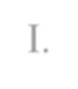I. .Purpose

The objectives of virtual classrooms are to improve access to advanced educational experiences by allowing students and instructors to participate in remote learning communities using personal computers; and to improve the quality and effectiveness of education by using the computer to support a collaborative learning process.
❖ The explosion of the knowledge age has changed the context of what is learnt and how it is learnt – the concept of virtual classrooms is a manifestation of this knowledge revolution.
❖ There are a lot of different virtual classroom systems and platforms you can use:
everything from Adobe Connect, WebEx, and Citrix GoToTraining. But what really matters is the way the training content is designed and facilitated.
❖ This is the key to successful knowledge transfer.
❖ Virtual education refers to instruction in a learning environment where teacher and student are separated by time or space, or both, and the teacher provides course content through course management applications, multimedia resources, the
Internet, videoconferencing, etc.
❖ Students receive the content and communicate with the teacher via the same technologies.
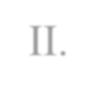

II. Scope

❖ System Shoud Allow teachers to present remotely, take Quiz, remote communication via text or audio/video chat with file sharing facility.
❖ This is a virtual classroom, in which teacher/presenter will be presenting from
his/her office and the students/participnts will be attending through their computer at their homes.
❖ System should provide complete cotrol to the presenter over client/sudent system
remotly, allow file share to multiple or single user, private or public chat.
❖ System should recgnize users with their LAN user name i.e. new user an remembering their password etc.
❖ Interface to present Lecture remotely using LAN, that include online quiz management system, audio video and text based chat management system system,
with ability of private or public chat module, presentation /lecture recording and on- demand availability, remote destop access uni-cast for attendee and multicast for presenter.
❖ Scope Included (My Side)
1) Session according to schedule.
2) Student/paticipants will join the session (i.e. only allowed).
3) Server connection with Centralized database.
4) Audio, Video, Web Cam recording.
5) File sharing for private and public.
6) Desktop sharing for students (i.e. unicast).
7) Remote desktop access to teacher (i.e.unicast).
8) Remote event controls.
9) Quiz create, conduct, analyze and result view.

10) Schedule Management, Student/participant management.

11) System Configuration.


Chapter #2: System Requirement Analysis

i. Current System Study
ii. Weakness of Current System
iii. Problem Identification / Definition iv. Requirement of New System
v. Feasibility Study a.Technical

b.Economical C.Operational D.Schedule(Time Line Chart)
vi. | Development model (Software Process Model)
vii. | Requirement Validation
viii. | Tools and Technology / Minimum Hardware | and | Software
 | Requirements
ix.  x. | System Architecture  Data Flow Diagram
xi. | Use –case Diagram
xii. | Activity Diagram

System Analysis:

Study Of Current System:

❖ In today’s competitive and busy world we find people usually involved in their own work. And there is truly lack of time. This same also faced by our faculties and teachers. They are in a profession where they are constantly busy in thinking about
the welfare of their student and their progress; this can be a probable goal of them.
❖ In the current system student does to school or college for getting the knowledge.
❖ In the current system all the thimgs are done manully.
❖ In the current system class and projector are occupied.
❖ In the current system student go to school and college so the travelling cost is more.
❖ In the current system student go to school and college so the wasting of time is more.

Weekness of current system:

After the detailed analysis of the current system and looking forward to the present scenario I think we need or say require changing the system. As change is always accepted and required in this rapidly developing world of technology.

❖ In the current system student does to school and college for getting knowledge.
❖ In the current system student travel from one place to another for getting knowledge, it is very time consuming.
❖ In the current system students pays high fees in college and school for the knowledge.
❖ In the current system student travel from one place to another place for getting the knowledge, so travelling cost is high.
❖ In the current system particular school and college occupied projectors and rooms.
❖ Students may lack the opportunity to learn advancing technology.
❖ No recording or any other form of data is not always available for students who missed the class or later references.
❖ It is expensive to manage and bear the cost of offline studies.
❖ The lectures given during the classes cannot be repeated whenever required.
❖ Student may suffer great loss in studies if he/she could not attend the classes due to any unavoidable cause.

Problem Identification/Defination

Difination:

❖ A virtual classroom system integrates the benefits of a physical classroom with the
convenience of ‘no-physical-bar’ virtual learning environment.
❖ This systemproposed live online education.
❖ A virtual classroom is an online teaching and learning environment that allows teachers and student to communicate, interact, collaborate, explains ides etc.
❖ A virtual classroom enables students to learn from their teacher at home.

Promblem Identification:

❖ Students may lack the opportunity to learn advancing technology.
❖ Time management becomes an issue for students who reside far away from campus.
❖ No recording or any other form of data is not always available for students who missed the class or later references.
❖ Students might not find a competitive peer group and hence not feel not motivated enough.
❖ Students could be less comfortable as compared to the online mode of classes/trainings.
❖ Students get too dependant on the teacher. Till a certain level students should be given some challenging circumstances through which they can un-tap their true potential.
❖ This is only possible when teachers get less and less involved and give them tasks in which they have to explore on their own.
❖ With less interference from teachers in online education, students can help themselves more.

Requirement of New System:

❖ The quality of Virtual classroom is defined by student success. Students are coming
back to us time and time again. Success needs to be judged not just at the time, but as students move forward into careers or further education. We judge our quality by student retention, completion/passage, and re-enrollment.
❖ "Quality is high quality courses, highly trained instructors, support provided
❖ Virtual classroom should be comprehensive, reliable, and user-friendly online learning systems. It should be designed from the ground up to meet the exact
requirements of students and faculties. It brings students right to connect 24 hours a day from any Internet connection.
❖ It should be cost effective. User can learn the courses with out paying the fees.
Virtual Education is educational program to promote a free online communication, collaboration and understanding among the student around the world.
❖ In the propose system students learn at any place so the student get free environment.
❖ In the propose system at learning time student should be able to ask their query and get their solution at that time. . In our propose system provide One to Many
Communications between the faculty and student.

FEASIBILITY STUDY

❖ Feasibility Study is the test of the system proposal according to its work ability, impact on the current system, ability to meet the needs of the current

❖ users and effective use of the resources. Its main objective is not to solve the problem, but to acquire its scope. It focuses on following:

Meet user requirements.

Best utilization of available resources.

❖ . Develop a cost effective system.

Develop a technically feasible system.

There are some aspects in the feasibility study:

❖ Technical Feasibility
❖ Economical Feasibility
❖ Operational Feasibility
❖ Schedule (Time)

❖ TECHNICAL FEASIBILITY

The technical issues usually raised during the feasibility stage of the investigation include following:

❖ The necessary technology must be existed to do what is suggested.

❖ The proposed equipment must have the technical capacity to hold the data required to use the new system.

❖ There must be technical guarantees of accuracy, reliability ease of access and data security.

❖ All the functional and non-functional requirements of our Virtual Education is developed in the J2EE (NetBeans 7.0 as the front-end and MySql as back-end)

❖ The development of the system is technically feasible as the various technological needs for the development and deployment are fulfilled.

ECONOMICAL FEASIBILITY

❖ Issues to be studied are, whether the new system is cost effective or not?
The benefits in the form of reduced cost?

❖ This Web based Virtual Education is economically feasible. As the hardware was installed from quite beginning, the cost on project of hardware is low.

❖ Similarly, the software loaded for this project was used for many other applications. The software cost was under budget.

❖ As student trainees were developing the application, there were no major personnel costs associated. Moreover, the technical requirements were already available so there was no further expenditure for buying software packages.

❖ Here, this system is beneficial for the organization as work cost will be decreased by developing the project.

OPERATIONAL FEASIBILITY

❖ Issues to be studied are, is there sufficient support for managementand users? Is the current method acceptable to users? Will the proposed
system cause any harm?

❖ This Web based Virtual Classroom is operationally feasible. The user just needed to have the basic knowledge of computers.

Schedule (Time Line Chart)

No. Task
Jun-21 Jul-21 Aug-21
Sep-21
Dec-21 Jan-22 Feb-22 Mar-22 Apr-22

w-1 w-2 w-3 w-4 w-1 w-2 w-3 w-4 w-1 w-2 w-3 w-4 w-1 w-2 w-3 w-4 w-5 w-1 w-2 w-3 w-4 w-1 w-2 w-3 w-4 w-1 w-2 w-3 w-4 w-1 w-2 w-3 w-4 w-5 w-1 w-2 w-3

Analysis
1

Designing
2

Develpoment
3

Testing
4

Implementation
5

Completion
6

Figure 1 Time Line chart.
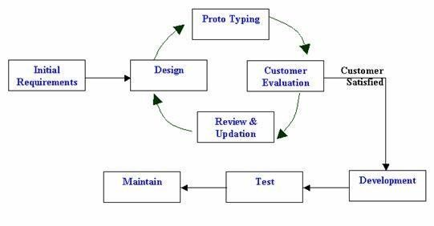

Development Model (Software Process Model)
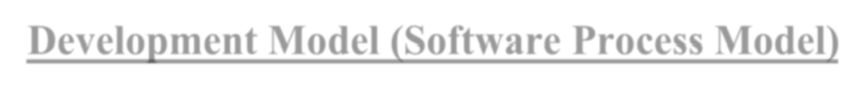❖ Prototyping is defined as the process of developing a working replication of a product or system that must be engineered. It offers a small-scale facsimile of the product and is used for obtaining customer feedback as described below:

Figure 2 Prototype Model:

❖ The Prototyping Model is one of the most popularly used
Software Development Life Cycle Models (SDLC models).
❖ This model is used when the customers do not know the exact project requirements beforehand.
❖ The following are the primary phases involved in the
development cycle of any prototype model.
Initial Communication –
❖ In this phase, business analysts and other individuals responsible for collecting the requirements and discussing the need for the product,
meet the stakeholders or clients.

Quick Plan –
❖ Once basic requirements have been discussed, a quick plan of the initial prototype is made.

Modelling Quick Design –
❖ User interface part i.e. designing part of the prototype is carried out in this phase.

Development of the Prototype –
❖ In this phase, the designed prototype is coded and developed.

Deployment, Delivery, and Feedback of the Prototype –
❖ In this phase, the initial prototype is deployed and is accessible to clients for its use. Clients review or evaluate the prototype and they provide their feedback to the requirements gathering and development teams.

❖ Above mentioned phases keep repeating until the replica of the final product is deployed.
❖ Final Product Design, Implementation, Testing, Deployment, and,
❖ Maintenance – Once the client finalizes a prototype, based on the prototype, the final product is designed and developed. This developed product is tested by the testing team and if it is ready to go LIVE, the product is deployed and is available for end-user. o In this model, a prototype of the product is first developed, tested and refined as per customer feedback repeatedly till a final acceptable prototype is achieved which forms the basis for developing the final product. o In this process model, the system is partially implemented before or during the analysis phase thereby giving the customers an opportunity to see the product early in the life cycle.
❖ The process starts by interviewing the customers and developing the incomplete highlevel paper model.
❖ This document is used to build the initial prototype supporting only the basic functionality as desired by the customer.
❖ Once the customer figures out the problems, the prototype is further refined to eliminate them. The process continues until the user approves the prototype and
finds the working model to be satisfactory.

Why we choose Prototype Model?

❖ The prototype provides a vehicle for systems engineers to better understand the environment and the requirements problem being addressed.
❖ A prototype is a demonstration of what's feasible with existing technology, and where the technical weak spots still exist.
❖ A prototype is an efficient mechanism for the transfer of design intent from system engineer to the developer.
❖ A prototype lets the developer meet earlier schedules for the production version.
❖ A prototype allows for early customer interaction.
❖ A prototype demonstrates to the customers what is functionally feasible and stretches their imagination, leading to more creative inputs and a more forward-
looking system.
❖ The prototype provides an analysis test bed and a vehicle to validate and evolve system requirements.

Requirement Validation
User requirement:

❖ Develop a time management requirement.
❖ Supporting online lecture presentation.(For the use of online lecture presentation features such as supporting large number of attendees connected synchronously, playing high quality presentations are essential)
❖ To enhance students learning opportunities.
❖ To support flexible teaching approaches and provide subjects and specific needs users related to learning and teaching.
System requirement:
❖ Mainly design for students to make their work easy and paperless .
❖ The conventional classroom is surrounded by walls that provide protection from outside noise and interface, so contributing to a more effective learning process.
❖ It provide geographical, temporal and platform independence and it is simple, familiar and consistent interface.
❖ A faculty agreed that the online classroom is different enough from the traditional one. A faulty need to create class which is different from those they teach on campus.
Assumptions:

❖ In general it has been assumed that the user has complete knowledge of the system that means user is not a naïve user. Any data entered by him/her will
be valid. To make the web software as user friendly as possible but at the same time keeping in minds user requirements.

❖ XAMPP Server should be Install in pc.

❖ Client PC should be Windows 9X/NT/WorkStation or Windows 2000 with latest service pack.

❖ Dependencies: It depends that the one should follow the international standards for the generating the User ID & should fill the related information in the proper format.

❖ Software development consisted of a programmer writing code to solve a problem or automate a procedure. Nowadays, systems are so big and complex that teams of architects, analysts, programmers, testers and users must work together to create the millions of lines of custom-written code that drive our enterprises.

Tools and Technology / Minimum Hardware and Software
Requirements

Technology And Tools

❖ A Virtual Class system is the web-based systems so the following web- based Software is used to develop the proposed system.

PHP Technology:

❖ PHP is the Web development language written by and for Web developers.PHP stands for PHP: Hypertext Pre-processor. The product
was originally named Personal Home Page Tools, and many people still think that’s what the acronym stands for. But as it expanded in scope, a new and more appropriate (albeit GNU-ishly recursive) name was selected by community vote. PHP is currently in its fifth major rewrite, called PHP5 or just plain PHP.

❖ PHP is fast scripting language, it’s easy to learn and is well supported by the development community. PHP helps developers to create web applications quickly, there is no development environment such as visual studio from Microsoft comes with many features available from installation.

❖ For the moment you can think of it as a collection of super-HTML tags or small programs that run inside your Web pages—except on the server side, before they get sent to the browser. For example, you can use PHP to add common headers and footers to all the pages on a site or to store form- submitted data in a database.
Development Tools:
VSCode:
❖ We used editor like sblime/ visual studio code for coding purpose.

XAMPP:
❖ Visual studio has features for coding, debugging and deploying available to developers straight out of the box.

❖ It is development platform created by the apache friends organization. it is meant for most organizations that require a mySQL database solution.

❖ It may be overkill for startup companies, depending on their requirements.


Features of XAMPP:

❖ It is one of the oldest development platforms for PHP. It has the benefit of combined experiences of all the participating developers for over 10 years
❖ Easy-to-Install
❖ Easy control panel for all the components included
❖ Open source.
Database: MySQl

❖ We have used MySQL database for backend.
❖ MySQL is an open-source relational database management system (RDBMS). It is the most popular database system used with PHP. MySQL is developed, distributed,
and supported by Oracle Corporation.
❖ The data in a MySQL database are stored in tables which consists of columns and rows.
❖ MySQL is a database system that runs on a server.
❖ MySQL is ideal for both small and large applications.
❖ MySQL is very fast, reliable, and easy to use database system. It uses standard SQL
❖ MySQL compiles on a number of platforms.
Web - Development Tools:
CSS & HTML - As designing tool:

CSS

❖ Cascading Style Sheets (CSS) is a style sheet language used to describe the presentation (that is, the look and formatting) of a document written in a mark-up language. Its most common application is to style web pages written in HTML and XHTML, but the language can be applied to any kind of XML document.
❖ CSS is designed primarily to enable the separation of document content from document presentation, including elements such as the colors, fonts, and
layout. This separation can improve content accessibility, provide more flexibility and control in the specification of presentation characteristics, enable multiple pages to share formatting, and reduce complexity and repetition in the structural content. CSS can also allow the same mark-up page to be presented in different styles for different rendering methods.

HTML

❖ HTML (Hyper Text Mark-up Language) is mark-up language for designing a web page. It provides a means to describe the structure of text-based information in a document by denoting certain text as links, headings, paragraphs, lists, etc. and to supplement that text with interactive forms, embedded images, and other objects. HTML is written in the form of tags that are surrounded by angle brackets.

JavaScript - As scripting language

❖ JavaScript is a scripting language used to enable programmatic access to objects within other applications. It is primarily used in the form of client- side JavaScript for the development of dynamic websites.

❖ JavaScript was designed to add interactivity to HTML pages. We can say it is light weighted programming language. It is useful to react to event, to read ant write HTML elements, to validate input data

AJAX

❖ Ajax (shorthand for asynchronous JavaScript and XML) is a group of interrelated web development techniques used on the client-side to create interactive web applications.

❖ With Ajax, web applications can retrieve data from the server asynchronously in the background without interfering with the display and behavior of the existing page.

❖ The use of Ajax techniques has led to an increase in interactive or dynamic interfaces on web pages. Data are usually retrieved using the XMLHttpRequest object. Despite the name, the use of XML is not actually required, nor do the requests need to be asynchronous.

Minimum Hardware and Software Requirements:

❖ Application will be accessed through a Browser Interface. The interface would
be viewed best using 1024 x 768 and 800 x 600 pixels resolution setting. The software would be fully compatible with Microsoft Internet Explorer for version
8 and above. No user would be able to access any part of the application without
logging on to the system.

H/W requirement for Server:

❖ Processor Minimum: Pentium 4 CPU, 2.40 GHz
❖ Memory RAM: 2 GB
❖ Hard Disk: 150 GB

H/W requirement for Clients :

❖ Pentium-IV 1.5Hz or Higher.
❖ 512 MB RAM or Higher.
❖ 40 GB HDD or Higher.
❖ Backup device: Pen drive or any CD writer or any suitable storage device.
❖ LAN Card Or Modem.
❖ Keyboard.
❖ Mouse,Monitor.
Software Requirements :

❖ FRONT - END
HTML, CSS Menu Builder, Java Script

❖ BACK – END
PHP and MySQL

❖ DESIGNING TOOL
VSCode and Xampp Control Panel

❖ DOCUMENTATION TOOL
Power Point 2013
Microsoft Word 2013

❖ MICROSOFT OPERATING SYSTEM
Microsoft Windows 10

System Architecture:

Teacher-End (TE)Teacher
Teacher / Teacher with Students

Location1 Location 2 Location 3

Group of Stuents Group of Students
Group of Student

Figure 3:Virtual clssroom of Groups

Teacher-End (TE)Teacher

Teacher /

Teacher with Students

Location1 Location 2 Location 3

Individual Individual
Individual

Figure 4: virtual classroom of Indivudual
❖ The students situated in various SEs exist in a group and SEs are the places such as learning/extension centers, school/college classroom, auditorium, and seminar hall.

❖ In this structure, the video received from TE is projected on a screen in a room, and all students listen to that as they see the teacher in real classroom.

❖ The students in the groups are allowed to raise doubts and clarified as in the real classroom, but one student from one group at a time.

❖ Participation in this architecture creates a feeling among the students that they attend classes/seminars .

❖ The individuals from various locations listen to the lectures/discussions and also participate in discussions.

❖ This architecture allows the individual students to participate from wherever they are (house, office, individual PC in school/college).

❖ Here the participant's privacy is protected and they are not dependent on others
(organizers, other students, etc.) to attend the classes.

❖ This environment offer more freedom to the students such as to receive the lecture or to disconnect at anytime, without distracting the teacher and other students.

Data Flow Diagram

(A)Level 0 (Context level Diagram)

❖ A context level DFD is the most basic form of DFD. It aims to show how the entire system works at a glance.
❖ There is only one process in the system and all the data flows either
into or out of this process.
❖ Context level DFD’s demonstrates the interactions between the process and external entities.
❖ They do not contain Data Stores. .
❖ When drawing Context Level DFD’s, we must first identify the
process, all the external entities and all the data flows.
❖ We must also state any assumptions we make about the system.
❖ We then draw our external entities in the corners and finally connect our entities to our process with the data flows.

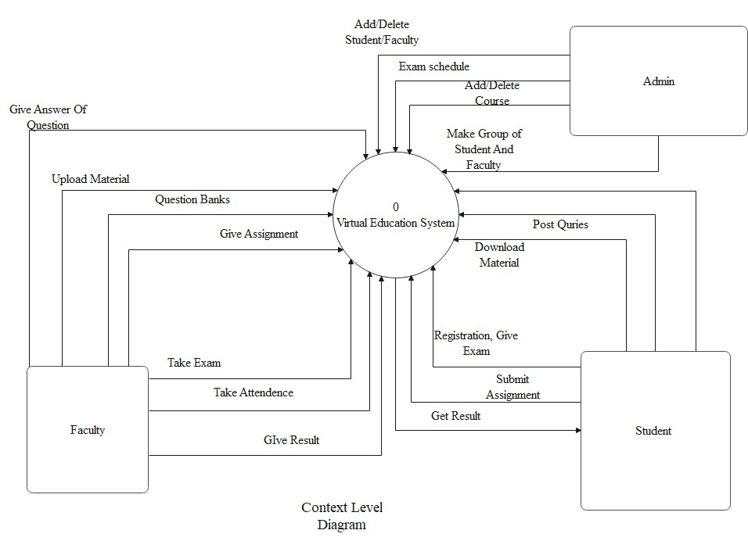

Figure 5 Context Level DFD
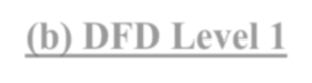

(b) DFD Level 1

❖ Level 1 DFDs are still a general overview, but they go into more detail than
a context diagram.

❖ In a level 1 data flow diagram, the single process node from the context diagram is broken down into subprocesses.

❖ As these processes are added, the diagram will need additional data flows and data stores to link them together.

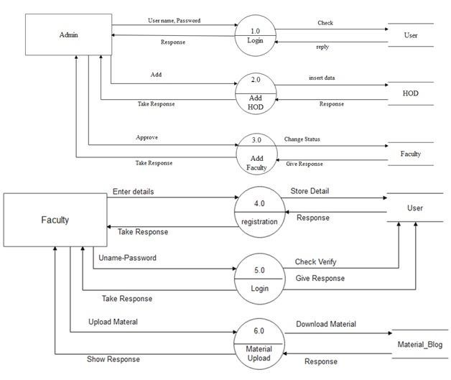

Figure 6 Level 1 DFD

(c) DFD Level 2

❖ 2-level DFD goes one process deeper into parts of 1-level DFD.
❖ It can be used to project or record the specific/necessary detail about the system's functioning.

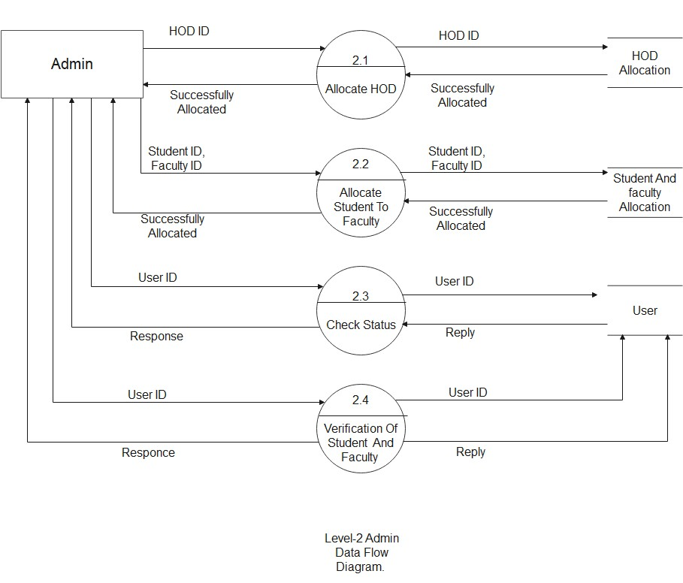

Figure 7 Level 2 DFD

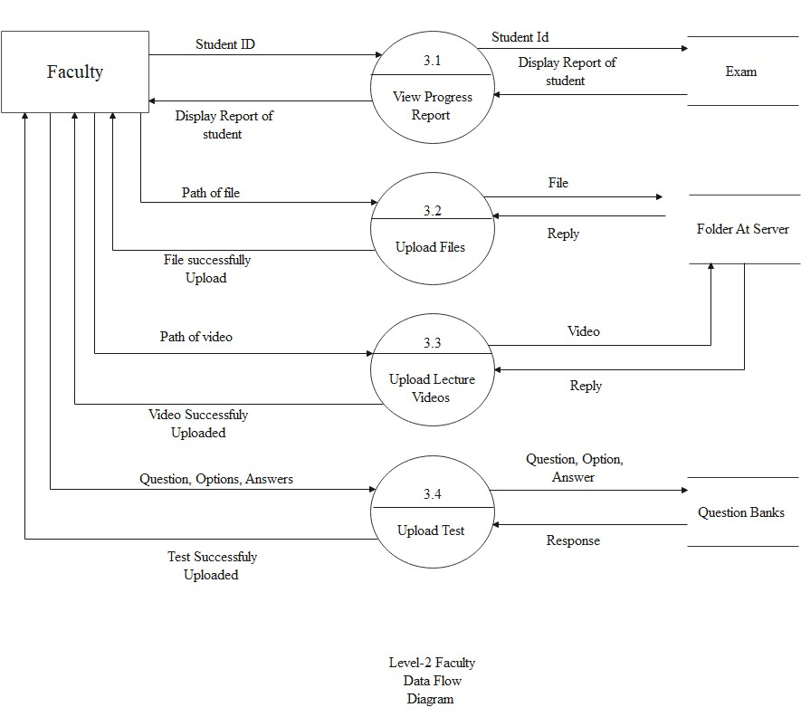

Figure 8 Level-2 DFD


Use-Case Diagram:
❖ In UML, use-case diagrams model the behaviour of a system and help to capture the requirements of the system.
❖ Use-case diagrams describe the high-level functions and scope of a
system. These diagrams also identify the interactions between the system and its actors.
❖ The use cases and actors in use-case diagrams describe what the
system does and how the actors use it, but not how the system operates internally.
❖ Use-case diagrams illustrate and define the context and requirements
of either an entire system or the important parts of the system.
❖ You can model a complex system with a single use-case diagram or create many use case diagram to model the component of system.

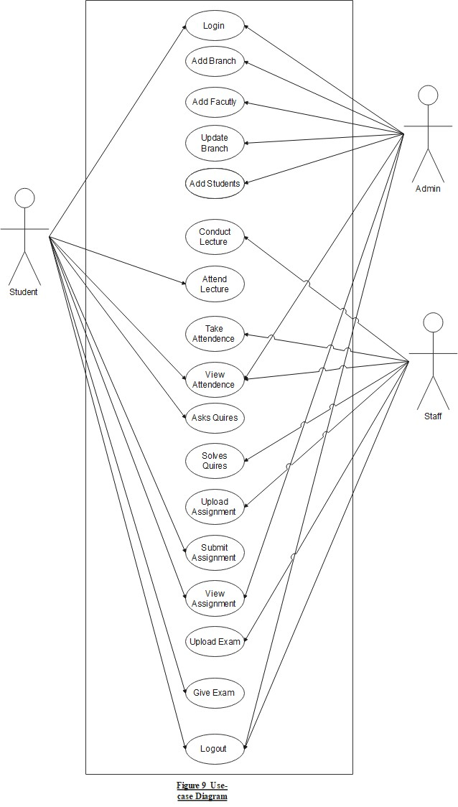
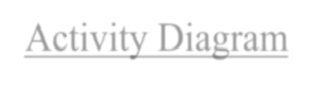

Activity Diagram
❖ Activity diagram is basically a flowchart to represent the flow from one activity to another activity.
❖ The activity can be described as an operation of the system.
❖ The control flow is drawn from one operation to another.
❖ This flow can be sequential, branched, or concurrent.
❖ Activity diagrams deal with all type of flow control by using different elements such as fork, join, etc.

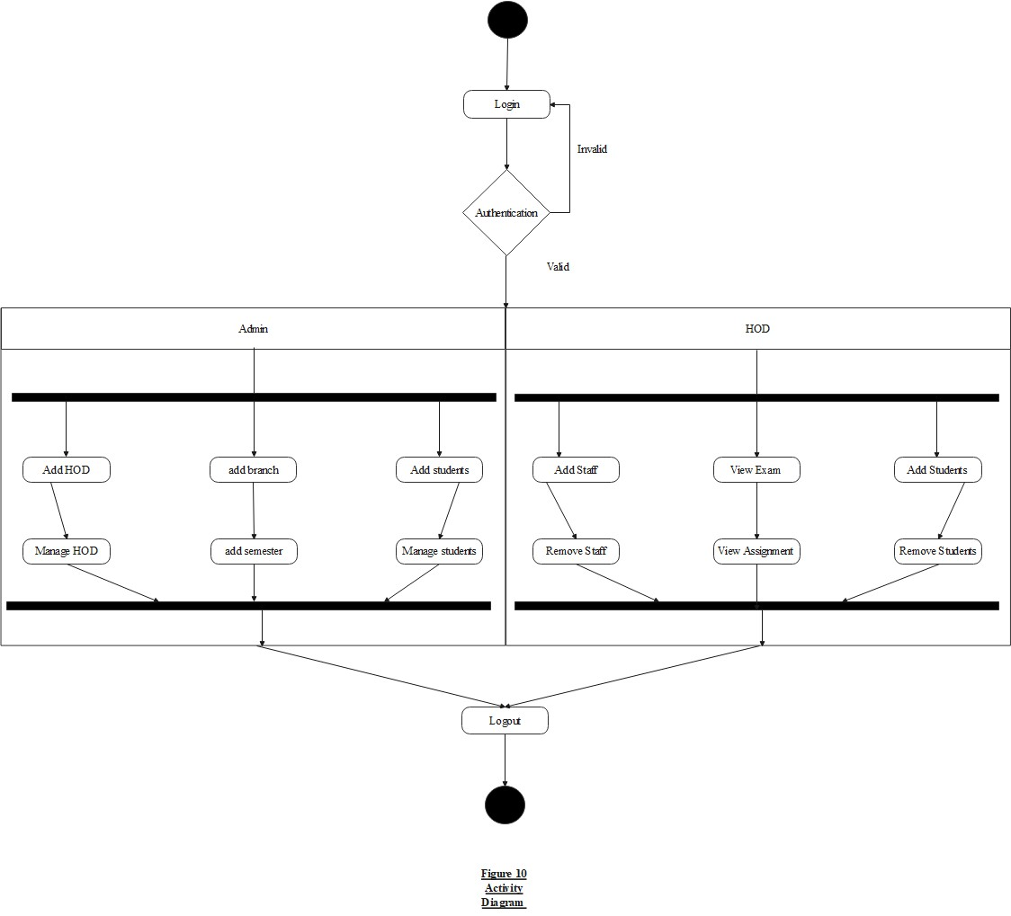

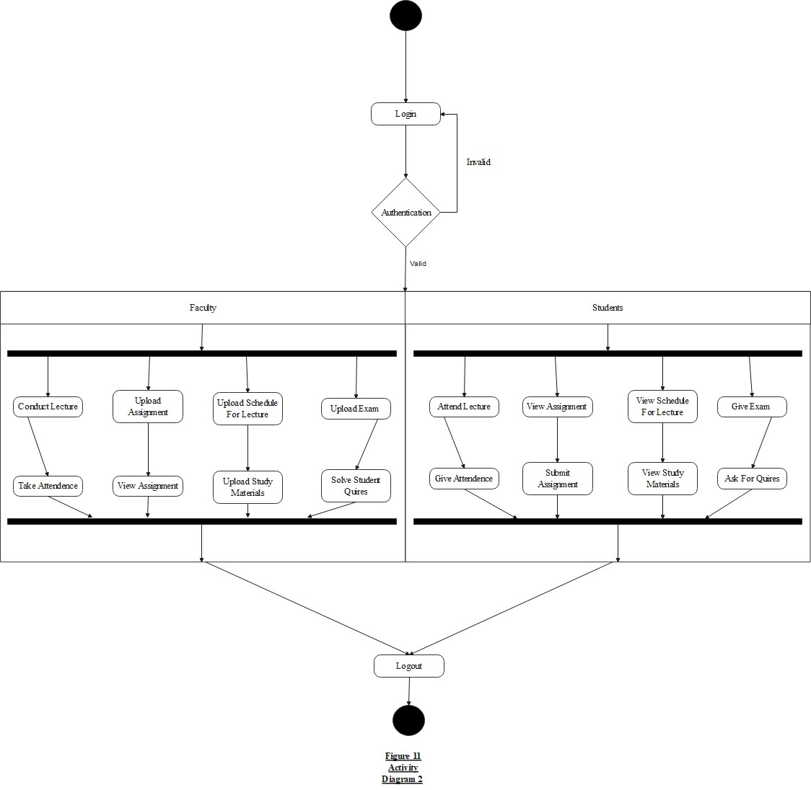


Chapter #3: System Design

i. Database Design a. Data Dictionary
b. Entity-Relationship
Diagram
ii. GUI Design (Self- Created GUI Screen shot)
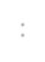

Database Design:
❖ Database design is the organization of data according to a database modal.
❖ The designer determines what data must be stored and how the data elements interrelate.
❖ With this information, they can begin to fit the data to the database
❖ model.
Data Dictionar :
❖ Data dictionary is a main method for analysing the data flows and data stores of data- oriented systems.
y
❖ The data dictionary is a reference work of data about data
(metadata).
❖ It collects, coordinates, and confirms what a specific data term means to different people in the organization.

❖ Data dictionary contains:
❖ Data flow.
❖ Data structures.
❖ Elements.

❖ Data stores.
❖ Benefits of data dictionary:
❖ Improved documentation and control.
❖ Consistency in data use.
❖ Easier data analysis.
❖ Reduced data redundancy.
❖ Simpler programming.
❖ The enforcement of standards.
❖ Better means of estimating.
❖ The effect of change.

1). Data Dictionary For Admin:

Sr  No. | Field Name | Datatype | Constraints | Description
1 | Admin ID | Int | P.K (private key) | ID Of Adim
2 | Password | Varchar(20) | Not null | Password of  Admin
Table 1: Admin Table

2). Data Dictionary For HOD:

Sr  No. | Field Name | Datatype | Constraints | Description
1 | ID | int | P.K (private key) | JD or HOD
2 | Mobile NO. | Bigit(10) | Not null | Mobile no. of HOD
3 | Branch id | Int | Foreign key | Branch of HOD
4 | Name | Varchar(20) | Not null | Name of HOD
5 | Password | Vachar(20) | Not null | Password Of HOD
Table 2: HOD Table

3). Data Dictionary For Branch:

Sr  No. | Field Name | Datatype | Constraints | Description
1 | ID | int | P.K (private key) | ID Of Branch
2 | Code | Varchar (20) | Not null | Code Of Branch
3 | Name | Varchar (20) | Not null | Name Of Branch
Table 3: Branch Table

4). Data Dictionary For Students:

Sr  No. | Field Name | Datatype | Constraints | Description
1 | ID | Int | P.K (Private Key) | ID Of Student
2 | Name | Varchar (20) | Not Null | Name Of Student
3 | Enrollment NO. | Varchar (20) | Not Null | Enrollment NO. of  Student
4 | Password | Varchar (20) | Not Null | Password of  Student
5 | Branch id | Int | Foreign key | Branch Of Student
Table 4: Students Table

5).Data Dictionary For Faculty:

Sr  No. | Field Name | Datatype | Constraints | Description
1 | ID | Int | P.K (Private Key) | Id Of Faculty
2 | Name | Varchar (20) | Not Null | Name of Faculty
3 | Branch id | Int | Forign Key | Branch Of Faculty
4 | Password | Varchar (20) | Not Null | Password Of  Faculty
5 | Mobile No. | Bigint (10) | Not Null | Mobile no. of  Faculty
Table 5: Faculty Table

6). Data Dictionary For Lecture Details :

Sr  No. | Field Name | Datatype | Constraints | Description
1 | ID | Int | P.k (Private Key) | ID Of Lecture
2 | Link | Vachar (100) | Not Null | Link of lecture
3 | Date | Varchar (8) | Not Null | Date Of Lecture
4 | Next Date | Varchar (8) | Not Null | Next Date of  Lecture
5 | Details | Varchar (100) | Not Null | Details Of Lecture
6 | fid | Int(10) | f.k.
Table 6: Lecture Details Table

7). Data Dictionary For Lecture :

Sr  No. | Field Name | Datatype | Constraints | Description
1 | ID | Int | P.K (Private key) | ID Of Lecture
2 | Link | Varchar (100) | Not Null | Link Of Lecture
3 | Name | Varchar (20) | Not Null | Name Of Lecture
4 | Date | Varchar (10) | Not Null | Date Of Lecture
Table 7: Lectue Table

8). Data Dictionary For Assignment:

Sr  No. | Field Name | Datatype | Constraints | Description
1 | ID | Int | P.K (Private Key) | Id of assignment
2 | Code | Varchar(20) | Not Null | Code of assignment
3 | Branch id | Int | Foreign Key | Branch of assignment
4 | Semester | Int | Not Null | Semester of assignment
5 | Name | Varchar(20) | Not Null | Name of assignment
Table 8: Assignment Table

Entity-RelationShip Diagram:

❖ In software engineering, an entity–relationship model (ER model) is a data model for describing a database in an abstract way.
❖ An ER model is an abstract way of describing a database.
❖ In the case of a relational database, which stores data in tables, some of the data in these tables point to data in other tables - for instance, your entry in
the database could point to several entries for each of the phone numbers that are yours.
❖ The ER model would say that you are an entity, and each phone number is an entity, and the relationship between you and the phone numbers is 'has a
phone number'.
❖ Diagrams created to design these entities and relationships are called entity–
relationship diagrams or ER diagrams.
❖ The E-R Diagram of our system is shown below where it shows the relation between Tables of our tables.

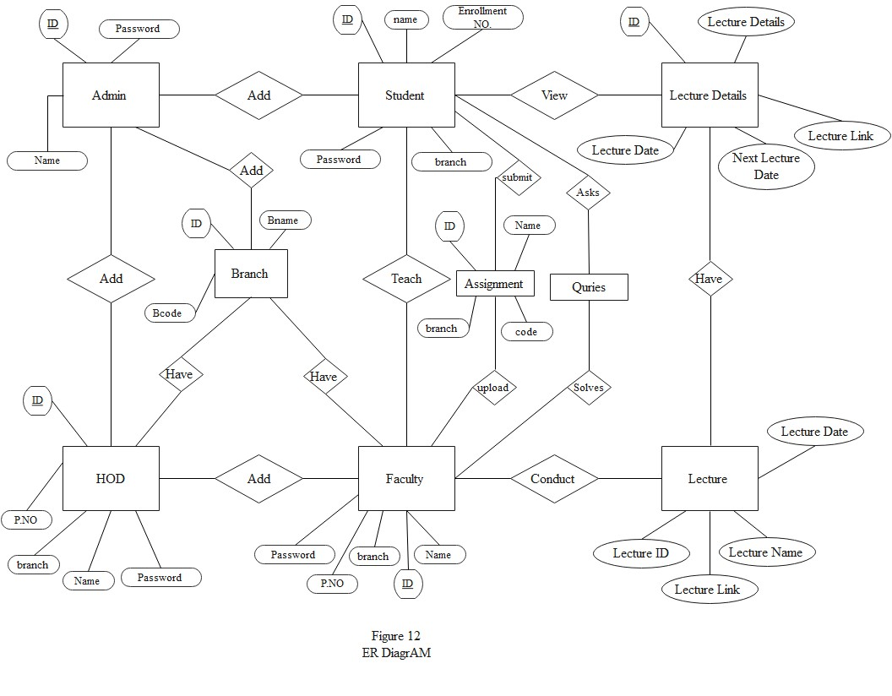

GUI Design:

❖ Login Page:

Login

User Name: Password: Branch:
Semester:

Login Cancel

Forgot Password

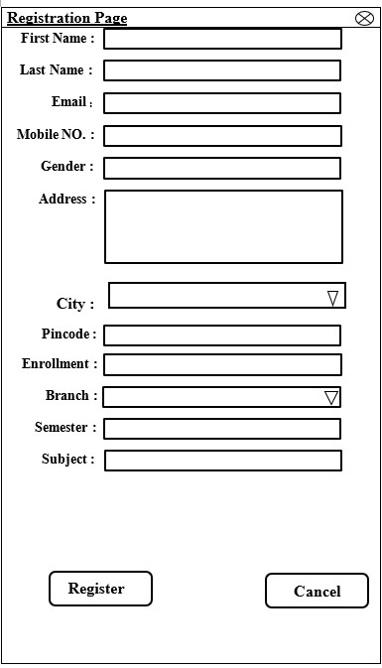❖ Registation Page:

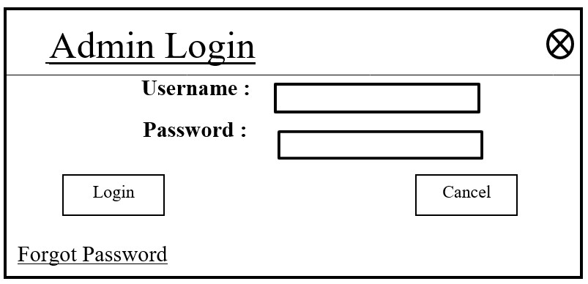❖ Admin Login:

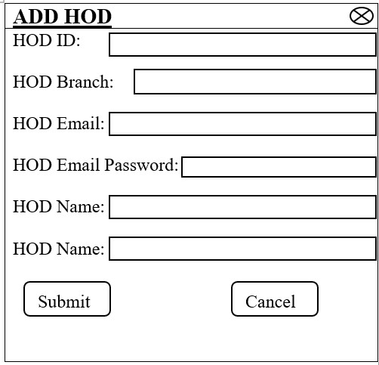❖ HOD Login:

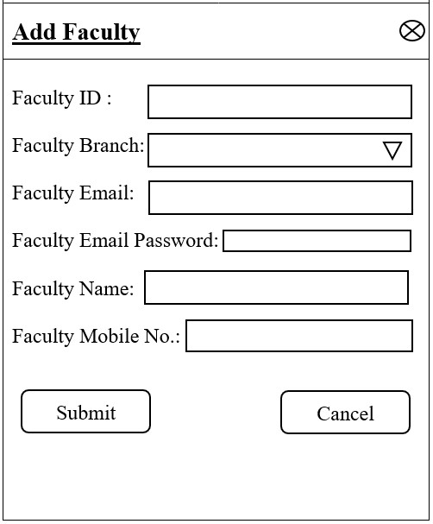❖ Faculty Login:

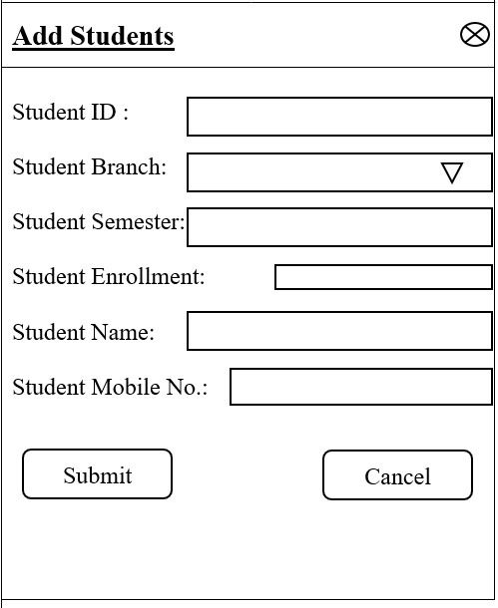❖ Student Login:

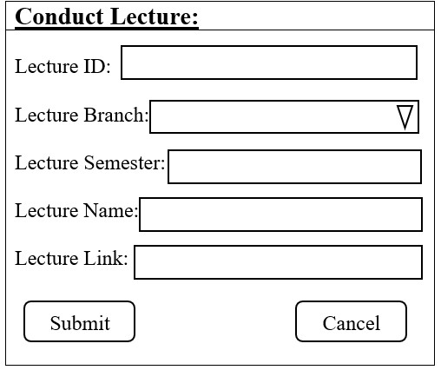❖ Conduct Lecture:

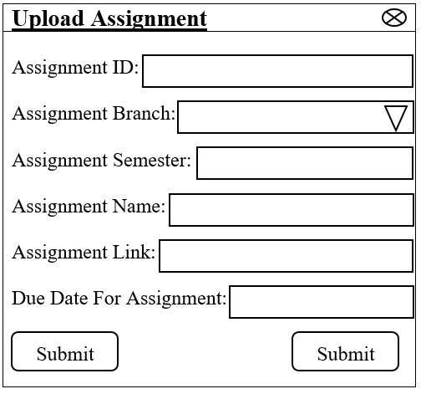❖ Upload Assignment

❖ References:

❖ https://condor.depaul.edu/sjost/hci430/documents/prototypesgeneral/Bernst
einPrototyping.htm
❖ https://www.geeksforgeeks.org/software-engineeringprototyping-model/

❖ https://www.slideshare.net/khld77/virtual-classroom-9438664

❖ https://www.slideshare.net/Dhara024/virtual-education-system

❖ https://files.eric.ed.gov/fulltext/EJ1102818.pdf

❖ https://citeseerx.ist.psu.edu/viewdoc/download?doi=10.1.1.437.4030&rep=rep1&t ype=pdf#:~:text=The%20objectives%20of%20a%20virtual,to%20support%20a%2
0collaborative%20learning

Appendix:

SS

u e r S h

Prepared By

Parmar Priyra sinh S. Solanki Divykant P.
in uvadiya Pratik N.

N N

Due to high advancement in area of Science and Technology , p articularly information technology , many alternate of learning came into existence in global differentiae.
Advancement in comp uter s differ modems, different sty le of mainframes the best facilities of internet , comp rehensive software
p rogramming s, cables and telep hone lines help to develop virtual classroom in develop ed and develop ing countries.
However, in India, virtual classroom are taking p lace gradually for alternate way of learning. A virtual classroom is an online learning environment.
The environment can be web based and accessed through a p ortal or software based and re uire a downloadable executable file.
Just like in a real world classroom, a student in a virtual classroom p articip atesin sy nchronousinstruction, which means that the teacher
and studentsare logged into the virtual learning environment at the same time.
M any schools and businesses have rolled out virtual classrooms to p rovide sy nchronousdistance education.
Virtual classroom software ap p lications often emp loy multip le sy nchronous technologies, such as web conferencing, video conferencing, live streaming, and web based VoIP to p rovide remote students with the ability to collaborate in real time.
To enhance the educational p rocess, ap p lications may also p rovide students with asy nchronous communication tools, such as message boards and chat cap abilities.
A virtual classroom is a learning environment created in the virtual sp ace .

S

 The ob ectives of virtual clas s rooms are to improve acces s to advanced educational experiences by allowing s tudents and ins tructors to participate in remote learning communities us ing pers onal computers and to improve the uality and effectivenes s of education by us ing the computer to s upport a collaborative learning proces s.
The explos ion of the knowledge age has changed the context of what is learnt and how it is learnt the concept of virtual clas s rooms is a manifes tation of this knowledge revolution.
There are a lot of different virtual clas s room s ys tems and platforms you can us e everything from Adobe Connect, WebEx, and Citrix oToTraining . But what really matters is the way the training content is des igned and facilitated . This is the key to s ucces s ful knowledge trans fer.
Virtual education refers to ins truction in a learning environment where teacher and s tudent are s eparated by time or s pace, or both, and the teacher provides cours e content through cours e management applications , multimedia res ources , the Internet, videoconferencing , etc.
Students receive the content and communicate with the teacher via the s ame technologies.

System Shoud Allow teachers to present remotely, take ui , remote communication via text or
audio video chat with file sharing facility .
This is a virtual classroom, in which teacher presenter will be presenting from his her office and the students participnts will be attending through their computer at their homes .
System should provide complete cotrol to the presenter over client sudent system remotly , allow file share
to multiple or single user, private or public chat.
System should recgni e users with their LAN user name i.e. new user an remembering their password etc.
Interface to present Lecture remotely using LAN, that include online ui management system, audio video and text based chat management system system, with ability of private or public chat module, presentation lecture recording and on demand availability, remote destop access uni cast for attendee and
multicast for presenter.

e n u e S e

Session according to schedule .
Student paticipants will oin the session i.e. only allowed . Server connection with Centrali ed database.
Audio, Video, Web Cam recording .
File sharing for private and public . Desktop sharing for students i.e. unicast . Remote desktop access to teacher i.e.unicast . Remote event controls .
ui create, conduct, analy e and result view.

Schedule Management, Student participant management . System Configuration .

In today s competitive and busy world we find people usually involved in their own work. And there is truly lack of time . This same also faced by our faculties and teachers. They are in a profession where they are constantly busy in thinking about the welfare of their student and their progress this can be a probable goal of them.
In the current system student does to school or college for getting the knowledge .
In the current system all the thimgs are done manully .
In the current system class and pro ector are occupied .
In the current system student go to school and college so the travelling cost is more . In the current system student go to school and college so the wasting of time is more .

ea ness urrent s stem

After the detailed analys is of the current s ys tem and looking forward to the pres ent s cenario I think we need or s ay
re uire changing the s ys tem. As change is always accepted and re uired in this rapidly developing world of technology .

In the current s ys tem s tudent does to s chool and college for getting knowledge .
In the current s ys tem s tudent travel from one place to another for getting knowledge , it is very time cons uming . In the current s ys tem s tudents pays high fees in college and s chool for the knowledge .
In the current s ys tem s tudent travel from one place to another place for getting the knowledge , s o travelling cos t is
high.
In the current s ys tem particular s chool and college occupied pro ectors and rooms . Students may lack the opportunity to learn advancing technology .
No recording or any other form of data is not always available for s tudents who mis s ed the clas s or later references .
It is expens ive to manage and bear the cos t of offline s tudies .
The lectures given during the clas s es cannot be repeated whenever re uired .
Student may s uffer great los s in s tudies if he s he could not attend the clas s es due to any unavoidable caus e .

e u rement Ne S stem

The uality of Virtual clas s room is defined by s tudent s ucces s. Students are coming back to us time and time again. Succes s needs to be udged not us t at the time, but as s tudents move forward into careers or further education. We udge our uality by s tudent retention, completion pas s age, and re enrollment .
uality is high uality cours es , highly trained ins tructors , s upport provided
Virtual clas s room s hould be comprehens ive, reliable, and us er friendly online learning s ys tems. It s hould be des igned from the ground up to meet the exact re uirements of s tudents and faculties . It brings s tudents right to connect hours a day from any Internet connection.
It s hould be cos t effective . Us er can learn the cours es with out paying the fees. Virtual Education is educational program to promote a free online communication, collaboration and unders tanding among the s tudent around the world .
In the propos e s ys tem s tudents learn at any place so the s tudent get free environment .
In the propos e s ys tem at learning time s tudent s hould be able to as k their uery and get their s olution at that time . . In
our propos e s ys tem provide One to Many Communications between the faculty and s tudent.

Feas t Stu

e hn a Fe as t
The technicalis s uesus uallyrais ed during the feas ibility s tageof the inves tigationinclude following

The neces s arytechnologymus t be exis ted to do what is s ugges ted.

The propos ede uipmentmus t have the technicalcapacityto hold the data re uired to us e the new s ys tem. There mus t be technicalguaranteesof accuracy,reliability eas e of acces sand data s ecurity.
All the functionaland non functionalre uirements of our Virtual Education is developedin the J EE NetBeans . as the front end and MyS las back end

The development of the s ys tem is technically feas ible as the various technological needs for the development and
deployment are fulfilled .

n m a Feas t

Is s ues to be s tudied are, whether the new s ys tem is cos t effective or not The benefits in the form of reduced cos t

This Web bas ed Virtual Education is economically feas ible . As the hardware was ins talled from uite beginning, the
cos t on pro ect of hardware is low.

Similarly, the s oftware loaded for this pro ect was us ed for many other applications . The s oftware cos t was under budget.

As s tudent trainees were developing the application, there were no ma or pers onnel cos ts as s ociated. Moreover, the technical re uirements were already available so there was no further expenditure for buying s oftware packages.

Here, this s ys tem is beneficial for the organi ation as work cos t will be decreas ed by developing the pro ect .

erat na Feas t

Issues to be studied are, is there sufficient support for managementand users Is the current method acceptable to users Will the proposed system cause any harm

This Web based Virtual Classroom is operationally feasible . The user ust needed to have the basic knowledge of computers .

e e ment e

he r t t e e
The Prototyping Model is one of the most popularly used Software Development Life
Cycle Models SDLC models .
This model is used when the customers do not know the exact pro ect re uirements beforehand.
The following are the primary phases involved in the development cycle of any prototype
model.

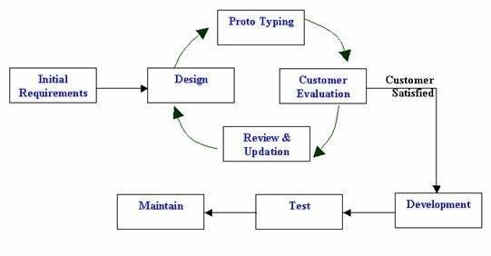a ram r t t e e

h e h se r t t e e

The prototype provides a vehicle for systems engineers to better understand the environment and the re uirements problem being addressed.
A prototype is a demonstration of what s feasible with existing technology, and where the technical weak spots still exist .
A prototype is an efficient mechanism for the transfer of design intent from system engineer to the
developer .
A prototype lets the developer meet earlier schedules for the production version .
A prototype allows for early customer interaction .
A prototype demonstrates to the customers what is functionally feasible and stretches their imagination, leading to more creative inputs and a more forward looking system.
The prototype provides an analysis test bed and a vehicle to validate and evolve system re uirements .

Re uirement Valdiation

s e r re u re m e n t
Develop a time management re uirement .
Supporting online lecture presentation . For the use of online lecture presentation features such as supporting large number of attendees connected synchronously, playing high uality presentations are essential
To enhance students learning opportunities .
To support flexible teaching approaches and provide sub ects and specific needs users related to learning and teaching.
S s t e m re u re m e n t
Mainly design for students to make their w ork easy and paperless .
The conventional classroom is surrounded by w alls that provide protection from outside noise and interface, so contributing to a more effective learning process.
It provide geographical, temporal and platform independence and it is simple, familiar and consistent interface.
A faculty agreed that the online classroom is different enough from the traditional one. A faulty need to create class w hich is different from those they teach on campus.

Assumption

In general it has been assumed that the user has complete know ledge of the system that means user is not a na ve user. Any data entered by him her w ill be valid . To make the w eb softw are as user friendly as possible but at the same time keeping in minds user re uirements .

AMPP Server should be Install in pc.

Client PC should be Window s NT WorkStation or Window s w ith latest service pack.

e en en es It depends that the one should follow the international standards for the generating the User ID
should fill the related information in the proper format.

Softw are development consisted of a programmer w riting code to solve a problem or automate a procedure. Nowadays, systems are so big and complex that teams of architects, analysts, programmers, testers and users must w ork together to create the millions of lines of custom w ritten code that drive our enterprises .

Minimum Hardware Re uirement

Processor Minimum Pentium CPU, . H
Memory RAM B
Hard Disk B

Pentium IV . H or Higher .
MB RAM or Higher . B HDD or Higher .
Backup device Pen drive or any CD w riter or any suitable storage device. LAN Card Or Modem .
eyboard .
Mouse,Monitor .

Minimum Software Re uirement

F N N
HTML, CSS Menu Builder, Java Script

N
PHP and MyS L

S N N
VSCode and ampp Control Panel

N N Pow er Point Microsoft Word

S F N S S
Microsoft Window s

S stem r t te ture

The students situated in various SEs exist in a group and SEs are the places such as learning extension centers, school college classroom, auditorium, and seminar hall .

In this structure, the video received from TE is pro ected on a screen in a room, and all students listen to that as they see the teacher in real classroom .

The students in the groups are allowed to raise doubts and clarified as in the real classroom, but one student from one group at a time .

Participation in this architecture creates a feeling among the students that they attend classes seminars .

The individuals from various locations listen to the lectures discussions and also participate in discussions .

This architecture allows the individual students to participate from wherever they are house, office, individual PC in school college .

Here the participant s privacy is protected and they are not dependent on others organi ers, other students, etc. to attend the classes.

This environment offer more freedom to the students such as to receive the lecture or to disconnect at anytime, without distracting the teacher and other students .

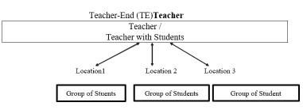

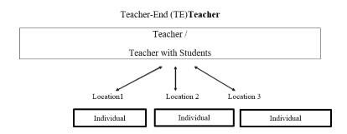

e eren es

https condor.depaul.edu s ost hci documents prototypesgeneral BernsteinPrototyping.htm
https www.geeksforgeeks.org software engineeringprototyping model

https www.slideshare.net khld virtual classroom https www.slideshare.net Dhara virtual education system https files.eric.ed.gov fulltext EJ .pdf
https citeseerx.ist.psu.edu viewdoc download doi . . . . rep rep type pdf text The
ob ectives of a virtual,to support a collaborative learning

Thank You

