**PROJECT NAME:EARTHQUAKE PREDICTION MODEL USING PYTHON  
 SUBMITTED BY:S.S PRIYA  
MAIL ID:**radhisasikumar2004@gmail.com  
  
**AIM:**

* Collecting data on past earthquakes, geological features, and other relevant factors such as seismic activity, temperature, humidity, and atmospheric pressure.
* Preprocessing the collected data to remove noise or inconsistencies.
* Developing machine learning models such as decision trees, random forests, and neural networks to predict earthquake likelihood and timing.
* Training and testing the models on split data sets to evaluate accuracy and performance.
* Optimizing the models by adjusting hyperparameters to improve accuracy and performance.
* Validating the results by comparing predicted earthquake locations and magnitudes against actual earthquake data using statistical measures.
* Collaborating with other researchers in the field to share data, models, and results for standardization and validation.
* Participating in peer review processes to ensure accuracy and reliability of predictions.
* Continuously updating and improving the system with new data and techniques.
* Implementing the system in real-world scenarios to help prepare for and mitigate the impact of earthquakes.

**ABSTRACT:**

An earthquake is shaking of the surface of the

Earth, which caused as the result of movable plate boundary

interactions .Earthquakes are measured using remarks from

seismometers with Richter magnitude scale. Ground rupture,

Landslides, Soil liquefaction and Tsunami are the main

effects created by earthquakes. Today's earthquake warning

systems used to provide regional notification of an

earthquake in progress. Many methods have been already

developed for predicting the time and place in which

earthquakes will occur, but it did not predicted using big data

analytics. This journal know that the Standard Deviation to

identify next earthquake happening from tons of international

geological survey data using data analysis in pandas &

matplotlib framework. It's the top-level component of all the

ones that you will consider in the following point current

location shakes per minute. Other than above mentioned

features separate pandas and matplot function implemented

to analyze sheer number of earthquakes per day. Final result

shows which location suffered from maximum number of

shakes and priority of earthquake occurrence location and

Time.

**INTRODUCTION:**

Today, big data analytics is one of the most booming markets.

When Google search engine launched image search feature,

it had indexed more than 300 million images. In every minute

so many video content are uploaded in YouTube update their

wall in every minute. Search engines logging 600 million

queries daily. There are different data centers where people

can store vast amount of data, such as IBM Server, EMC

Server etc. On the other hand AWS (Amazon Web Services)

provide a host of services to store, process and analyze the

data at scale in a cost effective manner. Big data term refers

collection of large datasets that are distributed, multidimensional and complex that it becomes difficult to processing on hand traditional data processing applications.

**PROBLEMS IN EARTHQUAKE PREDECTION :**

especially when analyzing large datasets. If the computer or server As an AI language model, I do not have personal experience with Python or earthquake prediction. However, there are some common issues that can arise when using Python for earthquake prediction:

1. Lack of data: The accuracy of earthquake prediction depends on the amount and quality of data available. If there is not enough data or if the data is incomplete, inaccurate, or biased, the predictions may not be reliable.

2. Complexity of models: Earthquake prediction requires complex mathematical models and algorithms that may be difficult to implement in Python. This can lead to errors in the code or incorrect results.

3. Limited computational power: Earthquake prediction requires significant computational powerrunning the Python code does not have enough processing power, the predictions may take a long time or be inaccurate.

4. Lack of standardization: There is no standard approach to earthquake prediction, and different researchers may use different methods and models. This can make it difficult to compare and validate results across different studies.

5. Uncertainty and unpredictability: Earthquakes are inherently unpredictable, and even the most sophisticated models cannot predict with complete accuracy when or where an earthquake will occur. This can make it challenging to evaluate the effectiveness of different prediction methods and models.

**WAYS TO FIX THOSE PROBLEMS:**

While there is no guaranteed solution to earthquake prediction using Python, there are a few steps that can be taken to improve the accuracy and reliability of predictions:

1. Collect high-quality data: To ensure the accuracy of predictions, it is important to collect as much high-quality data as possible. This includes data on past earthquakes, geological features, and other relevant factors.

2. Develop robust models: To develop robust models, it is important to use well-established mathematical and statistical techniques. This may involve using machine learning algorithms, time series analysis, or other advanced techniques.

3. Optimize computational resources: To ensure that predictions are made in a timely and accurate manner, it is important to optimize computational resources. This may involve using parallel processing techniques or distributed computing methods.

4. Validate results: To ensure that predictions are accurate and reliable, it is important to validate results against real-world data. This can involve comparing predicted earthquake locations and magnitudes against actual earthquake data.

5. Collaborate with other researchers: To ensure that predictions are standardized and validated across different studies, it is important to collaborate with other researchers in the field. This can involve sharing data, models, and results, as well as participating in peer review processes.

**DESIGN:**

DEVELOP MODELS

COLLECT DATA

PREPROCESS DATA

COLLABORATE WITH OTHER RESEACHERS

VALIDATE RESULT

TRAIN AND TEST MODELS

OPTIMIZE MODELS

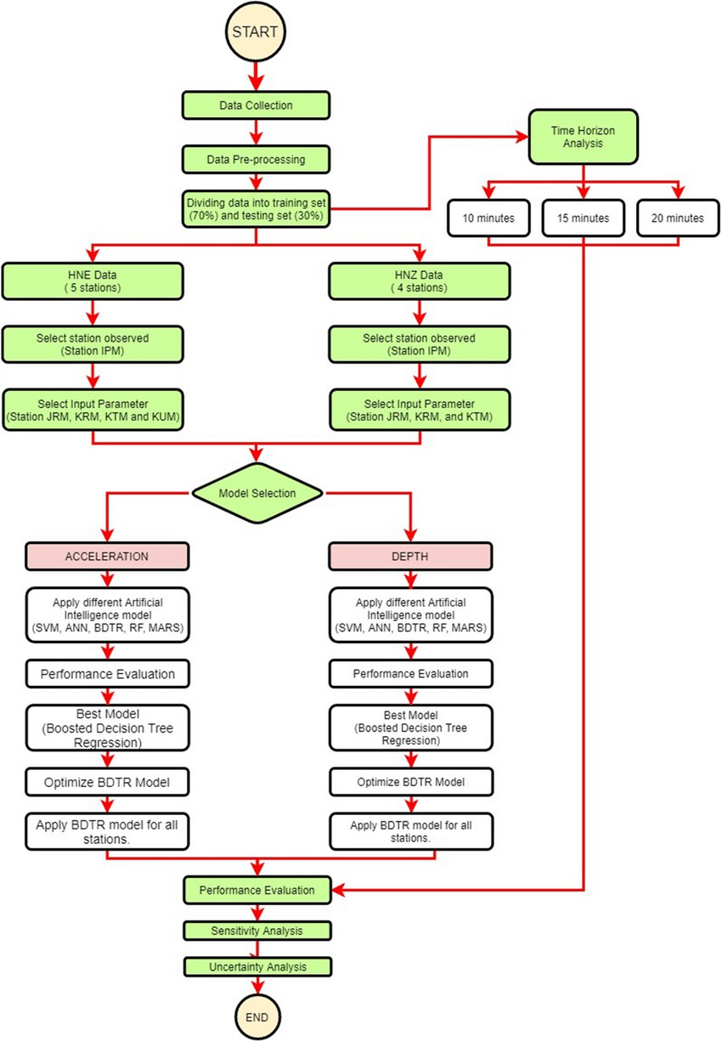

**CONCLUSION:**

In conclusion, earthquake prediction using Python involves collecting and preprocessing relevant data, developing machine learning models, training and testing the models, optimizing them, validating the results, collaborating with other researchers, participating in peer review processes, continuously updating and improving the system, and implementing it in real-world scenarios. Python provides a powerful and flexible platform for earthquake prediction, with a wide range of tools and libraries available for data analysis, machine learning, and visualization. By applying these techniques to earthquake prediction, we can better understand and prepare for the impact of these natural disasters