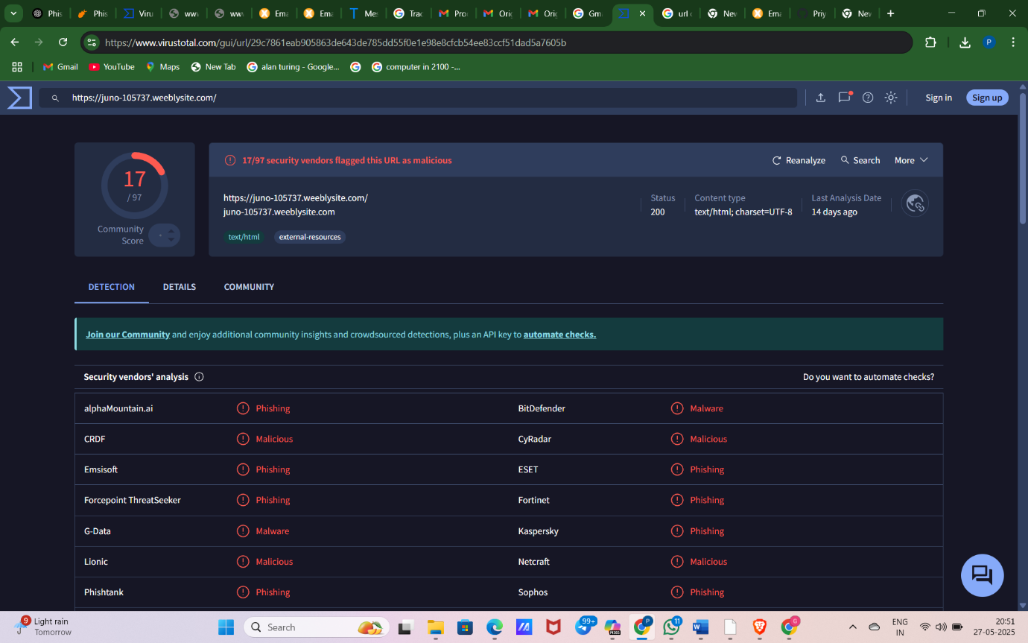

https://www.virustotal.com/gui/url/29c7861eab905863de643de785dd55f0e1e98e8cfcb54ee83ccf51dad5a7605b

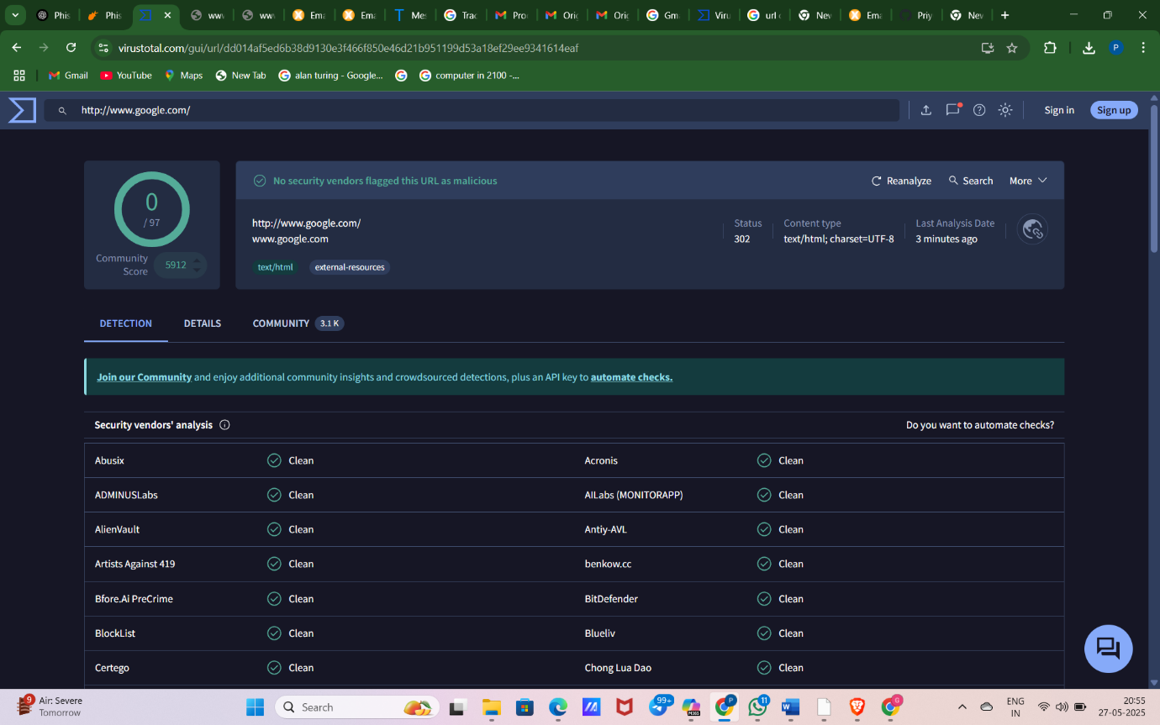

https://www.virustotal.com/gui/url/dd014af5ed6b38d9130e3f466f850e46d21b951199d53a18ef29ee9341614eaf

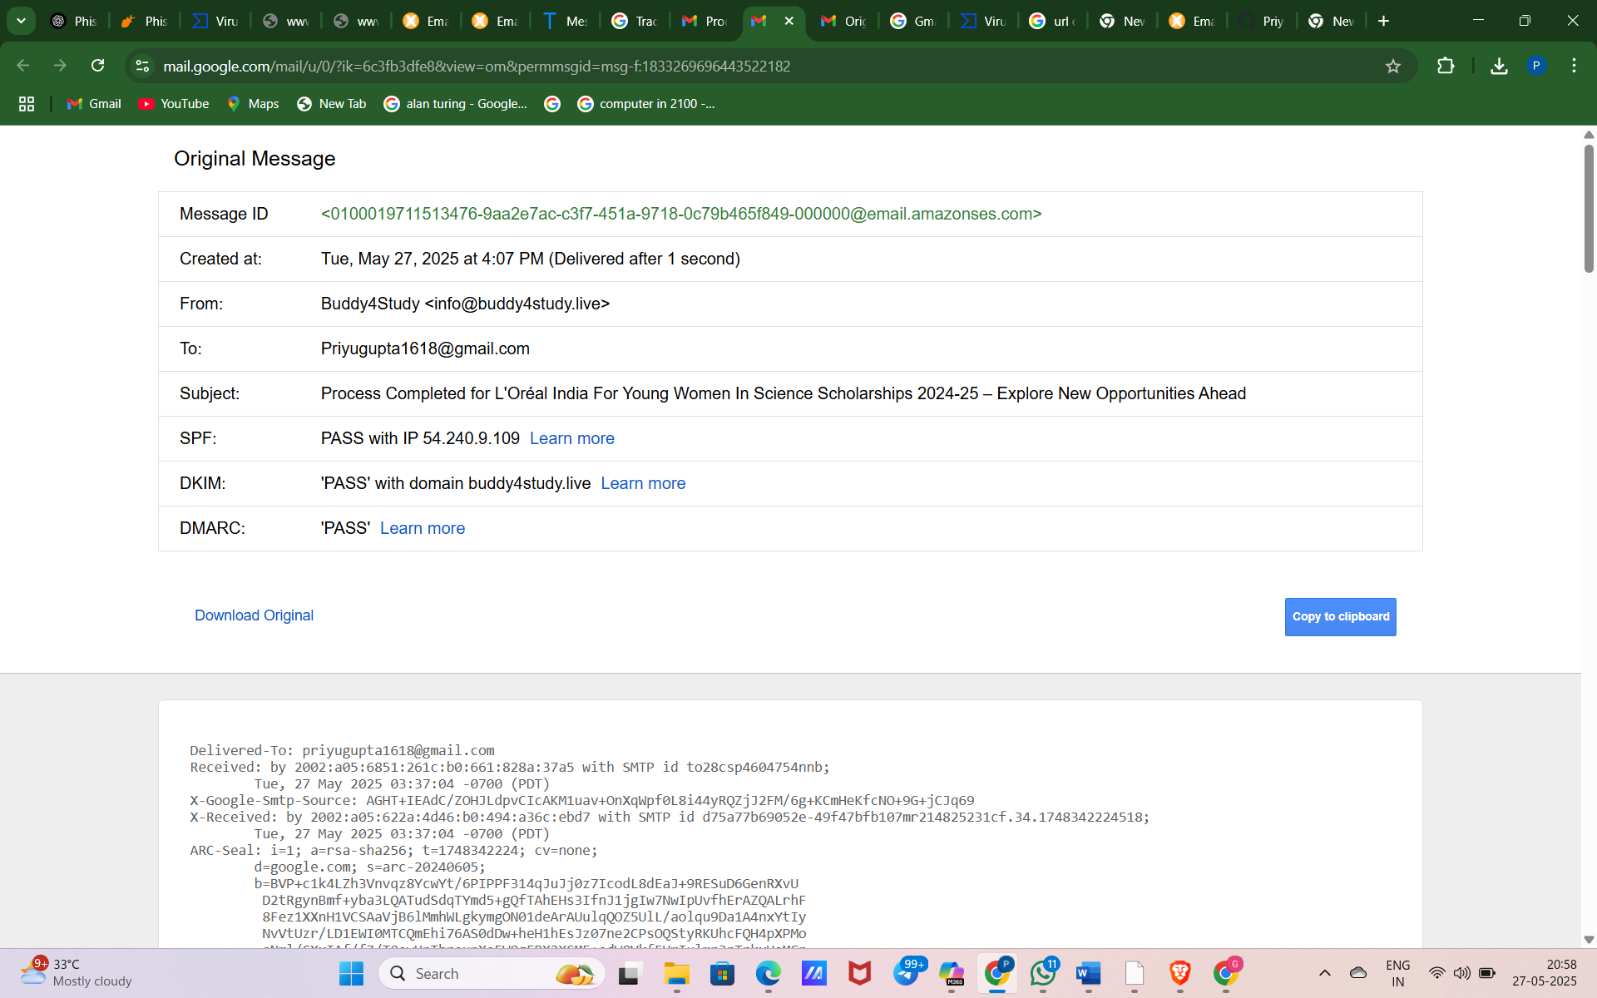

https://mail.google.com/mail/u/0/?ik=6c3fb3dfe8&view=om&permmsgid=msg-f:1833269696443522182

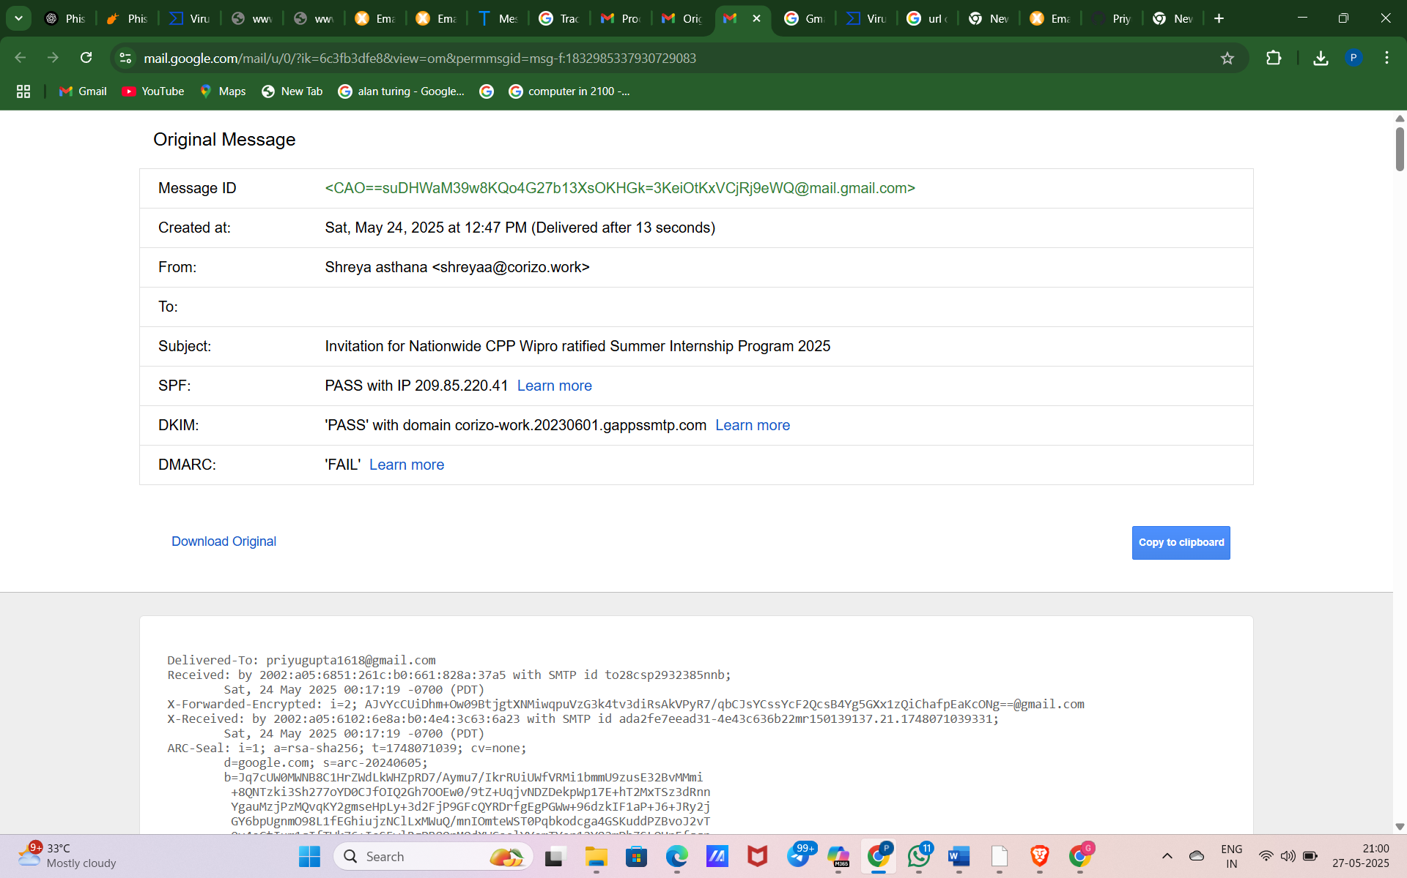

https://mail.google.com/mail/u/0/?ik=6c3fb3dfe8&view=om&permmsgid=msg-f:1832985337930729083