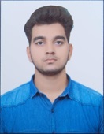**RESUME**

**Priyanshu Sharma**

**Fresher**

Phone: +(91)-7248677065 |

Muradnagar, Ghaziabad, Up-201206 |

Email: - [bhardwajpriyanshu90@gmail.com](mailto:bhardwajpriyanshu90@gmail.com) |

LinkedIn: - <https://www.linkedin.com/in/priyanshu-bhardwaj-4929992b7>

**OBJECTIVE**

As a BCA fresher, my objective is to leverage my technical skills and theoretical knowledge to contribute effectively to the IT industry. I aspire to embark on a challenging career path that allows me to continuously learn, innovate, and grow professionally while making meaningful contributions to organizational success.

**EDUCATIONAL QUALIFICATION**

* Pursuing BCA 3rd Year from CCS University
* Passed out 12th from CBSE in 2022
* Passed out 10th from CBSE in 2020

**TECHNICAL SKILL**

* Programming Languages: Proficiency in languages like Java, C.
* Database Management: Understanding of database concepts and experience with SQL queries.
* Web Development: Knowledge of HTML, CSS, and basic web development frameworks.
* Operating Systems: Familiarity with Windows.

**STRENGTH**

* Strong analytical skills
* Technical aptitude
* Adaptability
* Teamwork
* Time management
* Creativity
* Communication skills

**PROJECT**

**Title: Creating Web Layouts for Try Out**

**Organization: Tech Innovators**

**Project Overview:**

The project involves creating web layouts for a tryout overview. It aims to design easy-to-navigate and visually appealing pages that clearly present information about tryouts, including schedules and registration details, ensuring a smooth experience for users.

**Detail Description:** The project involves creating web layouts specifically for detailing tryout Sinformation. This includes designing user-friendly pages that present essential details such as:

1. **Tryout Dates and Times**: Clearly listed dates and times for each tryout session.
2. **Locations**: Maps or directions to venues where tryouts will take place.
3. **Requirements**: Information on what participants need to bring or prepare.
4. **Registration Process**: Step-by-step instructions for signing up, including links to forms.
5. **Contact Information**: Details for reaching out with questions or for further assistance.

The overall aim is to ensure the layout is visually appealing, easy to navigate, and mobile-responsive, providing a seamless experience for users looking to participate in tryouts.

**PERSONAL DETAILS**

Father’s Name: Amit Sharma

Date of birth: 21-11-2003

Marital Status: Single

Nationality: Indian

I hereby declare that all the information given above is true and correct to the best of my knowledge.

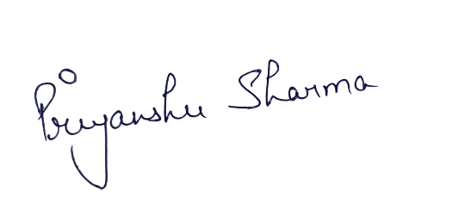

Date ……………………….. (Priyanshu Sharma)