

AMITY UNIVERSITY ONLINE, NOIDA, UTTAR PRADESH

In partial fulfillment of the requirement for the award of degree of
Bachelor of Computer Application (General)
Discipline – Information Technology

TITLE: NextStepAI: Intelligent Career Guidance and Adaptive Planning System

Guide Detail:
Name: Prem Nidhi
Designation: Project Leader, Newgen

Submitted By:
Name of the Student: Priyvrat Modi
Enrolment No.: A99223002787 (el)
ABSTRACT

Choosing a career is a high-impact decision that significantly influences an individual’s long-term future learning, work stability, and personal confidence. However, in a country like India, learners often face challenges such as lack of personalized guidance, limited exposure to newer and less visible career routes, financial and social constraints, and family, peer, and social pressure. Many current guidance platforms are mostly broad and template-driven and fail to incorporate contextual and individual-specific factors. To address this gap, this work presents an intelligent, AI-driven Career Path Finder System that provides career suggestions shaped around the individual user and step-by-step execution plans tailored to each user.
NextStepAI leverages a hybrid approach combining decision-tree algorithms and artificial intelligence techniques to deliver accurate, context-aware guidance. Initially, the application collects multi-dimensional user data including academic stage (10th, 12th, or graduation), educational background, interests, skill set, personality traits, and cognitive preferences through a structured assessment module. Unlike conventional systems, this work introduces additional real-world parameters such as budget limits, available preparation time, location and mobility limits, and personal circumstances, which are often overlooked but play a crucial role in career feasibility within the Indian education-to-employment environment.
The decision-tree model is employed as the primary filtering mechanism to classify users into relevant career domains based on their responses. This keeps the recommendation process transparent and easy to interpret. Once the domain is identified (e.g., government sector, private jobs, entrepreneurship, or niche careers), an AI recommendation layer refines the output by suggesting three optimized career paths: (i) Safe Path – stable and low-risk options, (ii) High-Reward Path – careers with higher growth potential but increased competition or risk, and (iii) Wildcard Path – unconventional or emerging career opportunities aligned with user interests. This multi-perspective recommendation framework enables users to choose with better clarity based on their risk appetite and long-term aspirations.
In addition to career identification, the application incorporates a roadmap-generation module, which transforms selected career paths into workable timelines. This module generates a personalized, day-wise task schedule that includes preparation strategies, required examinations, skill acquisition milestones, and progress checkpoints. The application also integrates adaptive features such as task completion tracking, automatic rescheduling of pending tasks, and behavioral analysis. Based on user engagement patterns, the application can provide contextual motivational support and adjust schedules to optimize productivity and reduce burnout.
A feedback loop mechanism is embedded within the application, allowing users to re-evaluate and modify their inputs, thereby ensuring continuous improvement in recommendations. This iterative approach enhances system reliability and user satisfaction over time.
From an implementation perspective, the application is developed using Flutter, enabling seamless cross-platform deployment across Android and iOS devices. The application architecture is designed to be scalable and user-focused, incorporating features such as calendar integration, push notifications, and real-time updates related to career milestones and deadlines.
The key innovation and Unique Selling Proposition (USP) of this work lies in its integration of non-traditional yet highly impactful parameters specific to the Indian education and employment context, combined with an intelligent suggestion layer and actionable execution planning. By bridging the gap between career guidance and practical implementation, NextStepAI does not merely assist users in identifying suitable career options but also empowers them with a clear and adaptive pathway to achieve their goals.
Overall, the Career Path Finder System aims to revolutionize career counseling by providing a data-driven, personalized, and well-rounded support model that addresses both decision-making and execution challenges faced by learners, thereby lowering uncertainty and supporting stronger career outcomes.

DECLARATION

I, Priyvrat Modi, a student pursuing 6th Semester of Bachelor of Computer Application at Amity University Online, hereby declare that the project work entitled “NextStepAI: Intelligent Career Guidance and Adaptive Planning System” has been prepared by me during the academic year 2026 under the guidance of Prem Nidhi, Newgen. I assert that this work is a piece of original bona-fide work done by me. It is the outcome of my own effort and that it has not been submitted to any other university for the award of any degree.

Signature of Student

CERTIFICATE

This is to certify that Priyvrat Modi of Amity University Online has carried out the project work presented in this work report entitled Title of Project Report “NextStepAI: Intelligent Career Guidance and Adaptive Planning System” for the award of Bachelor of Computer Application under my guidance. The project report embodies results of original work, and studies are carried out by the student himself/herself. Certified further, that to the best of my knowledge the work reported herein does not form the basis for the award of any other degree to the candidate or to anybody else from this or any other University/Institution.

Signature
Prem Nidhi
Project Leader, Newgen Software Technology

TABLE OF CONTENTS

TITLE PAGE…………………………………………………………………..……………..1
ABSTRACT……………………………………………………………………………….….2
DECLARATION………………………………………………………………………..……5
CERTIFICATE……………………………………………………………………….……...6
LIST OF FIGURES………………………………………………………………….……..10
CHAPTER 1: INTRODUCTION TO THE TOPIC…………………………....……10 - 18
1.1. Background of Study
1.2. Problem Statement
1.3. Need of the Study
1.4. Scope of the Study
1.5 Significance of the Study
CHAPTER 2: REVIEW OF LITERATURE……………………………..…………20 – 37
2.1. Existing Career Guidance Systems
2.2. Research Papers / Previous Work
2.3. Limitations of Existing Work
2.4. Role of Artificial Intelligence in Career Guidance
2.5. Recommendation Systems in Career Guidance
2.6. AI Chatbot Limitations
2.7. Importance of Real-World Constraints in Career Planning
2.8. Need for Execution-Based Systems
2.9. Adaptive Systems
2.10. Summary
CHAPTER 3: RESEARCH OBJECTIVES AND METHODOLOGY…………….38 - 67
3.1. System Objective
3.2. Problem Definition
3.3. System Design / Methodology
3.4. System Architecture
3.5. Development Environment and Tools Used
3.6. Algorithms Used
3.7. Testing Methodology
3.8. Screenshots
CHAPTER 4: DATA ANALYSIS AND RESULT………………………….……….68 - 71
4.1. Data Analysis
4.2. Results
4.3. Interpretation
CHAPTER 5: FINDINGS AND CONCLUSION………………………….………...72 - 75
5.1. Findings
5.2. Conclusion
CHAPTER 6: RECOMMENDATIONS AND LIMITATIONS………………...…76 - 80
6.1. Recommendations
6.2. Limitations
BIBLIOGRAPHY……………………………………………………….………………….81

LIST OF FIGURES

Fig 1: Working of the Intelligent Career Guidance System
Fig 2: Home Screen of NextStep AI
Fig 3: Dashboard Screen of NextStep AI
Fig 4: Assessment Screen of NextStep AI
Fig 5: Recommended Career Option Screen and Detailed Explanation About the Option
Fig 6: Schedule Generation Screen of NextStep AI

CHAPTER 1: INTRODUCTION TO THE TOPIC

  - Background of the Study
At present, career planning has become a complex and important process for learners. The growth of academic streams, changes in technology, and a more connected job market have significantly increased the number of available career opportunities. Unlike earlier times, when career choices were limited to a few conventional fields such as medicine, engineering, or government jobs, today’s learners are exposed to a wide range of routes across domains like information technology, management, creative industries, data science, entrepreneurship, and many emerging interdisciplinary fields. Each of these domains also contains numerous specialized sub-domains, making the decision process even more intricate and challenging.
While the availability of diverse career options is beneficial, it has also led to a state of confusion and uncertainty among learners. Many learners struggle to identify the most suitable career path due to a lack of proper guidance, limited self-awareness regarding their interests and skills, and insufficient exposure to real-world opportunities. This issue is particularly prominent in developing countries like India, where career decisions are not solely based on individual preferences but are also influenced by multiple external factors. These factors include financial constraints, family expectations, social pressure, lack of access to quality education, and limited awareness of non-traditional or emerging career paths. Because of this, learners often make uninformed or pressured decisions, which may lead to dissatisfaction, career instability, and underutilization of their true potential.
Conventional counseling methods, such as offline counseling sessions and standard aptitude tests, attempt to address this issue but often fall short in delivering effective results. These methods typically provide generalized recommendations that do not account for individual differences and real-life circumstances. Also, most digital guidance products focus only on basic parameters like academic performance or interest mapping, ignoring critical factors such as financial feasibility, time availability, geographic limitations, and personal responsibilities. This creates a significant gap between career suggestions and their practical implementation.
With the continuous advancement in artificial intelligence and data-driven technologies, there is a growing opportunity to develop intelligent systems that can provide personalized, adaptive, and context-aware guidance. Such systems have the potential to analyze multiple user-specific parameters simultaneously and generate recommendations that are both realistic and achievable. Recognizing this need, the present project aims to design and develop an intelligent career guidance system that integrates decision tree algorithms with AI-based recommendation techniques to assist learners in making better career choices.
In this report, a key highlight and innovative contribution of this work is its ability to go beyond simple career recommendation by incorporating a structured execution mechanism. The application does not merely suggest suitable career paths but also generates a detailed, goal-oriented schedule tailored to the selected career. This schedule breaks down long-term goals into manageable daily or periodic tasks, enabling learners to follow a clear and organized preparation strategy. In addition, the application introduces a dynamic and adaptive planner, where the generated timeline is continuously adjusted based on the user’s activity, performance, and consistency. If a user fails to complete certain tasks or shows irregular engagement, the application intelligently reschedules the plan to maintain feasibility and effectiveness.
This adaptive and flexible scheduling approach addresses one of the most overlooked aspects of career guidance, which is the execution of plans in real-life scenarios. Compared with static guidance tools that provide fixed suggestions, this work emphasizes continuous support and guidance throughout the user’s journey. Such an approach ensures that the application remains relevant, practical, and user-focused.
Overall, this work is developed with the objective of bridging the gap between career choice and its practical implementation. By combining intelligent recommendation techniques with practical constraints and adaptive planning, the application aims to provide a end-to-end support model that empowers learners to choose and successfully pursue a career path best suited to their individual capabilities and circumstances.

  - Problem Statement
In the current educational landscape, learners face significant difficulty in selecting an appropriate career path due to the overwhelming number of available options and the lack of structured, individual guidance. Most existing career counseling methods and digital platforms rely on standard assessments that primarily consider academic performance or basic interest mapping, without taking into account critical practical factors such as financial limitations, time constraints, personal responsibilities, and accessibility to resources. This gap becomes more prominent in the Indian education and employment context, where career decisions are often influenced by socio-economic conditions and family, peer, and social pressure rather than individual aptitude and long-term feasibility.
In addition, existing systems fail to provide a clear execution strategy after suggesting career options. Learners are often left without a proper roadmap, resulting in confusion, poor planning, and lack of consistency in preparation. The absence of an integrated system that combines career recommendation with actionable planning leads to inefficient decision-making and increases the risk of choosing unsuitable or impractical career paths.
For this reason, there is a need for an intelligent and adaptive system that can analyze multiple user-specific parameters, incorporate practical constraints, and provide not merely career suggestions shaped around the individual user but also a structured timeline for achieving those goals. This work aims to address these challenges by developing a system that bridges the gap between career choice and practical implementation using decision tree analysis and AI-based recommendations.

  - Need of the Study
With the rapid growth of career opportunities and increasing competition, learners today require more than just basic guidance to choose with better clarity about their future. Traditional career counseling methods and existing digital platforms often fail to provide personalized, practical, and context-aware recommendations, as they overlook crucial factors such as financial constraints, time availability, and individual circumstances. This creates a gap between career aspirations and real-world feasibility, leading to confusion and ineffective decision-making among learners.
There is a strong requirement for an intelligent system that not merely analyzes a student’s interests, skills, and academic background but also incorporates real-life constraints to provide realistic and achievable career options. Further, learners require a clear route map that guides them step-by-step toward their goals, rather than just fixed suggestions. NextStepAI addresses this need by combining decision tree logic and AI-based recommendations with adaptive timeline creation, thereby offering a end-to-end support model for both career choice and execution.

  - Scope of the Study
The scope of this study focuses on the development of an intelligent and adaptive career guidance system designed to assist learners in making informed, personalized, and practically feasible career decisions. The application is primarily targeted at learners across various academic stages, including secondary (10th and 12th) and higher education levels, who often face uncertainty due to the increasing complexity of career options in the modern educational and professional landscape.
NextStepAI covers a broad spectrum of career domains such as government jobs, private sector roles, entrepreneurship, freelancing, and emerging interdisciplinary fields. It is designed to analyze multiple dimensions of user data, including interests, skills, academic performance, personality traits, and situational constraints such as budget limits, time availability, and geographic limitations. This multi-parameter approach ensures that the recommendations generated by the application are not merely personalized but also aligned with real-world feasibility, which is often overlooked in conventional systems.
A key component within the scope of this work is the integration of intelligent decision-making mechanisms using decision-tree algorithms and AI-based recommendation models. These techniques enable the application to classify users into relevant career domains and provide optimized career paths, including safe, high-reward, and alternative options. This structured approach enhances user understanding and supports better decision-making.
Within the application design, in addition to career recommendation, the application extends its scope to include execution-level planning, which is a important limitation in existing career guidance platforms. The application generates a dynamic and structured timeline that breaks down larger career goals into smaller tasks that can be completed and tracked. These tasks are organized in a day-wise or phase-wise manner, enabling users to follow a systematic preparation strategy.
In addition, the scope includes the implementation of an adaptive scheduling logic, which continuously monitors user engagement, performance, and consistency. Based on this data, the application intelligently recalibrates the schedule, ensuring that the plan remains achievable even if the user deviates from the initial timeline. This dynamic adaptability makes the application more realistic and effective in real-world scenarios.
The study also explores the scope for integrating advanced behavioral and productivity-enhancing features. One such extension is the development of a distraction control module, which can restrict or manage access to distracting applications during focused study sessions. This feature aims to improve user discipline and concentration, which are critical factors in achieving larger career goals.
Another innovative extension within the scope is the introduction of a career simulation module, which provides users with a “day-in-the-life” experience of their targeted job roles. By assigning practical tasks that mirror real-world job responsibilities, the application helps users gain deeper insights into their chosen careers. This experiential learning approach reduces uncertainty and enables users to validate their career choices before committing fully.
Further, the application includes the potential for a career transition and fallback mechanism, which ensures continuity in the user’s career journey. In cases where a user is unable to succeed in a particular path or chooses to switch, the application can recommend alternative career options that require similar skill sets. This minimizes the loss of effort and helps users efficiently redirect their preparation.
The scope further extends to the integration of real-time data systems, such as job notifications, examination updates, and industry trends, which can provide users with up-to-date and relevant information aligned with their career paths. This feature can significantly enhance the practical value of the application by connecting planning with real-world opportunities.
From a technical perspective, the application is developed using Flutter and Dart, ensuring cross-platform compatibility and scalability. Firebase is utilized for backend services, including authentication and data management, while AI models and APIs are integrated to enable intelligent recommendations. The modular architecture of the application allows for easy future expansion and integration of advanced features.
From a practical implementation view, despite its extensive capabilities, the current scope is limited to guidance, recommendation, and planning. The application does not guarantee career success, as outcomes depend on individual effort, external conditions, and evolving industry demands. Further, certain advanced features such as real-time data integration, predictive analytics, and full-scale behavioral tracking are considered part of future enhancements and are not fully implemented in the present version.
Overall, the scope of this study is comprehensive and forward-looking, encompassing both career choice and execution support. It not merely addresses the immediate challenges faced by learners but also lays the foundation for developing a complete, intelligent career ecosystem that can evolve with changes in technology and user needs.

1.5 Significance of the Study
The significance of this study lies in its ability to address one of the most critical challenges faced by learners today—making informed and practical career decisions in an increasingly complex and competitive environment. With the rapid expansion of career opportunities and the lack of structured guidance, many learners struggle to identify a path that aligns with their interests, skills, and real-world circumstances. This study contributes to solving this problem by proposing an intelligent, personalized, and execution-oriented career guidance system.
One of the major contributions of this study is the shift from generic career advice to personalized decision-making. Compared with static guidance tools that rely on limited parameters, NextStepAI considers multiple factors such as interests, skills, academic background, financial conditions, and time constraints. This multi-dimensional approach ensures that career recommendations are not merely suitable but also realistic and achievable, especially in the Indian education and employment context.
Another important aspect of this study is its focus on bridging the gap between career choice and career execution. Most existing systems stop at suggesting career options, leaving users without a clear direction on how to achieve them. This study introduces a structured timeline and adaptive scheduling logic that guides users step-by-step toward their goals. This makes the application more practical and useful in real-life scenarios.
The study also highlights the importance of consistency and persistence in career guidance systems. By maintaining user data and ensuring stable recommendations across sessions, the application improves reliability and builds user trust. This is a significant improvement over AI-based chatbot systems that often generate inconsistent results.
For learners using the platform, in addition, the integration of artificial intelligence and decision-tree algorithms demonstrates how modern technologies can be effectively applied to solve real-world problems. The study showcases the potential of combining rule-based logic with intelligent models to create systems that are both interpretable and adaptive.
From a user perspective, the application enhances decision-making confidence, productivity, and long-term planning. Features such as adaptive scheduling, progress tracking, and structured task management help users stay focused and consistent in their preparation. This not merely improves efficiency but also reduces confusion and stress associated with career planning.
The study is also significant in terms of its future potential and scalability. NextStepAI can be further extended by integrating real-time job updates, examination notifications, career simulations, and distraction management features. This opens the possibility of transforming the application into a complete career development ecosystem.
From an academic perspective, this study contributes to the field of intelligent decision support systems by presenting a practical implementation that combines multiple technologies and methodologies. It provides a framework that can be further explored and improved by future researchers.
Overall, the significance of this study lies in its comprehensive, practical, and innovative approach to career guidance. By addressing the limitations of existing systems and introducing adaptive, user-focused solutions, NextStepAI has the potential to make a meaningful impact on learners’ career choice and overall professional development.

CHAPTER 2: REVIEW OF LITERATURE

2.1 Existing Career Guidance Systems
At the project level, career guidance systems have undergone significant transformation over the years, evolving from traditional human-centered counseling approaches to advanced digital and AI-driven platforms. In earlier times, learners primarily depended on teachers, career counselors, and family members for guidance. While these sources provided basic direction, they were often influenced by personal bias, limited exposure, and lack of structured evaluation methods. Because of this, learners frequently made career decisions based on incomplete or subjective information.
With the rapid growth of technology, several online career guidance platforms have been introduced that aim to provide more systematic and data-driven recommendations. These platforms typically use assessment-based approaches, including aptitude tests, personality tests, and interest mapping techniques. Based on user responses, the applications generate career suggestions that are aligned with predefined models. Some platforms also provide additional information such as course details, entrance examinations, and career pathways.
However, despite these advancements, current guidance platforms still suffer from several fundamental limitations. One of the major issues is that most of these systems are designed using a generalized framework and are not specifically tailored to the Indian education system. The Indian education and employment context presents unique challenges, such as intense competition for government jobs, limited access to quality education in certain regions, financial constraints, and strong societal and familial influences on career decisions. Most global platforms fail to incorporate these factors, making their recommendations less practical and sometimes irrelevant for Indian learners.
Another serious limitation is the over-dependence on a single type of assessment. Many existing systems focus deeply on either personality tests or aptitude tests. While personality assessments help in understanding behavioral traits and preferences, and aptitude tests evaluate logical and analytical abilities, relying solely on one dimension does not provide a comprehensive evaluation of a student’s potential. Such narrow approaches often result in incomplete or misleading recommendations. In contrast, a more holistic system should combine multiple parameters, including skills, interests, academic performance, and practical constraints, to provide accurate and balanced guidance.
Also, most existing systems are primarily recommendation-oriented and lack an execution-focused approach. They provide users with a list of possible career options but do not offer guidance on how to achieve those goals. This creates a significant gap between decision-making and implementation. Learners are often left confused about the next steps, such as which exams to prepare for, how to manage their time, and what skills to develop. Without a clear route map, even well-informed decisions may fail to translate into successful outcomes.
In recent years, AI-based chatbots have emerged as a modern approach to career guidance. These systems allow users to interact conversationally and receive instant career suggestions. While this approach improves accessibility and user engagement, it introduces another important limitation—lack of consistency. The recommendations provided by such chatbots often vary with each new session, even if the user’s inputs remain similar. This inconsistency reduces user trust and makes it difficult to rely on the application for long-term planning.
Further, chatbot-based systems are often context-sensitive but not state-persistent. This means that they do not retain user-specific data effectively across sessions, leading to changes in recommendations over time. In contrast, a robust career guidance system should ensure persistence by storing user data and generating stable recommendations based on fixed parameters unless explicitly modified by the user.
In this report, another limitation observed in existing systems is the absence of adaptability and continuous feedback mechanisms. Most platforms generate fixed outputs that do not evolve based on user progress or behavior. They do not track whether the user is following the suggested path or facing difficulties in execution. This lack of dynamic interaction reduces the practical effectiveness of such systems in real-world scenarios.
In addition, existing systems often ignore productivity-related challenges faced by learners, such as lack of focus, procrastination, and distractions caused by digital platforms. Without addressing these behavioral aspects, even the best career recommendations may not lead to successful outcomes. Modern career guidance systems should integrate productivity-enhancing features to support users throughout their journey.
Another important gap is the lack of experiential learning opportunities in existing systems. Learners are rarely provided with insights into what a particular job actually involves in day-to-day life. Without practical exposure, learners may choose careers based on assumptions rather than reality, leading to dissatisfaction in the long term. A more advanced system should provide simulated experiences or task-based insights to help users understand the real nature of their chosen careers.
In addition, most systems do not provide flexibility in case of failure or change in interest. If a user is unable to succeed in a particular career path, existing platforms do not offer structured alternatives based on transferable skills. This forces users to restart their journey from scratch, resulting in loss of time and effort. A well-designed system should include a transition mechanism that suggests alternative paths with similar skill requirements.
In summary, although current guidance platforms have made progress in utilizing technology for decision-making, they remain limited in terms of personalization, contextual relevance, adaptability, consistency, and execution support. These limitations highlight the need for a more comprehensive, intelligent, and user-focused system that not merely recommends career paths but also ensures that users can realistically achieve their goals.
NextStepAI addresses these gaps by integrating multiple assessment parameters, ensuring recommendation consistency, incorporating practical constraints, and providing a dynamic and adaptive roadmap for career success. This makes it more aligned with practical requirements and significantly more effective compared to existing solutions.

2.2 Research Papers / Previous Work
For NextStepAI, several research studies have been conducted in the domain of career guidance systems, focusing on decision-making models, machine learning techniques, and recommendation systems. These studies provide a strong foundation for the development of intelligent career guidance applications.
The work by Itamar Gati and Idit Asher, titled “The PIC Model for Career Decision Making: Prescreening, In-Depth Exploration, and Choice” (2001), presents a structured framework for career choice. The PIC model divides the decision process into three stages: prescreening, where irrelevant options are eliminated; in-depth exploration, where suitable options are analyzed; and choice, where the final decision is made. This model highlights the importance of a systematic approach in reducing confusion and improving decision accuracy. However, the model is primarily theoretical and does not incorporate modern computational techniques or real-time adaptability.
Another study by Amit Kumar, Sandeep Sharma, and Rajesh Singh, titled “Career Recommendation System Using Machine Learning” (2017), focuses on the application of machine learning algorithms for analyzing user data and generating career suggestions. The application uses user inputs such as academic performance and interests to recommend suitable career paths. While this approach improves the accuracy of recommendations, it mainly relies on limited parameters and does not consider practical constraints such as financial conditions or accessibility to resources.
Similarly, Ravi Sinha and Ankit Sinha, in their research titled “An Intelligent Career Guidance System Using Data Mining Techniques” (2019), explore the use of data mining methods to enhance career prediction. Their system analyzes patterns in user data to suggest career options. Although the study demonstrates the effectiveness of data-driven approaches, it lacks dynamic features such as continuous user interaction, adaptive scheduling, and execution planning.
In another study, Pradeep Singh, Mohit Verma, and Kunal Patel developed a system titled “decision-tree-Based Career Prediction System for Learners” (2020). This research highlights the use of decision-tree algorithms for classifying learners into different career domains based on structured input data. The decision tree approach is efficient, interpretable, and easy to implement. However, the application mainly focuses on classification and does not extend to providing actionable plans or adaptive guidance for achieving career goals.
In addition, the work by Neha Bhatia and Saurabh Jain, titled “Educational Recommendation Systems Using artificial intelligence: A Review” (2021), provides a comprehensive overview of AI-based recommendation systems in education. The study discusses various techniques such as collaborative filtering, content-based filtering, and hybrid approaches. While it offers valuable insights into recommendation technologies, it is primarily a review paper and does not propose a complete system that integrates decision-making with execution support.
In recent advancements, AI-based conversational systems and chatbots have also been explored for career guidance. These systems use natural language processing to interact with users and provide suggestions. However, as observed in practice, such systems often lack consistency and persistence, as recommendations may vary across different sessions. This reduces reliability and makes them less suitable for long-term planning.
Within the application design, overall, the existing research demonstrates the effectiveness of machine learning, data mining, and decision tree techniques in career guidance. However, most of the studies focus either on prediction accuracy or recommendation generation, without addressing practical challenges such as practical constraints, execution planning, adaptability, and consistency.
NextStepAI builds upon these research contributions by combining decision tree-based classification with AI-driven recommendations, while also introducing innovative features such as dynamic scheduling, adaptive planning, and persistent recommendation mechanisms. This integrated approach ensures that the application does does not merely suggest suitable career paths but also supports users in achieving their goals in a structured and realistic manner.

2.3 Limitations of Existing Work
Despite the significant advancements in career guidance systems and the application of artificial intelligence and machine learning techniques, existing solutions still suffer from several serious limitations that reduce their effectiveness in real-world scenarios.
One of the primary limitations of existing systems is the lack of personalization. Most platforms rely on a limited set of parameters, such as aptitude scores or personality traits, to generate recommendations. This narrow approach fails to capture the complete profile of a user, including skills, real-life constraints, and individual circumstances. Because of this, the recommendations generated may not be fully aligned with the user’s actual potential and situation.
Another important limitation is that many existing systems are not designed specifically for the Indian education and employment context. They often follow a generalized global model, ignoring important factors such as intense competition in government jobs, financial limitations, regional disparities in education, and societal pressures. This makes their recommendations less practical and sometimes unrealistic for Indian learners.
In addition, most systems are heavily dependent on a single type of assessment, such as personality tests or aptitude tests. While these methods provide valuable insights, relying solely on one type of evaluation leads to incomplete analysis. A comprehensive career guidance system should integrate multiple dimensions, including interests, skills, academic performance, and situational constraints, to provide more accurate and balanced recommendations.
From a practical implementation view, another serious limitation is the absence of execution planning. Existing systems typically stop at recommending career options and do not provide guidance on how to achieve those goals. There is no clear route map, timeline, or task-based approach to help users move from decision-making to actual implementation. This creates a gap between career choice and career achievement.
In addition, many systems lack dynamic adaptability. The recommendations generated are often static and do not change based on user progress, behavior, or performance. This limits the application’s ability to provide continuous support and guidance, which is essential for long-term career development.
AI-based chatbot systems, although innovative, also introduce certain limitations. One of the major issues is the lack of consistency in recommendations. The suggestions provided by chatbots can vary across different sessions, even when the user inputs remain similar. This inconsistency reduces reliability and makes it difficult for users to trust the application for long-term planning.
Also, such chatbot systems generally lack data persistence, meaning they do not effectively store and utilize user-specific information across sessions. Because of this, recommendations may change frequently, leading to confusion and lack of direction.
Another limitation is the absence of productivity and behavioral support mechanisms. Existing systems do not address challenges such as lack of focus, procrastination, and digital distractions, which significantly impact a student’s ability to achieve their goals. Without managing these factors, even accurate career recommendations may not lead to successful outcomes.
Further, most systems do not provide practical exposure or real-world insights into career roles. Learners are often unaware of the actual responsibilities and daily tasks associated with a particular job, leading to unrealistic expectations and dissatisfaction in the future.
Finally, existing systems lack flexibility in career transition. If a user fails in a chosen path or decides to change direction, there is no structured support to suggest alternative careers based on transferable skills. This forces users to restart their journey, resulting in loss of time and effort.
For learners using the platform, overall, although current guidance platforms have contributed significantly to the field, they remain limited in terms of personalization, contextual relevance, adaptability, consistency, execution support, and flexibility. These limitations highlight the need for a more advanced, integrated, and user-focused system, which is addressed by the proposed project.

2.4 Role of Artificial Intelligence in Career Guidance
artificial intelligence (AI) has emerged as a transformative technology in various domains, including education and career guidance. With the increasing complexity of career options and the need for personalized decision-making, AI has an important role in enhancing the effectiveness and accuracy of career guidance systems.
One of the primary contributions of AI in career guidance is its ability to provide personalized recommendations. Compared with static guidance tools that rely on fixed rules or limited assessments, AI can analyze large amounts of user data, including interests, skills, academic performance, and behavioral patterns. By processing this data, AI systems can generate tailored career suggestions that align closely with individual user profiles.
AI also enables data-driven decision-making, which reduces the dependency on subjective judgment. Traditional counseling methods often rely on human intuition, which may introduce bias or inconsistency. In contrast, AI systems use algorithms and statistical models to evaluate multiple parameters simultaneously, ensuring more objective and reliable recommendations.
Another significant role of AI is in handling complex and unstructured data. Learners often have diverse and evolving preferences that cannot be easily captured through standard questionnaires. AI models, especially large language models, can interpret natural language inputs and provide meaningful insights. This allows users to interact with the application in a more flexible and intuitive manner.
In addition, AI enhances career guidance systems by enabling dynamic and adaptive recommendations. Unlike static systems, AI-based platforms can continuously learn from user interactions and update their outputs accordingly. This adaptability ensures that the application remains relevant even as user preferences or external conditions change over time.
At the project level, aI also supports the development of recommendation systems, which are widely used in career guidance applications. These systems analyze patterns in user data and suggest suitable career paths based on similarities with other users or predefined models. Techniques such as content-based filtering and machine learning algorithms improve the accuracy and relevance of these recommendations.
In recent years, AI-powered chatbots and conversational agents have gained popularity in career guidance. These systems allow users to interact in a conversational manner and receive instant responses. While they improve accessibility and user engagement, they often lack consistency and persistence, as recommendations may vary across sessions. This highlights the need for integrating AI with structured data storage and decision-making mechanisms.
Another important role of AI is in automating the career planning process. AI can generate detailed study plans, suggest skill development strategies, and provide insights into required qualifications and career pathways. This reduces the manual effort required by users and makes the planning process more efficient.
In addition, AI can be used for predictive analysis, where the application anticipates user needs and suggests future actions. For example, based on user performance and activity, the application can recommend adjustments in study schedules or suggest alternative career paths.
Despite its advantages, AI in career guidance also has certain limitations, such as dependency on data quality and potential lack of contextual understanding. For this reason, it is important to combine AI techniques with structured algorithms and real-world parameters to achieve optimal results.
In the context of this work, AI plays a central role in generating personalized and adaptive career recommendations. When combined with decision-tree algorithms and persistent data handling, it enhances the overall intelligence, reliability, and practicality of the application. This integration ensures that users not merely receive accurate career suggestions but also benefit from a structured and dynamic approach to achieving their goals.

2.5 Recommendation Systems in Career Guidance
In this report, recommendation systems are an essential component of modern intelligent applications and play a significant role in enhancing user experience by providing personalized suggestions. In the context of career guidance, recommendation systems are used to analyze user data and suggest suitable career paths based on individual preferences, skills, and other relevant factors.
A recommendation system works by identifying patterns in user data and matching them with predefined models or datasets. These systems are widely used in domains such as e-commerce, entertainment, and education, and have recently gained importance in career guidance applications due to their ability to deliver customized outputs.
There are primarily three types of recommendation systems used in career guidance:
1. Content-Based Filtering:
This approach recommends career options based on the user’s own profile, including interests, skills, and academic background. It analyzes the characteristics of different career paths and matches them with the user’s attributes. For example, a student interested in programming and problem-solving may be recommended careers in software development or data science.
2. Collaborative Filtering:
This method generates recommendations based on similarities between users. It identifies patterns among users with similar profiles and suggests career paths that have been suitable for others with comparable characteristics. While effective, this method requires large datasets and may not work well for new users (cold-start problem).
3. Hybrid Recommendation Systems:
Hybrid systems combine both content-based and collaborative approaches to improve accuracy and overcome the limitations of individual methods. These systems provide more balanced and reliable recommendations by considering both user-specific data and patterns from similar users.
In traditional career guidance systems, recommendation mechanisms are often limited to basic rule-based approaches. These systems lack flexibility and fail to adapt to diverse user needs. In contrast, modern AI-powered recommendation systems use machine learning algorithms to analyze complex datasets and generate more accurate and context-aware suggestions.
For NextStepAI, despite their advantages, existing recommendation systems in career guidance have certain limitations. Many systems rely on limited input parameters and do not consider practical constraints such as financial conditions, time availability, and accessibility to resources. Further, most systems provide static recommendations that do not evolve based on user behavior or progress.
Another challenge is the lack of consistency and persistence in AI-based recommendation systems. In chatbot-based systems, recommendations may vary across different sessions, even with similar inputs. This inconsistency reduces user trust and makes it difficult to rely on such systems for long-term planning.
NextStepAI improves upon existing recommendation approaches by integrating decision-tree classification with AI-based recommendation techniques. The decision-tree first identifies the appropriate career domain, and then the AI model generates refined career paths within that domain. This layered approach increases both accuracy and relevance.
In addition, the application introduces a persistent recommendation mechanism, where user data is stored and used consistently across sessions. This ensures that recommendations remain stable unless the user updates their inputs. This feature improves reliability compared to traditional AI systems.
In addition, NextStepAI extends the functionality of recommendation systems by incorporating execution-oriented features such as timeline generation and adaptive scheduling. This ensures that recommendations are not merely accurate but also actionable, helping users move from decision-making to successful implementation.
Overall, recommendation systems play a vital role in modern career guidance by enabling personalized and data-driven decision-making. However, to achieve maximum effectiveness, they must be integrated with real-world parameters, adaptive mechanisms, and execution support, as demonstrated in NextStepAI.

2.6 AI Chatbot Limitations
Within the application design, aI-based chatbots have recently gained popularity in career guidance due to their ability to provide instant and conversational responses. However, these systems have several limitations that reduce their effectiveness for long-term career planning.
One important limitation is the lack of consistency in recommendations. The career suggestions provided by chatbots often change with each new session, even when user inputs remain similar. This inconsistency creates confusion and reduces user trust in the application.
Another limitation is the absence of data persistence. Most chatbot systems do not store user-specific information effectively, which means they cannot maintain a stable career path for the user over time.
Further, chatbot-based systems are generally suggestion-oriented and do not provide step-by-step execution plans such as timelines or schedules. They also fail to consider practical constraints like financial conditions and time availability in a detailed manner.
For this reason, while AI chatbots improve accessibility and interaction, they are not sufficient for comprehensive career guidance. A more advanced system must ensure consistency, personalization, and execution support, as implemented in the proposed project.
2.7 Importance of Real-World Constraints in Career Planning
Career planning is not merely influenced by a student’s interests, skills, and academic performance but also significantly affected by practical constraints. These constraints include financial conditions, time availability, geographical limitations, family responsibilities, and access to educational resources. Ignoring these factors can lead to unrealistic career choices that are difficult to achieve in practice.
From a practical implementation view, in many current guidance platforms, recommendations are generated based solely on theoretical parameters such as aptitude or personality. While these factors are important, they do not reflect the complete situation of a student. For example, a career path that requires expensive education or long preparation time may not be suitable for a student with financial limitations or urgent employment needs. For this reason, considering practical constraints is essential for generating practical and achievable career options.
The importance of these constraints is particularly evident in the Indian education and employment context, where socio-economic conditions play a major role in career choice. Many learners face challenges such as limited financial resources, lack of access to quality coaching, and strong family expectations. Without addressing these factors, career recommendations may remain idealistic but not actionable.
Incorporating practical constraints into career planning ensures that the suggested paths are not merely aligned with user interests but also feasible within their circumstances. It helps in reducing the risk of failure, improving decision-making confidence, and increasing the chances of long-term success.
NextStepAI emphasizes the integration of these constraints as a core component of its recommendation process. By analyzing factors such as budget limits, time commitment, and personal limitations, the application generates more realistic and user-focused career paths. This approach makes the guidance more practical and effective compared to static guidance tools.
Overall, practical constraints play a crucial role in career planning, and their inclusion is necessary for developing a comprehensive and reliable career guidance system.

2.8 Need for Execution-Based Systems
In the field of career guidance, most existing systems focus primarily on recommending suitable career paths based on user inputs such as interests, skills, and academic performance. While these recommendations are useful for decision-making, they often fail to address a more critical aspect—how to actually achieve the selected career goals. This creates a gap between career choice and practical implementation.
For learners using the platform, traditional systems provide users with a list of career options but do not offer a structured approach for execution. Because of this, learners are left without clear guidance on the steps they need to follow, such as preparation strategies, skill development, time management, and goal tracking. This lack of direction often leads to confusion, inconsistency, and reduced motivation, ultimately affecting the success rate of career planning.
Execution-based systems are designed to overcome this limitation by focusing not merely on “what to choose” but also on “how to achieve it.” These systems convert larger career goals into smaller tasks that can be completed and tracked, providing users with a clear and clear route map. By breaking down complex goals into manageable steps, execution-based systems make the process more practical and achievable.
Another important aspect of execution-based systems is their ability to improve user discipline and consistency. When users are provided with a well-defined plan, including daily or weekly tasks, they are more likely to stay focused and track their progress effectively. This structured approach helps in maintaining motivation and reduces the chances of deviation from the chosen path.
In addition, execution-based systems can incorporate dynamic features such as progress tracking and schedule adjustments. This ensures that the application remains flexible and can adapt to changes in user behavior or external conditions. Such adaptability is essential for long-term career planning, where delays and challenges are common.
NextStepAI addresses this need by integrating a adaptive timeline creation and adaptive scheduling logic. It does not merely suggest career paths but also provides a detailed execution plan tailored to the user’s profile. This approach ensures that users are guided throughout their journey, from decision-making to goal achievement.
Overall, execution-based systems are essential for making career guidance more practical and effective. By bridging the gap between planning and implementation, these systems play a crucial role in helping users achieve their career goals in a structured and efficient manner.

2.9 Adaptive Systems
At the project level, adaptive systems are intelligent systems that continuously adjust their behavior and outputs based on user interactions, performance, and changing conditions. In the context of career guidance, adaptive systems play a crucial role in providing dynamic and personalized support to users over time.
Traditional career guidance systems are generally static in nature, meaning they provide fixed recommendations that do not change once generated. Such systems fail to account for variations in user behavior, progress, or changing circumstances. Because of this, they may become less relevant over time and do not effectively support long-term career development.
In contrast, adaptive systems monitor user activity and modify their outputs accordingly. For example, if a user is unable to complete certain tasks within a given timeframe, an adaptive system can adjust the schedule by redistributing tasks or extending deadlines. This flexibility ensures that the application remains practical and user-friendly, even when the user deviates from the original plan.
Adaptive systems also enhance personalization by learning from user behavior. They can identify patterns such as consistency, performance levels, and engagement, and use this information to refine recommendations and planning strategies. This leads to a more tailored experience for each user.
In career guidance, adaptability is particularly important because career paths are long-term and often influenced by changing conditions such as academic performance, financial situations, and personal priorities. A system that can adjust to these changes is more effective in guiding users toward success.
NextStepAI incorporates an adaptive scheduling logic that dynamically updates the user’s timeline based on their activity and progress. This ensures that the career plan remains realistic, achievable, and aligned with the user’s current situation.
Overall, adaptive systems significantly improve the effectiveness of career guidance by providing continuous, flexible, and personalized support. Their integration into modern applications is essential for bridging the gap between planning and real-world execution.

2.10. Summary
The review of literature highlights the evolution and current state of career guidance systems, along with their strengths and limitations. Existing systems utilize various approaches such as aptitude testing, personality analysis, and machine learning techniques to provide career recommendations. Research studies demonstrate the effectiveness of decision-tree algorithms, data mining, and AI-based recommendation systems in improving decision-making accuracy.
However, the analysis also reveals several serious limitations in existing solutions. Most systems lack personalization, fail to consider practical constraints, and provide only static recommendations without execution support. AI chatbot-based systems, although interactive, suffer from inconsistency and lack of persistence across sessions. Further, existing approaches often focus on a single type of assessment and do not provide a holistic evaluation of the user.
The literature further emphasizes the importance of incorporating modern technologies such as artificial intelligence, recommendation systems, and adaptive mechanisms to enhance career guidance. It also highlights the need for execution-based systems that not merely suggest career paths but also guide users in achieving them through structured planning.
Based on the review, it is evident that there is a need for a more comprehensive, intelligent, and user-focused system. The proposed project addresses these gaps by integrating decision-tree classification, AI-based recommendations, practical constraints, and adaptive scheduling. This ensures that the application provides not merely accurate career suggestions but also a practical roadmap for successful implementation.

CHAPTER 3. RESEARCH OBJECTIVES AND METHODOLOGY

3.1 SYSTEM OBJECTIVES
1. To design and develop an intelligent career guidance application using Decision Tree and Artificial Intelligence techniques.
This objective focuses on building a smart system that can analyze user data and make logical decisions regarding suitable career paths. The decision-tree algorithm is used to classify users into different career domains based on structured conditions, while artificial intelligence enhances the application by providing deeper insights and refined recommendations. The combination of these technologies ensures that the application is not merely automated but also capable of handling complex decision processes effectively.

2. To provide personalized career recommendations based on user inputs such as interests, skills, academic background, and real-world constraints.
This objective aims to ensure that every user receives customized career suggestions tailored to their individual profile. Unlike generic systems, the proposed application considers multiple parameters, including user interests, skill levels, academic performance, financial conditions, and personal limitations. By analyzing these factors together, the application generates recommendations that are both relevant and practical, improving the chances of user success.

3. To implement a dynamic scheduling system that generates a structured timeline for achieving selected career goals.
This objective focuses on bridging the gap between career choice and execution. Once a user selects a career path, the application generates a detailed timeline that divides long-term goals into smaller, manageable tasks. This structured plan helps users understand what steps they need to take, such as preparation strategies, skill development, and exam readiness, making the overall process more organized and achievable.

4. To develop an adaptive scheduling mechanism that modifies the timeline based on user activity and progress.
Within the application design, this objective enhances the scheduling system by making it flexible and responsive. The application continuously tracks user performance and engagement. If a user is unable to complete tasks on time or shows inconsistent behavior, the schedule is automatically adjusted. This adaptability ensures that the plan remains realistic and prevents users from feeling overwhelmed, thereby improving consistency and long-term productivity.

5. To build a cross-platform mobile application using Flutter for better accessibility and usability.
This objective focuses on the implementation and deployment aspect of the project. By using Flutter, the application can run on multiple platforms such as Android and iOS using a single codebase. This ensures wider accessibility and a consistent user experience across devices. Further, Flutter provides a responsive and user-friendly interface, which enhances usability and encourages user engagement.

3.2. PROBLEM DEFINITION
In today’s rapidly evolving educational and professional environment, learners are faced with an overwhelming number of career options across various domains. While this diversity creates opportunities, it also introduces significant confusion and difficulty in making informed career decisions. Many learners struggle to identify a career path that aligns with their interests, skills, and long-term goals due to the absence of structured and individual guidance systems.
Existing career guidance methods, including traditional counseling and online assessment platforms, are often limited in scope and effectiveness. Most of these systems rely heavily on generalized approaches, focusing primarily on a single dimension such as aptitude tests or personality assessments. This narrow evaluation fails to capture the complete profile of a student, including critical factors such as practical skills, practical constraints, financial conditions, and time availability. Because of this, the recommendations generated are often incomplete, unrealistic, or not applicable to the user’s actual situation.
In addition, many existing systems are not specifically designed for the Indian education and employment context, where career decisions are significantly influenced by socio-economic conditions, intense competition in government and private sectors, and limited access to quality resources. These systems fail to incorporate such contextual factors, making their suggestions less relevant and difficult to implement in real-life scenarios.
From a practical implementation view, another major issue is that most current platforms focus only on career recommendation and do not address the equally important aspect of career execution. Learners are often provided with a list of possible career options but are not guided on how to achieve those goals. The absence of a clear route map, timeline, or actionable plan creates a gap between decision-making and implementation, leading to confusion, lack of direction, and inconsistency in efforts.
In recent years, AI-based chatbot systems have emerged as an alternative solution for career guidance. While these systems improve accessibility and provide quick responses, they suffer from a lack of consistency and persistence. The career suggestions generated by such systems may vary across different sessions, even when the input parameters remain similar. This inconsistency reduces user trust and makes it difficult to rely on these systems for long-term planning.
Further, existing systems do not effectively address behavioral challenges such as lack of focus, procrastination, and digital distractions, which play a significant role in a student’s ability to achieve their career goals. Without mechanisms to manage these challenges, even accurate recommendations may fail to produce desired outcomes.
Another serious limitation is the absence of flexibility in handling failure or change in career direction. Most systems do not provide alternative career paths based on transferable skills if a user is unable to succeed in their initially chosen path. This forces users to restart their journey, resulting in loss of time, effort, and motivation.
For this reason, there is a strong requirement for an intelligent, adaptive, and comprehensive career guidance system that does not merely provide personalized and context-aware career recommendations but also supports users in achieving their goals through structured planning and continuous guidance. The application should integrate multiple parameters, ensure consistency in recommendations, incorporate practical constraints, and provide dynamic scheduling capabilities.
This work aims to address these challenges by developing an intelligent career guidance application that combines decision-tree algorithms and artificial intelligence techniques to deliver personalized recommendations along with an adaptive execution plan. By bridging the gap between career choice and practical implementation, NextStepAI seeks to provide a more effective and user-focused solution to one of the most critical challenges faced by learners today.

3.3. SYSTEM METHODOLOGY
Figure 1 Working of Intelligent Career Guidance System
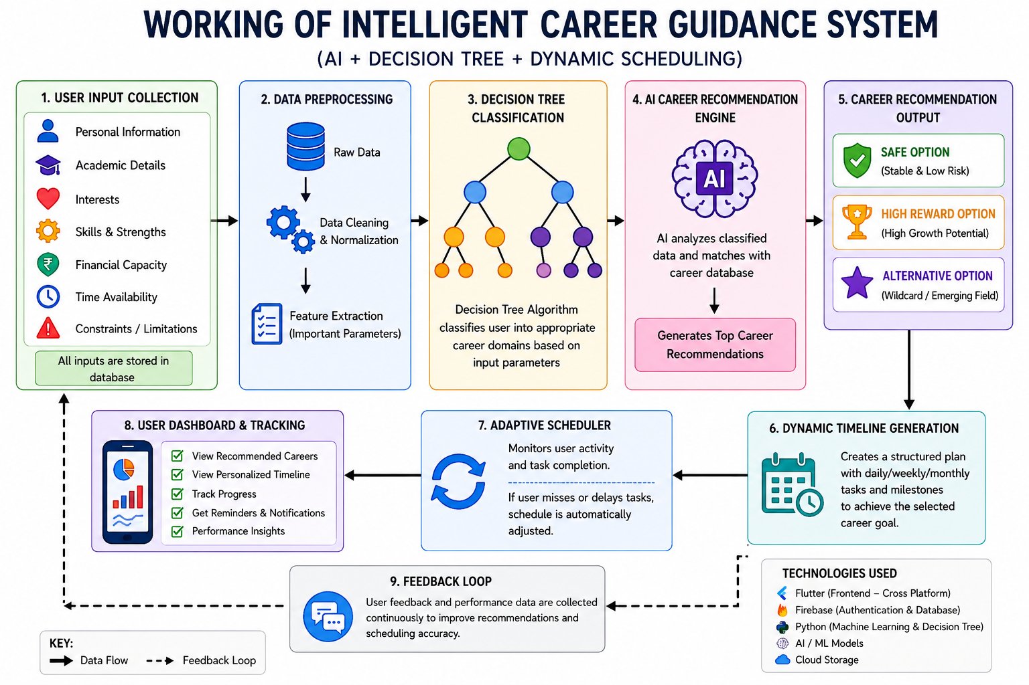
Source: Created by Author
For learners using the platform, nextStepAI follows a structured and modular methodology that integrates data collection, decision-making algorithms, artificial intelligence, and adaptive scheduling to provide comprehensive career guidance. The methodology is designed to ensure that the application is both intelligent and practical in real-world scenarios.
1. Data Collection and Input Processing
The first stage of the application involves collecting user-specific data through structured input forms within the application. The data includes multiple parameters such as:
- Personal interests and preferences
- Skill levels and competencies
- Academic background and performance
- Financial capacity
- Time availability and constraints
This data is preprocessed and organized into a structured format so that it can be effectively used by the decision-making algorithms.
2. Decision Tree-Based Classification
The processed user data is then passed to the decision-tree model, which acts as the primary classification mechanism. The decision tree evaluates user inputs through a series of logical conditions and splits the data into different branches based on predefined rules.
Each node in the tree represents a decision based on a specific parameter (e.g., interest in technical fields, preference for stability, financial condition), and each branch leads to a more refined classification. The final output of this stage is the identification of a suitable career domain, such as:
- Government sector
- Private sector
- Entrepreneurship
- Specialized or emerging fields
The decision-tree is chosen due to its interpretability, efficiency, and ability to handle structured decision-making problems.
3. AI-Based Career Recommendation Engine
After identifying the appropriate career domain, the application uses an AI recommendation layer to generate specific career paths. This module analyzes the user profile in a more flexible, context-sensitive manner compared to rule-based systems.
The AI model generates multiple career options categorized as:
- Safe Path – Stable and low-risk options
- High-Reward Path – High-growth but competitive options
- Alternative Path – Non-traditional or emerging careers
The AI ensures that recommendations are personalized and aligned with both user capabilities and practical constraints.
4. Persistent Recommendation System
Unlike traditional AI chat-based systems, NextStepAI implements a persistence mechanism. User data and generated career recommendations are stored securely, ensuring that:
- Recommendations remain consistent across sessions
- Results do not change unless user inputs are modified
- Users can revisit and track their selected career paths
This improves reliability and builds user trust in the system.
5. Timeline Generation Module
Once a user selects a career path, the application generates a structured timeline that converts long-term goals into actionable steps. The timeline includes:
- Daily or weekly tasks
- Skill development milestones
- Preparation strategies (e.g., exams, certifications)
From a practical implementation view, this module ensures that users have a clear roadmap to follow, reducing confusion and improving execution.
6. Adaptive Scheduling Mechanism
A key innovation of the application is the adaptive scheduling module. This module continuously monitors user activity and performance, such as:
- Task completion rate
- Consistency of usage
- Delays or missed tasks
Based on this analysis, the system dynamically adjusts the schedule by:
- Rescheduling incomplete tasks
- Modifying workload intensity
- Updating timelines to maintain feasibility
This ensures that the plan remains realistic and flexible according to user behavior.
7. Feedback and Continuous Improvement
The application incorporates a feedback loop where users can update their preferences or provide feedback on recommendations. This allows:
- Refinement of career suggestions
- Improved personalization over time
- Better alignment with user goals
8. System Integration and Deployment
The complete system is implemented using:
- Flutter (Frontend) – for cross-platform UI development
- Dart (Programming Language) – for application logic
- Firebase (Backend Services) – for authentication and data storage
- API Integration (LLM - LLaMA 3.1) – for intelligent recommendations
The modular architecture ensures scalability and allows future enhancements such as real-time data integration and advanced analytics.
Conclusion of Methodology
The proposed methodology combines structured decision-making with adaptive intelligence to create a comprehensive career guidance system. By integrating decision-tree classification, AI-based recommendations, persistent data handling, and dynamic scheduling, the application effectively bridges the gap between career choice and execution.
3.4 System Architecture
The application architecture of the proposed intelligent career guidance system is designed using a modular and layered approach to ensure scalability, flexibility, and efficient data processing. The architecture integrates frontend, backend, decision-making, and adaptive planning components to deliver a seamless and intelligent user experience.
1. User Interface Layer (Frontend)
For NextStepAI, the frontend of the application is developed using Flutter, which provides a cross-platform user interface. This layer acts as the interaction point between the user and the application.
Functions:
- Collect user inputs such as interests, skills, academic details, and constraints
- Display career recommendations and schedules
- Provide an interactive and user-friendly experience
The frontend ensures smooth navigation and responsiveness across different devices.
2. Data Input and Preprocessing Module
This module is responsible for collecting and preparing user data for further processing.
Functions:
- Gather structured input data from users
- Clean and organize data into a usable format
- Validate user inputs for accuracy
This step ensures that the system receives high-quality data for accurate decision-making.
3. Decision Tree Engine
The Decision Tree module acts as the primary classification component of the system.
Functions:
- Analyze user inputs using predefined logical conditions
- Classify users into suitable career domains
- Provide structured and interpretable decision outcomes
This module reduces the complexity of decision-making and narrows down career options effectively.
4. AI Recommendation Engine (LLM Integration)
For learners using the platform, after classification, the application uses an AI recommendation layer powered by a Large Language Model (LLaMA 3.1).
Functions:
- Generate personalized career paths
- Provide multiple options (safe, high-reward, alternative)
- Offer detailed explanations and guidance
This module enhances flexibility and ensures context-aware recommendations.
5. Persistent Data Layer (Firebase Backend)
The backend of the system is implemented using Firebase, which provides cloud-based services.
Functions:
- Store user profiles and input data
- Maintain consistency of recommendations across sessions
- Handle authentication and user management
This ensures data persistence and reliability.
6. Timeline Generation Module
This module converts selected career paths into structured plans.
Functions:
- Break long-term goals into smaller tasks
- Generate daily or weekly schedules
- Provide a clear execution roadmap
It helps users move from decision-making to action.
7. Adaptive Scheduling Module
This is a key feature of the system that ensures flexibility and practicality.
Functions:
- Monitor user activity and task completion
- Detect delays or inconsistencies
- Adjust schedules dynamically
This module ensures that the system adapts to real-world user behavior.
8. Feedback and Update Module
This module allows continuous improvement of the system.
Functions:
- Accept user feedback
- Update recommendations based on new inputs
- Improve personalization over time
Overall Workflow
- User provides input through the frontend
- Data is processed and structured
- Decision Tree classifies the user into a career domain
- AI engine generates personalized career paths
- User selects a career option
- Timeline is generated
- Adaptive scheduler updates the plan based on activity
- Data is stored for future use

Conclusion
The application architecture effectively integrates decision-making algorithms, AI intelligence, and adaptive planning into a unified framework. This ensures that the application is not merely capable of providing accurate career recommendations but also supports users in achieving their goals through structured and flexible planning.

3.5 Development Environment and Tools Used
The development of the proposed intelligent career guidance system is carried out using modern cross-platform and cloud-based technologies to ensure scalability, performance, and user accessibility. The following tools, frameworks, and technologies are used in the implementation of the application:
Flutter
Flutter is an open-source UI toolkit developed by Google used to build natively compiled applications for mobile, web, and desktop from a single codebase. In this work, Flutter is used to develop a cross-platform application that ensures smooth performance and a consistent user experience across devices.
Benefits over competitors:
- At the project level, unlike traditional native development (Java/Kotlin for Android, Swift for iOS), Flutter allows single codebase development, reducing development time and effort.
- Compared to frameworks like React Native, Flutter provides better performance due to its direct compilation to native code.
- It offers rich UI components and customizable widgets, enabling the creation of an attractive and responsive user interface.
- Hot Reload feature allows faster development and debugging.
Usefulness in this work:Flutter is ideal for this work because it allows the application to run on multiple platforms with consistent behavior, making the career guidance system accessible to a wider audience without increasing development complexity.
Dart
Dart is the programming language used by Flutter for building application logic and user interfaces. It is optimized for developing fast, scalable, and efficient applications.
Benefits over competitors:
- Compared to languages like JavaScript, Dart provides better performance and type safety.
- It supports asynchronous programming, which is essential for handling API calls and real-time updates efficiently.
- Offers clean and structured syntax, improving code maintainability.
Usefulness in this work:Dart helps in implementing complex logic such as decision tree processing, API handling, and dynamic scheduling efficiently, ensuring smooth performance of the application.
Firebase
Firebase is a cloud-based backend platform provided by Google. It is used in this work for authentication, database management, and real-time data handling.
Benefits over competitors:
- Eliminates the need to build a backend from scratch, unlike traditional server-based systems.
- Provides real-time database capabilities, which are faster than conventional REST-based systems.
- Built-in authentication features (email, Google sign-in) simplify user management.
- Highly scalable and secure compared to custom backend solutions.
Usefulness in this work:Firebase is particularly useful for storing user data, maintaining persistent career recommendations, and handling authentication. It ensures that user progress, schedules, and preferences are securely stored and accessible across sessions.
Google Antigravity IDE
Within the application design, google Antigravity (agent-based IDE) is used as the Integrated Development Environment for developing and testing the Flutter application. As an agent-driven platform, it automates routine development tasks while offering advanced tools for coding, debugging, UI design, and performance optimization. Why it was selected:
- Uses intelligent agents to automate setup, dependency management, and repetitive workflows, saving developer time compared to traditional editors like VS Code.
- Includes built-in emulator orchestration for testing across multiple virtual devices and configurations.
- Provides deep integration with Flutter and Firebase services through agent-managed toolchains and templates.
- Supports real-time performance profiling, anomaly detection, and proactive error reporting.
Usefulness in this work:Google Antigravity accelerates development, testing, and debugging by automating environment setup and repetitive tasks, ensuring the application is reliable and performs efficiently across diverse environments.
Conclusion
From a practical implementation view, the selected development environment provides a powerful combination of frontend, backend, and development tools that enhance the overall efficiency, scalability, and usability of the application. Compared to older approaches, these technologies reduce development complexity, improve performance, and ensure that the application meets the requirements of a modern intelligent career guidance system.
2. Large Language Model (LLM) Used
LLaMA 3.1 (8B Instant):The application integrates the LLaMA 3.1 8B Instant model for generating intelligent career recommendations and study schedules. This model is capable of understanding user inputs in a contextual manner and generating meaningful, human-like responses. It analyzes multiple parameters such as interests, skills, and constraints to produce personalized and adaptive outputs.
Benefits over traditional systems:
- Provides context-aware recommendations, unlike rule-based systems which follow fixed logic.
- Capable of handling complex and unstructured inputs, improving flexibility.
- Generates dynamic and detailed responses, enhancing user understanding.
- Faster inference compared to larger models, making it suitable for real-time applications.
Usefulness in this work:The LLM has an important role in enhancing personalization by generating career paths and schedules that are tailored to each user. It also supports adaptive planning and improves the overall intelligence of the application.
3. State Management & Architecture
flutter_riverpod (3.3.1):
Used for efficient and reactive state management throughout the application. It manages user data, career assessments, and dynamic scheduling states.
Benefits over alternatives:
- More scalable and flexible compared to Provider or setState.
- Ensures better separation of concerns, improving code structure.
- Supports reactive programming, enabling real-time UI updates.
- Reduces bugs related to state inconsistencies.
Usefulness in this work:Riverpod is essential for managing complex states such as user inputs, career recommendations, and adaptive schedules. It ensures that changes in data are instantly reflected in the UI, improving responsiveness and user experience.
4. Networking & API Integration
http (1.6.0):
Used to send HTTP requests to external APIs (such as the Groq API) for generating AI-based career recommendations and study schedules.
Benefits:
- Lightweight and easy to integrate.
- Supports asynchronous operations for smooth performance.
- Enables communication between frontend and AI services.
Usefulness in this work:It allows seamless integration with AI models, enabling real-time generation of recommendations and schedules.
flutter_dotenv (6.0.0):
Used to securely store and manage environment variables such as API keys.
Benefits:
- Prevents exposure of sensitive information.
- Improves security and maintainability.
- Allows easy configuration across environments.
Usefulness in this work:Ensures that API keys like GROQ_API_KEY are securely handled, protecting the application from unauthorized access.
5. Authentication & Backend Services
firebase_core (4.7.0):
Initializes Firebase services within the application.
firebase_auth (6.4.0):
Handles user authentication such as sign-up, login, and logout.
google_sign_in (7.2.0):
Allows users to sign in using their Google accounts.
Benefits over traditional backend:
- Eliminates need for custom backend development.
- Provides secure and scalable authentication.
- Supports multiple login methods.
- Reduces development time significantly.
Usefulness in this work:These services ensure secure user management and allow users to save and access their data across sessions, which is critical for maintaining persistent recommendations and schedules.
6. Local Storage
shared_preferences (2.3.2):
Used for storing data locally on the user’s device.
Benefits:
- Enables offline access to important data.
- Improves performance by reducing repeated API calls.
- Simple and efficient for storing small data.
Usefulness in this work:It helps store user progress, schedules, and preferences locally, ensuring continuity even without internet access.
7. Utilities
intl (0.19.0):
Used for formatting dates and supporting internationalization.
Benefits:
- Provides accurate and consistent date formatting.
- Supports multiple languages and regions.
- Improves readability of schedules.
Usefulness in this work:It ensures that the generated timelines and schedules are displayed in a clear and user-friendly format, enhancing usability.
Conclusion
The integration of these tools and technologies provides a robust, scalable, and efficient system architecture. Each component plays a specific role in enhancing performance, security, and user experience, making the overall system more reliable and effective compared to traditional career guidance solutions.

3.6 Algorithms Used
NextStepAI utilizes a combination of structured decision-making algorithms and artificial intelligence techniques to provide accurate and personalized career guidance. The primary algorithms used in the application are the decision-tree algorithm and an AI-based recommendation algorithm (LLM-based processing).
1. Decision Tree Algorithm
The decision-tree algorithm is a supervised learning technique used for classification and decision-making. It works by splitting data into branches based on specific conditions and parameters, ultimately leading to a final decision or classification.
In this work, the decision-tree is used to classify users into appropriate career domains based on their input data. The process involves:
- Taking user inputs such as interests, skills, academic background, and constraints
- Evaluating these inputs through a series of logical conditions
- In this report, dividing the data into branches based on decisions (e.g., technical vs non-technical, risk-taking ability, financial condition)
- Reaching a final node that represents a suitable career domain
Advantages of Decision Tree:
- Simple and easy to understand
- Highly interpretable decision-making process
- Fast execution and low computational cost
- Suitable for handling structured data
For NextStepAI, use in this work:The decision-tree acts as the foundation of the application by narrowing down the broad career options into specific domains. It ensures that the recommendations are logically structured and aligned with user inputs.
2. AI-Based Recommendation Algorithm (LLM Integration)
After classification using the decision-tree, the application uses an AI-based recommendation approach powered by a Large Language Model (LLaMA 3.1) to generate personalized career paths and study schedules.
The AI model performs the following functions:
- Analyzes user data in a contextual and flexible manner
- Generates multiple career options (safe, high-reward, alternative)
- Provides detailed explanations and guidance
- Creates structured timelines and preparation strategies
- Unlike traditional algorithms, the AI model can process both structured and unstructured data, making it highly adaptable and intelligent.
Advantages of AI-based approach:
- Provides highly personalized recommendations
- Handles complex and multi-dimensional data
- Generates dynamic and human-like responses
- Adapts to different user profiles
From a practical implementation view, use in this work:The AI model enhances the application by refining the output of the decision-tree and generating meaningful career paths. It also supports timeline generation and adaptive planning.
3. Adaptive Scheduling Logic
In addition to the above algorithms, the application implements an adaptive scheduling logic, which can be considered a rule-based dynamic algorithm.
This logic includes:
- Monitoring user activity and task completion
- Identifying delays or inconsistencies
- Adjusting schedules dynamically
- Redistributing tasks to maintain feasibility
Use in this work:This ensures that the application is not static and can respond to real-time user behavior, making the planning process more practical and flexible.
Conclusion
The combination of decision-tree, AI-based recommendation, and adaptive scheduling algorithms provides a powerful framework for intelligent career guidance. The decision-tree ensures structured classification, the AI model enhances personalization, and the adaptive logic ensures continuous support and execution, making the application both effective and user-focused.

3.7 Testing Methodology
Testing is an essential phase in the development of the proposed career guidance system to ensure that all components function correctly and efficiently. The testing methodology adopted in this work focuses on verifying the accuracy of career recommendations, the reliability of the application, and the usability of the application.
1. Functional Testing
At the project level, functional testing is performed to verify that each module of the application operates according to the specified requirements. The following components are tested:
- User input module (data collection accuracy)
- Decision Tree classification (correct career domain selection)
- AI recommendation engine (relevance of career suggestions)
- Timeline generation module (proper task scheduling)
- Adaptive scheduler (correct adjustment of schedules based on user activity)
This ensures that all functionalities are working as intended.
2. Unit Testing
In unit testing, individual components or modules of the application are tested separately. Each module, such as input handling, API integration, and data storage, is verified independently to ensure correctness before integration.
3. Integration Testing
Integration testing is carried out to ensure that all modules of the application work together seamlessly. The interaction between the decision-tree, AI suggestion layer, Firebase backend, and scheduling modules is tested to confirm proper data flow and system coordination.
4. User Acceptance Testing (UAT)
User Acceptance Testing is conducted by allowing a group of users (learners) to interact with the application. The users provide input data and evaluate:
- Accuracy of career recommendations
- Usefulness of generated timelines
- Ease of use of the application
- Feedback from users is collected to identify improvements and validate the effectiveness of the application.
5. Performance Testing
Performance testing is conducted to evaluate the responsiveness and speed of the application. It includes:
- API response time for AI-generated recommendations
- App loading time and navigation speed
- Handling of multiple user inputs
This ensures that the application performs efficiently under normal usage conditions.
6. Usability Testing
Usability testing focuses on evaluating the user interface and overall user experience. It ensures that:
- The application is easy to navigate
- Instructions and outputs are clear and understandable
- Users can interact with the system without confusion
7. Test Data and Sample Size
The application is tested using data collected from a sample group of approximately 20–50 users. These users provide diverse inputs to evaluate the application’s performance across different scenarios.
Conclusion
The testing methodology ensures that NextStepAI is reliable, efficient, and user-friendly. By combining functional, integration, and user-based testing approaches, the application is validated to provide accurate career recommendations and effective scheduling support.

3.8. Screenshots
Actual Screenshots of App:
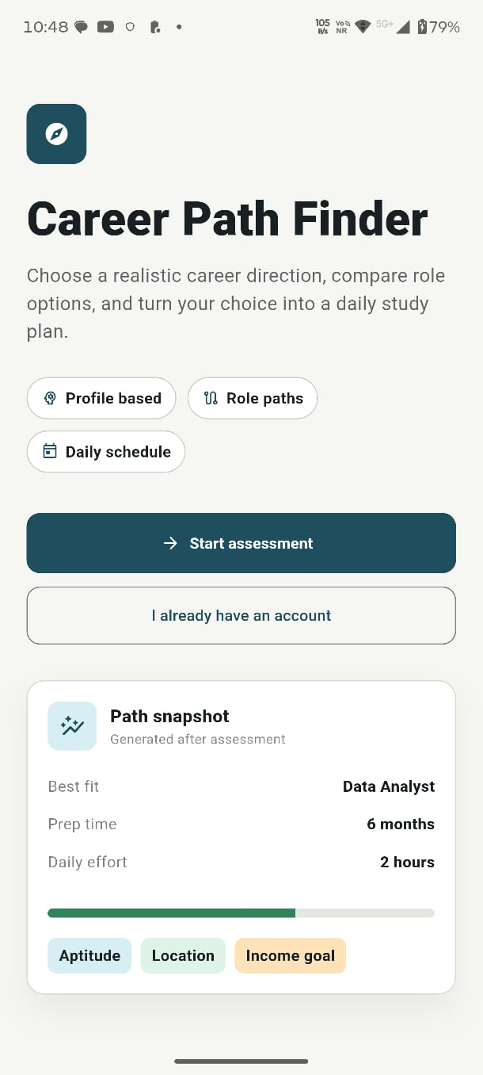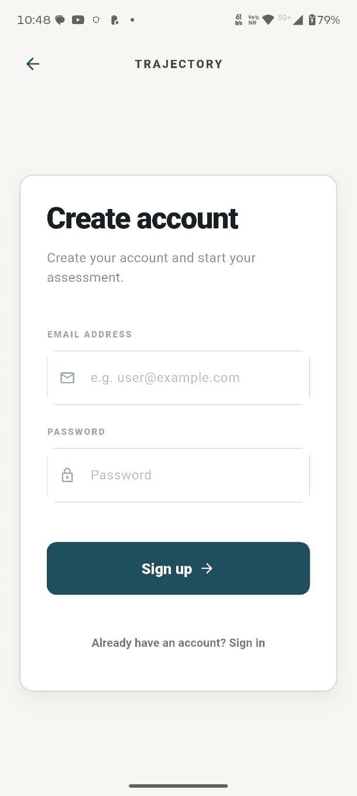
1. Home Screen (Career Path Finder Interface)
For learners using the platform, this screen represents the main dashboard of the application where users can start their career assessment journey. It provides key features such as profile-based recommendations, role exploration, and daily scheduling. The “Start Assessment” button allows users to begin the career analysis process. Further, a “Path Snapshot” section displays a quick overview of a suggested career path, including preparation time, daily effort, and key factors like aptitude and income goals.

2. Account Creation Screen (User Authentication Interface)
This screen is used for user registration and authentication. It allows new users to create an account by entering their email and password. The interface is simple and user-friendly, ensuring easy onboarding. It also provides an option for existing users to sign in, enabling secure access to career suggestions shaped around the individual user and saved progress.
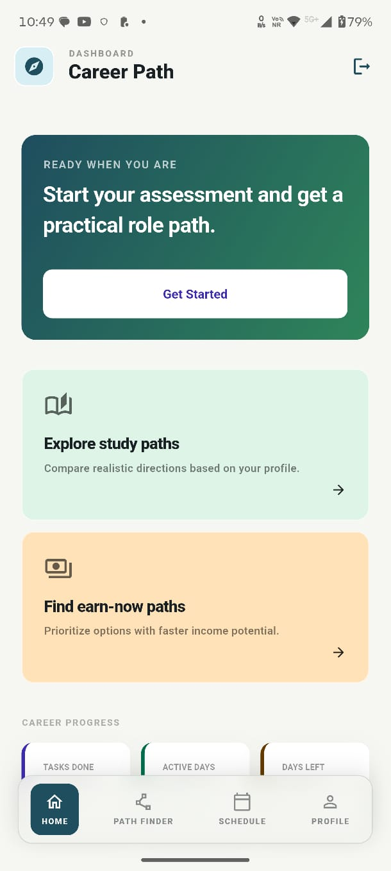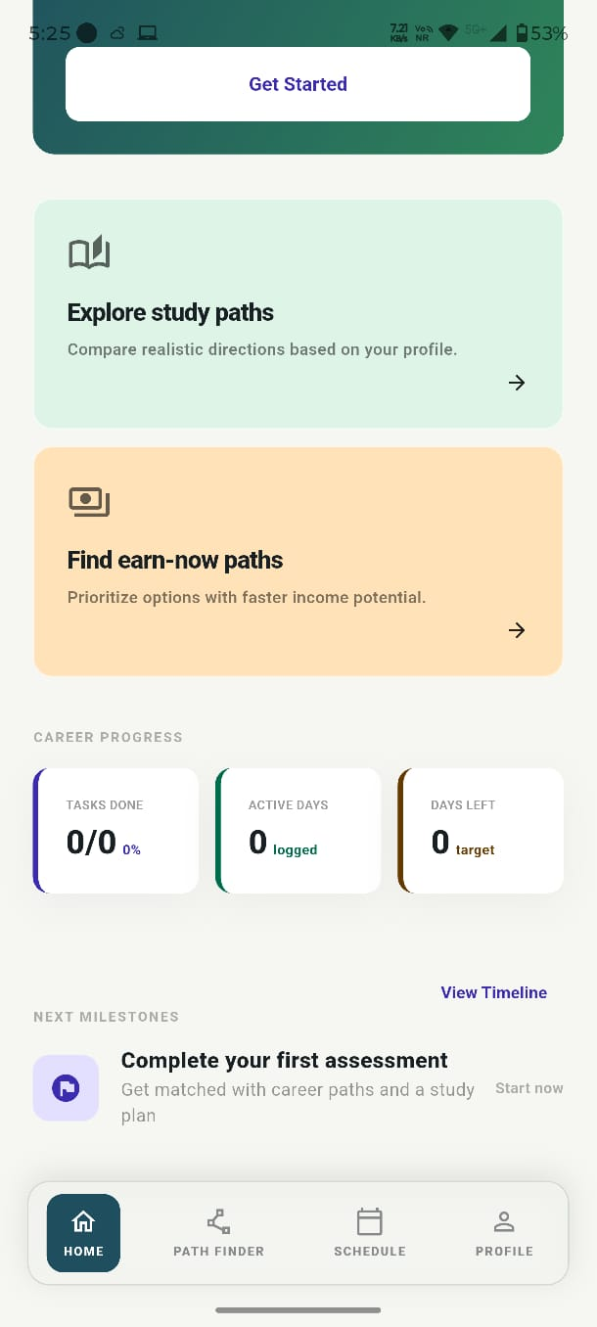
1. Dashboard Screen (Career Path Overview)
This screen represents the main dashboard of the application after user login. It provides a quick overview of the user’s career journey and progress. The “Get Started” button allows users to begin their assessment, while options like “Explore study paths” and “Find earn-now paths” help users explore different career directions based on their goals. The screen also displays progress indicators such as tasks completed, active days, and remaining targets, along with upcoming milestones to guide the user’s next steps.

2. Career Path Dashboard (Assessment Entry Screen)
This screen is designed to initiate the career assessment process. It highlights the main functionality of the application by encouraging users to start their assessment and receive a practical career path. The interface provides quick navigation options such as exploring study paths and income-focused career options. The bottom navigation bar allows users to switch between Home, Path Finder, Schedule, and Profile sections, ensuring smooth and structured navigation within the application.
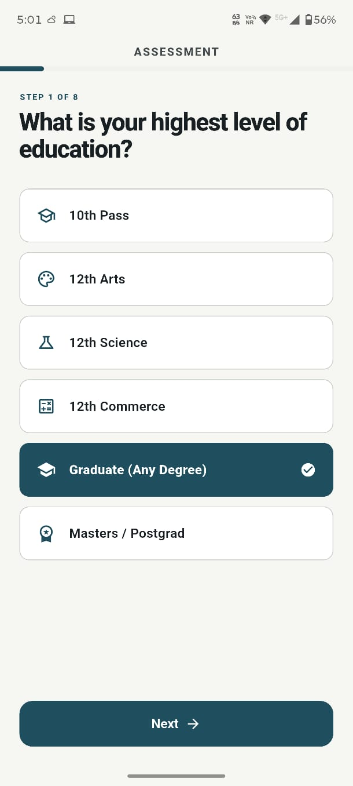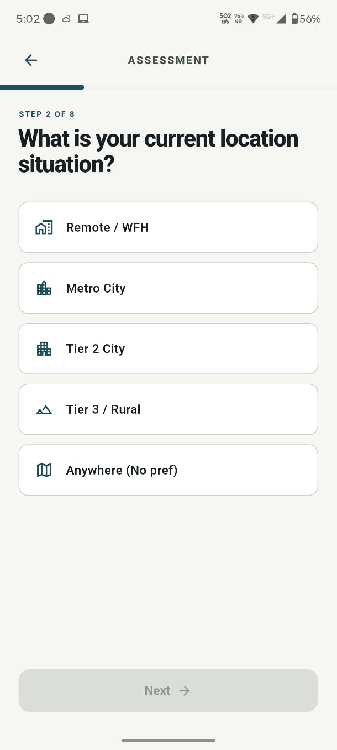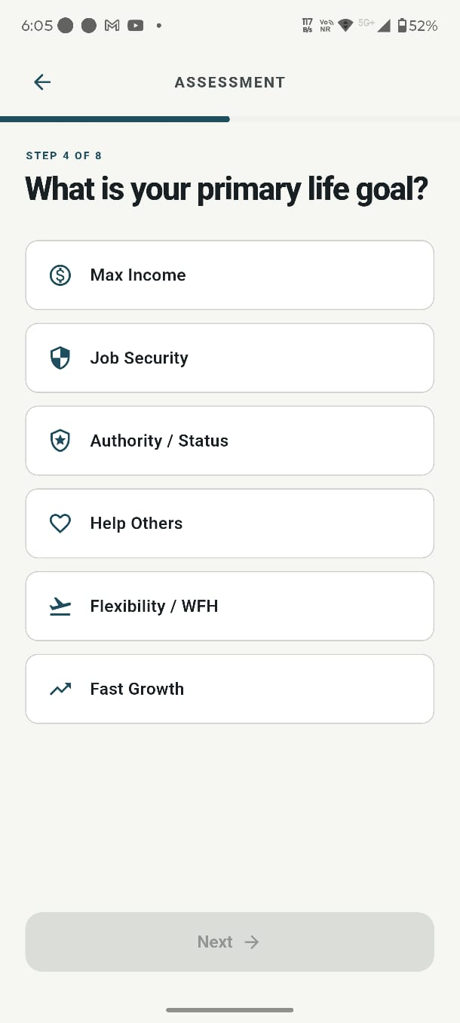
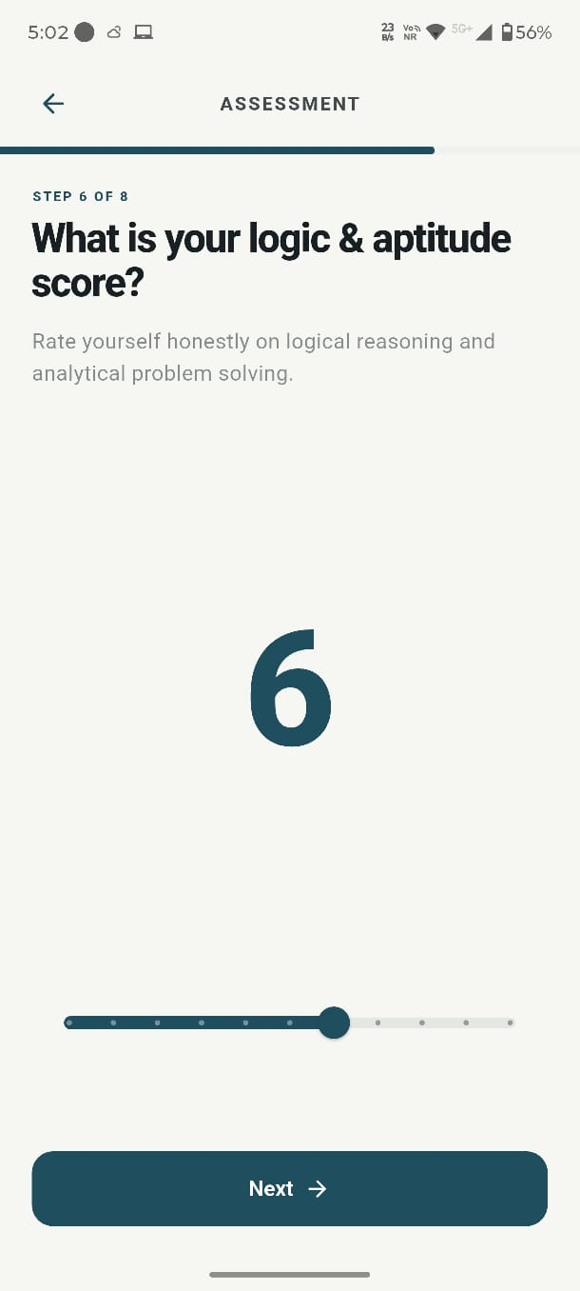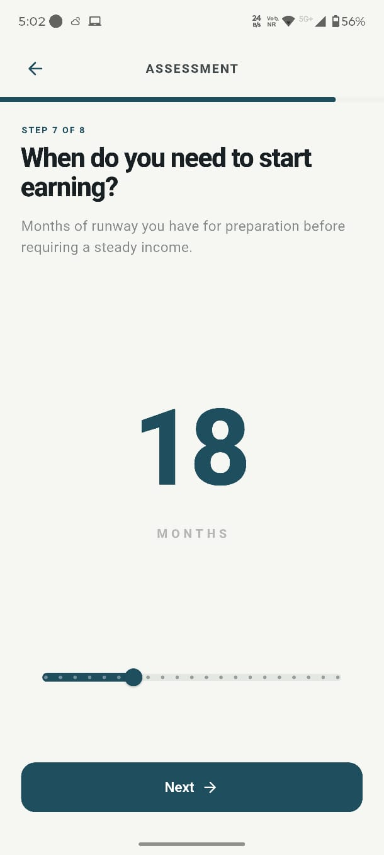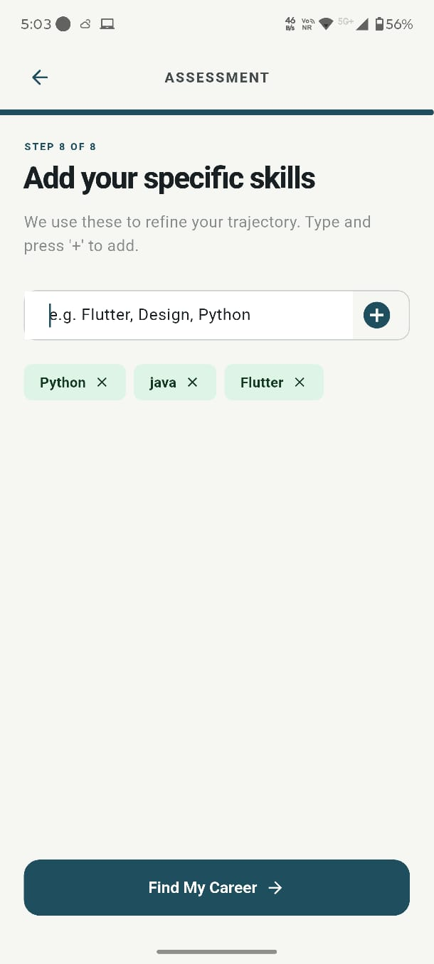
Assessment Module Overview
The assessment module of the application is designed to collect comprehensive user data through a structured and step-by-step process. It gathers important information such as the user’s career goals, personality type, logical and analytical ability, time constraints for earning, and existing skill set. This multi-dimensional input approach ensures that the application understands both the user’s preferences and real-world situation. By combining these parameters, the application is able to generate highly personalized and practical career recommendations. The assessment process is interactive and user-friendly, guiding users progressively while ensuring that all critical factors influencing career decisions are considered.
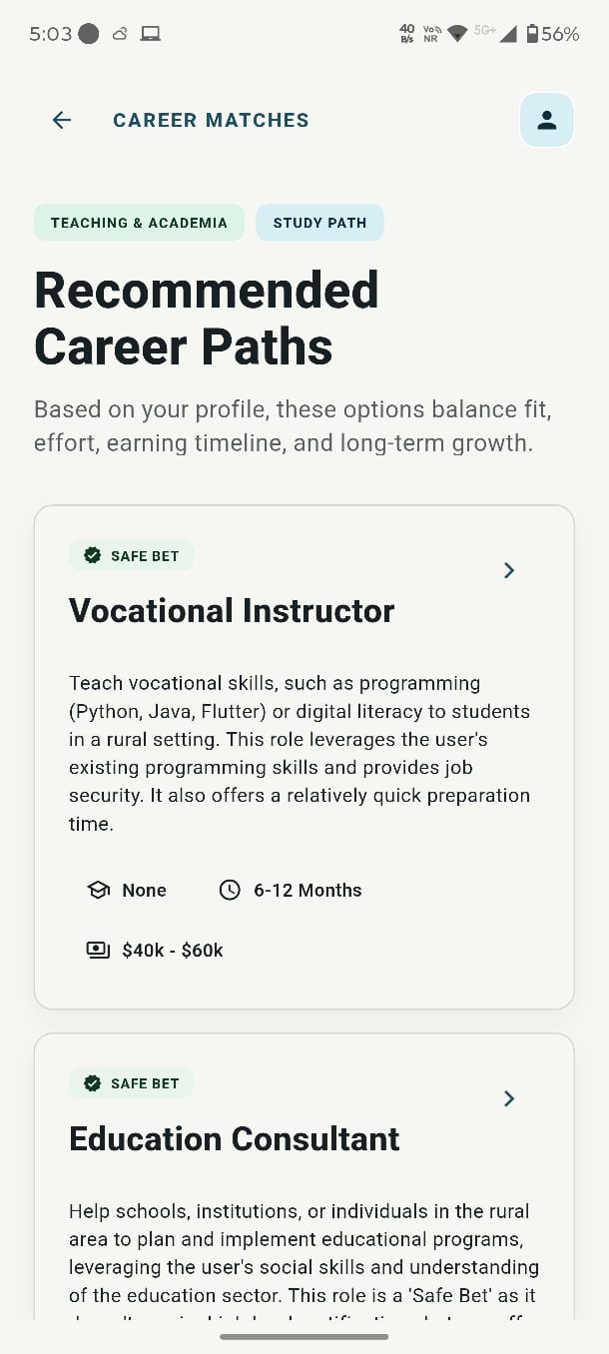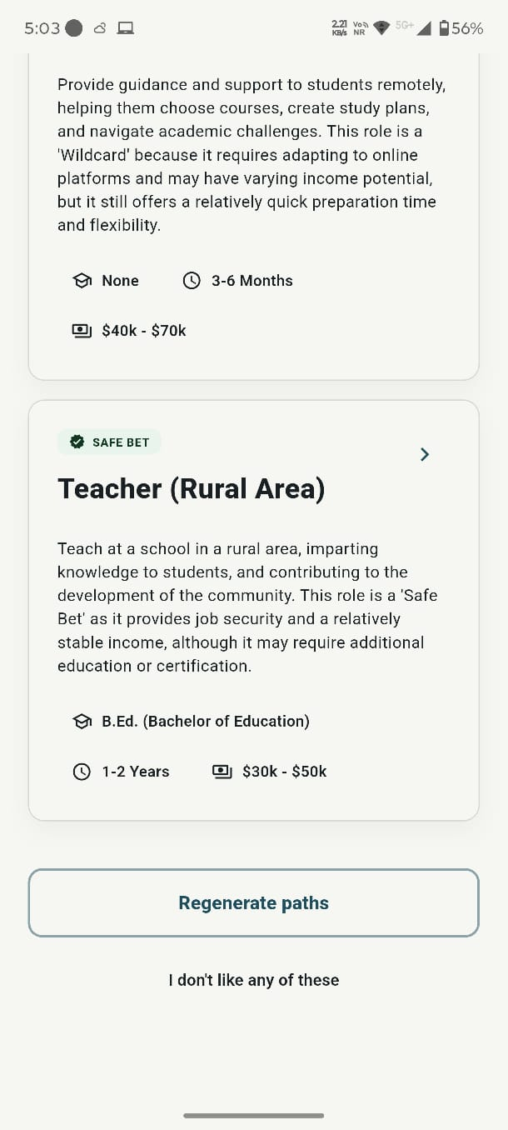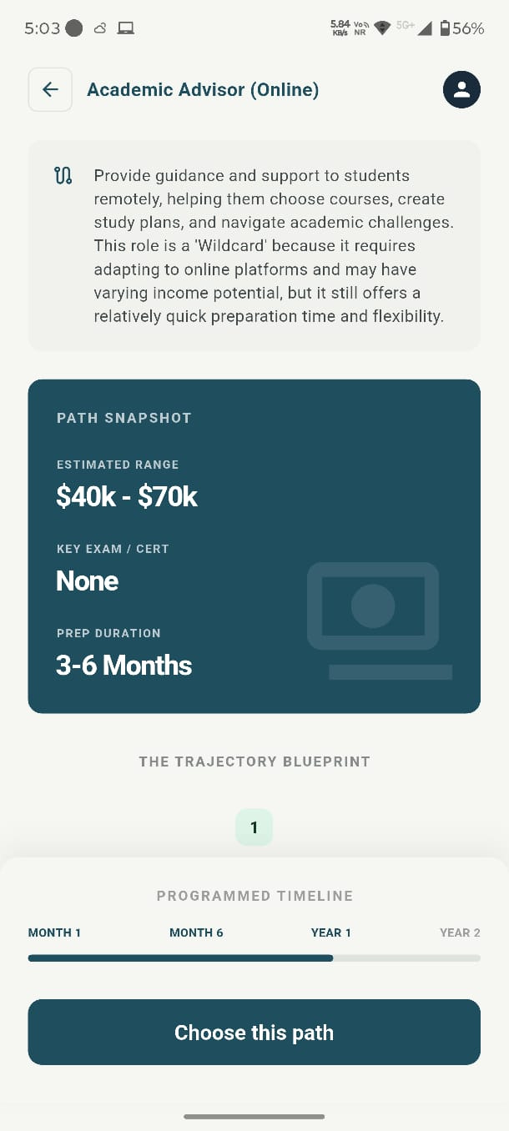
Career Recommendation and Selection Module
These screens represent the output and decision-making phase of the application, where users receive career suggestions shaped around the individual user based on their assessment inputs. The application presents multiple career paths categorized into different types such as safe, stable, or flexible options. Each career option includes important details such as role description, required qualifications, preparation time, and expected income range, helping users choose with better clarity.
The application also allows users to explore detailed information about each career path, including a structured overview and a “path snapshot” that summarizes key factors like duration, certification requirements, and earning potential. Further, users are provided with a visual timeline or roadmap that outlines the steps required to achieve the selected career goal.
Users can either select a recommended path, regenerate new suggestions if they are not satisfied, or explore alternative options. This module ensures that users not merely receive recommendations but also understand the practical steps needed to achieve their chosen career, making the application both informative and action-oriented.
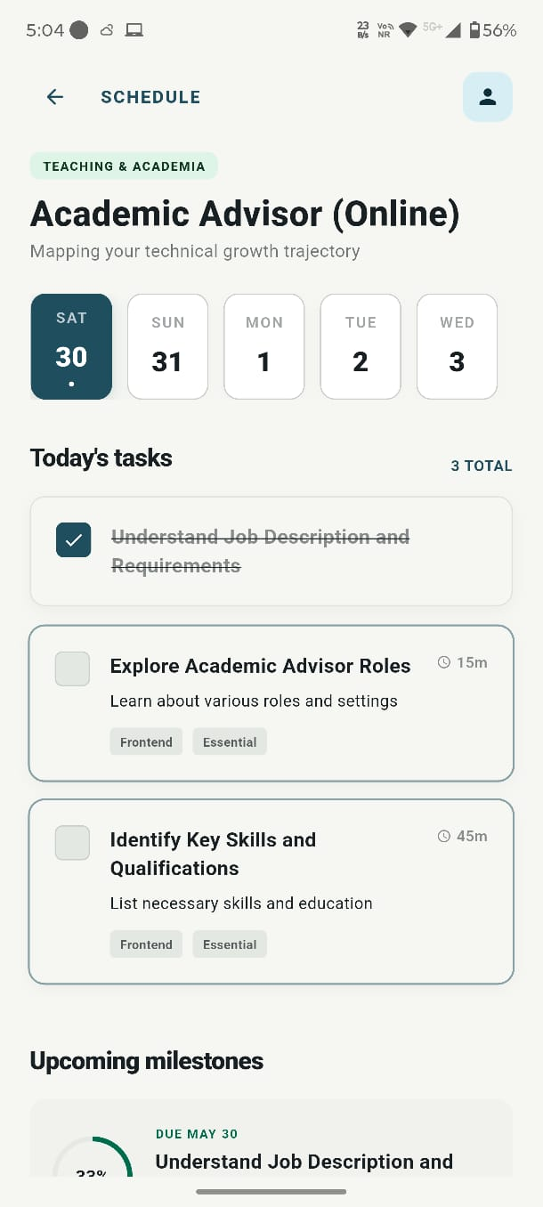
Career Plan Generation and Scheduling Module
In this report, these screens represent the final stage of the application where the user’s personalized career plan is generated and transformed into a structured execution strategy. After completing the assessment, the application processes user inputs and uses decision-making algorithms along with AI to create a tailored career path. A loading or processing screen is displayed to indicate that the application is analyzing the data and generating optimized recommendations.
Once the plan is ready, the application presents a detailed schedule interface where the selected career path is broken down into daily tasks and milestones. The schedule includes day-wise planning, task duration, and priority levels, allowing users to clearly understand what actions they need to take. It also tracks progress through completed tasks and upcoming milestones, ensuring continuous engagement and productivity.
This module plays a critical role in converting career recommendations into actionable steps. It ensures that users are not merely guided in choosing a career but are also supported in achieving it through structured planning and adaptive task management.

Conclusion
The overall system successfully integrates career assessment, intelligent recommendation, and execution planning into a single platform. Unlike traditional career guidance systems that only suggest options, this application focuses on both decision-making and implementation. By incorporating practical constraints, personalized AI recommendations, and adaptive scheduling, the application provides a practical and user-focused solution for career planning. It helps users gain clarity, stay consistent, and systematically work toward their goals, making it a comprehensive and impactful career guidance tool.

CHAPTER 4. DATA ANALYSIS, RESULTS, AND INTERPRETATION

4.1 Data Analysis
For NextStepAI, the data used in this work is primarily collected from users through structured input forms integrated within the application. The collected data includes both qualitative and quantitative parameters such as user interests, skills, academic background, budget limits, time availability, and personal constraints.
The application processes this data using a decision-tree algorithm, which classifies users into appropriate career domains based on their responses. The decision tree helps in simplifying complex decision-making by breaking it into smaller logical conditions. After classification, the processed data is passed to the AI recommendation layer, which analyzes multiple parameters to generate suitable career paths.
The application also tracks user interaction and activity data, which is used by the adaptive scheduling module to adjust timelines dynamically. This ensures that the analysis is not static but continuously updated based on user performance and engagement.

4.2 Results
The developed system successfully demonstrates the ability to generate personalized and context-aware career recommendations based on user inputs. By analyzing multiple parameters such as interests, skills, academic background, financial conditions, and time constraints, the application produces tailored outputs that align closely with individual user profiles.
For each user, the application provides multiple career options categorized into different levels of risk and opportunity:
- Safe Career Options: These include stable and low-risk career paths that offer consistent growth and job security.
- Within the application design, high-Reward Career Options: These are career paths with high growth potential, often requiring more effort and competition but offering greater long-term benefits.
- Alternative or Wildcard Options: These include non-traditional or emerging career paths that may not be commonly considered but align well with the user’s profile.
This categorization allows users to explore multiple possibilities and choose with better clarity based on their preferences and risk tolerance.
In addition to career recommendations, the application generates a structured and detailed timeline that breaks down larger career goals into smaller, actionable tasks. The timeline includes daily, weekly, or phase-wise activities that guide users step-by-step toward their objectives. This feature improves the practical usability of the application.
A key result observed is the effectiveness of the adaptive scheduling logic. The application continuously monitors user activity and adjusts the schedule accordingly. If a user fails to complete certain tasks or shows inconsistent engagement, the application automatically reschedules tasks to maintain continuity. This ensures that users do not lose progress and can continue their preparation without disruption.
Testing of the application was conducted on multiple users with varying profiles. The results indicated that:
- Career recommendations were relevant and aligned with user inputs
- Users found the system easy to use and understand
- The scheduling feature helped improve consistency and discipline
- The adaptive nature of the system made it more practical and user-friendly
Overall, the application performed effectively in providing both career guidance and execution support, addressing key gaps present in static guidance tools.
4.3 Interpretation
The results obtained from the application highlight the importance of incorporating multiple parameters in career choice. By considering factors such as personal interests, skill levels, and practical constraints, the application is able to generate more accurate and practical recommendations compared to older approaches.
One of the most significant insights from the results is that personalization greatly enhances decision-making quality. Unlike generic systems that provide similar suggestions to all users, NextStepAI delivers customized outputs that are specifically tailored to individual profiles. This improves user confidence and reduces uncertainty in career choice.
For learners using the platform, the integration of practical constraints further strengthens the application’s effectiveness. By considering factors such as financial limitations and time availability, the application ensures that the recommended career paths are not merely suitable but also achievable in real-life situations.
Another important interpretation is the impact of the adaptive planner. This feature has an important role in bridging the gap between career choice and execution. It ensures that users are not merely guided in choosing a career but are also supported throughout their preparation journey. The ability to dynamically modify schedules based on user behavior makes the application more realistic, flexible, and user-focused.
The combination of decision-tree logic and AI-based recommendation techniques proves to be highly effective. The decision-tree provides structured and interpretable classification, while the AI model enhances flexibility and personalization. Together, they create a robust framework for intelligent career guidance.
In addition, the results demonstrate that providing a step-by-step execution plan significantly improves user engagement and consistency. Users are more likely to stay focused and motivated when they have a clear roadmap to follow, which highlights the importance of execution-based systems.
Overall, the application successfully addresses the limitations of existing career guidance solutions by combining intelligent decision-making with practical implementation support. The findings validate that the proposed approach is effective, scalable, and capable of providing a comprehensive framework for career planning and development.

CHAPTER 5. FINDINGS AND CONCLUSION

5.1 Findings
At the project level, the development and implementation of the proposed intelligent career guidance system have led to several important observations and findings. These findings highlight the effectiveness of integrating decision-making algorithms with practical planning features in addressing real-world career challenges faced by learners.
Firstly, it is observed that the application is capable of providing highly career suggestions shaped around the individual user by analyzing multiple user-specific inputs such as interests, skills, academic background, and situational constraints. Compared with static guidance tools that rely on limited parameters, this system considers a broader range of factors, which significantly improves the relevance and applicability of the recommendations.
Secondly, the inclusion of practical constraints, such as budget limits, time availability, and personal limitations, has an important role in enhancing the practicality of career suggestions. This is particularly important in the Indian education and employment context, where such factors often influence career decisions. The application ensures that recommended career paths are not only based on user preferences but are also feasible within their real-life conditions.
Another key finding is the effectiveness of the decision-tree algorithm in classifying users into appropriate career domains. The structured and rule-based nature of the decision tree allows for transparent and logical decision-making, making it easier to interpret how recommendations are generated. This improves both system reliability and user trust.
In addition, the integration of an AI recommendation layer enhances the overall decision process by offering multiple career options categorized into safe, high-reward, and alternative (wildcard) paths. This approach allows users to evaluate different possibilities based on their risk tolerance and future aspirations, thereby supporting better decision-making.
One of the most significant findings of this work is the impact of the adaptive timeline creation feature. The application successfully converts larger career goals into short-term actionable steps, providing users with a clear roadmap for achieving their objectives. This structured planning helps users maintain focus and consistency in their preparation.
In addition, the adaptive scheduling logic emerges as a unique and highly effective feature of the application. Unlike static planning tools, this system continuously monitors user activity and adjusts the schedule accordingly. If a user fails to complete certain tasks or shows inconsistent behavior, the application intelligently reschedules tasks to maintain feasibility. This flexibility ensures that the plan remains realistic and achievable, thereby increasing user engagement and productivity.
In this report, user testing further indicates that the application improves clarity, confidence, and decision-making ability among learners. Many users found the application more helpful compared to traditional career guidance methods, as it does not merely suggest career options but also provides a clear path to follow.
Overall, the findings demonstrate that combining intelligent recommendation techniques with adaptive planning improves the effectiveness of career guidance systems.

5.2 Conclusion
Overall, the proposed intelligent career guidance system successfully addresses the major challenges associated with career choice and planning among learners. By integrating decision-tree algorithms with AI-based recommendation techniques, the application provides personalized, accurate, and context-aware career suggestions.
One of the key strengths of the application lies in its ability to go beyond traditional recommendation models by incorporating practical constraints into the decision process. This ensures that the suggested career paths are not merely aligned with user interests and abilities but are also practical and achievable within their circumstances.
Also, the application introduces an innovative approach by combining career guidance with execution planning. The adaptive timeline creation feature transforms abstract career goals into concrete, manageable tasks, enabling users to follow a structured preparation strategy. This significantly reduces confusion and improves consistency in efforts.
The adaptive planner further enhances the application by making it responsive to user behavior. By continuously updating the schedule based on performance and activity, the application ensures that users remain on track even if they face delays or inconsistencies. This adaptability makes the application more realistic and effective compared to existing static solutions.
For NextStepAI, from a technological perspective, the use of Flutter enables cross-platform compatibility, making the application accessible to a wide range of users. The modular system design ensures scalability and allows for future enhancements such as integration with real-time job market data, advanced machine learning models, and expanded career databases.
In summary, the project successfully bridges the gap between career choice and its practical implementation. It does not merely help learners identify suitable career paths but also empowers them with a clear, flexible, and actionable roadmap to achieve their goals. The application has the potential to reduce career-related uncertainty, improve planning efficiency, and support learners in making informed and confident career decisions.
Future improvements can further enhance the application’s capabilities by incorporating more advanced AI techniques, expanding the dataset, and integrating real-time updates. Despite certain limitations, NextStepAI represents a significant step toward developing intelligent, user-focused career guidance solutions.

CHAPTER 6. RECOMMENDATIONS AND LIMITATIONS OF THE STUDY

6.1 Recommendations
The proposed intelligent career guidance system demonstrates significant potential in assisting learners with career choice and planning. However, there are several areas where the application can be further enhanced to improve its efficiency, scalability, and real-world applicability.
One of the primary recommendations is the integration of advanced artificial intelligence and machine learning models. While the current system uses a combination of decision-tree and LLM-based recommendations, future versions can incorporate more sophisticated models such as deep learning and predictive analytics. These models can analyze larger datasets, identify complex patterns, and provide more accurate and context-aware career suggestions.
Within the application design, another important enhancement is the incorporation of real-time job market data and industry trends. By integrating APIs that provide live updates on job openings, skill demands, salary trends, and industry growth, the application can ensure that users receive the most relevant and up-to-date career guidance. This feature will bridge the gap between theoretical planning and actual market requirements.
The application can also be expanded to include a wider range of career domains and specialized fields, including emerging areas such as artificial intelligence, blockchain, cybersecurity, and digital entrepreneurship. This will allow users to explore modern career opportunities beyond traditional paths and align themselves with future industry demands.
Integration with government exam portals, educational platforms, and certification providers is another valuable recommendation. This will enable users to directly access important notifications, exam schedules, application deadlines, and preparation resources within the application, making it a centralized platform for career development.
To improve accessibility, the application should support multilingual interfaces, allowing users from different linguistic backgrounds across India to interact with the application in their preferred language. This will make the application more inclusive and user-friendly, especially for learners from rural or non-English-speaking regions.
A web-based version of the application can also be developed alongside the mobile app to ensure broader accessibility. This will allow users to access the application from desktops and laptops, making it more convenient for different types of users.
The application can be further enhanced by introducing mentor guidance, expert consultation, and community support features. Users can connect with professionals, educators, or peers to gain real-world insights, share experiences, and receive personalized advice. This human interaction layer will complement the AI-based recommendations.
A highly impactful addition would be the implementation of a distraction management system, which can help users stay focused during their scheduled study time by limiting access to distracting applications such as social media. This feature addresses one of the major challenges faced by learners in maintaining consistency.
From a practical implementation view, another innovative recommendation is the inclusion of a “Day-in-the-Life Simulation” feature, where users can experience tasks similar to those performed in their target job roles. This will provide practical exposure and help users understand the real nature of their chosen careers, lowering uncertainty and improving decision-making.
The application can also incorporate a career transition or fallback mechanism, which suggests alternative career paths requiring similar skills if a user is unable to succeed in their initially chosen path. This ensures continuity in career development and prevents loss of time and effort.
In addition, the adaptive scheduling system can be improved by integrating predictive analytics and behavioral analysis. By analyzing user patterns such as consistency, performance, and engagement, the application can proactively adjust schedules and provide intelligent suggestions to optimize productivity.
The addition of gamification features, such as progress tracking, achievement badges, and reward systems, can further enhance user engagement and motivation. These features encourage users to stay consistent and make the learning process more interactive.
Finally, future versions of the application can incorporate data analytics dashboards that provide insights into user performance, progress trends, and goal completion rates. This will help users monitor their journey more effectively and choose with better clarity.
Overall, while NextStepAI provides a strong foundation for intelligent career guidance, the above recommendations can transform it into a comprehensive, scalable, and real-world career development platform capable of addressing diverse user needs and evolving industry demands.

6.2. Limitations of the Study
For learners using the platform, despite the effectiveness of NextStepAI, certain limitations exist that may affect its performance and applicability in real-world scenarios.
- Dependence on user-provided data: The accuracy of the application’s recommendations largely depends on the correctness and completeness of the data entered by the user. If users provide incorrect, incomplete, or biased information, the application may generate career suggestions that are less accurate or unsuitable.
- Limited dataset scope: The current system operates on a relatively limited dataset, which may restrict the diversity and depth of career recommendations. A broader dataset would enable the application to cover a wider range of career options and improve recommendation quality.
- No live market-data connection: The application does not currently incorporate real-time job market trends, industry demands, or examination updates. This may affect the relevance of recommendations, especially in rapidly evolving fields where requirements change frequently.
- Basic AI model implementation: The AI model used in the application, while effective, is relatively basic and may not fully capture complex human behaviors, preferences, and long-term career dynamics. Advanced models could improve predictive accuracy and personalization.
- Internet dependency: The application requires internet connectivity for accessing AI services and backend data. This may limit usability in areas with poor or unstable network connections.
- Limited testing sample size: The application has been tested on a relatively small group of users, which may not fully represent the diversity of real-world users. A larger and more diverse testing sample would provide better validation of system performance.
- At the project level, no guarantee of career success: The application provides guidance, recommendations, and planning support; however, it does not guarantee career success. Outcomes depend on multiple external factors such as user effort, consistency, opportunities, and changing market conditions.
Conclusion of Limitations
These limitations highlight areas for future improvement and development. Addressing these challenges through advanced AI models, real-time data integration, and larger-scale testing can significantly enhance the application’s effectiveness and reliability.

BIBLIOGRAPHY
Research paper
[1] I. Gati and I. Asher, “The PIC model for career decision making: Prescreening, in-depth exploration, and choice,” Journal of Vocational Behavior, vol. 58, no. 3, pp. 327–344, 2001.
[2] A. Kumar, S. Sharma, and R. Singh, “Career recommendation system using machine learning,” International Journal of Computer Applications, vol. 160, no. 7, pp. 25–29, 2017.
[3] R. Sinha and A. Sinha, “An intelligent career guidance system using data mining techniques,” International Journal of Advanced Research in Computer Science, vol. 10, no. 2, pp. 45–50, 2019.
[4] P. Singh, M. Verma, and K. Patel, “Decision tree-based career prediction system for students,” International Journal of Engineering Research & Technology (IJERT), vol. 9, no. 5, pp. 1120–1124, 2020.
[5] N. Bhatia and S. Jain, “Educational recommendation systems using artificial intelligence: A review,” International Journal of Scientific & Technology Research, vol. 10, no. 3, pp. 210–215, 2021.

Websites
[1] Google, “Firebase Documentation,” Available: https://firebase.google.com
[2] Google, “Flutter Documentation,” Available: https://flutter.dev
[3] Google, “Dart Programming Language,” Available: https://dart.dev
[4] Groq Inc., “Groq API Documentation,” Available: https://console.groq.com/docs
[5] Meta AI, “LLaMA: Large Language Model Meta AI,” Available: https://ai.meta.com/llama
[9] ResearchGate GmbH, “ResearchGate,” Available: https://www.researchgate.net

