A Comprehensive Study of Robotic Sensors and Their Practical Application in Autonomous Rail Inspection (Project RailSight)
[ Name:Piyanshi Sinha / Student Registration Number: 261090050740]
RoboManipal Research Taskphase, Department of Mechatronics / Electronics
Manipal Institute of Technology, MAHE, Manipal, India
Email: priyanshi1.mitmpl2026@learner.manipal.edu

Abstract—This paper presents a concise study of core robotic sensors—including proximity sensors (inductive, capacitive, optical, ultrasonic, and magnetic), Inertial Measurement Units (IMUs), rotary encoders, Hall effect sensors, and Light Dependent Resistors (LDRs)—along with three extended modalities: piezoelectric transducers, Time-of-Flight (ToF) LiDAR, and strain gauges. Each sensor is examined for its operating physical principle, signal conditioning, and failure modes. Finally, these sensory systems are integrated into Project RailSight, an autonomous broad-gauge rail-inspection micro-rover, demonstrating real-world sensor fusion for track defect detection and localized infrastructure health monitoring.
Keywords—Proximity Sensors, IMU, Rotary Encoders, Hall Effect, LDR, Non-Destructive Testing, Sensor Fusion, Project RailSight.

I. Introduction
Every mobile robot operates in a continuous loop:

Sense->Think->Act
The "Sense" phase is handled by devices that convert physical quantities (like distance, magnetic flux, light, or acceleration) into measurable electrical voltages.
In mobile robotics, choosing the wrong sensor causes system failure: optical sensors get blinded by sunlight or dust, while mechanical switches wear out over time. In specialized tasks—such as inspecting railway tracks in Project RailSight—sensors must survive outdoor conditions, dirt, and vibrations while detecting microscopic cracks.
This paper breaks down every essential sensor in plain terms and demonstrates how they unite inside a real robot.
II. Proximity Sensors (Contactless Object Detection)
Proximity sensors detect whether an object is nearby without physically touching it. This prevents mechanical wear and tear.
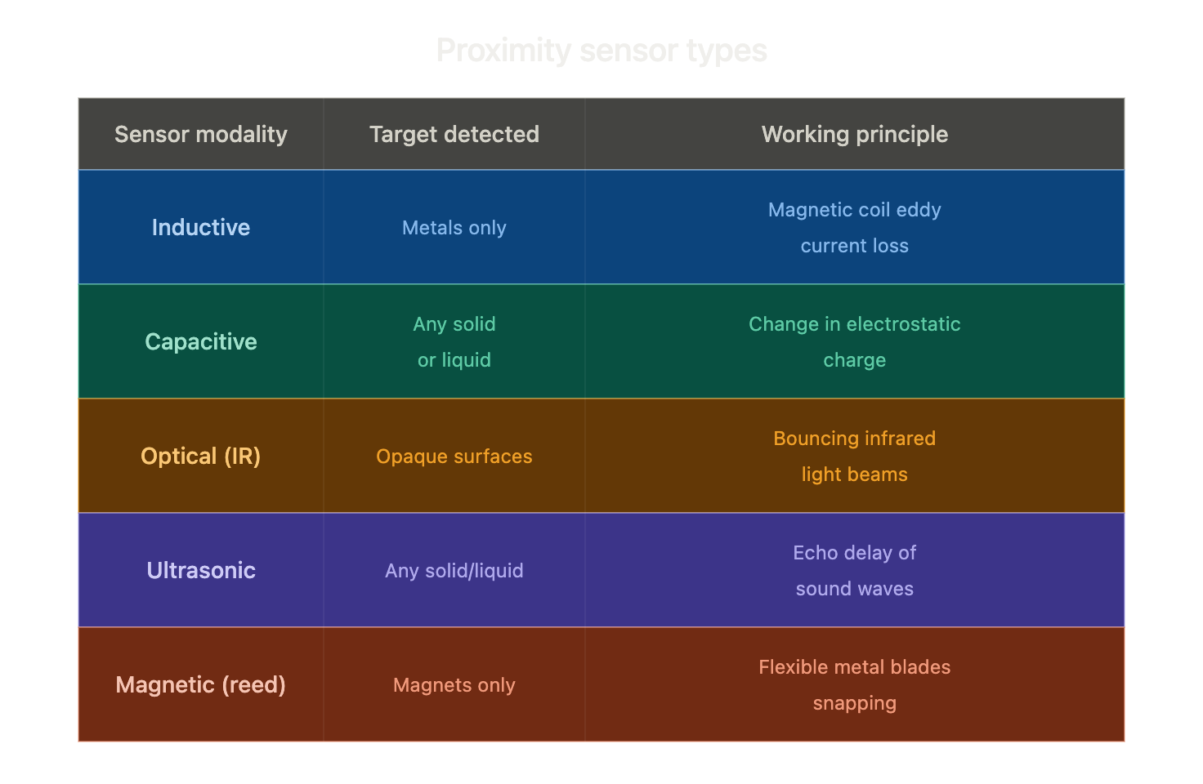

A. Inductive Proximity Sensors
- How It Works: The sensor contains an internal copper coil and oscillator that produces an invisible, alternating magnetic field at its front tip. When a metal target enters this field, tiny circular electrical currents (called eddy currents) are induced inside the metal. These currents steal energy from the sensor's magnetic field, making the internal signal drop. A threshold detector spots this drop and switches an output transistor “on”.
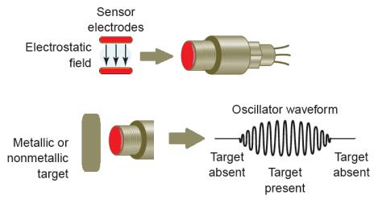
- Key Feature: Completely immune to dust, water, and oil; it strictly detects metallic objects.
- Application in Project RailSight: Pointed downward directly at the steel rails to verify that steel clips and joint bolts are present and tightly in place.

B. Capacitive Proximity Sensors
- How It Works : A capacitive proximity sensor detects the presence of nearby solid, liquid, or powder targets without physical contact. Instead of a magnetic field, this sensor creates an electrostatic field using open metal capacitor plates at its tip. When any object plastic, wood, water, or stone approaches the face, it acts as a new dielectric material and changes the sensor's capacitance
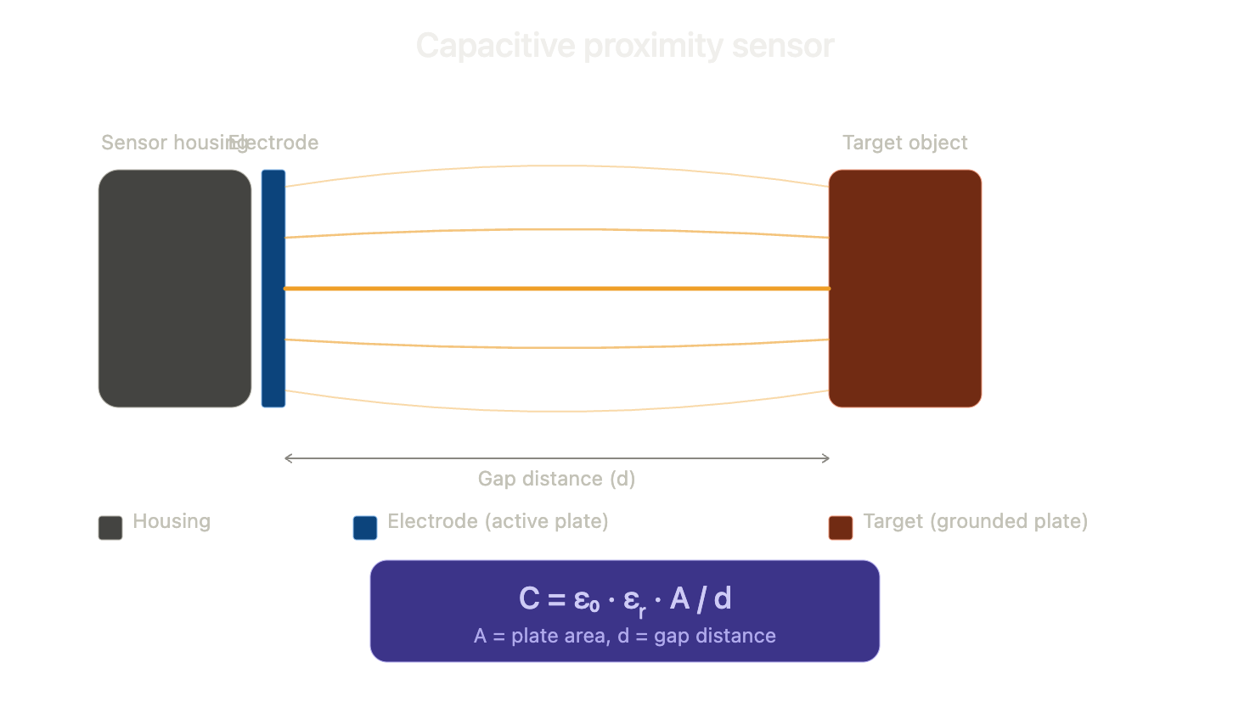
- Application in Project RailSight: Detects non-metallic track clogs (like plastic debris, stray ballast stones, or puddles of rainwater in track grooves) that inductive sensors cannot see.

C. Optical (Infrared) Proximity Sensors
- How It Works: An Infrared LED fires an invisible light beam forward. If an obstacle blocks the path, the light reflects back into an adjacent photodiode and the sensor detects it . Meanwhile if there was no obstacle the rays would just pass by and there wouldn't be any detection captured . A small circuit compares the reflected light intensity against an adjustable potentiometer threshold.the sensor decides whether an object is close enough to trigger an alert.
- Reflected light intensity: The infrared (IR) LED shines an invisible light forward. When an obstacle gets closer, more light bounces back into the sensor's receiver (photodiode), producing a higher voltage signal.
- Potentiometer: A tiny, twistable screw dial on the sensor board. By turning this screw, you manually set a reference "cut-off" voltage level (the threshold).Turning this tiny screw simply adjusts how close an object must get before the sensor triggers.If the bouncing light signal is stronger than the set threshold , the circuit decides an obstacle is present and outputs a “high” or “low ”digital signal to the microcontroller.
- If the bouncing light is weaker than the threshold it ignores it as empty space.

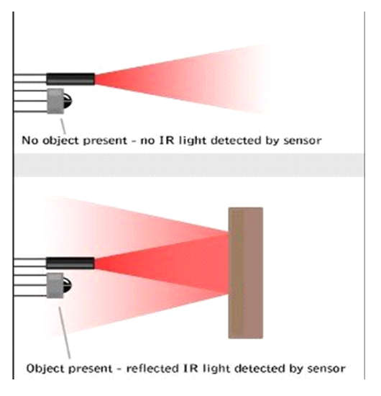
- Limitation: Can be tricked by dark black surfaces (which absorb light) or direct outdoor sunlight.
- Application in Project RailSight: Serves as a short-range forward bumper to detect obstacles or animals sitting on the tracks ahead.

D. Ultrasonic Proximity Sensors (Acoustic Echo)
- How It Works: Works like bat echolocation. A piezoelectric crystal vibrates rapidly to send out a short burst of sound waves (typically 40 kHz). The sound hits an object, bounces back, and the sensor measures the round-trip travel time . where a piezoelectric crystal is a specialized material that converts electrical energy into mechanical movement and vice-versa.
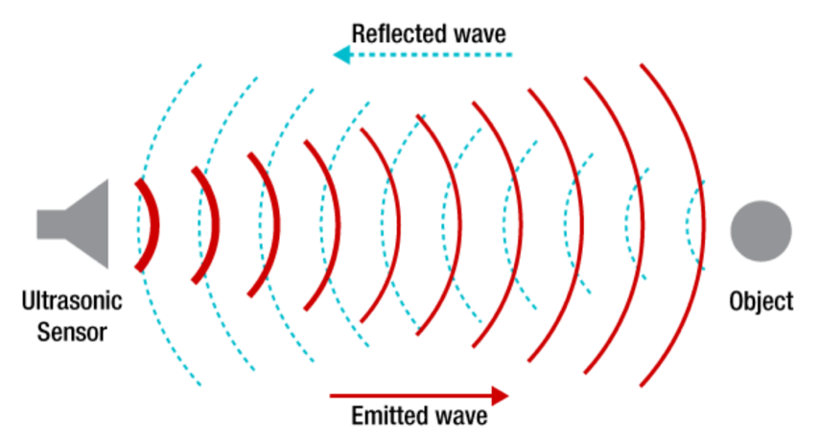
- Application in Project RailSight:
  - Air-based (40 kHz): Measures the chassis ride-height above the rough track bed.Where a Chassis is for reference is : The main frame or skeleton of the robot. Think of it as the foundation that holds everything else like we have the wheels, motors, circuit boards, and sensors together.
  - Contact-based (2 MHz): Sends sound pulses directly into the rail steel using a soft rubber roller. Unlike sensors that only detect surface obstacles, the 2 MHz contact-based application enables non-destructive testing for subsurface as well as internal rail fractures.If an internal hairline fracture exists, the echo returns early, warning the robot of a crack before the steel splits.

E. Magnetic Reed Switches
- How It Works: Two tiny, flexible metal strips (reeds) are sealed inside a small glass tube. When a magnet comes near, opposite magnetic charges are induced in the two strips, pulling them together to complete a circuit . We must have seen its very important role in one of the daily observations such as our home security systems , they are the standard component in door and window sensors . One part (the magnet) is attached to the moving door/window, and the switch is attached to the frame. When the door opens, the magnetic field breaks, and the alarm circuit triggers.
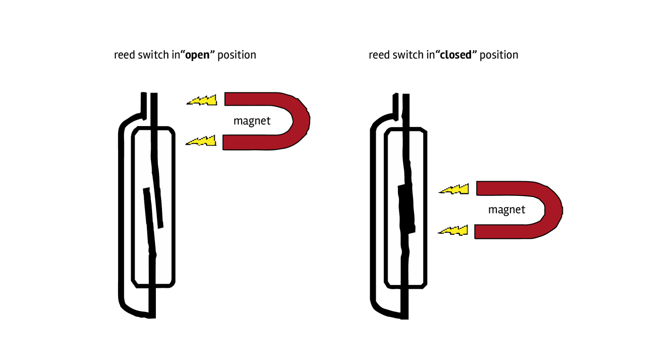
Their other interesting facts and uses:
- Zero Power Consumption: A major benefit is that they consume zero electrical power when in standby mode, as they are essentially passive switches that only activate in the presence of a magnetic field.
- High Reliability: Because the moving parts are sealed inside a glass tube, they are protected from environmental factors like dust, moisture, oxidation, and corrosion. This makes them highly durable and long-lasting.
- Contactless Operation: Since they are magnetically operated , they do not require physical contact with the object being sensed, which reduces mechanical wear and tear.
- Simple Implementation: They are compact, inexpensive, and easy to integrate into circuits, often acting as a simple digital trigger (ON/OFF).
- Application in Project RailSight: Used as emergency shut-off mechanism on the rover’s under-rail clamping arms.

III. Inertial Measurement Unit (IMU)
An IMU measures a robot’s movement, tilt, and balance. It combines three separate micro-sensors on a single silicon chip:
- Accelerometer: A microscopic silicon mass hangs on tiny springs. When the robot speeds up or tilts, the mass shifts, changing internal electrical capacitance. It gives a steady tilt angle when stationary, but gets noisy when the robot vibrates.
- Gyroscope: Measures rotational speed (degrees per second) using the Coriolis effect. It reacts instantly to sudden turns, but its angle estimate slowly drifts over time if integrated directly
- Magnetometer: Measures the Earth's magnetic field to act like an electronic compass, preventing the heading from drifting.
- Sensor Fusion: Sensor Fusion is the process of combining data from multiple different sensors to get a clearer, more accurate, and more reliable picture of the environment than any single sensor could provide on its own.
- Application in Project RailSight: Mounted in the center of the rover to track rail balance , detect track slope, and identify sudden vertical shocks caused by broken rail joints.

IV. Rotary Encoders (Measuring Motor Rotation)
Encoders track how fast and how far motor shafts and wheels have rotated . It acts as a precise measurement tool for motors and wheels. We can think of it as a digital odometer that tells a robot exactly how far and how fast its wheels have turned.
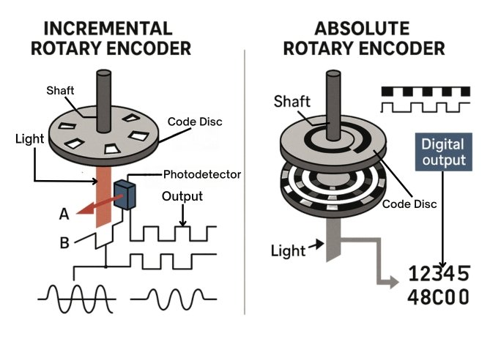
The encoder uses a system called Quadrature Decoding with two output signals, known as Channel A and Channel B, which are slightly offset from each other as :
- Counting: As the motor shaft rotates, the encoder generates a series of ON/OFF square pulses. By counting these pulses, the robot knows exactly how far it has moved.1
- Direction: Because the two channels (A and B) are offset, one will always turn "ON" before the other. By watching which channel triggers first, the system instantly knows if the wheel is spinning clockwise or counter-clockwise.
Clockwise Rotation:
- Channel A: [ON ] [OFF] [ON ] [OFF]
- Channel B: [ON ] [OFF] [ON ] [OFF] (Channel A turns ON before B)
Counter-Clockwise Rotation:
- Channel A: [ON ] [OFF] [ON ] [OFF]
- Channel B: [ON ] [OFF] [ON ] [OFF] (Channel B turns ON before A)
Types of Encoders
- Incremental: Outputs simple pulses as the wheel turns. If the robot loses power, it "forgets" where it is.1
- Absolute: Each angle position has a unique digital code. It remembers its exact mechanical angle even after being powered off.
- Quadrature Decoding: Uses two output signals (Channels A and B) offset by 90 degrees. By checking which channel triggers first, the microcontroller detects rotation direction. By counting both rising and falling edges of both channels measurement resolution is quadrupled.
- Application in Project RailSight: Attached to the drive wheels. When the rover enters tunnels or railway stations where satellite GPS is lost, the encoder counts wheel turns to calculate position within, ensuring defect locations are accurately tagged.
Benefits :
- Position Tracking: Allows for calculating the robot's location based on wheel movement rather than external signals like GPS.
- High Precision: By counting the rising and falling edges of both signal channels, the measurement resolution is quadrupled, allowing for very accurate positioning.

V. Hall Effect Sensors (Magnetic Proximity & Speed)
- How It Works: When an electric current flows through a thin semiconductor strip and a magnetic field passes through it perpendicularly, moving electrons are pushed to one side by the Lorentz Force F =q(vxb) .This builds up a small transverse voltage across the edges, known as the Hall Voltage

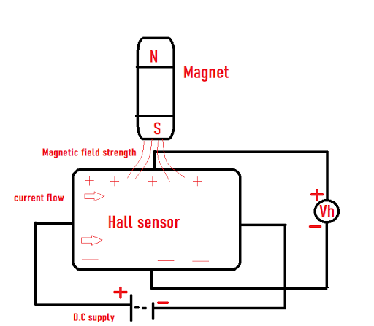
- Types:
  - Analog Hall Sensor: Outputs a smooth voltage proportional to magnetic strength.
  - Digital Hall Switch: Snaps cleanly between 0V and 5V when a magnet gets close.
- Application in Project RailSight:
  - Tachometer: Senses magnets embedded in guide wheels to calculate true ground speed and detect if the drive wheels are slipping on wet rail steel.

VI. Light Dependent Resistor (LDR)

. How It Works: An LDR is a resistor made of Cadmium Sulfide .In the dark, its electrons are locked in place, giving it high resistance .When light shines on it, photons knock electrons free into conduction band, causing its resistance to drop to a hundred ohms.
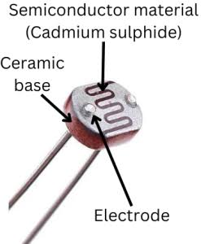
- Application in Project RailSight: Automatically detects when the rover enters a dark tunnel, underpass, or night maintenance window, turning on the onboard LED headlights to keep track cameras and optical sensors clear.

VII. Bonus Sensors (Advanced Sensory Systems)

A. Piezoelectric Vibration Sensor
- How It Works: Uses a specialized ceramic disk that generates an electric voltage spike whenever it is bent,physically compressed or shaken by external vibrations, the mechanical stress distorts the internal crystal like structure of the material.This structural distortion creates a measurable electrical voltage spike hence telling us it has detected some movement .
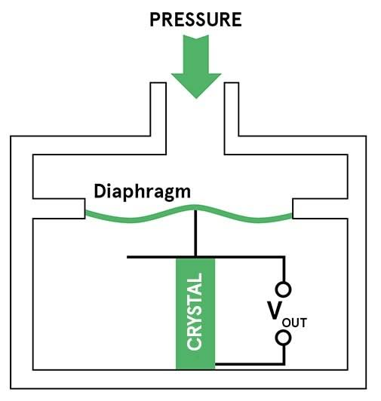
- Detection: Because it responds instantly to mechanical stress, it is highly effective at capturing vibrations or sound waves traveling through solid objects like steel rails.
- Application in Project RailSight: Clamped to the wheel frame. It senses sound vibrations traveling through the steel rails from oncoming trains kilometers away, commanding the rover to stop automatically.

B. Time-of-Flight (ToF) LiDAR

- How It Works: Fires laser pulses and times their return speed using the speed of light.
- -> My breakdown of its step by step functions :
- Emission: The sensor fires a short, invisible pulse of laser light.
- Reflection: The light hits a target (like a wall or rail) and reflects back to the sensor.
- Calculation: Because the speed of light is constant and known, the sensor uses an internal clock to measure the tiny delay between sending the pulse and receiving the reflection. It uses this "time of flight" to calculate the exact distance to the object
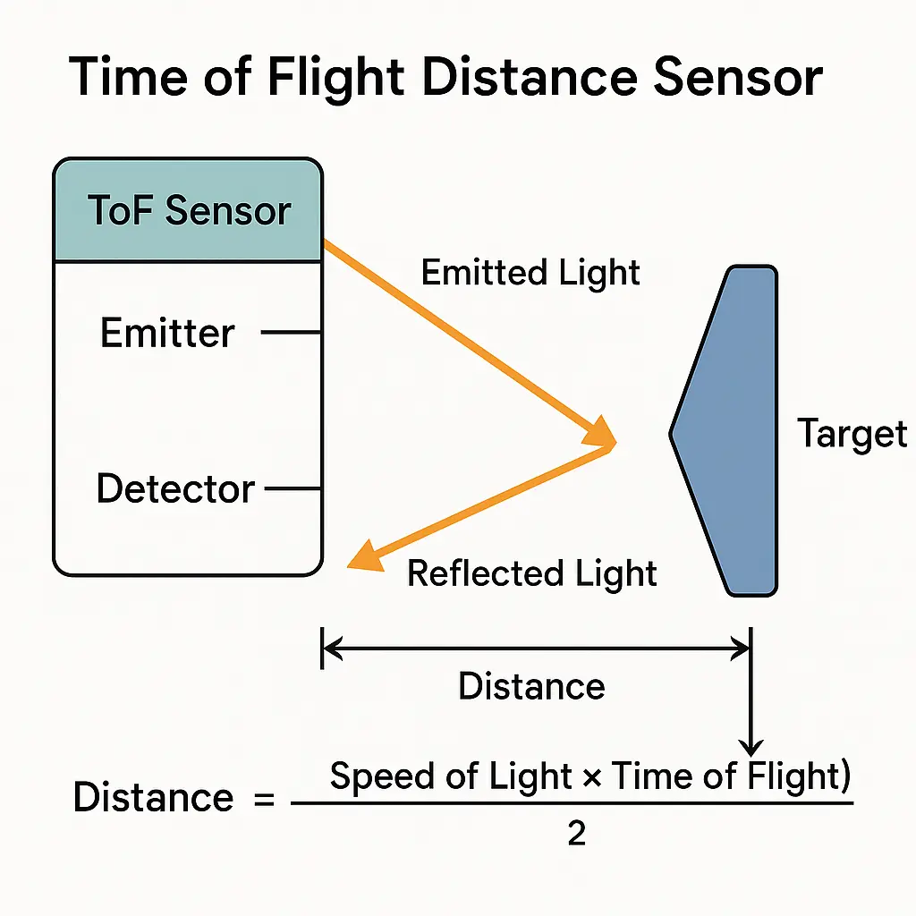

- Application in Project RailSight: Sweeps horizontally across both tracks to measure track gauge spacing to catch tracks bending outward or inward due to summer heat expansion.

C. Foil Strain Gauge

A Foil Strain Gauge is a sensor designed to measure physical deformation, such as stretching or compression, in a material. You can think of it as a "mechanical stress sensor" that converts physical force into a readable electrical signal

- How It Works: A zigzag pattern of thin foil that stretches or compresses with mechanical load, altering its electrical resistance slightly . By measuring this tiny change in resistance, the system can calculate exactly how much force or "strain" the object is under.
- 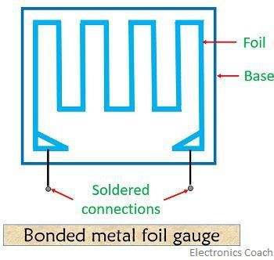

- Application in Project RailSight : Glued to the rover’s under-rail spring-clamp arm. It continuously monitors the downward clamping force, verifying the rover remains locked onto the rail head without slipping.

Key Properties

Highly Precise: It can detect microscopic changes in shape that are invisible to the naked eye.

Sensitivity to Strain: It is specifically designed to respond to mechanical load, making it ideal for monitoring force and pressure.

Adhesive-Based: Because it works by moving with the object, it must be securely glued or bonded to the surface it is monitoring.

VIII. System Integration: Project RailSight Recap and Foundation :

Task 1 : Problem Statement- High-Risk, Low-FrequencyTrack Inspection in Indian Rail Networks.

To quickly recap the concept our proposal was Project RailSight—>a lightweight, under-10 kg autonomous micro-rover designed to run on Indian railway tracks during maintenance gaps, spotting hidden cracks and missing track fasteners even which can be missed out by the human eye before they cause derailments . When the bot finds a defect, it uses GPS and wheel counters to pinpoint the exact location and immediately sends an alert with the coordinates to the maintenance team.
FACT :

It weighs under 10 kg, so one person can place it on or take it off the track in seconds. It’s practical, low-cost, and solves a major real-world safety challenge in India!

This report takes that idea down to the component and electronics level: How does the robot actually 'see' and measure the track?

Rather than relying on a single camera that can get blinded by dust, rust, or night conditions, RailSight uses a multi-modal sensor suite. We use Magnetic and Ultrasonic sensors to scan for surface and internal track cracks, Optical Encoders and an IMU to pinpoint exact locations within centimeters even in tunnels, and Hall sensors and LDRs for motor control and automatic tunnel lighting.

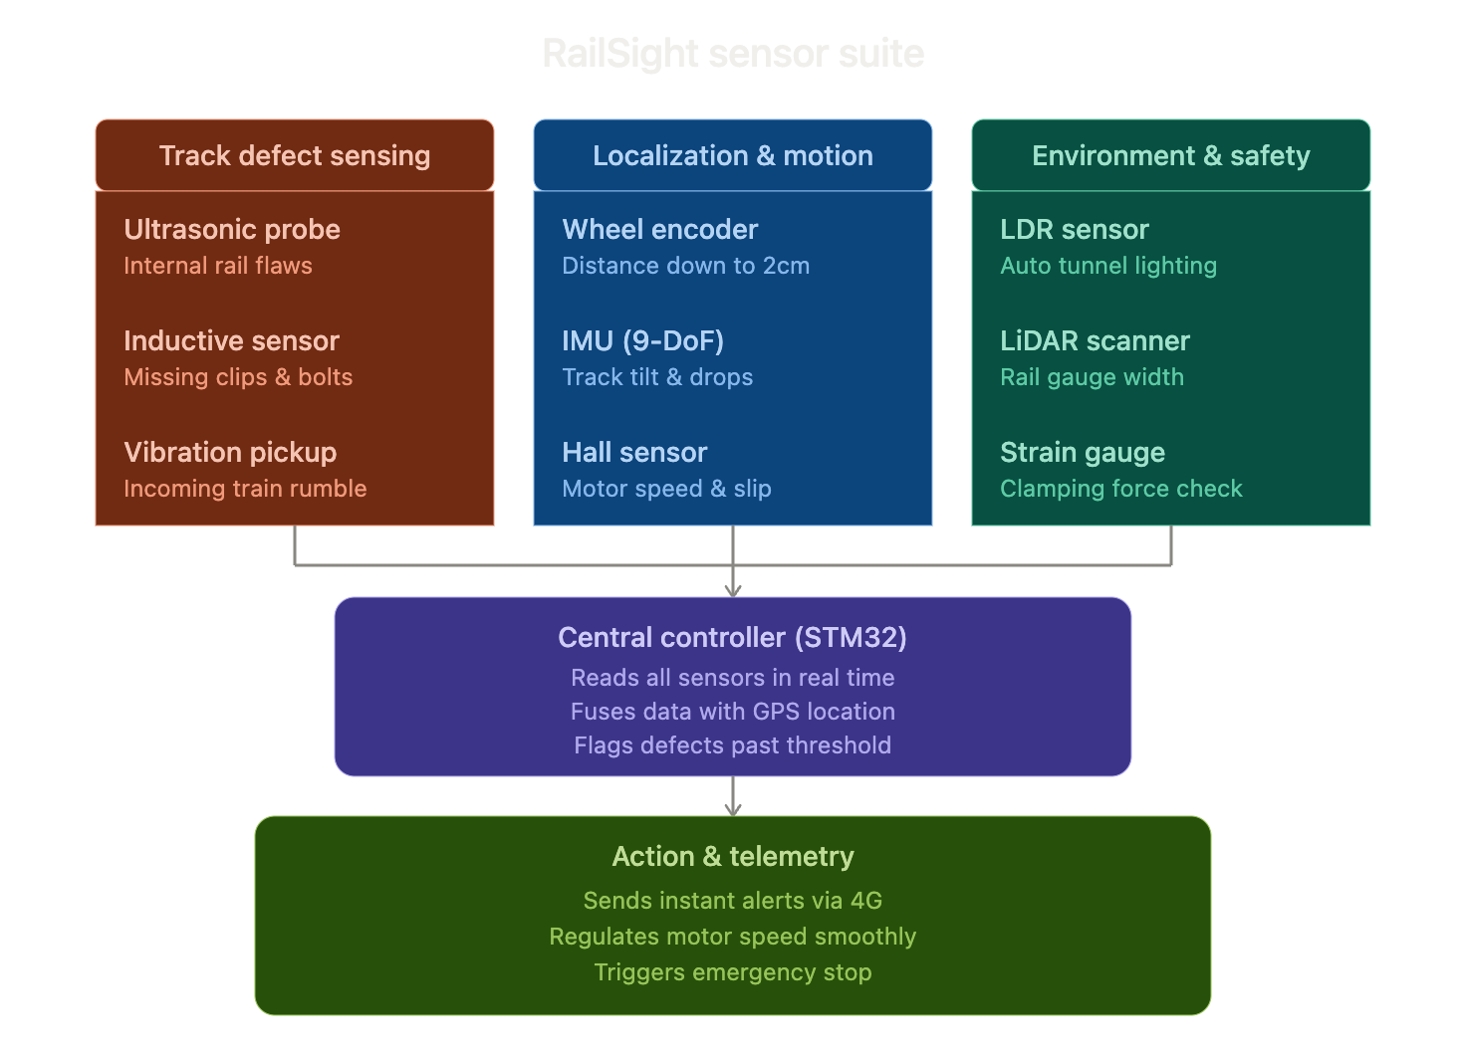

IX. Conclusion
Sensors are the fundamental link that allow a machine to safely navigate the physical world. As demonstrated across this study, no single sensor modality is universally sufficient. Optical sensors offer high precision but struggle in low-light or dusty environments; magnetic and inductive sensors provide robust, contactless metallic tracking but operate only at short ranges; and inertial units provide rapid orientation data that inevitably drifts without external reference correction. True robotic autonomy requires multi-sensor fusion, where complementary modalities compensate for individual hardware limitations. By matching the underlying physics of each transducer to the operating constraints of the target environment, engineers can build reliable, fault-tolerant robotic systems capable of real-time decision-making across industrial automation, mobile robotics, and critical infrastructure monitoring
In Project RailSight, combining these affordable sensors creates a lightweight inspection vehicle capable of continuously safeguarding railway infrastructure without disrupting everyday operations.

X.References
- G. F. Edelmann, Sensors and Actuators: Control System Fundamentals, 2nd ed., CRC Press, 2018.
- J. Fraden, Handbook of Modern Sensors: Physics, Designs, and Applications, 5th ed., Springer, 2016.(TO LEARN THE VARIOUS TYPES AND MECHANISM OF SENSORS )
- R. Siegwart, I. R. Nourbakhsh, and D. Scaramuzza, Introduction to Autonomous Mobile Robots, 2nd ed., MIT Press, 2011.(ONLY FOR FUNCTIONS )
- Indian Railways Permanent Way Manual (IRPWM), Ministry of Railways, Government of India, New Delhi, 2020.
- STMicroelectronics, RM0090 Reference Manual: STM32F405/415, STM32F407/417 32-bit MCUs, 2021.
- Google Scholar,Research oriented learning.

