Analysis of Fundamental Logic Gates and Their Integration with Embedded Sensing Subsystems

Priyanshi Sinha
Department of Computer Engineering
Manipal Institute of Technology
Karnataka ,India
priyanshi1.mitmpl2026@learner.manipal.edu

Abstract
Digital electronics relies on binary logic gates to execute arithmetic operations, data routing, and decision-making tasks within microprocessors and embedded controllers. This paper analyzes the five foundational logic gates: AND, OR, NOT, XOR, and XNOR, examining their boolean expressions , truth tables, and applications. Additionally, this paper investigates the operational principles and integration of key components used in automated embedded designs: Ultrasonic distance sensors, Light Dependent Resistors (LDR), and automated Traffic Light control systems.
Keywords—Boolean logic, digital circuits, AND, OR, NOT, XOR, XNOR, ultrasonic sensor, LDR, traffic control system.

I. Introduction
Modern digital computation processes complex algorithms through networks of binary switching elements. The mathematical framework introduced by George Boole in the mid-nineteenth century enables continuous electrical potentials to represent discrete binary states: logical High 1 and logical Low 0.
Modern microchips are built out of tiny electronic switches called CMOS transistors, which connect together to form basic logic gates that process digital data. In automated devices, these interconnected logic gates constantly evaluate incoming data without needing human intervention. They take inputs from sensors that detect changes in the surroundings—such as light levels or object distances—and instantly send commands to output components like LEDs, motors, or alarms, allowing the system to respond and react to its environment completely on its own.

The AND Gate -

Definition: A multi-input logic gate that outputs High (1) if and only if all of its inputs are simultaneously High (1)
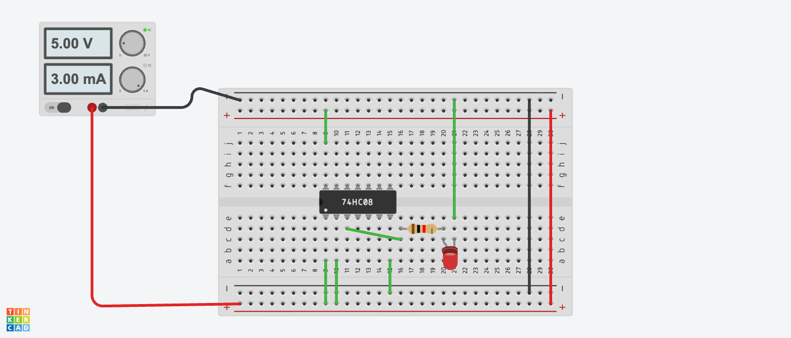
https://www.tinkercad.com/things/cVEsIqtuzoK-smashing-robo-bruticus?sharecode=Yb3EehCVE6E6re3JfC8jxITALVtwLsm4tvRIiaoWrjE

Boolean Expression:
Y = A .B

Working Principle: In transistor logic, an AND gate is built by connecting two N-channel MOSFETs in series between the pull-down path and ground. Current only flows to ground when both gate terminals are energized, pulling the output Low. An inverter stage at the output then flips this state, driving the final terminal to High only when both inputs are energized.
Truth Table:
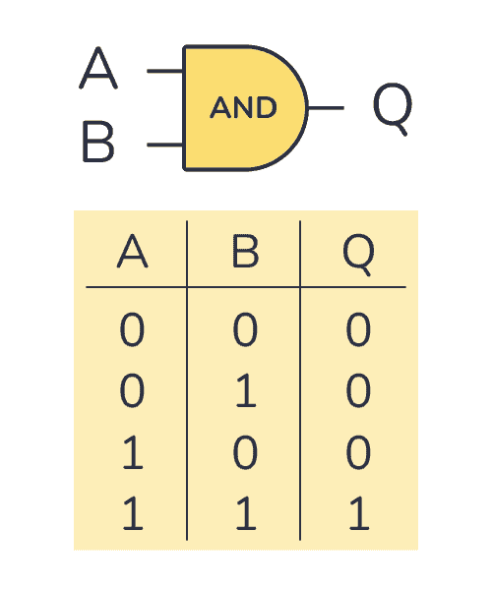
Applications: Interlock safety circuits for example when machinery enabling only when a safety guard is down and the start button is pressed

B. The OR Gate

Definition: A logic gate that produces a High (1) output if at least one of its inputs is High (1).

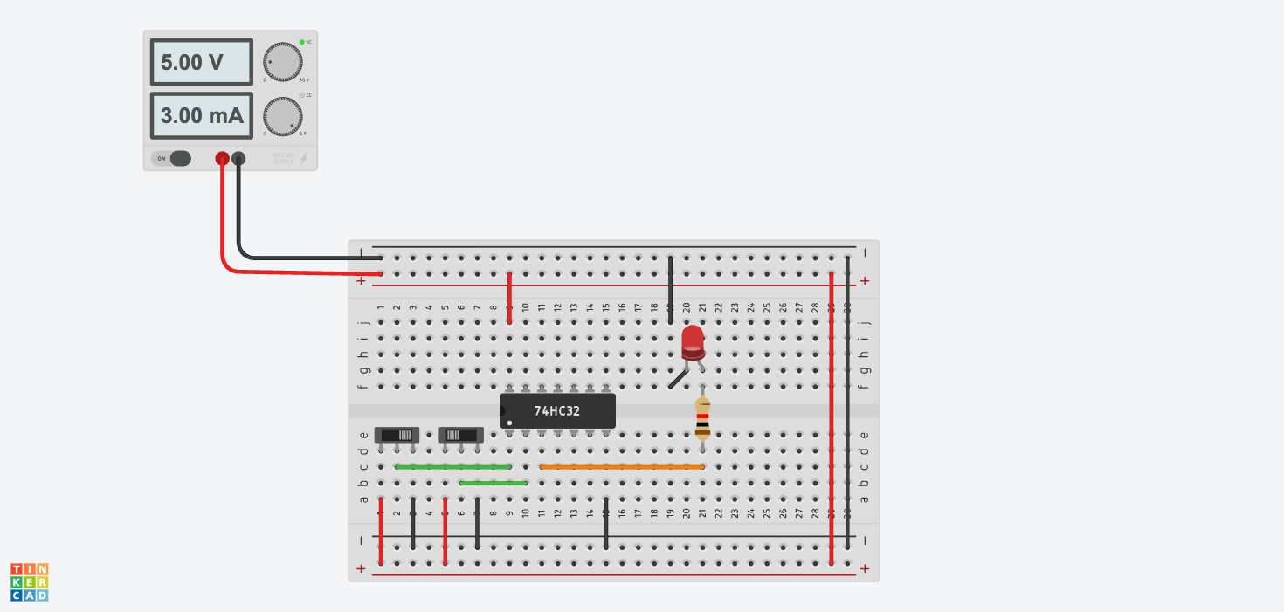
https://www.tinkercad.com/things/7Y0gyyTICAP-smashing-bruticus-bigery?sharecode=oOiaKpo1bJDl3xhhXg7SFZlVc3yiBsS85RYKozQQRyk

Boolean Expression:
Y = A + B

Working Principle: An OR gate built using only two switches and an LED connects the two of them in parallel between the positive power terminal and the LED's positive leg (anode), with the LED's negative leg (cathode) wired back to ground. In this parallel arrangement, each switch acts as an alternate route for the electric current to reach the indicator. Pressing switch A, switch B, or both switches at the same time closes the circuit and powers the LED ON. The LED remains completely OFF only when neither switch is pressed, directly demonstrating the basic OR truth table using pure mechanical switching.

Truth Table:
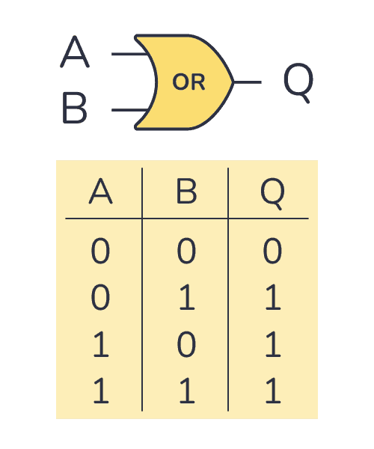

Applications: Industrial alarm monitors triggering an alert if temperature exceeds limits or pressure drops

C. The NOT Gate (Inverter)
- Definition: A simple logic gate with one input and one output that flips whatever signal you give it. If you feed in a 0, it gives out a 1; if you feed in a 1, it gives out a 0
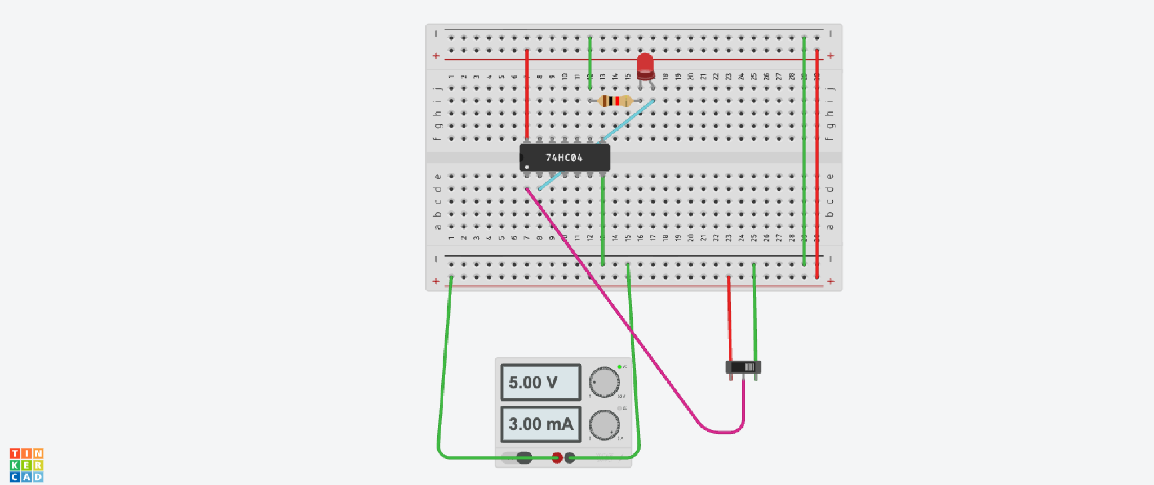
https://www.tinkercad.com/things/f77CfmdDSLQ-incredible-bojo-amur?sharecode=8JfE1HxFohOyWI7CKSHdl7fZRwBy6mlgStWPpPraCe4
- Boolean Expression:
Y = A(bar) or A(compliment)

- Working Principle: Think of it like a light switch that does the exact opposite of what you tell it. Inside, it uses two electronic switches (transistors):

  - When the input is HIGH (1): The top switch disconnects from power and the bottom switch connects directly to Ground (0V), pulling the output down to Low (0).

  - When the input is LOW (0): The bottom switch disconnects and the top switch connects to the power supply, pushing the output up to High(1)

- Truth Table:
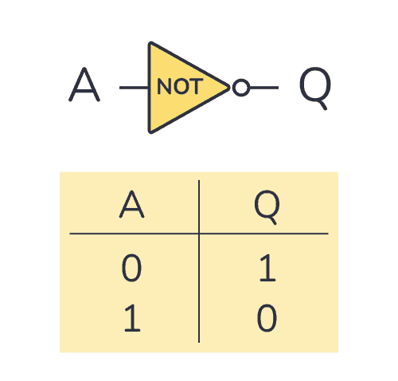

Applications: 1.Automatic Night Light: Inverts a daylight sensor's HIGH signal so the street lamp turns ON only when it gets dark (LOW).
2. Car Door Warning: Inverts the closed-door switch (HIGH) so the dashboard alert turns ON only when the door opens (LOW).

D. The XOR Gate (Exclusive-OR)
- Definition: A logic gate that yields a High 1 output whenever its inputs are non identical
- Boolean Expression:
Y = A.B(bar) + B.A(bar)
- Working Principle: Combines AND, OR, and NOT sub-circuits (or transmission gates). It asserts an output of 1 under asymmetric input conditions , When both inputs share an identical logic state , the internal destructive cancellation pulls the output terminal to 0.
https://www.tinkercad.com/things/cVEsIqtuzoK-smashing-robo-bruticus?sharecode=Yb3EehCVE6E6re3JfC8jxITALVtwLsm4tvRIiaoWrjE

- Truth Table:
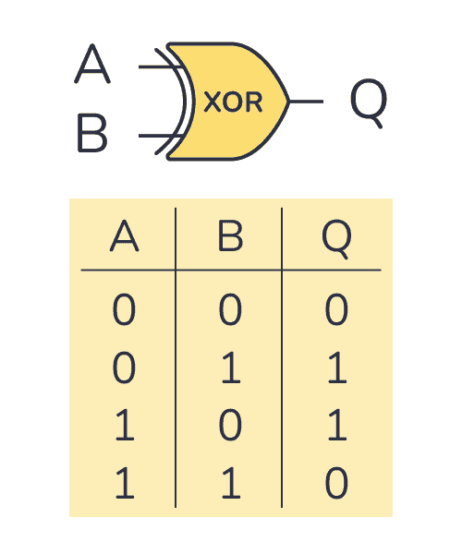

Applications: Two-Way Staircase Light: Allows flipping either the upstairs or downstairs switch to toggle the light state independently.
Binary Adder (Math Circuits): Calculates the basic sum bit 1 + 1 = 0 with a carry, 1 + 0 = 1 in digital calculators and computers.

E. The XNOR Gate (Exclusive-NOR)
Definition: The complement of the XOR gate, producing an active High 1 output when all inputs match.
Boolean Expression:
Y = AB + A(bar)B(bar)
Working Principle: Formed by cascading an XOR gate into a NOT inverter stage, or via pass-transistor logic configuring pull-up networks to switch High when A and B are both 1 or both 0
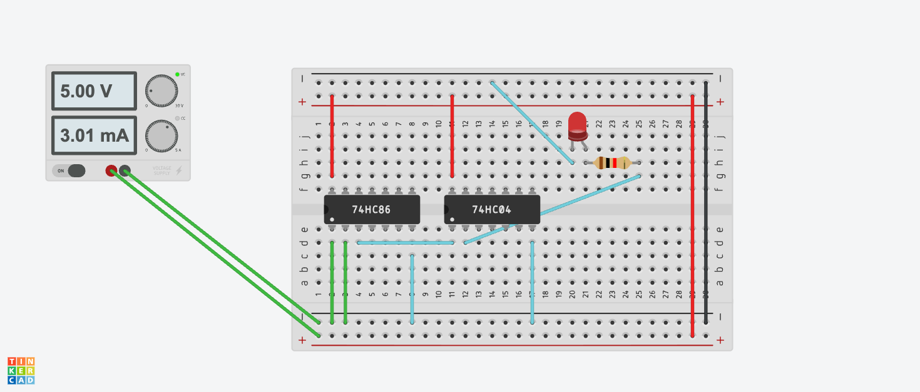
https://www.tinkercad.com/things/7Y3zvNI5UIc-mighty-curcan?sharecode=N7F6Y-UmC05YVvpJVfbUbAKlSsJP6SXoBHGMdE_UEGU
.Truth Table:
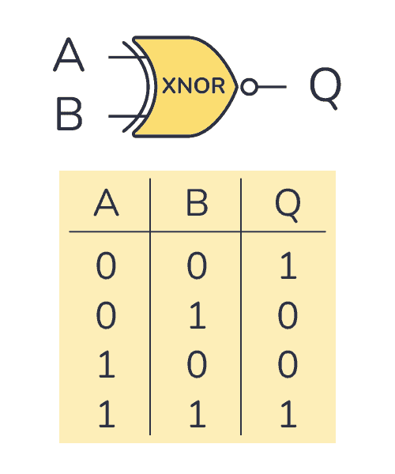

Applications: Digital Equality Comparator: Outputs HIGH 1 to confirm a match only when two incoming digital bits are identical both 0 or both 1.
Parity Checker (Error Detection): Detects transmission errors in digital data lines by checking whether the total number of 1’s are even.

The Formation of And / Or gates using diodes as well as switches :

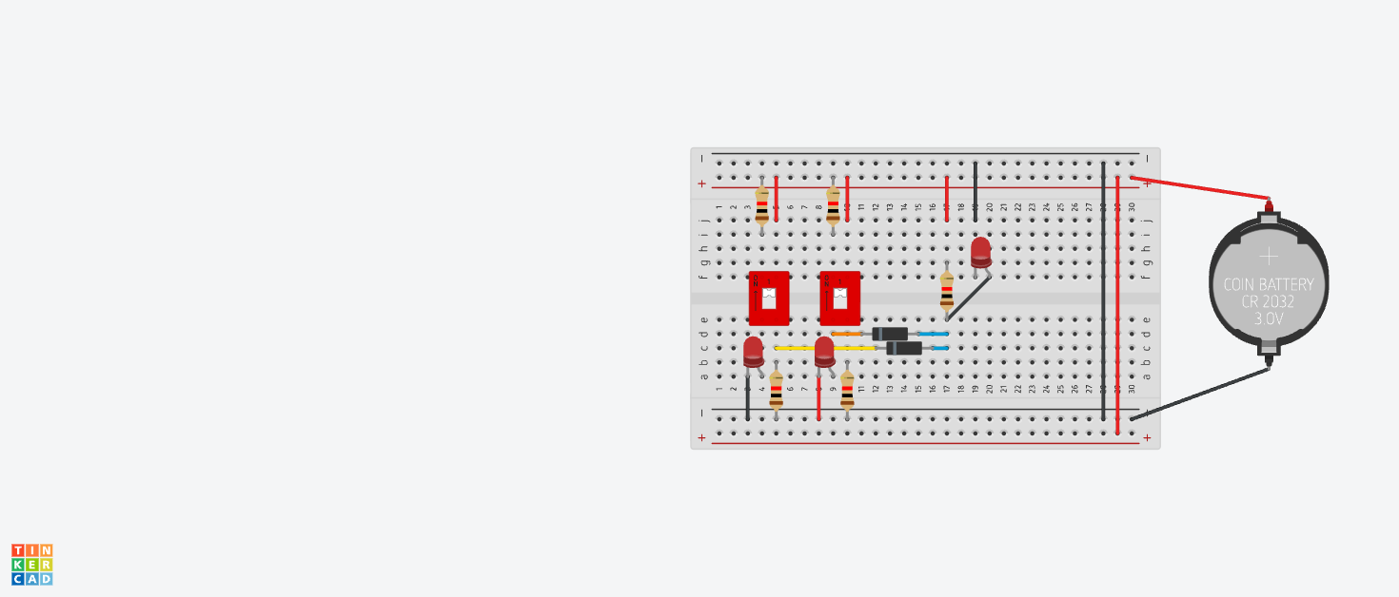

https://www.tinkercad.com/things/7Y3zvNI5UIc-mighty-curcan?sharecode=N7F6Y-UmC05YVvpJVfbUbAKlSsJP6SXoBHGMdE_UEGU
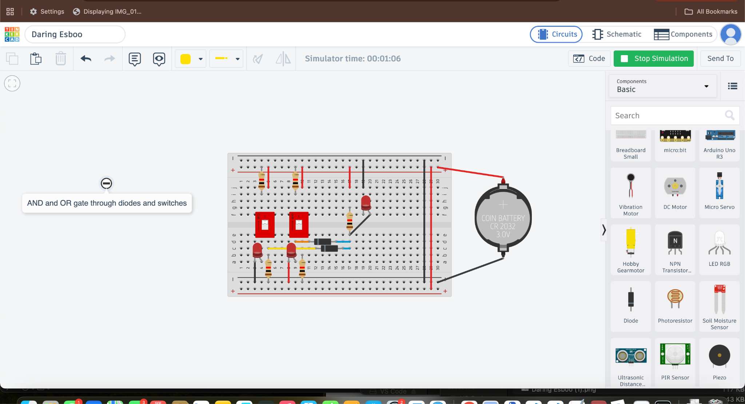

In Tinkercad, AND and OR gates are simulated on a breadboard using switches and diodes paired with a resistor and an indicator LED. For the switch logic, two switches are wired in series for an AND gate both must be pressed to complete the circuit and light the LED and in parallel for an OR gate as pressing either switch completes the circuit. For diode logic, two input lines feed into diodes . In an OR gate, the diode has the anodes at inputs, cathodes tied to resistor and the LED, allowing 5V from either input to turn the LED on. In an AND gate, the diodes are reversed toward the inputs with a pull-up resistor to 5V, so the output stays high only when both inputs are at 5V, effectively matching digital logic truth tables. As far as the other logic gates are concerned we cantt make them just using diodes , we may have to use the application of even transistors

D. Ultrasonic Proximity Sensors

How It Works: Works like bat echolocation. An ultrasonic proximity sensor measures distance by emitting sound waves and calculating how long their echo takes to bounce back from an object. When triggered, its onboard quartz crystal provides an ultra-precise frequency clock so the transmitter can fire an exact burst of eight 40 kHz ultrasonic pulses. These sound waves bounce off an obstacle and hit the receiver, which immediately stops an internal timer. The microcontroller then calculates the object's distance using the round-trip travel time and the speed of sound.
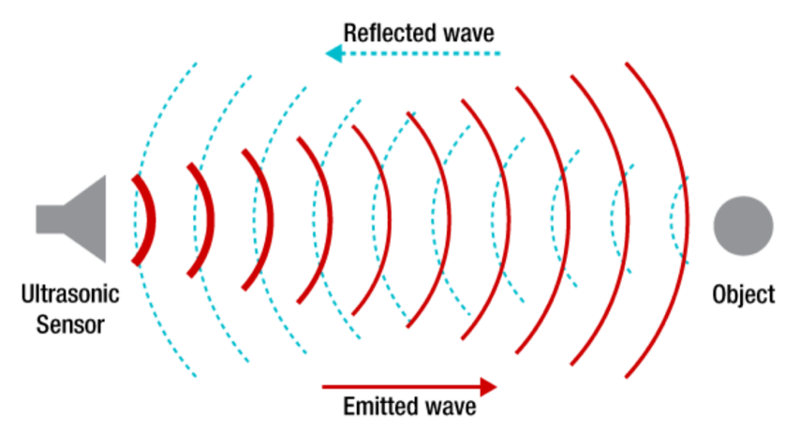

Write up of the programe done using these sensors to build a Traffic Light system :
We used Tinkercad to utilize an Ultrasonic Traffic Light System which was built by placing an Arduino Uno r3 on the workspace alongside a half breadboard, ultrasonic distance sensor, and three LED’s (Red, Yellow, and Green) each paired with a 330 Ω current-limiting resistor connected to digital output pins. The ultrasonic sensor's VCC and GND pins are wired to the Arduino's 5V and GND rails, while its Trigger and Echo pins are mapped to digital I/O pins to measure distance with help of high-frequency sound pulses. In the code editor, the program initiates a 10-microsecond trigger pulse, measures the echo return time with pulse(n) and converts this duration into centimeters (distance = duration \times 0.034 / 2). Conditional if else logic then controls the traffic states based on object proximity lighting the green LED when the vehicle is far away, switching to yellow as it enters an intermediate warning zone, and triggering the red LED to signal a complete stop when the target is within a critical threshold distance.

These were the following outputs :
https://www.tinkercad.com/things/4C8yhlPq18u-incredible-robo-sango?sharecode=RCM-qosbzZzcPEEzxl-6LWts4WQBwo2uTU11zhDVV6k
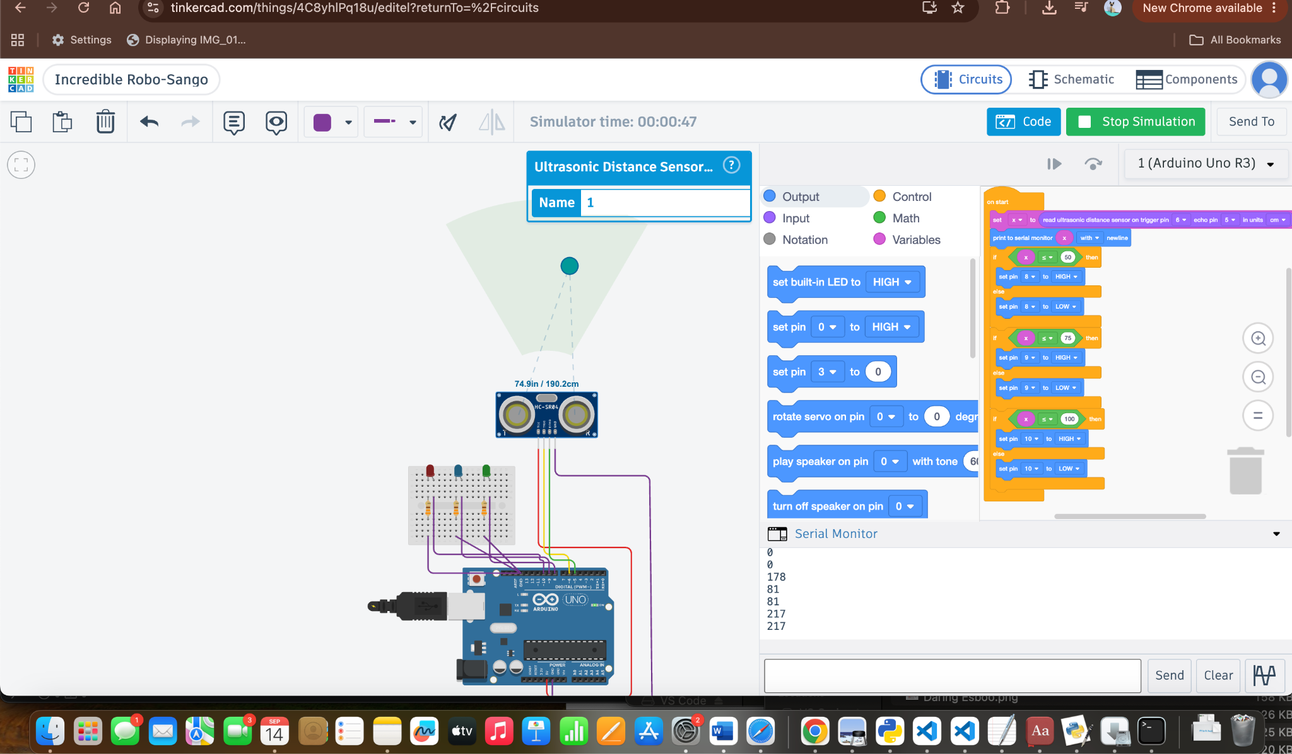

VI. Light Dependent Resistor (LDR)

. How It Works: An LDR is a resistor made of Cadmium Sulfide .In the dark, its electrons are locked in place, giving it high resistance .When light shines on it, photons knock electrons free into conduction band, causing its resistance to drop to a hundred ohms.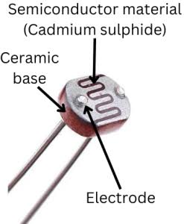
Applications : Automatically detects when the bot enters a dark tunnel, underpass, or night maintenance window, turning on the onboard LED headlights to keep track cameras and optical sensors clear.

Writeup of the programe on Tinkercad to show the simulation of the LDR sensors :

In Tinkercad, an LDR-based Automatic Light System is simulated by wiring a photoresistor and a fixed resistor in series between the Arduino Uno’s 5V and GND pins to form a voltage divider, tapping the junction between them into analog pin named as A0. An LED with a 330 Ω current limiting resistor is connected to digital pin 13 and GND. When the simulation starts, the Arduino continuously reads the changing analog voltage on pin A0 which shifts between 0 and 1023 depending on light exposure and prints the values to the serial monitor. An if else condition evaluates this reading against a predetermined threshold such as 500 : dragging the interactive slider on the photoresistor toward darkness drops the sensor value and turns the LED on “high” while increasing the light level pushes the value above the threshold and turns the LED off “low”.

This is the output we obtained :

https://www.tinkercad.com/things/1y1woWSssQo-amazing-jofo?sharecode=AZIxR_vtp32iahKtAmZcbAACJkBi3dtRMqMpdAVzu5Q

