A Comprehensive Study of Degrees of Freedom, Gruebler's Equation, Links, Joints, and Mechanisms with a Special Study on the Stewart Platform
[Priyanshi Sinha / 2610090050740]
RoboManipal Research Taskphase, Department of Research
Manipal Institute of Technology, MAHE,
Email: priyanshi1.mitmpl2026@learner.manipal.edu

Abstract—This report presents a grounded study of the fundamentals of mechanisms: Links, Joints, and Degrees of freedom (DOF). It explains the classification of joints based on the relative motion they allow, derives and explains Gruebler's equation for calculating the mobility of a mechanism, and shows us examples for clarity. As a bonus research , the report examines the Stewart Platform, a parallel mechanism with six degrees of freedom, explaining its structure, working principle, and applications. The goal of this report is to build strong concept alongside the mathematical formulation, so that even a new learner can grasp them .
Key words —Degrees of Freedom, Gruebler's Equation, Kutzbach Criterion, Kinematic Pair, Link, Joint, Mechanism, Mobility, Stewart Platform, Parallel Manipulator.

I. INTRODUCTION
Every machine we see around us like — a door hinge, a car engine, a robotic arm, or an office chair — is built from simple building blocks connected together in a specific way. The branch of mechanical engineering that studies how these blocks move relative to each other is called Kinematics of Mechanisms.
The topics we will mainly deal with are :
- Link — a rigid non-deformable body that carries a part of the mechanism . It can also be said that it connects different parts of the machine to transmit force to it or cause some kind of relative motion with respect to it .
- Joint — the connection between two links that allows or restricts motion.
- Degree of Freedom (DOF) — the number of independent ways a body or system of bodies is free to move.

II. LINKS: THE BUILDING BLOCKS

A. Definition
A link which is also called an element or a member is a rigid body having at least two nodes (points of attachment) through which it connects to other links with the help of joints. In this report we would be covering links in terms of mechanics which are Kinematic links . In kinematic analysis, an individual member or component of a mechanism that possesses relative motion with respect to other components is designated as a kinematic link . In classical rigid-body mechanics, links are treated as perfectly non-deformable bodies. It does not bend, stretch, or deform under normal operating loads it is treated as perfectly rigid for the purpose of motion analysis.

B. Classification of Links
Links are classified based on how many other links they connect to:
- Binary link — connects to exactly 2 other links (2 joints).
- Ternary link — connects to 3 other links (3 joints).
- Quaternary link — connects to 4 other links (4 joints), and so on.

C. Types of Links in terms of structure:

.Rigid link — no deformation under load (its the ideal assumption used in analysis).
- Flexible link — can deform but still transmit motion (example : a spring or belt).

- Fluid link — motion transmitted via a fluid medium (example : hydraulic jack).

III. JOINTS (KINEMATIC PAIRS)

A. Definition
A joint, formally called a kinematic pair, is the connection between two or more kinematic links that permits some relative motion while restricting other motions. Every joint removes some freedom of motion between the two links it connects that is the key concept that links joints to Degree of freedom.

B. Classification Based on Nature of Contact
- Lower Pair : the two links touch over a surface (surface contact). Lower pairs are generally more durable due to distributed contact.
- Higher Pair : the two links touch at a point or line
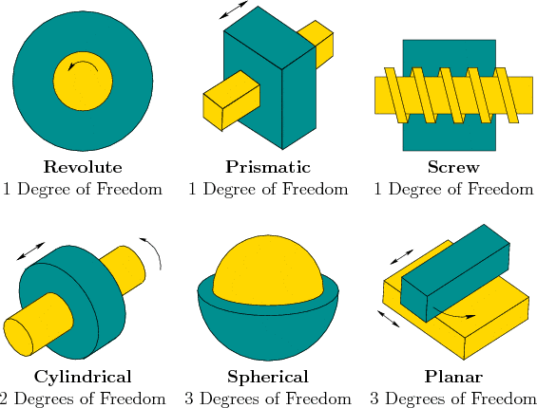

C. Classification Based on Degrees of Freedom Allowed
This is the most important classification for calculating mechanism mobility. Every joint is described by how many independent relative motions (translations + rotations) it permits between the two links it connects.
A joint's DOF value tells you how much freedom remains between the two links after they are joined. A revolute joint (hinge) leaves only 1 possible motion (rotation) — everything else (all translations, other rotations) as we can see in the picture are locked .

D. Why Joint Classification Matters
When we build Gruebler's equation later, each joint is assigned a numeric "restriction value" based on how many DOFs it removes from the two links it connects. This is where the terms "Lower Pair (1 DOF)" and "Higher Pair (2 DOF)" become central to the formula in planar mechanisms.

IV. KINEMATIC CHAINS AND MECHANISMS

A. Kinematic Chain
A kinematic chain is an assembly of rigid bodies (links) connected by joints so that motion in one link causes predictable motion in the others.When several links are connected by joints such that relative motion between them is possible, and the chain closes on itself (every link is connected to at least two others), it is called a kinematic chain.
Types of Kinematic Chains
Kinematic chains are classified by how their ends connect:
- Open Kinematic Chain:
  - Structure: The chain has free ends it resembles an open tree or serial branch. There is no closed loop.
  - Example: An industrial robot arm.
  - Advantages and Disadvantages: High reach, large workspace, and higher ability of movement but lower structural stiffness and lower payload capacity (as in lower mechanical force or exertion on the end points of the open system at its end effector (the hand or tool) compared to systems with closed joints.

- Closed Kinematic Chain:
  - Structure: Every link is connected to at least two other links, forming one or more closed geometric loops.
  - Example: A classic four-bar linkage, or a 3D printer's parallel Delta arms.
  - Advantages and Disadvantages: Extremely rigid, high load-bearing capacity, and high positional accuracy but a significantly restricted workspace and complex kinematic math.

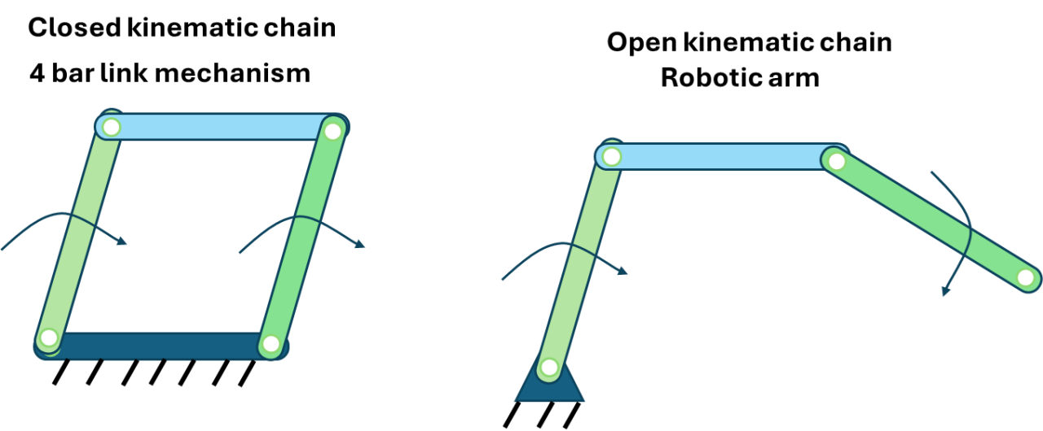

When Does a Chain Become a "Mechanism"?
A floating chain of links in space is just geometry. It becomes a mechanism the exact moment you fix (anchor) one link to the ground:
Kinematic Chain + 1 Ground link = A mechanism
- Fixing a link establishes an inertial frame of reference.
- This allows you to apply an input motion (like a motor turning a crank) to get a targeted output motion (like a slider pushing forward).

B. Mechanism
A mechanism is a kinematic chain in which one link is fixed (called the frame or fixed link), and it is used to transmit or transform motion from an input link to an output link. In simple words: a mechanism is a chain of links that turns one useful motion into another useful motion.
Example: In a four-bar mechanism used in a car's windshield wiper system, rotary input motion from a small motor is converted into an oscillating (back-and-forth) output motion of the wiper blade.

C. Structure vs. Mechanism
It's useful to distinguish:
- Structure — DOF = 0. No relative motion is possible (e.g., a truss bridge).
- Mechanism — DOF ≥ 1. Relative motion between links is possible.
- Over-constrained/Locked chain — DOF < 0. More constraints than necessary; the assembly cannot move without breaking a joint .

V. DEGREES OF FREEDOM (DOF)

A. Conceptual Meaning
The degree of freedom or Mobility of a system is the minimum number of independent parameters , coordinates , variables needed to completely define its position and orientation in space at any instant .Think of it this way: if you had to give instructions to a robot to fully describe where every part of a mechanism is, the number of independent numbers you'd need to specify is the DOF.

B. DOF of a Single Rigid Body
- In a plane (2D): a free rigid body has 3 DOF — 2 translations (along x and y) + 1 rotation (about z).
- In space (3D): a free rigid body has 6 DOF’s : 3 translations (x, y, z) + 3 rotations (about x, y, z) The 3 linear translations are : surge (x), sway (y), and heave (z).
  - 3 angular rotations: roll (theta x), pitch (theta y ), and yaw (theta z).

This "3" and "6" are the base numbers used throughout Gruebler's formula for planar and spatial mechanisms respectively.

C. Why DOF Matters in Design
Knowing the DOF of a mechanism tells an engineer:
- How many independent inputs (motors/actuators) are needed to fully control the mechanism.
- Whether the mechanism is a rigid structure (DOF = 0), a controllable mechanism (DOF = 1, usually preferred for simple machines), or a complex multi-input system (DOF > 1, as in robotic arms).
Once we understand these three ideas, we can combine them using Gruebler's Equation to predict whether an assembly of links and joints will move at all, and if it does, how many independent motions it can perform. This single idea is the backbone of designing everything from a simple four-bar mechanism to a six-legged flight simulator (the Stewart Platform).

VI. GRUEBLER'S EQUATION (KUTZBACH CRITERION)

A. The Core Idea
Gruebler's equation (often called the Kutzbach criterion) provides a quick algebraic way to calculate the total mobility (DOF) of a mechanism without physically building it , purely by counting links and joints.
The logic:
- Start with the total freedom all the links would have if they were completely disconnected (floating in space).
- Subtract the freedom removed by each joint that connects them together.
- What remains is the net mobility of the mechanism.

B. Derivation (Planar Mechanisms)
Let:
- n = total number of links ,including the fixed links
- j₁ = number of lower pairs (1-DOF joints, e.g., revolute, prismatic)
- j₂ = number of higher pairs (2-DOF joints, e.g.,cylindrical)
Step 1 — Total freedom before connection:
If all n links were floating freely in a plane, each would have 3 DOF (2 translation + 1 rotation).
Total = 3n
Step 2 — Fix one link (the frame):
One link is always fixed to the ground, removing 3 DOF immediately.
Remaining = 3n − 3 = 3(n − 1)
Step 3 — Subtract restrictions from joints:
- Each lower pair (1-DOF joint) removes 2 DOF (since it allows only 1 out of 3 possible planar motions).
- Each higher pair (2-DOF joint) removes 1 DOF (since it allows 2 out of 3 possible planar motions).
Final Gruebler's Equation (Planar):
F = 3(n − 1) − 2j₁ − j₂
Where:
- F = degrees of freedom (mobility) of the mechanism
- n = number of links
- j₁ = number of 1-DOF (lower) pairs
- j₂ = number of 2-DOF (higher) pairs

C. Extension to Spatial (3D) Mechanisms — Kutzbach–Gruebler General Form
For spatial mechanisms, since a free rigid body has 6 DOF instead of 3:
F = 6(n − 1) − Σ(6 − fᵢ), summed over all joints
or more commonly written as:
F = 6(n − 1) − 5j₁ − 4j₂ − 3j₃ − 2j₄ − j₅
Where j₁, j₂, j₃, j₄, j₅ represent the number of joints allowing 1, 2, 3, 4, and 5 DOF respectively (a joint allowing f DOF removes 6 − f DOF from the system).

D. Solved Example (Planar — Four-Bar Mechanism)
A standard four-bar linkage has:
- n = 4 links (1 fixed + 3 moving)
- j₁ = 4 revolute joints (all lower pairs)
- j₂ = 0
F =3(4 − 1) − 2(4) − 0 = 9 − 8 =1
Interpretation: The four-bar mechanism has exactly 1 DOF meaning a single motor/input (like turning one link) is enough to fully define the motion of the entire mechanism. This is why the four-bar linkage is one of the most widely used simple mechanisms (found in wipers, engine linkages, and even human knee joint models).

E. Locked Structure Application
Consider a triangle made of 3 links joined by 3 revolute joints:
n = 3, j₁ = 3, j₂ = 0
F = 3(3 − 1) − 2(3) = 6 − 6 = 0
Interpretation: F = 0 means this is a rigid structure, not a mechanism — this is exactly why triangles are used in trusses and bridges; they cannot move/deform, providing structural strength.

VII. BONUS STUDY: THE STEWART PLATFORM

A. What is it?
The Stewart Platform (also called a Stewart-Gough Platform) is a type of parallel manipulator — a mechanism where a moving (top) platform is connected to a fixed (base) platform through six independent, extendable legs (usually prismatic actuators), arranged so that the platform can move with 6 degrees of freedom: 3 translations (surge, sway, heave) and 3 rotations (roll, pitch, yaw).
Unlike a robotic arm (a serial manipulator, where links are connected end-to-end like a chain), the Stewart Platform is a parallel mechanism — all six legs act simultaneously and independently on the same moving platform, giving it much higher rigidity, precision, and load capacity for its size.

B. Structure
- Base platform — fixed to the ground.
- Top (moving) platform — the platform whose position/orientation is being controlled.
- Six legs — each leg typically consists of a prismatic (linear actuator) joint, connected to the base and top platforms via spherical or universal joints at each end. Hence each leg is commonly a Universal–Prismatic–Spherical (UPS) chain.
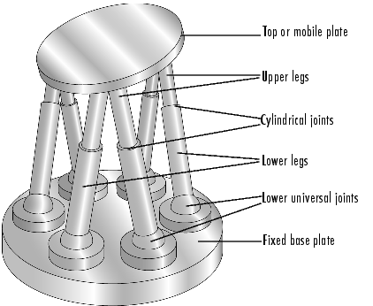

C. DOF Verification Using Gruebler's Equation (Spatial)
For a standard Stewart Platform:
- n = 14 (1 base + 1 top platform + 6×2 leg segments = 14 links)
- Each leg contributes: 1 universal joint (2 DOF) + 1 prismatic joint (1 DOF) + 1 spherical joint (3 DOF)
Applying the spatial Gruebler (Kutzbach) equation across all 6 identical legs confirms the well-known result:
F = 6
This matches its real-world behavior — full 6-DOF spatial motion (position + orientation) of the top platform relative to the base.

D. Working Principle
By simultaneously and independently controlling the length of each of the six legs (extending or retracting them), the controller can precisely position and orient the top platform anywhere within its workspace. Small, coordinated changes in leg lengths translate into smooth, controlled motion of the platform in all six directions.

E. Applications
- Flight simulators — replicating aircraft motion (pitch, roll, yaw, vibration) for pilot training.
- Machine tool positioning — high-precision CNC machining heads.
- Vehicle simulators and motion platforms — driving simulators, amusement park rides.
- Medical robotics — precise positioning in robotic surgery platforms.

F. Advantages and Limitations
Advantages: High stiffness, high load-to-weight ratio, high positioning accuracy, since the load is shared by six legs in parallel.
Limitations: Smaller workspace compared to serial manipulators, and more complex inverse kinematics/control.

VIII. SUMMARY TABLE — QUICK REFERENCE
Concept | Key Formula/Value
DOF of free rigid body (2D) | 3
DOF of free rigid body (3D) | 6
Gruebler's Equation (Planar) | F = 3(n−1) − 2j₁ − j₂
Gruebler's Equation (Spatial) | F = 6(n−1) − 5j₁ − 4j₂ − 3j₃ − 2j₄ − j₅
Four-bar mechanism DOF | 1
Stewart Platform DOF | 6

IX. CONCLUSION
Understanding degrees of freedom, links, and joints forms the foundation of mechanism design in mechanical and robotic engineering. Gruebler's equation offers a simple yet powerful mathematical tool to predict the mobility of any planar or spatial mechanism purely from its link and joint count, without needing to physically prototype it. Extending this concept to complex real-world systems like the Stewart Platform shows how the same fundamental principles can solve or enable precise, multi axis motion control used in aerospace, robotics, and simulation technologies today.

