A Comparative Study of Electric Motors: Construction, Working Principles, and Engineering Applications

Name: Piyanshi Sinha / Student Registration Number: 261090050740]
RoboManipal Research Taskphase, Department of Mechatronics / Electronics
Manipal Institute of Technology, MAHE, Manipal, India
Email: priyanshi1.mitmpl2026@learner.manipal.edu

Abstract
Electric motors are fundamental electro-mechanical transducers converting electrical energy into mechanical work across industrial, robotic, and consumer platforms. This research report investigates nine major motor topologies: Brushed Direct Current (DC), Brushless Direct Current (BLDC), Servo Motors, Smart Servos, Stepper Motors, Induction Motors, Synchronous Motors, Permanent Magnet Synchronous Motors (PMSM), and Reluctance Motors. For each motor class, this study outlines basic construction, operational principles, torque production mechanisms, variations, and typical application domains. A summary table is provided to ease motor selection for mechatronic and robotic implementations.

I. Introduction
Electric motors turn electrical energy into mechanical movement using magnetic fields. When choosing a motor for a robot or machine, engineers balance key factors like speed, torque, precision, efficiency, size, and cost. This report breaks down the main types of electric motors mainly : how they work, their internal parts, their pros and cons, and where each is best used.
II. Direct Current (DC) Motors (Brushed)

1. Definition & Fundamental Principle
A brushed DC motor converts direct-current electrical energy into mechanical rotational energy using the Lorentz Force Principle: a current-carrying conductor placed inside an external magnetic field experiences a mechanical force perpendicular to both the conductor and field lines:
$F=I(L×B)$

2. Basic Construction & Core Components
- Stator: Stationary outer frame (yoke) housing either permanent magnets (in PMDC motors) or electromagnets (field windings) to produce a fixed magnetic flux $Φ$.
- Armature (Rotor): Laminated silicon steel cylinder keyed to the shaft with axial slots containing insulated copper coils. Lamination reduces eddy current losses.
- Commutator: Split copper ring segments mounted on the shaft, insulated with mica, connected to the armature coils.
- Brushes & Springs: Spring loaded carbon/graphite blocks pressing against the rotating commutator to transfer DC current to the spinning armature.

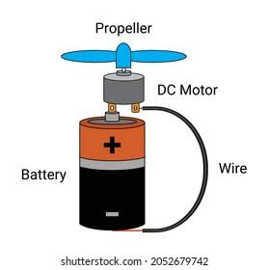

Working Principle & Torque Production
- Torque Generation: When DC current $I_{a}$ flows through the armature coils in magnetic field $B$, opposite sides of the coil experience equal and opposite Lorentz forces, creating electromagnetic torque:
- $τ=K_{t}ΦI_{a}$
- (where $K_{t}$ is the motor torque constant, $Φ$ is flux per pole, and $I_{a}$ is armature current).
- Commutation: As the coil rotates past the magnetic neutral plane, the commutator segments switch brush contact. This reverses current direction in the coil every $180^{∘}$ electrical, keeping torque unidirectional.As the armature spins, it cuts the stator flux lines, inducing a Back-EMF ($E_{b}=K_{e}Φω$) opposing the applied voltage.
- Back-EMF ($E_{b}$): Rotating conductors cut stator flux lines, inducing a counter-voltage (Lenz's Law):
- $E_{b}=K_{e}Φω$ ( Back Emf ) :
The circuit voltage balance is:
V = E(b) + I(a) R(a) and I(a) = [V - E(b)]\R(a)
  - At startup ($ω=0$, $E_{b}=0$), $I_{a}$ surges ($I_{start}=V/R_{a}$).
  - Under mechanical load omega decreases-> E(b) decreases ->, torque increases until it matches the load.

Classifications & Variations
- Permanent Magnet (PMDC): Stator uses permanent magnets. Delivers a linear speed-torque curve and high low-end efficiency. It cannot perform field weakening.
- Series Wound: Field coils connect in series with the armature ($I_{f}=I_{a}$). Produces very high starting torque ($τ∝I_{a}^{2}$). Caution: Unloaded operation causes dangerous runaway ($ω→∞$).
- Shunt Wound: Field coils connect in parallel across the armature. Operates at nearly constant speed across varying loads; easily regulated via field rheostat.
- Compound Wound: Combines series and shunt field windings.
  - Cumulative: High starting torque with safe maximum no- load speed.
  - Differeential: Series field opposes shunt field; rarely used due to speed instability.

Performance Characteristics

Torque vs. Current ($τvs.I_{a}$): Strictly linear in PMDC and Shunt motors ($τ∝I_{a}$); parabolic in Series motors ($τ∝I_{a}^{2}$) until magnetic saturation.

Speed vs. Torque ($N vs τ$):

Shunt/PMDC: Nearly flat line with a gentle downward slope due to the internal $I_{a}R_{a}$ voltage drop.

Series: Steep hyperbolic droop; produces high torque at low speeds and low torque at high speeds.

Speed Control Methods:

Armature Voltage Control (PWM): Varies terminal voltage from $0$ to rated voltage while keeping field flux constant. Controls speed below base speed at constant torque.

Field Weakening: Reduces field current to lower flux $Φ$. Allows the motor to run above base speed at reduced torque (constant power mode).

- Advantages:
  - Simple drive requirements (battery or standard H-bridge PWM; no sensors or inverters required).
  - Linear torque-current and voltage-speed relationships simplify closed-loop control.
  - High stall torque in series configurations; low initial manufacturing cost.
- Disadvantages:
  - Mechanical brush/commutator wear requires periodic replacement (1,500–5,000 hour of lifespan).
  - Commutation arcing creates severe electromagnetic interference (EMI) and fire hazards in volatile environments.
  - Poor heat dissipation (armature copper losses occur inside the rotating core).

Real-World Applications (Brushed DC)
- Automotive: Power windows, windshield wipers, and electric seat adjusters (chosen for low cost and intermittent use).
- Industrial & Traction: Cranes and classic train engines (series-wound designs favored for high starting torque).
- Robotics & Tools: Cordless power drills and mobile wheeled robot bases (driven bidirectionally using H-bridge circuits).

Brushless DC (BLDC) Motors
Construction and Components
- Stator: Stationary outer iron core wrapped with 3-phase wire coils (wired in star or delta layout).
- Rotor: Permanent magnets (usually strong Neodymium magnets) with alternating North and South poles.
- Position Sensors: Three Hall-effect sensors placed $60^{∘}$ or $120^{∘}$ apart to track rotor angle (or sensorless circuits that measure voltage pushback/back-EMF).
- Mechanical Formats:
  - Inrunner: Rotor spins inside the coils; low inertia, built for high speeds (RPM).
  - Outrunner: Outer magnet bell spins around inner coils; delivers higher torque, ideal for direct drive.
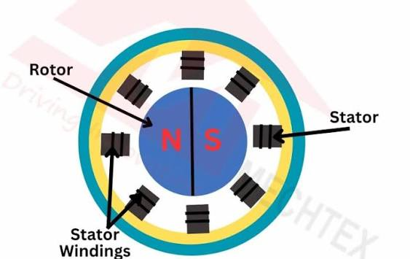

Working Principle & Torque Production
- Electronic Switching: Replaces physical brushes with an electronic speed controller (ESC) using six electronic switches (MOSFETs).
- Magnetic Synchronization: The controller energizes stator coils in lockstep with the rotor magnets to keep pulling the rotor forward.
- Six-Step Commutation: Current is powered through two coil phases at any given instant ($120^{∘}$ block timing), maintaining a steady pushing angle to create continuous torque.

$τ=\frac{E_{line}I}{ω_{m}}$
The interaction between the energized stator electromagnets and the permanent magnets forces the rotor to align continuously with the advancing stator magnetic field vector.

C. Types and Variations
- Sensored BLDC: Uses Hall sensors; delivers reliable torque at zero and low speeds.
- Sensorless BLDC: Senses zero-crossing points of the unenergized phase back-EMF; reduces wiring and sensor cost, but struggles with starting torque under heavy initial load.

D. Advantages and Disadvantages
- Advantages: High efficiency (>85-92%), high power/torque density, long operational lifespan (limited only by bearing life), minimal acoustic noise, high thermal dissipation (windings located on the stationary outer case).
- Disadvantages: Requires complex electronic speed controllers (ESC), higher component cost, torque ripple during phase commutation steps.

E. Applications
- Drone and multicopter propulsion, electric vehicles (EV powertrains), cooling fans, robotic manipulators .

IV. Servo Motors (Standard Analog/Digital)

Construction and Components
- Core Motor: Small DC or brushless motor providing rotational power.
- Gearbox: Metal or plastic gears that lower motor speed while increasing output torque.
- Feedback Sensor: Potentiometer or magnetic encoder attached to the output shaft to monitor current angle.
- Control Board: Small circuit that calculates positioning error and powers the motor to correct it.
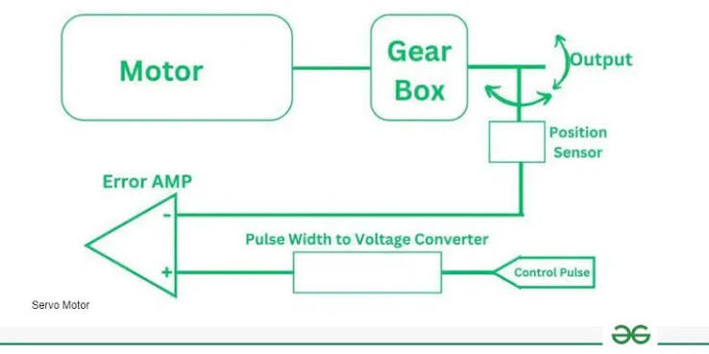

Working Principle & Control
- Input Signal: Controlled via standard timed electrical pulses (PWM), where pulse width determines the desired angle (typically 1.0 ms to 2.0 ms corresponding to 0∘ to 180∘).
- Closed-Loop Correction: The board continuously tracks error between target angle and current angle (e=target−actual).
- Torque Generation: When error is detected (e=0), current drives the motor toward the target position; driving force drops to zero once the target position is reached.

C. Types and Variations
- Analog Servo: Uses standard analog comparators; pulses motor at $50Hz$; slower response and lower holding torque.
- Digital Servo: Microcontroller-driven; processes signal and pulses motor at $300-400Hz$; significantly faster response, higher holding torque, and tighter deadband.
- Continuous Rotation Servo: Potentiometer disconnected or mechanical end-stops removed; PWM controls speed and direction rather than absolute angle.

D. Advantages and Disadvantages
- Advantages: Self-contained closed-loop actuation, simple single-wire control signal, compact integration.
- Disadvantages: Restricted range of motion (typically $180^{∘}$ or $270^{∘}$ for position types), susceptibility to gear stripping under impact shock, lack of telemetry feedback to the host controller.

E. Applications
- RC aircraft control surfaces, camera pan-tilt units, robotic grippers, steering linkages in small mobile robots.

V. Smart Servos (Bus-Driven Actuators)

A. Construction and Components

Construction and Components
- Internal Motor: Coreless DC or brushless DC (BLDC) motor for high torque and compact power.
- Gearbox: Heavy-duty steel or titanium gears (planetary or cycloidal) to increase torque and reduce speed.
- Built-in Sensors: Magnetic encoder for exact angle tracking, plus onboard current and temperature sensors for overload protection.
- Processor: 32-bit chip that runs fast, self-correcting position, speed, and force loops directly on the motor.
- Data Interface: Serial communication line (TTL, RS-485, or CAN) for linking multiple units along a single cable.
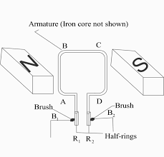

Working Principle & Control
- Single Shared Cable: Motors link together in a daisy-chain along one data line. Each unit has a unique digital ID, allowing a central controller to send commands across one shared wire instead of dedicated wires for every motor.
- Onboard Microcontroller Loops: A built-in processor manages three self-correcting layers:
  - Torque/Force Control: Adjusts electric current to control exact pushing force and prevent damage.
  - Speed Control: Regulates acceleration and deceleration for smooth motion.
  - Position Control: Locks the shaft to the exact specified target angle.
- Two-Way Communication: The main controller sends motion targets, and the servo sends back real-time operating data, including actual position, speed, load, operating temperature, and voltage.
Common Examples
- Dynamixel series,integrated Field-Oriented Control (FOC) robotic actuators.
Advantages & Disadvantages
- Advantages: Minimal wiring, full continuous 360-degree multi-turn rotation, live health monitoring (overheating/overload detection), and software-adjustable joint stiffness.
- Disadvantages: High component cost, steeper software learning curve, and the requirement for specialized communication code.
Key Applications
- Multi-axis robotic arms, walking quadruped and biped robots, humanoid robot joints, and powered exoskeletons.

VI. Stepper Motors

A. Construction and Components
- Stator: Outer ring of toothed electromagnets grouped into paired coils (usually 2-phase).
- Rotor: Spinning inner core—plain toothed iron , a permanent magnet (PM), or a magnet sandwiched between offset toothed cups (Hybrid).
- Drive Interface: Motor driver chip (like a A4988, TMC2209) that sends precise current pulses to switch coils and smooth out steps (microstepping).

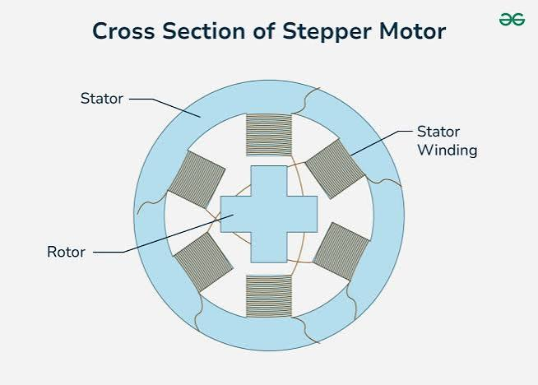

B. Working Principle and Torque Production
Stepper motors rotate in discrete angular increments (step angles, typically $1.8^{∘}$ or $0.9^{∘}$ per full step). The operational principle combines magnetic attraction and minimum reluctance. Energizing a stator phase polarizes specific stator teeth, pulling the nearest offset rotor teeth into magnetic alignment:

$θ_{s}=\frac{360^{∘}}{m⋅Z_{r}}$
where $m$ is the number of stator phases and $Z_{r}$ is the number of rotor teeth.
Torque is generated by the angular displacement between the stator field and rotor teeth. Microstepping smoothly apportions phase currents using sine-cosine ratios, synthesizing intermediate magnetic vectors that divide each mechanical step into fractional sub-steps (like $1/16$, $1/256$).

C. Types and Variations
- Permanent Magnet (PM): Cylindrical rotor, larger step angles ($7.5^{∘} to 15^{∘}$), low cost.
- Variable Reluctance (VR): Non-magnetic soft iron toothed rotor; driven purely by minimum reluctance.
- Hybrid Stepper: Combines PM and VR designs; delivers fine step resolution ($1.8^{∘}$ / $0.9^{∘}$), high torque, and excellent detent torque.

D. Advantages and Disadvantages
- Advantages: Open-loop precise positioning without encoders, exceptional holding torque at zero speed, digitally indexed motion via simple Step/Direction pulses.
- Disadvantages: Torque falls off dramatically at high speeds; risk of losing synchronization (missed steps) under unexpected overload; resonance frequencies cause vibration; draws substantial current even while stationary (causing high heat).

E. Applications
- 3D printers, flatbed scanners, camera sliding rigs.

VII. Induction Motors (Asynchronous Motors)

A. Construction and Components
- Stator: Slotted steel laminations housing three-phase distributed windings spaced $120^{∘}$ electrical apart, fed by sinusoidal AC mains or a Variable Frequency Drive (VFD).
- Rotor:
  - Squirrel-Cage: Conducting aluminum or copper bars short-circuited at both ends by heavy end-rings, embedded in a laminated steel core.
  - Wound Rotor (Slip-ring): Three-phase insulated windings brought out to external slip rings for adding external resistance.
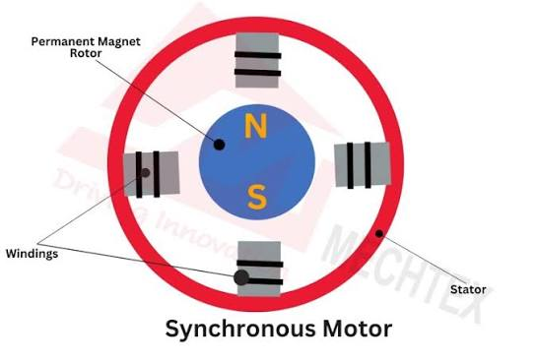

B. Working Principle and Torque Production
Three-phase balanced currents in the stator produce a constant-magnitude Rotating Magnetic Field (RMF) spinning at synchronous speed:

$N_{s}=\frac{120f}{P}$
where $f$ is the supply frequency and $P$ is the number of poles.
By Faraday's Law of Electromagnetic Induction, the moving stator flux cuts the stationary rotor bars, inducing an electromotive force (EMF) and high circulating rotor currents $I_{r}$. By Lenz's Law, the induced currents produce a rotor magnetic field that interacts with the stator RMF to produce torque:

$τ∝\frac{s⋅E_{2}^{2}⋅R_{2}}{R_{2}^{2}+(sX_{2})^{2}}$
where $s$ is the slip, For the running torque formula $\frac{sE_{2}^{2}R_{2}}{R_{2}^{2}+(sX_{2})^{2}}$:
- $s$ (Slip): Relative speed lag between the magnetic field and the rotor ($1$ at start, drops near $0$ at full speed).
- $E_{2}$ (Rotor EMF): Voltage induced in the rotor coils when at a standstill.
- $R_{2}$ (Rotor Resistance): Physical electrical resistance of the rotor bars.
- $X_{2}$ (Standstill Reactance): Inductive pushback of the rotor when stopped.
- $sX_{2}$ (Running Reactance): Actual inductive pushback while spinning (drops as the motor speeds up).
- $R_{2}^{2}+(sX_{2})^{2}$ (Impedance Squared, $Z_{2r}^{2}$): Total electrical opposition to current flow in the spinning rotor.

$s=\frac{N_{s}-N_{r}}{N_{s}}$
The rotor must always rotate at a speed $N_{r}<N_{s}$ ($s>0$); if $N_{r}=N_{s}$, no flux cutting occurs, zero current is induced, and electromagnetic torque drops to zero.

C. Types and Variations
- Squirrel-Cage Induction Motor : Rugged, maintenance-free, industry workhorse.
- Wound-Rotor Induction Motor : Allows insertion of external rotor resistance to provide high starting torque with low starting current.
- Single-Phase Induction Motor: Requires auxiliary starting mechanisms (split-phase, capacitor-start, or shaded-pole) to create a rotating net field from a pulsating single-phase input.

D. Advantages and Disadvantages
- Advantages: Extremely durable and self-starting (three-phase), low manufacturing and maintenance costs, intrinsically explosion-safe (no brushes/sparks).
- Disadvantages: Inherently lagging power factor, speed varies with load (slip-dependent), drawing up to 5–7× rated current during direct-on-line (DOL) startup.

E. Applications
- Industrial pumps, compressors, heavy HVAC chillers,

VIII. Synchronous Motors

A. Construction and Components

B. Working Principle and Torque Production

Stator: The fixed outer ring with 3-phase AC coils; creates a smooth, spinning magnetic wave (just like a standard induction motor).
Rotor: The spinning inner core powered by DC current (via contact rings or a brushless setup) to turn it into an electromagnet.

Rotor Styles:
- Salient Pole: Chunky, protruding teeth—ideal for heavy, slow-speed setups like hydroelectric dams.
- Cylindrical: Smooth and round—ideal for high-speed, high-RPM setups like steam and gas turbines.

The stator produces an RMF spinning at $N_{s}=\frac{120f}{P}$. The rotor DC field creates fixed magnetic poles ($N$ and $S$). When energized, opposite magnetic poles between the stator RMF and the rotor lock together through magnetic interlocking. The rotor spins at the exact synchronous speed ($N_{r}=N_{s}$, $s=0$):

$τ=\frac{V_{t}E_{f}}{X_{s}ω_{s}}sin(δ)$
where $V_{t}$ is terminal voltage, $E_{f}$ is excitation voltage, $X_{s}$ is synchronous reactance, and $δ$ is the torque/power angle. If the mechanical load exceeds the pull-out torque ($δ>90^{∘}$), the magnetic link breaks and the motor stalls.
A synchronous motor cannot start on its own because the stator's magnetic field spins too fast for the heavy rotor to catch up, resulting in zero starting torque. To fix this, metal bars called damper windings are built into the rotor so it can temporarily start spinning like a normal induction motor; once it gets close to full speed, DC power is switched on to turn the rotor into an electromagnet, instantly snapping it into lockstep with the spinning field.

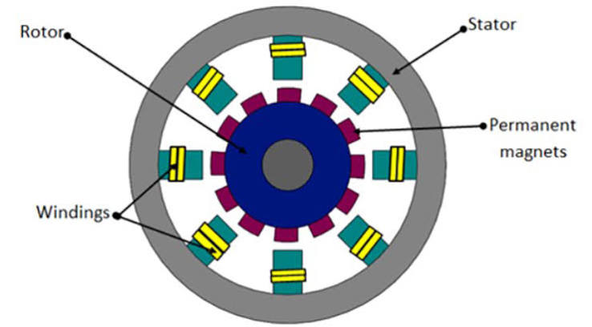

C. Types and Variations
- Electrically Excited Synchronous Motors : Rotor excitation actively controlled; allows continuous power factor tuning.
- Brushless Synchronous Motors: Uses an integrated AC exciter and rotating diode bridge on the shaft to eliminate slip rings.

D. Advantages and Disadvantages
- Advantages: Synchronous motors maintain an exact, constant speed regardless of the load until overloaded, and by boosting the rotor's DC power, they can clean up power grid efficiency by acting as a power-factor corrector (synchronous condenser).
- Disadvantages: They cannot start on their own, need two separate power sources (AC for the outer frame and DC for the spinning rotor), involve complex control hardware, and can wobble or vibrate erratically ("hunt") if the load suddenly changes.

E. Applications
- Constant-speed heavy industrial drives (ball mills, paper mills, large reciprocating gas compressors), grid power-factor correction units.

IX. Permanent Magnet Synchronous Motors (PMSM)

A. Construction and Components
- Stator: Balanced 3-phase distributed or concentrated windings configured to produce a sinusoidal back-EMF profile.
- Rotor: High-flux rare-earth permanent magnets mounted on or within the rotor core.
- Feedback: High-resolution optical/magnetic encoders or resolvers to continuously inform Field Oriented Controllers

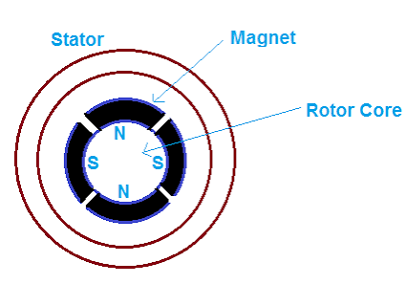
- B. Working Principle and Torque Production
PMSMs operate on synchronous magnetic alignment: the stator generates an RMF, and the permanent magnets lock to it synchronously ($s=0$). Unlike BLDC motors (which utilize trapezoidal drive signals), PMSMs are driven with sinusoidal currents via Field-Oriented Control (FOC) / Vector Control.
The stator current vector is decomposed into direct-axis ($d$-axis, field flux) and quadrature-axis ($q$-axis, torque production) components:
Instead of dealing with three messy AC current waves, engineers split the electricity into two easy jobs using math (called the $d$-$q$ transform):
- $q$-axis current ($i_{q}$): The useful push that spins the wheel forward.
- $d$-axis current ($i_{d}$): A push directed straight at the center axle, used to control internal magnetic strength.
- Magnetic Torque: The main push. The stator's magnetic field grabs the permanent magnets on the rotor and pulls them along (powered by $i_{q}$).
- Reluctance Torque: The bonus push. Because the rotor's iron core isn't shaped like a perfect uniform cylinder, magnetism flows through some directions easier than others ($L_{d}≠L_{q}$). The motor naturally pulls itself toward the position where magnetic flow is easiest, creating extra free twist (powered by the product of $i_{d}$ and $i_{q}$).
- current ($i_{d}$): A push directed straight at the center axle, used to control internal magnetic strength.
The motor then creates total twisting force (torque) from two sources:
- Magnetic Torque: The main push. The stator's magnetic field grabs the permanent magnets on the rotor and pulls them along (powered by $i_{q}$).
- Reluctance Torque: The bonus push. Because the rotor's iron core isn't shaped like a perfect uniform cylinder, magnetism flows through some directions easier than others ($L_{d}≠L_{q}$). The motor naturally pulls itself toward the position where magnetic flow is easiest, creating extra free twist (powered by the product of $i_{d}$ and $i_{q}$).

C. Types and Variations
- Surface PMSM (SPMSM): Magnets glued onto the outer surface of the rotor ($L_{d}≈L_{q}$). Reluctance torque is negligible; primarily delivers pure magnetic torque.
- Interior PMSM (IPMSM): Magnets embedded deep within the rotor core lamination pockets ($L_{q}>L_{d}$). Delivers substantial reluctance torque alongside magnetic torque, mechanically shields magnets against centrifugal forces, and supports deep field weakening for expanded high-speed operation.

D. Advantages and Disadvantages
- Advantages: Highest torque density and efficiency among standard AC motors, ripple-free torque output, wide operating speed range with field weakening, exceptional dynamic response.
- Disadvantages: High raw material cost (Neodymium), risk of high-temperature demagnetization, requires complex FOC digital signal processing and tuning.

E. Applications
- Modern electric vehicle drivetrains (Tesla Model 3/Y, Porsche Taycan), collaborative robot joints, industrial high-performance servo systems.

X. Reluctance Motors

A. Construction and Components
- Stator: Salient-pole structure carrying concentrated phase windings (often 3-phase or 4-phase).
- Rotor: Solid or laminated ferromagnetic material shaped with prominent salient teeth, containing no windings, no permanent magnets, and no brushes.
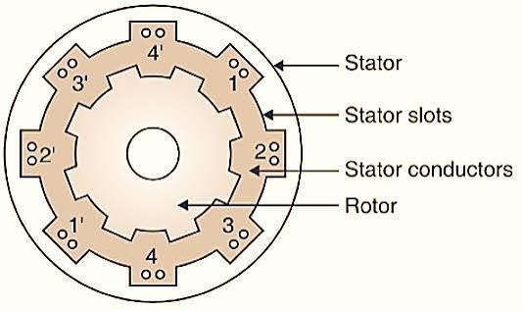

B. Working Principle and Torque Production
Reluctance motors operate on the fundamental physical principle of minimum magnetic reluctance: magnetic flux lines always seek the path of least magnetic resistance (least reluctance $R$). When a stator pole pair is energized, the rotor experiences an alignment torque pulling its nearest salient teeth into direct coaxial alignment with the stator poles:

$τ=\frac{1}{2}i^{2}\frac{dL(θ)}{dθ}$
where $i$ is the excitation current and $\frac{dL(θ)}{dθ}$ is the spatial rate of change of phase inductance with respect to rotor position $θ$. Torque production is independent of current polarity; it depends solely on the derivative of inductance. By sequentially switching the phase currents in synchronization with rotor angle, continuous rotation is produced.

C. Types and Variations
Both of these motors spin without using expensive permanent magnets; instead, their iron rotors simply want to align with where magnetic flow is easiest (the path of least reluctance).
- Switched Reluctance Motor (SRM):
  - The Build: Both the outer frame (stator) and spinning core (rotor) have blocky, protruding teeth like chunky gears sticking out toward each other ("doubly salient"). There are no magnets and no wires on the rotor.
  - How It Runs: An electronic switch rapidly fires power to one pair of stator teeth at a time, pulling the closest rotor teeth into line like a dog chasing a treat.
  - Key Trait: Incredibly tough, cheap, and virtually indestructible, but it requires a specialized electronic drive (asymmetric bridge) and tends to be noisy and jerky.
- Synchronous Reluctance Motor (SynRM):
  - The Build: The outer frame looks like a standard, smooth motor with evenly spread wire loops. The rotor has clever air gaps cut through the iron sheets (flux barriers) so magnetic lines can flow effortlessly along one direction ($L_{d}$) but get blocked across another ($L_{q}$).
  - How It Runs: The stator creates a smooth, continuously rotating wave of magnetism that drags the rotor along with it in perfect lockstep.
  - Key Trait: Runs much quieter and smoother than an SRM, and plugs into standard industrial AC motor controllers (inverters).

D. Advantages and Disadvantages

- Advantages: The rotor is practically indestructible, cheap to build, and immune to high heat because it has zero copper wiring and no expensive rare-earth magnets; it can survive harsh environments, tolerate electrical faults, and operate reliably without delicate physical sensors.

Report on EC :

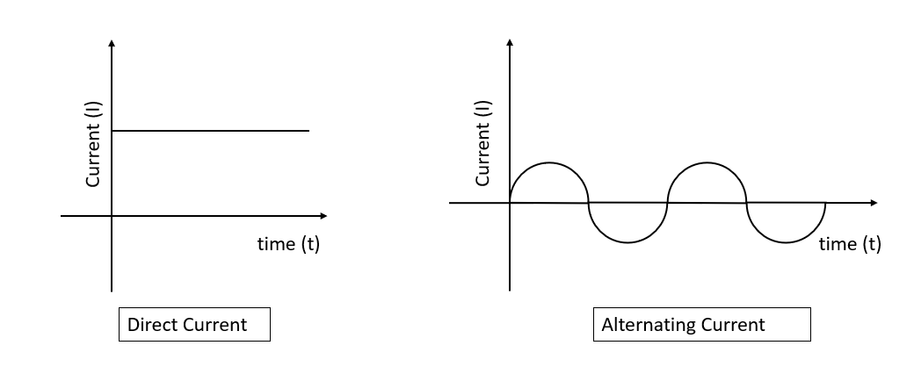

1. Direct Current (DC) vs. Alternating Current (AC) Fundamentals
- Direct Current (DC): Electric charge flows unidirectionally through a conductor. The voltage and current magnitudes remain invariant with respect to time ($V(t)=V_{dc}$), yielding a zero operating frequency ($f=0Hz$).
- Alternating Current (AC): Electric current periodically reverses direction, accompanied by continuous changes in voltage magnitude and polarity over time. Standard AC drives utilize sinusoidal or quasi-sinusoidal waveforms described by:
- $v(t)=V_{m}sin(ωt+ϕ)$
- where $V_{m}$ is the peak amplitude, $ω=2πf$ is the angular frequency (rad/s), and $ϕ$ is the initial phase displacement angle.

2. Signal Metrics & Waveform Definitions
The energetic equivalence and mathematical quantification of AC signals relative to constant DC power rely on distinct analytical definitions:
- Instantaneous Value: The magnitude of voltage or current at any specific instant $t$:
- $v(t) and i(t)$
- Peak Value ($V_{m},I_{m}$): The maximum displacement from zero reference to the highest positive or negative excursion. Peak-to-peak amplitude is given by:
- $V_{p-p}=2V_{m}$
- Average Value ($V_{avg}$): The mathematical mean over one half-cycle for symmetric sinusoidal waveforms (the net average over a full symmetrical cycle equals zero):
- $V_{avg}=\frac{1}{π}\int_{0}^{π}{}V_{m}sin(θ)dθ=\frac{2}{π}V_{m}≈0.637V_{m}$
- Root Mean Square / Effective Value ($V_{rms}$): The equivalent DC heating value that dissipates the identical thermal power across an ohmic load over one complete cycle $T$:
- $V_{rms}=\sqrt{\frac{1}{T}\int_{0}^{T}{}[v(t)]^{2}dt}=\frac{V_{m}}{\sqrt{2}}≈0.707V_{m}$
- Waveform Shape Factors:
  - Form Factor ($k_{f}$): Ratio of RMS value to average value. For a pure sine wave:
  - $k_{f}=\frac{V_{rms}}{V_{avg}}=\frac{π}{2\sqrt{2}}≈1.11$
  - Crest / Peak Factor ($k_{a}$): Ratio of peak value to RMS value:
  - $k_{a}=\frac{V_{m}}{V_{rms}}=\sqrt{2}≈1.414$
Impedance, Phase Shift, and AC Power Theory :
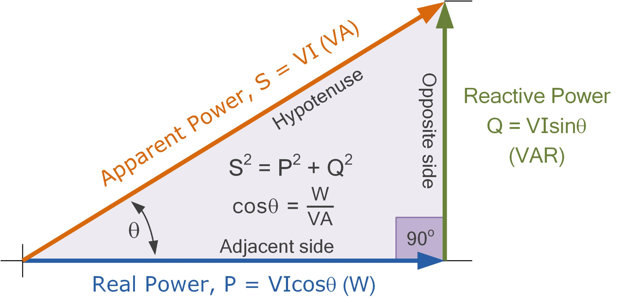
Unlike pure DC circuits governed exclusively by Ohm’s Law (V=IR), AC motor windings introduce inductive reactance due to magnetic field storage:
- Inductive Reactance (XL​): The frequency-dependent opposition to alternating current presented by winding inductance L:
XL​=ωL=2πfL[Ω]
- Total Stator Impedance (Z): The vector sum of winding resistance R and inductive reactance XL​:
Z = R+jXL​=R2+XL2 ​​∠θ
where the phase angle θ = arctan(RXL​​) causes phase current i(t) to lag phase voltage v(t).
- Power Components in Motor Drives:
  - Active / Real Power (P): The actual power converted into mechanical shaft output and thermal losses:
P=Vrms ​Irms ​cos(θ) [W]
  - Reactive Power (Q): The non-working power oscillating between the supply and stator magnetic field:
Q=Vrms ​Irms​ sin(θ) [VAR]
  - Apparent Power (S): Total volt-ampere product delivered to the drive terminals:
S=Vrms ​Irms​ = (P^2+Q^2)^½ [VA]
  - Power Factor (PF): Defined as cos(θ)=SP​. Inductive motor loads operate at a lagging power factor, necessitating power factor correction mechanisms (like synchronous condensers )

5. Multi-Phase Systems & Rotating Magnetic Fields (RMF):
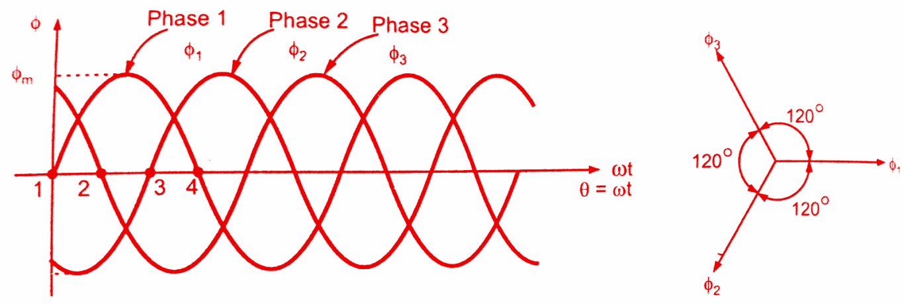
Connecting three balanced sinusoidal phases displaced spatially by 120∘ along the stator core:
ia​(t)=Im​cos(ωt)
ib​(t)=Im​cos(ωt−120∘)
ic​(t)=Im​cos(ωt−240∘)
produces individual pulsating magnetic fields that sum vectorially into a single, constant-magnitude
Rotating Magnetic Field (RMF):
Bnet​= 3/2 ​Bm​∠(ωt)
This net field rotates around the stator air gap at synchronous speed Ns​=120f /P ​ without mechanical commutation, serving as the electrodynamic operating principle for induction and synchronous AC motors.

